**\*\*\*Special Welcome to our Guests! There is a place for you at Stony Hill! Please register on the fellowship pads on the inside aisle of each pew\*\*\***

**STONY HILL UNITED METHODIST CHURCH**

**28996 Stony Hill Rd. Albemarle, NC 28001 Phone: 704.982.7211**

**Pastor: “Lanny” Lancaster Ministers: The Whole Congregation**

**July 30, 2017 Eighth Sunday after Pentecost**

Prelude and Lighting of the Candles

Choral Call to Worship

Christian Greeting: L: The Lord be with you! **P: And also with you!**

Announcements and Passing of the Pew Pads

Prayer for the Holy Spirit

Hymn of Praise: 89 Joyful, Joyful, We Adore Thee

The Mission of Stony Hill United Methodist Church is to: **FOLLOW JESUS, MAKE DISCIPLES, AND TRANSFORM THE WORLD.**

Psalm Reading: #828 Psalm 105 8:45: Tim Wysocki 10:45: Margaret Fields

Welcoming Kayla Aiton, our new Christian Educator

Children’s Story

**Morning Prayer &** The Lord’s Prayer, #895

**Stewardship Scripture: MATTHEW 23.23:** “How terrible it will be for you teachers of religious law and you Pharisees. Hypocrites! For you are careful to tithe even the tiniest part of your income, but you ignore the important things of the law: justice, mercy, and faith. You should tithe, yes, but you should not leave undone the more important things.”

Worship with Our Tithes & Offerings

*Doxology 95 Praise God from Whom All Blessings Flow

Choir Anthem

Scripture: Luke 15.11-32

Sermon: ***Gathering***

Hymn: 110 A Mighty Fortress

Benediction

Postlude

Greeters: 10:45 Kappa Eash, Melissa Rager Sound: Richard Wood

Ushers: 8:45 Jim Cranford, Guill Russell Projection:

10:45: David Eash, Michael Rager Piano: Sid Fields

Counters: Sid Fields, Jill Almond Organ: Elaine Crawley

Pastor: Michael “Lanny” Lancaster

Acolytes: 10:45 Natalia Arita, Eli Fields Assisted by: Bonnie Ward

**\*Jesus & Java Host for July:** 30-Dink & Drinda Hathcock

**\*Jesus & Java Host for August:**6-Bruce&Wanda Smith 13-Jim & Gayle Humphrey

20-Sid & Margaret Fields 27-Henry & Bonnie Springer

**Food Collection for August: Canned Vegetables**

**Every Week at Stony Hill**

**“The Connection”** Sundays: 8:45am: Worship Service with Modern worship music and traditional hymns with praise band, “generations” **Jesus and Java** 9:30am: coffee time, Fellowship Hall 9:45am: Sunday School for all ages **“Traditions”** 10:45am: Worship Service with traditional hymns and the Stony Hill Choir

5:00pm (during school year): Youth Group meeting

Wednesdays: 7:00pm: Choir

**Prayer Concerns:** Our State and Nation, Community Schools, The United Methodist Church, Barry Mullinix, Bobby Mills, Ruby Murray family, Dewel Cook, Josh Holt, Jacob Lancaster, Tani Kepp, Betty Measmer family, Aaron Ash, Bryan Starnes, Joe Mills, Nyoka Myers, Buck Thompson family, Jahala Burris family, Donald Shaver, “Sprinky” Burris Family, Edith Matheney, Ophelia Riggins, Lauren Gift, Frank Sanders, Melissa Crisco, Jacob Kime, Dorthina Samples, Billy Miller, Kenneth and Barbara Stoker, Theresa Henderson and family, Laura McIntyre, Ophelia Blalock, Sonia Simmons, Bryan Booth, Ned Stallings, Gerald Janey and family, Trent Bowers, Elaine Crawley, Victoria Hutchins, Bobby Clodfelter, UMAR, Andria Bell, Lin Senter, Tony Furr, Stella Senter, Pastor Lanny, Janet and family

Shut-ins: Mary Ellen Aldridge, Wayne Mauldin, Ron & Loretta Allred, Gene Helms, Ruby Murray, Carolyn Terry, Gene Watkins

**\*\*\*If you have a prayer concern that you would like added or deleted from the list, please call or email Pastor Lanny at the parsonage or church office**

**Announcements**

**\*Special Welcome!** To KAYLA AITON, our new Christian Educator. She will be focusing on ministry with children and youth.

**\*Soul Food:** worship and food outreach ministry: TOMORROW! Monday, July 31 at 6pm at First St. United Methodist Church. For more information, please contact Pat Mills

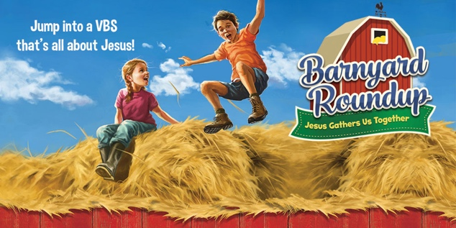**\*Vacation Bible School!**

**Special Thanks to all who worked in the Bible School! You did great!**

**\*HOMECOMING, CELEBRATING 213 YEARS OF FOLLOWING JESUS, MAKING DISCIPLES, AND TRANSFORMING THE WORLD! NEXT SUNDAY AUGUST 6:** welcoming Rev. Laura Auten, District Superintendent of the Uwharrie District, who will be preaching at 8:45am and 10:45am, covered dish luncheon following, seating will be available inside and outside (weather permitting)

**“Transform the World”** at Badin School:

**\*Reading Buddies** / assisting teachers. If you would like to volunteer to be a reading or math buddy or assist teachers at Badin, volunteer forms are available. A background check is required.

**\*Check out** our church website: [www.stonyhillumc.org](http://www.stonyhillumc.org) , like us on Facebook, and follow us on Twitter! Check them for upcoming worship experiences and activities at the Church!

**\*Did you know** that you could set up an electronic payment or bank draft to manage your giving to the church? For more information, contact your bank.