**\*\*\*Special Welcome to our Guests! There is a place for you at Stony Hill! Please register on the fellowship pads on the inside aisle of each pew\*\*\***

**STONY HILL UNITED METHODIST CHURCH**

**28996 Stony Hill Rd. Albemarle, NC 28001 Phone: 704.982.7211**

**Pastor: “Lanny” Lancaster Ministers: The Whole Congregation**

**March 12, 2017 Second Sunday in Lent**

Prelude and Lighting of the Candles

Christian Greeting: L: The Lord be with you! **P: And Also with You!**

Announcements and Passing of the Pew Pads

Prayer for the Holy Spirit

Hymn of Praise: 362 Nothing But the Blood

The Mission of Stony Hill United Methodist Church is to: **FOLLOW JESUS, MAKE DISCIPLES, AND TRANSFORM THE WORLD.**

Psalm Reading: #844 Psalm 121 8:45: Bonnie Russell 10:45: Barbara Stoker

Children’s Story

Morning Prayer & The Lord’s Prayer, #895

**Stewardship Scripture: HAGGAI 2.8: “**'The silver is mine and the gold is mine,' declares the LORD Almighty.”

Worship with Our Tithes & Offerings

*Doxology 95 Praise God from Whom All Blessings Flow

Choir Anthem

Scripture: **Matthew 26.36-46**

Sermon: **“*Our will and God’s will”***

Hymn:  454 Open My Eyes That I May See

Benediction

Postlude

Greeter: 10:45 William & Laura Fields Sound: Rick Stamper

Ushers: 8:45 Dink Hathcock, Jack McRae Projection:

10:45: William Fields, Dean Springer Piano: Sid Fields

Counters: Stephen Eudy, Dean Springer Organ: Elaine Crawley

Pastor: Michael “Lanny” Lancaster

Acolytes: 10:45 Eli Fields, Cole Stinnett Assisted by: Valerie Putnam

**\*Jesus & Java Host for March:** 5 - Bobby & Kathy Johnson

12 - Lee & Christine Smith 19 - David & Pat Mills 26 – Charles & Karen Herlocker

**Food Collection for March: Canned meats (tuna, chicken, spam)**

**Every Week at Stony Hill**

**“The Connection”** Sundays: 8:45am: Worship Service with Modern worship music and traditional hymns with praise band, “generations” **Jesus and Java** 9:30am: coffee time, Fellowship Hall 9:45am: Sunday School for all ages **“Traditions”** 10:45am: Worship Service with traditional hymns and the Stony Hill Choir

5:00pm (during school year): Youth Group meeting

Wednesdays: 7:00pm: Choir

**Prayer Concerns:** Our State and Nation, Community Schools, The United Methodist Church, Bonnie Springer, Angie Peele, Betty Measmer family, Aaron Ash, Bryan Starnes, Joe Mills, Nyoka Myers, Buck Thompson family, Jahala Burris family, Donald Shaver, “Sprinky” Burris Family, Edith Matheney, Ophelia Riggins, Lauren Gift, Mary Ellen Aldridge, Frank Sanders, Melissa Crisco, Jacob Kime, Valerie Putnam, Annette Steed family, Dorthina Samples, Billy Miller, Kenneth and Barbara Stoker, Theresa Henderson and family, Laura McIntyre, Ophelia Blalock, Sonia Simmons, Bryan Booth, Ned Stallings, Gerald Janey and family, Trent Bowers, Elaine Crawley, Victoria Hutchins, Bobby Clodfelter, UMAR, Andria Bell, Lin Senter, Tony Furr, Stella Senter, Pastor Lanny, Janet and family

Shut-ins: Wayne Mauldin, Ron & Loretta Allred, Gene Helms, Ruby Murray, Carolyn Terry, Gene Watkins

**\*\*\*If you have a prayer concern that you would like added or deleted from the list, please call or email Pastor Lanny at the parsonage or church office**

**Announcements**

**“FOLLOWING JESUS IN 2017”: Bible Study on the Gospel of Matthew! NO HOMEWORK! meeting on Thursdays at 7pm. For questions, contact the church office: 704.982.7211 or** [**surferlanny@yahoo.com**](mailto:surferlanny@yahoo.com)

**HOLY WEEK**

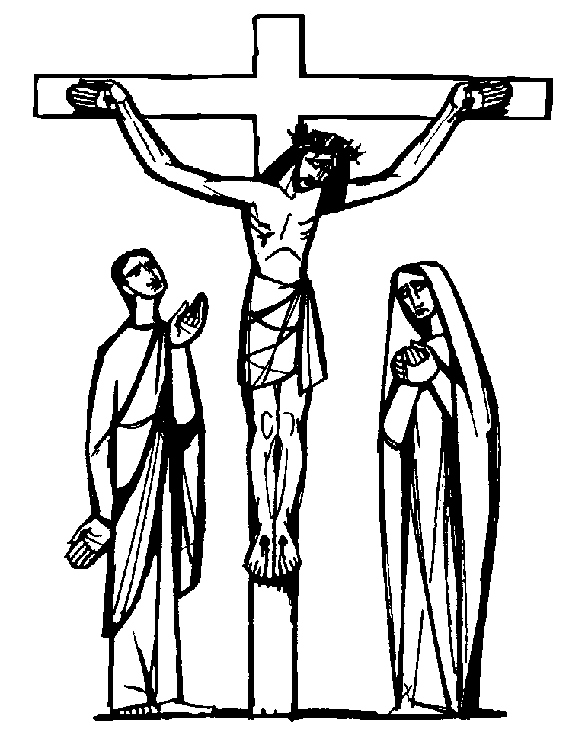*HOLY THURSDAY: APRIL 13: UPPER ROOM COMMUNION AT 8PM, COMMUNITY MEAL AT 6:30PM

*GOOD FRIDAY: APRIL 14: STATIONS OF THE CROSS AT 8PM, COMMUNITY MEAL AT 6:30PM

*HOLY SATURDAY: APRIL 15: EASTER EGG HUNT AT 2PM



*EASTER SUNDAY: APRIL 16: SUNRISE SERVICE AT 7AM FOLLOWED BY COMMUNITY BREAKFAST AT 7:30AM, MUSICAL CELEBRATION OF THE RESURRECTION AT 9AM

*New Address for Jean Holt: 920 N. 6th St. Albemarle, NC 28001. Phone: 704.982.6397

**\*Winter Jam Christian Concert: Saturday, March 25 in Greensboro**

**“Transform the World”** at Badin School:

**\*Reading Buddies** / assisting teachers. If you would like to volunteer to be a reading or math buddy or assist teachers at Badin, volunteer forms are available. A background check is required.

**\*Check out** our church website: [www.stonyhillumc.org](http://www.stonyhillumc.org) , like us on Facebook, and follow us on Twitter! Check them for upcoming worship experiences and activities at the Church!

**\*Did you know** that you could set up an electronic payment or bank draft to manage your giving to the church? For more information, contact your bank.