**\*\*\*Special Welcome to our Guests! There is a place for you at Stony Hill! Please register on the fellowship pads on the inside aisle of each pew\*\*\***

**STONY HILL UNITED METHODIST CHURCH**

**28996 Stony Hill Rd. Albemarle, NC 28001 Phone: 704.982.7211**

**Pastor: “Lanny” Lancaster Ministers: The Whole Congregation**

**March 25, 2018 Palm/Passion Sunday**

Prelude and Lighting of the Candles

Christian Greeting: L: The Lord be with you! **P: And also with you!**

Welcome

Prayer for the Holy Spirit

**Palm Sunday Reading: Mark 11.1-11**

Hymn of Praise: 213 Lift Up Your Heads, Ye Mighty Gates

Procession of the Palms

The Mission of Stony Hill United Methodist Church is to: **FOLLOW JESUS, MAKE DISCIPLES, AND TRANSFORM THE WORLD.**

Psalm Reading: #764 Psalm 31 8:45: Tim Wysocki 10:45: Bonnie Springer

Children’s Story

**Morning Prayer &** The Lord’s Prayer, #895

**Stewardship Scripture: 2CORINTHIANS 8.2-3a: “**In the midst of a very severe trial, their overflowing joy and their extreme poverty welled up in rich generosity. For I testify that they gave as much as they were able, and even beyond their ability.”

Worship with Our Tithes & Offerings

*Doxology 95 Praise God from Whom All Blessings Flow

Scripture: **Mark 15.25-39**

Sermon: **Love, Art and Laughter: Part II**

Hymn of Praise: 189 Where He Leads Me

Benediction

Postlude

Greeters: 10:45 John Henderson & Darlene Owens Sound: Richard Wood

Ushers: 8:45 Jim Cranford, Guill Russell Projection:

10:45: John Henderson, Lee Smith Piano: Sid Fields

Counters: Sid Fields, Kathy Johnson Organ: Elaine Crawley

Pastor: Michael “Lanny” Lancaster

Acolytes: 10:45 Addison Burleson, Zoe Finney Assisted by: Bonnie Ward

**\*Jesus & Java Host for March:** 25–Tump & Joanne Mills

**\*Jesus & Java Host for April:** 1-EASTER 8–Timmy& Mary Wysocki

15–Dink & Drinda Hathcock 22–Bobby & Kay Mills 29–Barry & Vanessa Mullinix

**Food Collection for March: Rice, Macaroni & Cheese, Pasta, instant potatoes**

**Food Collection for April: Canned Meat – tuna, chicken, spam, salmon**

**Every Week at Stony Hill**

**“The Connection”** Sundays: 8:45am: Worship Service with Modern worship music and traditional hymns with praise band, “generations” **Jesus and Java** 9:30am: coffee time, Fellowship Hall 9:45am: Sunday School for all ages **“Traditions”** 10:45am: Worship Service with traditional hymns and the Stony Hill Choir

5:00pm (during school year): Youth Group meeting

Wednesdays: 7:00pm: Choir

**Prayer Concerns:** Our State and Nation, Community Schools, The United Methodist Church, David Mills, Bobby Mills, Ali Speight, Ember McCombs, Bill Scholl, Jack Lilly, Bonnie Mehalechko, Frank Gilmore Family, Lonnie Crisco Family, Frank Dennis Family, Margie Carter, Mary Connell family, Dewel Cook, Bonnie Ward, Shelly Eudy, Wayne Mauldin Family, Rev. David Hamlyn, Bobby Mills, Josh Holt, Tani Kepp, Aaron Ash, Bryan Starnes, Joe Mills, Nyoka Myers, Donald Shaver, Edith Matheney, Ophelia Riggins, Lauren Gift, Frank Sanders, Melissa Crisco, Jacob Kime, Dorthina Samples, Billy Miller, Kenneth and Barbara Stoker, Theresa Henderson and family, Ophelia Blalock, Sonia Simmons, Bryan Booth, Trent Bowers, Elaine Crawley, Victoria Hutchins, Bobby Clodfelter, UMAR, Andria Bell, Lin Senter, Stella Senter, Pastor Lanny, Janet and family

Shut-ins: Mary Ellen Aldridge, Ron & Loretta Allred, Tony Furr, Gene Helms, Zelma Johnson, Gene Watkins

**\*\*\*If you have a prayer concern that you would like added or deleted from the list, please call or email Pastor Lanny at the parsonage or church office**

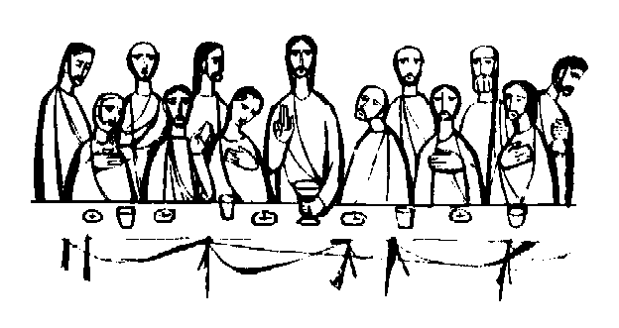**HOLY WEEK**

**\*Holy Thursday: March 29,**

**fellowship meal at 7pm,**

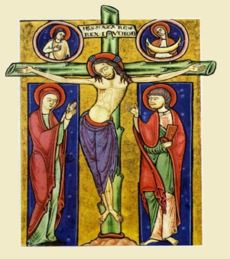**worship at 8pm**

**\*Good Friday: March 30,**

**fellowship meal at 7pm, worship at 8pm**

**\*Holy Saturday: March 31, placing flowers on graves**

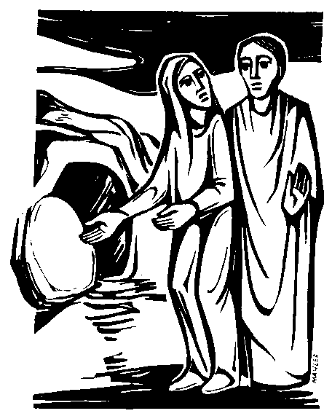**\*Easter Sunday: April 1:**

**Sunrise Service at 7am,**

**Community Breakfast afterwards,**

**9am: Musical Celebration of the Resurrection**

**\*Bring fresh flowers on Easter Sunday to place on the Resurrection Cross**

**NATIVE AMERICAN MINISTRIES SUNDAY and Musical Celebration of God: APRIL 15 AT 10:45AM: with guests, The Ninth Senior Ms. Lumbee, Sherry Carter 2017-2018 and Family**

**“Transform the World”** at Badin School **\*Reading Buddies** / assisting teachers. If you would like to volunteer to be a reading or math buddy or assist teachers at Badin, volunteer forms are available. A background check is required.

**\*Check out** our church website: [www.stonyhillumc.org](http://www.stonyhillumc.org) , like us on Facebook, and follow us on Twitter! Check them for upcoming worship experiences and activities at the Church!

**\*Did you know** that you could set up an electronic payment or bank draft to manage your giving to the church? For more information, contact your bank.