**Analysis of Fire Accident Factors on Construction Sites**

**Using Web Crawling and Deep Learning**

Jaehong Kim1, Sangpil Youm2, Yongwei Shan 3

1 Ph.D. Student, School of Civil & Environmental Engineering, Oklahoma State University, Stillwater, OK, [jaehong.kim@okstate.edu](mailto:jaehong.kim@okstate.edu)

2 Master Student, Luddy School of Informatics, Computing and Engineering, Indiana University, Bloomington, IN, youms@iu.edu

3 Assistant Professor, School of Civil & Environmental Engineering, Oklahoma State University, Stillwater, OK, [yongwei.shan@okstate.edu](mailto:yongwei.shan@okstate.edu)

*Corresponding author: [yongwei.shan@okstate.edu](mailto:yongwei.shan@okstate.edu)

**ABSTRACT**

The construction site is one of the industrial sites that can be exposed to fatal accidents. As the construction becomes complicated in recent years, on-site safety management has become very important. Fire accidents on construction sites are an important part of the site safety plan. However, because fire accidents have fewer frequencies than other types of accidents such as falls, plans related to fire safety at construction sites have been rarely studied. It has different characteristics compared to other types of accidents, such as the possibility of leading to further damage around fire accidents at construction sites. Without considering the characteristics of these fire accidents, it is unreasonable to evaluate the risk based only on the frequency of accidents. To fill the knowledge gap, this study was conducted to find factors related to accidents at the construction site and includes big data analysis. In this study, web-crawling was used to collect data related to accidents at construction sites in the past 20 years. Based on the collected data, the authors found the frequency of exposure of keywords related to accidents and provided similarity between related keywords through word embeddings and network analysis. In addition, it was visualized through the Uniform Manifold Approximation and Projection (UMAP) to show in multi-dimensional. The contribution of this study is important to reduce the risk by identifying factors related to construction site accidents, including fires. Through the visualization of keywords related to accidents, potential risks can be predicted in advance. Also, this study can play an important role in establishing the regulations necessary to increase safety in construction sites.

**KEYWORDS:** Construction sites, Safety, Fire accidents, Web crawling, Deep learning

**Introduction**

Recently, due to the development of various construction technologies, skyscrapers and large-scale construction projects are under construction. The development of construction technologies has shortened the construction period and improved the convenience of residents, but the safety of the construction site is developing slowly. The Bureau of Labor Statistics (BLS) recently released Census of Fatal Occupational Injuries (CFOI) in 2018, and the construction industry topped the list with 1,008 worker deaths. In addition, 5,250 fatal work injuries were recorded, a 2% increase from 2017. The fatal work injury rate was about 3.5 per 100,000 full-time equivalents (FTE) workers. As such, various types of accidents occur on construction sites, including fires. Fire accidents are greatly affected by the external environment, making it difficult to control and prevent them. This is especially dangerous because fire safety equipment has not been completed on construction sites.

Most construction accident-related research focuses on the frequency of accidents in the past. However, there are limitations when analyzing only the frequency of accidents. For example, fall accidents on construction sites are fatal but are unlikely to lead to additional accidents to the surroundings. The frequency of fire accidents is lower than that of fall accidents, but it can have a greater impact on the construction site. In other words, in order to improve the safety of the construction site, it is necessary to consider how the accident type affects the construction activity and the surrounding environment. The impact of each type of accident on the construction project and the surrounding environment involves various external conditions, and it is difficult to quantify these effects. For this reason, most construction accident studies focus on the frequency of accidents. To compensate for this limitation, this study investigated the frequency of media exposure. The media has characteristics that deal with social issues that have a great influence around them, and this is expressed in articles. Rather than minor accidents on construction sites, fatal accidents that can affect the surroundings are more likely to be exposed to the media. In addition, the articles provided by the media are organized in a similar format, which is efficient for many researchers to use as low data.

To enhance construction safety, including fires at construction sites, this study collected articles on construction site accidents reported in The New York Times over the past 20 years. The web-crawling method is used for efficient and accurate data collection. Using collected articles, we analyzed the frequency of keywords related to construction site accidents. In addition, similarity and relationships between related keywords were analyzed through word embedding and network analysis. To intuitively visualize words that have high relationship between fire accident and fall accident, the Uniform Manifold Approximation and Projection (UMAP) method is applied. In this study, the frequency of media exposure of construction site accidents was conducted to analyze accidents on construction sites and to present a new perspective to improve safety. In the case of fire accidents, the media frequency was higher than the actual frequency when compared to the fall accident. This shows the possibility that fire accidents may have a greater impact on the surroundings than the actual frequency. The results of this study can be used as data to establish new safety regulations for construction sites. In addition, it is possible to intuitively check the factors related to each accident type and help to institutionalize them.

**Background**

***Construction site safety***

The construction industry always considers safety, but the fatality rate at construction sites is always high(Abdullah and Wern 2011). The fatality rate of the construction industry was found to be the fourth highest after agriculture, mining, and transportation. According to the Occupational Safety & Health Administration (OSHA), 20.5% of fatal workplace accidents occurred on construction sites in 2014 (Zou and Zhang 2009, Hosseinian and Torghabeh 2012). Various studies have been conducted to analyze accidents on construction sites. The OSHA provided that the main reasons for the construction worker's fatal accidents are by falls, struck by an object, electrocutions, and caught-in/between. One study suggested that the seven causes of accidents are lack of training, deficient enforcement of safety, no provided safety equipment, unsafe methods, unsafe site condition, no use of safety equipment, safety ignorance, and isolated sudden deviation (O'Toole 2002). Other studies have shown that construction accidents have occurred due to improper safety management due to a lack of safety awareness by managers (Zhou, Fang et al. 2008). A study investigating the construction industry accident in Malaysia suggested that the accident on the construction site was due to the manager's fault and the attitude of the worker (Abdullah and Wern 2011). In another study, the cause of the accident was identified by analyzing 40 deaths at the construction site from 2003 to 2008(Ling, Liu et al. 2009). The findings indicated that unskilled workers and lack of safety training are the main causes.

In particular, it is important to prevent fire accidents on construction sites, as they are likely to cause secondary accidents such as collapse, burial, and explosion. According to a related study, fires on construction sites are mainly caused by the transfer of sparks to the surrounding insulation during welding (Lee 2012). In order to evaluate the fire hazards at construction sites, there are also studies evaluating fire hazard tracking systems and related training (Hui, Yongqing et al. 2012). In addition, several studies have been conducted on effective evacuation in case of fire at the construction site (Ingason, Lönnermark et al. 2010, De-Ching, Shen-Wen et al. 2011, Jeong, Lee et al. 2014). However, because these studies are based on case studies and specific projects, they are limited in application to general construction sites. In order to prevent these accidents, establishing relevant policies is one of the best ways. It is important to establish appropriate safety regulations for the construction, as well-established policies for construction safety can directly reduce accidents(Aires, Gámez et al. 2010).

***Web crawling***

Web crawling is a technique for systematically browsing the web for the purpose of web indexing (Paul, Mitra et al. 2017). It is often used for tracking web documents on the Internet to effectively collect the information the user needs. There are also studies to properly use online data for research purposes (Massimino 2016). This study provided guidelines on the skills and responsibilities required to collect online data. Because the data on the web is very huge, collecting web data manually can take a lot of time, and the accuracy can be reduced. However, web crawling technology automatically rotates the web server to repeatedly collect information that fits the purpose. These web crawling technologies are used in a variety of fields, especially in research involving decision models and prioritization (D’Haen, Van den Poel et al. 2016, Guy, Schwartz et al. 2019). Recently, research on safety and security through web crawling has been conducted (Morgan, Tietje et al. 2020). Web crawling technology has begun to be used not only for text but also for image analysis (Ali, Ali et al. 2018). In addition, research was conducted to utilize real-time data on the web rather than past data (Kim, Kim et al. 2019). To use web crawling in the research, researchers must set a clear target. Target is primarily a website, and researchers should make sure that web crawling technology is available on selected websites. This is very important because there are issues with data security. Next, the researcher determines the scope and frequency of data collection.

Traditionally, the main purpose of using web crawling in the construction field consists of two main parts. The first is construction material management and optimization. To improve the efficiency of construction material management, related researches used web crawling technology to collect relevant information and provide automated processes. (Yang, Wi et al. 2018, Hong, Lee et al. 2019). It also used web crawling to manage massive documents in construction projects. An example is a web crawling used to develop a system that collects text data with the latest information from the construction market and automatically assigns it to each applicable construction document (Moon, Shin et al. 2018). As above, the use of web crawling in the construction field was limited. Recently, this technology is used in various fields related to construction. An example is a study that collects a variety of geographic information on the web and provides a model to predict air emissions from heating (Lopez-Aparicio, Grythe et al. 2018). However, few studies have analyzed the factors related to the safety of a construction site using web crawling. In this study, web crawling technology was used to find factors related to site safety, which may suggest a new approach to improving construction site safety. The authors used the python language and libraries to implement web crawler.

***Word embedding and network analysis***

Word embedding is a technique that provides a way to express similar words with the same meaning through data analysis (Yin and Shen 2018). This is a new way to represent words and documents and is one of the key breakthroughs in deep learning (Lai, Liu et al. 2016). Each word has a unique vector value through analysis using an embedding layer or hidden layer (Yoshioka and Dozono 2019). This method of analysis was mainly used as a new method for analyzing text or documents (Shao, Zhang et al. 2017, Zhang, Huang et al. 2018). This methodology overcomes the limitations of a one-hot encoding analysis, which was widely used for text analysis (Rodríguez, Bautista et al. 2018). In the one-hot encoding method, since all words are composed independently, it is impossible to measure the similarity of each other. However, in the word embedding method, each word is expressed as a dependent relationship, and similarity can be measured (Rekabsaz, Lupu et al. 2017). The word embedding method is currently used mainly in text analysis and natural language processing (NLP). The main models using word embedding are Word2vec (Church 2017), GloVe (Hindocha, Yazhiny et al. 2019), and fastText (Choi and Lee 2020), and Word2vec was used in this study. Word2vec Model was created and published in 2013 by a research team of Google. This model has been subsequently analyzed and updated by other researchers. Word2vec has very efficient performance and accuracy (Ombabi, Lazzez et al. 2017). In addition, it has a lot of google news pre-trained data, so it is suitable for transferring learning based on it (Khatua, Khatua et al. 2019).

In this study, network analysis was used to analyze not only the vector value of each word, but also the relationship between linked words. Network analysis is one of the methodologies for finding the relationship between various types of low data, and basically consists of nodes and edges (Smith and Gorgoni 2018). Links between words can be expressed as graphs or structures, and relationships between words can be analyzed using them. Through the analysis of various centralities such as eigenvector centrality, degree centrality, and betweenness centrality, it is possible to check which nodes are important (Risselada, Verhoef et al. 2016). Also, the correlation between nodes can be analyzed by calculating the Jaccard coefficient that can measure the similarity of sample data (Bag, Kumar et al. 2019). This network analysis is widely used in recent safety issues, such as pandemic research. There are studies to effectively prevent pandemic by analyzing the paths and conditions in which the pandemic spreads using network analysis (Sandhu, Gill et al. 2016).

**Methodology**

* 데이터 이용한 논문들 읽어보니, 방법론 하나하나 설명할때 수학적 설명 + 다른논문 레퍼런스를 꼭 넣더라.

1. ***Data collection procedures and sample (Web crawling)***

* ***Selenium***
* ***Beautiful Soup***
* ***Data facts***

Table 1. Source data information

|  |  |
| --- | --- |
| **Category** | **Information** |
| Issued duration | 2000.01.01 – 2019.12.31 |
| News source | The New York Times |
| Total number of articles | 1010 |
| The number of relevant articles | 861 |
| Total number of words | 453,283 |

* 뉴스기사는 1010 개 까지의 most relevant article 을 추려냈다
* Non relevant article은 format이 블로그 형식 즉 글로만 이루어진article 형식이 아니다
* 그리고 조금 필요없는 정보라도 data information을 추가하는게 좋을듯. 우리가 말하고 있는 기사의 계절별 뭐 요일별 등등 추가정보(같이 생각해보자)
* ***Data preprocessing***

1. ***Network analysis***
2. ***Word Embedding (Word2Vec)***

* ***Why Word2Vec***
* ***Theoretical grounds in Word2Vec***
* ***Deep learning***

***One hot encoding***

***Hidden layer***

***Skip-gram vs Cbow***

Figure . Skip-gram

Figure . CBOW

* ***Setting of Word2Vec***

***Mincount : 200***

***Training Algorithm : CBOW***

***Dimensionality of the word vectors : 400***

* ***Cosine similarity***

$$\cos{θ}=\frac{\overset{→}{U ∙} \overset{→}{V}}{\left|u\right|\left|v\right|}$$

1. ***UMAP***

* ***Why UMAP***
* ***Dimensional Reduction***

**Results**

***Preliminary analysis***

* 웹크롤링을 통하여, 총 몇 1010 개의 relevant articles을 찾아 냈습니다. 기본적으로 newyork times 에서 “construction accident” 를 search term 으로 사용 하였으며 상위 1010개의relevant articles을 retrieved. 해당 URL 을 기본 URL fh 설정하였으며, Selenium을 이용하여 automated crawling 을 실행했습니다.

Selenium is a set of powerful different software tools working with many browsers, operating systems, programming languages, and testing frameworks each with a different approach to supporting automation test for testing web-based application.

* Fei Wang, Wencai Du(2012), A Test Automation Framework Based on WEB

이를 통해 얻어진 Article 각각의 URL 은HTML parser와 BeautifulSoup 을 통하여 data를 parsing 했습니다.

* HTMLParser defines a class HTMLParser that serves as the basis for parsing text files formatted in HTML and XHTML. Beautiful Soup is a Python library that parses broken HTML. It yeilds a parse tree that makes approximately as much sense as the original document.
* Eloisa Vargiu, Mirko Urru (2012), Exploiting web scraping in a collaborative filtering based approach to web advertising.
* 이 라이브러리는 많은 연구에서 사용되고 있으며, 신뢰성이 있다고 판단됩니다.(참고문헌)
* The authors checked irrelevant data. 여기서 document type의 article 만 분석의 대상으로 활용했고, interactive document and blog type 의 149개의article은 분석대상에 제외했다. 이 타입들은 structure 가 불규칙 적이기 때문에 scraping 하는데 있어서 유효하지 않다. 따라서 총 861 개의 article을 분석했다.
* 데이터 클리닝을 마친후, 저자는 articles 들을 분류 하였습니다. 일반적으로 기사들은 Title, date, body로 구성되기 때문에 이에 따라 분류하였습니다. 분류하는데 있어서 beautiful soup 로 원하는 부분을 scraping 하였다.

***Basic statistical analysis***

* Preliminary analysis 를 통해 얻어진 선별된 데이터를 바탕으로, nltk library 를 활용하여 Natural Language Process 를 진행하였습니다 . 구체적으로, nltk 에서 제공하는 english stopwords(179개) 를 제거하고, 모든 단어들을 lower case 로 바꿨습니다. 후에 word2vec을 진행하는데에 있어서 최대한 origin data를 변형시키지 않는 범위 내에서 위와같이 최소한의 preprocessing 을 진행하였습니다.
* Basic statistic 중 하나로 각 키워드에 관한 빈도분석을 하였습니다 . fire, collapsed, fell, building , people이 each article 에서 나타나면 한번으로 간주하고, 중복해서 count하지 않았습니다. We measured frequency of words appearing in each article and we did not count the words repetitively in an article.

In this study, text analysis was conducted by setting the minimum frequency to 200 times. Among the words satisfying this condition, 5 keywords related to this study were selected. The five keywords are fire, fell, collapsed, building, and people. The selection criteria considered the types of accidents on construction sites and keywords representing fire. In many studies, three major elements of building fire are defined as a fire, building, and people. In addition, fell and collapsed are the most frequent types of accidents at construction sites. All keywords have sufficient frequency to be used in this study.

According to the analyzed results, buildings and people were the most frequent. The fire, fell, and collapsed keywords related to the type of accident on the construction site showed relatively similar frequency. Since fell and collapsed are similar words, it may be reasonable to compare fire with the frequency of combining them. When comparing the combined numbers of fell and collapsed, the fire has a frequency of 27% and fell and collapsed have a frequency of 73%. This result differs significantly from the Bureau of Labor Statistics (BLS) analysis of construction site accident frequency. According to the BLS report, among the accidents at the construction site, fell and collapsed accidents account for about 40% of all accidents, and fire accidents are 2%. When converted to 100%, fire accidents have a frequency of 5% in fell-related accidents. There is a large gap in 27% of the results of this study and 5% of the BLS report. The possible reasoning about this difference can be explained by the characteristics of the media that the author described in the intro. Fire-related accidents may be more exposed to the media than fell-related accidents, which may explain that fire accident on construction sites have a greater effect than fell-related accidents.



Figure 3. Frequency of keywords

***Network analysis (Threshold: cosine similarity 0.5)***

* 네트워크 분석은 데이터를 Node와 edge 로 설명하는 것입니다. 이러한 네트워크 분석을 활용하면 우리는 node와 node와의 관계를 좀더 용이하게 파악할 수 있습니다 . 이 study 에서는 기본적으로 keywords 가 기본적인 노드가 되고 각 단어들과 유사한 단어중 cosine similarity 가 0.5 이상인 유사단어들과 edge로 연결됩니다. 그리고 5개 keyword 각각의 네트워크를 하나의 네트워크로 합쳐줍니다. 이는 Figure 4 에 시각화하여 나타냈습니다. 이를 통해 keywords 간의 jaccard coefficient 를 확인 할 수 있습니다 . 이는 Table 3 에서 확인 가능합니다. 즉, 각 단어간의 coefficient를 확인함으로써, 키워드 간의 관계를 파악할 수 있습니다.
* 총 136개의 nodes와 353개의 edges 로 이루어 져있다
* 각 키워드의 연결된 node는 cosine similarity 0.5 이상의 단어를 연결된 노드로 갖는다 . Fire 는 80 개 , Fell 은 88개, Collapsed 91 개, Building 50개 , People 50 개를 갖는다

Table 2. Network analysis information by keywords

|  |  |
| --- | --- |
| **Keywords** | **Connected Nodes** |
| Collapsed | 91 |
| Fell | 88 |
| Fire | 80 |
| Building | 50 |
| People | 50 |
| Total nodes: 136 / Total edges: 353 | |

Figure 4. The network of keyword's similar words

* 이 네트워크는 degree 를 기준으로 node 와 annotation에 사이즈에 차이를 두었습니다. 즉 많은 node들과 연결될 수록( degree가 높을수록 ) node의 size 가 큰것을 볼수 있습니다. 다섯 가지 키워드 중에는 collapsed 가 가장 큰 degree 를 갖습니다. 그리고 다섯가지 키워드 이외에 notable 하게 사이즈가 큰 것은 death 입니다. 이는 death 라는 단어가 Figure 4 network 에서 키워드를 제외하곤 높은 degree 를 갖는 것을 보여줍니다.

Jaccard Coefficient

$$J\left(A,B\right)= \frac{\left|A∩B\right|}{\left|A∪B\right|}$$

|  |  |
| --- | --- |
| **Relationship between keywords** | **Jaccard Coefficient** |
| Fire and Building | 0.262 |
| Fire and People | 0.262 |
| Fire and Collapsed | 0.513 |
| Fire and Fell | 0.541 |
| People and Fell | 0.484 |
| People and Collapsed | 0.424 |
| People and Building | 0.020 |
| Building and Collapsed | 0.205 |
| Building and Fell | 0.160 |
| Fell and Collapsed | 0.772 |

Table 3. Jaccard Coefficient between keywords

***Word embedding with Word2vec***

* 본 연구에서는 cosine similarity을 활용하여, 각 키워드간의 Similarity를 제공하였습니다. 등의 개념적인 설명 필요
* cosine similarity는 ~~~~~ 개념이며, 이를 구하는 방법은 ~~~~ 이며, 수식은 아래와 같습니다. (개념과 수식 넣어야함). cosine similarity의 범위를 알려줫으면 좋겠음. 예를 들어서 0.5?? 이상이면 유사도가 있다고 판단된다 등등 일반적인 범위 ~~~~~

A total of 10 combinations were made by classifying each of the 5 keywords selected above, and the similarity of each was calculated. In order to confirm the reliability of this study, cosine similarity among the most similar words among the analyzed words was first checked. The words chosen by the author are fell and collapsed. The dictionary meaning between these two words is very similar, so if the results of this study are reliable, the similarity between these words should be high. The similarity between the two words was 0.951, which was calculated much higher than the similarity between the other keywords. Through this, the author can confirm the reliability of this study.

In the results related to the fire keyword, the fire keyword was more similar to the building keyword than the people keyword. The similarity between fire and building was 0.525, and the similarity between fire and people was 0.331. It can be interpreted that fire showed a much higher degree of similarity to words related to the building than words related to people. For the fell and collapsed keywords, the similarity between each keyword and the people and building keywords was very similar. In the case of the fell, the similarity with the building keyword was 0.443, and the similarity with the people keyword was 0.486. This result contrasts with the fire keyword and fell has a higher similarity to the people keyword. Also, the similarity between people and buildings was calculated as a negative value, indicating that the correlation between the two keywords is not great. This table shows similarity between keywords.

Table 4. Similarity between keywords

|  |  |
| --- | --- |
| **Relationship between keywords** | **Similarity** |
| Fire and Building | 0.525 |
| Fire and People | 0.331 |
| Fire and Collapsed | 0.691 |
| Fire and Fell | 0.728 |
| People and Fell | 0.486 |
| People and Collapsed | 0.510 |
| People and Building | - 0.144 |
| Building and Collapsed | 0.554 |
| Building and Fell | 0.443 |
| Fell and Collapsed | 0.951 |

The table below shows 5 selected keywords and 20 words with high similarity. It was written based on the cosine similarity values, listed in order of similarity. In the results, the fell and collapsed keywords were calculated to be most similar to each other. This shows the reliability of this study, as well as the calculation of cosine similarity between keywords. In terms of similarity word results related to the type of accident on the construction site, such as fire, fell, and collapsed keywords, the words Monday and Friday are included in the list. This shows results consistent with research on the construction industry's 'The distribution of injuries'. In a related study, the day of the week where injuries were most likely to occur in the field was found to be Monday, which is consistent with the results of this study (Wigglesworth 2006).

In addition, unlike the results of other keywords, the fire keyword result showed a high degree of similarity with the word “night”. Generally, the possibility of spread increases when a fire occurs at night. Because, most commercial buildings are less likely to stay after working hours, and even residential buildings have difficulty recognizing fire during sleep. In most fire accidents, the probability of the spread of a fire tends to increase as the initial detection of the fire is delayed. In particular, a construction site may have a small number of employees staying overnight for the monitoring or may be empty. The characteristics of these construction sites can lead to the rapid spread of fires in fire accidents. Also, during the construction phase of the building, it is more difficult to recognize fires because safety equipment such as fire and smoke alarms have not been completed (Hamid, Yusof et al. 2003). This was highlighted once again through the results of this study. There are many words that have a meaning of ‘administration’ or ‘inspection’ in words with high similarity to the building keyword. The top five words with the most similarity to the building keyword are department, inspectors, issued, commissioner, and city, and these words tend to have a common meaning. These results show that articles related to accidents on construction sites mainly deal with building inspection and management issues. In addition, words with high similarity to the people keyword have many words related to action or behavior.

Table 5. Top 20 list of similar words of keywords

|  |  |  |  |  |
| --- | --- | --- | --- | --- |
| **Fire** | **Fell** | **Collapsed** | **Building** | **People** |
| police | collapsed | fell | department | died |
| investigators | side | debris | inspectors | injured |
| authorities | floor | floor | issued | killed |
| hospital | debris | ground | commissioner | men |
| injuries | ground | west | city | accident |
| chief | street | steel | cranes | authorities |
| night | Friday | street | contractor | debris |
| floor | avenue | death | violations | train |
| man | death | side | tower | injuries |
| dead | morning | site | crane | dead |
| Monday | worker | Friday | investigation | workers |
| Friday | injuries | march | office | ground |
| driver | Monday | wall | equipment | Monday |
| investigation | injured | injuries | site | crash |
| truck | dead | authorities | district | march |
| officials | wall | Monday | charges | residents |
| death | authorities | avenue | investigators | members |
| worker | steel | tower | company | Tuesday |
| fell | crash | Tuesday | officials | Thursday |
| working | died | injured | mayor | cars |

***Visualizing with UMAP***

* 본 연구에서는 Word2vec을 통해 분석한 결과를 UMAP에 가시화 하였습니다.

UMAP(Uniform Manifold Approximation and Projection) is a novel manifold learning technique for dimension reduction. The result is a practical scalable algorithm that applies to real word data. (Leland Mcnnes etal, 2018) 밑에것과 같은 논문입니다

* 본 연구에서는 UMAP을 활용하여 다차원 공간의 vector를 2차원 공간으로 차원을 축소하여 가시화하여 보여줍니다. 이는 보다 직관적으로 키워드간의 관계를 볼 수 있습니다. 이를 구현하기 위해 Python 으umap library 를 사용하여 구현했고, 결과를 Matplotlib 를 활용하여scatter plot 형식으로 구현했습니다.
* UMAP 의 작동원리를 computational view 에서 본다면,
* As with other k-neighbour graph based algorithms, UMAP can be described in two phases. Un the first phase a particular weighted k-neighbor graph is constructed. In the second phase a low dimensional layout of this graph is computed.( Leland Mcinnes et al, 2018) Leland McInnes, John Healy, James Melville (2018) , UMAP : Uniform Manifold Approximation and Projection for Dimension Reduction.
* 이러한 과정을 거친 UMAP을 통해서 각각의 vector 간의 유사도를 물리적 거리로 2차원 공간 에서 파악가능하고. 또한, 각 벡터간의 그룹을 만드는데 있어서 효과적입니다.

In order to increase the discernment of the graph, each keyword is expressed in a different color, and the range of each keyword is indicated by gradation. The gray dots on the UMAP are words with low similarity to keywords. As shown in the figure below, fell and collapsed were almost overlapped on the UMAP. This means that the similarity between the two keywords in UMAP is very high. In the case of the fire keyword, the range appears wider than other keywords, and there is an intersection with the building keyword. For the fell and collapsed keywords, the people keyword appeared to be closer than the building keyword.

Figure 5. Word2vec result overview with UMAP

The figures below show the UMAP visualization limited to each keyword. Through this, it is possible to know how similar words with each keyword are expressed at the UMAP and the distance between each word. By using this, this study can provide information grouped according to the similarity of words.

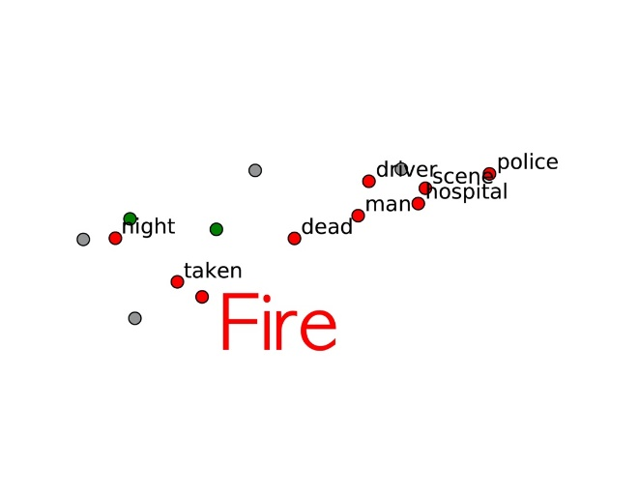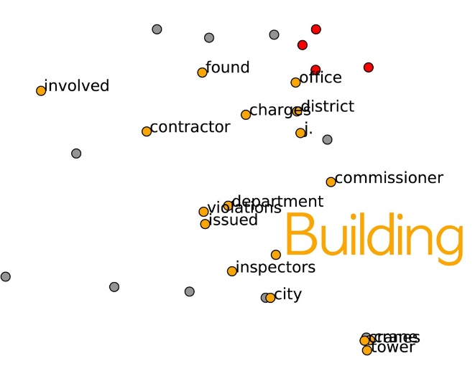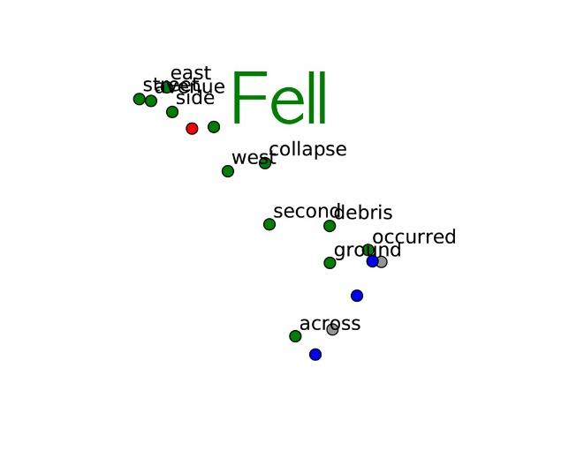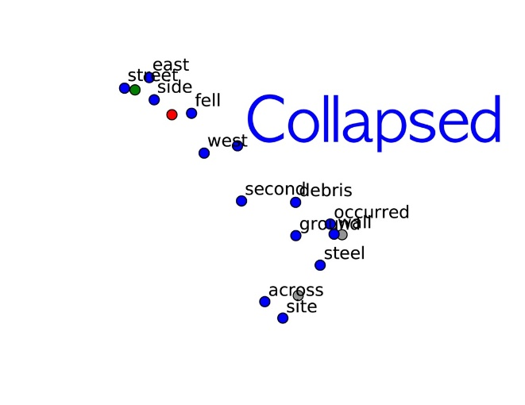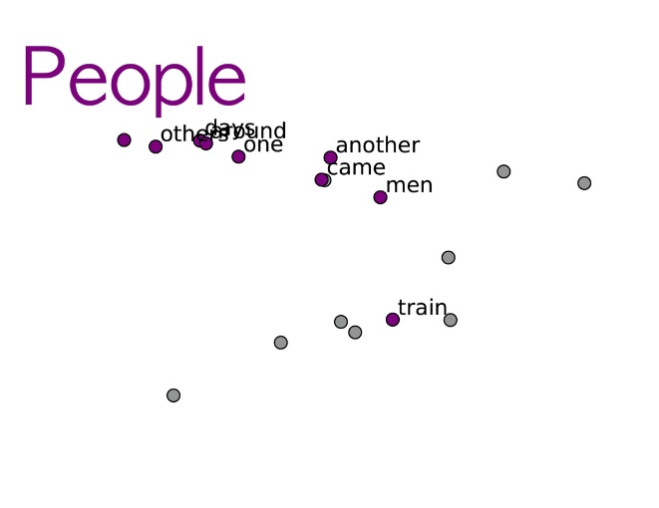

Figure 6. Subgraphs for keywords

**Discussion**

This study explored the relationship between factors related to fire accidents at construction sites through web crawling and deep learning. For data collection to be used in this study, web crawling was used to collect enough news articles related to accidents on construction sites. A total of 1,010 articles were collected using the keyword search method, and 861 articles were finally used after data cleaning. In addition, network analysis and word embedding techniques were used to investigate the relationship between factors related to accidents on construction sites. Through this analysis, the similarity and relationship between each keyword were defined and visualized by UMAP. To verify the reliability of this methodology, the relationship between similar words was analyzed.

First, keyword analysis was conducted with 861 articles collected by web crawling in this study. Since the authors set the search condition when using web crawling as a “construction accident,” most articles focus on accidents on construction sites. For the next step of data analysis, five keywords related to accidents and safety on the construction site were selected, which are fire, fell, collapsed, building, and people. Since the frequency of these keywords must be sufficient for further analysis of the collected data, the authors checked the frequency. The smallest frequency was fire, measured 192 times. The keyword with the highest frequency was building, which was measured 514 times. Of the 5 keywords, the minimum frequency was 192, which was sufficient for further analysis. The most interesting thing about frequency analysis is that the frequency of fire is relatively high. As mentioned earlier, the frequency of fire is 192 times, which is not much different from the frequency of fell and collapsed. The frequency of fire was about 10% smaller than fell and about 20% smaller than collapsed.  In the BLS report, the frequency of fire accidents is investigated within 2% of the total construction accidents, so it differs from the results in this study. The difference between the frequency of actual accidents and the frequency of media exposure can be used as evidence to confirm the great impact of fire accidents on construction sites. Of all the accidents on the construction site, fire accidents have a low frequency, and thus fire accidents are excluded from the list of major accidents on the construction site. OSHA announces "Fatal Four" on the construction site every year. The "Fatal Four" section of this report includes accident types related to falls, struck by object, electrocutions, and caught-in/between. As OSHA publishes reports and statistics related to 'Fatal Four' every year, many stakeholders on the construction site can check this and reflect it on the construction site. However, because the report is based on the frequency of accidents and deaths, there are limitations. Fire accidents are excluded from this “Fatal Four,” but the results of this study confirmed that the fire accident had a similar impact on the media as the main types of accidents on the construction site. Types of accidents in which the media frequency is higher than the actual accident frequency, such as fire accident, means that the impact of one accident frequency is greater than that of other accident types. This result is in line with the fire accident characteristics. Fire accidents are more likely to lead to additional accidents than other types of accidents on the construction site. Due to the spread of fire, it can affect the surrounding buildings and roads. Currently, most research and reports related to the safety of construction sites focus on the frequency of accidents. If researchers consider the characteristics of the accident types and their surrounding influence along with the frequency of the accident, this could be a new approach to improving construction site safety.

**네트워크 관련 추가 / 본 연구에서 네트워크 분석을 통해, 각 키워드들과 링크 된 단어들을 분석하였습니다.** This study also conducted an analysis using Word2vec, one of the word-embedding models. Through this model, the similarity between each keyword was calculated, and the reliability of this analysis was verified. The reliability of the analysis method of this study was confirmed by calculating the cosine similarity of fell and collapsed, which have similar meanings. According to the results of this study, the fire keyword showed higher similarity to the building keyword than the people keyword. This can be explained by the fact that fires on construction sites have a higher relationship with building factors. In the case of fell keyword, the similarity with the people was higher than the building. This shows that in the case of a fell accident, the impact of people's activity or behavior may be greater than that of building factors. These results can be used as relevant data when establishing safety regulations on construction sites. For example, when trying to improve the fire safety of a construction site, it may be more efficient to provide regulations considering factors related to building. In addition, in the case of fell-related accidents, it may be effective to establish rules that affect people's activity or behavior. The list of words with high similarity to the three keywords related to accidents (fire, fell, collapsed) commonly includes Monday and Friday. This result is consistent with statistical data related to accidents on construction sites. According to a related study, workers' injuries on construction sites were the highest on Monday. Unlike other types of accidents on construction sites, the word 'night' has a high degree of similarity in the fire keyword. Construction sites tend to have few occupants after work hours compared to other building types. This may not be sufficient for the initial detection and response to the most important in extinguishing a fire. In the case of a construction site, safety facilities related to fire are not completed, so systems and regulations to compensate for this are necessary. Additional equipment or monitoring systems, such as fire and smoke alarms, are necessary for fire safety in construction sites. In addition, regulations must be supplemented so that such fire safety equipment can be installed effectively and compulsorily on construction sites. Also, words with a high similarity between the fire and building keywords have words related to ‘inspection’ in common. This shows that inspection is an important issue in construction site fire accidents and safety articles. The results of this study remind us once again that periodic and detailed inspection is essential to improve the safety of construction sites.

In this study, the results through Word2vec analysis were visualized and provided as UMAP. When the results are visualized in 2D space through UMAP, the results can be interpreted more intuitively. UMAP expresses words that show relatively high frequency among all the languages used in the article. In the whole UMAP graph with all keywords marked, the five keywords the authors selected are concentrated in similar locations. This shows that the five keywords are organically related and can affect each other. In detail, the fire keyword was expressed close to the building keyword in UMAP, and some ranges overlapped. The fell and collapsed keywords existed in almost the same range and were relatively closer to the people keyword than the building keyword. Also, by providing sub-graphs of each of the five keywords through UMAP, it shows words with similar characteristics. By providing UMAP visualization graphs, the results of the research can be expressed in graphs, not texts, which can enhance the understanding of related researchers.

**Conclusion**

**References**

Abdullah, D. and G. C. M. Wern (2011). An analysis of accidents statistics in Malaysian construction sector. International Conference on E-business, Management and Economics, IACSIT Press Honk Kong.

Aires, M. D. M., M. C. R. Gámez and A. Gibb (2010). "Prevention through design: The effect of European Directives on construction workplace accidents." Safety science **48**(2): 248-258.

Ali, R., A. Ali, A. M. Khatak and M. S. Aslam (2018). Large Scale Image Dataset Construction Using Distributed Crawling with Hadoop YARN. 2018 Joint 10th International Conference on Soft Computing and Intelligent Systems (SCIS) and 19th International Symposium on Advanced Intelligent Systems (ISIS), IEEE.

Bag, S., S. K. Kumar and M. K. Tiwari (2019). "An efficient recommendation generation using relevant Jaccard similarity." Information Sciences **483**: 53-64.

Choi, J. and S.-W. Lee (2020). "Improving FastText with inverse document frequency of subwords." Pattern Recognition Letters.

Church, K. W. (2017). "Word2Vec." Natural Language Engineering **23**(1): 155-162.

D’Haen, J., D. Van den Poel, D. Thorleuchter and D. F. Benoit (2016). "Integrating expert knowledge and multilingual web crawling data in a lead qualification system." Decision Support Systems **82**: 69-78.

De-Ching, H., C. Shen-Wen, L. Chien-Hung, H. Po-Ta, S. Yi-Ting and S. Huei-Ru (2011). "A study for the evacuation of hospital on fire during construction." Procedia Engineering **11**: 139-146.

Guy, I., I. Schwartz and K. Radinsky (2019). Search system for providing web crawling query prioritization based on classification operation performance, Google Patents.

Hamid, A. R. A., W. Z. W. Yusof and B. S. B. J. Singh (2003). Hazards at construction sites, Universiti Teknologi Malaysia.

Hindocha, E., V. Yazhiny, A. Arunkumar and P. Boobalan (2019). "Short-text Semantic Similarity using GloVe word embedding."

Hong, S.-H., S.-K. Lee and J.-H. Yu (2019). "Automated management of green building material information using web crawling and ontology." Automation in Construction **102**: 230-244.

Hosseinian, S. S. and Z. J. Torghabeh (2012). "Major theories of construction accident causation models: A literature review." International Journal of Advances in Engineering & Technology **4**(2): 53.

Hui, L., W. Yongqing, S. Shimei and S. Baotie (2012). "Study on safety assessment of fire hazard for the construction site." Procedia Engineering **43**: 369-373.

Ingason, H., A. Lönnermark, H. Frantzich and M. Kumm (2010). Fire incidents during construction work of tunnels.

Jeong, M.-J., M.-G. Lee and E.-G. Ham (2014). "Assessment of Fire Evacuation Safety for Building Construction." Journal of the Korean Society of Safety **29**(6): 119-124.

Khatua, A., A. Khatua and E. Cambria (2019). "A tale of two epidemics: Contextual Word2Vec for classifying twitter streams during outbreaks." Information Processing & Management **56**(1): 247-257.

Kim, Y.-A., G.-H. Kim, H.-J. Kim and C.-G. Kim (2019). "Design and Implemention of Real-time web Crawling distributed monitoring system." Journal of Convergence for Information Technology **9**(1): 45-53.

Lai, S., K. Liu, S. He and J. Zhao (2016). "How to generate a good word embedding." IEEE Intelligent Systems **31**(6): 5-14.

Lee, S.-R. (2012). "An Experimental Study on the Fire Risk at Welding· Cutting Process." Fire Science and Engineering **26**(3): 60-66.

Ling, F. Y. Y., M. Liu and Y. C. Woo (2009). "Construction fatalities in Singapore." International Journal of Project Management **27**(7): 717-726.

Lopez-Aparicio, S., H. Grythe, M. Vogt, M. Pierce and I. Vallejo (2018). "Webcrawling and machine learning as a new approach for the spatial distribution of atmospheric emissions." PloS one **13**(7).

Massimino, B. (2016). "Accessing online data: Web‐crawling and information‐scraping techniques to automate the assembly of research data." Journal of Business Logistics **37**(1): 34-42.

Moon, S., Y. Shin, B.-G. Hwang and S. Chi (2018). "Document management system using text mining for information acquisition of international construction." KSCE Journal of Civil Engineering **22**(12): 4791-4798.

Morgan, J., R. Tietje, D. Wang and T. Pattabhi (2020). Web Threat Investigation Using Advanced Web Crawling, Google Patents.

O'Toole, T. (2002). "Construction site safety roles Journal of Construction Engineering and Management 128."

Ombabi, A. H., O. Lazzez, W. Ouarda and A. M. Alimi (2017). Deep learning framework based on Word2Vec and CNNfor users interests classification. 2017 Sudan Conference on Computer Science and Information Technology (SCCSIT), IEEE.

Paul, S., A. Mitra and S. Dey (2017). Issues and challenges in web crawling for information extraction. Bio-Inspired Computing for Information Retrieval Applications, IGI Global**:** 93-121.

Rekabsaz, N., M. Lupu and A. Hanbury (2017). Exploration of a threshold for similarity based on uncertainty in word embedding. European Conference on Information Retrieval, Springer.

Risselada, H., P. C. Verhoef and T. H. Bijmolt (2016). "Indicators of opinion leadership in customer networks: self-reports and degree centrality." Marketing Letters **27**(3): 449-460.

Rodríguez, P., M. A. Bautista, J. Gonzalez and S. Escalera (2018). "Beyond one-hot encoding: Lower dimensional target embedding." Image and Vision Computing **75**: 21-31.

Sandhu, R., H. K. Gill and S. K. Sood (2016). "Smart monitoring and controlling of Pandemic Influenza A (H1N1) using Social Network Analysis and cloud computing." Journal of Computational Science **12**: 11-22.

Shao, L., H. Zhang, M. Jia and J. Wang (2017). "Efficient and effective single-document summarizations and a word-embedding measurement of quality." arXiv preprint arXiv:1710.00284.

Smith, M. and S. Gorgoni (2018). "An introduction to network analysis." Networks of International Trade and Investment: Understanding globalisation through the lens of network analysis: 1.

Wigglesworth, E. (2006). "Occupational injuries by hour of day and day of week: a 20‐year study." Australian and New Zealand journal of public health **30**(6): 505-508.

Yang, S., S. Wi and S. Kim (2018). "Development Methodology of Web Crawling Based on Physical Properties DB of Building Materials for the Efficiency of Building Energy Simulation." 한국생활환경학회지 **25**(4): 467-475.

Yin, Z. and Y. Shen (2018). On the dimensionality of word embedding. Advances in Neural Information Processing Systems.

Yoshioka, K. and H. Dozono (2019). The Classification of the Documents Based on Word Embedding and 2-layer Spherical Self Organizing Maps. Proceedings of the 2019 11th International Conference on Machine Learning and Computing.

Zhang, Z., Y. Huang, P. Zhu and H. Zhao (2018). Effective character-augmented word embedding for machine reading comprehension. CCF International Conference on Natural Language Processing and Chinese Computing, Springer.

Zhou, Q., D. Fang and X. Wang (2008). "A method to identify strategies for the improvement of human safety behavior by considering safety climate and personal experience." Safety Science **46**(10): 1406-1419.

Zou, P. X. and G. Zhang (2009). "Comparative study on the perception of construction safety risks in China and Australia." Journal of construction engineering and management **135**(7): 620-627.