My participants seemed to base their trust of an interface primarily on the principle of cleanliness. When the ratings were low, one element of criticism was almost always that the page was cluttered, the font was not centered, the colors were not well chosen; anything to suggest shortcut-taking in the layout design, given that simplistic, clean design is the norm on webpages, was a flag-raiser.

Another common thread among the interfaces shown was that the use of Paypal generally made the website more trustworthy. One participant commented that they feel more secure when using Paypal because it is designed to be used by small businesses and bootstrap softwares to supplant Paypal’s security for their own lack. Perhaps this indicates that the best way to deceive users is to put effort into faking the payment receiver rather than the website itself.

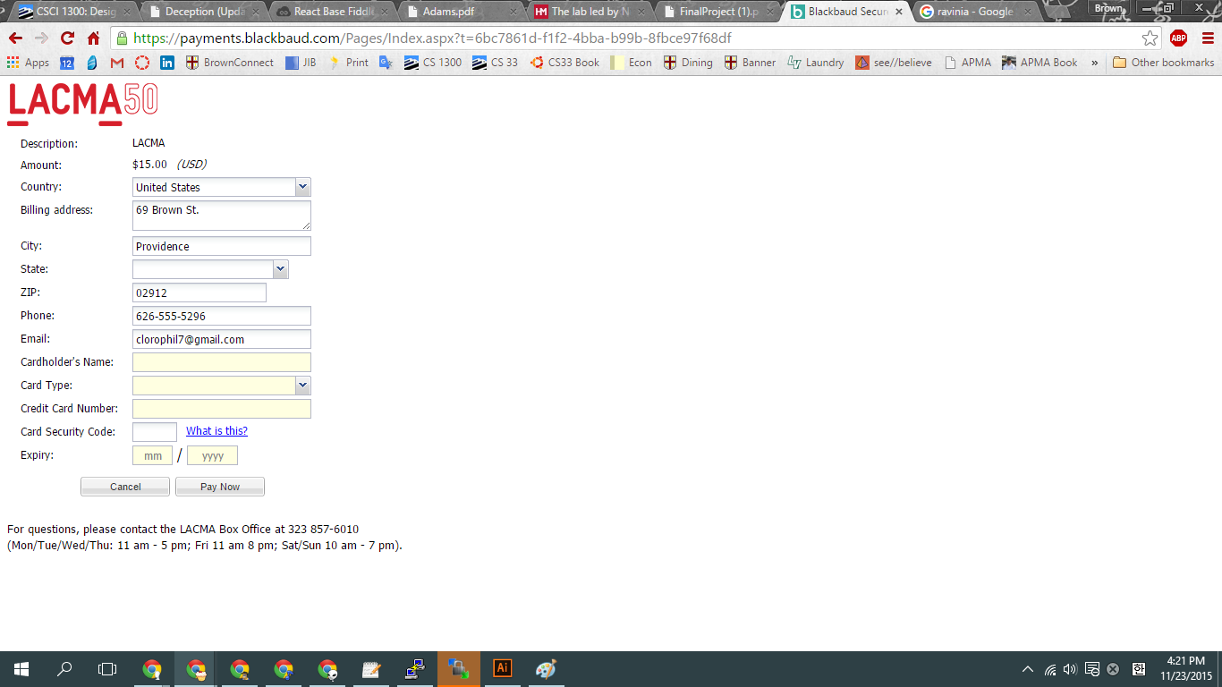

The real LACMA interface.

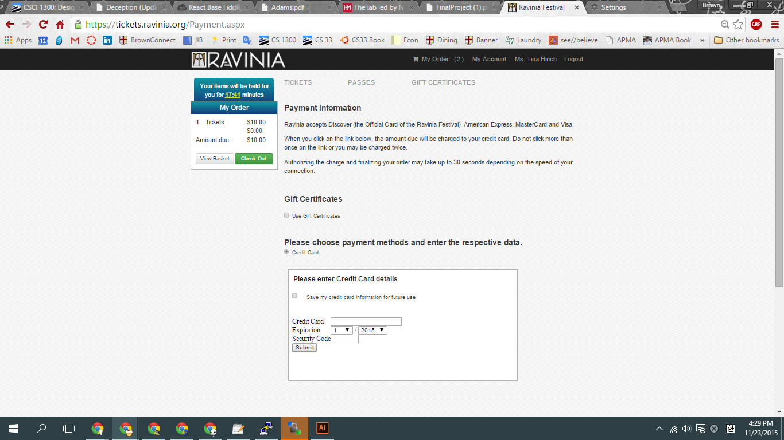

The real Ravinia interface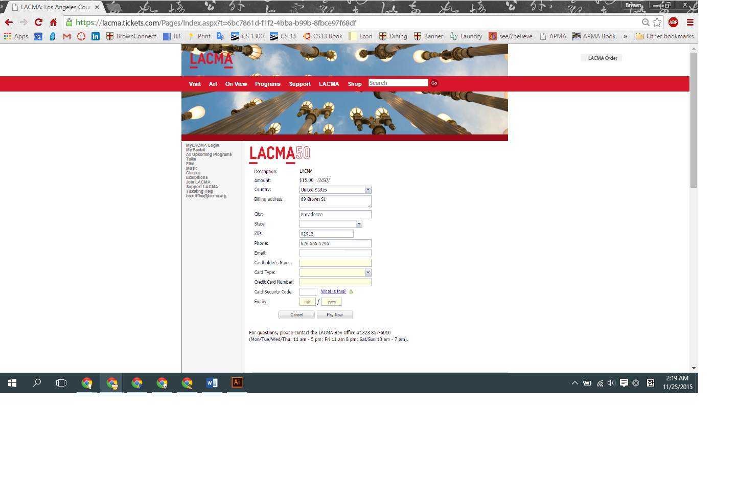

My fake LACMA interface