Data Birth Integrity: A Modular Scoring Framework for Assessing Automation-Readiness of Clinical DICOM Series in Neuroimaging Research

[Author list — to be completed by team]
[Affiliations — to be completed by team]

Corresponding author: [Name, email]

Highlights
- Data Birth Integrity (DBI) is a modular 0–1 score quantifying how well a DICOM series meets automation-oriented structural requirements before any image processing.
- Retrospective audit of 1,445 MR series across 81 sessions and four scanner clusters reveals systematic variation in metadata completeness and naming compliance.
- DBI is complementary to image-quality metrics (e.g., MRIQC) and downstream BIDS validation; it operates at the earliest point in the data lifecycle.
- Open-source Python implementation with YAML-configurable rules enables site-specific tuning.

Abstract
Background: Modern neuroimaging analysis pipelines increasingly depend on well-structured DICOM metadata—manufacturer identity, spatial geometry, diffusion encoding parameters, and consistent naming conventions—yet no published scalar metric exists to quantify this structural readiness at the point of data creation. The mismatch between what clinical scanners produce and what research pipelines require is a persistent bottleneck for reproducible large-scale studies.
New Method: We introduce Data Birth Integrity (DBI), a modular scoring framework (0–1) that evaluates five components of each DICOM series: metadata completeness (M), protocol/naming conformity (P), gradient integrity for diffusion (G), spatial consistency (S), and naming compliance for automation (N). Components that do not apply to a given modality are excluded via renormalization rather than penalized. All rules, weights, and thresholds are specified in a versioned YAML configuration, making DBI reproducible, auditable, and site-configurable.
Results: We applied DBI v1.0.4 to a clinical neuroimaging cohort of 81 MR sessions (1,445 series) exported from an institutional XNAT archive across four scanner clusters (two GE, two Siemens). Mean series-level DBI was 0.810 (SD = 0.060). Metadata completeness (M = 0.993) and spatial consistency (S = 0.999) were uniformly high, whereas naming compliance (N = 0.740) and gradient integrity for DWI (G = 0.192) drove most inter-series DBI variation. Session-level analysis (N = 81) revealed large inter-scanner heterogeneity (ε² = 0.60). Standard DICOM-to-NIfTI conversion with dcm2niix (v1.0.20250505) succeeded for 361/1445 series (25.0%), with pass rates among the four primary clusters ranging from 0.0% to 46.7%.
Comparison with existing methods: Unlike image-quality metrics (MRIQC, QUAD/SQUAD) that operate on processed NIfTI or corrected volumes, DBI assesses raw DICOM metadata upstream of conversion. Unlike BIDS validation, which checks a curated dataset layout, DBI scores the source series that must eventually feed that layout. No prior tool occupies this niche.
Conclusions: DBI provides a transparent, reproducible summary of whether clinical DICOM data meet the structural prerequisites for automated neuroimaging workflows. Routine DBI audits can identify acquisition-site heterogeneity early, inform protocol harmonization, and reduce silent failures in downstream pipelines.

Keywords: DICOM; data quality; neuroimaging; automation; BIDS; metadata; diffusion MRI; reproducibility

1. Introduction
The Digital Imaging and Communications in Medicine (DICOM) standard has served as the backbone of medical image exchange for over three decades (Bidgood & Horii, 1997). While DICOM provides a rich information model, manufacturers implement it inconsistently: critical acquisition parameters are often encoded in vendor-specific private tags rather than standardized public fields (Rorden et al., 2025; Larobina & Murino, 2014). This variability is largely invisible in clinical workflows, where readers rely on pixel data, but becomes a critical failure mode when the same images enter research pipelines that assume well-formed metadata.
The Brain Imaging Data Structure (BIDS; Gorgolewski et al., 2016) has transformed how curated neuroimaging datasets are organized and shared, enabling standardized processing through tools such as fMRIPrep (Esteban et al., 2019), Nipype (Gorgolewski et al., 2011), and FreeSurfer (Fischl, 2012). Extensions to new modalities—most recently PET-BIDS (Norgaard et al., 2022)—underscore the growing dependence of the field on well-structured input metadata. However, BIDS operates at the curated-output end of the data lifecycle. Before a DICOM series can be converted to NIfTI (Li et al., 2016) and organized into a BIDS layout (Halchenko et al., 2024), its metadata must already meet certain structural prerequisites—prerequisites that are rarely checked systematically.
Image-quality control tools such as MRIQC (Esteban et al., 2017) and diffusion-specific QC frameworks (Bastiani et al., 2019) provide post-conversion assessments of signal quality, motion, and distortion. These are invaluable but operate downstream: they cannot detect a missing MagneticFieldStrength tag, an ambiguous SeriesDescription, or a DWI series whose b-value encoding is discoverable only through undocumented private tags.
Multi-site consortia such as ENIGMA (Thompson et al., 2020) and TRACK-TBI (Yue et al., 2013) have demonstrated that protocol standardization at the point of acquisition is essential for meaningful cross-site analyses. Statistical harmonization methods (Fortin et al., 2017, 2018) can mitigate residual scanner effects, but they presuppose that the input data are structurally sound. When upstream metadata is incomplete or inconsistent, harmonization may mask problems rather than resolve them.
The FAIR principles (Wilkinson et al., 2016) call for data that are Findable, Accessible, Interoperable, and Reusable. Interoperability and reusability, in the context of neuroimaging DICOM, depend on the presence and correctness of metadata at the point of creation—what we term the "birth" of the data. Reproducibility concerns in neuroimaging are well documented (Poldrack et al., 2017), and open data-sharing platforms such as OpenNeuro (Markiewicz et al., 2021) have demonstrated the value of standardized, BIDS-compliant datasets for reuse across laboratories. Yet despite growing awareness of these issues, no published metric quantifies the structural readiness of raw DICOM series for automation-oriented research workflows.
Here we introduce Data Birth Integrity (DBI), a modular scoring framework that assigns each DICOM series a scalar value between 0 and 1, reflecting how well it satisfies automation-oriented structural requirements. DBI is not a measure of diagnostic image quality, signal-to-noise ratio, or clinical acceptability. Instead, it captures whether the metadata foundation exists for reproducible conversion, classification, and processing. We describe the DBI specification, apply it retrospectively to a clinical cohort of 81 MR sessions across four scanner clusters, report conversion outcomes with dcm2niix, and discuss implications for prospective acquisition governance.

2. Methods

2.1 Cohort and data source
We analyzed 81 MR imaging sessions (1,445 series) from a clinical neuroimaging archive exported using the XNAT platform (Marcus et al., 2007). Each session corresponds to one imaging visit; each series corresponds to one XNAT scan folder containing DICOM files under a standardized directory structure (resources/DICOM/files/*.dcm). Sessions spanned four scanner clusters identified by concatenating Manufacturer, ManufacturerModelName, and MagneticFieldStrength from the first readable DICOM in each session.

Table 1. Scanner clusters in the cohort.
Scanner cluster | Sessions (n) | DBI mean | DBI SD | DBI min | DBI max
GE MEDICAL SYSTEMS | SIGNA Artist | 1.5T | 3 | 0.8129 | 0.0030 | 0.8101 | 0.8162
GE MEDICAL SYSTEMS | SIGNA Premier | 3T | 47 | 0.8198 | 0.0135 | 0.7836 | 0.8606
SIEMENS | Skyra | 3T | 18 | 0.7951 | 0.0049 | 0.7869 | 0.8049
Siemens Healthineers | MAGNETOM Vida Fit | 3T | 13 | 0.7997 | 0.0041 | 0.7906 | 0.8059

2.2 DBI specification overview
DBI v1.0.4 defines five components scored at the series level, each producing a value in [0, 1] or not-applicable (NA). Components marked NA are excluded from the composite via weight renormalization rather than scored as zero, ensuring modality-appropriate evaluation.
The five components are: (M) Metadata completeness—presence and plausibility of required DICOM tags per modality class; (P) Protocol and naming conformity—folder structure and prospective protocol token compliance; (G) Gradient integrity—diffusion encoding evidence, applicable only to DWI series; (S) Spatial consistency—pixel spacing and slice geometry within configured plausibility bounds; and (N) Naming compliance—conformity of SeriesDescription and ProtocolName to automation-oriented conventions, per-class standards, and derived-scan suffix rules.
A sixth component, Drift control (D), is defined in the specification for future use but assigned NA for all series in this retrospective analysis, as protocol version time-series data are not available from static exports.

2.3 Component M — Metadata completeness
For each series, M is the fraction of required DICOM elements that are present and valid:
 | M = n_pass / n_required | (1)
where n_pass is the count of required tags that are present with plausible values and n_required is the total number of tags checked for the series’ modality class. A fractional score was chosen over binary pass/fail to provide graded feedback: a series missing one tag out of ten is structurally closer to automation-ready than one missing five, and the continuous score preserves this information for cohort-level stratification. All required tags receive equal weight within M because they represent minimum prerequisites rather than a ranked priority; differential tag importance is instead captured across components (e.g., spatial tags also influence S, diffusion tags also influence G). Universal elements checked for all non-localizer series include: Modality (must equal MR), Manufacturer, ManufacturerModelName, MagneticFieldStrength (positive number), SeriesInstanceUID, StudyInstanceUID, and at least one of SeriesDescription or ProtocolName. Spatial elements (PixelSpacing or ImagerPixelSpacing; SliceThickness or SpacingBetweenSlices within configured bounds) are required for all classes except localizer. Class-specific add-ons include diffusion evidence for DWI, RepetitionTime and EchoTime for BOLD and ASL, and EchoTime for field maps.

2.4 Component P — Protocol / naming conformity
P comprises two sub-scores averaged equally:
 | P = (P_minimal + P_ideal) / 2 | (2)
The equal-weight average was selected because the two sub-scores capture complementary aspects of protocol conformity—structural (folder naming, text presence) and semantic (prospective token compliance)—and neither can substitute for the other. P_minimal checks whether the scan folder name matches the expected XNAT indexing pattern (digits followed by a hyphen) and whether at least one descriptive text field is non-empty. P_ideal checks whether SeriesDescription or ProtocolName matches a site-defined prospective protocol token regex. For this legacy cohort, P_ideal is expected to be zero for most series, and P_minimal serves as the primary retrospective metric.

2.5 Component G — Gradient integrity (DWI only)
G is applicable only when the heuristic series class is DWI. Series whose names match configured derivative tokens (ADC, FA, TRACE, etc.) receive G = 0 and are flagged as derivative. For non-derivative DWI series, G is a weighted sum of three binary indicators:
 | G = 0.45 · I_bval + 0.45 · I_grad + 0.10 · I_vol | (3)
where I_bval = 1 if b-value evidence is discoverable (from standard DICOM tags, ImageType heuristics, or Enhanced MR functional group sequences), I_grad = 1 if gradient direction information is present (DiffusionGradientOrientation or per-frame functional group sequences), and I_vol encodes volume-count plausibility. In the current implementation (v1.0.3), I_vol = 1 for all series because single-frame DWI acquisitions cannot be reliably distinguished from legitimate single-slice protocols using DICOM metadata alone; this indicator is retained as a placeholder for future refinement when multi-frame heuristics are better validated. The sub-weights reflect the relative importance of each indicator for downstream diffusion processing: b-values and gradient directions are both indispensable for tensor or fibre-orientation estimation, justifying equal and dominant weight (0.45 each), whereas volume count carries less diagnostic value in the current version, warranting a smaller weight (0.10).

2.6 Component S — Spatial consistency
S verifies that pixel spacing and slice thickness/spacing fall within configurable plausibility bounds (0.05–15.0 mm for in-plane, 0.05–20.0 mm for slice). A three-tier ordinal scale is used:
 | S = { 1 if in-plane ∧ slice pass; 0.5 if in-plane passes, slice missing; 0 otherwise } | (4)
This tiered approach captures the practical reality that in-plane resolution can be fully verified independently of slice geometry: a series with valid in-plane spacing but absent slice thickness is partially usable (many 2-D analyses do not require the through-plane dimension), whereas a series failing both checks is unsuitable for any spatial reconstruction. A continuous formulation was considered but rejected because only two binary checks are involved, making intermediate scores beyond 0, 0.5, and 1 semantically unmotivated. Localizer series are assigned S = 1 (NA equivalent).

2.7 Component N — Naming compliance
N aggregates binary checks on the combined text of scan folder basename, SeriesDescription, and ProtocolName:
 | N = Σ check_i / n_checks , check_i ∈ {0, 1} | (5)
Legacy checks (folder pattern, absence of path separators, description length) are always applied. Additional configurable checks test for control-character safety, BIDS-style entity tokens, modality/contrast lexicon, and token separators. Per-class SeriesDescription compliance rules verify that the trimmed description matches modality-specific patterns (e.g., DWI descriptions must contain phase-encoding and direction count text; T2 anatomical descriptions must end with THIN). A derived-scan naming rule requires series matching derivative markers to end their description with "reformat" or "derived".

2.8 Composite DBI
The composite DBI for each series is the weighted mean of applicable component scores:
 | DBI = Σ(w_c × score_c) / Σ(w_c) , c ∈ { M, P, G, S, N, D } where na_c = false | (6)
where w_c is the weight assigned to component c and the sums run only over components whose not-applicable flag is false for the given series.
Choice of aggregation function. A weighted arithmetic mean was chosen over alternative formulations (geometric mean, harmonic mean, minimum) for three reasons. First, it permits graceful handling of NA components through weight renormalization: when a component is not applicable (e.g., G for non-DWI series, D for all series in v1), its weight is excluded from both numerator and denominator, redistributing weight to applicable components without penalizing the series or distorting the scale. A geometric or harmonic mean would require imputing NA values, introducing arbitrary assumptions. Second, a minimum-based composite would collapse all information to the weakest component, obscuring the profile of strengths and weaknesses that a weighted mean preserves. Third, the weighted mean produces a score on the same [0, 1] interval as the individual components, simplifying interpretation and threshold-setting.
Default weights. The YAML-specified weights (M: 0.28, P: 0.18, G: 0.22, S: 0.17, N: 0.15; D: 0.00 in v1) were set by domain-expert consensus, informed by the relative severity of each component’s failure mode for downstream automation. Metadata completeness (M) receives the highest weight because the absence of fundamental DICOM tags (field strength, manufacturer) propagates failures to every subsequent step—conversion, classification, and processing alike. Gradient integrity (G) is weighted second-highest because diffusion encoding parameters are both critical for DWI processing and difficult to recover when missing (vendor-specific private tags are the sole fallback). Protocol conformity (P), spatial consistency (S), and naming compliance (N) receive progressively lower weights reflecting their decreasing impact on hard failures: naming non-compliance, for instance, complicates classification but rarely prevents conversion. These weights are explicitly exposed in the versioned YAML configuration, allowing sites to adjust them as empirical evidence about their relative impact accumulates. Formal data-driven calibration (e.g., via logistic regression against conversion or BIDS-validation outcomes) is identified as future work.
Session-level DBI is the mean of series-level scores, excluding localizer series.

2.9 Series classification
Each series is assigned a heuristic class by matching the concatenation of scan folder basename and SeriesDescription against ordered pattern rules in the YAML configuration. Eleven classes are defined: DWI, BOLD, ASL, field map, SWI, FLAIR, perfusion, T1 anatomical, T2 anatomical, localizer, and other. The first matching rule wins; series matching no rule are classified as "other." Classification is rule-based and heuristic; formal validation against human labels (Phase 4) is optional and was not performed for this cohort.

Table S1. Series class distribution.
Class | n | % of total
other | 385 | 26.6
t2_anat | 249 | 17.2
dwi | 214 | 14.8
swi | 170 | 11.8
t1_anat | 155 | 10.7
asl | 69 | 4.8
flair | 55 | 3.8
perf | 55 | 3.8
bold | 35 | 2.4
localizer | 35 | 2.4
fmap | 23 | 1.6

2.10 DICOM-to-NIfTI conversion (Phase 3)
Each series' DICOM folder was converted using dcm2niix (v1.0.20250505; Li et al., 2016) with the command pattern: dcm2niix -z y -f '%n_%s' -o <output_dir> <dicom_dir>. Conversion was judged successful if at least one NIfTI file (.nii or .nii.gz) was present in the series output directory. For this cohort, outcomes were reconstructed from a previously completed conversion run by inspecting the saved NIfTI tree ("backfill"); original dcm2niix exit codes were not recovered, and success was inferred solely from the presence of output files. Series without DICOM files in the expected location were excluded from conversion summaries.

2.11 Software and reproducibility
DBI scoring was implemented in Python 3.9 using pydicom (Mason et al.) for DICOM parsing and pandas for tabulation. All rules, weights, and thresholds are specified in dbi_v1_config.yaml (version 1.0.4). The full specification is provided in DBI_v1_SPECIFICATION.md. Source code, configuration, and unit tests (18 passing) are available in the study repository. The audit is deterministic: identical inputs and configuration version produce identical scores. DBI was computed on research-export DICOM as ingested (pre–de-identification); only aggregate statistics and de-identified exemplars are included in public materials. Per-series CSV output includes N_pass and N_total for full transparency of naming compliance sub-checks.

2.12 Statistical analysis
Series-level DBI scores were non-normally distributed (Shapiro–Wilk W = 0.660, p < 0.001, n = 500; skewness = -2.07, excess kurtosis = 3.34). All group comparisons therefore used non-parametric tests, which make no assumptions about the shape of the underlying distribution.
Between-cluster differences in DBI were assessed with the Kruskal–Wallis H test (the non-parametric analogue of one-way ANOVA for rank-ordered data), followed by pairwise Mann–Whitney U tests with Bonferroni correction for multiple comparisons (dividing the nominal α = 0.05 by the number of pairwise tests to control the family-wise error rate). Effect size for the omnibus test is reported as epsilon-squared:
 | ε² = H / (n − 1) | (7)
which represents the proportion of variance in ranks explained by group membership; values below 0.01 are considered negligible, 0.01–0.06 small, 0.06–0.14 medium, and above 0.14 large (Tomczak & Tomczak, 2014).
Associations between conversion outcome (binary) and DBI (continuous) were quantified with the point-biserial correlation coefficient (r_pb), which is mathematically equivalent to the Pearson r when one variable is dichotomous. Point-biserial correlation was preferred over logistic regression because the goal was to quantify the strength of association rather than to build a predictive model; with only five candidate predictors and a binary outcome dominated by factors outside the DBI construct (e.g., transfer syntax), a regression model would be over-specified and difficult to interpret.
Scanner-cluster differences in conversion pass rate were tested with Pearson’s chi-squared test (appropriate for comparing proportions across independent groups). Effect size is reported as Cramér’s V:
 | V = √( χ² / ( n × (min(r, c) − 1) ) ) | (8)
where r and c are the rows and columns of the contingency table. V ranges from 0 (no association) to 1 (perfect association), with 0.10, 0.30, and 0.50 as conventional benchmarks for small, medium, and large effects (Cohen, 1988). All tests were two-sided; significance was set at α = 0.05 (Bonferroni-adjusted for pairwise comparisons). Analyses used scipy.stats (Python 3.9).

2.13 Weight sensitivity analysis
Because the default component weights reflect expert judgment rather than empirical calibration, we assessed the sensitivity of DBI to weight perturbation using a Monte Carlo approach. In each of 1,000 trials, every component weight was independently drawn from a uniform distribution spanning ±20% of its default value; the composite DBI was recomputed for all series. We report the 95% interval for the cohort-mean DBI and the minimum Spearman rank correlation between the baseline and perturbed DBI vectors. High rank stability indicates that relative ordering of series is preserved regardless of exact weight choices within the tested range.

3. Results

3.1 Cohort overview
The cohort comprised 81 MR sessions containing 1,445 series (mean 17.8 series per session, range 6–45) across four primary scanner clusters (Table 1). A fifth minor cluster (two series from a single session with incomplete scanner metadata) appears in conversion statistics but is excluded from DBI range calculations. No DICOM read failures were encountered. The most prevalent series classes were "other" (385), T2 anatomical (249), DWI (214), and SWI (170).

3.2 Series-level DBI scores
Mean series-level DBI was 0.810 (SD = 0.060, range 0.516–0.861). Component-level means were: M = 0.993 (SD = 0.027), P = 0.494 (SD = 0.037), G = 0.192 (SD = 0.243; DWI-only), S = 0.999 (SD = 0.019), and N = 0.740 (SD = 0.078). P_ideal was 0.000 for all series, as expected for a legacy cohort without prospective protocol tokens; P_minimal was 0.989. Three components exhibited near-uniform values: M was at ceiling (≈ 1.0) across all clusters, S was likewise near-ceiling (0.999) with only 2 of 1445 series receiving partial credit, and P was uniformly ≈ 0.5 because P_ideal = 0 for all series. Consequently, inter-series DBI variation was driven primarily by G (for DWI, where derivative maps receive G = 0) and N (naming compliance). This uniformity in M, P, and S is a property of the cohort, not the framework: prospective adoption of protocol tokens would activate P_ideal, and sites with less consistent spatial metadata would exhibit greater S variation.

3.3 Scanner-cluster variation
Session-level mean DBI (excluding localizers) was 0.811 (SD = 0.015, range 0.784–0.861). Cluster-level session-mean DBI ranged from 0.795 (SIEMENS | Skyra | 3T) to 0.820 (GE MEDICAL SYSTEMS | SIGNA Premier | 3T), indicating small but statistically reliable inter-scanner heterogeneity (Table 1). Figure 1 displays the distribution of session-mean DBI by scanner cluster.
A Kruskal–Wallis test confirmed that series-level DBI differed significantly across the four primary scanner clusters (H(3) = 57.15, p = 2.39e-12, ε² = 0.0396). The small series-level effect size reflects the inflated N (multiple non-independent series per session). To account for this, we repeated the analysis at the session level, using session-mean DBI as the unit of observation.
The session-level Kruskal–Wallis test (N = 81 sessions) yielded H(3) = 49.20, p < 0.001, ε² = 0.60—a large effect, indicating that scanner cluster identity explains approximately 60% of the variance in session-level DBI ranks. Post-hoc pairwise Mann–Whitney U tests with Bonferroni correction at the session level identified the following significant pairs:
- GE Artist 1.5T vs. Skyra 3T: U = 54, p_bonf = 4.35e-02, r = -1.000 (n₁ = 3, n₂ = 18)
- GE Premier 3T vs. Skyra 3T: U = 810, p_bonf = 8.62e-08, r = -0.915 (n₁ = 47, n₂ = 18)
- GE Premier 3T vs. Vida Fit 3T: U = 580, p_bonf = 5.23e-06, r = -0.899 (n₁ = 47, n₂ = 13)
The remaining 3 pairwise comparisons were not significant after Bonferroni correction (all p_bonf > 0.05).
At the series level, post-hoc Mann–Whitney U tests with Bonferroni correction (6 comparisons, α_adj = 0.0083) corroborated these findings. The full series-level and session-level results are reported in Table 4.
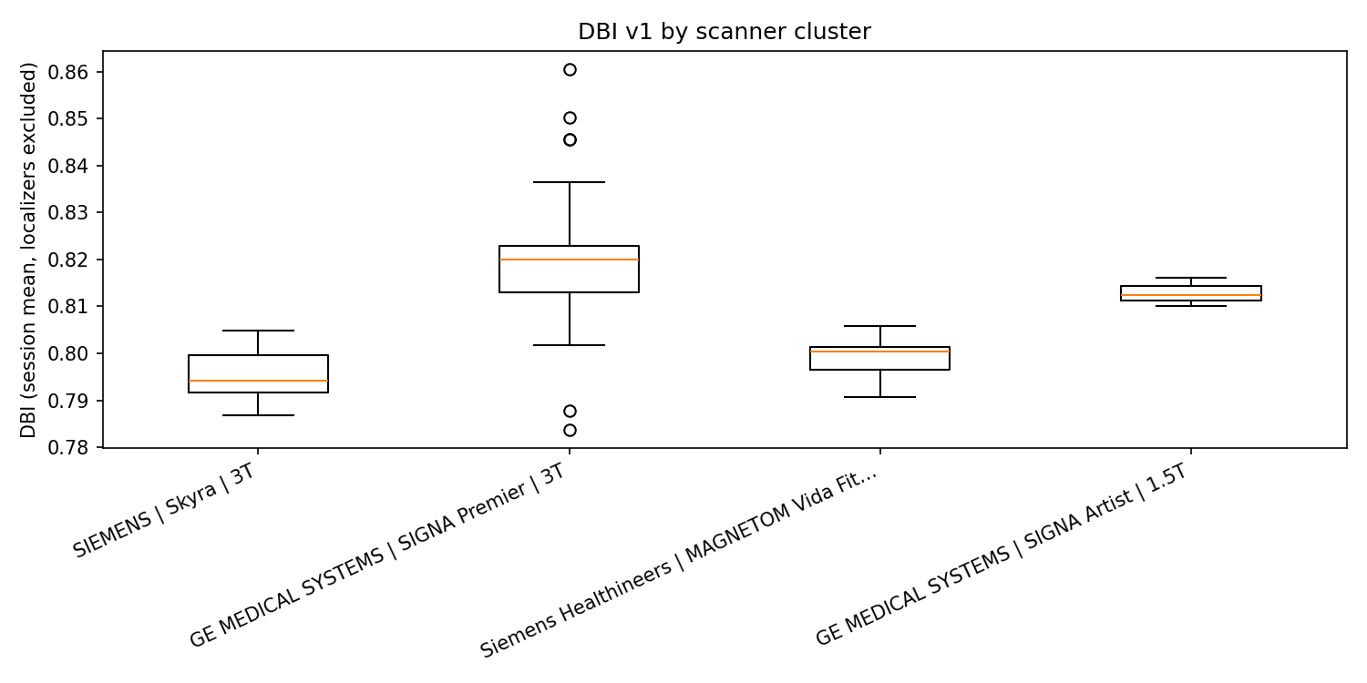
Figure 1. Distribution of session-mean DBI by scanner cluster. Each point represents one session; boxes show median and interquartile range.

3.4 Component-level patterns
Having established that DBI differs across scanner clusters, we next examined which components drive this variation.
Metadata completeness (M = 0.993) and spatial consistency (S = 0.999) were consistently high across clusters, indicating that fundamental DICOM tags and spatial geometry fields were generally well-populated by all four scanner platforms. Only 2 of 1445 series received partial spatial credit (S = 0.5), due to missing SliceThickness. Naming compliance (N) averaged 0.740, reflecting partial adherence to automation-oriented conventions; the per-class SeriesDescription rules and derived-scan suffix requirement contributed most to N failures. Table 3 provides component-level means for each scanner cluster; Figure 3 displays the same data as a heatmap.
Among 214 DWI-classified series, 101 (47.2%) were flagged as derivative (ADC, FA, TRACE, etc.) and received G = 0. For the remaining 113 raw DWI series, mean G was 0.363, indicating partial discoverability of diffusion encoding parameters from DICOM. The low overall G mean (0.192) is dominated by derivative maps, which receive G = 0 by design.

Table 3. Component means (± SD) by scanner cluster.
Scanner cluster | M | P | S | N | G (raw DWI)
GE Artist 1.5T | 0.987 ± 0.035 | 0.481 ± 0.067 | 1.000 ± 0.000 | 0.725 ± 0.057 | 0.280 ± 0.246
GE Premier 3T | 0.989 ± 0.035 | 0.492 ± 0.045 | 0.999 ± 0.025 | 0.741 ± 0.068 | 0.129 ± 0.111
Skyra 3T | 1.000 ± 0.000 | 0.500 ± 0.000 | 1.000 ± 0.000 | 0.742 ± 0.092 | 0.550 ± 0.000
Vida Fit 3T | 1.000 ± 0.000 | 0.500 ± 0.000 | 1.000 ± 0.000 | 0.739 ± 0.091 | 0.550 ± 0.000
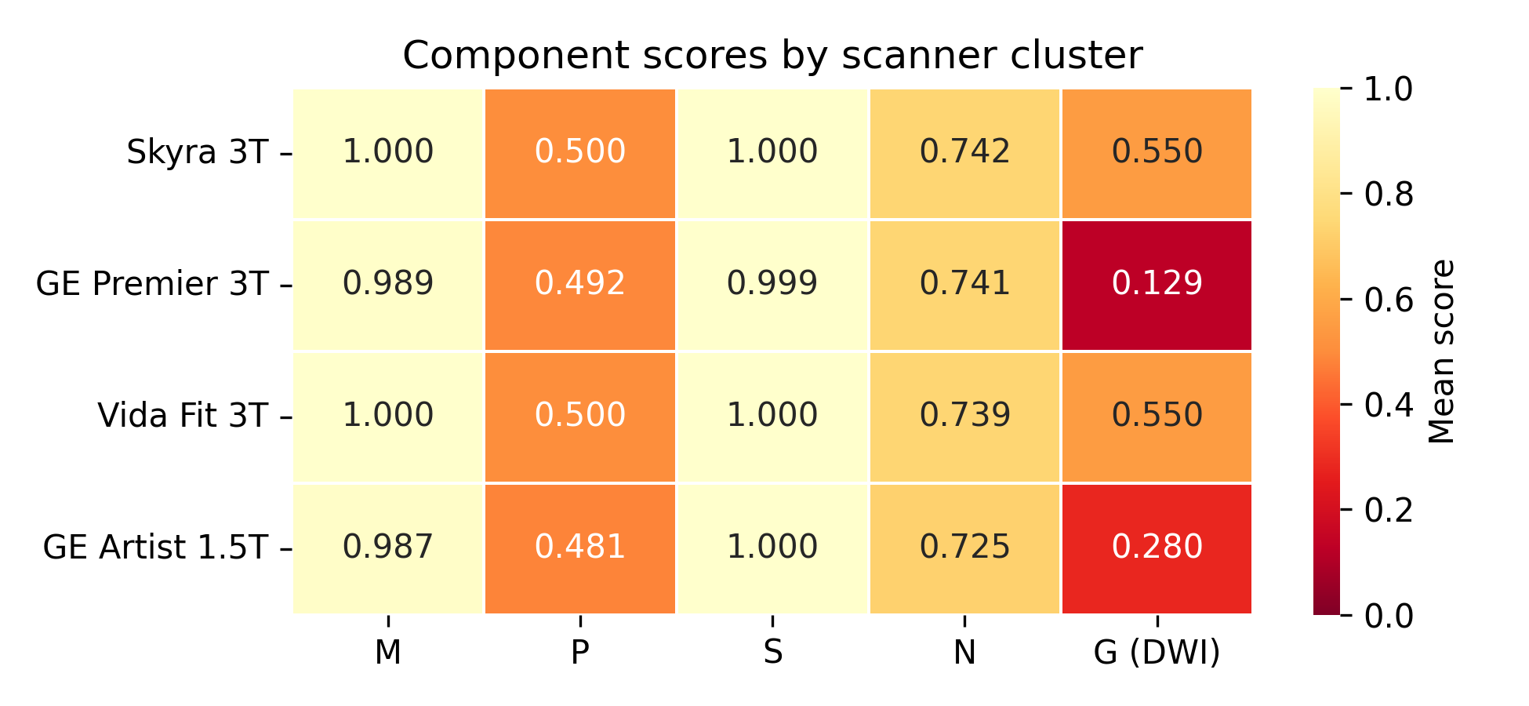
Figure 3. Component-level mean scores by scanner cluster. Colour scale: 0 (red) to 1 (green). G is reported for raw (non-derivative) DWI series only.
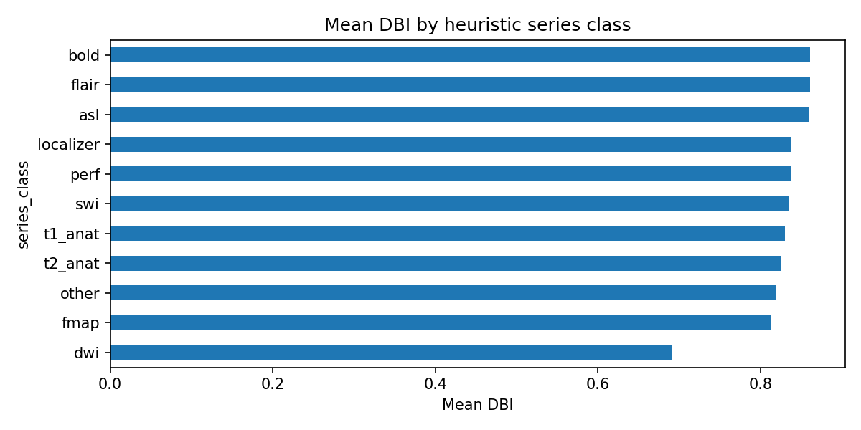
Figure S1. Mean DBI by heuristic series class.

3.5 DICOM-to-NIfTI conversion outcomes
To assess the practical consequences of metadata variability, we examined dcm2niix conversion outcomes as an external benchmark.
Across 1445 series with DICOM present, 361 (25.0%) met the conversion success criterion (at least one NIfTI file in the output directory). Among the four primary scanner clusters (n ≥ 10 series each), pass rates ranged from 0.0% to 46.7% (Table 2). The overall rate of 25% reflects the clinical nature of this archive: a substantial proportion of series are derived maps (ADC, FA, TRACE), reformatted images, screen captures, or scout/localizer acquisitions that dcm2niix is not designed to convert to research-grade NIfTI. A fifth cluster comprising two series from a session with incomplete scanner metadata (missing model and field strength) achieved 100% conversion but is excluded from range statistics due to its negligible size. Figure 2 displays the pass-rate heatmap stratified by scanner cluster and series class.
Conversion pass rates differed significantly across the four primary clusters (χ²(3) = 98.43, p = 3.38e-21, Cramér’s V = 0.261), indicating a medium-sized association between scanner cluster membership and conversion success.

3.5.1 DBI as a predictor of conversion success
Point-biserial correlation between composite DBI and conversion outcome was not significant (r_pb = -0.038, p = 0.152, n = 1445); per-component correlations were likewise negligible (all |r_pb| < 0.07). This null result indicates that the metadata-quality dimensions captured by DBI and the factors governing conversion success (e.g., compressed transfer syntaxes, proprietary encoding) are largely orthogonal in this cohort (Figure S2).

Table 2. dcm2niix conversion pass rate by scanner cluster.
Scanner cluster | n | n pass | Pass rate
GE MEDICAL SYSTEMS | | T | 2 | 2 | 1.0000
GE MEDICAL SYSTEMS | SIGNA Artist | 1.5T | 66 | 0 | 0.0000
GE MEDICAL SYSTEMS | SIGNA Premier | 3T | 789 | 165 | 0.2091
SIEMENS | Skyra | 3T | 330 | 154 | 0.4667
Siemens Healthineers | MAGNETOM Vida Fit | 3T | 258 | 40 | 0.1550
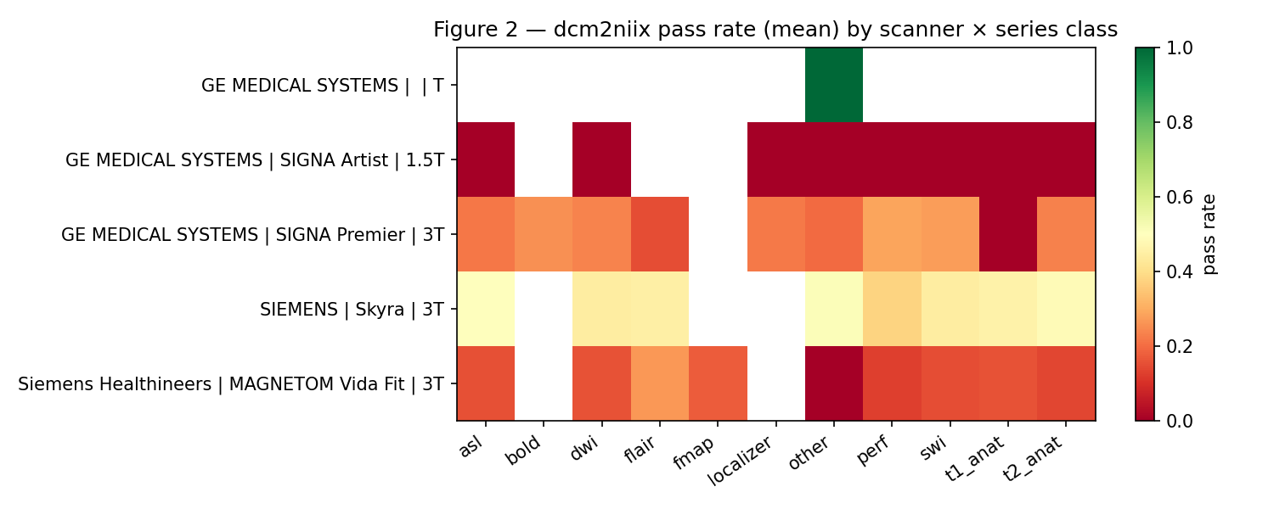
Figure 2. dcm2niix conversion pass rate (mean) by scanner cluster and heuristic series class.
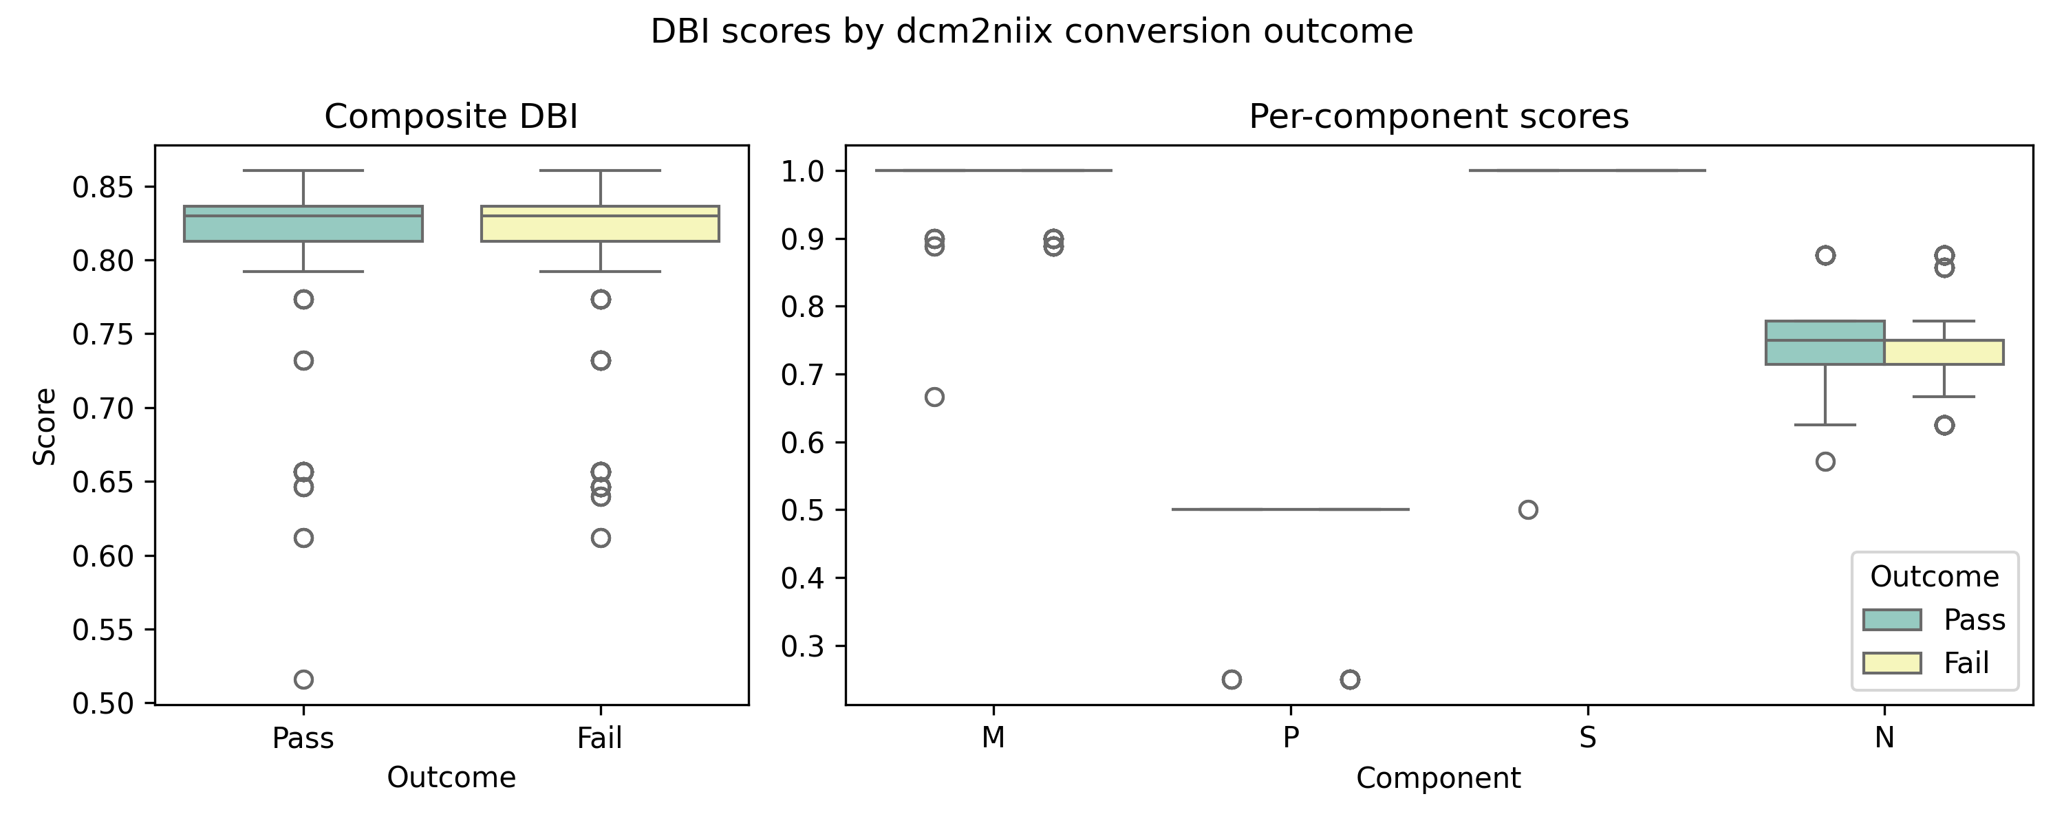
Figure S2. DBI scores by dcm2niix conversion outcome. Left: composite DBI; Right: per-component scores. Overlapping distributions confirm the null association (r_pb = -0.038, p = 0.152).

Table 4. Summary of inferential statistical tests.
Test | Comparison | Statistic | p-value | Effect size
Shapiro–Wilk | DBI normality (n = 500) | W = 0.660 | 2.18e-30 | —
Kruskal–Wallis | Session DBI ~ scanner cluster (N = 81) | H(3) = 49.20 | < 0.001 | ε² = 0.60 (large)
Mann–Whitney U | GE Artist 1.5T vs Skyra 3T (session-level) | U = 54 | p_bonf = 4.35e-02* | r = -1.000
Mann–Whitney U | GE Premier 3T vs Skyra 3T (session-level) | U = 810 | p_bonf = 8.62e-08* | r = -0.915
Mann–Whitney U | GE Premier 3T vs Vida Fit 3T (session-level) | U = 580 | p_bonf = 5.23e-06* | r = -0.899
Kruskal–Wallis | Series DBI ~ scanner cluster (N = 1445) | H(3) = 57.15 | 2.39e-12 | ε² = 0.0396 (small†)
Pearson χ² | Conversion pass ~ scanner cluster | χ²(3) = 98.43 | 3.38e-21 | V = 0.261 (medium)
Point-biserial | DBI vs conversion outcome | r = -0.038 | 0.152 | n.s.
Monte Carlo | Weight ±20% (1,000 trials) | ρ_min = 0.988 | — | DBI 95% CI [0.782, 0.824]
† Series-level ε² is attenuated by inflated N (multiple non-independent series per session); the session-level analysis is the primary test.

4. Discussion

4.1 Summary of findings
Applied to 81 clinical MR sessions across four scanner clusters, DBI revealed that metadata completeness (M) and spatial consistency (S) are generally high, while naming compliance (N) and gradient integrity (G, for DWI) exhibit the greatest room for improvement—deficiencies invisible to any tool operating downstream of DICOM conversion. At the session level, scanner cluster membership explained a large share of DBI variance (ε² = 0.60), confirming that scanner identity introduces substantial heterogeneity in metadata quality. This effect was robust to weight perturbation: Monte Carlo simulation (±20% on all weights, 1,000 trials) showed that series-level DBI rankings were virtually unchanged (Spearman ρ ≥ 0.988 across all trials), and the 95% CI for cohort-mean DBI spanned only [0.782, 0.824]. These results underscore the need for acquisition-level governance and the stability of DBI as a composite measure.

4.2 Positioning relative to existing tools
DBI occupies a distinct niche in the neuroimaging data lifecycle. MRIQC (Esteban et al., 2017) assesses image quality from NIfTI volumes; QUAD/SQUAD (Bastiani et al., 2019) evaluates diffusion data after eddy-current correction; bids-validator checks the layout of a curated BIDS dataset. DBI operates upstream of all of these, at the level of raw DICOM metadata. A series that scores poorly on DBI may still produce acceptable images for clinical reading but is at elevated risk of silent failure in automated pipelines—conversion errors, misclassification, missing sidecar fields, or incorrect spatial geometry in downstream analyses.
The closest conceptual parallel is the MIDRC CRP 12 initiative (Kinahan et al., 2024), which develops structured DICOM data-quality objects for radiology (CT/XR). In a different domain, the METhodological RadiomICs Score (METRICS; Kocak et al., 2024) uses a modular checklist to rate methodological rigor in radiomics studies, illustrating the general utility of composite quality scores. DBI is neuroimaging-specific, modality-aware (e.g., the G component applies only to DWI), and designed for cohort-level stratification rather than individual-image triage. Thirty years of DICOM evolution (NEMA, 2023) have not fully resolved inter-vendor metadata inconsistencies, reinforcing the need for automated upstream checks.

4.3 Interpretation of component scores
High M and S scores across clusters indicate that fundamental DICOM tags and spatial geometry fields are well-populated by all four scanner platforms in this cohort, consistent with Rorden et al. (2025). The near-ceiling S (mean 0.999) suggests that modern clinical scanners reliably emit PixelSpacing and SliceThickness within plausible bounds; only two series received partial spatial credit, both due to missing SliceThickness. This is encouraging for pipelines that compute voxel-to-world transformations (e.g., FreeSurfer; Fischl, 2012), but may not generalize to older or heterogeneous archives.
Naming compliance (N) was moderate, reflecting the gap between legacy clinical naming practices and the automation-oriented conventions encoded in the DBI specification. The per-class SeriesDescription rules (e.g., DWI descriptions must include phase-encoding direction and direction count) are intentionally strict to surface naming heterogeneity that, while tolerable for human readers, creates ambiguity for automated classification and BIDS curation.
The "other" class accounted for 26.6% of all series (385/1445). These are series whose SeriesDescription and scan folder name did not match any of the ten defined modality rules (DWI, BOLD, ASL, field map, SWI, FLAIR, perfusion, T1 anat, T2 anat, localizer). Inspection revealed that the majority correspond to screen captures, secondary reformats, post-processing outputs (e.g., cerebral blood flow maps), and vendor-specific QA series. Because these series are not intended for research pipelines, their presence does not invalidate the classification schema but highlights the heterogeneity of clinical DICOM archives compared to research-only acquisitions.

4.4 Conversion outcomes and their relationship to DBI
dcm2niix conversion pass rates differed significantly across scanner clusters (χ² = 98.43, Cramér’s V = 0.261), confirming that acquisition-site characteristics influence downstream ingest. However, the point-biserial correlation between DBI and conversion outcome was not significant (r_pb = -0.038, p = 0.152), nor were any individual component scores predictive of conversion success. This null result is interpretable: the backfill conversion criterion (presence of any NIfTI file) captures a coarse success/failure distinction driven by factors largely orthogonal to metadata quality—e.g., compressed transfer syntaxes, proprietary vendor sequences, or encoding schemes that dcm2niix does not support. DBI, by contrast, measures whether the metadata foundation exists for correct interpretation of the converted output. A series may convert to NIfTI yet still carry incomplete sidecar JSON (low M), ambiguous naming (low N), or inconsistent geometry (low S)—problems that surface only during downstream BIDS curation or pipeline processing. Future work should examine the correlation between DBI components and finer-grained conversion quality metrics (e.g., sidecar completeness, spatial geometry accuracy) rather than binary pass/fail.

4.5 Practical implications
DBI audits can serve as an acquisition governance tool. By running the audit after each imaging session or batch export, sites can identify scanner-specific metadata gaps early—before data enter long-term archives or multi-site pooling. The YAML-based configuration allows sites to tune rules to local SOPs (e.g., requiring specific SeriesDescription patterns for SWI or T2 anatomical series) without modifying code. The naming compliance component (N) directly encodes site-specific acquisition standards documented in a companion SOP (MR Acquisition Automation and BIDS-Inspired Naming Conventions).

4.6 Limitations
- Single institution: All 81 sessions come from one clinical archive. Multi-site validation is needed to assess generalizability.
- Retrospective design: P_ideal was universally zero because the cohort predates prospective protocol-token adoption. Prospective deployment is required to evaluate this component.
- Heuristic classification: Series class assignment is rule-based and was not validated against human labels in this study. Misclassification could bias component-specific scores (especially G).
- Conversion backfill: Phase 3 outcomes were inferred from saved NIfTI files rather than recovered dcm2niix exit codes. This may overcount passes if some NIfTI files are incomplete.
- Binary conversion criterion: The backfill conversion metric (NIfTI file presence) is coarse; the null DBI–conversion association may partly reflect this measurement limitation.
- Component uniformity: In this cohort, M, P, and S exhibited near-uniform values (M ≈ 1.0, P ≈ 0.5, S ≈ 1.0), limiting their discriminative contribution. The framework’s modularity is designed to handle this, but its full value is realized only when components vary.
- Expert-set weights: Default weights were set by domain-expert consensus rather than empirical calibration. Although Monte Carlo sensitivity analysis confirmed rank stability (±20%), data-driven weight optimization remains future work.
- Drift control (D) is not scored in v1; protocol version time-series analysis requires external logs.

4.7 Future directions
Near-term extensions include: (1) formal Phase 4 validation of series classification against human labels with Cohen’s kappa; (2) predictive modeling of conversion failure as a function of DBI components; (3) drift control (D) using SoftwareVersions time series across sessions; and (4) integration with BIDS curation pipelines (HeuDiConv, dcm2bids) to quantify the correlation between DBI and bids-validator (BIDS Community, 2024) error counts. Provenance tracking with tools such as DataLad (Halchenko et al., 2021) would further strengthen reproducibility by linking each DBI audit to a versioned data snapshot. Longer-term, DBI could be computed in real time at the scanner console or PACS gateway, providing immediate feedback to technologists on naming and metadata compliance.

5. Conclusions
Data Birth Integrity (DBI) provides a transparent, reproducible, and site-configurable metric for assessing the automation readiness of clinical DICOM series at the earliest point in the neuroimaging data lifecycle. By quantifying metadata completeness, protocol conformity, gradient integrity, spatial consistency, and naming compliance in a modular framework, DBI complements existing image-quality tools and BIDS validators. Routine DBI audits can surface acquisition-site heterogeneity, inform protocol harmonization, and reduce silent failures in downstream pipelines. The open-source implementation and YAML-driven configuration lower the barrier to adoption across institutions and cohorts.

Acknowledgments
[To be completed by team. Acknowledge funding, computational resources, and individuals who contributed to data collection or infrastructure.]

Data and code availability
The DBI scoring code, YAML configuration, unit tests, and audit scripts are available at [repository URL]. The DBI v1 specification (DBI_v1_SPECIFICATION.md) and companion acquisition conventions document are included in the repository. Raw DICOM data are not publicly shared due to institutional data-use agreements; aggregate statistics and de-identified exemplars are available upon reasonable request. [Adjust per team's data-sharing tier.]

Author contributions
[CRediT taxonomy: Conceptualization, Methodology, Software, Validation, Formal analysis, Investigation, Data curation, Writing — original draft, Writing — review & editing, Visualization, Supervision, Project administration, Funding acquisition. Assign per team.]

Declaration of competing interests
[To be completed by team.]

References
Bastiani, M., Cottaar, M., Fitzgibbon, S. P., et al. (2019). Automated quality control for within and between studies diffusion MRI data using a non-parametric framework for movement and distortion correction. NeuroImage, 184, 801–812. https://doi.org/10.1016/j.neuroimage.2018.09.073
BIDS Community. (2024). bids-validator: Validator for the Brain Imaging Data Structure. https://github.com/bids-standard/bids-validator
Bidgood, W. D., & Horii, S. C. (1997). Understanding and using DICOM, the data interchange standard for biomedical imaging. Journal of the American Medical Informatics Association, 4(3), 199–212. https://doi.org/10.1136/jamia.1997.0040199
Cohen, J. (1988). Statistical power analysis for the behavioral sciences (2nd ed.). Lawrence Erlbaum Associates.
Esteban, O., Birman, D., Schaer, M., Koyejo, O. O., Poldrack, R. A., & Gorgolewski, K. J. (2017). MRIQC: Advancing the automatic prediction of image quality in MRI from unseen sites. PLoS ONE, 12(9), e0184661. https://doi.org/10.1371/journal.pone.0184661
Esteban, O., Markiewicz, C. J., Blair, R. W., et al. (2019). fMRIPrep: A robust preprocessing pipeline for functional MRI. Nature Methods, 16(1), 111–116. https://doi.org/10.1038/s41592-018-0235-4
Fischl, B. (2012). FreeSurfer. NeuroImage, 62(2), 774–781. https://doi.org/10.1016/j.neuroimage.2012.01.021
Fortin, J.-P., Parker, D., Tunç, B., et al. (2017). Harmonization of multi-site diffusion tensor imaging data. NeuroImage, 161, 149–170. https://doi.org/10.1016/j.neuroimage.2017.08.047
Fortin, J.-P., Cullen, N., Sheline, Y. I., et al. (2018). Harmonization of cortical thickness measurements across scanners and sites. NeuroImage, 167, 104–120. https://doi.org/10.1016/j.neuroimage.2017.11.024
Gorgolewski, K. J., Auer, T., Calhoun, V. D., et al. (2016). The brain imaging data structure, a format for organizing and describing outputs of neuroimaging experiments. Scientific Data, 3, 160044. https://doi.org/10.1038/sdata.2016.44
Gorgolewski, K. J., Burns, C. D., Madison, C., et al. (2011). Nipype: A flexible, lightweight and extensible neuroimaging data processing framework in Python. Frontiers in Neuroinformatics, 5, 13. https://doi.org/10.3389/fninf.2011.00013
Halchenko, Y. O., Wagner, A. S., et al. (2021). DataLad: Distributed system for joint management of code, data, and their relationship. Journal of Open Source Software, 6(63), 3262. https://doi.org/10.21105/joss.03262
Halchenko, Y. O., et al. (2024). HeuDiConv — flexible DICOM conversion into structured directory layouts. Journal of Open Source Software, 9(99), 5839. https://doi.org/10.21105/joss.05839
Kinahan, P., Fedorov, A., & Sullivan, D. (2024). MIDRC CRP 12: Determining image data quality, provenance, and harmonization. https://www.midrc.org/midrc-collaborating-research-projects/project-one-crp12
Kocak, B., et al. (2024). METhodological RadiomICs Score (METRICS): A quality scoring tool for radiomics research endorsed by EuSoMII. Insights into Imaging, 15, 8. https://doi.org/10.1186/s13244-023-01572-w
Larobina, M., & Murino, L. (2014). Medical image file formats. Journal of Digital Imaging, 27(2), 200–206. https://doi.org/10.1007/s10278-013-9657-9
Li, X., Morgan, P. S., Ashburner, J., Smith, J., & Rorden, C. (2016). The first step for neuroimaging data analysis: DICOM to NIfTI conversion. Journal of Neuroscience Methods, 264, 47–56. https://doi.org/10.1016/j.jneumeth.2016.03.001
Marcus, D. S., Olsen, T. R., Ramaratnam, M., & Buckner, R. L. (2007). The Extensible Neuroimaging Archive Toolkit: An informatics platform for managing, exploring, and sharing neuroimaging data. Neuroinformatics, 5(1), 11–34. https://doi.org/10.1385/NI:5:1:11
Markiewicz, C. J., Gorgolewski, K. J., Feingold, F., et al. (2021). The OpenNeuro resource for sharing of neuroscience data. eLife, 10, e71774. https://doi.org/10.7554/eLife.71774
Mason, D. L., et al. pydicom: An open source DICOM library. https://github.com/pydicom/pydicom
NEMA/DICOM Standards Committee. (2023). Thirty years of the DICOM standard. Journal of Digital Imaging. https://doi.org/10.1007/s10278-023-00915-z
Norgaard, M., et al. (2022). PET-BIDS, an extension to the Brain Imaging Data Structure for positron emission tomography. Scientific Data, 9, 65. https://doi.org/10.1038/s41597-022-01164-1
Poldrack, R. A., Baker, C. I., Durnez, J., et al. (2017). Scanning the horizon: Towards transparent and reproducible neuroimaging research. Nature Reviews Neuroscience, 18(2), 115–126. https://doi.org/10.1038/nrn.2016.167
Rorden, C., Harms, M. P., et al. (2025). DICOM datasets for reproducible neuroimaging research across manufacturers and software versions. Scientific Data, 12(1), 1168. https://doi.org/10.1038/s41597-025-05503-w
Thompson, P. M., Jahanshad, N., Ching, C. R. K., et al. (2020). ENIGMA and global neuroscience: A decade of large-scale studies of the brain in health and disease across more than 40 countries. Translational Psychiatry, 10(1), 100. https://doi.org/10.1038/s41398-020-0705-1
Tomczak, M., & Tomczak, E. (2014). The need to report effect size estimates revisited. An overview of some recommended measures of effect size. Trends in Sport Sciences, 21(1), 19–25.
Wilkinson, M. D., Dumontier, M., Aalbersberg, I. J., et al. (2016). The FAIR guiding principles for scientific data management and stewardship. Scientific Data, 3, 160018. https://doi.org/10.1038/sdata.2016.18
Yue, J. K., Vassar, M. J., Lingsma, H. F., et al. (2013). Transforming research and clinical knowledge in traumatic brain injury pilot: Multicenter implementation of the common data elements for traumatic brain injury. Journal of Neurotrauma, 30(22), 1831–1844. https://doi.org/10.1089/neu.2013.2970

Supplementary Material

S1. DBI component weights and YAML configuration
All DBI parameters are specified in dbi_v1_config.yaml (version 1.0.4). Default weights: M = 0.28, P = 0.18, G = 0.22, S = 0.17, N = 0.15 (D = 0.00, not scored in v1). Spatial plausibility bounds: pixel spacing 0.05–15.0 mm, slice thickness 0.05–20.0 mm.

S2. Per-class SeriesDescription compliance rules
The following table summarizes the per-class naming standards enforced by component N (naming.class_series_description_compliance in YAML). All listed patterns must match the trimmed SeriesDescription for the class-specific check to pass.
Class | SeriesDescription requirement (all must match)
dwi | Contains DTI/DWI; AP + digits + DIRECTION/DIR
fmap | Contains field map/fmap; PA + digits + DIRECTION/DIR
bold | Contains fMRI/BOLD/RESTING/TASK/EPI/rsfMRI
asl | Contains ASL
flair | Ends with FLAIR
perf | Contains perf/DSC/DCE/CBF
t1_anat | Ends with MPRAGE/SPGR/FSPGR/BRAVO/IR FSPGR
t2_anat | Contains T2 or BLADE; ends with THIN
swi | Contains SWI or SWAN
localizer | Contains localizer/LOC/scout

S3. Conversion outcomes by scanner cluster and series class
Scanner cluster | Series class | n | n pass | Pass rate
GE MEDICAL SYSTEMS | | T | other | 2 | 2 | 1.0000
GE MEDICAL SYSTEMS | SIGNA Artist | 1.5T | asl | 3 | 0 | 0.0000
GE MEDICAL SYSTEMS | SIGNA Artist | 1.5T | dwi | 5 | 0 | 0.0000
GE MEDICAL SYSTEMS | SIGNA Artist | 1.5T | localizer | 3 | 0 | 0.0000
GE MEDICAL SYSTEMS | SIGNA Artist | 1.5T | other | 20 | 0 | 0.0000
GE MEDICAL SYSTEMS | SIGNA Artist | 1.5T | perf | 3 | 0 | 0.0000
GE MEDICAL SYSTEMS | SIGNA Artist | 1.5T | swi | 11 | 0 | 0.0000
GE MEDICAL SYSTEMS | SIGNA Artist | 1.5T | t1_anat | 9 | 0 | 0.0000
GE MEDICAL SYSTEMS | SIGNA Artist | 1.5T | t2_anat | 12 | 0 | 0.0000
GE MEDICAL SYSTEMS | SIGNA Premier | 3T | asl | 37 | 8 | 0.2162
GE MEDICAL SYSTEMS | SIGNA Premier | 3T | bold | 35 | 9 | 0.2571
GE MEDICAL SYSTEMS | SIGNA Premier | 3T | dwi | 55 | 13 | 0.2364
GE MEDICAL SYSTEMS | SIGNA Premier | 3T | flair | 20 | 3 | 0.1500
GE MEDICAL SYSTEMS | SIGNA Premier | 3T | localizer | 32 | 7 | 0.2188
GE MEDICAL SYSTEMS | SIGNA Premier | 3T | other | 312 | 61 | 0.1955
GE MEDICAL SYSTEMS | SIGNA Premier | 3T | perf | 28 | 8 | 0.2857
GE MEDICAL SYSTEMS | SIGNA Premier | 3T | swi | 101 | 28 | 0.2772
GE MEDICAL SYSTEMS | SIGNA Premier | 3T | t1_anat | 49 | 0 | 0.0000
GE MEDICAL SYSTEMS | SIGNA Premier | 3T | t2_anat | 120 | 28 | 0.2333
SIEMENS | Skyra | 3T | asl | 16 | 8 | 0.5000
SIEMENS | Skyra | 3T | dwi | 90 | 40 | 0.4444
SIEMENS | Skyra | 3T | flair | 20 | 9 | 0.4500
SIEMENS | Skyra | 3T | other | 45 | 23 | 0.5111
SIEMENS | Skyra | 3T | perf | 8 | 3 | 0.3750
SIEMENS | Skyra | 3T | swi | 18 | 8 | 0.4444
SIEMENS | Skyra | 3T | t1_anat | 59 | 27 | 0.4576
SIEMENS | Skyra | 3T | t2_anat | 74 | 36 | 0.4865
Siemens Healthineers | MAGNETOM Vida Fit | 3T | asl | 13 | 2 | 0.1538
Siemens Healthineers | MAGNETOM Vida Fit | 3T | dwi | 64 | 10 | 0.1562
Siemens Healthineers | MAGNETOM Vida Fit | 3T | flair | 15 | 4 | 0.2667
Siemens Healthineers | MAGNETOM Vida Fit | 3T | fmap | 23 | 4 | 0.1739
Siemens Healthineers | MAGNETOM Vida Fit | 3T | other | 6 | 0 | 0.0000
Siemens Healthineers | MAGNETOM Vida Fit | 3T | perf | 16 | 2 | 0.1250
Siemens Healthineers | MAGNETOM Vida Fit | 3T | swi | 40 | 6 | 0.1500
Siemens Healthineers | MAGNETOM Vida Fit | 3T | t1_anat | 38 | 6 | 0.1579
Siemens Healthineers | MAGNETOM Vida Fit | 3T | t2_anat | 43 | 6 | 0.1395

