Master's Thesis Proposal

Libby Kirby

* Current State of Model
* Planned Experiments
* Expectations - What we plan to get out of it.

As the technology behind renewable energy sources becomes more advanced and cost-effective, they have become an ever-increasing portion of the generation profile of power systems across the country. While the shift away from non-renewable resources is generally considered to be beneficial, the fact remains that renewable sources present unique challenges associated with their individual generation profiles. Because of the high variability of renewable resources, the stability of the system can degrade. Generators are forced to ramp up and down quickly in order to supplement the rise and fall of the variable resources, causing frequency deviations, power swings, and other significant issues. In this thesis, we aim to measure the impact of renewable percentage on system stability.

In its current state, our model consists of 3 basic layers. Within the innermost layer, we do a dynamic simulation of the power flow model. Using

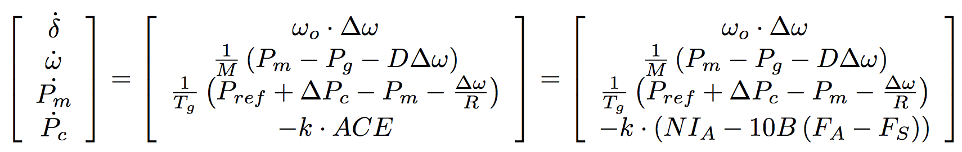

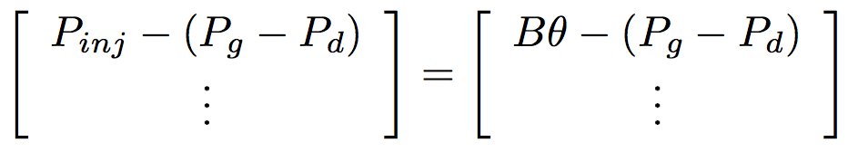to model the change in generator angle, speed, mechanical power output and PC with respect to time, and

to model the power flow along the system, we numerically integrate forward in time from set initial conditions of the current time step. The next layer of the program runs an economic dispatch for a specified time interval, which provides us with the input to the numerical integration subfunction. Economic dispatch performs a linear optimization under the following conditions: ECONDISPATCHEQNS, which calculates the optimal amount of generation to be provided by each generator. Over each time step of the economic dispatch, we run the above numerical integration. This gives us. At the outermost layer of the program, we check the stability of the system based on the numerical integration over the entire time period using the metrics Control Performance Standard 1 (CPS1) and Control Performance Standard 2 (CPS2), both of which provide a measure of frequency deviations over different time segments. The input system will be a 2 area, 39 bus per area system with 10 non-wind generators and 4 wind generators per area.

There are a number of parameter variations that will constitute our experiments. Most importantly, we control the percentage of regulation provided by the system; we expect the generally accepted value of 1% of peak load for the given time segment to fall short, and thus we will increase the amount of regulation until stability is reached. Additionally, we have control over the percent of generation produced by renewables (which in our case will be wind). These constitute the main goal of our experiment; we wish to quantify the amount of regulation needed to maintain adequate stability as a function of wind penetration level.

In addition to these basic controls, we wish to alter a number of other parameters in order to find further ways to maintain stability even as wind penetration levels increase. First, we plan to vary the time step size between economic dispatch runs; we wish to quantify the increase in stability associated with shorter times between dispatching generation. Then, we intend to compare the effects of consolidating balancing areas. Lastly, we wish to consider the influence of the amount of inertia and “slack” in the system on stability.

We expect to be able to form a fully quantified picture of the stability of power systems with regard to each of the variables in question. Specifically, we wish to examine the current claims that at most a few additional percentage points of regulation are necessary to maintain stability and APT SLACK CLAIM.

fig