Master's Thesis Proposal john undrill

Libby Kirby

As the technology behind renewable energy sources becomes more advanced and cost-effective, these sources have become an ever-increasing portion of the generation profile of power systems across the country. While the shift away from non-renewable resources is generally considered to be beneficial, the fact remains that renewable sources present unique challenges associated with their individual generation profiles. Because of the high variability of renewable resources, the stability of the system can degrade. Generators assigned to regulate frequency, are forced to ramp up and down quickly in order to supplement the rise and fall of the variable resources, causing transient frequency deviations, power swings, major interface transfer viations and other significant issues. In this thesis, we aim to measure the impact of renewable penetration level on system stability.

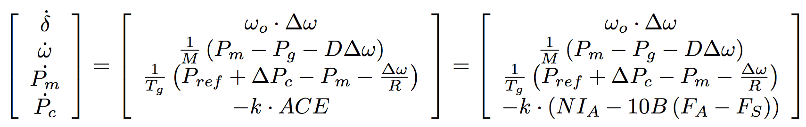In its current state, our model consists of 3 basic layers. Within the innermost layer, we employ a dynamic simulation of the power flow model. Using the following matrix equations

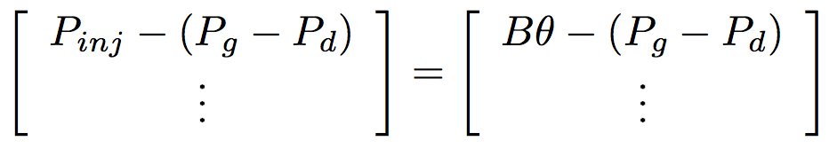to model the change in generator angle, speed, mechanical power output and PC with respect to time, and

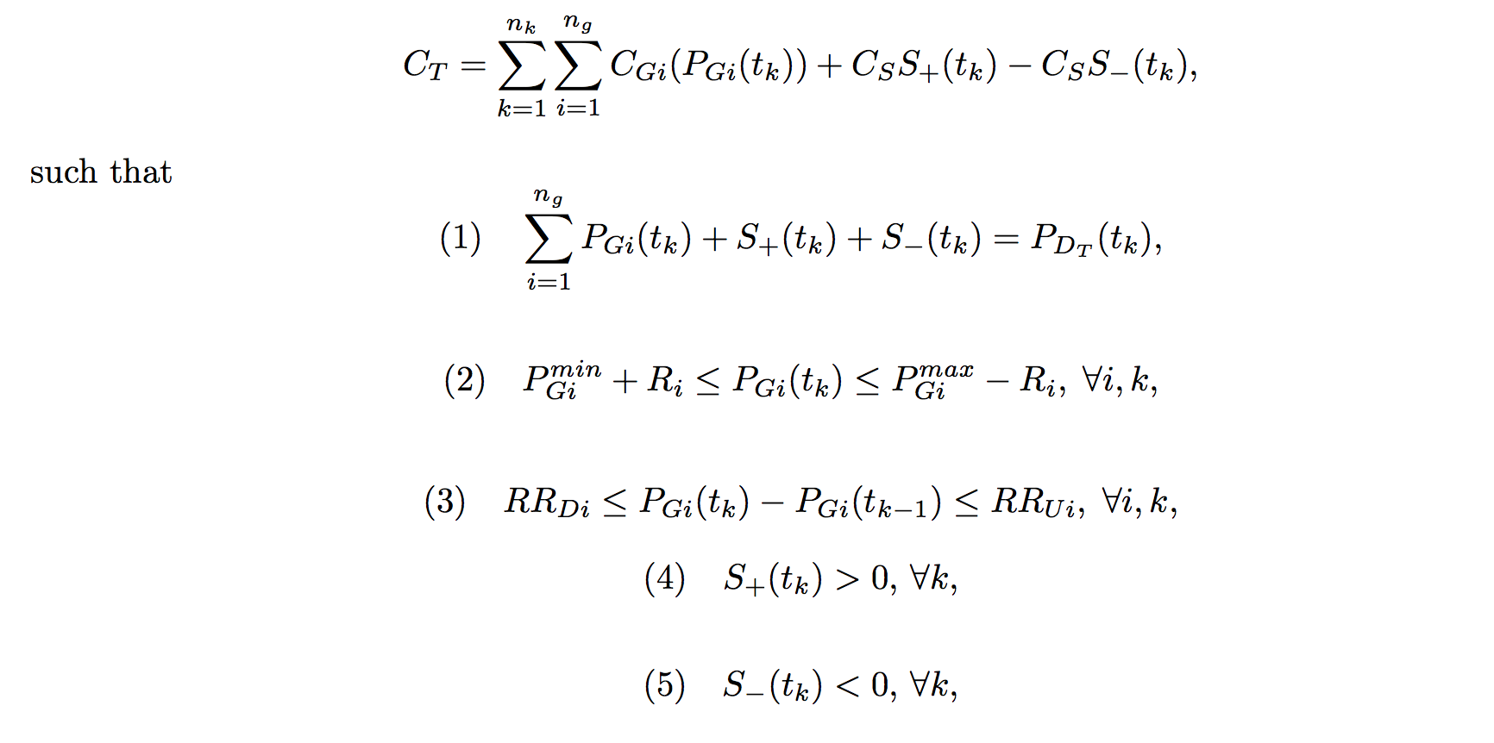to model the power flow along the system, we numerically integrate forward over the current time interval from set initial conditions. The next layer of the model runs an economic dispatch for each of the time intervals, which provides us with the input to the numerical integration subfunction. Economic dispatch performs a linear optimization under the following conditions:



which calculates the optimal amount of generation to be provided by each generator. Over each time-step of the economic dispatch, we run the above numerical integration. This gives us. At the outermost (3rd) layer of the model, we check the stability of the system based on the numerical integration over the entire time period using the metrics Control Performance Standard 1 (CPS1) and Control Performance Standard 2 (CPS2), both of which provide a measure of frequency deviations over different time segments. The input system will be a 2 area, 39 bus per area system with 10 non-wind generators and 4 wind generators per area, which is based on a commonly used simple model of New England.

There are a number of parameter variations that will constitute our experiments. Most importantly, we can control the percentage of regulation provided by the system(non-renewable, rapidly-dispatchable reserve); we expect the generally accepted value of 1% of peak load for the given time segment to fall short, and thus we will increase the amount of regulation until stability is reached. Additionally, we have control over the percent of generation produced by renewables (which in our case will be wind). The comparison of these two parameters and their net effect constitute the main goal of our experiment; we wish to quantify the amount of regulation needed to maintain adequate stability as a function of wind penetration level.

In addition to these basic controls, we wish to alter a number of other parameters in order to find further ways to maintain stability even as wind penetration levels increase. First, we plan to vary the time step size between economic dispatch runs; we wish to quantify the increase in stability associated with shorter times between re-dispatching generation. Then, separately, we intend to compare the effects of consolidating balancing areas. Lastly, we wish to consider the influence of the amount of inertia and “slack” in the system on stability.

We expect to be able to form a fully quantified picture of the stability of power systems with regard to each of the variables in question. Specifically, we wish to examine the current claims that at most a few additional percentage points of regulation are necessary to maintain stability and APT SLACK CLAIM. There’s no room for more comments so I’m putting one here (just delete it after you’ve read it). I think that if you get into consolidation of balancing areas (which is a good idea and has certain advantages for managing renewables) you need to mention certain potential drawbacks. I’m no expert on this, but I do see one obvious Achilles heel – you can’t consolidate areas very easily if they happened to have *other* issues, unrelated to renewable problems, that prevent them from easily backing each other up, such as stability/voltage/thermal interface limitations. I think this needs to be mentioned.

And one more thing – This proposal is both understandable and practically useful out in the real world and is therefore quite impressive – nice job engineer.

fig