Master's Thesis Proposal

Libby Kirby

As the technology behind renewable energy sources becomes more advanced and cost-effective, these sources have become an ever-increasing portion of the generation profile of power systems across the country. While the shift away from non-renewable resources is generally considered to be beneficial, the fact remains that renewable sources present unique challenges associated with their individual generation profiles. Because of the high variability of renewable resources, the stability of the system can degrade. Generators assigned to regulate frequency are forced to ramp up and down quickly in order to supplement the rise and fall of the variable resources, causing transient frequency deviations, power swings, major interface transfer variations and other significant issues.

In this thesis, we aim to measure the impact of renewable penetration level on power system stability. Currently, the generally accepted amount of regulation (non-renewable, rapidly-dispatchable reserve) is 1% of peak load. Because of the high variability associated with wind, this value is expected to need to be increased by at least a few percentage points. A key objective of the thesis is to quantify the amount of regulation necessary to maintain marginal stability as a function of the penetration level of wind.

Thus far, current literature has focused on a limited number of wind penetration data points. Additionally, few studies have employed a dynamic generator model.

Once this functional relationship is established for our base case, we wish to consider the influence of additional controllable parameters, to see if the measured regulation level can be decreased while maintaining the same desired stability on a given wind penetration percentage. Even simply maintaining regulation (as opposed to employing it) can be quite costly; additional measures may ease this burden. In accordance with current industry consideration, the model will employ various dispatch intervals, ranging from the common length of one hour down to five minutes. A decreased dispatch time allows less time for load to vary away from the current set point, and thus will hopefully increase stability without the need for additional regulation. Next, we intend to examine the effects of consolidating balancing areas. An increased number of generators contributing to load mitigation in a given area may ease the required ramping of each individual generator and increase stability. Lastly, we wish to consider the influence of the amount of inertia and “slack” in the system on stability. The inertia of the system should provide a buffer to frequency deviations, as the generators’ mass prevent them from changing speed quickly. The cost of each change will not directly be considered, but the information provided should allow for decisions on a case-by-case basis.

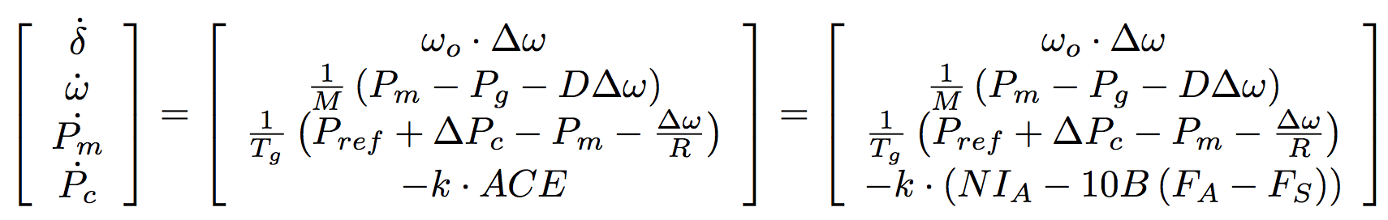In its current state, our model consists of 3 basic layers. Within the innermost layer, we employ a dynamic simulation of the power flow model. Using the following matrix equations

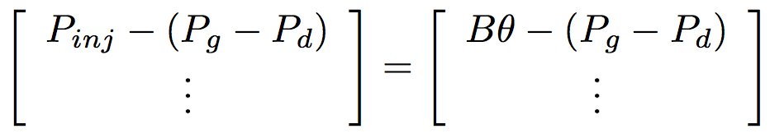to model the change in generator angle, speed, mechanical power output and change in power due to the governor with respect to time, and

to model the power flow along the system, we numerically integrate forward over the current time interval from set initial conditions. The next layer of the model runs an economic dispatch for each of the time intervals, which provides us with the input to the numerical integration subfunction. Economic dispatch performs a linear optimization under the following conditions:

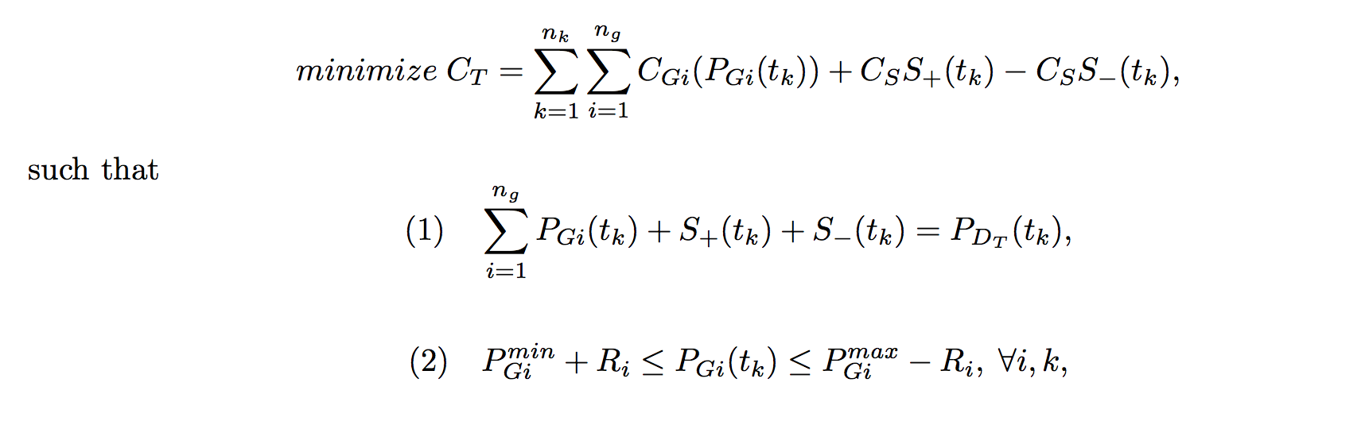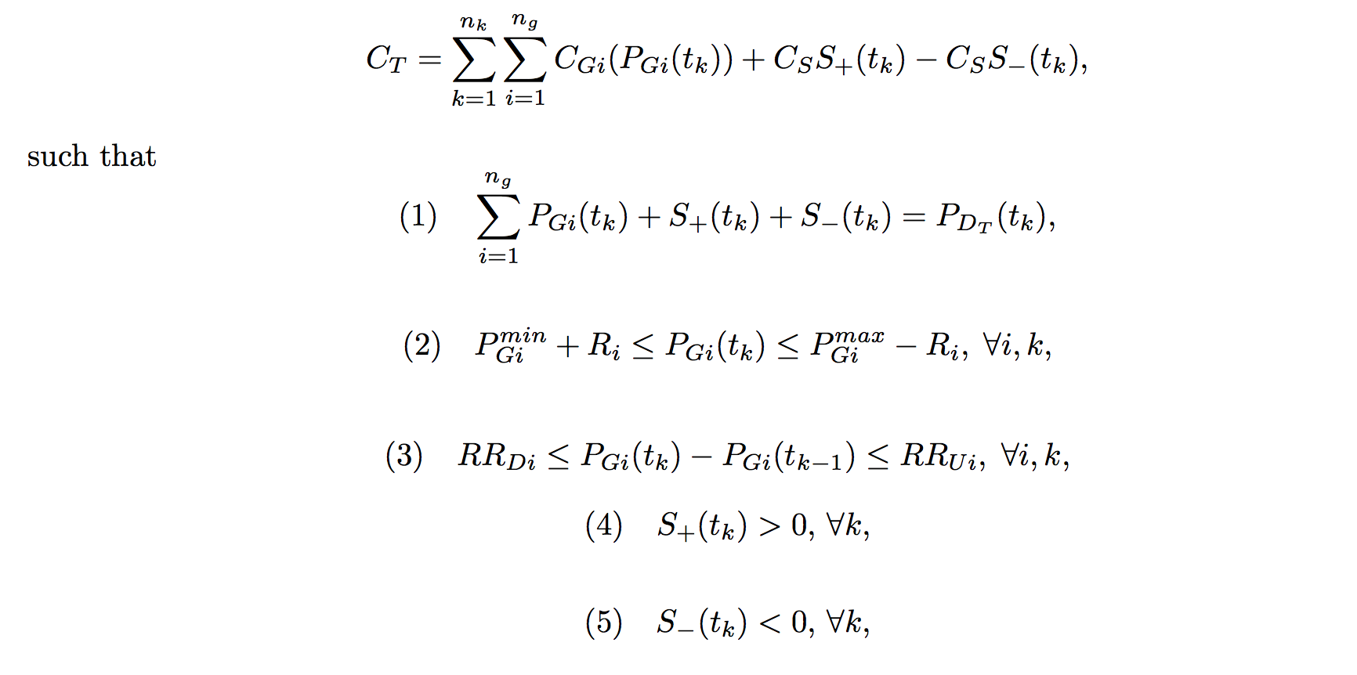

which calculates the optimal amount of generation to be provided by each generator. Over each time-step of the economic dispatch, we run the above numerical integration. At the outermost (3rd) layer of the model, we check the stability of the system based on the numerical integration over the entire time period using the metrics Control Performance Standard 1 (CPS1) and Control Performance Standard 2 (CPS2), both of which provide a measure of frequency deviations over different time segments. The input system will be a 2 area, 39 bus per area system with 10 non-wind generators and 4 wind generators per area, which is based on a commonly used simplified model of New England.

There are a number of parameter variations that will constitute our experiments. Most importantly, we can control the percentage of regulation (non-renewable, rapidly-dispatchable reserve) provided by the system; we expect the generally accepted value of 1% of peak load for the given time segment to fall short, and thus we will increase the amount of regulation until adequate stability is reached. Additionally, we have control over the percent of generation produced by renewables (which in our case will be wind). The functional relationship between these two parameters constitutes the main objective of our experiment; we wish to quantify the amount of regulation needed to maintain adequate stability as a function of wind penetration level.

In addition to these basic controls, we wish to alter a number of other parameters in order to find further ways to maintain stability even as wind penetration levels increase. First, we plan to vary the time step size between economic dispatch runs; we anticipate an increase in stability associated with shorter times between re-dispatching generation. Next, we intend to examine the effects of consolidating balancing areas. We expect that an increased number of generators contributing in a given area will ease the required ramping of each individual generator and increase stability. Lastly, we wish to consider the influence of the amount of inertia and “slack” in the system on stability.

We expect to be able to form a fully quantified picture of the stability of power systems with regard to each of the variables in question. Specifically, we wish to examine the current claims that at most a few additional percentage points of regulation are necessary to maintain stability and that stability can only be achieved by a second-to second matching of generation to load in the presence of wind machines.