Table of Contents
- Purpose of HLD
- How to Complete this Document
- Document Version History
• 1.0 Business Section
- 1.1 Business Solution Summary
- 1.2 Project Objectives
  - 1.2.1 Business Objectives
  - 1.2.2 Payment Modernization - Token Migration – Requirements
- 1.3 Solution Summary
- Referenced Documents
- 1.4 Scope Statement
  - 1.4.1 In Scope
  - 1.4.2 Out of Scope
  - 1.4.3 Uses Cases In Scope
  - 1.4.4 Use Cases out of Scope
  - 1.4.4 In scope item to use case mapping
- 1.5 Assumptions, Risks and Constraints
  - 1.5.1 Assumptions
  - 1.5.2 Risks
  - 1.5.3 Constraints/Dependencies/Limitations
- 1.6 Business Processes/Considerations
- 1.7 Deployment Approach
• 2.0 Solution Architecture
- 2.1 Project Context
  - 2.1.1 In-Scope Applications
- 2.2 Application Communication
- 2.3 Enterprise Services
- 2.4 Use Case Realization
  - 2.4.1 Business Processes
  - 2.4.2 Functional Use Case “UC-01:Mass Migration/Delta Migration – Validate Moneris Tokens”
  - 2.4.3 Functional Use Case “UC-02:Mass Migration is executed”
  - 2.4.4 Functional Use Case “UC-03:-Delta migration is executed”
  - 2.4.5 Functional Use Case “UC-04:Realtime Tokenization-PHUB-API Integration”
  - 2.4.5 Functional Use Case “UC-05 onwards”
  - 2.4.6 All Error use cases
- 2.5 Data Architecture
  - 2.5.1 Information Model
  - 2.5.2 Data Flow Diagram
  - 2.5.3 Data Integration Details
  - 2.5.4 Data Container Details
  - 2.5.5 Information Objectives Utilize
- 2.6 *Data Governance (Mandatory)*
  - 2.6.1 Data/Information Ownership & Stewardship
  - 2.6.2 Data Lifecycle and Retention
  - 2.6.3 Metadata Management
  - 2.6.4 Data Classification & Privacy
  - 2.6.5 Data Quality
  - During the process of selecting, preparing, extracting, and transforming data and permanently transferring it from one computer storage system to another, the migrated data must be validated for completeness.
  - 2.6.6 Data Access and Use
  - 2.6.7 Use of Third Parties and Third-Party Data
  - 2.6.8 Data Residency
- 2.7 Security Architecture
  - 2.7.1 Security Solution View
  - 2.7.2 Encryption - Data at Rest
  - 2.7.3 Encryption – Data in Transit
  - 2.7.4 Identity and Access Management
    - 2.7.4.1 Authentication
    - 2.7.4.2 Authorization
  - 2.7.5 Audit Logging and Monitoring
- 2.8 Other Architectural Characteristics
  - 2.8.1 Availability, Scalability, Reliability and Maintainability
  - 2.8.2 Disaster Recovery
  - 2.8.3 Response Time
  - 2.8.4 Industry Compliance
  - 2.8.5 Volumetric & Service Level Agreement - High Level Impact Analysis
  - Volumetric & Service Level Agreement - High Level Impact Analysis
  - 2.8.6 Enterprise Application Monitoring
• Technical Solution
- 3.0 Technical Solution Overview
  - 3.1 V21 AR
  - 3.2 IVR
    - 3.2.1 Cards Migration Files
    - 3.2.2 Use cases
    - 3.2.2 Application table changes
    - 3.2.3 Application Architecture/Design
    - 3.2.4 Application Security Specifications
  - 3.3 TSC
  - 3.3 SuperSystem
    - 3.3.1 Application Overview:
    - 3.3.2 Application architecture/design
    - 3.3.3 Application Security Specifications
    - <<This section is required to cover the security specifications for your application solution>>
  - 3.4 Admin3
    - Token Selection Criteria
    - File Format
    - Sample CSV Output
    - File Generation Batch Job
      - Prerequisites
      - Batch Job Steps
    - Process
    - EFT Configuration
    - 3.4.1 Application table changes
    - 3.4.2 Application Architecture/Design
    - 3.4.3 Application Security Specifications
  - 3.5 EFT
    - 3.5.1 Application Overview
    - 3.5.2 Application architecture/design
    - 3.5.3 Application Security Specifications
  - 3.6 Payment Hub
    - 3.6.1 Migration Microservice
    - Tables
      - Azure Functions
      - Input file format : Token File Processor : Upload File
  - Response file format from MC
      - Token Migration Response Sample.csv
      - Master card input file format
      - Response file format to Billing systems
    - 3.6.2 PHUB Token Management Microservice
  - 3.7 CIP
    - 3.7.1 Real time mapping Microservice
      - PG Dispatcher Microservice
      - PG Tokenization Microservice
  - 3.8 SSG
  - 3.9 WIN Online Media
    - 3.9.1 Encryption - Data at Rest
    - 3.9.2 Encryption - Data in Transit
    - 3.9.3 Overview:
  - 3.5 Infrastructure Solution
    - 3.5.1 Solution Deployment Diagram
    - 3.5.2 High Level Technical Solution
      - 3.5.2.1 Key Concepts
      - 3.5.2.2 Environments
      - 3.5.2.3 Locations
      - 3.5.2.4 Network Security Zones
      - 3.5.2.5 Availability
      - 3.5.2.6 Recoverability
      - 3.5.2.7 Capacity Management
  - 3.6 Infrastructure Design
    - 3.6.1 Current State
    - 3.6.2 Future State
    - 3.6.2.1 Migration microservice, phub-token-management-ms and RTMM infrastructure requirements
    - 3.6.3 Deployment Approach
      - 3.6.3.1 Deployment Units
      - 3.6.3.2 Third Party Infra Software Applications
      - 3.6.3.3 Infra Software Worksheets
      - 3.6.3.4 Enterprise Systems Management and Monitoring
      - 3.6.3.5 Server Worksheets
      - 3.6.3.6 Network and Storage Host Port Allocation
      - 3.6.3.7 Recovery Details
      - 3.6.3.8 Infra Support and Warranty
  - 3.7 Hardware and Software to Decommission/Repatriate
  - 3.8 Physical Architecture (where applicable)
    - 3.8.1 Physical Diagram
    - 3.8.2 Resource Unit Summary
•
• 4.0 Approvals
• 5.0 Appendix
- 5.1 List of Contributors
- 5.2 Sign-Off Definitions
- 5.3 Document Abbreviations
- 5.4 Template Version

1.3 Solution Summary

  - Develop Migration microservices to allow system configuration, file upload, migration execution management, throttling, fall-out management and report viewing capabilities
  - Develop two microservices for token migrations:
    - CIP application (PCI secure zone)
      - Real Time Mapping Microservice (RTMM) to run within Rogers on-prem CDE environment
        - Reuse Microservices
          - TNDispatcher (connecting to Moneris)
        - New Microservices
          - PGDispatcher (connecting to Mastercard)
            - Wrapping four batch and one real time APIs from master card
          - PGTokenizationService
            - Combination of (TSI, BPS-SCHEDULER,CS-PROCCESS,BPS). No changes will be done in existing services (TSI, BPS-SCHEDULER,CS-PROCCESS,BPS).
            - Expose realtime and batch API through SSG
            - Accept realtime and batch requests through https
            - Expose PGtokens, master card response attributes ,batch status and batch execution details
    - Payment Hub application
      - Migration Microservice (multiple azure functions) to run within Rogers Azure environment
        - Mass migration flow will use only azure components for file based migration
        - Delta migration will use mass migration flow in combination with CIP batch services (PGTokenizationService ) through SSG.
    - phub-token-management-ms microservice in AKS
      - Realtime Tokenization API will be exposed from "phub-token-management-ms"
      - Realtime Tokenization will use CIP real time service (PGTokenizationService ) through SSG to convert 1 Moneris token to master card at a time.
  - Both microservices are horizontally scalable (no coding required)
  - Migration Microservice will enable multithreading to allow achieving Rogers required throughput.
  - Proposed solution is fully PCI Compliant
    - Any PAN handling remains strictly in the on-prem CDE (RTMM service). No sensitive data will be processed in Azure environment
    - No PAN information in logs and database
    - Immutable audit trails, reconciliation and monitoring dashboards
  - Deduplication and other validations will be applied to all input data.
  - The solution will enable zero downtime migration implementation
  - Data retention, error processing protocols, access control will be implemented.
  - Audit and control requirements will be implemented for monitoring and fallout management

1.4 Scope Statement

1.4.1 In Scope
Impacted Area | In Scope
Mass Migration | Support file-based mass token migration
Mass Migration, Delta Migration and Real-time tokenization | Update Payment hub database with payment method details linking billing system, master card token details and Moneris token using PMR
Delta Migration | Support file-based delta token migration.
Real-time tokenization | Support real-time tokenization via API Gateway.
Delta Migration and Real-time tokenization | Provide secure integration with on-prem RTMM and token vaults.
Delta Migration and Real-time tokenization | Ensure PCI DSS compliance and data protection across the solution.
Delta Migration and Real-time tokenization | Provide simulation capabilities for testing without PCI data.
Mass migration, Delta Migration and Real-time tokenization | Provide centralized audit and reporting for all token operations.
Mass migration, Delta Migration | Support retry and error-handling mechanisms for failed batch records.
Mass migration, Delta Migration | Production Support should be able to terminate a batch or multiple batches
Mass migration, Delta Migration | Email notification will be sent at the end of the process (tracked by migration wave/file id/ batch)  email will be sent only at the beginning, failure and end only.  Start of migration email will have details so that production support can decide to let migration continue or terminate migration

1.4.2 Out of Scope
The Out-of-Scope statement should clearly mention the functionality that will not be delivered as a part of this solution.
Impacted Area | Out of Scope
Mass migration, Delta Migration | Production Support should be able to apply throttling (increase/ decrease number of threads) during migration execution in real time
Mass migration, Delta Migration | Production Support should be able to pause, resume a batch or multiple batches

1.4.3 Uses Cases In Scope
Use case id | Use case
UC-01 | Mass migration. Delta migration: Production support team/EFT uploads an input file to validate moneris tokens and apply migration status on data extracted from following source systems  1. WinOnline Media  2. V21 MACC  3. TSC
UC-02 | Mass migration : Production support team/EFT uploads an input file to migrate : “saved” payment tokens stored in source systems. Mass migration is executed.
UC-03 | Delta migration: Production support team/EFT uploads an input file to migrate : “saved” payment tokens stored in source system using RTMM simulator. Delta migration is executed
UC-04 | Realtime Tokenization: A user invokes payment hub API and payment hub api calls GetPGToken when PGtoken is missing for a moneris token. Payment hub APIs:  - Payment  - Refund  - Payment Batch Jobs  Using RTMM simulator
UC-05 | Delta migration: Production support team/EFT uploads an input file to migrate : “saved” payment tokens stored in source system using SSG endpoint.
UC-06 | Realtime Tokenization: A user invokes payment hub API and payment hub api calls GetPGToken when PGtoken is missing for a moneris token. Payment hub APIs:  - Payment  - Refund  - Payment Batch Jobs  Using SSG endpoint
UC-07 | Mass migration. Delta migration: Production support team should be able to see migration progress, error count etc in a reporting table.
UC-08 | Mass migration. Delta migration: Production support team/EFT uploads an input file to validate with existing payment hub database, record error and update migration status.
UC-09 | Mass migration : Production support team/EFT uploads an input file to migrate payment tokens stored in source system. Once process completes, production support team retries failed transactions
UC-10 | Delta migration : Production support team/EFT uploads an input file to migrate payment tokens stored in source system. Once process completes, production support team retries failed transactions
UC-11 | Delta migration, Realtime migration : ?? how to Validate :  1. Provide secure integration with on-prem RTMM and token vaults.  2. Ensure PCI DSS compliance and data protection across the solution.
UC-12 | Mass migration. Delta migration: Token file processor should apply validation rules before creating migration batches.

1.4.4 Use Cases out of Scope
Use case id | Use case name
NA | Mass migration : validate migration: “saved” payment tokens stored in source systems
NA | Delta migration : validate migration : “saved” payment tokens stored in source systems
NA | Mass migration : migrate payment tokens stored in source system, pause during migration and then resume to complete migrations
NA | Mass migration : migrate payment tokens stored in source system, terminate execution during migration
NA | Delta migration : migrate payment tokens stored in source system, pause during migration and then resume to complete migrations
NA | Delta migration : migrate payment tokens stored in source system, terminate execution during migration
NA | Mass migration. Delta migration: During migration execution the production support team increases or decreases number parallel executors manually.

1.4.4 In scope item to use case mapping
Impacted Area | In Scope | Use case
Mass Migration | Support file-based mass token migration | UC-01, UC-02,
Mass Migration | Update Payment hub database with payment method details linking billing system, master card token details and Moneris token using PMR | UC-02
Delta Migration | Support file-based delta token migration. | UC-01, UC-03, UC-05
Real-time tokenization | Support real-time tokenization via API Gateway. | UC-04, UC-06
Delta Migration and Real-time tokenization | Provide secure integration with on-prem RTMM and token vaults. | UC-05, UC-06, UC-11
Delta Migration and Real-time tokenization | Ensure PCI DSS compliance and data protection across the solution. | UC-05, UC-06, UC-12
Delta Migration and Real-time tokenization | Provide simulation capabilities for testing without PCI data. | UC-03, UC-04
Mass migration, Delta Migration and Real-time tokenization | Provide centralized audit and reporting for all token operations. | UC-07
Mass migration, Delta Migration | Support retry and error-handling mechanisms for failed batch records. | UC-08, UC-09, UC-10, UC-11
Mass migration, Delta Migration | Production Support should be able to terminate a batch or multiple batches | UC-08, UC-09, UC-10, UC-11
Mass migration, Delta Migration | Email notification will be sent at the end of the process (tracked by migration wave/ batch) | UC-01, UC-02,UC-03, UC-05, UC-08, UC-09, UC-10, UC-11
1.5
Phase/Single Drop | Components included | PVT (Y/N) | PET | BRT (Y/N)

2.0 Solution Architecture

2.1 Project Context

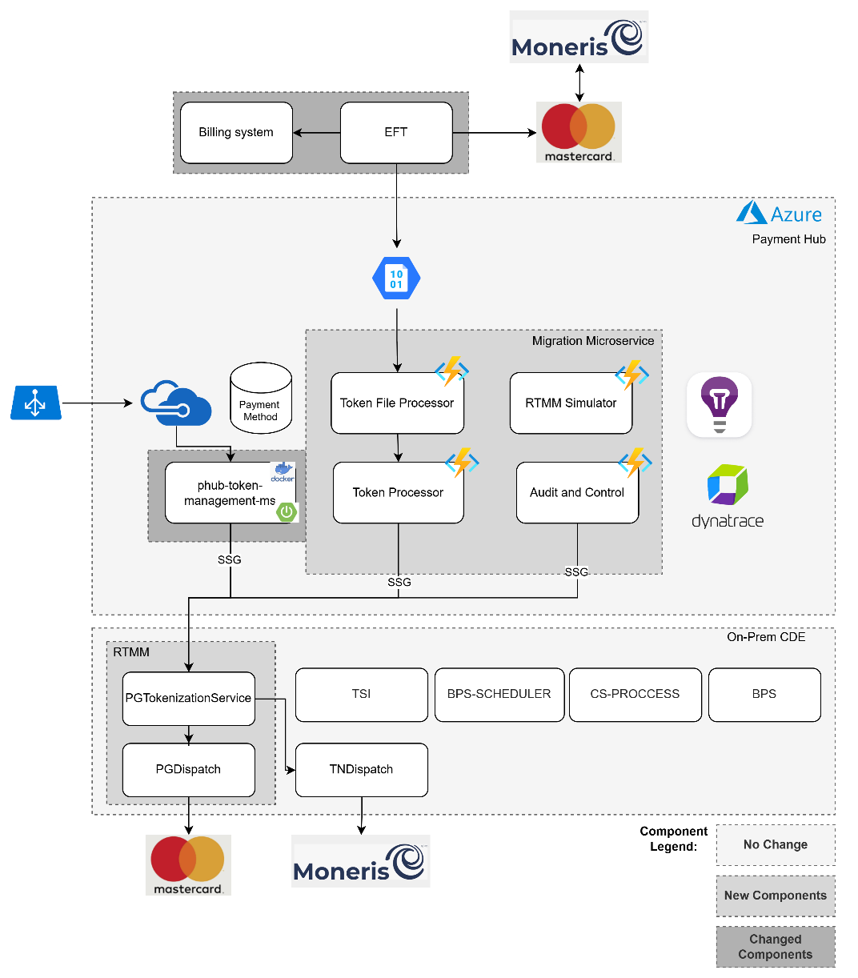
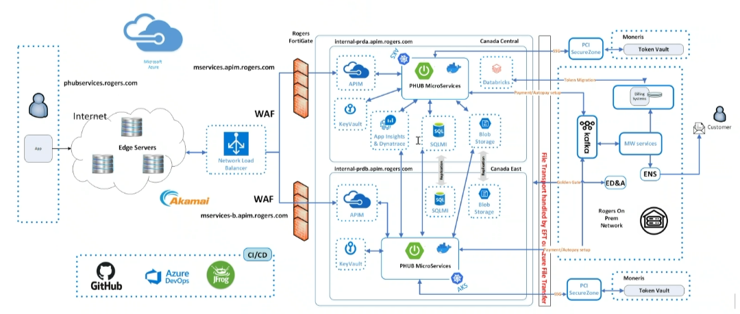

2.1.1 In-Scope Applications
App ID | App Name | New / Change | Description of Changes
 | WinOnline Media | Change | Extract Moneris tokens as per file format defined in interface agreement
 | V21 MACC | Change | Extract Moneris tokens as per file format defined in interface agreement
 | TSC | Change | Extract Moneris tokens as per file format defined in interface agreement
 | SSG | Change | MW for calls from PHUB to CIP services
 | EFT | Change | Transfer files between blob storage, Billing systems and Mastercard
0700 | PCI secure Zone (CIP- Cash integration platform) | Change | New RTMM microservice : Expose API to handle batch and real time migration using master card and Moneris APIs
2034 | Payment Hub | Change | New Migration microservice : handle mass migration, delta migration and real time migration.

2.2

2.4.6 All Error use cases
- In case of any of the following scenario file will be rejected and process will stop
  - File validation error - Moneris
Occurs when the uploaded moneris input file fails schema, size, or checksum validation.
  - File validation error - Mastercard
Occurs when the uploaded Mastercard response mapping file fails schema, size, or checksum validation.
  - Decryption or parsing error
Happens if the file cannot be decrypted or parsed due to corruption or incorrect encryption key.
  - Failure to insert records in database
Bulk insert into Migration DB fails because of deadlock, timeout, or constraint violation.
  - 100% API failure for first 5 batches in delta migration
    - Moneris API times out or gives error
    - Master card API times out or gives error
- In case of any of the following scenario Moneris token migration status (in table moneris_tokens_staging) and error details (in table Migration_Error_Details) will be updated but migration process will continue
  - Token validation error
    - Token value does not start with 9
    - Token value is not 16 digits
    - mandatory fields missing from input moneris file (mandatory fields to be defined in DDD)
    - mandatory fields missing from mastercard mapping file (mandatory fields missing from input moneris file)
    - expiry date is less than expiry date in payment hub
    - Token exist in PMR_MONERIS_MAPPING
    - PG Token exist in TOKENIZED_CARD
    - Tokens fail validation against Payment Hub DB (e.g., missing or invalid token).
    - More scenarios to be added in DDD.
    - Moneris API times out or gives error for a batch (retry should be done by Audit and control in this case)
  - Function timeout or crash
Token Processor or Audit and Control function crashes or exceeds execution time.
- In case of any of the following scenarios only reporting table (Migration_Error_Details) will be updated and email will be sent.
  - Billing file generation error
Generate Billing Mapping File function fails due to storage issues or data inconsistency.
- In of any failure in realtime tokenization , error will be logged, Migration_Error_Details table will be updated and "Internal Server Error" will be returned to API consumer

2.5 Data Architecture

2.5.2 Data Flow Diagram

MASS Migration
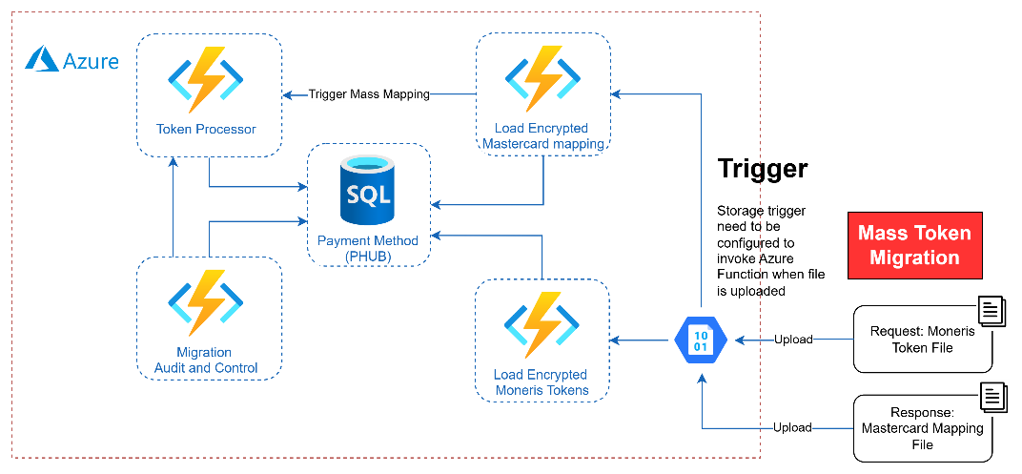
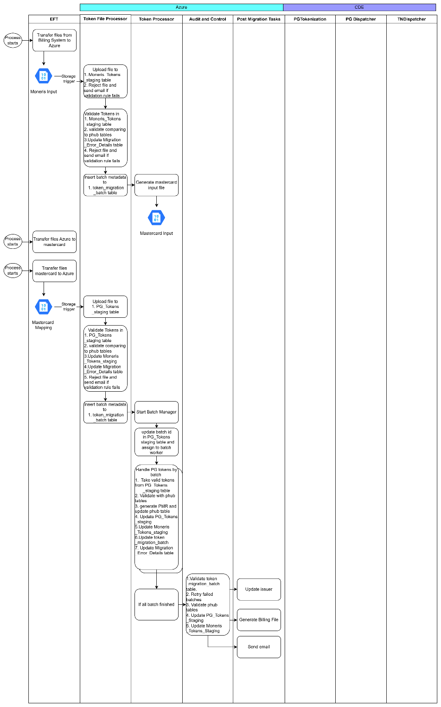
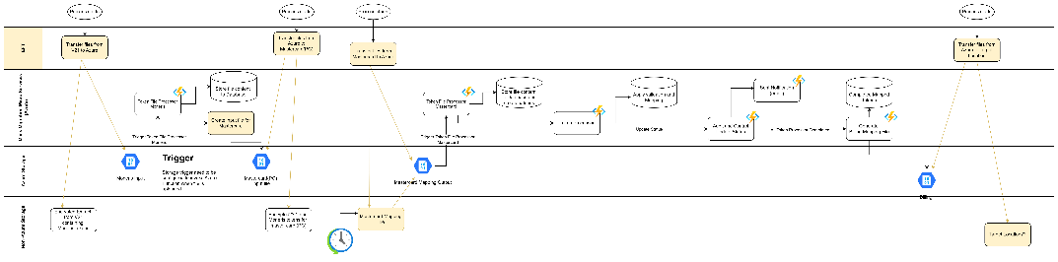

Delta Migration

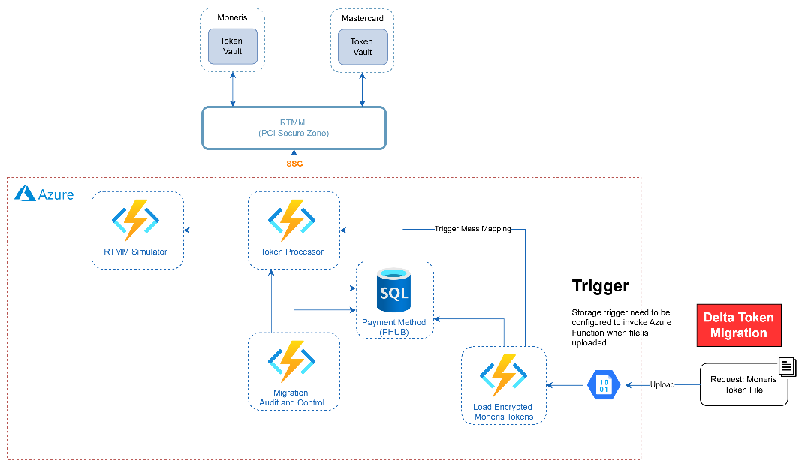

Delta Migration - preferred flow
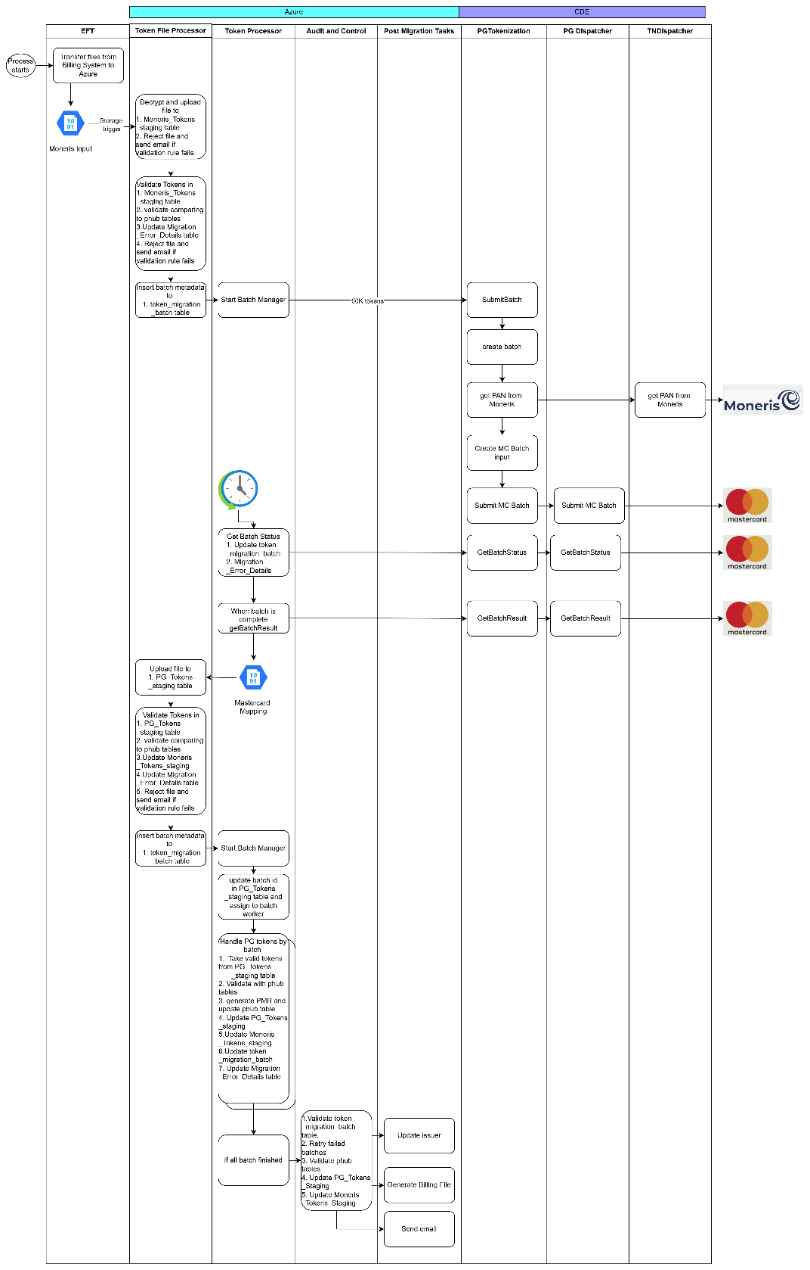
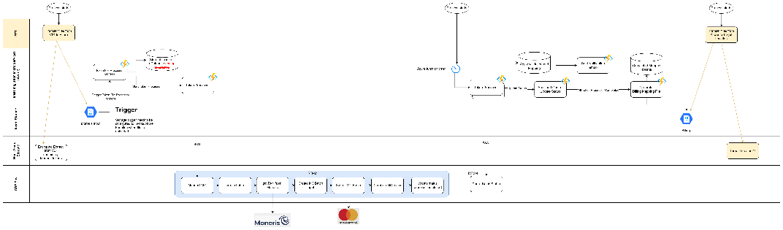

Delta Migration - flow option-2
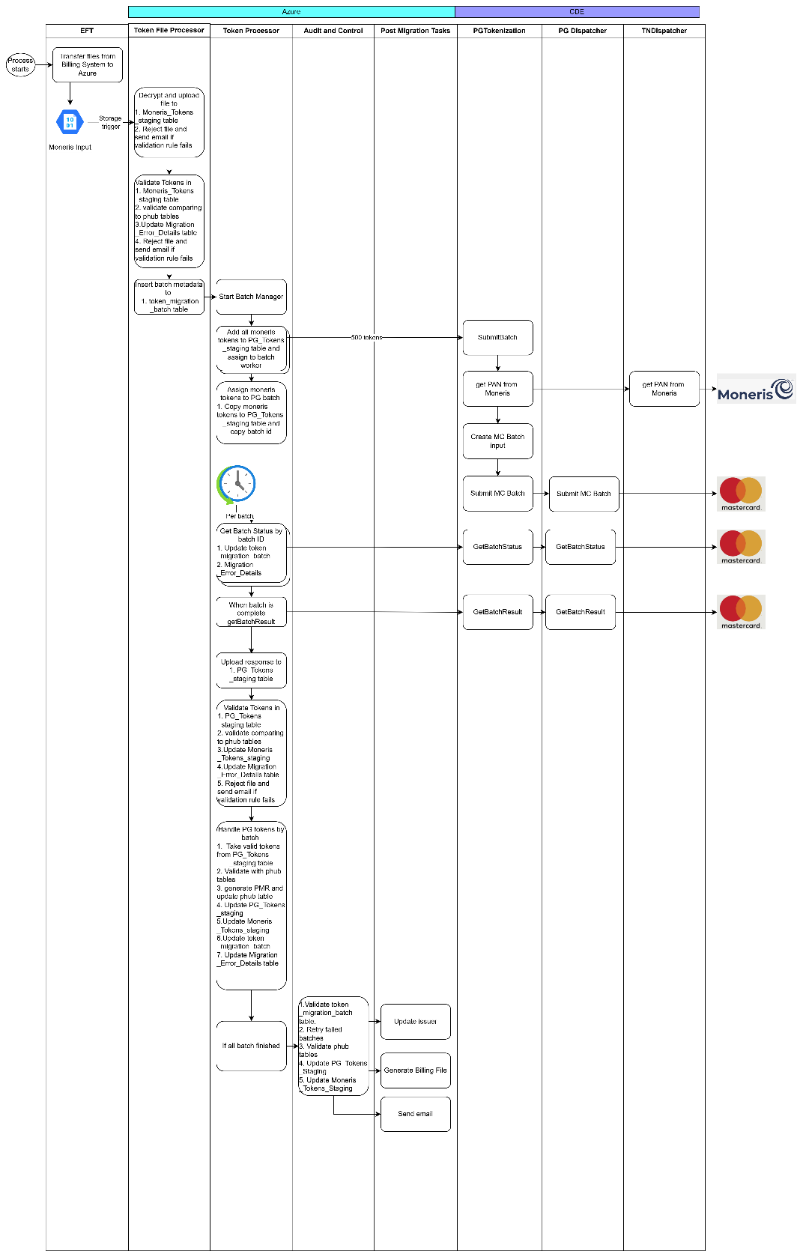
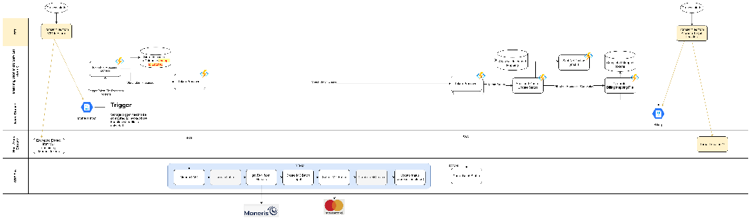

Realtime Gateway Tokenization
261px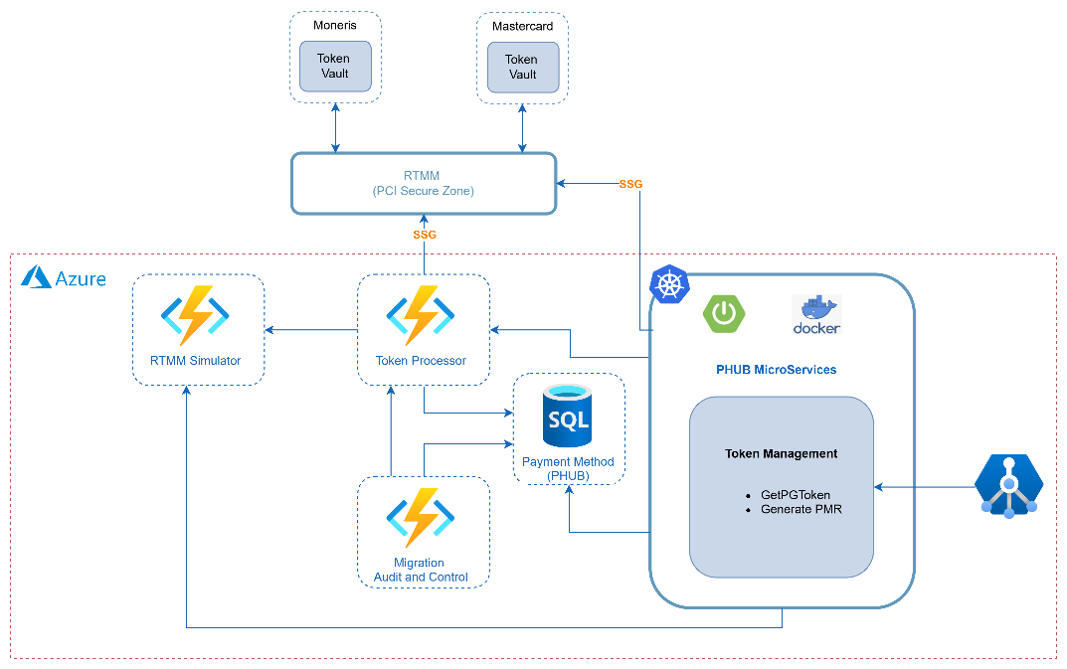
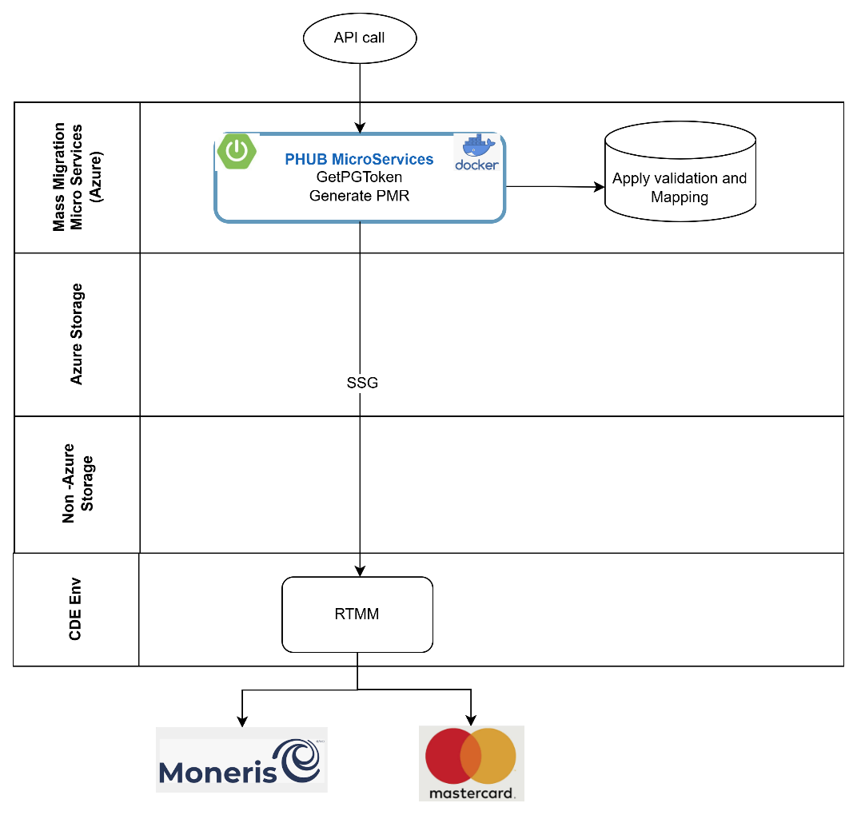

Technical Solution
List all the impacted applications and repeat the section 3.1 and it’s subsections to cover the end-to-end solution for all impacted applications. This section will be completed by application owners for their respective applications.

3.0 Technical Solution Overview

3.6 Payment Hub

3.6.1 Migration Microservice

Tables
Following tables will be used to orchestrate mass migration and delta migration
Schema | App Name | New / Change | Description of Changes/ Comments
Payment Method | PAYMENT_METHOD | No Change | Payment hub table keeping payment method details including PMR
Payment Method | TOKENIZED_CARD | No Change | Payment hub table
Payment Method | ENTITY_DETAILS | No Change | Payment hub table
Payment Method | ENTITY_PMR_MAPPING | No Change | Payment hub table
Payment Method | PMR_MONERIS_MAPPING | No Change | Payment hub table
Payment Method | TOKEN_ACTIVITY_LOG | No Change | Payment hub table
Payment Method/ TokenMigration | MONERIS_TOKENS_STAGING | New | Keeps all Moneris tokens sent in "Mass Migration" file or "Delta Migration" file along with migration statuses (multiple columns).
Payment Method/ TokenMigration | PG_TOKENS_STAGING | New | Keeps all master card tokens sent in "Mass Migration" file or returned in "Delta Migration" batch api output along with migration statuses (multiple columns)
Payment Method/ TokenMigration | MIGRATION_ERROR DETAILS | New | Keeps error details (multiple rows) explaining failure reason for a file id, batch id, Moneris Token, PG token, Entitiy ID or PMR
Payment Method/ TokenMigration | TOKEN_MIGRATION_BATCH | New | Reporting table to track each file and batch. token level infomation will not be present in this table.
Payment Method/ TokenMigration | TOKEN_MIGRATION_WORKERS | New | Tracks all workers of token processor along with mode.
Payment Method/ TokenMigration | TOKEN_MIGRATION_AUDIT_LOG | New | JSON based logging for reporting and quick action.  new record will be added to TOKEN_MIGRATION_AUDIT_LOG as needed in dev/ support phase. this table will never be updated.

  - All new tables will have create timestamp, update time stamp and last updator column.

Azure Functions
Following azure functions will be used to orchestrate mass migration and delta migration
Function name | Mode | Description of Changes/ Comments
Token File Processor | Upload File | - Triggered from blob storage  - Moneris location (billing/input)  - WinOnline Media (billing/input/winmedia)  - V21 (billing/input/v21)  - TSC (billing/input/tsc)  - Master card location (mastercard/mapping)  - Identify context  - Send email - start of process.  - Decrypt file in cases its required. Configuration will be defined in detailed design document.  - validate and load file content (validation rules mentioned in DDD)  - Moneris token will be uploaded to MONERIS_TOKENS_STAGING  - Master card token will be uploaded to PG_TOKENS_STAGING  - Reject file if file can not be read or loaded and send email  - Assign File id to the uploaded tokens and insert record to : TOKEN_MIGRATION_BATCH.  File formats mentioned in Input file format section
Token File Processor | Validate Tokens | - identify context (Moneris vs PG by corresponding file id) from TOKEN_MIGRATION_BATCH  - Validate tokens content by file id (validation rules mentioned in DDD)  - Moneris tokens → MONERIS_TOKENS_STAGING  - Master card token → PG_TOKENS_STAGING  - Look up in payment hub DB  - Moneris (detailed design will add/remove tables)  - PMR_MONERIS_MAPPING  - ENTITY_PMR_MAPPING  - Master card (detailed design will add/remove tables)  - PAYMENT_METHOD  - TOKENIZED_CARD  - ENTITY_PMR_MAPPING  - Validate tokens relation to payment hub details (validation rules mentioned in DDD) and update migration status on MONERIS_TOKENS_STAGING, PG_TOKENS_STAGING per token.  - if more than 50% (configurable) failure, reject the file (update TOKEN_MIGRATION_BATCH, MIGRATION_ERROR DETAILS) and send the failure email.  - On success update TOKEN_MIGRATION_BATCH.  - Based on successfully validated token count, create batch metadata and update TOKEN_MIGRATION_BATCH  - Batch size (to be used by token processor manager), total batches, wait time, retry time etc.
Token File Processor | Create Batch | - Based on successfully validated token count, create batch metadata and update TOKEN_MIGRATION_BATCH  - Batch size (to be used by token processor manager), total batches, wait time, retry time etc.  - Max batch size, other metadata will be configurable per billing system and can be changed by production support team (reference table name to be finalized in DDD)  Note: This will be needed when token migration status is updated manually and rerun is needed on migration.
Token Processor | fileGen | - Based on migration status in : MONERIS_TOKENS_STAGING, create input file for master card  - File will be combined for multiple inputs when needed. This will be handled by cohort id which include multiple input file IDs.  - Files will be encrypted based on configuration per target system.  - File format defined in Master card input file format  - Store generated file to Azure Blob storage → mastercard/input  - update TOKEN_MIGRATION_BATCH
Token Processor | BatchManager | - Take input as file id  - Retrieve batch metadata from : TOKEN_MIGRATION_BATCH  - Based on context and batch size, assign batch id to MONERIS_TOKENS_STAGING or PG_TOKENS_STAGING  - create new entry in TOKEN_MIGRATION_BATCH (unique batch name, file id, token count, migration type (mass or delta) context (Moneris or PG) along with stats and status )  - Initiate Token Processor (mode : worker) with newly created batch id  - go to step 3 for next batch creation.  - update TOKEN_MIGRATION_WORKERS  - Repeat these steps till all tokens are assigned to a batch or .max active workers reached
Token Processor | BatchWorker | - Take input batch id,  - Retrieve batch metadata from : TOKEN_MIGRATION_BATCH  - Based on context and batch id retrieve tokens MONERIS_TOKENS_STAGING or PG_TOKENS_STAGING  - if mass migration proceed to payment hub update (step 7)  - if delta migration (context = Moneris ) and batch is not submitted  - retrieve tokens from MONERIS_TOKENS_STAGING  - create batch request for PGTokenizer  - submit batch request to PGTokenizer through SSG  - Submit Azure Function timer to check for batch status  - if delta migration (context = Moneris ) and batch is submitted  - Check batch status  - if batch status is "Complete"  - invoke Get Batch Result  - if Batch metadata says full delta migration,  - store batch result to Azure Blob storage → mastercard/input using file format : Master card input file format  - if Batch metadata says "throttled delta migration"  - Store batch result to PG_TOKENS_STAGING  - Reuse code of "Token File Processor: Validate Tokens".  - update TOKEN_MIGRATION_BATCH with stats  - On successful validation proceed to payment hub update (step 7)  - Else if batch status is not "Complete"  - Submit Azure Function timer to check for batch status  - Update Payment Hub DB  - PAYMENT_METHOD  - TOKENIZED_CARD  - ENTITY_DETAILS (Entity may exists but PMR mapping may not exist, do not update for id migration and transaction history migration)  - ENTITY_PMR_MAPPING  - PMR_MONERIS_MAPPING  - TOKEN_ACTIVITY_LOG (if existing token attributes is changed)  - update migration status on MONERIS_TOKENS_STAGING, PG_TOKENS_STAGING per token.  - update TOKEN_MIGRATION_BATCH with stats
Audit and Control |  | - Scan TOKEN_MIGRATION_BATCH, MONERIS_TOKENS_STAGING, PG_TOKENS_STAGING and identify if retry is need (retry rules to be defined in DDD)  - Once all batches are complete (failed batches and failed tokens are OK, batch status or token status should not PENDING)  - check configuration if response file for billing should be generated as part of bulk/delta migration for specific Billing System.  - If yes: invoke "Generate Billing Mapping File"  - Send Notification email taking stats from TOKEN_MIGRATION_BATCH, MONERIS_TOKENS_STAGING, PG_TOKENS_STAGING
Generate Billing Mapping File |  | - Following input will be taken in this function  - Billing System (Source ID)  - Migration Start Date and Migration End Date. (Optional).  - File ID (Optional)  - Batch ID (Optional)  - Identify tokens from MONERIS_TOKENS_STAGING (exact criteria to be finalized in DDD)  - Based on migration status in MONERIS_TOKENS_STAGING, Generate out file to with successful tokens and failure tokens in billing/output (Use data from PMR_MONERIS_MAPPING, TOKENIZED_CARD, ENTITY_PMR_MAPPING)  - WinOnline Media (billing/output/winmedia/success , billing/output/winmedia/failure)  - V21 (billing/output/v21/success, billing/output/v21/failure)  - TSC (billing/output/tsc/success,billing/output/tsc/failure )  - File will be encrypted based on configuration (if encryption is needed.) Default value will be always encrypt and it will need deployment change this setting so that configuration will go through change management process.  - Based on input, only one file will be created irrespective of number of input files.  - File format is defined in Response file format to Billing systems.  - Update MONERIS_TOKENS_STAGING with extract details if needed (update rules to be finalized in DDD)  - insert new record in TOKEN_MIGRATION_BATCH with stats.
Post Migration Task | Update Issuer | Update values where source and target both are phub database  - Update Issuer name in TOKENIZED_CARD table  - Only update tokens with final status COMPLETED (or per defined rules in detailed design).

Input file format : Token File Processor : Upload File
Input migration file for payment tokens (2026 and 2027)

    - No limit for the number of records

    - Billing system should exclude duplicate records based on Entity ID and Moneris token.
Field Name | Format | Description
MONERIS_TOKEN | 16 digits, starting with 9 | Moneris token
EXP_DATE | MMYY | Expiration date of Moneris token. May be expired
ENTITY_ID | Up to 36 alphanumeric characters:  - for Maestro: Maestro account number  - for V21 – BAN  - for WinOnline Media – GUID  - for SS – CAN  - for TSC – customer account number  - etc. | Entity (or account), to which payment method is linked,
ENTITY_TYPE | ‘1’ for Account Number  ‘2’ for GUID | Account number or GUID
ENTITY_STS | 1 character:  ‘O’ – Open/Active  ‘S’ – Suspended  ‘N’ – Cancelled  ‘C’ - Closed | Entity (or account) status.  It should be mapped by Channel as per definition provided.  For investigations  Optional, e.g. not available in WinOnline Media
CREATION_DATE | YYYYMMDD | Creation or last update date of the token. For cleanup.  Optional, e.g. might not be available in SS or Admin3
LAST_USE_DATE | YYYYMMDD | Last use date of the token. For cleanup.  If not provided, it will be populated by PHUB as migration date  Optional
TRX_SEQ_NO |  | N/A for this type of file. Should be left empty
BUSINESS_UNIT |  | Not applicable for bulk migration, should be left empty

Input migration file for tokens from transactional history (2027)

    - These files will be created by CASH and TSC applications in the Second Bulk Migration (2027)
Field Name | Format | Description
MONERIS_TOKEN | 16 digits, starting with 9 | Moneris token
EXP_DATE | MMYY | Expiration date of Moneris token. May be expired.
ENTITY_ID |  | N/A for this type of file. Should be left empty
ENTITY_TYPE |  | N/A for this type of file. Should be left empty
ENTITY_STS |  | N/A for this type of file. Should be left empty
CREATION_DATE | YYYYMMDD | N/A for this type of file. Should be left empty
LAST_USE_DATE | YYYYMMDD | Last use date of the token. For cleanup  Optional
TRX_SEQ_NO | Alphanumeric, up to 36 characters  - For tx in CASH: value from MERCHANT_ORDER_NO field in TRANSACTION_REQUEST or BATCH_TRANSACTION tables.  - For TSC: TBD. | Reference to the transaction used for extract of Moneris token (in CASH or TSC)
BUSINESS_UNIT |  | N/A for this type of file. Should be left empty

Input migration file for ID tokens (2027)

    - These files will be created by V21, SuperSystem and Maestro applications in the Second Bulk Migration (2027)
Field Name | Format | Description
MONERIS_TOKEN | 16 digits, starting with 9 | Moneris token
EXP_DATE | MMYY | Expiration date of Moneris token. May be expired.
ENTITY_ID |  | N/A for this type of file. Should be left empty
ENTITY_TYPE |  | N/A for this type of file. Should be left empty
ENTITY_STS |  | N/A for this type of file. Should be left empty
CREATION_DATE | YYYYMMDD | N/A for this type of file. Should be left empty
LAST_USE_DATE | YYYYMMDD | Last use date of the token. For cleanup  Optional
TRX_SEQ_NO |  | N/A for this type of file. Should be left empty
BUSINESS_UNIT |  | N/A for this type of file. Should be left empty

Header and trailer in the input migration file from Billing Systems
Header: MONERIS_TOKEN, EXP_DATE, ENTITY_ID, ENTITY_TYPE, ENTITY_STS, CREATION_DATE, LAST_USE_DATE, TRX_SEQ_NO, BUSINESS_UNIT
Trailer: TRANSACTION_COUNT, TIMESTAMP

    - Format of TRANSACTION_COUNT: 10-digit number with leading 0s. For example, 0000123456

    - Format of timestamp: YYYYMMDDHH24MISS

Response file format from MC (filed mapping will be done in DDD phase)

Response file format from MC

    - MasterCard will generate Gateway Migration response file.
    - MC Gateway is expected to provide token migration response file for each input file with below the data fields. In case error happened during Gateway tokenization, detail error will be returned for each record.
Field Name | Format | Description
apiOperation |  | Empty
correlationId | 16 digits starting with ‘9’ | Moneris token
sourceOfFunds.type
sourceOfFunds.provided.card.number | 16 characters | Masked card number, including first 6 and last 4
sourceOfFunds.provided.card.expiry.month | Blank | Expiration month of Moneris token.
sourceOfFunds.provided.card.expiry.year | Blank | Expiration year of Moneris token.
result | e.g. SUCCESS, FAILURE | Migration status (error, success)
error.cause |  | Cause of the error. Short description (1-2 words)
error.explanation |  | Error description (in case of error)
error.field |  | Field which is affected. Say, first name is provided in invalid format
error.supportCode |  | Code of the error. Recommended to keep it
error.validationType |  | What exactly was validated
token | 16 digits starting with ‘9’ | Gateway token (Random with Luhn, starting with 9)
schemeToken.status | e.g. PROVISIONING | Network Tokenization status
sourceOfFunds.provided.card.fundingMethod |  | Funding Method Type (i.e., Credit, Debit, Prepaid or other)
sourceOfFunds.provided.card.expiry |  | Expiration date
sourceOfFunds.provided.card.scheme |  | Card Brand (i.e., Visa, Mastercard, Amex as per MC specification)
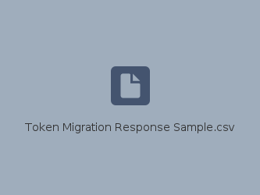

Master card input file format
Format each token record as per Mastercard input specification.
Format of input file to MC

    - Remove duplicate tokens, so that we don’t send same Moneris token multiple times.

    - File will have header and trailer.

    - Header: MONERIS_TOKEN, EXP_DATE_MM, EXP_DATE_YY

    - trailer : BU, SOURCE_ID, TRANSACTION_COUNT, TIMESTAMP.

      - Format of TRANSACTION_COUNT: 10-digit number with leading 0s.

      - Format of timestamp: YYYYMMDDHH24MISS

      - Below is the example of trailer:
BU=WL,SOURCE_ID=CSR, TRANSACTION_COUNT=0000001033,TIMESTAMP=20251212130151
Field Name | Format | Description
MONERIS_TOKEN | 16 digits starting with 9 | Moneris token
EXP_DATE_MM | MM | Expiration month of Moneris token. May be expired.
EXP_DATE_YY | YY | Expiration year of Moneris token. May be expired.
Compose header/trailer and counts.

Response file format to Billing systems
Response file format to Billing systems

    - The response file will be generated only for payment tokens file, not ID or transactional history.

    - In phase1 response file will be sent to WinOnline Media only

    - WinOnline Media should use response file to replace Moneris tokens with PMRs.

    - Below is the format for the response file to be sent to Billing systems:
Field Name | Format | Description
MONERIS_TOKEN | 16 digits, starting with 9 | Moneris token
EXP_DATE | MMYY | Expiration date of Moneris token. May be expired.
ENTITY_ID | Up to 36 alphanumeric characters:  - for Maestro: Maestro account number  - for V21 – BAN  - for WinOnline Media – GUID  - for SS – CAN  etc. | Entity (or account), to which payment method is linked,
ENTITY_REF_TYPE | 1 digit  ‘1’ – Account Number  ‘2’ - GUID | Account number or GUID. Same as in the input file
PMR | 16 digits, starting with ‘8’ | PMR will not have last 4 digits of the credit card
CARD_BRAND | 1 character  ‘V’ – Visa  ‘M’ – Mastercard  ‘A’ - Amex | Card brand
FIRST_SIX | 6 digits | First six digits of the credit card
LAST_FOUR | 4 digits | Last four digits of the credit card
FUNDING_METHOD | Enumeration:  CHARGE  CREDIT  DEBIT  UNKNOWN | Funding Method Type (i.e., Credit, Debit, Prepaid or other).  Do Billing systems need it? No direct need, but will be sent, and can be ignored by the app.

    - YD recommendation is to split response file from MC to records with success and failures. Failures file will not be sent to Billing systems.

    - Reference table or property file will be created to keep configuration if response file should be generated as part of bulk/delta migration for specific Billing System.

      - Fallout management will be described in the YD solution.
    - Migration file naming convention
      - Input file name from Billing systems will follow “Source_ID.Type.YYYYMMDD.NNNN.input” convention, where:
      - Source_ID: V21, WINM (for WinOnline Media), etc.
      - Type: P (payment tokens for future use), T (transactional history), I (ID).
      - YYYYMMDD: year, month, day
      - NNNN: File sequence no, starting from 0001
      - Output file name to Billing systems will follow “Source_ID.Type.YYYYMMDD.NNNN.output” convention
      - Each file will have file sequence number increased by 1.
      - Each sequence will have

3.6.2 PHUB Token Management Microservice

    - If token already exist in PHUB DB, do not invoke "PG Tokenization's createPgtoken service"
    - If token not found in PHUB DB, Invoke PG Tokenization's createPgtoken service through SSG and return response.
    - Update Payment Hub DB
      - PAYMENT_METHOD
      - TOKENIZED_CARD
      - ENTITY_DETAILS
      - ENTITY_PMR_MAPPING
      - PMR_MONERIS_MAPPING
      - TOKEN_ACTIVITY_LOG (if existing token attributes is changed)
    - If configured for debug, insert new record to : TOKEN_MIGRATION_AUDIT_LOG

3.7 CIP

3.7.1 Real time mapping Microservice

PG Dispatcher Microservice
Role:
PGDispatcher is the integration and orchestration layer between CIP and Mastercard. It wraps Mastercard’s real-time and batch tokenization APIs and exposes them as a consistent, PCI-compliant service to the rest of CIP services. It will reuse code from TNDispather.

    - Wrap four batch and one real-time Mastercard APIs behind a single logical service.
    - Expose simplified internal interfaces (e.g., createPgtoken, submitBatch, getBatchStatus, getBatchResult).
Mastercard needs validate batch API as well which will be invoked internally from getBatchStatus API.
Note: master card APIs takes <versionNum> (the version of Batch) as input. this will be configured in application configuration and will need testing and deployment to change to version.

      - createPgtoken
        - realtime API to take PAN details as input and return PG token.
        - Invoke mastercard online API to create token.
      - Submit Batch
        - Async API to submit a batch.
        - takes json/csv as input along with
          - <merchantId> is Merchant identifier
          - <batchName> is unique name for the batch
        - Taken from configuration
          - <versionNum>
        - The master card hosted batch upload allows maximum of 3MB. If the file exceeds the specified limit, ensure files are split into two or more parts, which must not exceed the specified limit, 3MB. Each batch can include up to 18,000 records.
NOTE: 60K Moneris tokens input pay load will reach 8 MB. This limit will be increased to 500 K in new version of master card hosted batch API. ETA is not finalized yet.
      - getBatchStatus
        - takes following as input
          - <merchantId> is Merchant identifier
          - <batchName> is unique name for the batch
        - Taken from configuration
          - <versionNum>
        - invokes get batch status API of mastercard
        - Possible statuses of a batch in mastercard
          - Uploading — the batch is in the process of being uploaded.
          - Uploaded — the batch is successfullly uploaded.
          - Ready — the batch is ready for processing.
          - Processing — the batch processing has commenced.
          - Complete — the batch processing is complete.
        - invokes validatebatch API of mastercard once batch status is "Uploaded"
      - getBatchResult
        - invokes get batch response API of mastercard
        - map result to PG domain (define details in DDD) and send in response.
    - Normalize Mastercard-specific payloads and response formats into RTMM domain objects (PGToken, batch job, batch status).
    - No retry logic will be present in this service

PG Tokenization Microservice
Reuse code of (TSI, BPS-SCHEDULER,CS-PROCCESS,BPS) to expose following APIs: through SSG
Expose following APIs to SSG similar to TSI APIs

  - createPgtoken
    - Invoke TNDispatcher (or TSI) to detokenize Moneris token
    - Invoke PGDispatcher to create mastercard token from PAN details retrieved from TNDispatcher
  - Submit Batch
    - Use BPS logic (Copy) to create multiple batches for moneris
    - generate unique pg batch id
    - if number of tokens are more than 500
      - return pg batch id
      - Reuse current configuration (5 threads, 500 tokens) to create batches and invoke TNDispatcher (or TSI) to detokenize Moneris token
      - wait for all batches to finish.
      - combine file to create one request for mastercard
    - else invoke TNDispatcher (or TSI) to detokenize Moneris token
      - Invoke PGDispatcher Submit Batch with unique pg batch id
      - return pg batch id
  - getBatchStatus
    - if Submit Batch was called and PGDispatcher is not invoked for input batch id return :"Pending"
    - Else : Invoke PGDispatcher getBatchStatus with batch id to get status
  - getBatchResult
    - Invoke PGDispatcher getBatchResult with batch id and return retrieved response

3.6 Infrastructure Design

3.6.1 Current State
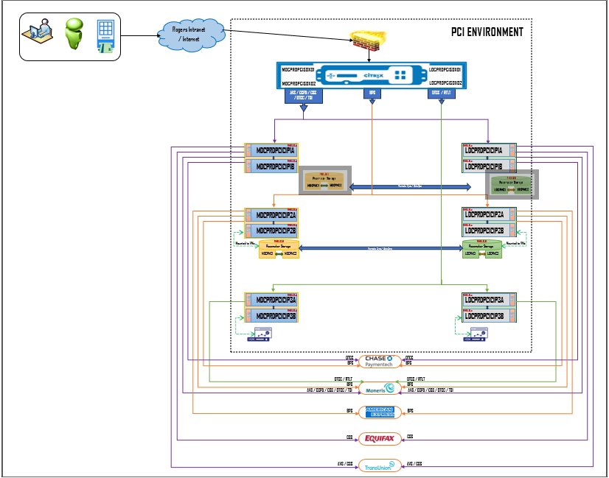
Currently, we donot have any connection from PCI infra to MasterCard

3.6.2 Future State

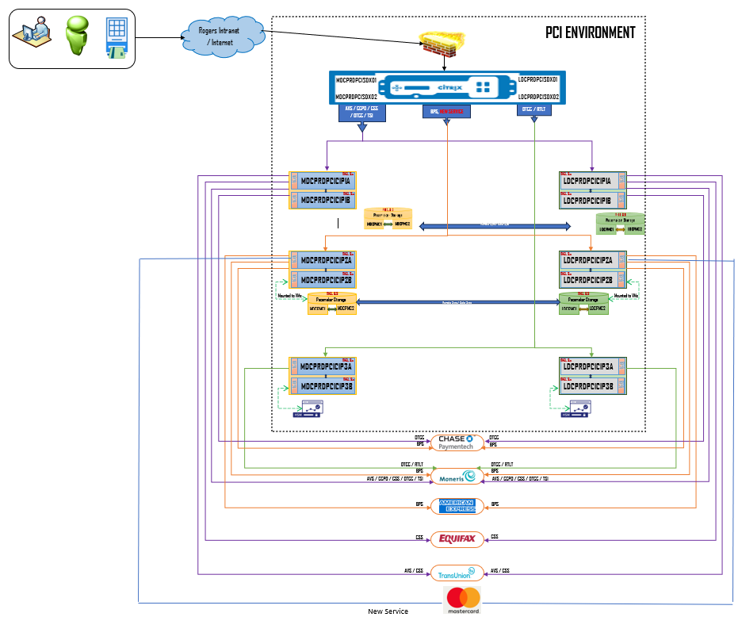

The new service will be created on Netscaler and GSLB will be configured.
The IP of the new service has to be published on Rogers DNS.
The new service will be hosted on an existing VM which hosts BPS service (MDCPEDPCICIP2A/2B and LDCPRDPCICIP2A/2B)
Connection to Master card DC will have to be established from PCI onprem datacenter.
Master Card IP address on PCI infra network components has to be whitelisted.

3.6.2.1 Migration microservice, phub-token-management-ms and RTMM infrastructure requirements
