

**MBARARA UNIVERSITY OF SCIENCE AND TECHNOLOGY**

**FACULTY OF COMPUTING AND INFORMATICS**

**DEPARTMENT OF COMPUTER SCIENCE**

**COURSE NAME: WEB DEVELOPEMENT**

**LECTURER: EGWAU TONNY**

**END OF SEMESTER**

**ACADEMIC YEAR: 2022/2023**

**SEMESTER: TWO**

**STUDENT NAME: NAGAWA PHIONAH**

**REG NO. :2021/BCS/075/PS**

**MUSIC NATION WEBSITE CLONE**

**PROJECT REPORT**

Table of Contents

DECLARATION 3

APPROVAL 4

DEDICATION 5

ACKNOWLEDGEMENT 6

**ABSTRACT** 7

**INTRODUCTION** 8

**FEATURES** 9

**SOFTWARE USED** 10

Windows 10 10

Visual studio code 10

Html 10

CSS 11

JavaScript 11

The 3 pages. 12

**CONCLUSION** 14

**FUTURE WORK** 15

# DECLARATION

I Nagawa Phionah, hereby certify that this report is my research work with my original additions to the existing Music Nation Website that I cloned.

Date: 28th August, 2023.

Signature: nagawa phionah

NAGAWA PHIONAH

2021/BCS/075/PS

# APPROVAL

The research work of this proposal will be conducted under my guidance and supervision

Signature: ………………………………

EGWAU TONNY

Date: …………………………………

# DEDICATION

I dedicate this project to my Beloved Guardians, Supportive Brother, Cherished Friends and Guiding lecturer for your constant presence, financial support and motivation into all my moves.

I also dedicate it to my boyfriend who inspired me to work on a music project due to his love of music. He is a musician and from wanting to be a supportive Partner, I decided to clone a music website hopping to one day create him one.

# 

# ACKNOWLEDGEMENT

Gratitude is given to God, the source of all knowledge and creativity, his unending grace has led actions, choices and ideas giving them direction and significance. May this suggestion serve as evidence of recognition of His kind assistance at each stage of this trip.

I am eternally grateful to my Guardians for their everlasting love, selflessness and faith in my ability to succeed. Their unwavering support and encouragement has always given me the strength to achieve my goals. Not forgetting their financial support especially towards paying tution in time.

I take this opportunity to acknowledge and appreciate my Web Development Lecturer, Mr. EGWAU TONNY. His guidance, tolerance and knowledge have been essential in determining the course of this project. His informative advice and kind criticism have improved my work and your confidence in my competence has motivated me to work harder.

I also acknowledge my classmates and friends. The relationships I have developed with my classmates via our common experiences and friends have been priceless. You have expanded my educational experience and shown the strength of group determination via cooperative efforts, spirited conversations, and mutual support.

Lastly, I thank all of my other lecturers, whose commitment to fostering my intellectual growth has been the cornerstone of my academic growth. My perspectives and understanding has been widened and enriched by your expertise, advice, and insights.

# **ABSTRACT**

Enter the colorful world of music as we take you on a melodious tour through the heart and soul of our country's musical terrain. Welcome to Music Nation, the premier location for discovering the various tunes that shape our cultural identity.

Music Nation is more than just a website, it is an invitation to explore the global diversity that reverberates through every note by allowing artists to upload their albums.

Explore in-depth accounts of well-known performers from the present who have made a lasting impact on music. Find undiscovered gems from up-and-coming musicians as they add fresh strands to the musical tapestry.

# **INTRODUCTION**

This website brings us into the center of a complex auditory tapestry in the always changing world of music, where innovation has no boundaries and genres mix freely. Welcome to the in-depth study, where we set off on an exciting adventure through the fascinating and ever-changing world of music. We explore the intricacies, trends, and cultural influences that determine the way we perceive sound, exploring the melodies as well as contemporary cutting-edge sounds.

This website is my revolutionary music hub, where artists become architects of their musical destinies. I believe that every artist deserves a stage to showcase their talent and this platform was designed to provide just that. Here, musicians of all genres and backgrounds can not only create accounts but also directly connect with their audience, transcend geographical limitations, and most importantly, share their stories through albums that resonate with authenticity.

Whether you're a seasoned performer looking to expand your digital presence or an emerging talent eager to make your mark, this platform is your canvas. It's a space where musical visions transform into realities, where melodies find their way into hearts, and where artistic evolution is nurtured with the support of a dynamic community.

Join me as we unveil the stories behind the songs, the artists behind the anthems, and the rhythms that resonate across continents.

# **FEATURES**

* Login
* Log out
* Sign up
* Home page
* About us
* Download music
* Play music
* Play back speed
* Add album
* Choose file
* Save

# **SOFTWARE USED**

## Windows 10

Microsoft's Windows 10 is the operating system that replaces Windows 8 and Windows 8.1, which were released in 2012 and 2013, respectively. In July 2015, Windows 10—then under development under the codename "Threshold"—was made available to everyone. Microsoft is seeking to standardize several operating systems for various devices, such as computers, phones, and video game consoles, by using Windows 10. Windows 10 may be downloaded for free by users of Windows 7 or Windows 8, while individual licenses cost between Ti100 and Ti200.The start menu is back in Windows 10, along with new icons, interface enhancements, and biometric security capabilities. Edge, a new browser included with Windows 10, replaces the venerable Internet Explorer. The addition of Cortana, a virtual assistant similar to Apple's, is another new feature.

## Visual studio code

For Windows, Linux, and MacOS, Microsoft offers the free source code editor Visual Studio Code. features include code snippets, code rewriting, embedded git, syntax highlighting, and intelligent code completion. Users have the option to modify their preferences, keyboard shortcuts, theme, and extension settings to add new features. With 50.7% of 87,317 developers responding to the stack overflow 2019 developer survey saying they use it, visual studio code was rated as the most popular developer environment tool. At the 2015 build conference on April 29, Microsoft made the first announcement of Visual Studio Code.

## Html

Hyper Text Markup Language is what HTML stands for. Utilizing markup language, it is used to create web pages. Markup language and hypertext are combined to create HTML. The links between the pages are known as hypertext. The text document inside the tag that specifies the structure of webpages is defined using a markup language. Text is annotated using this language so that computers can comprehend it and adjust the text as necessary. The language employs tags to specify what text processing is required. The browser manipulates text, graphics, and other content using the markup language html in order to display it in the desired format. Tim Bernes-Lee invented html in 1991. HTML 1.0 was the first version, but the

## CSS

Cascading Style Sheet, fondly referred to as CSS, is simply designed language intended to simplify the process of making web pages presentable.CSS allows you to apply styles to web pages. More importantly CSS enables you to do this independent of the HTML that makes up the web pages.it describes how a web page should look: It prescribes colors, fonts, spacing and much more. In short you can make your website look however you want.CSS lets developers and designers define how it behaves, including how elements are positioned in the browser.

## JavaScript

JavaScript is a lightweight, cross-platform, and interpreted compiled programming language which is also known as the scripting language for webpages. It is well known for the development of web pages, many non-browser environments also use it. JavaScript can be used for client side development as well as for server-side developments. JavaScript is both imperative and declarative type of language. JavaScript contains a standard library of objects like Array, date, Math, and core set language elements like operators, control structures, and statements.

# **THE PAGES**

The Home page

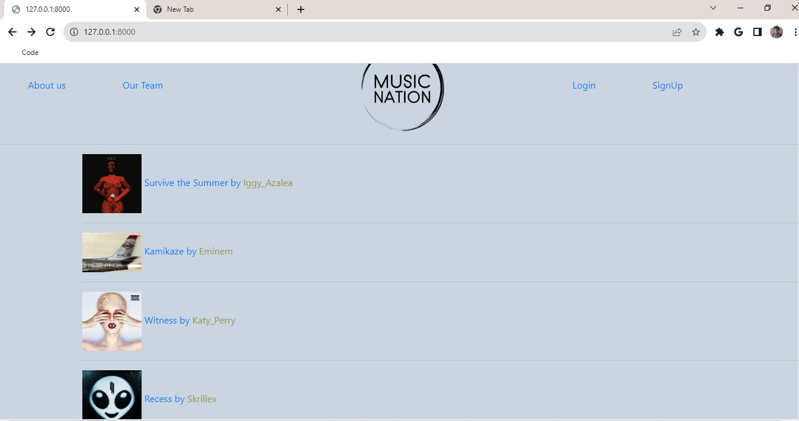

The Sign up page

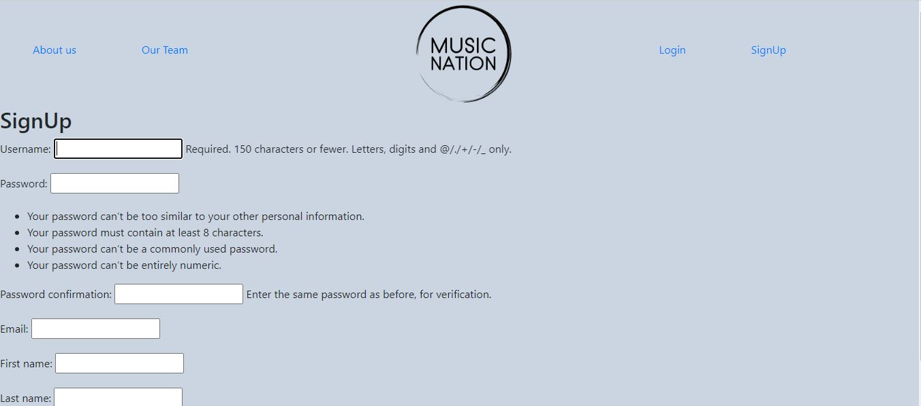

The add a new album page

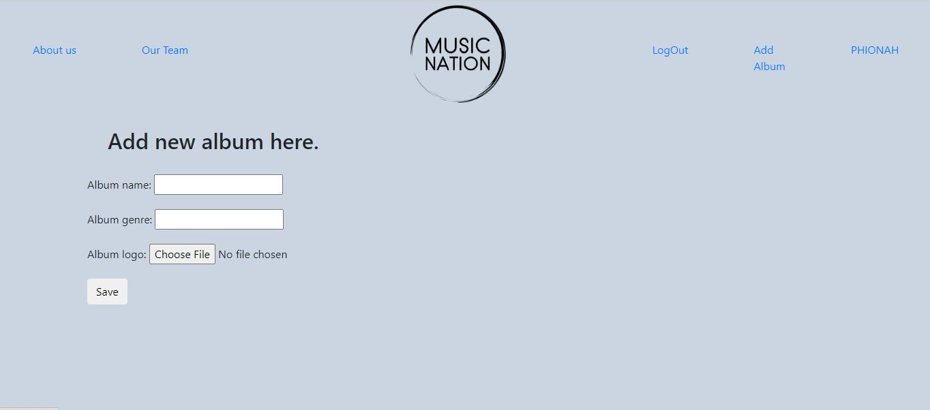

The admin page

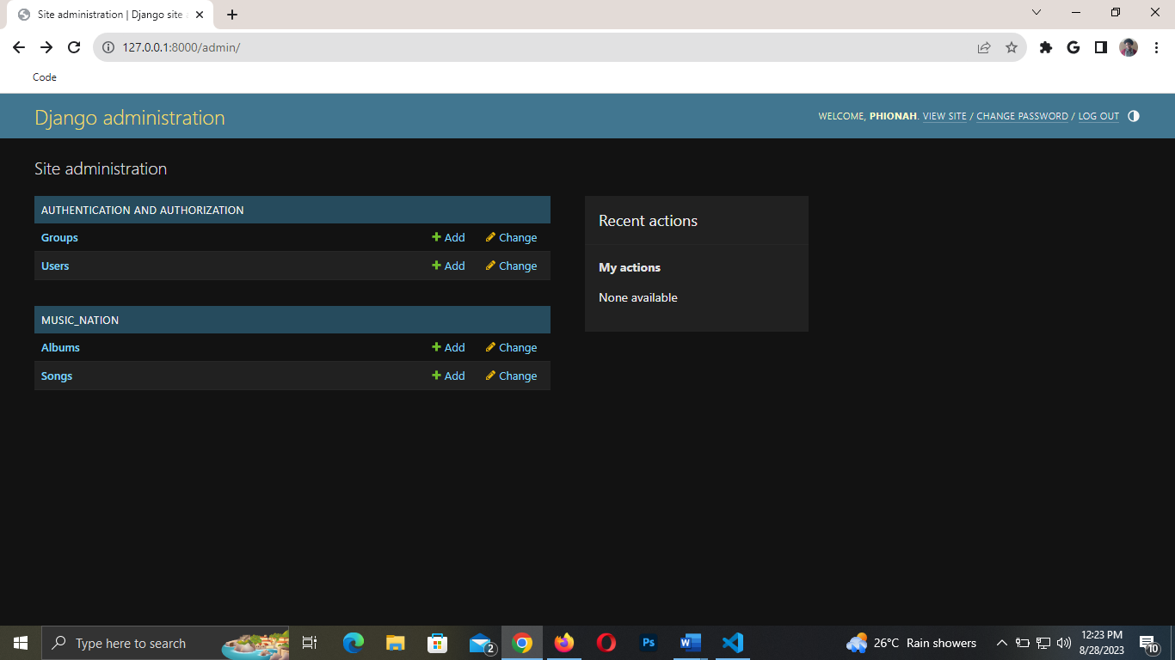

# **code**

The CSS

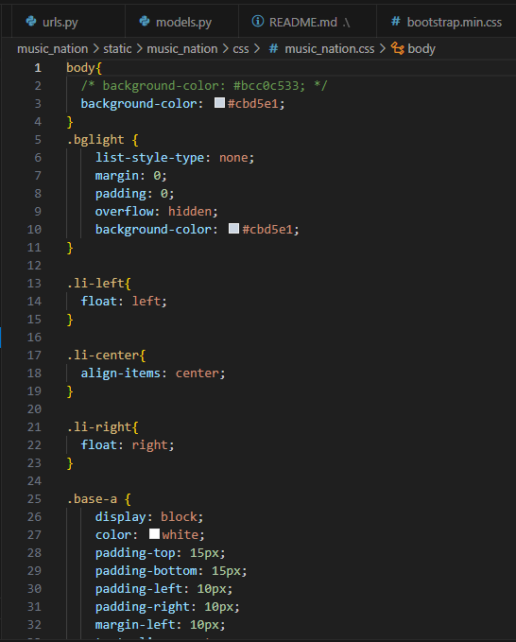

# **CONCLUSION**

In closing, this music website project stands as a testament to the power of innovation and collaboration within the realm of music. As you've journeyed through the pages of this report, you've unveiled the potential of a platform that doesn't just host music but orchestrates an entire symphony of opportunities for artists around the world.

From empowering artists to create their accounts and showcase their albums to providing a space for genuine connections and interactions, this platform represents a harmonious fusion of technology and creativity. As I conclude this report, I am not just marking the end of a document, I am heralding the beginning of a new era for musicians everywhere.

# **FUTURE WORK**

**1. Artist Verification and Approval:**

Develop an admin-controlled artist verification process to ensure that only genuine and deserving artists can create accounts.

Implement a comprehensive review mechanism to assess the authenticity and quality of artist profiles.

**2. Admin Dashboard Enhancements:**

Build a robust admin dashboard that provides real-time insights into artist applications, profiles, and activities.

Enable personalized communication channels between admin and artists for smoother interactions.

**3. Subscription Model and Fee Structure:**

Design a tiered subscription model that offers varying levels of features and benefits for artists.

Introduce a one-time account creation fee or recurring subscription fee to support platform maintenance and growth.

**4. Payment Gateway Integration:**

Partner with reliable payment gateways to facilitate secure and seamless payment transactions.

Implement features that allow artists to track their subscription status and payment history.

**5. Premium Features for Subscribers:**

Offer premium features to subscribing artists, such as enhanced profile customization, priority listing, and advanced analytics.

**6. Quality Control Measures:**

Implement content moderation tools to ensure that uploaded albums adhere to quality standards and guidelines.

Introduce a reporting mechanism that allows users to flag inappropriate content for admin review.

**7. Artist Showcase Opportunities:**

Collaborate with industry events, festivals, and music professionals to provide platform artists with opportunities for exposure.

Design exclusive showcases for subscribing artists to present their work to a wider audience.

**8. Educational Resources:**

Develop educational resources, webinars, and guides to help artists maximize the platform's potential for their careers.

Offer workshops on music promotion, copyright protection, and monetization strategies.

**9. User Feedback Loop:**

Establish a feedback channel for users to provide suggestions and insights on the platform's functionality and features.

Regularly incorporate user feedback into updates and improvements.

**10. Expansion and Outreach:**

Expand the platform's reach by targeting specific genres, regions, and artist demographics.

Foster partnerships with music institutions and organizations to amplify outreach efforts.

**11. Data Privacy and Compliance:**

Strengthen data privacy measures and ensure compliance with relevant regulations to safeguard user information.

**12. Continuous Iteration:**

Continuously update and iterate the platform based on user behavior, industry trends, and technological advancements.