Teamwork V (GitLab, Branch and Build)
Team 7
- Xubin Dong – Student Number: e2301515
- Dat Phi – Student Number: e2401782

Hotel Booking System – Web App

GitLab : https://gitlab.com/devops2402639/hotel-room-reservation

Programming Languages:
- Frontend: Next.js
- Backend: Java + Springboot
- Database: MySQL

Feature List

Normal Requirements (Must Have)
These are the essential features that must be implemented for the system to function.
- User Registration Form
  - Guests can register by entering their name, contact information, and ID/passport number.
- Room Booking
  - Users can select room type (single, double, suite), check-in, and check-out dates.
- Basic Input Validation
  - Required fields (name, date, room type) cannot be left empty.
- Store Booking Data
  - Save booking details in a database (MySQL) using Spring Data JPA.
- View Registered Guests / Bookings
  - Staff can view all current bookings in a list or table format.

Expected Requirements (Should Have)

These features improve usability and make the system more complete.
6. Search Functionality
- Staff can search bookings by guest name, date, or room number.
- Update / Cancel Booking
  - Staff can edit or cancel an existing reservation.
- Room Availability Check
  - The system prevents double-booking by checking if a room is available for selected dates.
- Staff Login System
  - Only authorized users (hotel staff) can manage bookings.
- Better UI
- Use Thymeleaf templates, CSS, or Bootstrap for a clean, user-friendly interface.

Exciting Requirements (Nice to Have)
These are advanced or optional features that make the system more professional.
11. Email Confirmation
- Send automatic confirmation emails to guests after successful booking.
- Data Export
- Export the list of guests/bookings to a CSV or Excel file.
- Analytics Dashboard
- Display statistics such as total bookings, occupancy rate, and revenue charts.
- Online Payment Simulation
- Integrate a simple payment API or simulate credit card payment.
- Multi-language Support
- Provide the interface in English and another language (e.g., Chinese or Finnish).

Make a plan for the iteration and divide the coding work among team members and start implementing features.
We make the plan in GitLab and divide the work through Issue boards in GitLab. In the board we can allocate the time and description needed for the task:
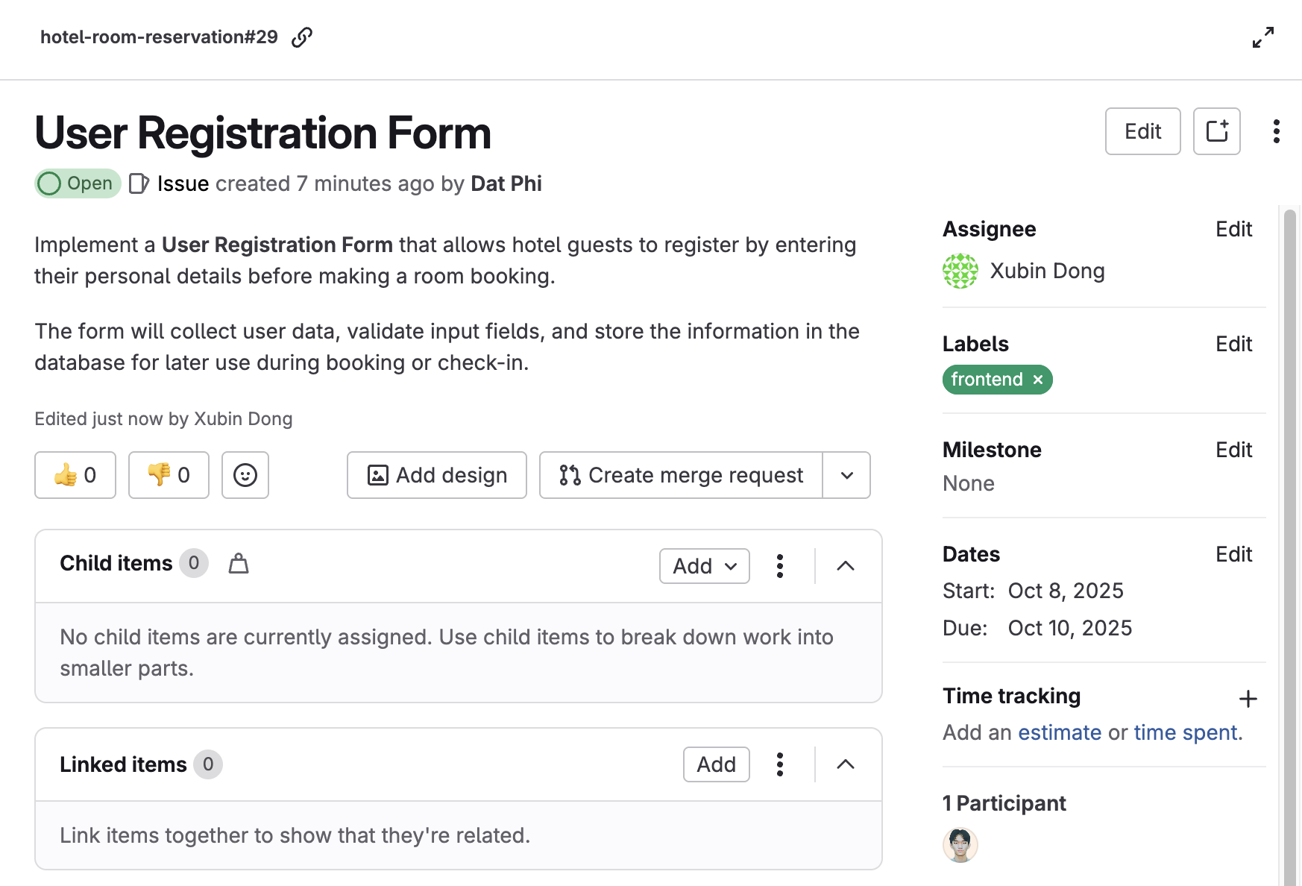
Do this by creating a branch of the main GitLab repository and modifying it by adding own implementation to the branch and committing it to the GitLab repository at the end.
We use the built-in feature Create branch in GitLab and start the implementation in that branch:
