Developer Manual



Total Cost of Ownership
Developer Manual for the TCO-Tool

Allgemeine Hinweise:

- Dieses Dokument enthält ”verborgener Text” als Hinweis zur Erstellung des Dokuments und als Erläuterungen zu den einzelnen Kapiteln. Es kann Probleme geben, wenn der verborgene Text bei Manipulationen nicht richtig berücksichtigt wird. Abhilfe: Verborgener Text löschen oder immer anzeigen
- Aktualisieren des Inhaltsverzeichnisses und der Kopf- und Fusszeilen sowie Numerierung der Abbildungen und Tabellen:
Verborgener Text ausblenden, in der Normalansicht das ganze Dokument markieren (Menü "Bearbeiten", Befehl "Alles markieren"), und F9-Taste drücken.
- Textmarken: Falls Sie alle Zeichen im gekennzeichneten Textmarkenblock ersetzen oder eine gekennzeichnete Stelle löschen, wird die betreffende Textmarke gelöscht. War dies nicht beabsichtigt, wählen Sie umgehend den Befehl "Rückgängig" aus dem Menü "Bearbeiten".

Vorgehen zum Erstellen einer DOK-Vorlage bzw. eines Dokuments:

- Datei öffnen
- speichern unter ........
- Datei-Info (Eigenschaften/properties) ausfüllen
- Einfügen Text bzw. ein ganzes Kapitel - aber nur, wenn verborgener Text angezeigt wird!
- Nach erfolgtem Einfügen Kopf- und Fusszeilen überprüfen bzw. ev. anpassen (in Normalansicht):
Die Kopfzeilen mit F9 aktualisieren und
die Fusszeilen im neuen Abschnitt mit ”Wie vorherige” aus dem vorangehenden Abschnitt übernehmen.
- Ev. Ergänzungen anbringen; Seitenumbrüche kontrollieren, Unerwünschtes entfernen.
- Zuletzt - verborgener Text ausblenden, in Normalansicht alles markieren und mit F9 Inhaltsverzeichnisse erstellen

Version 1.5.0

Document Info

Filename: 0000.doc

Responsible: Peter Hirzel (info@softenvironment.ch)
Classification: none

Change history
Date | Version | Status | Company | Author | Remarks
2005-12-22 | 1.4.1 | In Development | softEnvironment | Peter Hirzel | Extraction of Chapter 6 of User-Manual and Translation to english.
2006-02-18 | 1.4.2 | In Development | softEnvironment | Peter Hirzel | Design Diagrams actualized
2007-06-19 | 1.4.4 | Release | softEnvironment | Peter Hirzel | Adaption to Release V1.4.4
 | 1.5.0

Contents
1. Preface 4
1.1 Origin of Project 4
1.2 Goals of this Document 4
2. System- Architecture 5
3. Design-Goals 6
3.1 Framework structure 6
3.2 Static Data-Model of persistent classes 6
3.2.1 Model of a TCO-Tree 7
3.2.2 Presentation data 8
3.3 Profile-File 8
3.4 Saving of TCO-Configurations 9
3.4.1 XSD-Schema 9
3.4.2 XML-Instance 10
3.4.2.1 Main-Structure 10
3.4.2.1.1 Code-Entries – „upper part (1)“ 10
3.4.2.1.2 Configuration-Tree – “lower part (2)” 10
3.5 XSLT-Templates 11
3.5.1 Tree-Representation in HTML 12
3.6 Java/XML mapping 17
3.7 Plugin-Mechanism 17
4. Extend TCO-Tool yourself 17
4.1 Integration into eclipse 17
4.2 Builiding with apache ant 18
Appendix: Questions 19

Preface
For further References about this project, see:
- http://www.tcotool.org
- http://sourceforge.net/projects/tcotool

Origin of Project
The TCO-Tool results from an Open-Source Project by Swiss Government Informatikstrategieorgan Bund.



The Project is developed continuously by:


Goals of this Document
Provide:
- Administrator Info
- Technical Background
- Developer Info
Knappe Formulierung der erwarteten (Haupt-)Ergebnisse.

System- Architecture
The TCO-Tool comes as Standalone-Application. It is completely developed in Java (currently V1.4.2_* is tested).

All Software used within this Project is free and open source.

Remark:
- The Design is open and it will be easily possible to change the Architecture for e.g. to replace the XML-persistence mapping by a Client/Server DBMS.

Design-Goals

Framework structure
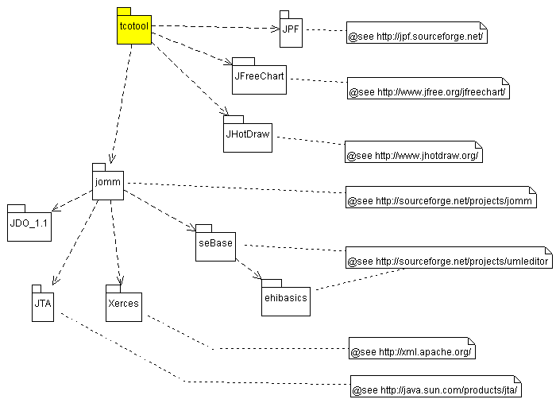
Package dependencies between involved frameworks (UML package diagram)

Static Data-Model of persistent classes
Design of persistent model classes mapped within a TCO-configuration (XML-instance) file.
Remark:
- The complete Data-Model ”TCO-model.uml” can be downloaded from http://cvs.sourceforge.net/viewcvs.py/tcotool/TCO-Tool/model/. It is to be opened by the Open Source UML/INTERLIS-Editor (http://www.umleditor.org).

Model of a TCO-Tree
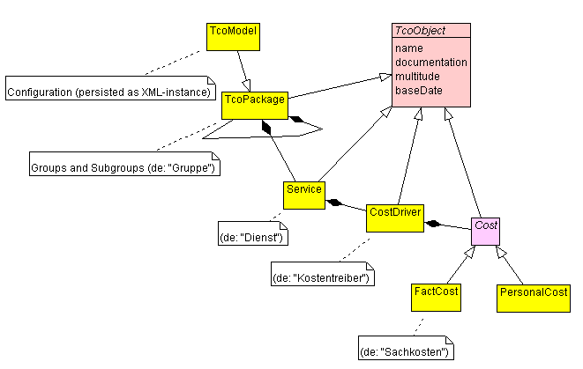
Short Overview of most important model classes (UML Class-Diagram)
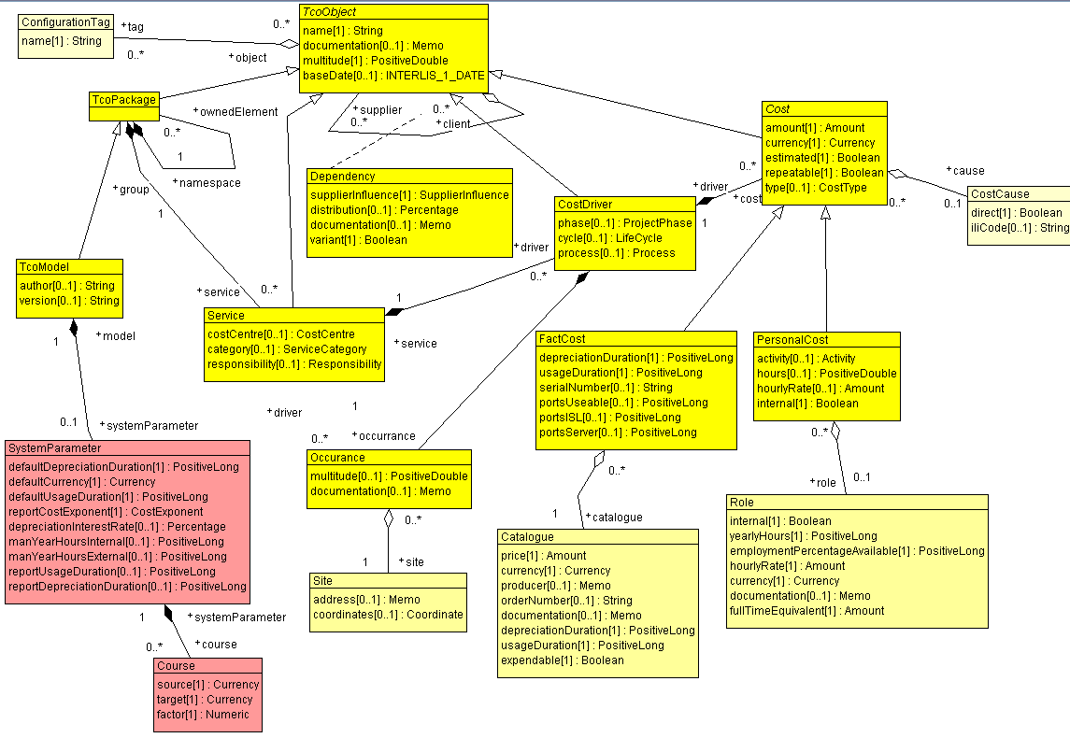
Complete Overview of all persistent classes (UML class diagram)

Presentation data
Currently the position of nodes in a dependency graph (if at least displayed once) is saved in another basket.
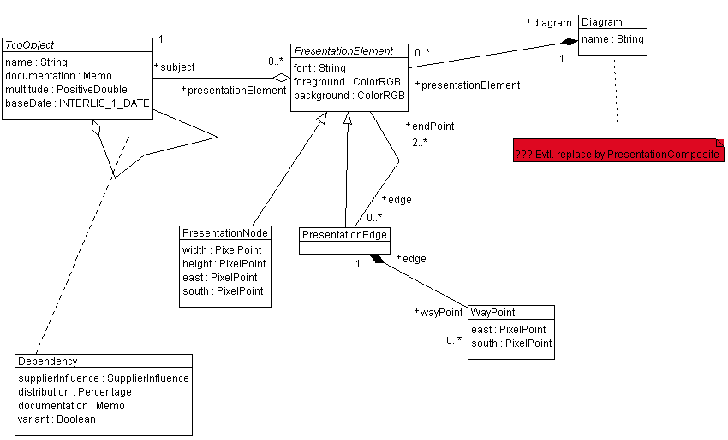
Presentation data (UML class diagram)

Profile-File
After each save of a configuration by the TCO-Tool a Profil- file will be created/updated in your <HOME> Directory, which is a simple ASCII-properties file (INI) containing some infos about Look & Feel and the like. No model data of your configuration is contained here.
HOME-Directory means:
Windows: HOME (environment variable System)
Linux: $HOME (dito)
Java: System.getProperty("user.home");

Contents of the file, might look like this:
<HOME>\.TCO_Tool
#TCO-Tool User Properties
#Wed Nov 17 13:42:00 GMT+01:00 2004
IMPORT_DIRECTORY=C\:\\Documents\ and\ Settings\\phirzel
WINDOW_Y=10
SHOW_STATUS_BAR=true
WINDOW_X=10
SHOW_TOOLBAR=true
WINDOW_WIDTH=850
LAST_FILES=D\:\\MyHome\\TestConf.xml;D\:\\MyHome\\TCO-Client.xml;
FOREGROUND_COLOR=-16777216
WORKING_DIRECTORY=D\:\\phirzel\\Development\\SourceLibrary\\Java\\TCO_Tool\\version\\V0.9.0
FONT=Monospaced-BOLD-9
COUNTRY=CH
LANGUAGE=de
LOOK_AND_FEEL=com.sun.java.swing.plaf.windows.WindowsLookAndFeel
BACKGROUND_COLOR=-1
WINDOW_HEIGHT=570

Saving of TCO-Configurations
TCO-Configurations are currently saved as XML-instances (for e.g. “MyTCO.xml”). They contain your System to be calculated by the TCO-Tool and therefore the mappings of your model (see chapter 3.2).
The advantage of XML-Format is its plattform-independency (as Java as well) and is therefore a good choice to exchange data. Rules for the internal structure are defined by an XSD-Schema, which makes reuse of the XML-instance portable for other tools (for e.g XSLT).

XSD-Schema
The XSD-Schema defines the structure within the XML-file (containing your TCO configuration data).
It makes it clear, how a TCO-Configuration must be saved or loaded from to/from an XML-instance and maps the static data model (see chapter 3.2).
The specific TcoTool.xsd schema is based on INTERLIS 2 standards and rules (see also Reference manuals in http://www.interlis.ch/). The <DATASECTION> contains two Ili-Basket’s:
- Basket „tcotool.model“ contains model objects like Groups, Services, Costdriver etc (see 3.2.1)
- Upper part (1): All multi-language codes of a configuration (s. chapter 3.4.2.1.1).
- Lower part (2): The TCO-tree (s. chapter 3.4.2.1.2).
- Basket „tcotool.presentation“ contains optional coordinates about Groups and Services of your dependency diagram. This Basket depends on Basket „tcotool.model“.
Technical fields (according to INTERLIS 2 Reference manual) keep the necessary consistency constraints within an XML-instance:
- Attribute TID=“<value>“ => Technical ID (Primary Key) of an element (UNIQUE within an XML-file).
- Attribute REF=“<value>“ => Technical Reference (Foreign Key) to a TID of referenced element.
- TODO: Code, NLS-translations, etc
Remarks:
- The XSD-Schema can be generated by UML-Editor after loading TCO-Model.uml by menu Extras->INTERLIS->Export.
- The „TcoTool.xsd“ schema (ASCII-file) can be validated by an XML-Validator (for e.g. http://www.w3.org/) against a saved TCO-configuration in an XML-File (for e.g. „MyIT.xml“).
- TODO: Tag’s <CODE> und <softenvironment.nls> are not considered in XSD yet.

XML-Instance
An XML-Instance is a real XML-file (e.g.. „MyIT.xml“) containing data.
TODO (FUTURE USE): correct Validation against TcoTool.xsd

Main-Structure
The XML-file is structured according to the XSD-Schema (see chapter 3.4.1):

Code-Entries – „upper part (1)“
This is a sample extract for a code entry of type CostCentre), where a Translation of NLS-value is given first and then the Code itself with a reference to its translation:

<CODE TYPE="tcotool.model.CostCentre">
<tcotool.model.CostCentre TID="x11003">
<name>
<softEnvironment.Nls>
<translation>
<softEnvironment.Translation>
<language>de</language>
<nlsText>Infrastruktur</nlsText>
</softEnvironment.Translation>
</translation>
</softEnvironment.Nls>
</name>
</tcotool.model.CostCentre>
<tcotool.model.CostCentre TID="x11001">
:
</tcotool.model.CostCentre>
</CODE>

Configuration-Tree – “lower part (2)”
XML-code sample extract for Group and Service entries:
<!-- 2) Model-Tree -->
<tcotool.model.TcoPackage TID="x1000002">
<namespace REF="x1000049"/>
<name>Backoffice Services</name>
<multitude>1.0</multitude>
<documentation>S&#228;mtliche Zahlen sind willk&#252;rlich und haben keine Berechtigung auf Echtheit in bezug auf reale Konfigurationen.</documentation>
<ownedElement REF="x1000008"/>
<ownedElement REF="x1000009"/>
</tcotool.model.TcoPackage>
…
<tcotool.model.Service TID="x1000021">
<group REF="x1000003"/>
<name>Grossraumb&#252;ro</name>
<multitude>1.0</multitude>
<driver REF="x1000022"/>
</tcotool.model.Service>
…
<!-- 3) THE Root-Element of Model-Tree (at last!) -->
<tcotool.model.TcoModel TID="x1000049">
<version>V1.0.2</version>
<systemParameter REF="x1000052"/>
<author>Peter Hirzel (softEnvironment)</author>
<name>TCO-Client (Bsp).xml</name>
<multitude>1.0</multitude>
<documentation>S&#228;mtliche Zahlen sind willk&#252;rlich und haben keine Berechtigung auf Echtheit in bezug auf reale Konfigurationen.</documentation>
<baseDate>2004-12-14</baseDate>
<ownedElement REF="x1000001"/>
<ownedElement REF="x1000002"/>
<ownedElement REF="x1000003"/>
<ownedElement REF="x1000004"/>
</tcotool.model.TcoModel>

XSLT-Templates
All XML-instances (see chapter 3.4.2) can be transformed by XSLT into other formats of your desire for e.g. by:
- Adding an XSL-stylesheet to your XML-instance (TODO: Namespace incorrect => remove for XSLT-Transformation):
<?xml version="1.0" encoding="UTF-8"?>
<?xml-stylesheet type="text/xsl" href="http://www.tcotool.org/XSLT/TCOModel_Tree.xsl"?>
<TRANSFER xmlns="http://www.interlis.ch/INTERLIS2.2" xmlns:xsi="http://www.w3.org/2001/XMLSchema-instance" xsi:schemaLocation="http://www.interlis.ch/INTERLIS2.2 TcoTool.xsd">
<HEADERSECTION VERSION="2.2" SENDER="www.tcotool.org (V1.4.0)">
<ALIAS/>
</HEADERSECTION>
<DATASECTION>
<!-- UNIQUE-ID of contained Object's is maintained by: TID -->
<!-- => Please allocate new TID's above MAX-TID in File -->
<tcotool.model BID="x1000138">
<!-- Basket of Configuration-Objects of org.tcotool.model.* -->
<!-- 1) Codes (global declaration => will be referenced in Model-Tree (see further below) -->
<CODE …
…
</TRANSFER>

Tree-Representation in HTML
An XSLT sample to transform from XML to HTML can be found in http://www.tcotool.org/XSLT/TCOModel_Tree.xsl.
Representation after transformation:
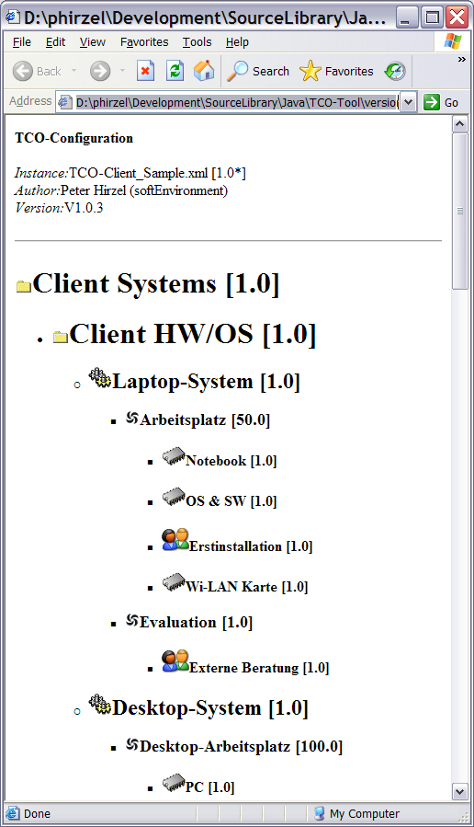
Code-sample for the necessary XSLT-Templates:
<?xml version="1.0" encoding="ISO-8859-1"?>
<!--xsl:stylesheet version="1.0"
xmlns:xsl="http://www.interlis.ch/INTERLIS2.2"-->
<xsl:stylesheet version="1.0"
xmlns:xsl="http://www.w3.org/1999/XSL/Transform">

<!-- elements not structured as tree-nodes in XML-instance, instead children are linked by REF=>TID -->
<xsl:template match="/TRANSFER/DATASECTION/tcotool.model"><!-- main() -->
<html>
<body>
<b>TCO-Configuration</b>
<xsl:apply-templates select="tcotool.model.TcoModel"/>
</body>
</html>
</xsl:template>

<xsl:template match="tcotool.model.TcoModel"><!-- root node -->
<p>
<i>Instance:</i> <xsl:value-of select="name"/> [<xsl:value-of select="multitude"/>*]<br/>
<i>Author:</i> <xsl:value-of select="author"/><br/>
<i>Version:</i> <xsl:value-of select="version"/>
</p>

<!-- see also in template "group" -->
<xsl:for-each select="ownedElement">
<hr/>
<xsl:call-template name="showGroup">
<xsl:with-param name="reference" select="@REF"/>
<!--xsl:with-param name="level" select="1"/-->
</xsl:call-template>
</xsl:for-each>
</xsl:template>

<xsl:template name="showGroup" match="/TRANSFER/DATASECTION/tcotool.model/tcotool.model.TcoPackage">
<xsl:param name="reference" />
<!--xsl:param name="level" /-->
<xsl:for-each select="/TRANSFER/DATASECTION/tcotool.model/tcotool.model.TcoPackage">
<xsl:if test="@TID=$reference" >
<!-- 1) show this group details -->
<h1>
<img alt="" src="http://www.tcotool.org/XSLT/images/TcoPackage.png"/>
<a name="{@TID}"/><!-- set anchor -->
<xsl:value-of select="name"/> [<xsl:value-of select="multitude"/>]
</h1>
<!-- 2) show sub groups (see also in template "TcoModel") -->
<ul>
<xsl:for-each select="ownedElement">
<li>
<xsl:call-template name="showGroup"><!-- recursive sub-groups -->
<xsl:with-param name="reference" select="@REF"/>
<!--xsl:with-param name="level" select="$level+1"/-->
</xsl:call-template>
</li>
</xsl:for-each>

<!-- 3) show owned services -->
<xsl:for-each select="service">
<li>
<xsl:call-template name="showService">
<xsl:with-param name="reference" select="@REF"/>
</xsl:call-template>
</li>
</xsl:for-each>
</ul>
</xsl:if>
</xsl:for-each>
</xsl:template>

<xsl:template name="showService" match="/TRANSFER/DATASECTION/tcotool.model/tcotool.model.Service">
<xsl:param name="reference" />
<xsl:for-each select="/TRANSFER/DATASECTION/tcotool.model/tcotool.model.Service">
<xsl:if test="@TID=$reference" >
<!-- 1) show this Service -->
<h2>
<img alt="" src="http://www.tcotool.org/XSLT/images/Service.png"/>
<a name="{@TID}"/>
<xsl:value-of select="name"/> [<xsl:value-of select="multitude"/>]
</h2>
<!-- show its 1:n CostDriver's -->
<ul>
<xsl:for-each select="driver">
<li>
<xsl:call-template name="showCostDriver">
<xsl:with-param name="reference" select="@REF"/>
</xsl:call-template>
</li>
</xsl:for-each>
</ul>
</xsl:if>
</xsl:for-each>
</xsl:template>

<xsl:template name="showCostDriver" match="/TRANSFER/DATASECTION/tcotool.model/tcotool.model.CostDriver">
<xsl:param name="reference" />
<xsl:for-each select="/TRANSFER/DATASECTION/tcotool.model/tcotool.model.CostDriver">
<xsl:if test="@TID=$reference" >
<!-- 1) show this CostDriver -->
<h3>
<img alt="" src="http://www.tcotool.org/XSLT/images/CostDriver.png"/>
<a name="{@TID}"/>
<xsl:value-of select="name"/> [<xsl:value-of select="multitude"/>]
</h3>
<!-- show its 1:n Cost's -->
<ul>
<xsl:for-each select="cost">
<li>
<xsl:call-template name="showPersonalCost">
<xsl:with-param name="reference" select="@REF"/>
</xsl:call-template>
<xsl:call-template name="showFactCost">
<xsl:with-param name="reference" select="@REF"/>
</xsl:call-template>
</li>
</xsl:for-each>
</ul>
</xsl:if>
</xsl:for-each>
</xsl:template>

<xsl:template name="showPersonalCost" match="/TRANSFER/DATASECTION/tcotool.model/tcotool.model.PersonalCost">
<xsl:param name="reference" />
<xsl:for-each select="/TRANSFER/DATASECTION/tcotool.model/tcotool.model.PersonalCost">
<xsl:if test="@TID=$reference" >
<h4>
<img alt="" src="http://www.tcotool.org/XSLT/images/PersonalCost.png"/>
<a name="{@TID}"/>
<xsl:value-of select="name"/> [<xsl:value-of select="multitude"/>]
</h4>
</xsl:if>
</xsl:for-each>
</xsl:template>

<xsl:template name="showFactCost" match="/TRANSFER/DATASECTION/tcotool.model/tcotool.model.FactCost">
<xsl:param name="reference" />
<xsl:for-each select="/TRANSFER/DATASECTION/tcotool.model/tcotool.model.FactCost">
<xsl:if test="@TID=$reference" >
<h4>
<img alt="" src="http://www.tcotool.org/XSLT/images/FactCost.png"/>
<a name="{@TID}"/>
<xsl:value-of select="name"/> [<xsl:value-of select="multitude"/>]
</h4>
</xsl:if>
</xsl:for-each>
</xsl:template>

</xsl:stylesheet>

Java/XML mapping
Mapping between TCO-Tool (Java) to XML-Instances and vice versa is done by the Open-source framework JOMM (s. http://sourceforge.net/projects/jomm).

Plugin-Mechanism
The TCO-Tool implements a Plugin-Mechanism to extend it by commercial or open source Plugins by anyone. The Java Plugin Framework (s. http://jpf.sourceforge.net/) is used for that task.
The file plugins\org.tcotool.core.runtime\plugin.xml defines the base Manifest to create individual (extension-points).
Remarks:
- TODO: This Manifest will be enhanced soon to allow more Plugin-Features.

Extend TCO-Tool yourself
Useful in case you feel like to build the TCO-Tool by yourself from source archive…

Integration into eclipse
Suggestion to organize the relevant sub-projects and libraries, where the marked LauncherView class represents the #main() program entry point:
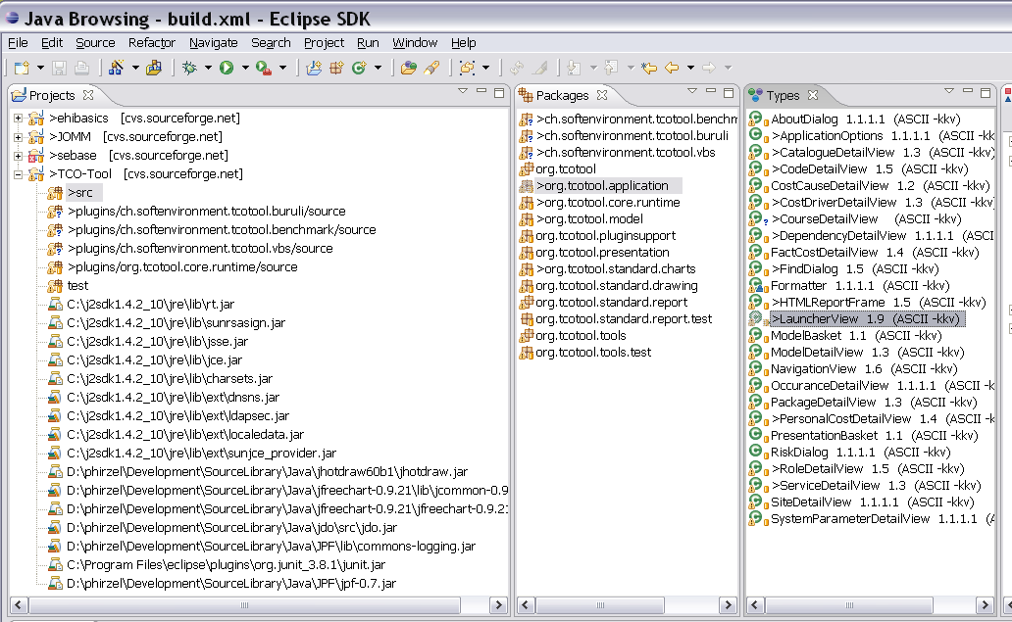
eclipse Project organization (Screenshot)
Remark:
- You can either download the necessary libraries yourself as mentioned in 3.1 by Framework-references or use them out the binary distribution (TCO-Tool.jar).

Builiding with apache ant
A build.xml sample is contained in the source-archive, which corresponds to the eclipse project organization.
The target corePlugin should build the TCO-Tool.jar with the Plugin-Manifest.

Appendix: Questions
Please use forum at http://sourceforge.net/projects/tcotool
Auflagen zur Darstellung der Ergebnisse.

See http://www.umleditor.org

