Titel: TCO-Tool Setup (Bindestrich statt Underscore, auch bei den folgenden Bezeichnungen bitte

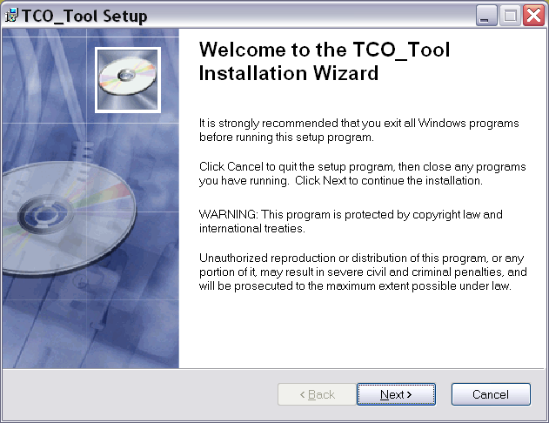
Welcome to the TCO-Tool Installation Wizard

- + 2. Absatz => ok
- + 4. Absatz => löschen: Statt dessen folgenden Text, falls es Platz hat:
This library is free software; you can redistribute it and/or modify it under the terms of the GNU Lesser General Public License as published by the Free Software Foundation; either version 2.1 of the License, or (at your option) any later version.

This library is distributed in the hope that it will be useful, but WITHOUT ANY WARRANTY; without even the implied warranty of MERCHANTABILITY or FITNESS FOR A PARTICULAR PURPOSE. See the GNU Lesser General Public License for more details.

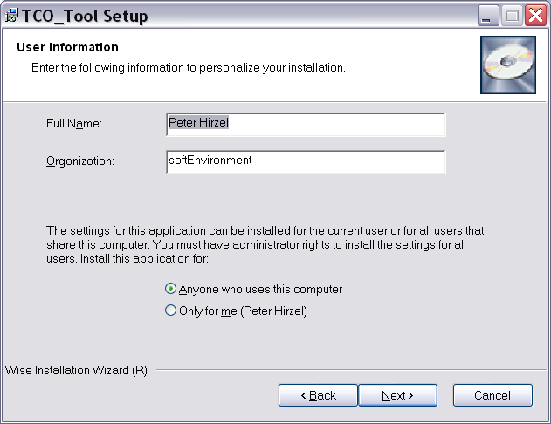

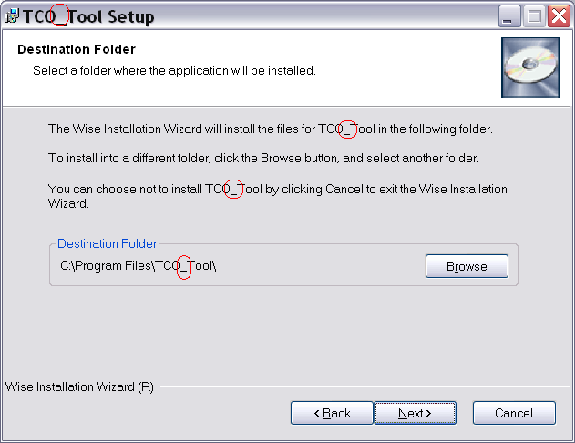

Bitte auch per default einen Desktop und Menu Link vorschlagen.

