User Manual



Total Cost of Ownership
A short introduction about using the TCO-Tool to calculate any System-Environment costs.

Version 1.5.0

Document Info

Filename: 0000.doc

Responsible: Peter Hirzel (info@softenvironment.ch)
Classification: none

Change History
Date | Version | Status | Company | Author | Remarks
 | 1.5.0 |  | softEnvironment | Peter Hirzel | Initial

Contents

1. Prolog iv
1.1 Origin of Project iv
1.2 About the document iv
1.3 Further reading iv
1.4 Licence iv
1.5 Technology v
2. Concepts of TCO 2
2.1 History 2
2.2 Goals 2
2.3 Why TCO-Tool instead of an Excel-Sheet? 2
3. Business Model 4
3.1 Aspects/Components 4
3.2 Data Model 5
4. User Interface 7
4.1 Launcher 7
4.1.1 Menu 7
4.1.2 Toolbar 11
4.1.3 Navigation-Tree 11
4.1.4 Note-Area 11
4.1.5 Output-Area for Reports 11
4.1.6 Statusbar 12
4.2 Managing Base-Information 12
4.2.1 TCO-Configuration 13
4.2.2 Group 14
4.2.3 Service 15
4.2.3.1 Dependency 16
4.2.4 Costdriver 18
4.2.4.1 Site occurance 19
4.2.5 Factcost 20
4.2.6 Personalcost 22
4.3 Control 23
4.3.1 Business Objects / Codes 23
4.3.1.1 Simple Codes 24
4.3.1.2 Complex Codes 25
4.3.1.2.1 Site 25
4.3.1.2.2 Role 25
4.3.1.2.3 Catalogue-Part 26
4.3.2 Options 27
4.3.3 Currencies 29
4.4 Generic Reports 29
4.4.1 Calculation basics 30
4.4.1.1 Multiplicity 30
4.4.1.2 Time duration 30
4.4.1.3 Risk-Calculation 30
4.4.1.4 Costblock 30
4.4.2 Concrete Standard-Reports 30
4.4.2.1 Configuration Reports 30
4.4.2.1.1 Report (complete) 30
4.4.2.1.2 Dependency-Graph 31
4.4.2.2 TCO-Reports 32
4.4.2.2.1 TCO-Costblock (overall) 32
4.4.2.2.2 TCO-Costblock (detailed) 33
4.4.2.2.3 Personal-/Factcosts (over all) 33
4.4.2.2.4 Charts by Business Objects 34
4.4.2.3 Financial Reports 35
4.4.2.3.1 Personal-Cost Report 36
4.4.2.3.2 Investments 38
4.4.2.3.3 Depreciation 38
4.4.3 TCO-Comparison 39
5. FAQ 40
Figures
Figure 1 - Core components 5
Figure 2 - Sample TCO-Tree 6
Figure 3 - Launcher areas 7
Figure 4 - Search-Dialog 8
Figure 5 - About-Dialog 10
Figure 6 - Platform-Dialog 11
Figure 7 - Toolbar 11
Figure 8 - Statusbar 12
Figure 9- TCO-elments in Navigationtree 12
Figure 10 - Common attributes of a TCO-element 13
Figure 11 - Detail: TCO-Configuration 14
Figure 12 - Detail: Group 14
Figure 13 - Detail: Service 15
Figure 14 - Detail: Service (Panel Dependencies) 16
Figure 15 - Detail: Service dependency 17
Figure 16 - Detail: Costdriver 18
Figure 17 - Detail: Costdriver (Panel Site-Assignment) 19
Figure 18 - Detail: Site occurance 20
Figure 19- Detail: Factcost 21
Figure 20 - Detail: Personalcost 22
Figure 21 - Code administration 24
Figure 22 - Simple Code 24
Figure 23 - Detail: Site (complex Code ) 25
Figure 24 - Detail: Role (complex code) 26
Figure 25 - Detail: Catalogue-Part (complex code) 27
Figure 26 – Options 28
Figure 27 - Detail: Currencies 29
Figure 28 - Report (Complete) 31
Figure 29 - Dependency Graph 32
Figure 30 - Report: TCO-Costblock (over all) 33
Figure 31 - Report: TCO Personal-/Factcost (over all) 34
Figure 32 - Report: Personal-Costs 38
Figure 33 - Report: Investment 38

Preface
For further References about this project, see:
- http://www.tcotool.org
- http://sourceforge.net/projects/tcotool

Goals of this document
Tutorial or demonstration of how to build your own TCO-configuration.

How to setup a TCO study?
Indeed this is the hardest part to model a cloud of information into a crystal clear structure of TCO-Objects within the TCO-Tool - the "pièce de résistance". Since the TCO-Tool is not a black-box tool, this means also you have to enter a lot of data by hand. A good TCO-study is not an easy task to do and needs its time.
Here are some general guidelines to consider to successfully realize that task:
- Download and read the "UserManual_*.pdf" (provides detailed explanation about each TCO-Object type)
- After starting the TCO-Tool you get a default configuration with pre defined business objects (codes). Check and adapt them by Menu-> Settings for your purpose. These are very important for later evaluation!
- Adapt the model tree in the navigation area, by defining your "general groups" which might correspond to your business areas (the TCO-Tool only suggests a default group-tree, which might not be of help if you want to calculate a non-IT environment)
- Think of all services you have to fulfill that should have known costs at the end. Generally a service is the unit you want to know what it costs exactly. Assign them to your specific groups (business areas).
- Each service consists of several costdrivers, which itself is defined by concrete fact- and personalcosts. A costdriver is somehow an artificial instance in the TCO-Tool just to give you more flexibility by separation of different service aspects distributed among different local sites.
- Now you should have all basic data. May be you want to share costs of a general service (for e.g. building-costs) among several other services. Define then dependencies on each client service.
- Either use the various overall reports in the “Menu->Reports” or more specifically by popup on each group or service to get your TCO-figures and graphs.
- Eventually export spreadsheet reports to *.csv for any further calculations by an external tool (for e.g. Excel).

Important notes:
- There is no rule behind the TCO-Tool which would result into one single calculated result, because the TCO-Tool cannot know what you want to report at the end exactly (for e.g. if you have 1000 PC's over all and you need to know average TCO-costs for a single PC, you will have to divide these resulting figures on yourself, probably outside of the TCO-Tool).
- The TCO-Tool is mainly an instrument to bring your infrastructure into a tree-model (which is a very hard thing to do by a Spreadsheet tool) with well defined TCO-object types by adding costs, multiplicity (down the tree) and time relations and of course proper formulas which act always the same.

Sample step by step
Here is a simple sample to adapt the general guidelines from chapter 2.

Suppose we have an infrastructure with an Ethernet of about 100 Desktops and a wireless network of about 50 Notebooks.

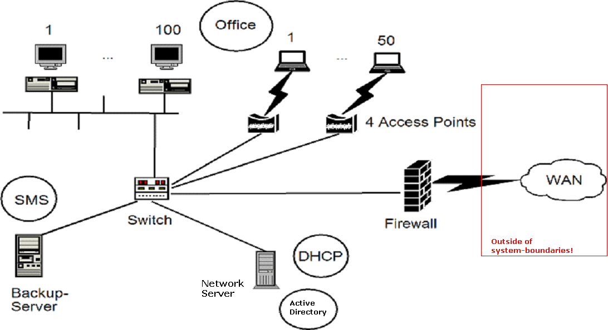

Check pre-defined parameters

Define the “business areas”

Determine “cost units”
Service
Costdriver
Personal- & Factcosts

Share common costs
Dependencies

Evaluate your study

http://sourceforge.net/projects/tcotool/
Comma separated format

