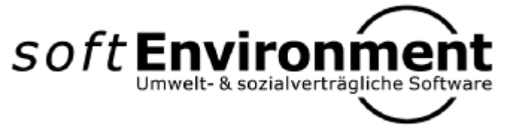

Technical Manual

Using JOMM

Java Object Model Mapping

Version 1.2.0 by Peter Hirzel



Document Info

Filename: 0000.doc
Template:

Responsible: Peter Hirzel
Classification: None

Edition History
Date | Version | State | Company | Author | Remarks
15.04.2005 | 1.0.0 | Released | softEnvironment | Peter Hirzel | Initial
02.10.2005 | 1.1.0 | Released | softEnvironment | Peter Hirzel | Enumerations & Codes, Referential Integrity, Case 1:1
 | 1.2.0 | In Work | softEnvironment | Peter Hirzel | Inheritance for relational SQL Schema

Contents

1 Abstract 1
2 Installation 2
2.1 Java Environment 2
2.2 Necessary base libraries 2
2.2.1 seBase 2
2.2.1.1 ehibasics 2
2.2.2 JDO 2
2.2.3 JTA 3
2.3 Optional base libraries 3
2.3.1 XML-Mapping 3
2.3.2 Relational Database Management Systems 3
2.3.2.1 MySQL 3
2.3.2.2 PostgreSQL 3
2.3.2.3 ORACLE 3
2.3.2.4 HSQLDB 3
2.3.2.5 MS Access 4
3 Technical definitions 5
3.1 Platform Independent Model (PIM) 5
3.2 Platform Specific Model (PSM) 5
3.2.1 Java 5
3.2.2 XML 6
3.2.3 SQL 6
3.2.3.1 Types 6
3.2.3.2 Technical Fields 6
3.2.3.3 Technical Tables 7
3.2.3.3.1 Key-Table 7
3.2.3.3.1.1 With SEQUENCE 7
3.2.3.3.1.2 Without SEQUENCE 8
3.2.3.3.2 NLS Support 8
3.2.3.4 Referential Integrity 8
3.2.3.4.1 Association 9
3.2.3.4.2 Aggregation 9
3.2.3.4.3 Composition 9
3.2.3.4.4 Inheritance 9
4 Design-Overview of JOMM 11
4.1 Implementing JDO-Interfaces 11
4.2 Persistency Hierarchy 11
4.3 Descriptor of DbObject 12
4.3.1 Technical properties 13
4.3.2 Problem domain properties 13
4.3.3 Inheritance 14
4.3.4 Enumerations 14
4.3.4.1 1:[0..1] Enumeration 14
4.3.4.2 1:[0..*] Enumeration 15
4.3.5 Codes 16
4.3.6 Associations 16
4.3.6.1 Case 1:1 16
4.3.6.1.1 Variant Reference defined in B (preferred) 16
4.3.6.1.2 Variant Reference defined in A (non-preferred) 17
4.3.6.2 Case 1:n 17
4.3.6.3 Case 1:n Ordered 18
4.3.6.4 Case n:n 18
4.3.6.5 Relationship to Relationship 20
4.3.6.6 Inherited Relationship 20
4.3.6.7 n-ary 20
4.3.6.8 Associations over “remote” packages 20
5 Application Development 21
5.1 Using the appropriate Object-Server 21
5.2 Establish a Database-Connection 21
5.3 Dealing with persistency Objects 21
5.3.1 Instantiating DbObject’s 21
5.3.2 Changing DbObject’s 21
5.3.3 Removing DbObject’s 21
5.3.4 Enumerations (DbEnumeration) 21
5.3.5 Code’s (DbCode) 22
5.4 Executing a Query 22
5.5 Checking Consistency of persistency Objects 22
Preface
JOMM is the result of an iterative process to design and implement a pragmatic Object-Relational Mapping Framework. After first experiences with TOPLink about a decade ago and an own first implementation in Smalltalk, a complete redesign followed in Java. Later on real project experiences with the concepts and specifications of ODMG, EJB and JDO left their fingerprints in this project as well. Finally the partnership with Eisenhut Informatik AG specifically during the project UML/INTERLIS-Editor (see http://www.umleditor.org) brought further insights in point of MDA approaches.
Therefore JOMM is not just another Object/Relational Mapper, but its more a serious trial to enhance the whole process from designing a logical data model in UML and generating different specific physical Models out of it with the UML/INTERLIS-Editor for any other Targets.

This document describes the necessary dependencies and usage of JOMM.

JOMM is an Open source Project written entirely in Java.

Abstract
JOMM is about mapping between different worlds of models such as
- Logical UML Model (for e.g. Class-diagram)
- Java Model Classes
- SQL relational schema for any Database Server Product (for e.g. MySQL, PostgreSQL, ORACLE, etc)
- XML instance

JOMM is useful in any n-Tier Architecture where one or more specific processes (for e.g. the GUI-Client) are written in Java. Any persistency behaviour from one layer to another must be transformed upon transformation rules. Usually any different Target-System (for e.g. a relational Database Management System) will deal with more or less the same data of a certain problem domain.

Any Java model class with persistency character will have its own descriptor in JOMM, which documents properties, relationships and inheritance in a transformable manner. Thereby some definitions for technical aspects are introduced and assumed with JOMM.

Installation
This chapter describes the necessary Software Components to run and compile JOMM as shown in the Package-Diagram (according to UML).
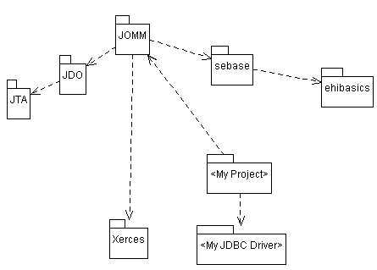

Java Environment
Java Software Development Kit:
- Based on J2SDK V1.4.* (see http://java.sun.com).
- Based on native JDBC.

Necessary base libraries
The following packages (jar-libraries) must be included in any JOMM-project separately.

seBase
Base library from softEnvironment -> sebase.jar
- http://sourceforge.net/projects/umleditor

ehibasics
seBase is based on the library by Eisenhut Informatik AG -> ehibasics.jar
- http://sourceforge.net/projects/umleditor

JDO
Java Data Objects (JDO) -> jdo.jar (tested with Version 1.0.1)
- http://www.sun.com/software/communitysource/jdo/download.xml

JTA
Java Transaction API (JTA) -> jta.jar (tested with Version 1.0.1B)
- http://java.sun.com/products/jta/

Optional base libraries
The following libraries will be necessary only if a specific Target Transformation is expected.

XML-Mapping
If JOMM shall be used for XML-Mappings, the Apache Xerces Project is used for parsing XML-Files. If this library is not included with JOMM compile errors will happen in package ch.softenvironment.jdo.xml which might be ignored as long no XML-Mappings are needed.

Apache Xerces for Java -> xerces.jar (tested with Version 1.4.4)
- http://xml.apache.org/xerces2-j/

Relational Database Management Systems
The following relational DBMS are implemented with JOMM (based on Standard SQL99).

Any JDBC (or ODBC) Driver must be installed for a desired target DBMS-Product. In the following some tested DBMS are listed, other DBMS might work as well or at least extended with minimal effort by creating new implementations such as ch.softenvironment.jda.<myDBMS>.

MySQL
MySQL V4.1.10 JDBC-Driver -> mysql-connector-java-3.2.0-alpha-bin.jar (tested)
- http://www.mysql.com

PostgreSQL
PostgreSQL V8.0 JDBC-Driver -> postgresql-8.0.309.jdbc2.jar (tested)
- http://www.postgresql.org/

ORACLE
ORACLE 9i JDBC-Driver -> ojdbc14.jar (tested)
- http://www.oracle.com

HSQLDB
HSQLDB V1.8.0 JDBC-Driver -> hsqldb.jar (tested)
- http://www.hsqldb.org

MS Access
MS Access 2002 -> uses JDBC/ODBC-Bridge (no library must be included specifically)

Technical definitions
In relation to MDA (Model Driven Architecture).

Platform Independent Model (PIM)
For e.g. a two related, persistent classes with problem domain specific properties (according to UML):
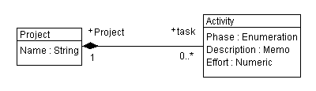
No technical fields are to be defined in a PIM.

Platform Specific Model (PSM)
Any Target Platform dependent Model should be generated out of the given PIM (for e.g. with http://www.umleditor.org).

According to the definitions of the target-system some technical attributes may or rather should be added to the PSM (as a transformation of PIM). Dependent of the Target-System’s capabilities such technical extensions must be defined from case to case separately. For JOMM these technical extensions are described in this chapter.

Java
Reserved Bean-Properties:
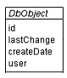

java.lang.Long fieldId;
setId();
getId();

java.util.Date fieldLastChange;
setLastChange();
getLastChange();

java.util.Date fieldCreateDate;
setCreateDate();
getCreateDate();

java.lang.String fieldUserId;
setUserId();
getUserId();

XML
Because the UML/INTERLIS-Editor (http://www.umleditor.org) already offers an XSD-Generator, JOMM is focused on the principles defined by INTERLIS (see http://www.interlis.ch).
This will make it very easy to generate an XSD out of a PIM and JOMM will map the specific Java-Objects to an XML-Instance which will validate with the very same XSD.

Reserved Attributes:
<ch.softenvironment.MyModel TID="x1000003">
…

SQL

Types
Some databases allow the definition of additional own Domain Types. If possible the following types might be assumed:

Domain Name | Java “Type” (for DbObject) | SQL Type [MySQL] | SQL Type [ORACLE] | SQL Type [MS Access] | Values | Remarks
DbBoolean | java.lang.Boolean | CHAR(1) | CHAR(1) | Text(1) | ‘T’(rue) or ‘F’(alse) | BIT(n) is not supported by all DBMS
DbDate | java.util.Date | DATE |  |  | Or DATETIME if DATE is not available
DbId | java.lang.Long | LONG | NUMERIC(9) | LONG INTEGER | >= 0
DbTimestamp | java.util.Date | TIMESTAMP (refreshes field at update automatically; once per table) | TIMESTAMP |  |  | Used for T_LastChange
DbDateTime | java.util.Date | DATETIME | TIMESTAMP |  |  | Used for T_CreateDate
DbUser | String | VARCHAR(30) | VARCHAR2(30) |  |  | UserId of a current Session between Client and Server.
DbTable | String | VARCHAR(64) Limited in MySQL to 64 Characters | VARCHAR2(30) |  |  | Use the minimal length for Migration-Reasons => 30

Technical Fields
Reserved Attributes in a Model-Schema:
Technical Field | Description | SQL Type | Example
T_Id | UNIQUE Object-Id, by means SQL PRIMARY KEY | DbId
T_Id_<RoleName> | ForeignKey’s are defined by a Prefix + the Rolename of the model. | Same Type as for T_Id | T_Id_Task
T_CreateDate | Date when record was INSERTed the very first time | DbDateTime
T_LastChange | Date when record was UPDATEd the last time | DbTimestamp
T_User | Session-User changing the record | DbUser
T_Type | Inherited Classes. The Root-Class must have this additional field to keep the TableName of the Concrete Subclass Type, by means the corresponding physical Table name in Schema. | DbTable | S. chapter 3.2.3.4.4
T_Attribute | The Attribute-Name of any Table. | DbTable
T_Sequence | Attribute to define UNIQUE ordering once per Table.  The Ordering is independent of Model Aggregation. | DbID | CREATE TABLE Weekdays (  T_ID..,  T_Sequence..,  T_ID_Name...  )
T_Seq_<RoleName> | For Ordered 1:n Relationships |  | If an Object aggregates many Companies by Role “Company” then they will be ordered according to T_Seq_Company for this very Relationship.
T_Ix_<RoleName> | CREATE INDEX T_IX_MyIndexName… | <none>
T_Ux_<Constraint> | CREATE UNIQUE INDEX T_UX_MyUniqueConstraint…

Technical Tables
Technical Table Name | Description | MS Access  MySQL | ORACLE  PostgreSQL
T_Key_* | Management Table of next free Unique ID for a given Class-type. | T_Key_Object | T_Key_<Sequence> | See chapter 3.2.3.3.1
T_Map_* | Mapping Table’s for an Attribute-Mapping with Mulitplicity [0..*] |  |  | Having the following Attributes:  - T_Id_Owner  - T_Type_Owner  - T_Attribute_Owner  - T_Id_Value
T_NLS | For Multi-language NLS Strings |  |  | See chapter 3.2.3.3.2
T_Translation | For Multi-language NLS Strings |  |  | See chapter 3.2.3.3.2

Key-Table
JOMM supports two kinds of obtaining unique Keys in a Multi-User environment.
- Sequence mechanism (for e.g. ORACLE, PostgreSQL, HSQLDB)
- Own utility mechanism via a dedicated Key-Table (for e.g. MS Access, MySQL)

With SEQUENCE
If your DBMS supports SEQUENCE, create a Sequence for any Table having insertables.

T_Key_<TableName> for appropriate SEQUENCE Tables for each DbObject which is insertable.

Without SEQUENCE
If your DBMS does not support SEQUENCE, the 2nd variant will assume a Table named T_Key_Object and add each DbObject’s Table as T_Key. The next free UNIQUE ID for a Key-Object will be therefore T_Id_Last + 1:

Physical SQL-Schema:
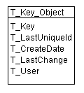
Where T_Key contains the name of any Table of the PSM and T_LastUniqueId is the latest used max. Key given for such an object.

NLS Support
Support for translatable Strings will be maintained by the following utility shema.

Physical SQL-Schema:
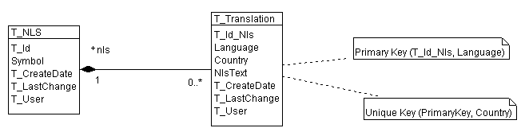

Where Symbol is a general description of what is meant by NLS-Text and T_Translation contains any Translation in another Language (and Country) for a given Symbol.

Languages: de; fr; en, etc
Countries : CH ; FR ; GB, etc

Referential Integrity
To make sure constraints are handled consistently within a DBMS or by a Client-Application, any such definitions are assumed to be done by physical Schema!
Though DbDescriptor (see chapter 4.3) makes it possible to define referential types, these definitions are rather for informational use only. Therefore JOMM does not delete any composited objects on the target-server by itself for example, instead a DELETE constraint is assumed on the target side.

In the following a short understanding of constraints between UML-model and SQL-Schema is outlined:

Association
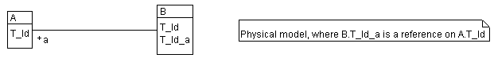
Any Foreign-key role-fields (such as T_Id_a) should be defined by a constraint as: ON DELETE SET NULL (from the view of A)

Aggregation
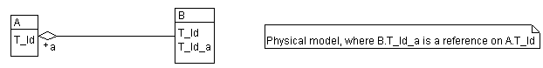
Any Foreign-key role-fields (such as T_Id_a) should be defined by a constraint as: ON DELETE RESTRICT (from the view of A)

Composition
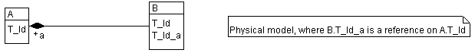
Any Foreign-key role-fields (such as T_Id_a) should be defined by a constraint as: ON DELETE CASCADE (from the view of A)

Inheritance
Since Inheritance is not supported by RDBMS, a substitute is expected as follows:
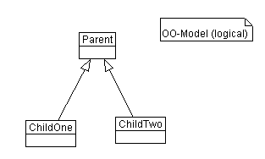
Will become the following physical SQL-Schema, where only one Parent/Child-Pair may exist for a certain T_Id. The Attribute T_Type for any Root-Table makes sure which kind the final Leaf in inheritance Chain is meant to be:
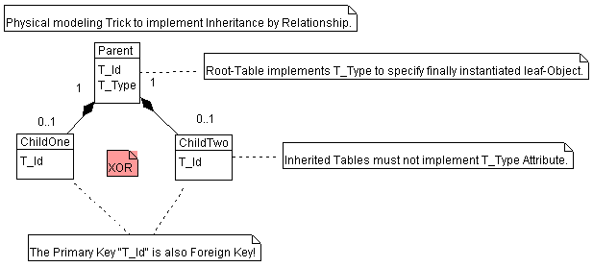
Sample Data for Inheritance Tables:

Parent
T_Id | T_Type | …
100 | ChildOne | …
200 | ChildTwo | …
ChildOne
T_Id | …
100 | …

ChildTwo
T_Id | …
200 | …

Design-Overview of JOMM
This chapter explains the Design and internal implementation of JOMM.

Implementing JDO-Interfaces
The green classes represent JDO-Interfaces and the white represent JOMM Implementations.
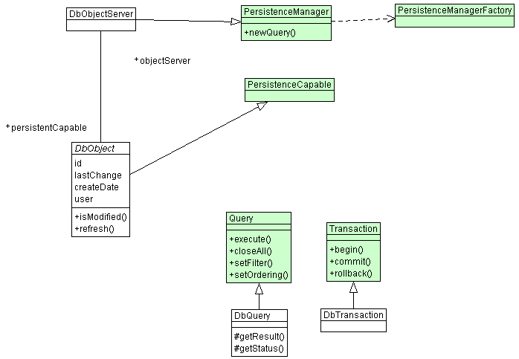

Persistency Hierarchy
Any persistent Object of the problem domain must inherit from DbObject or one of its predecessors (concepts of EJB and JDO are adapted here).
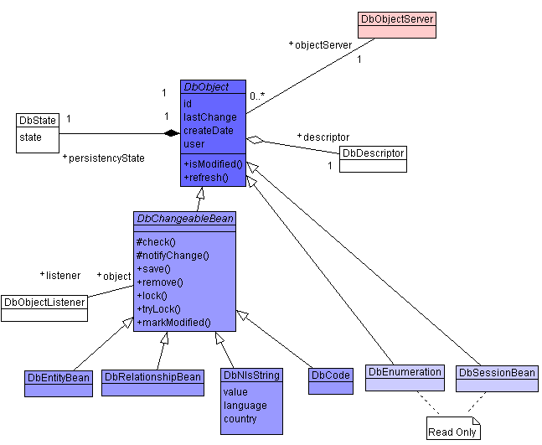

Descriptor of DbObject
Each persistency class inheriting from DbObject (see package ch.softenvironment.jomm.mvc.model) needs a static DbDescriptor (see package ch.softenvironment.jomm.descriptor) to describe its mappings. Such a description of the mappings is necessary to instantiate or make persistent from Java to other Target-Systems automatically.

The description for the Java-persistency-objects is always the same independent of the used Target-Systems.

Remark:
- Other JDO-Implementations tend to define Model-Descriptions outside of the Java-Source Code for e.g. in a XML-Descriptors.
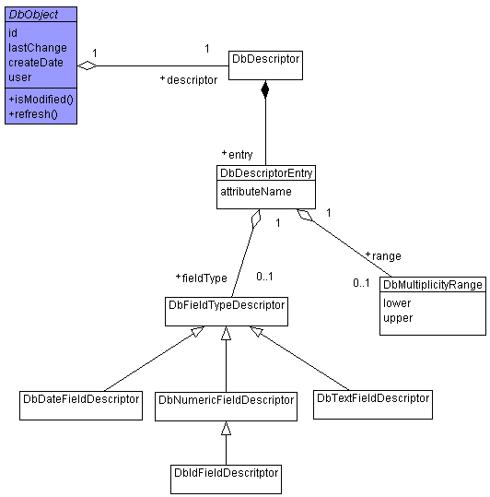

public class MyClass extends DbEntityBean {
public static DbDescriptor createDescriptor() {
DbDescriptor descriptor = new DbDescriptor(MyClass.class);
…
return descriptor;
}
…
}

Technical properties
Typical technical attributes such as Identity (for e.g. #id => T_Id) are mapped by JOMM implicitely, by means such mappings must not be done by any problem domain class.

Problem domain properties
Such properties must be added to the DbDescriptor of each concrete DbObject.

Any properties must be added by DbDescriptor#add*() methods.

Inheritance
Full inheritance is maintained by the DbDescriptor, by means any hierarchical class has its own descriptor mapping of its local attributes and associations.

Enumerations
Enumerations are some kind of Read-Only types in INTERLIS manner (where Codes are non-INTERLIS changeable types), by means they possess an attribute iliCode which make each entry unique.
An Enumeration also has a speaking attribute name (NLS):
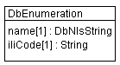 (where length of iliCode-String = 254)
Note:
- In UML/INTERLIS-Editor Enumerations are modelled as “DomainDef’s”.

1:[0..1] Enumeration
For e.g. a Person may be addressed by a language => language[0..1]:
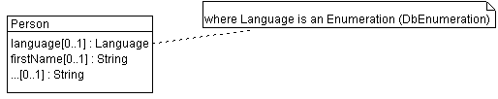
public class Language extends DbEnumeration {
public Language(ch.softenvironment.jomm.DbObjectServer objectServer) {
super(objectServer);
}
public static DbDescriptor createDescriptor(Class dbEnumeration) {
DbDescriptor descriptor=DbEnumeration.createDescriptor(dbEnumeration);
return descriptor;
}
// ILI-Code constants (UNIQUE)
public static final String GERMAN="de";
…
}

public class Person extends DbEntityBean {
private Language fieldLanguage;

public static DbDescriptor createDescriptor() {
DbDescriptor descriptor = new DbDescriptor(Person.class);
descriptor.addCode("language", "language",
new DbMultiplicityRange(0,1));
descriptor.add("firstName","firstName",
…
}
public Language getLanguage() {
refresh(false); // read lazy initialized objects
return fieldLanguage;
}
public void setLanguage(Language language){
Language oldValue=fieldLanguage;
fieldLanguage=language;
firePropertyChange("language", oldValue, fieldRole);
}
…
}

In SQL these are classic code tables, which must not be inherited and therefore do not need a T_Type Attribute, but have an additional field “IliCode”:
CREATE TABLE Language (
T_Id INTEGER NOT NULL PRIMARY KEY,
T_Id_Name INTEGER NOT NULL, -- (FK) T_NLS.T_Id
[T_Sequence INTEGER NOT NULL,] -- Optional if ordered
IliCode VARCHAR(254) NOT NULL, -- UNIQUE enum expression
T_CreateDate DATETIME NOT NULL,
T_LastChange TIMESTAMP NOT NULL,
T_User VARCHAR(30) NOT NULL
);
ALTER TABLE Lanugage ADD FOREIGN KEY (T_Id_Name) REFERENCES T_NLS(T_Id) ON DELETE CASCADE;
CREATE UNIQUE INDEX T_Ix_IliCodeLanguage ON Language (IliCode);

INSERT INTO T_NLS (T_Id, T_CreateDate, T_User) VALUES
(200, '2005-03-14 20:00:00', 'phirzel');
INSERT INTO T_Translation (T_Id_Nls, Language, NlsText, T_CreateDate, T_User) VALUES
(200, 'de', 'Deutsch', '2005-03-14 20:00:00', 'phirzel');
INSERT INTO Language (T_Id, T_Id_Name, [T_Sequence,] IliCode, T_CreateDate, T_User) VALUES
(2, 200, [1,] 'de', '2005-03-14 20:00:00', 'phirzel');

Remark:
- In the UML/INTERLIS-Editor Enumerations are defined by DomainDef’s in a TopicDef (within ModelDef) of type “Enumeration”.

1:[0..*] Enumeration
For e.g. a Person may speak more than 1 languages => language[1..*]:
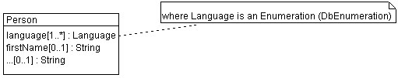
public class Language extends DbEnumeration {
(see chapter 4.3.4.1)
}

public class Person extends DbEntityBean {
private java.util.List fieldLanguage=new java.util.ArrayList();

public static DbDescriptor createDescriptor() {
DbDescriptor descriptor = new DbDescriptor(Person.class);
descriptor.addCode("language", "language",
new DbMultiplicityRange(1, DbMultiplicityRange.UNBOUND),
Language.class, "T_MAP_Language");
descriptor.add("firstName","firstName",
…
}
public java.util.List getLanguage() {
refresh(false); // read lazy initialized objects
return fieldLanguage;
}
public void setLanguage(java.util.List language){
java.util.List oldValue=fieldLanguage;
fieldLanguage=language;
firePropertyChange("language", oldValue, fieldLanguage);
}
…
}

Persistent Classes which map a [0..*]-Enumeration will need a T_Map_<EnumTable>. Such n:n generic maps are to be created for each Enumeration-type referenced in a multiple manner, though several different owners may be kept in this very same table, by means no real relations are modelled in an SQL-schema since enumeration-mappings are considered generic with this approach, for e.g.:
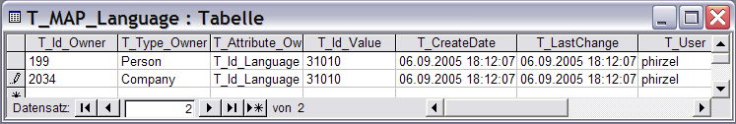
where:
- T_Id_Owner => id of owning Object mapping the enumeration (Person.T_Id mapping Language)
- T_Type_Owner => will be set to ROOT of inheritance chain of owning object (Person is the root Object here)
- T_Attribute_Owner => Owners attribute holding the content of T_Id_Value (n:n from DbEntityBean to Enumeration)
- T_Id_Value => Id of referenced Enumeration (Language.T_Id)

Codes
A code is a similar to a user-changeable “Enumeration” (where an Enumeration is RO and has an additional IliCode) but may containt next to a name (NLS) attribute any optional application-specific attributes.
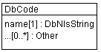

public class MyCode extends DbCode {
public Category(ch.softenvironment.jomm.DbObjectServer objectServer) {
super(objectServer);
}
public static DbDescriptor createDescriptor(Class dbCode) {
DbDescriptor descriptor = DbCode.createDescriptor(dbCode);
return descriptor;
}
}

Associations
Relationships between classes can be fully described by the DbDescriptor on each side of connected nodes.

An AssociationEnd may be of the following type:
- ASSOCIATION
- AGGREGATION
- COMPOSITION

Case 1:1
For all (referenced, aggregated or composited) combinations of A:B=[0..1]:[0..1]

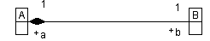

Variant Reference defined in B (preferred)
Where A.T_Id becomes a Foreign Key in B => B.T_Id_a (Role of +a as SQL-Reference-field in B):
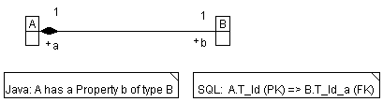

Remark:
- This is the preferred variant because it is easily changeable into 1:n if necessary at any time in point of the physical schema.

Usage within JOMM:

class A extends DbEntityBean {
public static DbDescriptor createDescriptor() {
DbDescriptor descriptor = new DbDescriptor(A.class);
descriptor.addOneToOne(..);
return descriptor;
}
}

class B extends DbEntityBean {
public static DbDescriptor createDescriptor() {
DbDescriptor descriptor = new DbDescriptor(B.class);
descriptor.addOneToOneReference(..);
return descriptor;
}
}

DbDescriptor Method | Description
#addOneToOne() | Use on side A where no physical reference of B exists. An instance of B will be mapped in A when A is instantiated.
#addOneToOneReference() | Use on side B where a physical reference of A exists. An instance of A will be mapped in B when B is instantiated.
#addOneToOneReferenceId() | Use on side B where a physical reference of A exists. Only Id of A will be mapped in B when B is instantiated for more efficency.

Variant Reference defined in A (non-preferred)
Where B.T_Id becomes a Foreign Key in A => A.T_Id_b (Role of +b as SQL-Reference-field in A)

DbDescriptor Method | Description
#addOneToOneId() | Use on side B where no physical reference of A exists.
#addOneToOneReference() | Use on side A where a physical reference of B exists.
#addOneToOneReferenceId() | Use on side A where a physical reference of B exists.

Case 1:n
- for all combinations of A:B=[0..1]:[0..*], where A.T_Id becomes a Foreign Key in B => B.T_Id_RoleOfA

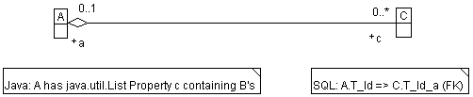

Usage within JOMM (see chapter ???):

class A extends DbEntityBean {
public static DbDescriptor createDescriptor() {
DbDescriptor descriptor = new DbDescriptor(A.class);
descriptor.addOneToMany(..);
return descriptor;
}
}

class C extends DbEntityBean {
public static DbDescriptor createDescriptor() {
DbDescriptor descriptor = new DbDescriptor(C.class);
// for the whole Object of A

descriptor.addManyToOneReference(..);
// or for the key reference T_Id_a only
descriptor.addManyToOneReferenceId(..);
return descriptor;
}
}

Case 1:n Ordered
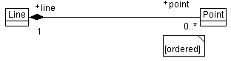

Table Point will have an Attribute allowing to specify the desired ORDER:
- T_Seq_Line

Example:
Line:
  - addOneToMany(DbDescriptor.COMPOSITION,
"point", "line",
new DbMultiplicityRange(1, DbMultiplicityRange.UNBOUND),
Point.class,
true); // => Point.T_Seq_Line
Point:
  - addManyToOneReference(DbDescriptor.ASSOCIATION,
"line", "T_Id_Line",
new DbMultiplicityRange(1,1));
  - optionally add Sequence-field if needed to be set by application: descriptor.add("T_Seq_Line","T_Seq_Line",new DbNumericFieldDescriptor(DbNumericFieldDescriptor.POSITIVE_INTEGER),new DbMultiplicityRange(0,1));

Case n:n
- for all combinations of A:D=[0..*]:[0..*]

Many to Many Relationships become “Attributed Associations”, by means A:D=n:n is mapped by an Association-Class/Table A_D.

A:D=n:n via Map C
A.d’s => java.util.List owning Object’s of type DbRelationshipBean A_D
D.a’s => dito

Remark:
- The UML-Editor shows an AssociationClass automatically if additional Attributes are defined on the Association.

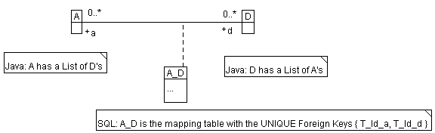

The AssociationClass A_D has is its own Object-Identity (by means in SQL: A_D.T_Id (PK)) for e.g. to support Relationship-to-Relationship. Additionally in SQL the combination of Foreign Keys in A_D pointing to the AssociationEnds must be UNIQUE

Usage within JOMM:

class A extends DbEntityBean {
public static DbDescriptor createDescriptor() {
DbDescriptor descriptor = new DbDescriptor(A.class);
descriptor. addAssociationAttributed(DbDescriptor.ASSOCIATION
“dId”,
new DbMultiplicityRange(0, DbMultiplicityRange.UNBOUND),
new DbMultiplicityRange(0, DbMultiplicityRange.UNBOUND),
A_D.class,
"aId");
return descriptor;
}
}

class D // analog A

class A_D extends DbRelationshipBean {
public static DbDescriptor createDescriptor() {
DbDescriptor descriptor = new DbDescriptor(A_D.class);
descriptor.addAssociationEnd(A.class, “aId”, “T_Id_a”);
descriptor.addAssociationEnd(D.class, “dId”, “T_Id_d”);

// evtl. other attributes

return descriptor;
}
}

DbDescriptor Method | Description
#addAssociationAttributed() | Use on side A (resp. D) for a list of D’s (resp. A’s).
#addAssociationEnd() | Use on A_D where a physical references of A and D are kept in an association class. Therefore both ends must be added to A_D.

Relationship to Relationship
FUTURE USE

Inherited Relationship
FUTURE USE

n-ary
FUTURE USE

Associations over “remote” packages
FUTURE USE remote means, packages containing Persistent Classes are not maintained by the same project.
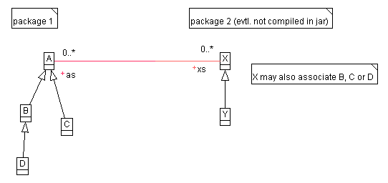
add(.., “package.Class-Name”, Attribute);

Generic Evaluation via:
Object get(Property);
void set(Property, Object);

Application Development
This chapter describes how to build a Java-Application based on JOMM.

Using the appropriate Object-Server
Any Java-Process (for e.g. Client-Application) uses a certain DbObjectServer to handle all requests against a Target-System. Therefore an appropriate DbObjectServer implementation should be chosen at connection time in a Java-Application.

javax.jdo.PersistenceManagerFactory pmFactory =
new MySqlObjectServerFactory(); // or any other Implementation
pmFactory.setConnectionURL(url /* + "?user=" + userId + "&password="*/);
pmFactory.setNontransactionalRead(false); // NO autoCommit while reading
pmFactory.setNontransactionalWrite(false);// NO autoCommit while writing
DbObjectServer server =
DbObjectServer)pmFactory.getPersistenceManager(userId, password);

Establish a Database-Connection
DbObjectServer.open(…)

Register all Persisent DbObject’s, to bind them for later usage (Descriptor registration):

DbObjectRegistry.registerClass(<myapp>.Project.class, "Project");
DbObjectRegistry.registerClass((<myapp>.Activity.class, "Activity");

Dealing with persistency Objects

Instantiating DbObject’s
server.createInstance(MyDbObject.class);

Changing DbObject’s
myDbChangeableBean.save();

Removing DbObject’s
Deletion assumes DBMS Referential Integrity (see chapter 3.2.3.4):
- for inherited DbObject’s the root Object (Table-Entry) will be deleted by Application only

myDbChangeableBean.remove();

Enumerations (DbEnumeration)
Language german = server.retrieveEnumeration(Language.class, “de”);

Code’s (DbCode)
java.util.List languages = server.retrieveCodes(Language.class);

Creating a new Code:
MyCode code = (MyCode)server.createInstance(MyCode.class);
code.getName().setValue(“deutscher Text”, Locale.GERMAN);
code.getName().setValue(“english text”, Locale.English);
code.save();
server.evict(code); // forces recache

Executing a Query
DbQueryBuilder
DbQuery
DbTransaction

Checking Consistency of persistency Objects
MVC-Pattern

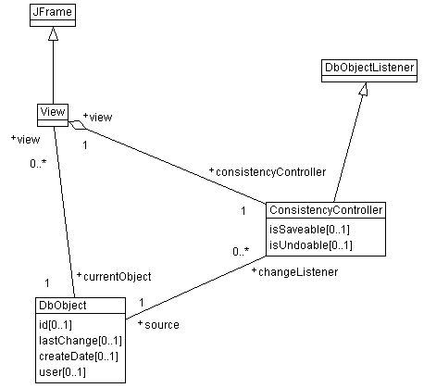

View for e.g. in a GUI to change a Project’s properties:

class ProjectDetailView() extends javax.swing.JFrame() {
…

public void setCurrentObject(java.lang.Object object) {
try {
setObject((Project)object);
getObject().addPropertyChangeListener(new ch.softenvironment.jomm.mvc.controller.ConsistencyController(this));
} catch(Throwable e) {
handleException(e);
}
}

/**
* Overwrites.
*/
public void dispose() {
getObject().removePropertyChangeListener(getConsistencyController()); super.dispose();
}

