

Specification

Licencing

… for softEnvironment Software Solutions

Version 1.1.0

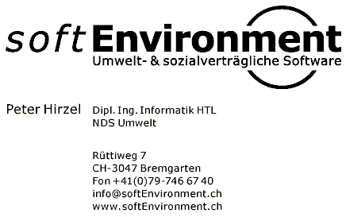

Angaben zum Dokument

Dateiname: 0000.doc
Vorlage:

Verantwortlicher: Peter Hirzel
Klassifikation: keine

Änderungsnachweis
Datum | Version | Status | Firma | Author | Bemerkungen
19.11.2003 | 1.0.0 | Working. | softEnvironment | Peter Hirzel | Ersterstellung
21.11.2003 | 1.0.1 | Reviewed | softEnvironment | Peter Hirzel | Review Correction acc. to Claude Eisenhut
15.12.2005 | 1.1.0 | Working | softEnvironment | Peter Hirzel | 3.5 Implementing Licence-Client

Inhalt

1 Introduction 1
2 Development Environment 2
2.1 Programming Language 2
2.1.1 Eclipse 2
2.2 Methods 2
3 Solution 3
3.1 Requirements 3
3.1.1 Future Use 3
3.2 Use Cases 3
3.3 Design 4
3.4 Prototype 4
3.4.1 Producer side Tool 4
3.4.2 Customer side Tool 5
Preface
This document is about licencing different Software-Applications by softEnvironment.

Introduction
The usage of individual Software-Application’s (Apps) implemented for any Customers shall be restricted by a licence mechanism.

A good example is Microsoft’s licence Policy and the like.

Development Environment

Programming Language
Programming Language: Java V1.4.* (or higher)

See http://java.sun.com

Eclipse
Suggestion of Java-IDE: http://www.eclipse.org (but other IDE’s may be used as well).

Methods
Unified Modelling Language UML V1.4

See http://www.omg.org/uml

Solution

Requirements
- The mechanism must work OFF-LINE (no Online Registration)
- The Licence-key may be generated/transmitted/entered as a plain String (for e.g. in a usual Licency-Key format, such as “1234-ABCD-56G…” for Product “MyProduct Vx.y”)
- The Licence-File shall be encrypted
- A specific Licence is validated against the following aspects:
  - the Machine-Date (where the application runs on it) must be younger than the expireDate
  - At Installation the Customer name is asked and part of the encrypted Licence-Key
  - The Machine name is determined at Installation as well and part of the encrypted Licence Key

Future Use
- Online-Registration
- Licence-Server for managing Floating Licences
- evtl. the physical Machine-Nr (Motherboard and the like) shall be retrieved at Installation and used for Licence Validation as well
- An Application may have several modules/subsystems where all or only some of them shall be licenced with an Application-Package. These Modules are called Services

Use Cases
1.A producer selling an Application (<AnyApplication>) will generate a Licence for the sold product with a Utility-Class LicenceGeneratorView.

2. Any Customer buying an Application (<AnyApplication>) will be given the generated Licence, which may be entered at installing with a Utility-Class LicenceSetupView and saved by LicenceChecker.
3. Starting an Application (<AnyApplication>) will run LicenceChecker to check for a valid Licence and either return either OK or ABORT.

Design

Model
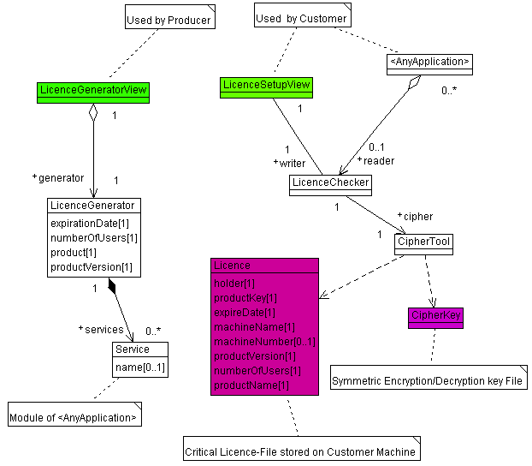
- UML Class-Diagram of licencing mechanism

Algorithm
Data to be encrypted:
- expiration duration:
  - 0 => 1 month
  - 1 => 2 months
  - 2 => 3 months
  - 3 => 6 months
  - 4 => 12 months
  - 5 => 24 months
  - 6 => non-limited
- Number of Users: String[3]
  - 001..999 => for e.g. 723 = nrUser[0]=7, nrUser[1]=2, nrUser[2]=3
- Productname: String[4] for e.g.:
  - “TCOp” (TCO-Tool softEnvironment Plugins)
  - “TRAr” (Traffic regional version)
  - “TRAn” (Traffic national version)
- Productversion: String[6]
  - V1.0.13 => for e.g. “010013”
ASCII-range:
- A..Z = 65..90
- a..z = 97..122
- 0..9 = 48..58

Key-Format:
abcd-efgh-ijkl-mnop

a = if (nrUser[2]==0) random(a..z) else 81 - nrUser[2]
b = expiration duration+103; => lower letter
c = if (nrUser[1]==0) random(A..Z) else 88 - nrUser[1]
d = Productname[3]

e = if (ProductVersion[0]==0) random(A..Z) else 119 - ProductVersion [0]
f = Productname [1]
g = if (ProductVersion[3]==0) random(A..Z) else 112 - ProductVersion[3]
h = if (ProductVersion[5]==0) random(a..z) else 112 - ProductVersion[5]

i = Productname [0]
j = Productversion[1]
k = random between a..z
l = Productversion[4]

m = Productname [2]
n = if (ProductVersion[2]==0) random(a..z) else 111 - ProductVersion [2]
o = random between A..Z
p = if (nrUser[0]==0) random(a..z) else 80 - nrUser[0]

Prototype

Producer side Tool
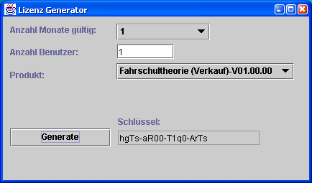
- LicenceGeneratorView

Customer side Tool
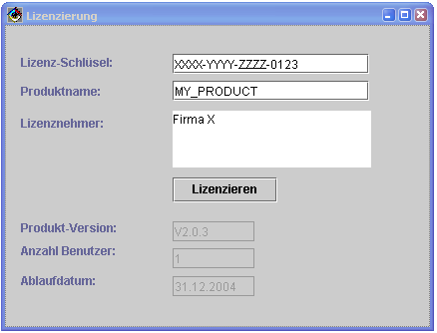
- LicenceSetupView

Implementing Licence-Client into an Application

Vendor side
Add new Product to LicenceGeneratorView#main(), for e.g.:

products.add("TCO-Tool-Plugin (softEnvironment) V01.04.00");
Adapt new Product in #LicenceGeneratorView#generateLicence():

// @see #main() for sequence
switch (getCbxProducts().getSelectedIndex()) {
case 0:
generator.setProductName("TCOp"); // softEnvironment-Plugins VBS for TCO-Tool
generator.setProductVersion("010400");
break;
…

Client side
To run the program in eclipse make sure the following libraries are to be found in classpath:
- jce.jar
- sunjce_provider.jar
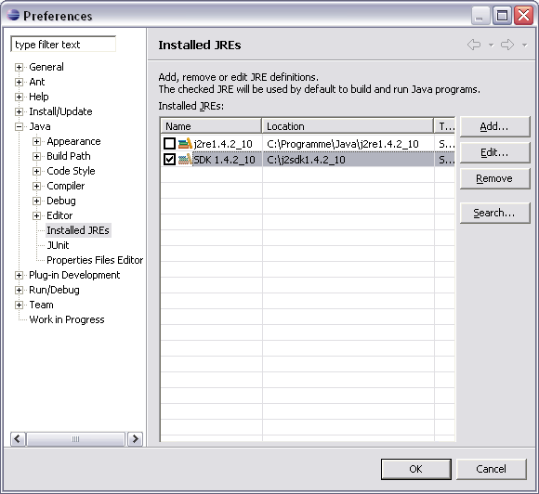

Call #checkLicence() in MyApp:

private static final byte[] IMG = { (byte)0x17, (byte)0x02, (byte)0x05, (byte)0x65, (byte)0x41, (byte)0x13, (byte)0x62, (byte)0x08 };

/*
* @throws IllegalStateException (in case licensing failed)
*/
private void checkLicence() {
try {
LicenceChecker checker = new LicenceChecker("TCO-Tool Plugin (by softEnvironment)", KeyTool.getDesKey(IMG), System.getProperty("user.home") + File.separator + ".sbv4");
if (checker.getProductName().equals("TCOp")) {
// Licence => OK!
licence = "LICENCE_TCO-PLUGIN";
} else {
getLauncher().showStatus(ResourceManager.getResource(LicenceChecker.class, "CELicenceInvalidProduct"));
}
} catch(UserException e) {
getLauncher().showStatus(e.getMessage());
}
}

