Legal Statement for Assessment of EUDR complant for agriculture plot : PIN w1wr55kp9f

|  |  |  |
| --- | --- | --- |
| No. | Riks Level | Explanation |
| 1 | High Risk | high deforestation risk – The agricultural plot overlaps both the official Thai National Forest boundary and the GFC2020 forest area, indicating strong likelihood of non-compliance with EUDR zero-deforestation criteria. Further legal and ground-based verification is required. |
| 2 | Medium Risk according to Thai Jurisdiction | The cultivated plot in question constitutes agricultural land for which the farmer has been lawfully granted usufruct rights under the Agricultural Land Reform Act (Sor Por Kor). While the plot is shown to spatially overlap with the boundaries of Thailand’s designated forest area, such boundaries are presently subject to verification under the national OneMap project. In consideration of the concurrent spatial overlap identified by the EUDR GFC2020 v.2 analysis, the plot is hereby classified as “Medium Risk” within the scope of Thai jurisdiction.  **DRAFT CERTIFICAT FOR DEMOSTRATION** |
| 3 | Potential Risk | The agricultural plot partially overlaps with forest area as identified by GFC2020, but is outside official Thai National Forest boundaries. This may indicate forest clearance after the EUDR cut-off date (31 December 2020). Ground verification and land-use history are required to confirm compliance. |
| 4 | Compliant | The agricultural plot is located outside both the GFC2020 forest extent and Thai National Forest boundaries, and is therefore not considered deforested land under EUDR requirements. The plot is deemed compliant with the EUDR zero-deforestation cut-off date (31 December 2020), pending confirmation of land use history. |

This certification is issued to the best of our knowledge, pursuant to and in reliance upon the collaborative verification undertaken among the relevant Thai government agencies, and is based on the most accurate and up-to-date information available at the time of issuance.

1. สำนักงานคณะกรรมการนโยบายที่ดินแห่งชาติ Office of the National Land Policy Board (NLB)

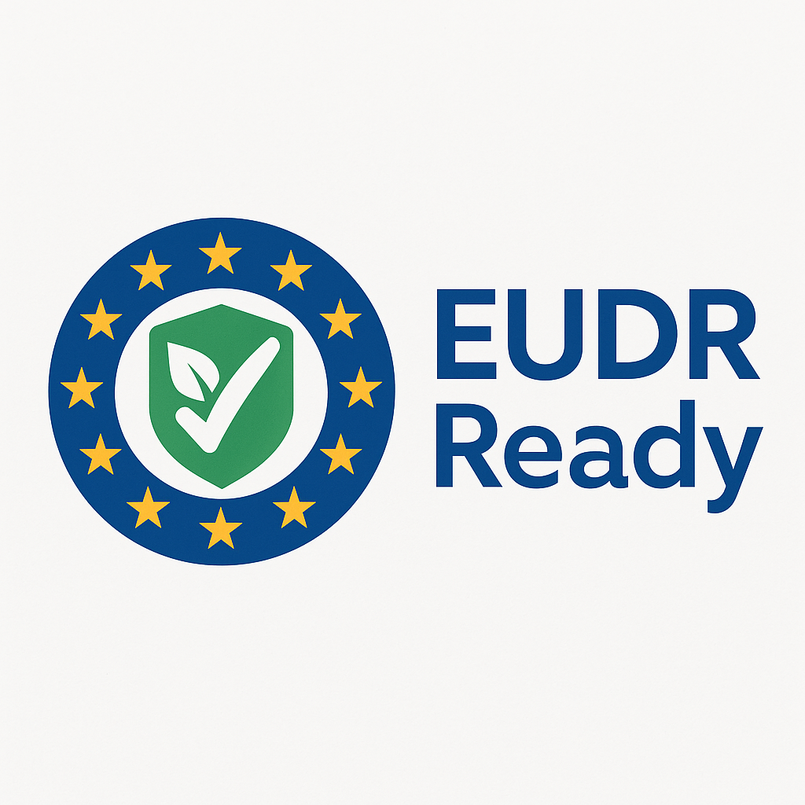2. สำนักงานการปฏิรูปที่ดินเพื่อเกษตรกรรม (อังกฤษ: Agricultural Land Reform Office: ALRO)

3. กรมส่งเสริมการเกษตร (Department of Agriculture Extension : DOAE)

4. การยางแห่งประเทศไทย (Rubber Authority of Thailand : RAOT)

5. กรมที่ดิน ( Department of Land : DOL )

|  |
| --- |
| สำนักงานคณะกรรมการนโยบายที่ดินแห่งชาติ - วิกิพีเดีย เข้าสู่ระบบ Mapping&LandText | ส.ป.ก. LOGO – ศูนย์ข่าวกรมส่งเสริมการเกษตร  กรมที่ดิน - วิกิพีเดีย |