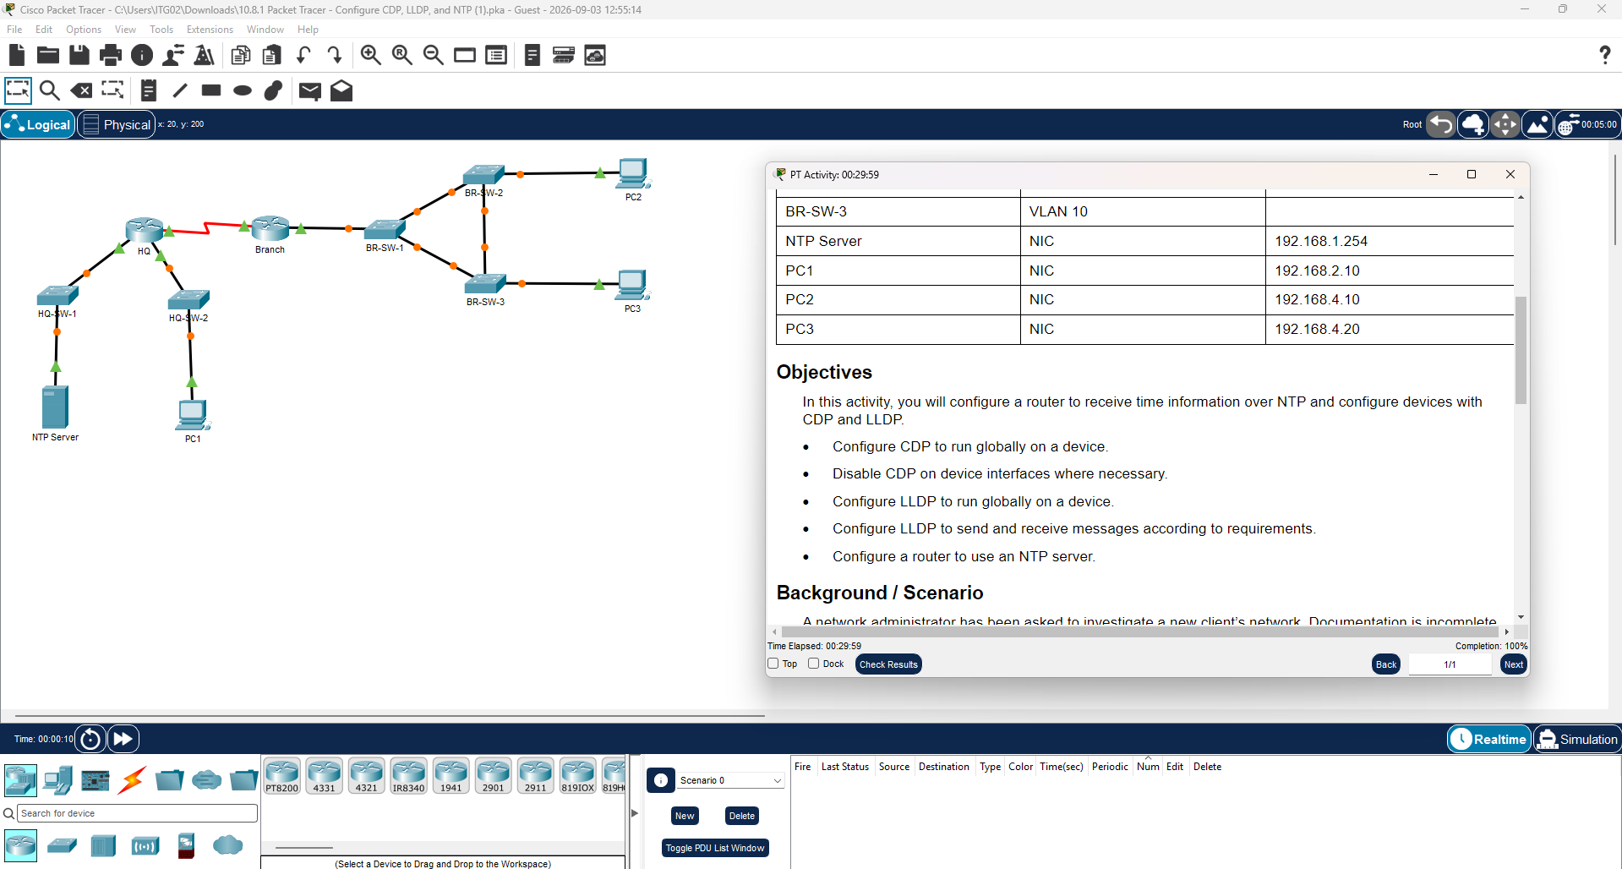

Packet Tracer Lab Report
Configure CDP, LLDP, and NTP
CCNA — Discovery Protocols and Network Time Protocol

Objectives
• Configure CDP to run globally on a device.
• Disable CDP on device interfaces where necessary.
• Configure LLDP to run globally on a device.
• Configure LLDP to send and receive messages according to requirements.
• Configure a router to use an NTP server.

Background / Scenario
A network administrator has been asked to investigate a new client's network. Documentation is incomplete, so some information must be discovered. In addition, the NTP server needs to be configured on a router. Discovery protocols must also be adjusted to control discovery-protocol traffic and prevent network information from being received by potentially unauthorized hosts. Some device IP addresses are unknown and must be discovered using CDP before they can be reached over SSH.

Network Topology
HQ site (HQ router, HQ-SW-1, HQ-SW-2, NTP Server, PC1) — serial link (red) — Branch site (Branch router, BR-SW-1/2/3, PC2, PC3)

Addressing Table
Device | Interface | IP Address
HQ | G0/0/0 | 192.168.1.1/24
HQ | G0/0/1 | 192.168.2.1/24
HQ | S0/1/0 | 192.168.3.1/30
Branch | G0/0/0 | 192.168.1.2/24
Branch | S0/1/0 | 192.168.3.2/30
HQ-SW-1 | VLAN 1 | Not configured
HQ-SW-2 | VLAN 1 | Not configured
BR-SW-1 | VLAN 10 | 192.168.4.250 (discovered via CDP)
BR-SW-2 | VLAN 10 | 192.168.4.253 (discovered via CDP)
BR-SW-3 | VLAN 10 | 192.168.4.254 (discovered via CDP)
NTP Server | NIC | 192.168.1.254
PC1 | NIC | 192.168.2.10
PC2 | NIC | 192.168.4.10
PC3 | NIC | 192.168.4.20

Note: The management IP addresses of BR-SW-1, BR-SW-2, and BR-SW-3 are not documented in advance. They are discovered during the activity using CDP neighbor information gathered from the Branch router and BR-SW-1, then used to reach the remaining switches over SSH.

Branch Switch SSH Credentials
Device | Username | User Password | Enable Secret
BR-SW1 | admin | SW1admin# | SW1EnaAccess#
BR-SW2 | admin | SW2admin# | SW2EnaAccess#
BR-SW3 | admin | SW3admin# | SW3EnaAccess#

Part 1: Configure LLDP (HQ Site)
LLDP is configured on the HQ router and its two access-layer switches. HQ is set to receive-only on its switch-facing links, while the switches are set to send-only toward HQ. LLDP is turned off completely on the switch ports facing end devices.

Step 1 — HQ Router
a. Disable CDP globally, then enable LLDP globally:
Router> enable
Router# configure terminal
Router(config)# hostname HQ
HQ(config)# no cdp run
HQ(config)# lldp run

b. On the links to the switches (G0/0/0 → HQ-SW-1, G0/0/1 → HQ-SW-2), allow LLDP to receive only — disable transmit, keep receive:
HQ(config)# interface GigabitEthernet0/0/0
no lldp transmit
lldp receive
HQ(config-if)# exit
HQ(config)# interface GigabitEthernet0/0/1
no lldp transmit
lldp receive
HQ(config-if)# exit

c. Configure the NTP client on HQ (see Part 3) and save:
HQ(config)# ntp server 192.168.1.254
HQ(config)# end
HQ# copy running-config startup-config

Step 2 — HQ-SW-1 and HQ-SW-2
a. On each switch, disable CDP globally and enable LLDP globally:
Switch> enable
Switch# configure terminal
Switch(config)# hostname HQ-SW-1
HQ-SW-1(config)# lldp run
HQ-SW-1(config)# no cdp run
(Repeat the same two commands on HQ-SW-2, using hostname HQ-SW-2.)

b. On the uplink to HQ (GigabitEthernet0/1 on both switches), send only — disable receive:
HQ-SW-1(config)# interface GigabitEthernet0/1
no lldp receive
HQ-SW-1(config-if)# exit
(Transmit remains enabled by default, so nothing further is needed for “send only.” Repeat on HQ-SW-2's uplink interface, GigabitEthernet0/1.)

c. On the access port in use on each switch (facing the NTP Server on HQ-SW-1, FastEthernet0/24; facing PC1 on HQ-SW-2, FastEthernet0/1), disable LLDP completely:
HQ-SW-1(config)# interface FastEthernet0/24
no lldp receive
no lldp transmit
HQ-SW-1(config-if)# end
HQ-SW-1# copy running-config startup-config
HQ-SW2(config)# interface FastEthernet0/1
no lldp receive
no lldp transmit
HQ-SW2(config-if)# end
HQ-SW2# copy running-config startup-config
Q: Why disable both CDP and part of LLDP on these links instead of leaving discovery protocols fully open?
A: Discovery protocols advertise device and network details in plaintext to any connected neighbor. Restricting CDP entirely at HQ and limiting LLDP direction per link (receive-only toward the switches, send-only toward HQ, and fully off on end-device ports) reduces the amount of internal topology information exposed to devices — including potentially unauthorized ones — that should not be learning it.

Part 2: Configure CDP (Branch Site)

Step 1 — Activate CDP on the Branch Router
Router> enable
Router# configure terminal
Router(config)# hostname Branch
Branch(config)# cdp run
Branch(config)# end

Step 2 — Discover and Connect to BR-SW-1 over SSH
a. Because BR-SW-1's management IP is undocumented, use CDP on the Branch router (its directly connected neighbor) to discover it:
Branch# show cdp neighbors detail
Q: What information from “show cdp neighbors detail” is used to reach BR-SW-1?
A: The IP address field in the CDP neighbor entry for BR-SW-1 — 192.168.4.250 — is what's used to open the SSH session, since BR-SW-1's CLI cannot be opened directly by clicking the device.
b. SSH into BR-SW-1 using the discovered address and the credentials provided:
Branch# ssh -l admin 192.168.4.250
Password: SW1admin#

BR-SW-1> enable
Password: SW1EnaAccess#
BR-SW-1#

Step 3 — Discover BR-SW-2 and BR-SW-3, then Configure Their Access Ports
a. From BR-SW-1, list its CDP neighbors to find the management IPs of BR-SW-2 and BR-SW-3:
BR-SW-1# show cdp neighbors detail
Q: What are the discovered management addresses of BR-SW-2 and BR-SW-3?
A: BR-SW-2 is at 192.168.4.253 and BR-SW-3 is at 192.168.4.254 (both on VLAN 10), found in the IP address field of their respective CDP neighbor entries reported by BR-SW-1.
b. SSH into BR-SW-2 and disable CDP on its access port in use (FastEthernet0/1, facing PC2) so it stops sending CDP advertisements out that port:
BR-SW-1# ssh -l admin 192.168.4.253
Password: SW2admin#

BR-SW-2> enable
Password: SW2EnaAccess#
BR-SW-2# configure terminal
BR-SW-2(config)# interface FastEthernet0/1
no cdp enable
BR-SW-2(config-if)# end
BR-SW-2# copy running-config startup-config
c. SSH into BR-SW-3 and do the same for its access port in use (FastEthernet0/1, facing PC3):
BR-SW-1# ssh -l admin 192.168.4.254
Password: SW3admin#

BR-SW-3> enable
Password: SW3EnaAccess#
BR-SW-3# configure terminal
BR-SW-3(config)# interface FastEthernet0/1
no cdp enable
BR-SW-3(config-if)# end
BR-SW-3# copy running-config startup-config
Q: Why use “no cdp enable” on the interface instead of “no cdp run” globally on BR-SW-2 and BR-SW-3?
A: “no cdp run” disables CDP for the entire device, which would also stop it from advertising to and learning from trusted neighbors like BR-SW-1. “no cdp enable” applied on the specific access port only stops CDP traffic on that one port (facing an end-user PC), leaving CDP fully functional on the uplinks where it's still needed for topology visibility.

Part 3: Configure NTP
a. On the HQ router, configure the device at 192.168.1.254 as the NTP server:
HQ# configure terminal
HQ(config)# ntp server 192.168.1.254
HQ(config)# end
HQ# copy running-config startup-config
b. Verify the association and synchronization status (use Fast Forward Time to speed this up if needed):
HQ# show ntp associations

address ref clock st when poll reach delay offset disp
*~192.168.1.254 127.127.1.1 8 12 64 17 1.000 0.203 0.94
* master (synced), # master (unsynced), + selected, - candidate, ~ configured
Q: How can you confirm HQ has synchronized its clock with the NTP server?
A: In the output of “show ntp associations,” an asterisk (*) next to the server's address indicates HQ has synchronized with it. “show ntp status” can also be used and will report “Clock is synchronized” once sync completes.

Summary of Key Configuration and Findings
Item | Result
HQ router | CDP disabled globally; LLDP enabled globally, receive-only on G0/0/0 and G0/0/1; NTP client pointed at 192.168.1.254.
HQ-SW-1 / HQ-SW-2 | CDP disabled globally; LLDP enabled globally; uplink to HQ set to send-only; access port to end device (NTP Server / PC1) LLDP fully disabled.
BR-SW-1 IP (discovered) | 192.168.4.250 — found via “show cdp neighbors detail” on Branch router.
BR-SW-2 IP (discovered) | 192.168.4.253 — found via “show cdp neighbors detail” on BR-SW-1.
BR-SW-3 IP (discovered) | 192.168.4.254 — found via “show cdp neighbors detail” on BR-SW-1.
Branch router | CDP activated globally with “cdp run.”
BR-SW-2 / BR-SW-3 | CDP left enabled globally; disabled per-port on the access port facing PC2 / PC3 with “no cdp enable.”
NTP | HQ synchronized to 192.168.1.254; verified with “show ntp associations” (“*” = synced).

