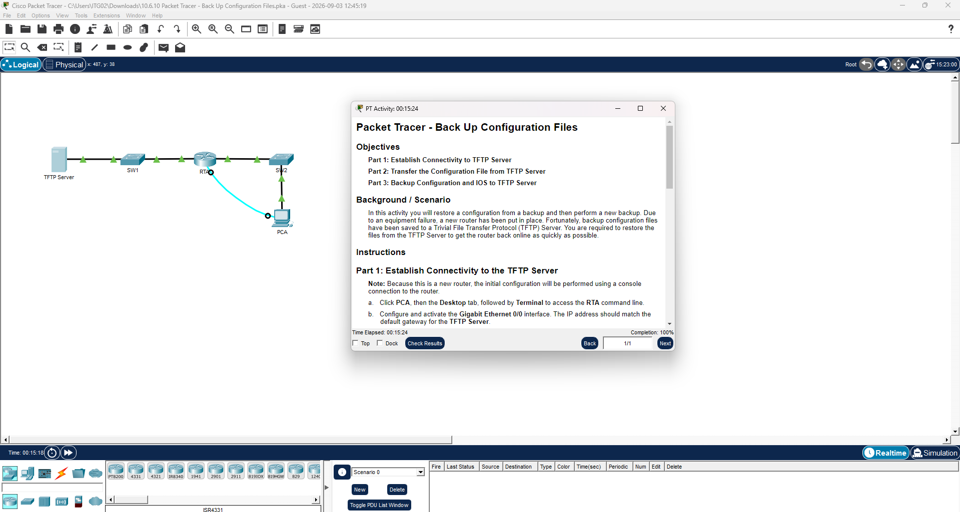

Packet Tracer Lab Report
Back Up Configuration Files
CCNA — Router and Switch Configuration

Objectives
Part 1: Establish Connectivity to TFTP Server
Part 2: Transfer the Configuration File from TFTP Server
Part 3: Backup Configuration and IOS to TFTP Server

Background / Scenario
In this activity, a configuration is restored from a backup and then a new backup is performed. Due to an equipment failure, a new router has been put in place. Fortunately, backup configuration files have been saved to a Trivial File Transfer Protocol (TFTP) server. The task is to restore the files from the TFTP server to get the router back online as quickly as possible, then create a fresh backup of the new configuration and the IOS image.

Network Topology
TFTP Server — SW1 — RTA — SW2 — PCA (PCA also connects to RTA via console)

Addressing Table
Device | Interface | IP Address | Subnet Mask | Default Gateway
TFTP Server | NIC | 172.16.1.2 | 255.255.255.0 | 172.16.1.1
RTA | G0/0 | 172.16.1.1 | 255.255.255.0 | —
RTA | G0/1 | 172.16.1.254 | 255.255.255.0 | —
PCA | Console → RTA | N/A (console) | N/A | N/A

Part 1: Establish Connectivity to the TFTP Server
Note: Because this is a new router, the initial configuration is performed using a console connection from PCA.
a. Click PCA, then the Desktop tab, followed by Terminal, to access the RTA command line.
b. Configure and activate the GigabitEthernet 0/0 interface. The IP address must match the default gateway of the TFTP Server (172.16.1.2 → gateway 172.16.1.1).
Router> enable
Router# configure terminal
Router(config)# interface GigabitEthernet0/0
Router(config-if)# ip address 172.16.1.1 255.255.255.0
Router(config-if)# no shutdown
Router(config-if)# exit

c. Test connectivity to the TFTP Server.
Router# ping 172.16.1.2

Sending 5, 100-byte ICMP Echos to 172.16.1.2, timeout is 2 seconds:
!!!!!
Success rate is 100 percent (5/5)

Part 2: Transfer the Configuration File from the TFTP Server
a. From privileged EXEC mode, copy the saved configuration file from the TFTP Server into the running configuration:
RTA# copy tftp running-config
Address or name of remote host []? 172.16.1.2
Source filename []? RTA-confg
Destination filename [running-config]?

Accessing tftp://172.16.1.2/RTA-confg...
Loading RTA-confg from 172.16.1.2: !
[OK - 785 bytes]
785 bytes copied in 0.001 secs
RTA#
%SYS-5-CONFIG_I: Configured from console by console
RTA#

b. Display the current configuration:
RTA# show running-config
Q: What changes were made?
A: The configuration stored on the TFTP Server was loaded into the router, and the hostname of the router changed from “Router” to “RTA.” Other saved settings (such as interface descriptions and line configuration) from the backup file were also applied.

c. Display the interface status:
RTA# show ip interface brief
Q: Are all interfaces active?
A: No. GigabitEthernet0/1 (the link to SW2/PCA) is administratively down, because the restored configuration file did not include a “no shutdown” command for that interface.

d. Correct the interface problem and test connectivity between PCA and the TFTP Server.
RTA# configure terminal
RTA(config)# interface GigabitEthernet0/1
RTA(config-if)# no shutdown
RTA(config-if)# end
RTA# ping <PCA IP address>

Part 3: Back Up Configuration and IOS to the TFTP Server
a. Change the hostname of RTA to RTA-1:
RTA(config)# hostname RTA-1

b. Save the configuration to NVRAM:
RTA-1# copy running-config startup-config

c. Copy the configuration to the TFTP Server:
RTA-1# copy running-config tftp:
Address or name of remote host []? 172.16.1.2
Destination filename [RTA-1-confg]?

d. Display the files stored in flash memory:
RTA-1# show flash:

e. Back up the IOS image in flash to the TFTP Server:
RTA-1# copy flash tftp:
Source filename []? c1900-universalk9-mz.SPA.151-4.M4.bin
Address or name of remote host []? 172.16.1.2
Destination filename [c1900-universalk9-mz.SPA.151-4.M4.bin]?
Q: What special character repeatedly displays indicating that the IOS file is being copied to the TFTP server successfully?
A: The exclamation point (!). Each “!” represents a successfully transferred block of data during the copy operation.

f. Open the TFTP Server, click the Services tab, select TFTP, and scroll through the list of files.
Q: Has the IOS file c1900-universalk9-mz.SPA.151-4.M4.bin been copied to the TFTP Server?
A: Yes. The file c1900-universalk9-mz.SPA.151-4.M4.bin appears in the list of files on the TFTP server, confirming the backup completed successfully.

Summary of Answers
Question | Answer
What changes were made after restoring the config? | Hostname changed to RTA; other saved settings from the backup were applied.
Are all interfaces active? | No — G0/1 was administratively down; corrected with “no shutdown.”
What character indicates a successful TFTP copy? | The exclamation point (!), repeated for each block transferred.
Was the IOS file copied to the TFTP Server? | Yes — confirmed listed under Services > TFTP on the server.

End of Report

