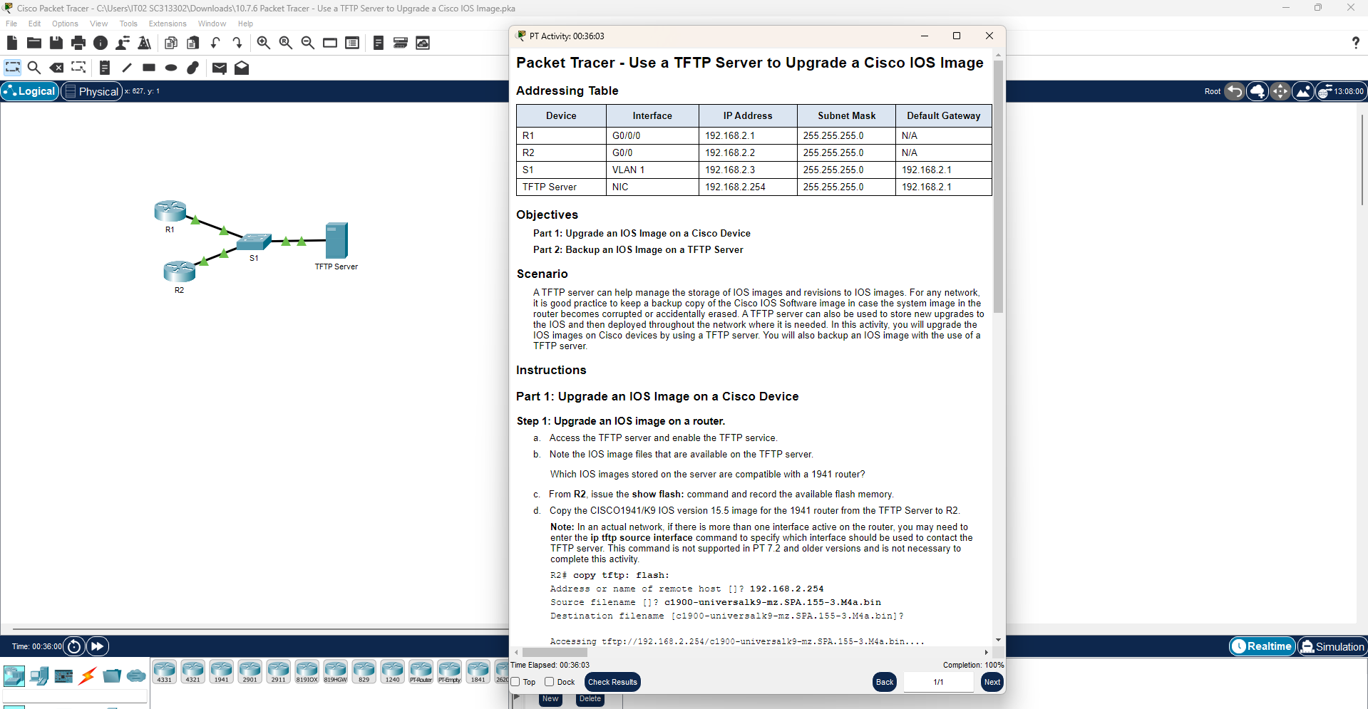

Packet Tracer Lab Report
Use a TFTP Server to Upgrade a Cisco IOS Image
CCNA — IOS Image Management

Objectives
Part 1: Upgrade an IOS Image on a Cisco Device
Part 2: Backup an IOS Image on a TFTP Server

Scenario
A TFTP server can help manage the storage of IOS images and revisions to IOS images. For any network, it is good practice to keep a backup copy of the Cisco IOS Software image in case the system image in the router becomes corrupted or accidentally erased. A TFTP server can also be used to store new upgrades to the IOS and then deploy them throughout the network where needed. In this activity, the IOS images on Cisco devices are upgraded using a TFTP server, and an IOS image is backed up to a TFTP server.

Network Topology
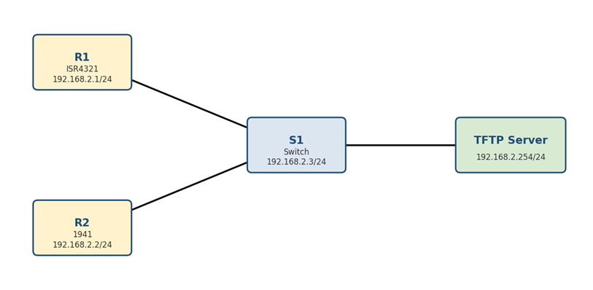
R1 and R2 connect to S1, which connects to the TFTP Server — all on the 192.168.2.0/24 network.

Addressing Table
Device | Interface | IP Address | Subnet Mask | Default Gateway
R1 | G0/0/0 | 192.168.2.1 | 255.255.255.0 | N/A
R2 | G0/0 | 192.168.2.2 | 255.255.255.0 | N/A
S1 | VLAN 1 | 192.168.2.3 | 255.255.255.0 | 192.168.2.1
TFTP Server | NIC | 192.168.2.254 | 255.255.255.0 | 192.168.2.1

Part 1: Upgrade an IOS Image on a Cisco Device

Section A — Upgrade the IOS Image on Router R2
a. Access the TFTP Server and enable the TFTP service (Desktop > Services > TFTP > On).
b. Note the IOS image files available on the TFTP server.
Q: Which IOS images stored on the server are compatible with a 1941 router?
A: c1900-universalk9-mz.SPA.151-4.M4.bin and c1900-universalk9-mz.SPA.155-3.M4a.bin — both are C1900-series images, matching the Cisco 1941 router platform.

c. From R2, check the available flash memory:
R2# show flash:
Q: How much available flash memory does R2 have (from show flash:)?
A: 221,896,413 bytes are available in flash — enough space to hold the new 15.5(3)M4a image (about 33.6 MB) alongside the existing one.

d. Copy the CISCO1941/K9 IOS version 15.5 image from the TFTP Server to R2:
R2# copy tftp: flash:
Address or name of remote host []? 192.168.2.254
Source filename []? c1900-universalk9-mz.SPA.155-3.M4a.bin
Destination filename [c1900-universalk9-mz.SPA.155-3.M4a.bin]?

Accessing tftp://192.168.2.254/c1900-universalk9-mz.SPA.155-3.M4a.bin....
Loading c1900-universalk9-mz.SPA.155-3.M4a.bin from 192.168.2.254: !!!!!!!!!!!!! ...
[OK - 33591768 bytes]
33591768 bytes copied in 4.099 secs (860453 bytes/sec)
Note: In an actual network, if more than one interface on the router is active, the ip tftp source-interface command may be needed to specify which interface reaches the TFTP server. This command is not supported in Packet Tracer 7.2 and older, and is not required to complete this activity.

e. Verify the IOS image copied successfully to flash:
R2# show flash:
Q: How many IOS images are located in flash after the copy?
A: 2 — the original 15.1(4)M4 image and the newly copied 15.5(3)M4a image are both present in flash.

f. Set the router to boot the new 15.5 IP Base image on the next reload:
R2# configure terminal
R2(config)# boot system flash c1900-universalk9-mz.SPA.155-3.M4a.bin
R2(config)# end

g. Save the configuration and reload R2:
R2# copy running-config startup-config
R2# reload

h. After R2 reboots, verify the upgraded IOS image is loaded:
R2# show version

Cisco IOS Software, C1900 Software (C1900-UNIVERSALK9-M), Version 15.5(3)M4a,
RELEASE SOFTWARE (fc1)
Technical Support: http://www.cisco.com/techsupport
Copyright (c) 1986-2016 by Cisco Systems, Inc.
Compiled Thu 06-Oct-16 13:56 by mnguyen
ROM: System Bootstrap, Version 15.0(1r)M9, RELEASE SOFTWARE (fc1)
R2 uptime is 21 seconds
System returned to ROM by power-on
System image file is "flash0:c1900-universalk9-mz.SPA.155-3.M4a.bin"
---- output omitted -----
Q: How can you confirm the router actually booted the new image, and not just copied it?
A: The “System image file” line in show version output points to flash0:c1900-universalk9-mz.SPA.155-3.M4a.bin and the Version line reads 15.5(3)M4a — confirming R2 booted from the newly copied image rather than the original 15.1(4)M4 file.

Section B — Upgrade the IOS Image on Switch S1
a. Access the TFTP Server and copy the c2960-lanbasek9-mz.150-2.SE4.bin image to S1:
S1# copy tftp: flash:
Address or name of remote host []? 192.168.2.254
Source filename []? c2960-lanbasek9-mz.150-2.SE4.bin
Destination filename [c2960-lanbasek9-mz.150-2.SE4.bin]?

b. Configure S1 to load the new image on the next boot:
S1# configure terminal
S1(config)# boot system flash:c2960-lanbasek9-mz.150-2.SE4.bin
S1(config)# end
S1# copy running-config startup-config

c. Reload S1 and verify the new image loaded into memory:
S1# reload

S1# show version
The Version line and System image file path in the show version output should now reference c2960-lanbasek9-mz.150-2.SE4.bin, confirming the switch booted the new image. Close the TFTP configuration window on the server once the transfer completes.

Part 2: Back Up an IOS Image to a TFTP Server
a. On R1, display the contents of flash and record the IOS image filename:
R1# show flash:
Q: What IOS image is currently in flash on R1?
A: isr4300-universalk9.03.16.05.S.155-3.S5-ext.SPA.bin — the IOS image running on the ISR4321 platform used for R1.

b. Use the copy command to back up R1's IOS image in flash to the TFTP Server:
R1# copy flash: tftp:
Source filename []? isr4300-universalk9.03.16.05.S.155-3.S5-ext.SPA.bin
Address or name of remote host []? 192.168.2.254
Destination filename [isr4300-universalk9.03.16.05.S.155-3.S5-ext.SPA.bin]?

Writing isr4300-universalk9.03.16.05.S.155-3.S5-ext.SPA.bin....!!!!!!!!!!!!!!! ...
--- output omitted ----
!!!!!!!!!!!!!!!!!!!!!!!!!!!!!!!!!!!!!!!!!!!!!!!!!!!!!!!!!!!!!!!!!!!!!!!!!!!!!!!!
[OK - 486899872 bytes]
486899872 bytes copied in 18.815 secs (83367 bytes/sec)
Note: The isr4300 image (roughly 487 MB) is considerably larger than the c1900 image, so it takes noticeably longer to transfer to the TFTP server.

c. Access the TFTP Server and verify the IOS image has been copied successfully.
Note: It may be necessary to stop and restart the TFTP service on the server for the newly copied file to appear in the file listing.
Q: How do you confirm the backup on the TFTP server succeeded?
A: On the TFTP Server, open Services > TFTP and check the file list — isr4300-universalk9.03.16.05.S.155-3.S5-ext.SPA.bin should be listed. The “[OK - 486899872 bytes]” confirmation and matching byte count in the router's copy output, together with the file appearing on the server, confirm the backup completed successfully.

Summary of Key Findings
Question | Answer
1941-compatible IOS images on TFTP server | c1900-universalk9-mz.SPA.151-4.M4.bin, c1900-universalk9-mz.SPA.155-3.M4a.bin
Available flash memory on R2 (before copy) | 221,896,413 bytes
IOS images in flash on R2 after copy | 2
Confirmed running version on R2 after reload | 15.5(3)M4a, booted from flash0:c1900-universalk9-mz.SPA.155-3.M4a.bin
IOS image found in flash on R1 | isr4300-universalk9.03.16.05.S.155-3.S5-ext.SPA.bin
R1 backup result | 486,899,872 bytes copied to the TFTP Server; verified present under Services > TFTP

End of Report

