**Documentation**

### **Requirements**

• Php 5.0 or higher

• MySql

### **Installation**

Open database.php file in /inc/ folder

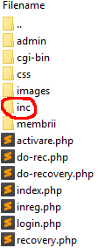

and change the variables with yours.

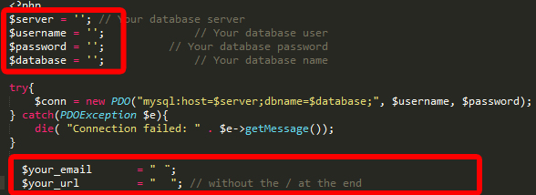

Run users.sql from your phpmyadmin to create the tables.

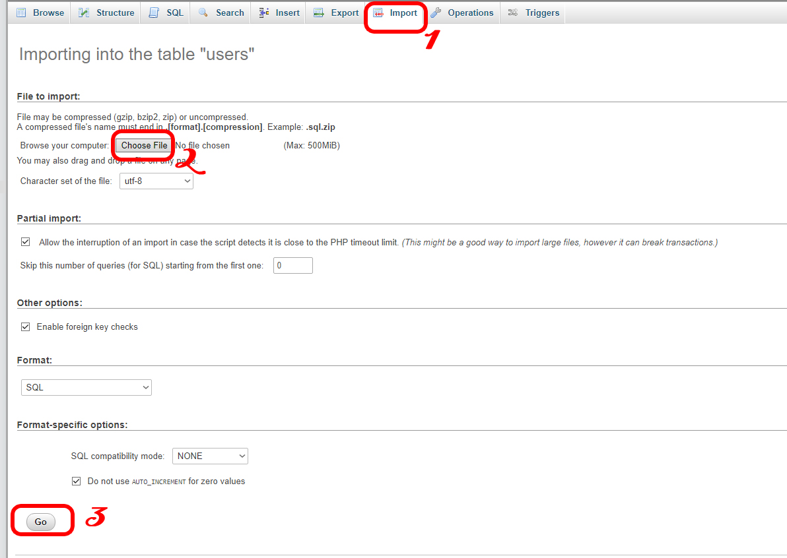

Log onto your Web space either via FTP software like filezilla or a FTP website

like net2ftp.com or wapftp.mobi using your webserver username and password.

Browse to the directory where you wish to place your script.

It is advisable to choose a folder where you will want to install the script.

it is preferable to choose your webhost root folder popularly name “public_html” or “htdoc”.

Select your script using the upload button in your FTP client,

then browse the drive/folder where the script is.

Click “Upload,” “Send,” or your FTP client’s equivalent.

Wait until the transfer is complete.

It has to look something like this

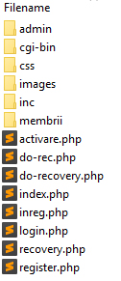

**Running for first time your script**

Create a new user with your e-mail address

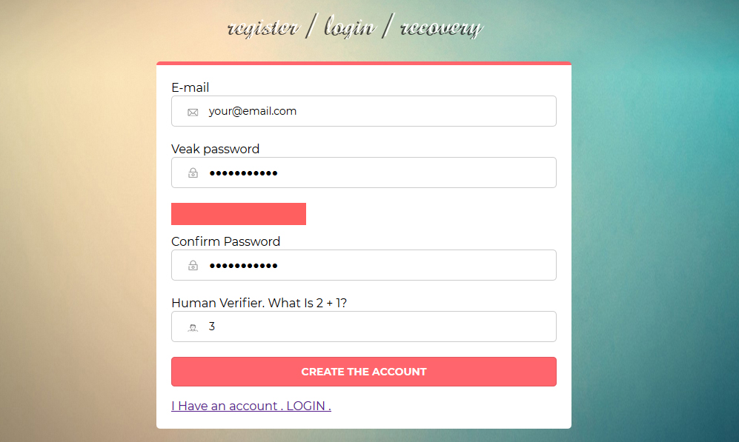

Now in your e-mail address in inbox or spam folder you have an email to activate your account.

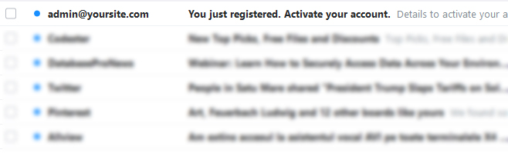

and activate your account

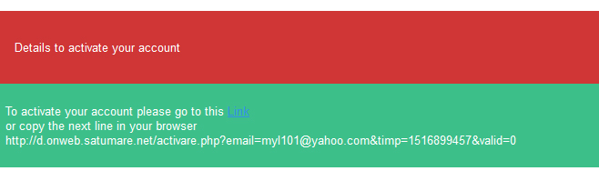

Now please login with:

username: [admin@admin.com](mailto:admin@admin.com) and password: admin 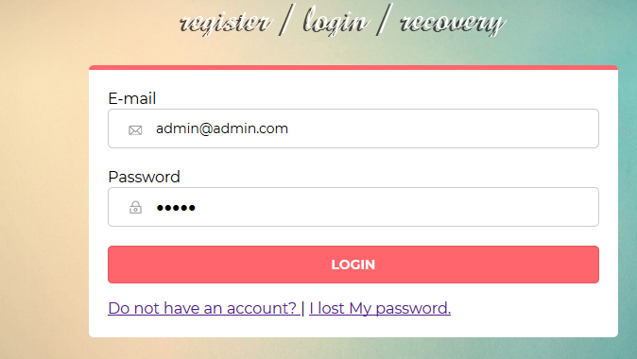

And edit your email as admin so you can delete [admin@admin.com](mailto:admin@admin.com).

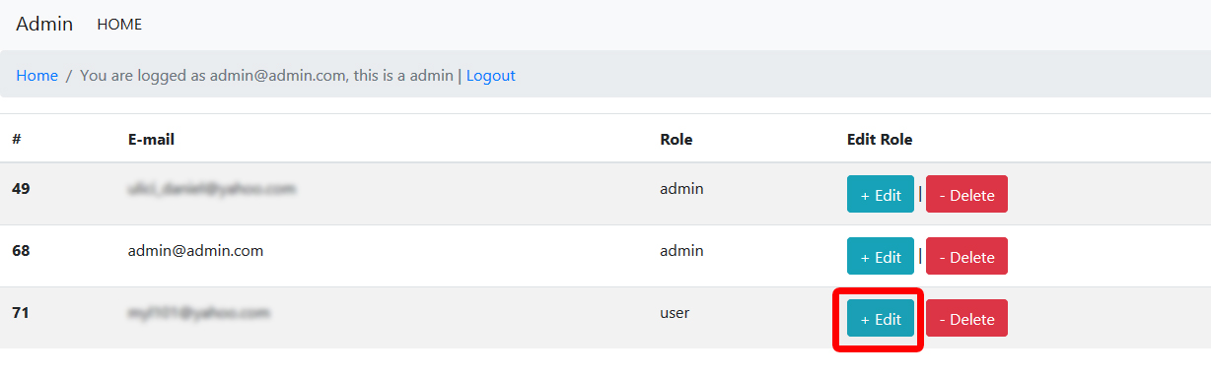

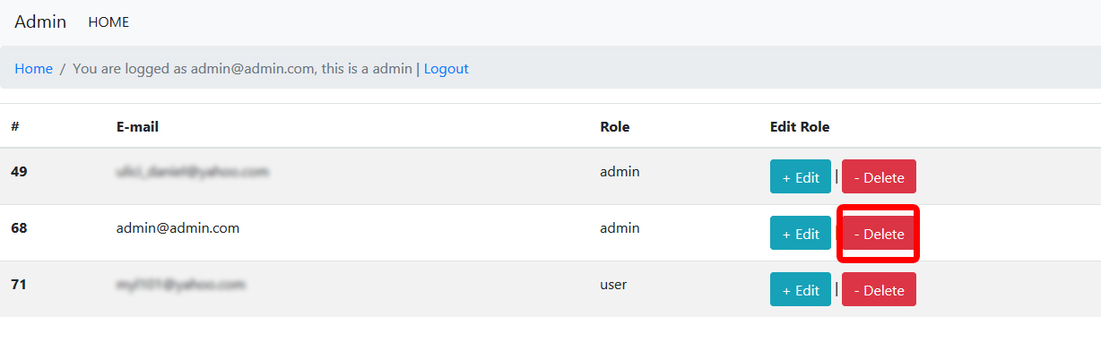

Logout and login as admin with your email and password.