# Création du serveur virtuel Linux ReadHat 7.1

La création du serveur virtuel VMWare / Linux ReadHat 7.1 a été réalisée par la société Telindus.

Elle est réside chez Telindus.

Cette machine virtuelle doit héberger deux bases de données Oracle :

* Une base pour le projet SDDV.
* Une base pour le projet SRD2.

En outre, les serveurs d’application suivants seront aussi hébergés dans la même VM :

* Un serveur Weblogic.
* Un serveur Oracle Forms.
* Un jdk
* Le serveur GTData.

Le paramétrage de la machine virtuelle Linux, prérequis à l’installation d’Oracle Database, a été effectué selon la procédure décrite à l’URL suivante :

<https://access.redhat.com/documentation/en-us/reference_architectures/2017/html-single/deploying_oracle_database_12c_release_2_on_red_hat_enterprise_linux_7/index>

Notez que Oracle Grid Infrastructure et Asm ne seront pas installé dans ce projet

# Préparation des systèmes de fichiers

# Installation de la distribution Oracle 12.2

L’installation Oracle est réalisé à partir du fichier linuxx64_12201_database.zip téléchargé à partir  
du site internet [www.oracle.com](http://www.oracle.com).

La version Oracle Database à installer est : Oracle Database Enterprise Editiion 12.2.0.1.0

* 1. Copier le fichier linuxx64_12201_database.zip dans le serveur Linux, dans le répertoire /var/tmp/ORACLE, avec le compte unix oracle.
  2. Dé-zipper le fichier : gunzip linuxx64_12201_database.zip
  3. Se déplacer dans le répertoire database
  4. Dans une session ssh ouverte avec le logiciel Mobaxterm, lancer l’installation ./runInstaller

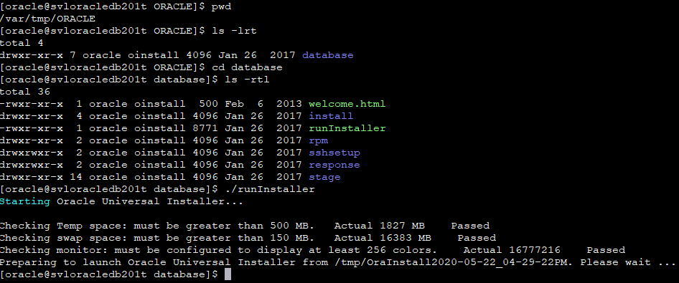

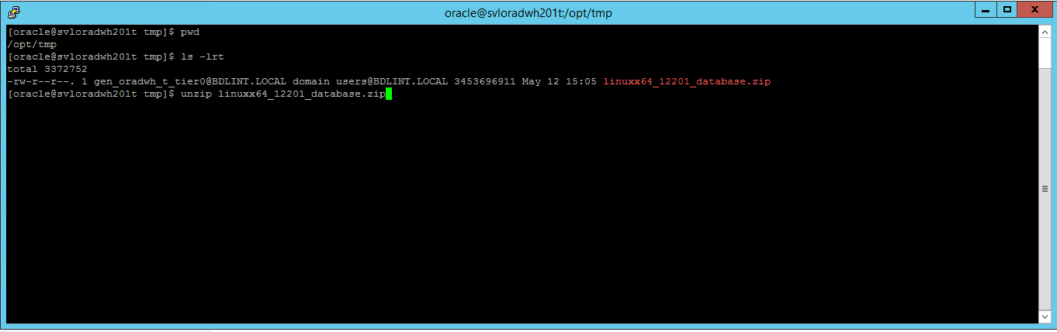

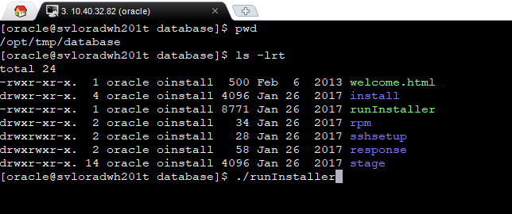

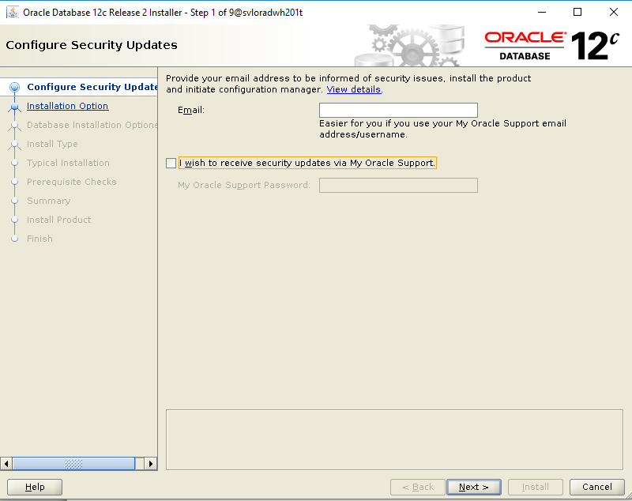

Dé-sélectionner l’option “I wish to receive security updates via My Oracle Support”.

Cliquer « Next »

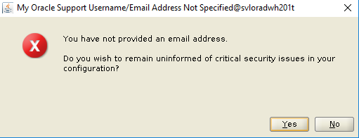

Cliquer “Yes”

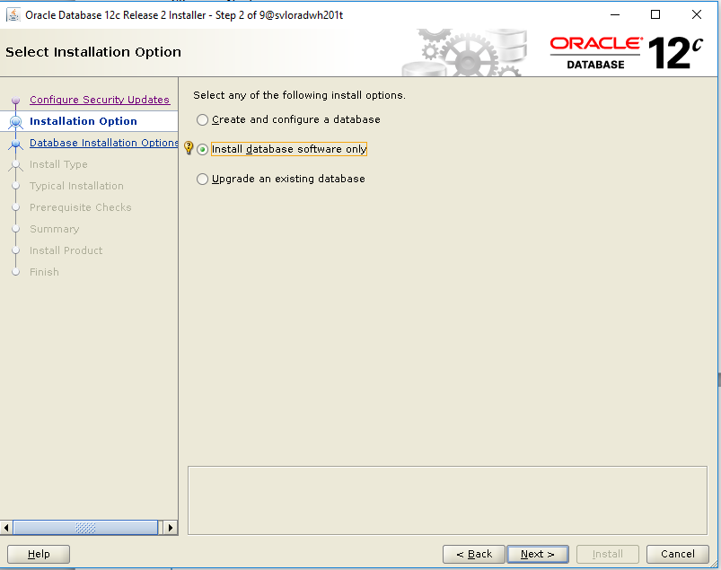

Sélectionner “Install database software only”

Cliquer “Next”

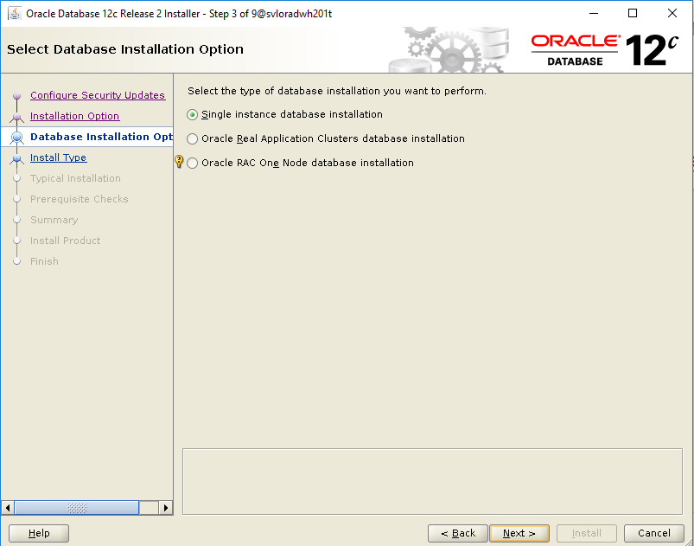

Cliquer “Next”

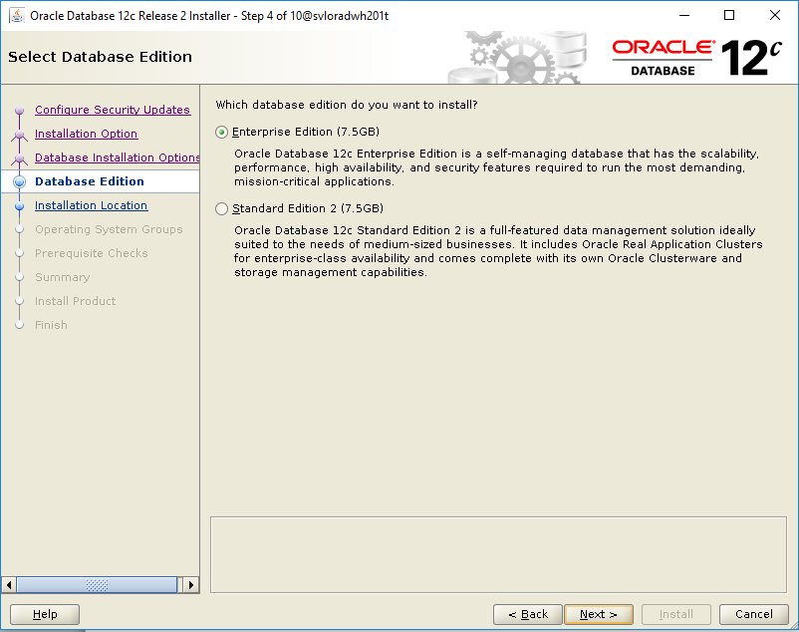

Cliquer “Next”

Encode « Oracle base » et « Software location » comme indiqué ci-dessus.

Cliquer « Next »

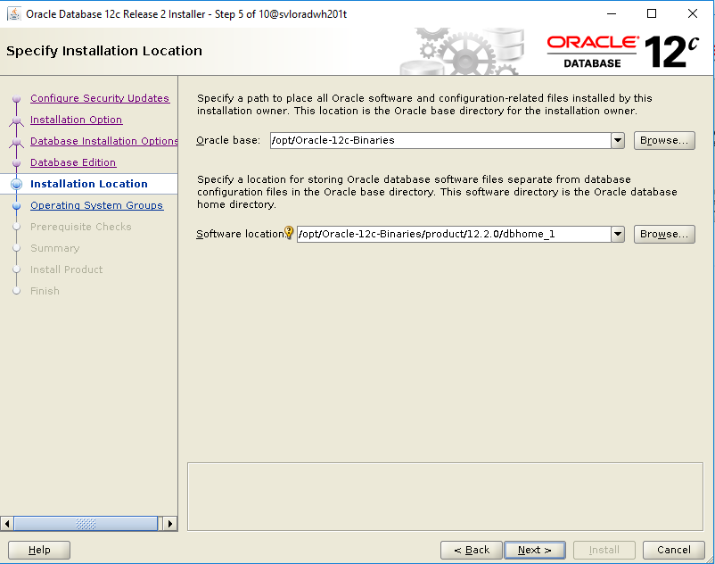

[root@svloradwh201t /]# chmod 777 opt

chmod 777 /opt

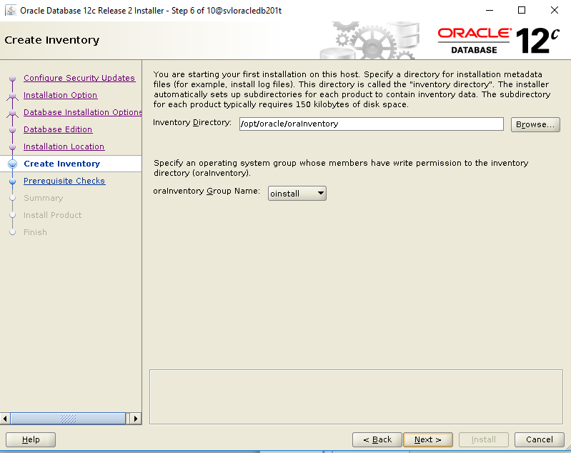

Compléter « Inventory Directory »

Cliquer « Next »

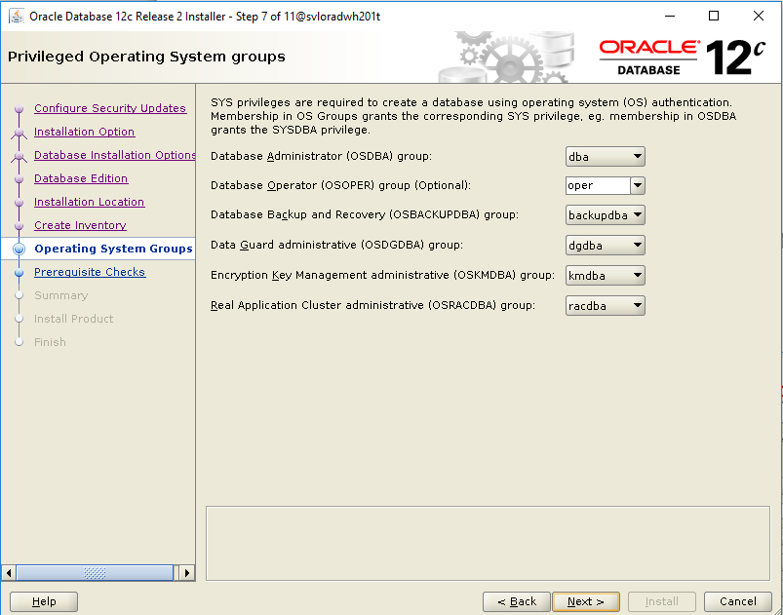

Sélectionner les groupes comme indiqué.

Cliquer « Next »

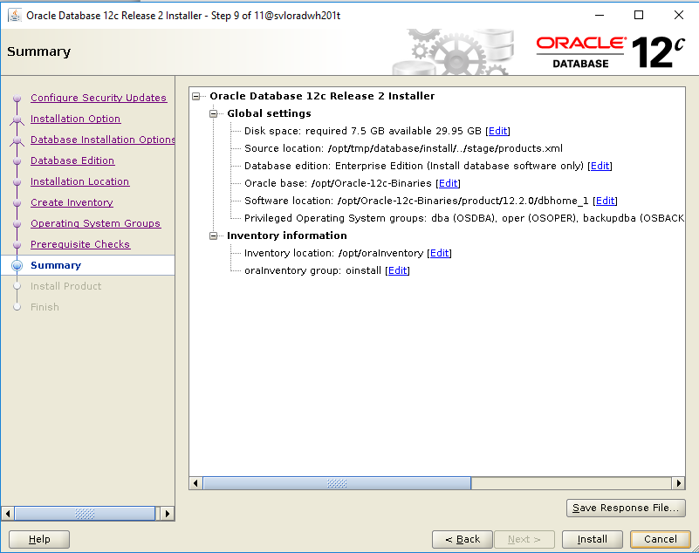

Cliquer sur « Save Response File… »

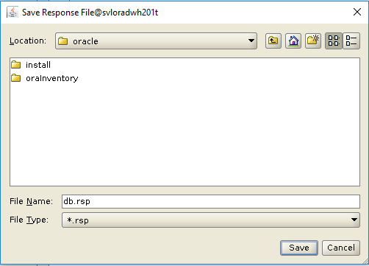

Cliquer sur « Save »

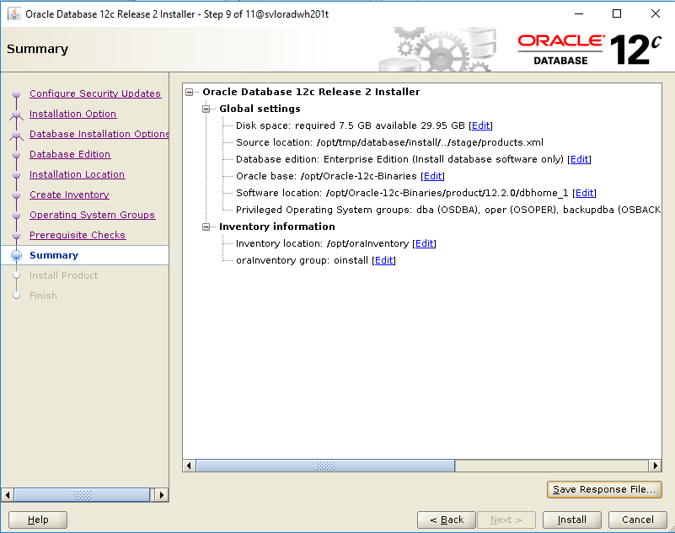

Cliquer « Install »

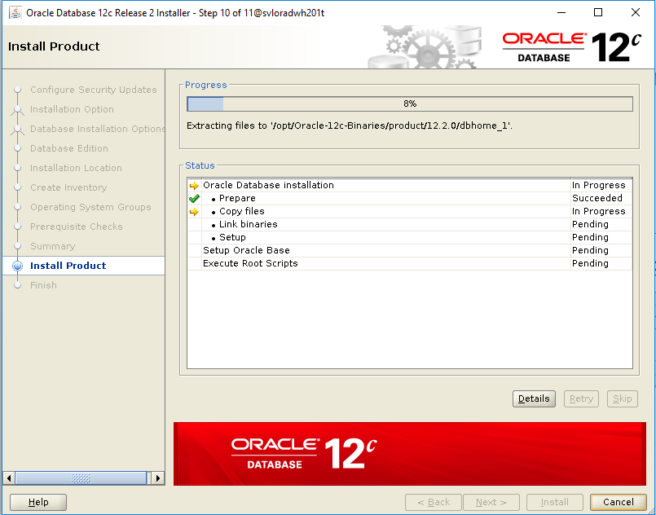

Et patientez le temps du déploiement des binaires.

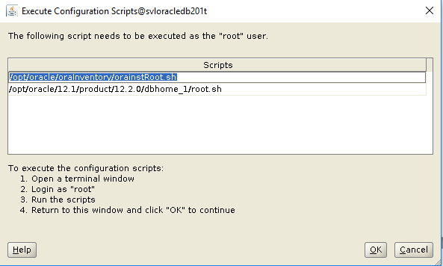

Lorsque la fenêtre ci-dessus apparaît, il faut exécuter chaque script dans une autre session unix ssh connecté avec l’utilisateur root, comme ci-dessous :

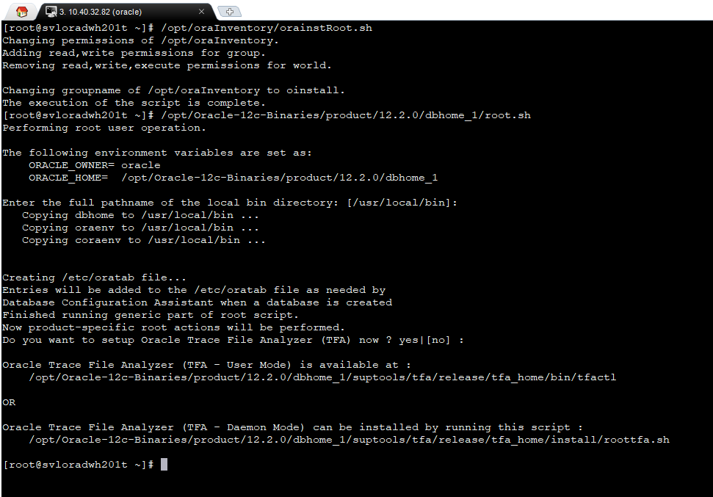

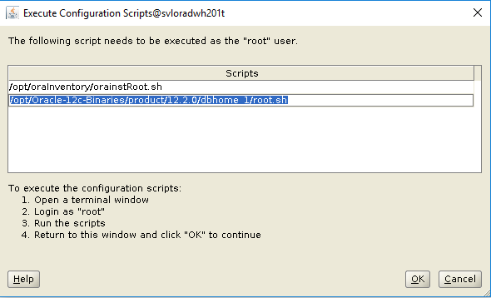

Lorsque les deux scripts ont été exécutés, cliquer « OK »

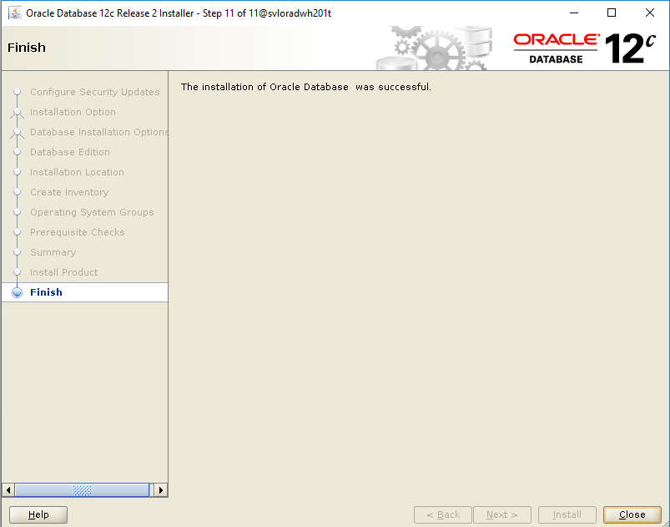

Cliquer « Close »

# Création de la base de données SRD2

La création de la base de données s’effectue avec l’utilitaire dbca.

1. Ouvrir une session ssh avec le logiciel Mobaxterm et se connecter le compte unix Oracle.
2. Préparer un script ($HOME/initsys.cfg par exemple) qui contient les variables d’environnements pour Oracle et qui sera aussi utilsé par les shell scripts  :

# ***********************

# Variables Oracle

# ***********************

ORACLE_BASE=/opt/Oracle-12c-Binaries

export ORACLE_BASE

ORACLE_HOME=/opt/Oracle-12c-Binaries/product/12.2.0/dbhome_1

export ORACLE_HOME

PATH=$PATH:$ORACLE_HOME/bin:$ORACLE_HOME/OPatch:/usr/ccs/bin

export PATH

ORACLE_SID=SRD2

export ORACLE_SID

NLS_LANG=AMERICAN_AMERICA

export NLS_LANG

ORASYSUSR=sys

export ORASYSUSR

ORASYSPWD=mdp

export ORASYSPWD

# ***********************

# Variables shell scripts

# ***********************

ENV=TST

export ENV

DATETIME=`date +%Y%m%d_%H%M%S`;

export DATETIME

DUMPDIR=/opt/oracle/DUMP/fast_recovery;

export DUMPDIR

TRACEDIR=/opt/oracle/DUMP/TRACES;

export TRACEDIR

echo `uname -n` | tr "[:lower:]" "[:upper:]" | read MACHINE

export MACHINE

1. Au prompt Unix, sourcer ce script

. $HOME/initsys.cfg

1. Lancer l’utilitaire dbca.

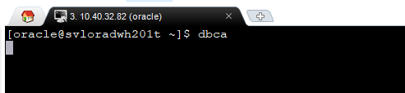

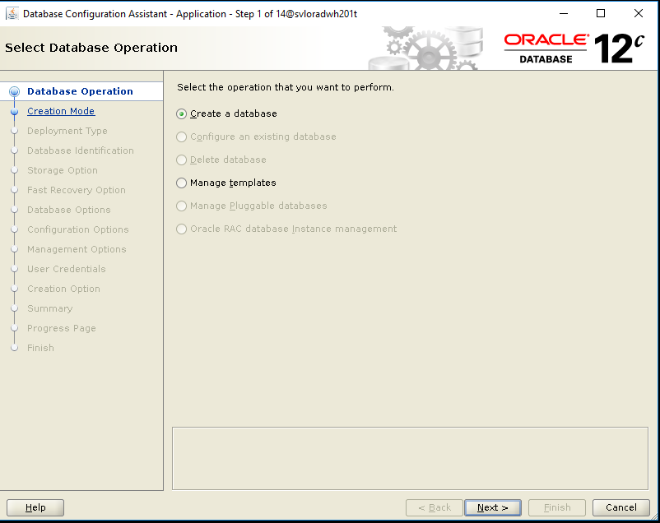

Cliquer « Next »

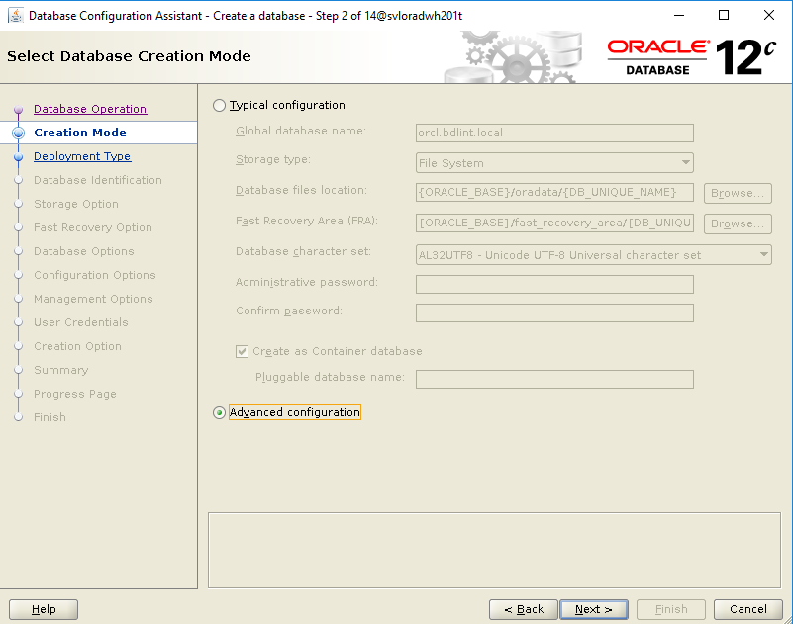

Sélectionner « Advanced configuration »

Cliquer « Next »

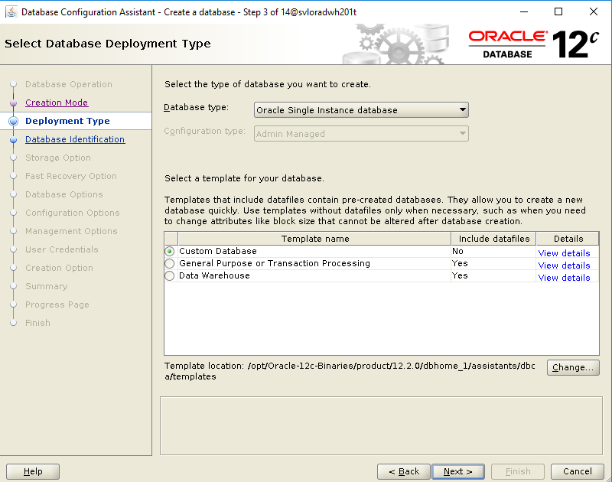

Sélectionner « Custom Database »

Cliquer « Next »

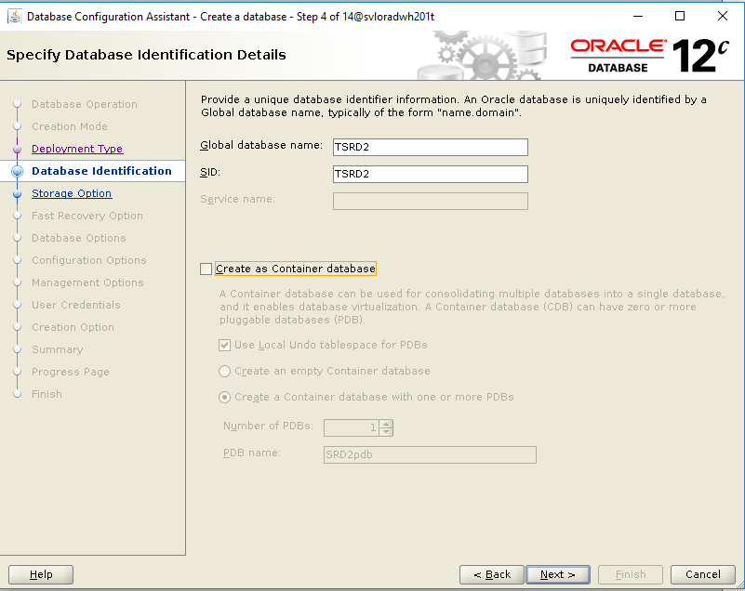

Encoder le nom de l’instance « Global database name »

Encoder le SID

Décocher « Create as Container database »

Cliquer « Next »

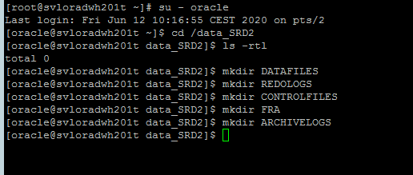

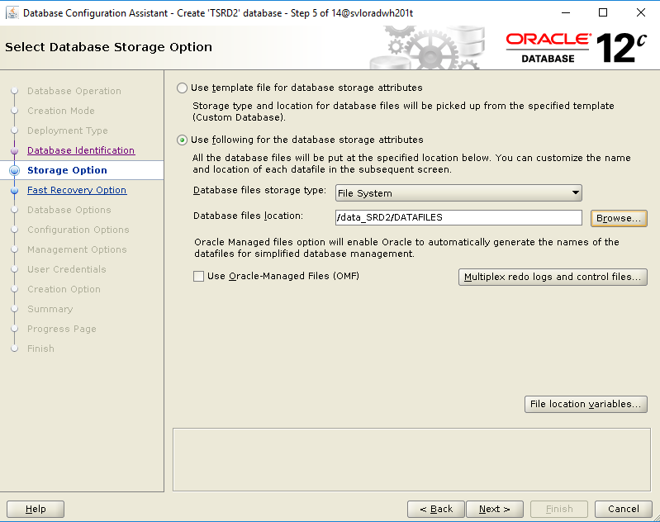

Encoder le paramètre « Database files location »

Cliquer « Next »

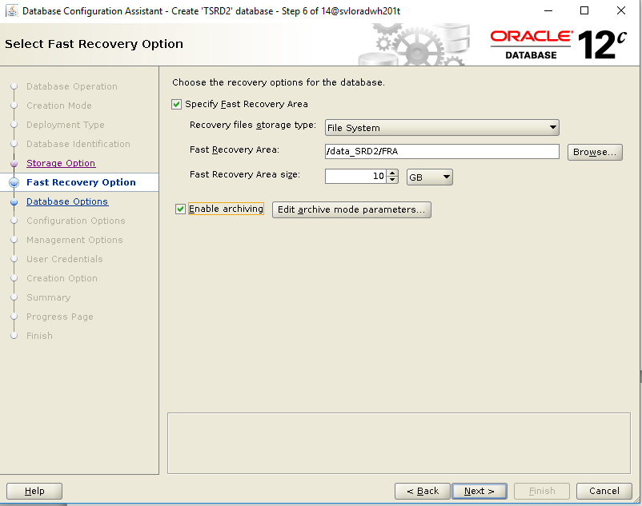

Encoder le paramètre “Fast Recovery Area”

Encoder le paramètre “Fast Recovery Area size”

Cochez la cache “Enable Archiving”

Cliquer « Edit archive mode parameters »

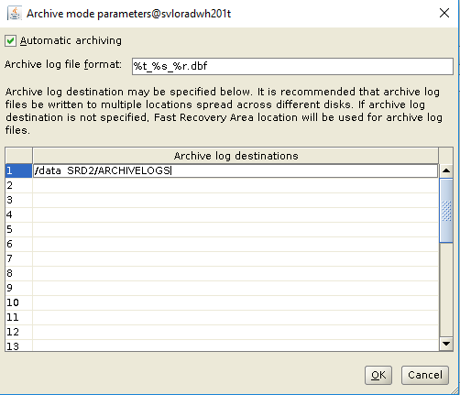

Encoder le répertoire où seront stockés les fichiers archivelog.

Cliquer « OK »

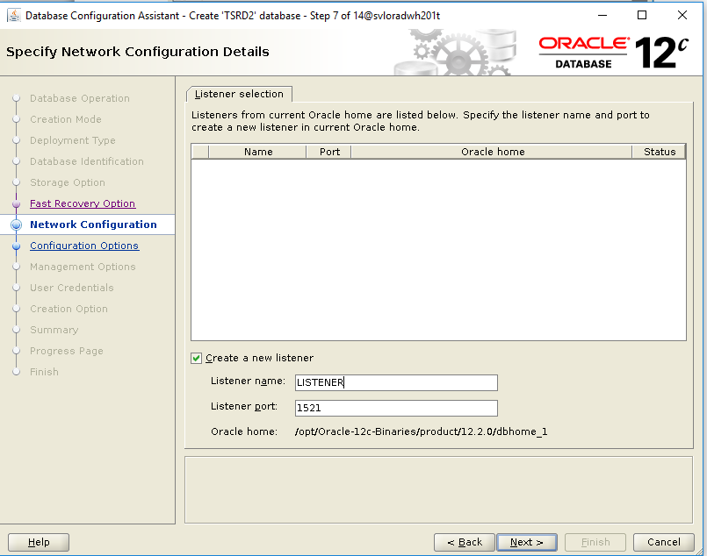

Cocher « create a new listener » et encoder les deux paramètres « Listener Name » et « Listener Port » comme indiqué.

Cliquer « Next »

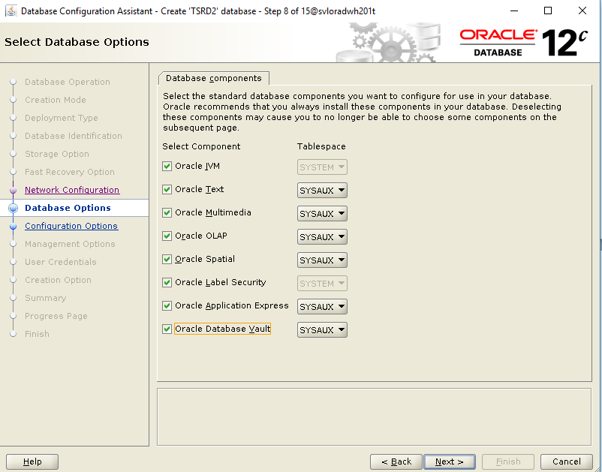

Cocher toutes les options

Cliquer « Next »

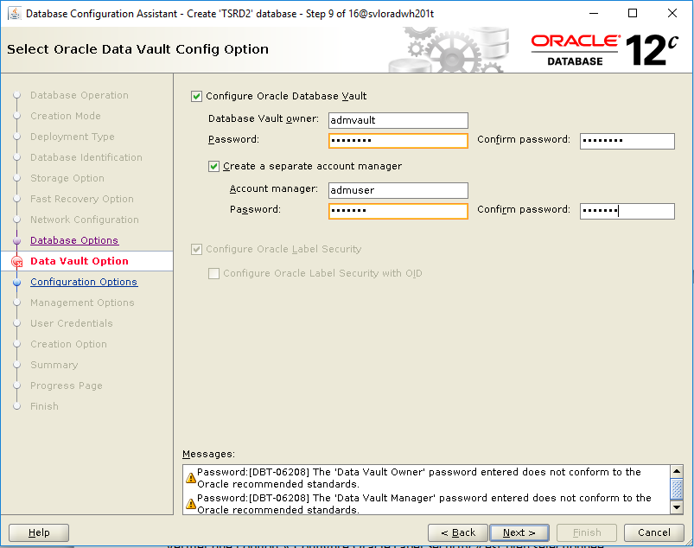

Vérifier que l’option « Configure Oracle Label Security » est bien sélectionnée.

Cocher les options « Configure Oracle Database Vault » et « Create a separate account manager »

Puis compléter les comptes et mots de passe :

admvault/SRD2vault

admuser/SRD2user

Cliquer « Next »

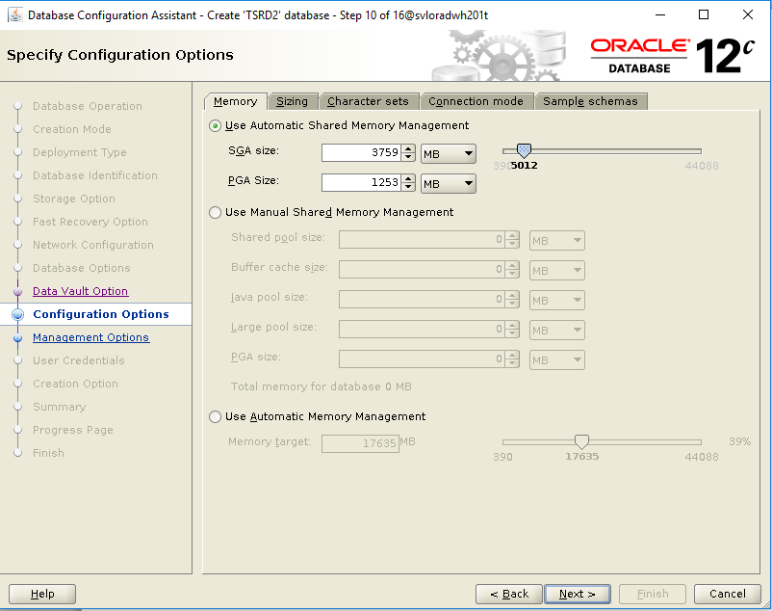

Sélectionner « Use Automatic Shared Memory Management »

Et indiquer les SGA et PGA size.

Cliquer sur l’onglet « Character sets »

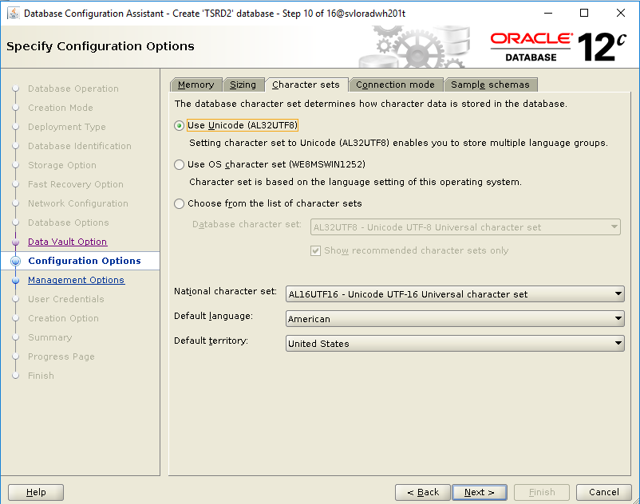

Sélectionner « Use Unicode (AL32UTF8)

Choisissez « National Character set, le « Default language ainsi que le Default Teritory

Cliquer sur l’onglet « Connection mode  ».

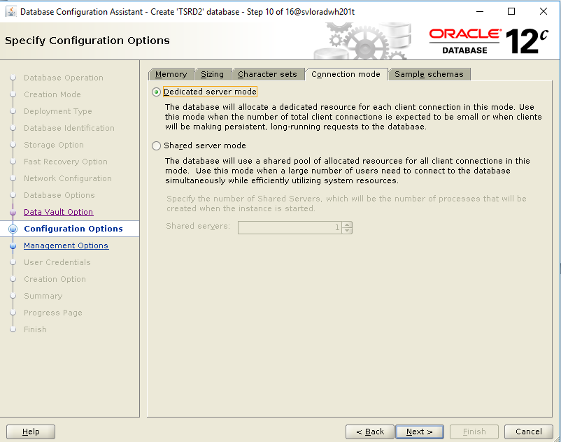

Sélectionner « Dedicated server mode »

Cliquer “Next”

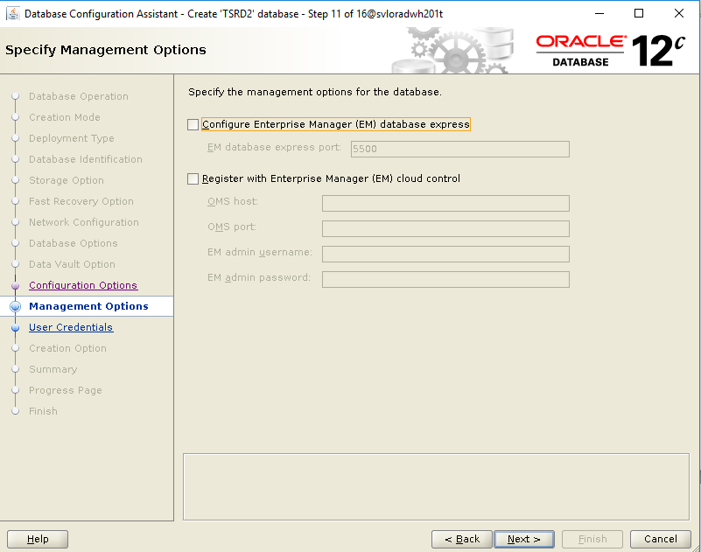

Dé-sélectionner « Configure Enterprise Manager EM database express »

Cliquer « Next »

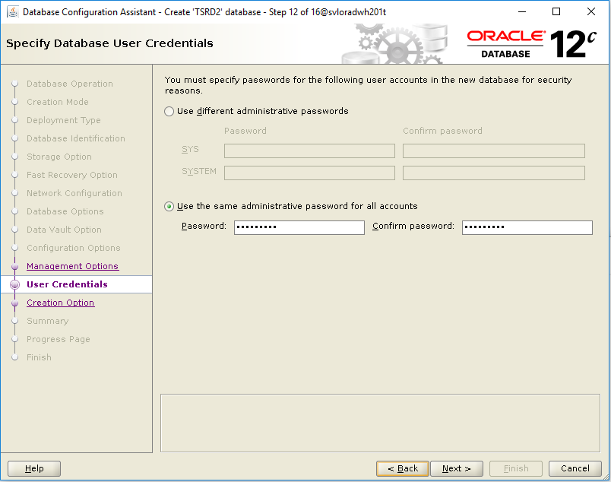

Sélectionner « Use the same administrative password for all accounts »

Encoder le mot de passe de SYS et SYSTEM : SRD2sys01

Cliquer « Next »

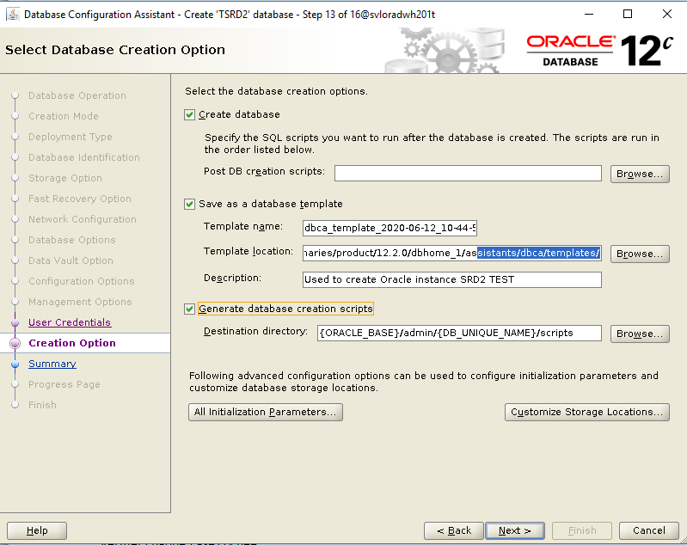

Sélectionner « Create database »

Sélectionner « Save as a database template » et encoder les champs comme indiqué.

Sélectionner « Generate database creation scripts » et encoder le champs comme indiqué.

Sélectionner « All Initialization parameters… »

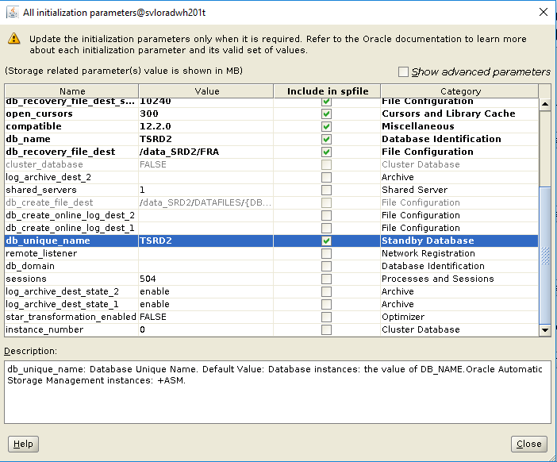

Vérifier chaque case cochée.

sélectionner et modifier db_uniq_name

Cliquer sur « Close »

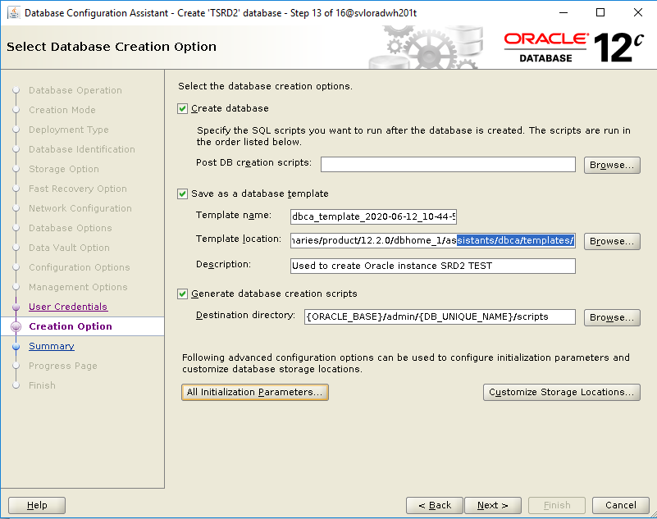

Sélectionner « Customize Storage Location »

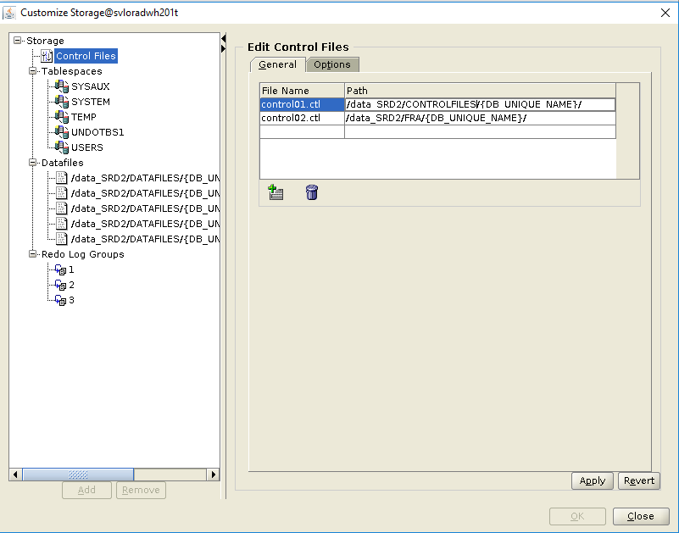

Cliquer « Apply »

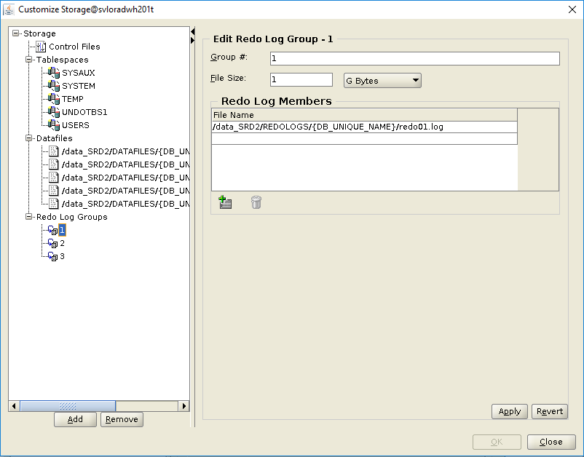

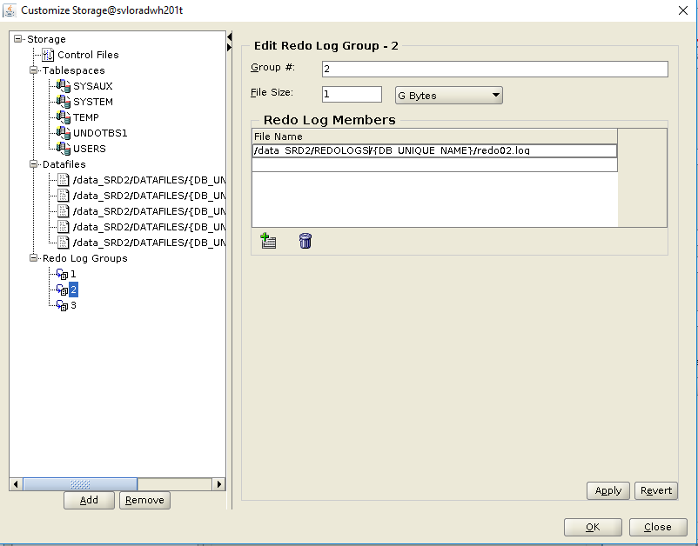

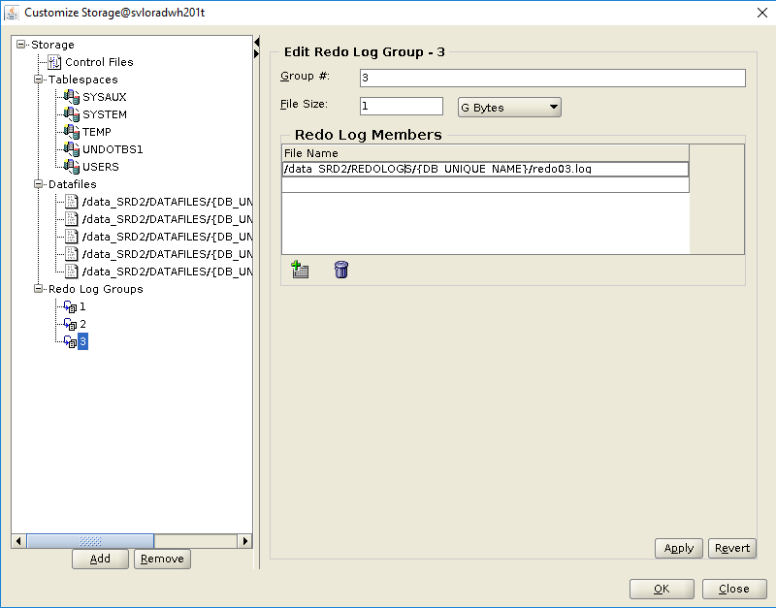

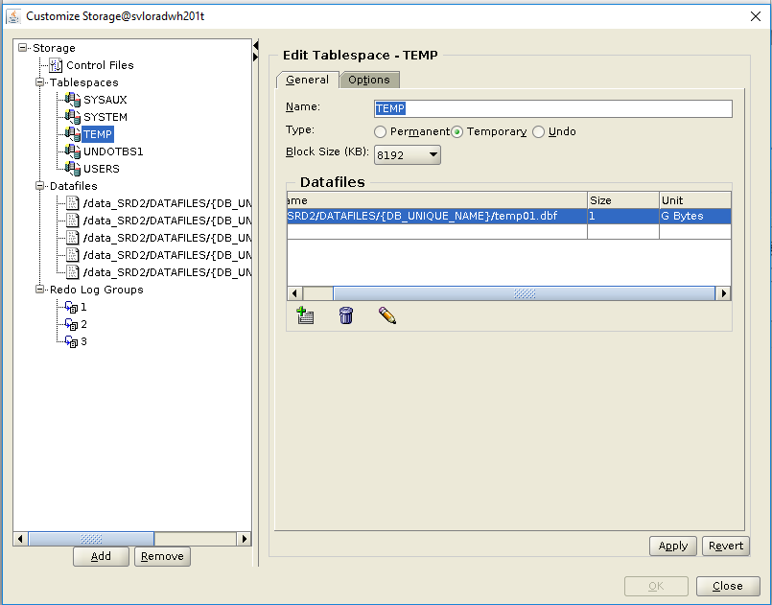

Changer la taille du fichier = 1 GB

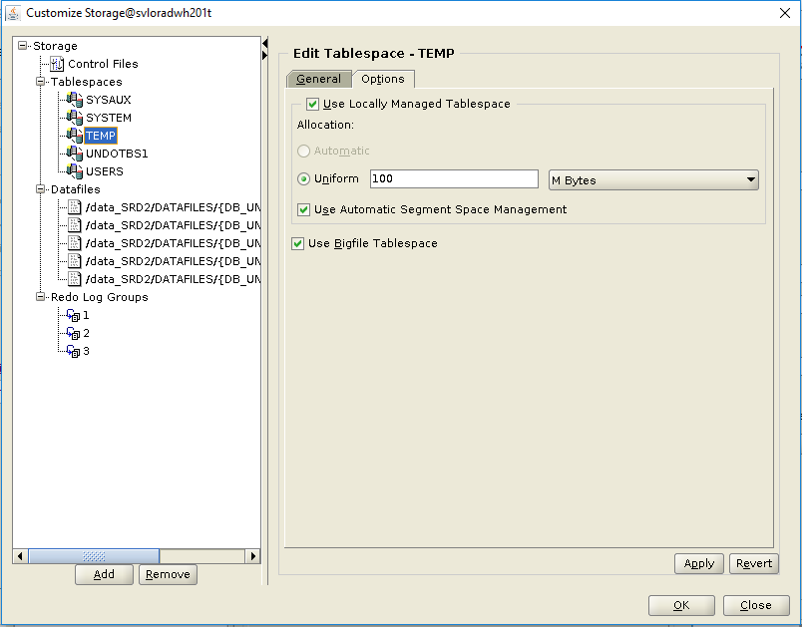

Changer « Uniform »

Sélectionner « Use Bigfile Tablespace »

Cliquer « Apply »

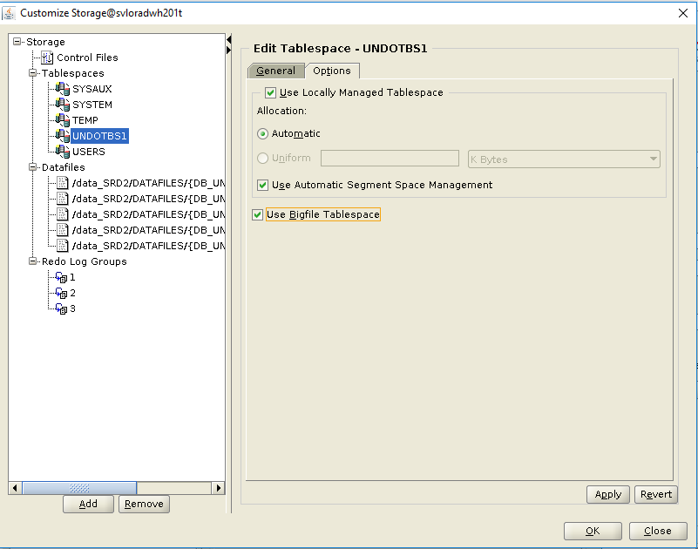

Sélectionner « Use Bigfile Tablespace »

Cliquer « Apply »

Cliquer « OK »

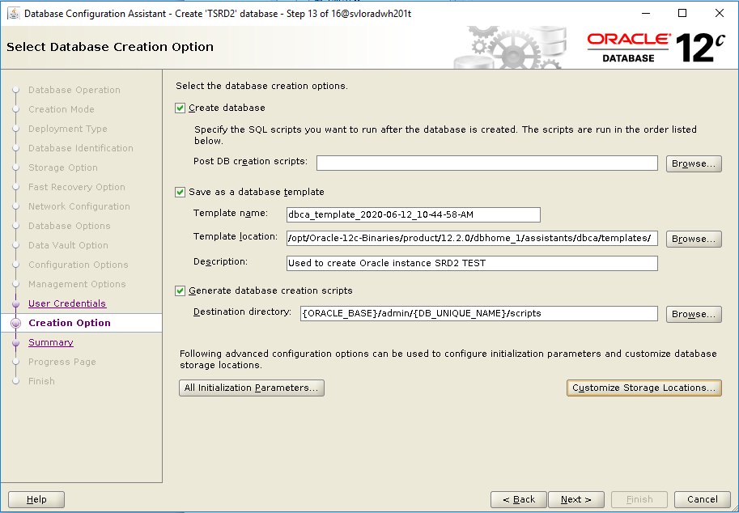

Cliquer « Next »

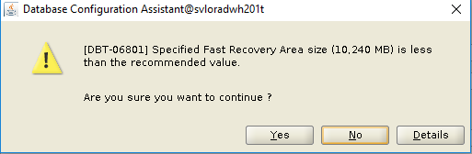

Cliquer « Yes »

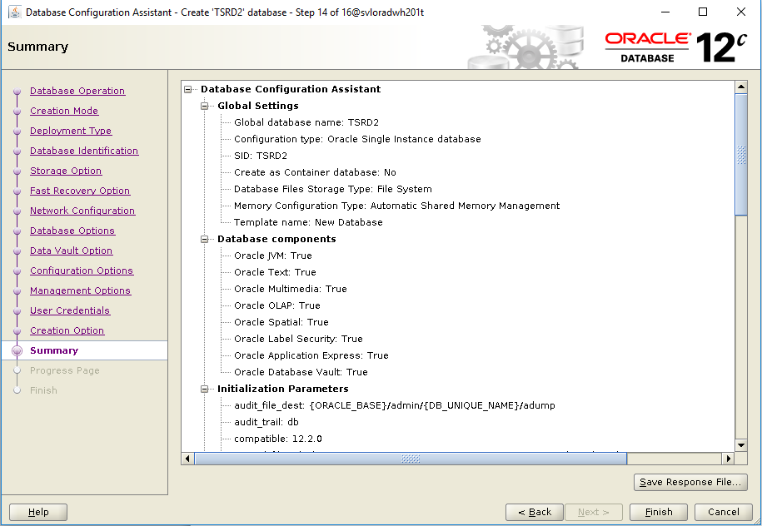

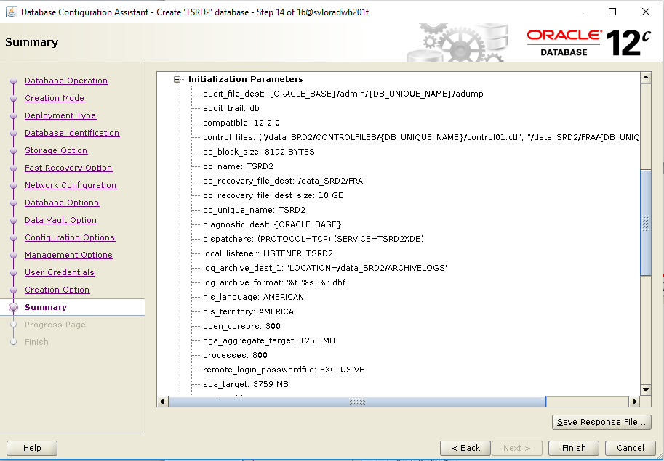

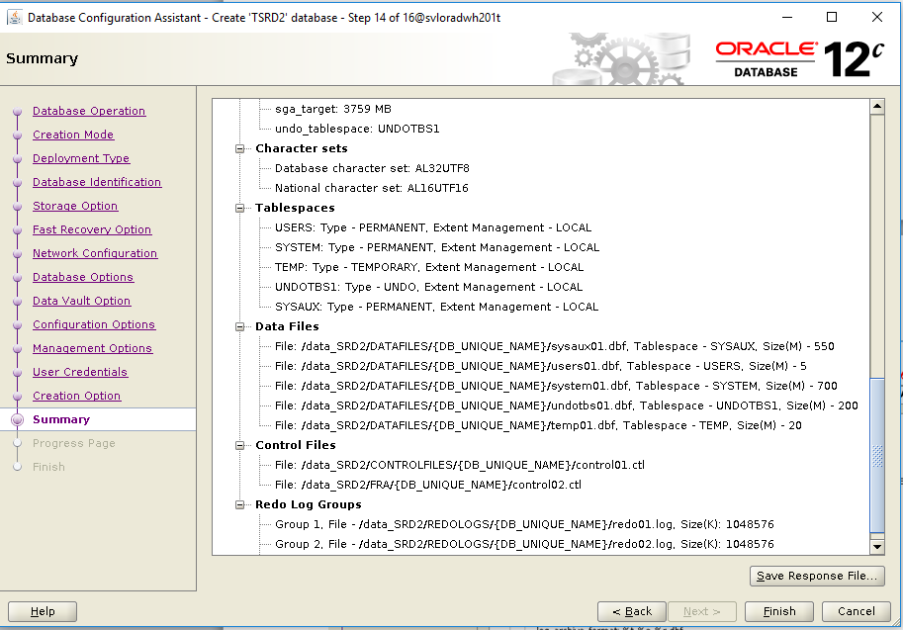

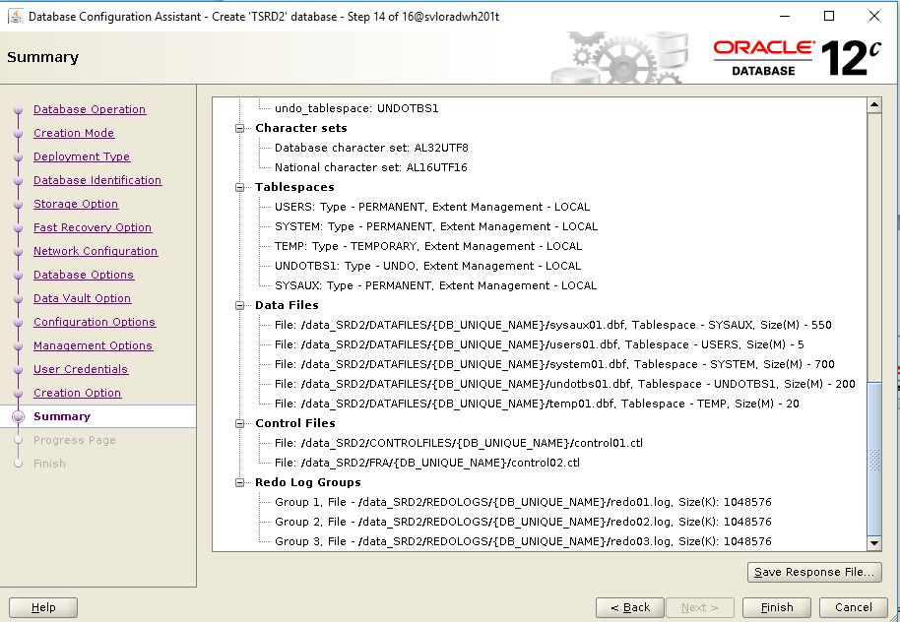

Cliquer sur « Save Response »

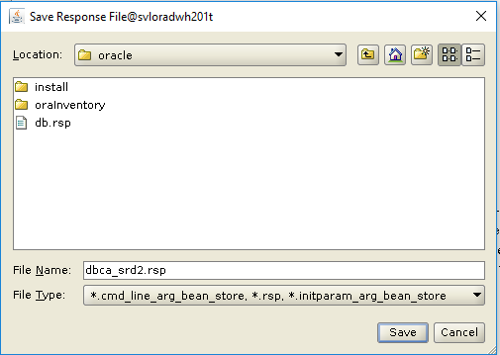

Enter le nom du fichier à sauvegarder

Cliquer « Save »

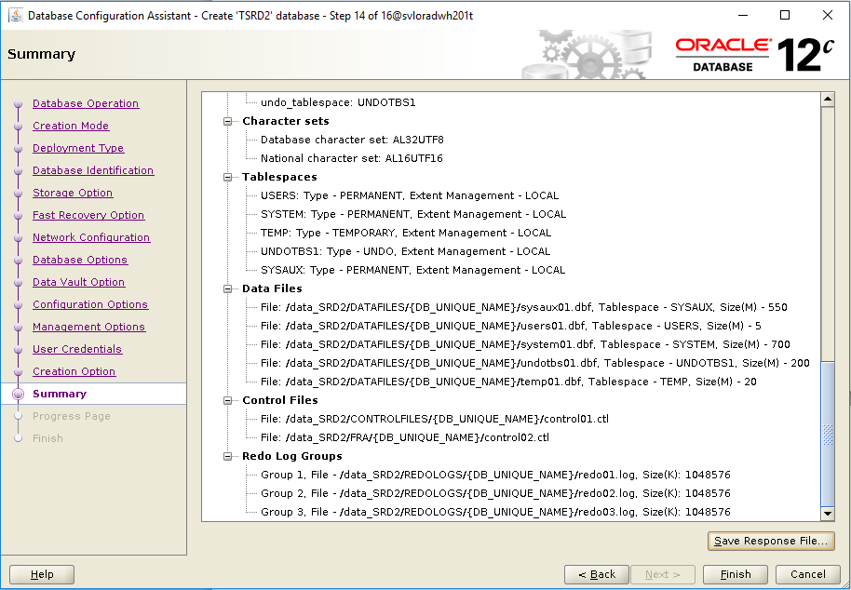

Cliquer « Finish »

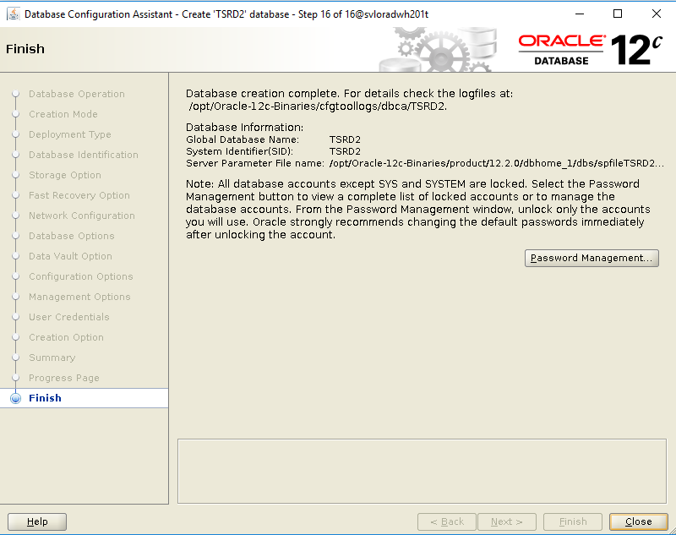

Cliquer « Close »

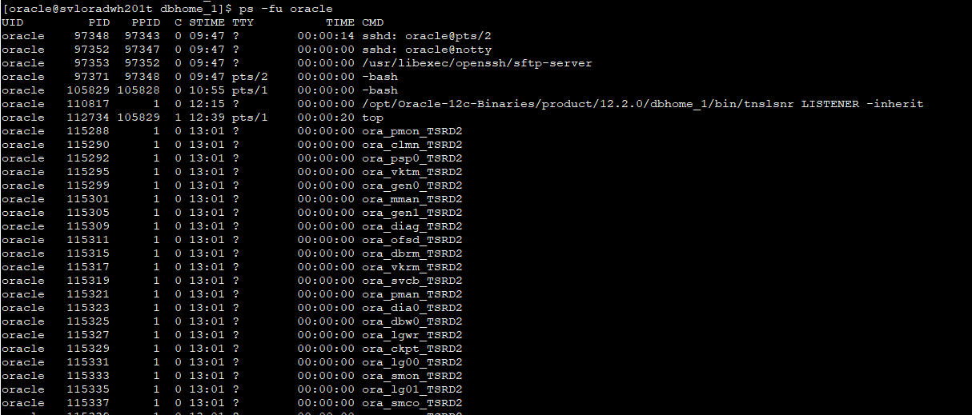

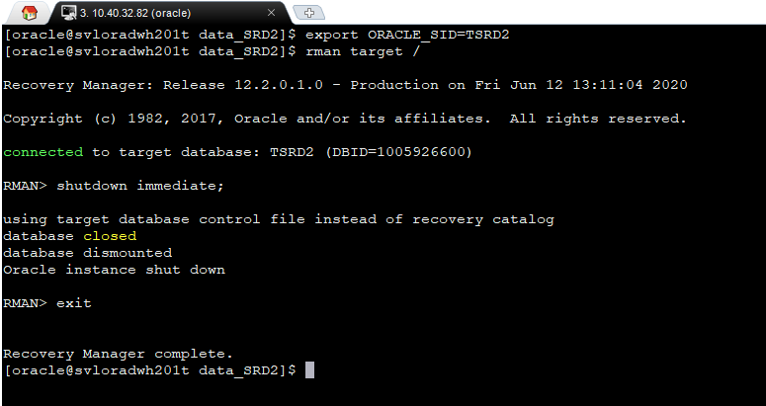



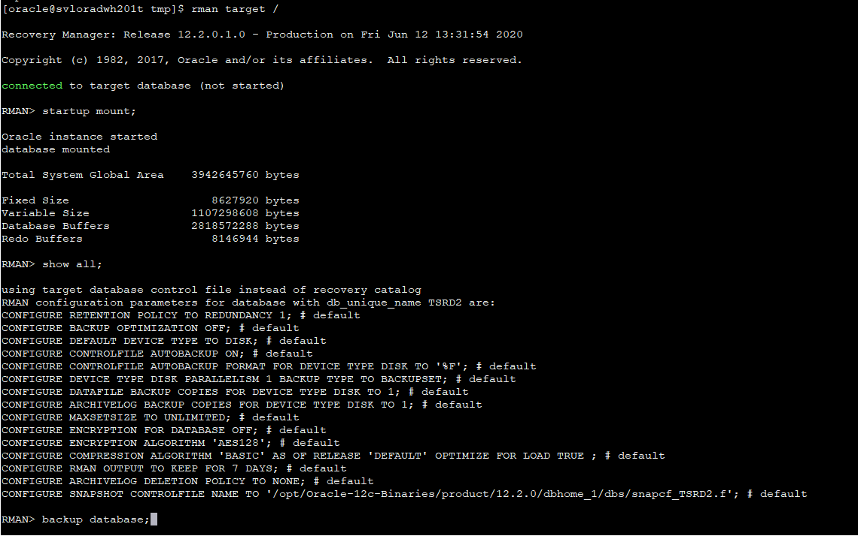

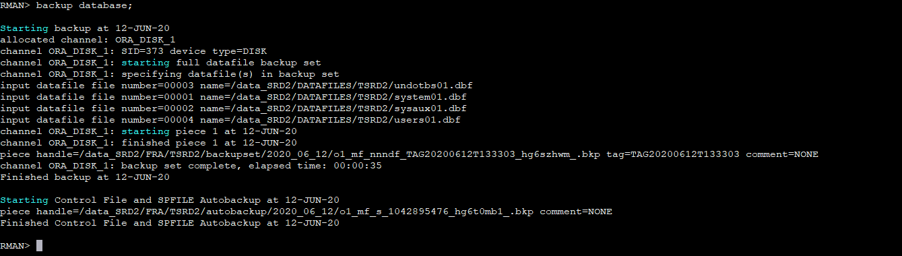

# Création de la base de données SDDV

La création de la base de données s’effectue avec l’utilitaire dbca.

1. Ouvrir une session ssh avec le logiciel Mobaxterm et se connecter le compte unix Oracle.
2. Préparer un script ($HOME/initsys.cfg par exemple) qui contient les variables d’environnements pour Oracle et qui sera aussi utilsé par les shell scripts  :

# ***********************

# Variables Oracle

# ***********************

ORACLE_BASE=/opt/Oracle-12c-Binaries

export ORACLE_BASE

ORACLE_HOME=/opt/Oracle-12c-Binaries/product/12.2.0/dbhome_1

export ORACLE_HOME

PATH=$PATH:$ORACLE_HOME/bin:$ORACLE_HOME/OPatch:/usr/ccs/bin

export PATH

ORACLE_SID=SRD2

export ORACLE_SID

NLS_LANG=AMERICAN_AMERICA

export NLS_LANG

ORASYSUSR=sys

export ORASYSUSR

ORASYSPWD=mdp

export ORASYSPWD

# ***********************

# Variables shell scripts

# ***********************

ENV=TST

export ENV

DATETIME=`date +%Y%m%d_%H%M%S`;

export DATETIME

DUMPDIR=/opt/oracle/DUMP/fast_recovery;

export DUMPDIR

TRACEDIR=/opt/oracle/DUMP/TRACES;

export TRACEDIR

echo `uname -n` | tr "[:lower:]" "[:upper:]" | read MACHINE

export MACHINE

1. Au prompt Unix, sourcer ce script

. $HOME/initsys.cfg

1. Lancer l’utilitaire dbca.

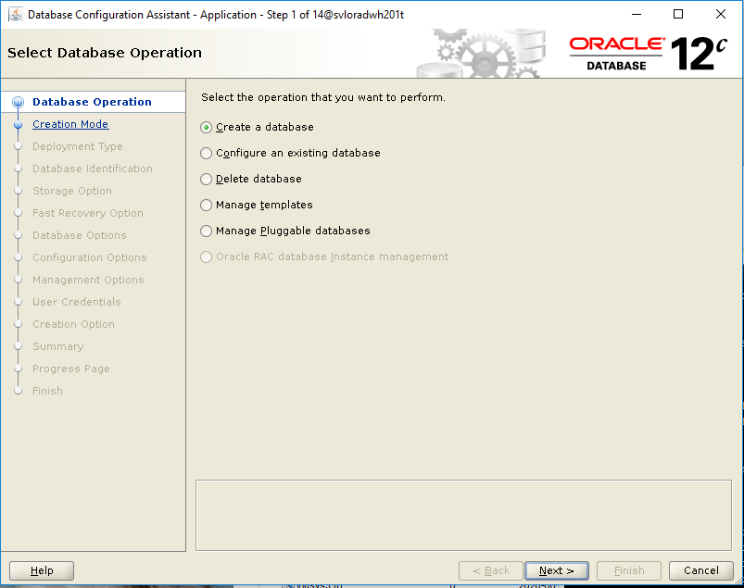

Cliquer « Next »

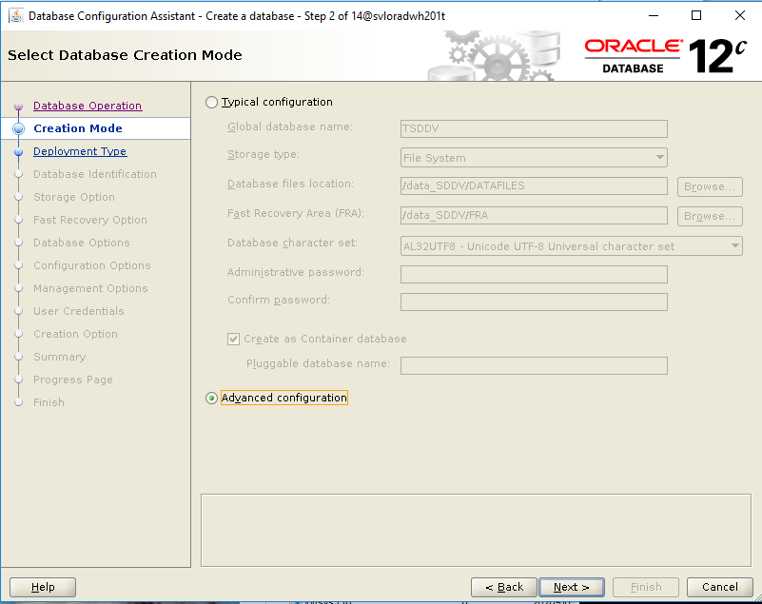

Sélectionner « Advanced configuration »

Cliquer « Next »

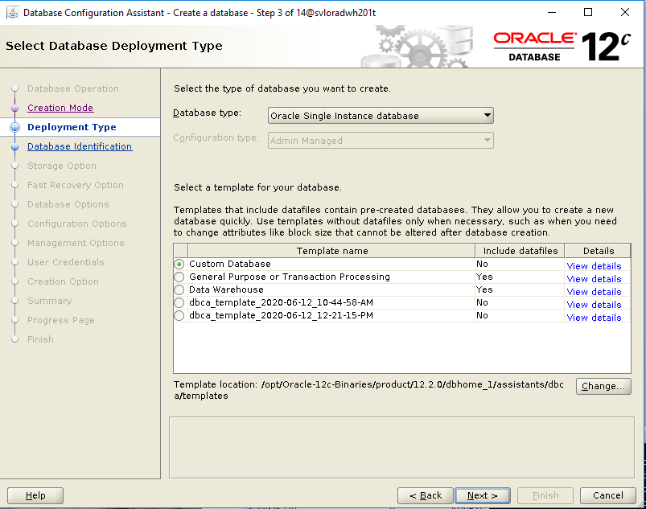

Sélectionner « Custom Database »

Cliquer « Next »

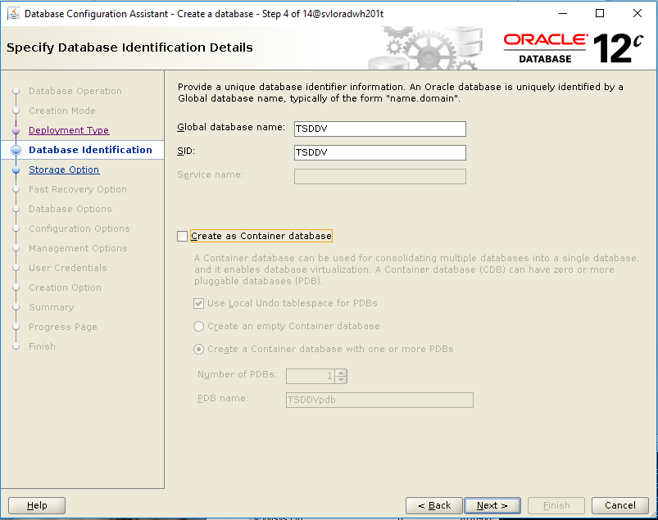

Encoder le nom de l’instance SID

Cliquer « Next »

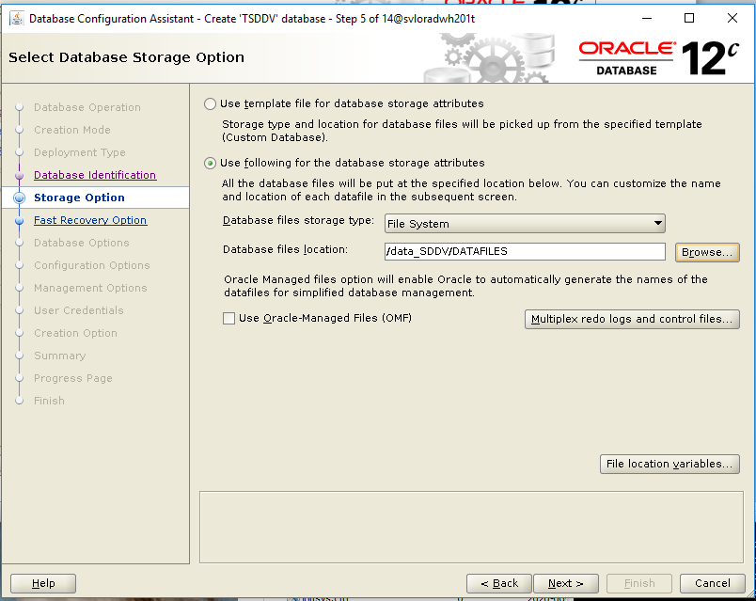

Encoder le paramètre « Database files location »

Cliquer « Next »

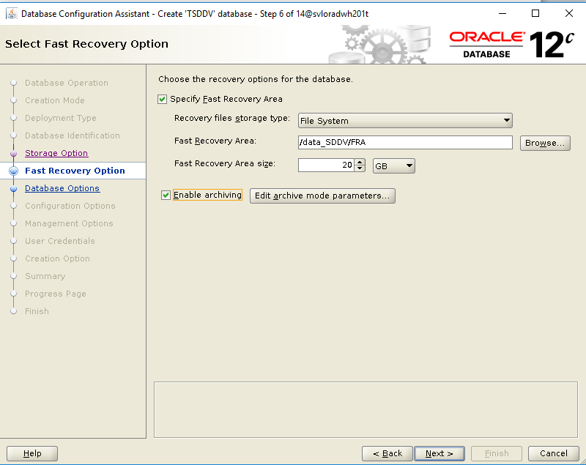

Encoder le paramètre “Fast Recovery Area”

Encoder le paramètre “Fast Recovery Area size”

Cochez la cache “Enable Archiving”

Cliquer « Edit archive mode parameters »

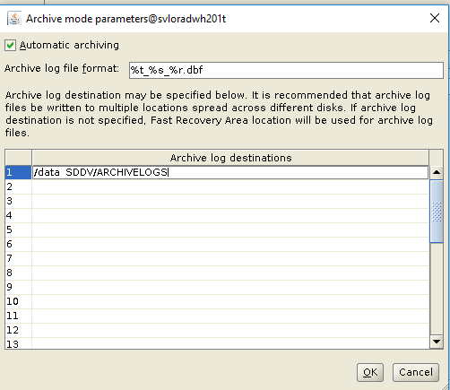

Encoder le répertoire où seront stockés les fichiers archivelog.

Cliquer « OK »

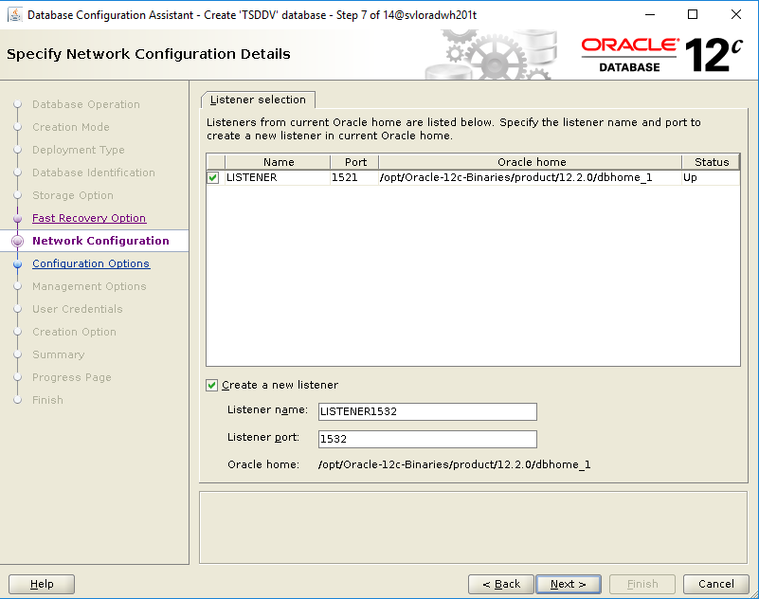

Cocher « create a new listener » et encoder les deux paramètres « Listener Name » et « Listener Port » comme indiqué.

Cliquer « Next »

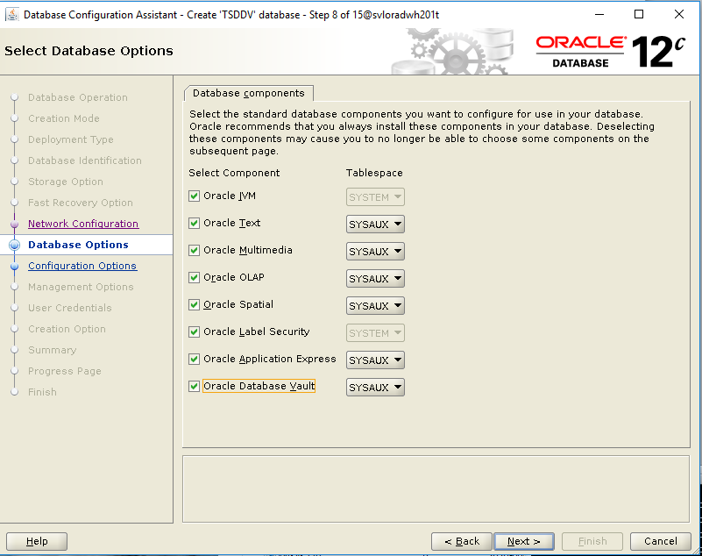

Sélectionner les composants comme indiqué.

Cliquer « Next »

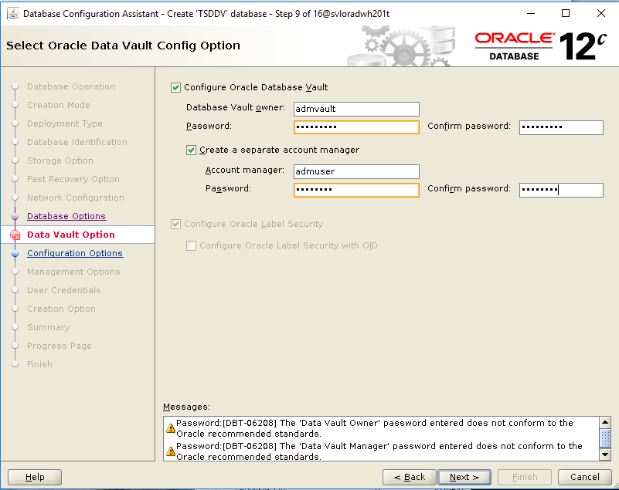

Vérifier que l’option « Configure Oracle Label Security » est bien sélectionnée.

Cocher les options « Configure Oracle Database Vault » et « Create a separate account manager »

Puis compléter les comptes et mots de passe : SDvault01 et SDuser01

Cliquer « Next »

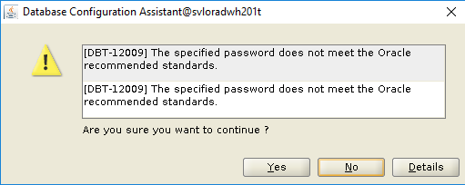

Cliquer « Yes »

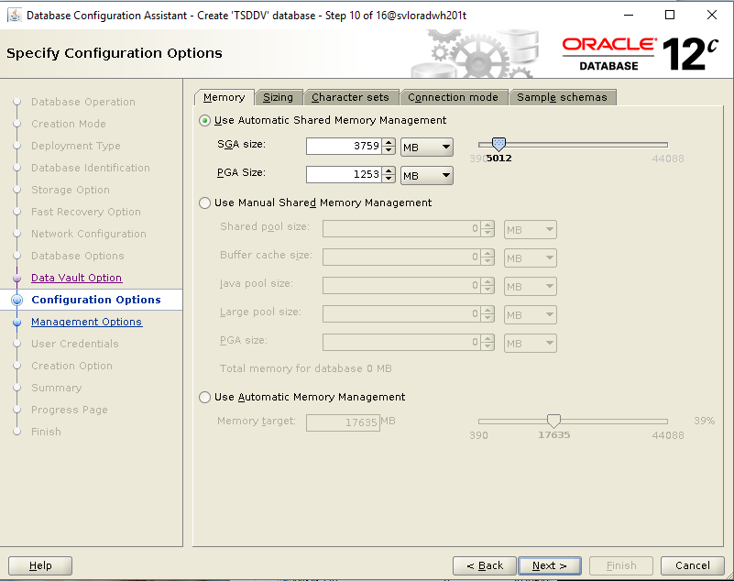

Sélectionner « Use Automatic Shared Memory Management »

Et indiquer les SGA et PGA size.

Cliquer sur l’onglet « Character sets »

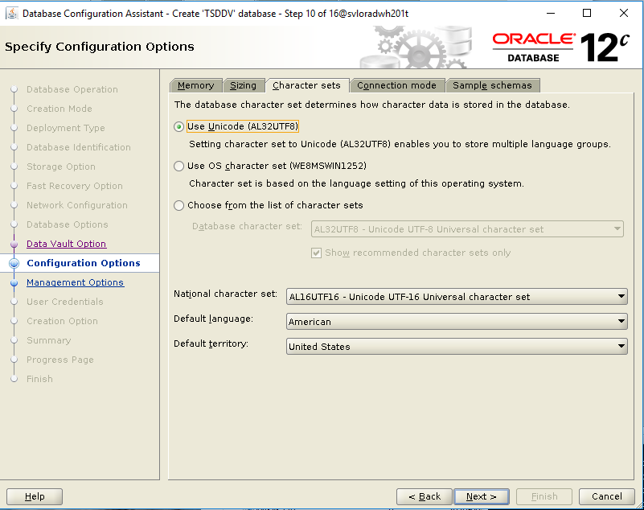

Vérifier les paramètres par défaut. Ils doivent être comme indiqués ci-dessus

Cliquer sur l’onglet « Connection mode  ».

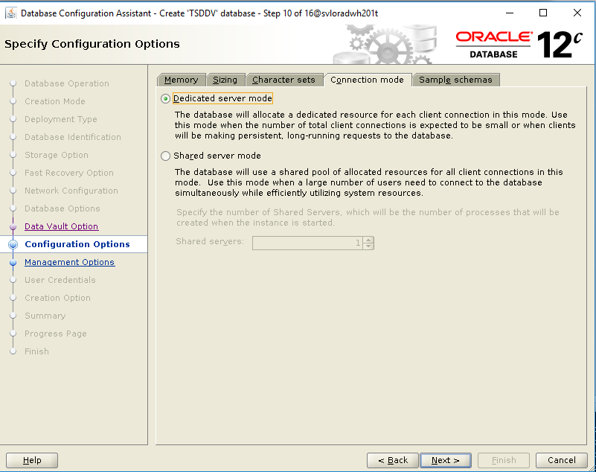

Sélectionner « Dedicated server mode »

Cliquer “Next”

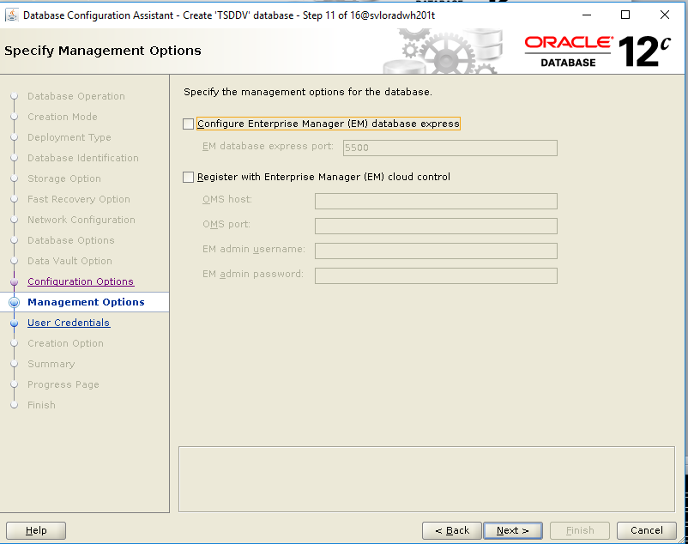

Dé-sélectionner « Configure Enterprise Manager EM database express »

Cliquer « Next »

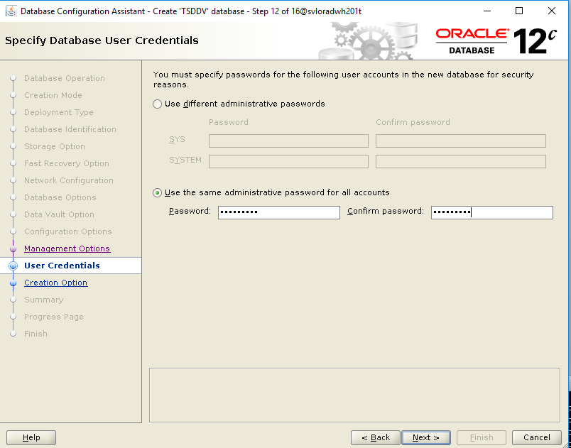

Sélectionner « Use the same administrative password for all accounts »

Encoder le mot de passe (des comptes Oracle SYS et SYSTEM).

Cliquer « Next »

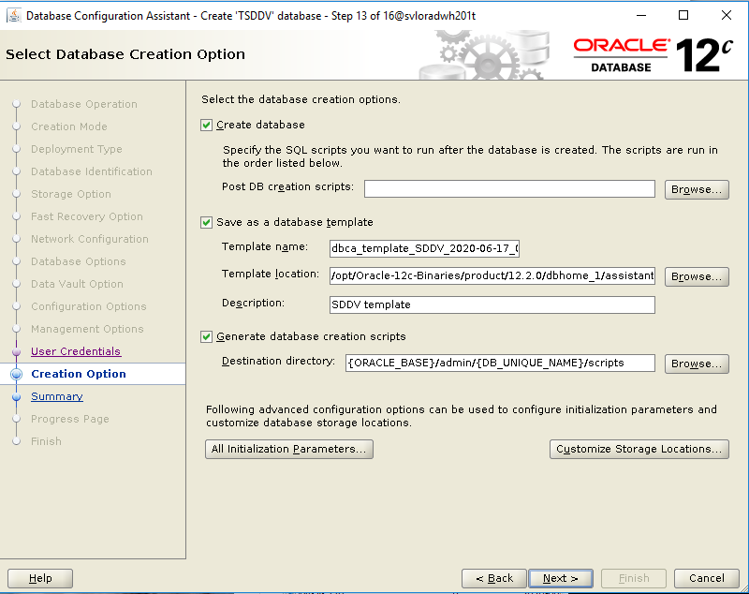

Sélectionner « Create database »

Sélectionner « Save as a database template » et encoder les champs comme indiqué.

Sélectionner « Generate database creation scripts » et encoder le champs comme indiqué.

Sélectionner « All Initialization parameters… »

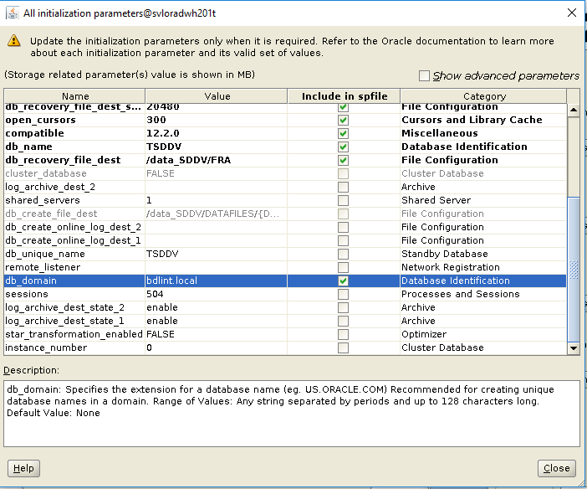

Encode le paramètre db_domain = bdlint.local

Cliquer « Close »

Sélectionner « Customize Storage Location »

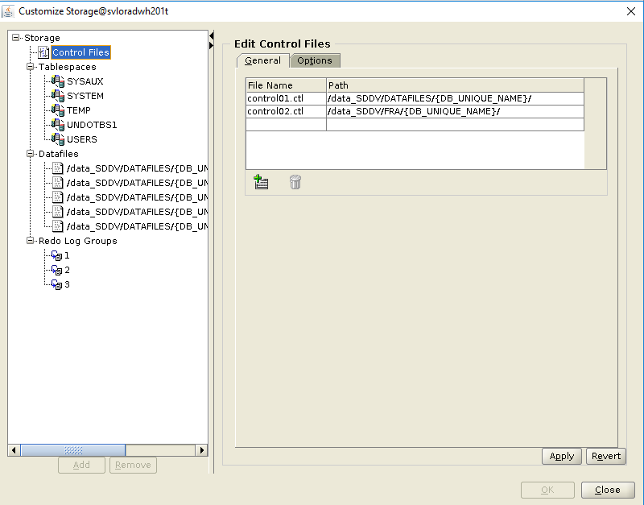

Encoder le répertoire où seront stockés les controlfiles

Cliquer sur « Apply »

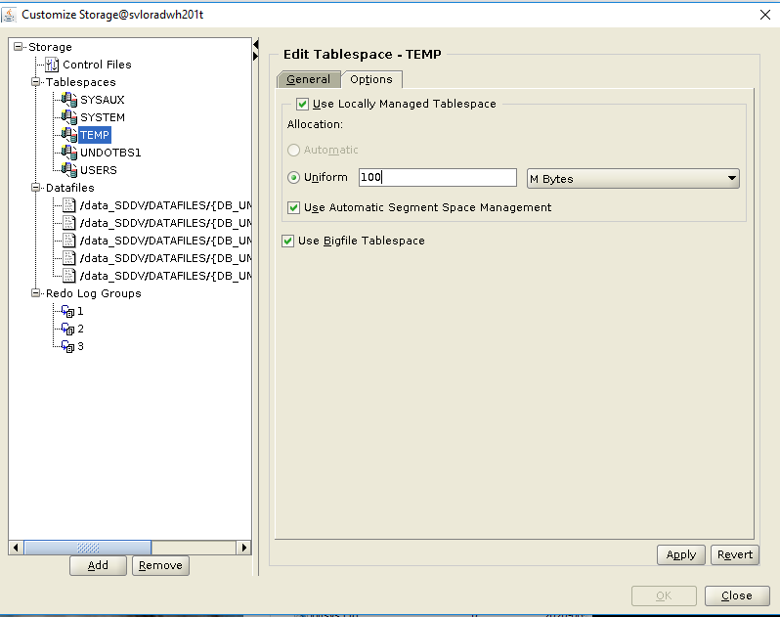

Changer le paramètre Uniform à 100 MB

Sélectionner l’option BigFile.

Cliquer Apply

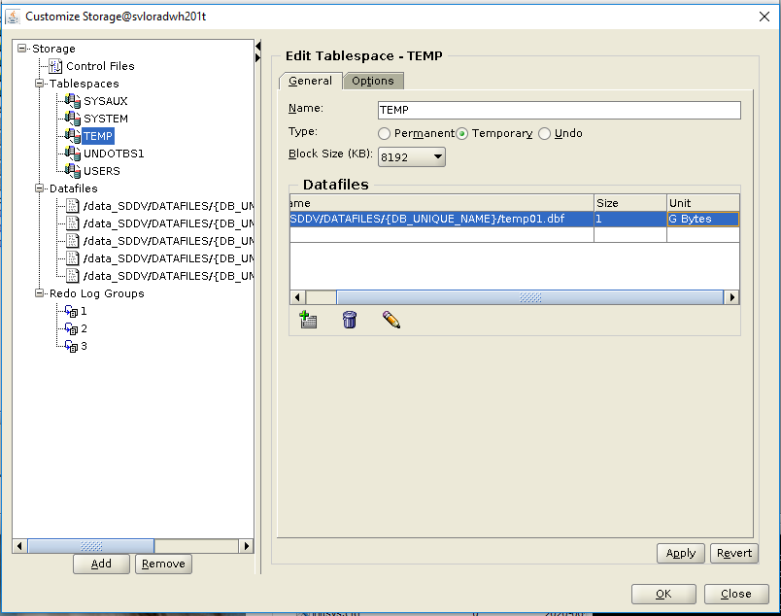

Changer la taille à 1 GB

Cliquer Apply

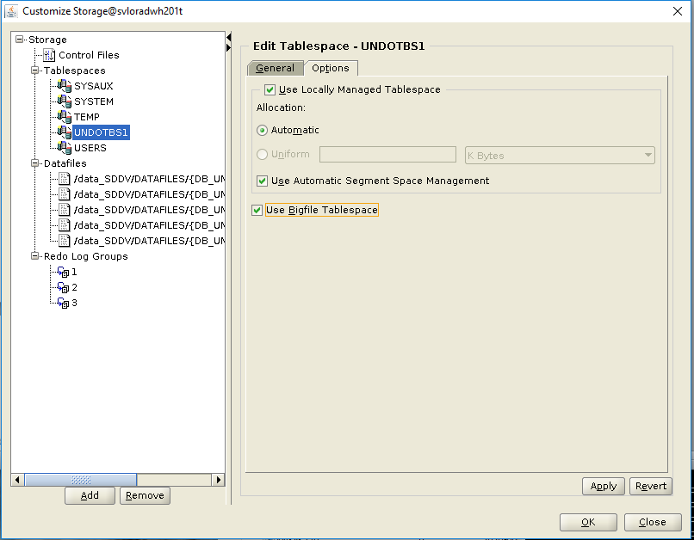

Sélectionner BigFile

Cliquer « Apply »

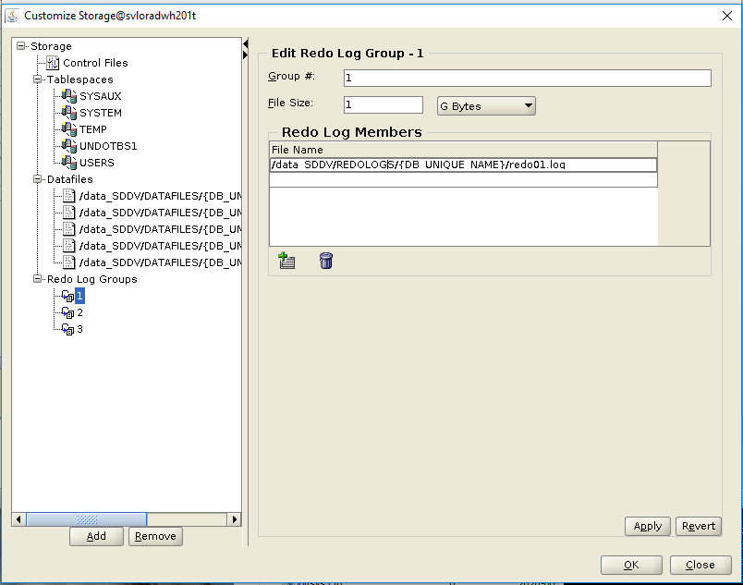

Cliquer sur Redo logs Groups 1

Editer le nom du fichier member 1 et préciser la taille

Cliquer « Apply »

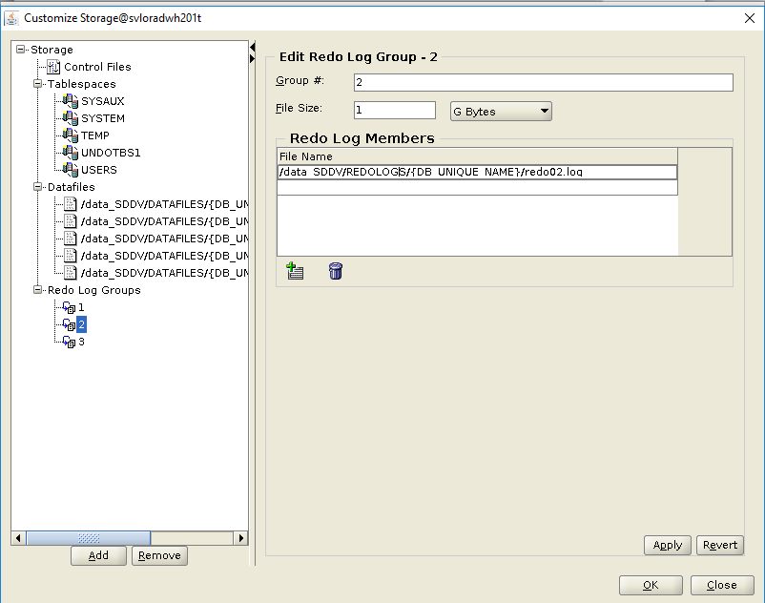

Cliquer sur Redo logs Groups 2

Editer le nom du fichier member 2 et péciser la taille

Cliquer « Apply »

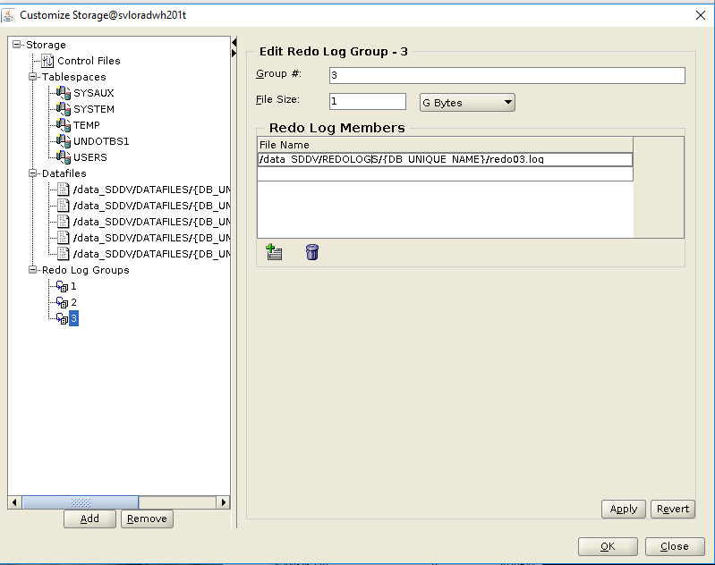

Cliquer sur Redo logs Groups 3

Editer le nom du fichier member 3 et préciser la taille

Cliquer « Apply »

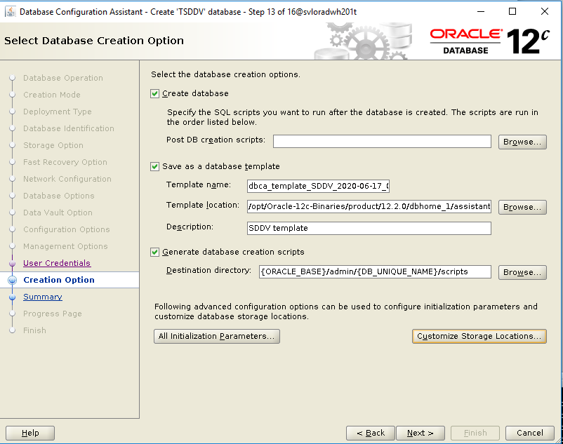

Cliquer sur « Next »

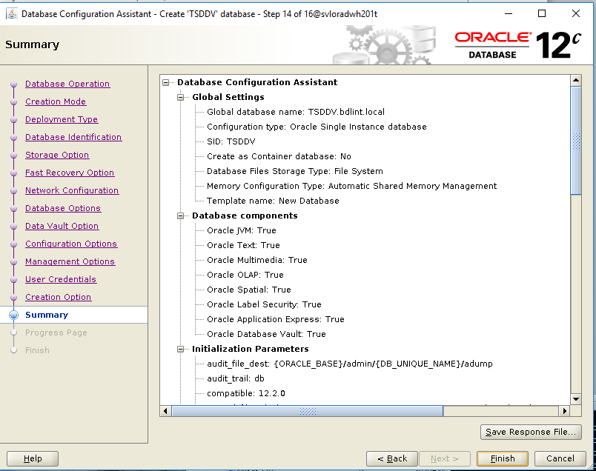

Vérifier les paramètres d’installation

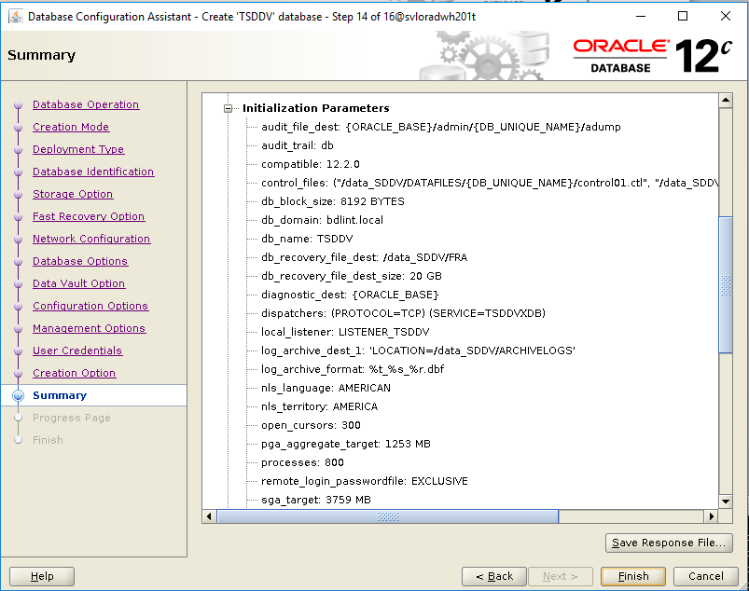

Vérifier les paramètres d’installation

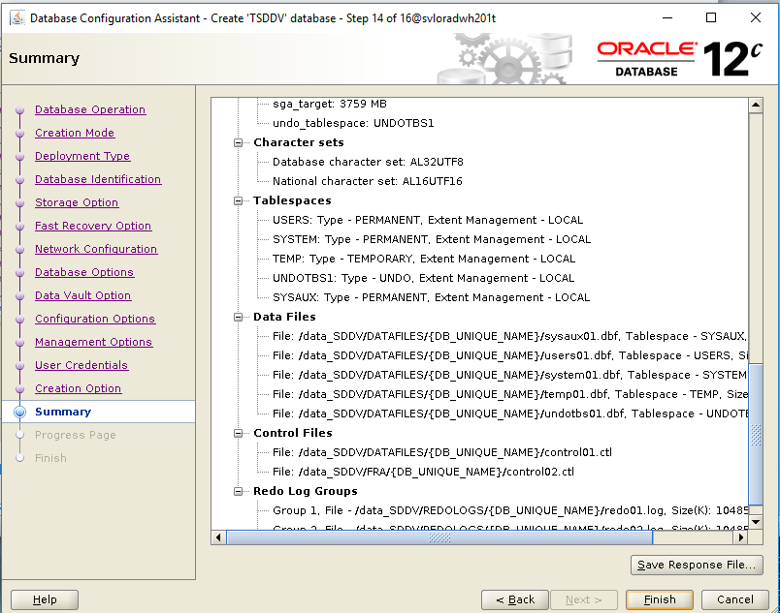

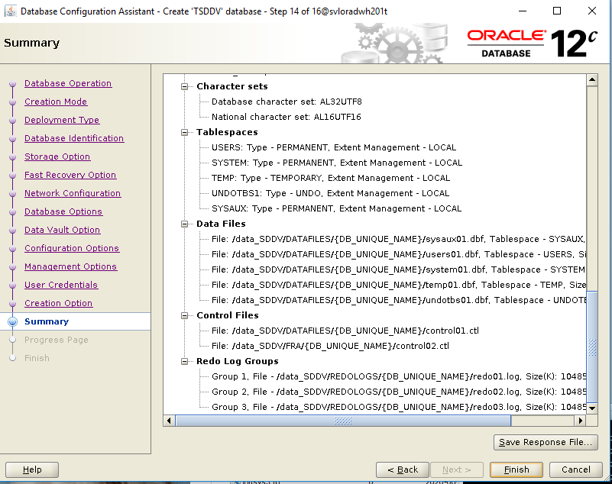

Vérifier les paramètres d’installation

Cliquer sur « Save Response File… »

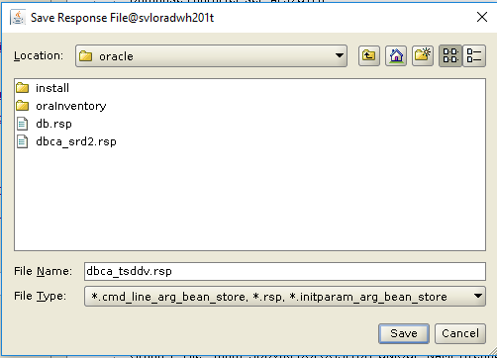

Encoder le nom du fichier où sera sauvegarder le « response file »

Cliquer « Save »

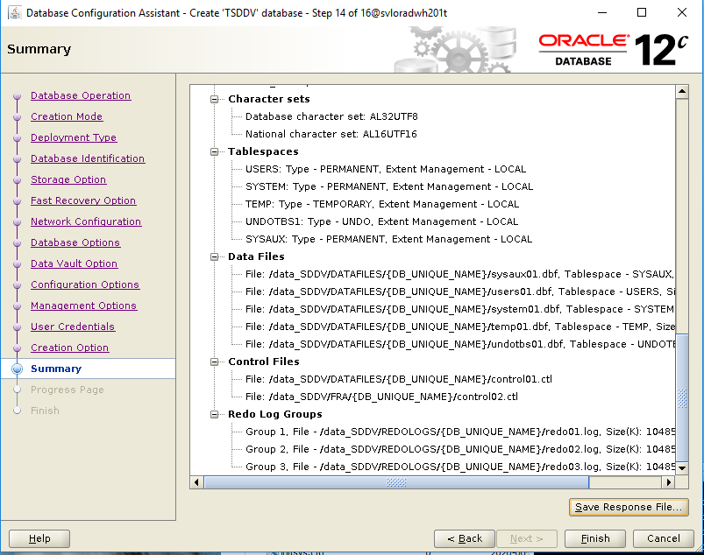

Cliquer sur « Finish »

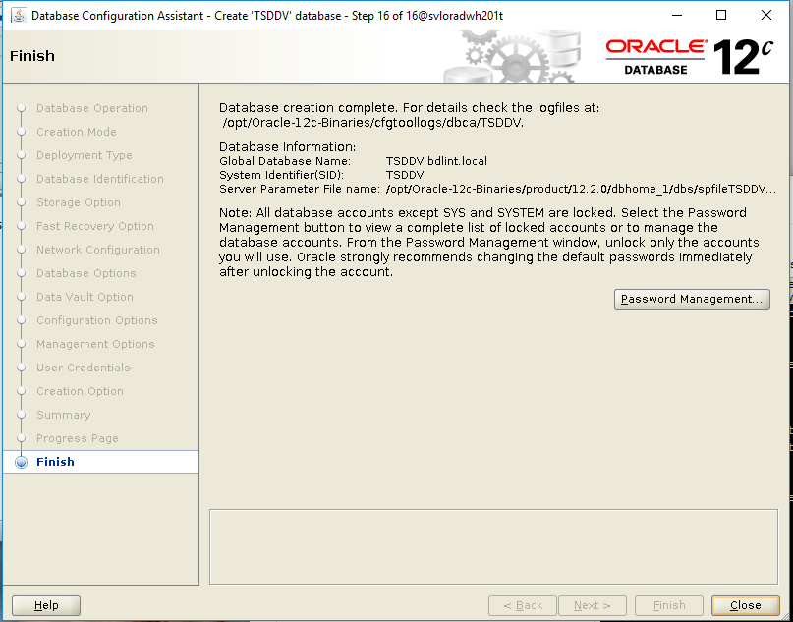

Cliquer sur « Close »

# Post installation tasks

## 5.1 Création des miroirs des redologs

## 5.2 Modification de paramètres

# Encryptage de la base de données SDDV

Password oracle TLS Linux : sddvsrd201

Editer le fichier sqlnet.ora, comme suit :

[oracle@svloracledb201t admin]$ pwd

/opt/oracle/12.1/product/12.2.0/dbhome_1/network/admin

[oracle@svloracledb201t admin]$ cp -p sqlnet.ora sqlnet.ora.org

[oracle@svloracledb201t admin]$ oracle@svloradwh201t admin]$ vi sqlnet.ora.org

# sqlnet.ora Network Configuration File: /opt/Oracle-12c-Binaries/product/12.2.0/dbhome_1/network/admin/sqlnet.ora

# Generated by Oracle configuration tools.

NAMES.DIRECTORY_PATH= (TNSNAMES, ONAMES, HOSTNAME)

ENCRYPTION_WALLET_LOCATION=

(SOURCE=

(METHOD=FILE)

(METHOD_DATA=

(DIRECTORY=/data_sddv/DATADEVICES/TSDDV)))

[oracle@svloracledb201t admin]$

Créer le keystore

[oracle@svloracledb201t admin]$ sqlplus / as syskm

SQL*Plus: Release 12.2.0.1.0 Production on Mon May 25 14:36:03 2020

Copyright (c) 1982, 2016, Oracle. All rights reserved.

Connected to:

Oracle Database 12c Enterprise Edition Release 12.2.0.1.0 - 64bit Production

SQL> ADMINISTER KEY MANAGEMENT CREATE KEYSTORE '/opt/oracle/DATADEVICES/SDDV' IDENTIFIED BY SDDV_2020;

keystore altered.

SQL> exit

Disconnected from Oracle Database 12c Enterprise Edition Release 12.2.0.1.0 - 64bit Production[oracle@svloracledb201t admin]$

Vérifier la création du wallet

[oracle@svloracledb201t SDDV]$ pwd

/opt/oracle/DATADEVICES/SDDV

[oracle@svloracledb201t SDDV]$ ls -rtl

total 1604588

-rw-r----- 1 oracle oinstall 20979712 May 22 20:33 temp01.dbf

-rw-r----- 1 oracle oinstall 5251072 May 25 14:07 users01.dbf

-rw-r----- 1 oracle oinstall 734011392 May 25 14:28 system01.dbf

-rw-r----- 1 oracle oinstall 576724992 May 25 14:32 sysaux01.dbf

**-rw------- 1 oracle oinstall 2400 May 25 14:36 ewallet.p12**

-rw-r----- 1 oracle oinstall 325066752 May 25 14:37 undotbs01.dbf

[oracle@svloracledb201t SDDV]$

[oracle@svloracledb201t SDDV]$ sqlplus / as sysdba

SQL*Plus: Release 12.2.0.1.0 Production on Mon May 25 14:45:50 2020

Copyright (c) 1982, 2016, Oracle. All rights reserved.

Connected to:

Oracle Database 12c Enterprise Edition Release 12.2.0.1.0 - 64bit Production

SQL> set lines 1000 pages 1000

SQL> select * from v$encryption_wallet;

WRL_TYPE

--------------------

WRL_PARAMETER

----------------------------------------------------------------------------------------------------------------------------------------------------------------------------------------------------------------------------------------------------------------------------------------------------------------------------------------------------------------------------------------------------------------------------------------------------------------------------------------------------------------------------------------------------------------------------------------------------------------------------------------------------------------------------------------------------------------------------------------------------------------------------------------------------------------------------------------------------------------------------------------------------------------------------------------------------------------------------------------------------------------------------------------

STATUS WALLET_TYPE WALLET_OR FULLY_BAC CON_ID

------------------------------ -------------------- --------- --------- ----------

FILE

/opt/oracle/DATADEVICES/SDDV/

OPEN PASSWORD SINGLE NO 0

SQL>

[oracle@svloracledb201t SDDV]$ sqlplus / as sysdba

SQL*Plus: Release 12.2.0.1.0 Production on Mon May 25 14:45:50 2020

Copyright (c) 1982, 2016, Oracle. All rights reserved.

Connected to:

Oracle Database 12c Enterprise Edition Release 12.2.0.1.0 - 64bit Production

SQL> set lines 1000 pages 1000

SQL> select * from v$encryption_wallet;

WRL_TYPE

--------------------

WRL_PARAMETER

----------------------------------------------------------------------------------------------------------------------------------------------------------------------------------------------------------------------------------------------------------------------------------------------------------------------------------------------------------------------------------------------------------------------------------------------------------------------------------------------------------------------------------------------------------------------------------------------------------------------------------------------------------------------------------------------------------------------------------------------------------------------------------------------------------------------------------------------------------------------------------------------------------------------------------------------------------------------------------------------------------------------------------------

STATUS WALLET_TYPE WALLET_OR FULLY_BAC CON_ID

------------------------------ -------------------- --------- --------- ----------

FILE

/opt/oracle/DATADEVICES/SDDV/

OPEN PASSWORD SINGLE NO 0

SQL> SHOW PARAMETER COMPATIBLE;

NAME TYPE VALUE

------------------------------------ ----------- ------------------------------

compatible string 12.2.0

noncdb_compatible boolean FALSE

SQL> select object_name, owner from dba_invalid_objects;

no rows selected

SQL>

[oracle@svloracledb201t SDDV]$ sqlplus / as sysdba

SQL*Plus: Release 12.2.0.1.0 Production on Mon May 25 14:38:44 2020

Copyright (c) 1982, 2016, Oracle. All rights reserved.

Connected to:

Oracle Database 12c Enterprise Edition Release 12.2.0.1.0 - 64bit Production

SQL> set lines 1000 pages 1000

SQL> select * from v$encryption_wallet;

WRL_TYPE

--------------------

WRL_PARAMETER

----------------------------------------------------------------------------------------------------------------------------------------------------------------------------------------------------------------------------------------------------------------------------------------------------------------------------------------------------------------------------------------------------------------------------------------------------------------------------------------------------------------------------------------------------------------------------------------------------------------------------------------------------------------------------------------------------------------------------------------------------------------------------------------------------------------------------------------------------------------------------------------------------------------------------------------------------------------------------------------------------------------------------------------

STATUS WALLET_TYPE WALLET_OR FULLY_BAC CON_ID

------------------------------ -------------------- --------- --------- ----------

FILE

/opt/oracle/DATADEVICES/SDDV/

CLOSED UNKNOWN SINGLE UNDEFINED 0

**SQL> ADMINISTER KEY MANAGEMENT SET KEYSTORE OPEN IDENTIFIED BY SDDV_2020;**

keystore altered.

SQL> select * from v$encryption_wallet;

WRL_TYPE

--------------------

WRL_PARAMETER

----------------------------------------------------------------------------------------------------------------------------------------------------------------------------------------------------------------------------------------------------------------------------------------------------------------------------------------------------------------------------------------------------------------------------------------------------------------------------------------------------------------------------------------------------------------------------------------------------------------------------------------------------------------------------------------------------------------------------------------------------------------------------------------------------------------------------------------------------------------------------------------------------------------------------------------------------------------------------------------------------------------------------------------

STATUS WALLET_TYPE WALLET_OR FULLY_BAC CON_ID

------------------------------ -------------------- --------- --------- ----------

FILE

/opt/oracle/DATADEVICES/SDDV/

OPEN_NO_MASTER_KEY PASSWORD SINGLE UNDEFINED 0

SQL>

**SQL> ADMINISTER KEY MANAGEMENT SET KEY USING TAG 'KEYSTORE_MASTER_KEY' IDENTIFIED BY SDDV_2020 WITH BACKUP USING 'keystore_master_key_sddv';**

keystore altered.

SQL>

[oracle@svloracledb201t SDDV]$ pwd

/opt/oracle/DATADEVICES/SDDV

[oracle@svloracledb201t SDDV]$ ls -lrt

total 1604592

-rw-r----- 1 oracle oinstall 5251072 May 25 14:07 users01.dbf

-rw------- 1 oracle oinstall 2400 May 25 14:41 **ewallet_2020052512414998_keystore_master_key_sddv.p12**

**-rw------- 1 oracle oinstall 4032 May 25 14:41 ewallet.p12**

-rw-r----- 1 oracle oinstall 734011392 May 25 14:41 system01.dbf

-rw-r----- 1 oracle oinstall 576724992 May 25 14:41 sysaux01.dbf

-rw-r----- 1 oracle oinstall 325066752 May 25 14:41 undotbs01.dbf

-rw-r----- 1 oracle oinstall 20979712 May 25 14:41 temp01.dbf

[oracle@svloracledb201t SDDV]$

[oracle@svloracledb201t SDDV]$ sqlplus / as sysdba

SQL*Plus: Release 12.2.0.1.0 Production on Mon May 25 14:45:50 2020

Copyright (c) 1982, 2016, Oracle. All rights reserved.

Connected to:

Oracle Database 12c Enterprise Edition Release 12.2.0.1.0 - 64bit Production

SQL> set lines 1000 pages 1000

SQL> select * from v$encryption_wallet;

WRL_TYPE

--------------------

WRL_PARAMETER

----------------------------------------------------------------------------------------------------------------------------------------------------------------------------------------------------------------------------------------------------------------------------------------------------------------------------------------------------------------------------------------------------------------------------------------------------------------------------------------------------------------------------------------------------------------------------------------------------------------------------------------------------------------------------------------------------------------------------------------------------------------------------------------------------------------------------------------------------------------------------------------------------------------------------------------------------------------------------------------------------------------------------------------

STATUS WALLET_TYPE WALLET_OR FULLY_BAC CON_ID

------------------------------ -------------------- --------- --------- ----------

FILE

/opt/oracle/DATADEVICES/SDDV/

OPEN PASSWORD SINGLE NO 0

SQL> SHOW PARAMETER COMPATIBLE;

NAME TYPE VALUE

------------------------------------ ----------- ------------------------------

compatible string 12.2.0

noncdb_compatible boolean FALSE

SQL> select object_name, owner from dba_invalid_objects;

no rows selected

SQL>

## Désactivation du Database Vault

sqlplus admvault/mot_depasse

EXECUTE DBMS_MACADM.DISABLE_DV;

CONNECT / AS SYSDBA

SHUTDOWN IMMEDIATE;

STARTUP;

Exit

## Création des user et tablespace pour SDDV

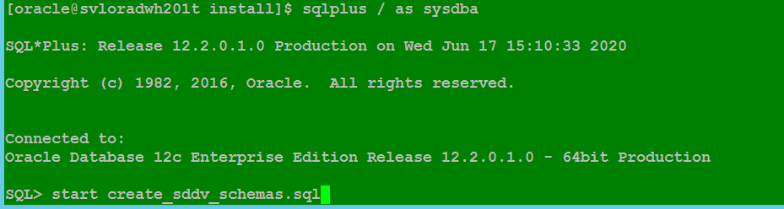

## Sauvegarde la base de données SDDV Vierge.

RMAN> backup database plus archivelog;

Starting backup at 17-JUN-20

current log archived

allocated channel: ORA_DISK_1

channel ORA_DISK_1: SID=129 device type=DISK

channel ORA_DISK_1: starting archived log backup set

channel ORA_DISK_1: specifying archived log(s) in backup set

input archived log thread=1 sequence=5 RECID=1 STAMP=1043332413

input archived log thread=1 sequence=6 RECID=2 STAMP=1043335417

channel ORA_DISK_1: starting piece 1 at 17-JUN-20

channel ORA_DISK_1: finished piece 1 at 17-JUN-20

piece handle=/data_SDDV/FRA/TSDDV/backupset/2020_06_17/o1_mf_annnn_TAG20200617T152338_hgn6bth9_.bkp tag=TAG20200617T152338 comment=NONE

channel ORA_DISK_1: backup set complete, elapsed time: 00:00:01

Finished backup at 17-JUN-20

Starting backup at 17-JUN-20

using channel ORA_DISK_1

channel ORA_DISK_1: starting full datafile backup set

channel ORA_DISK_1: specifying datafile(s) in backup set

input datafile file number=00003 name=/data_SDDV/DATAFILES/TSDDV/undotbs01.dbf

input datafile file number=00001 name=/data_SDDV/DATAFILES/TSDDV/system01.dbf

input datafile file number=00002 name=/data_SDDV/DATAFILES/TSDDV/sysaux01.dbf

input datafile file number=00005 name=/data_SDDV/DATAFILES/TSDDV/CRMLU_STG_PS1.dbf

input datafile file number=00006 name=/data_SDDV/DATAFILES/TSDDV/EDW_BV1.dbf

input datafile file number=00007 name=/data_SDDV/DATAFILES/TSDDV/EDW_CDC_CRMLU1.dbf

input datafile file number=00008 name=/data_SDDV/DATAFILES/TSDDV/EDW_CDC_IBBALU1.dbf

input datafile file number=00009 name=/data_SDDV/DATAFILES/TSDDV/EDW_DFV_CRMLU1.dbf

input datafile file number=00010 name=/data_SDDV/DATAFILES/TSDDV/EDW_DFV_IBBALU1.dbf

input datafile file number=00011 name=/data_SDDV/DATAFILES/TSDDV/EDW_EXT_CRMLU1.dbf

input datafile file number=00012 name=/data_SDDV/DATAFILES/TSDDV/EDW_EXT_IBBALU1.dbf

input datafile file number=00013 name=/data_SDDV/DATAFILES/TSDDV/EDW_FA_RUN_INFO_CRMLU1.dbf

input datafile file number=00014 name=/data_SDDV/DATAFILES/TSDDV/EDW_FA_RUN_INFO_IBBALU1.dbf

input datafile file number=00015 name=/data_SDDV/DATAFILES/TSDDV/EDW_FL1.dbf

input datafile file number=00016 name=/data_SDDV/DATAFILES/TSDDV/EDW_INI_CRMLU1.dbf

input datafile file number=00017 name=/data_SDDV/DATAFILES/TSDDV/EDW_INI_IBBALU1.dbf

input datafile file number=00018 name=/data_SDDV/DATAFILES/TSDDV/EDW_STG_CRMLU1.dbf

input datafile file number=00019 name=/data_SDDV/DATAFILES/TSDDV/EDW_STG_IBBALU1.dbf

input datafile file number=00020 name=/data_SDDV/DATAFILES/TSDDV/MIS_STG_PS_LU1.dbf

input datafile file number=00021 name=/data_SDDV/DATAFILES/TSDDV/EDW_PHYS_CRMLU1.dbf

input datafile file number=00022 name=/data_SDDV/DATAFILES/TSDDV/EDW_PHYS_IBBLU1.dbf

input datafile file number=00023 name=/data_SDDV/DATAFILES/TSDDV/SDDV_BO_RO1.dbf

input datafile file number=00024 name=/data_SDDV/DATAFILES/TSDDV/SDDV_TALEND1.dbf

input datafile file number=00025 name=/data_SDDV/DATAFILES/TSDDV/EDW_TALEND1.dbf

input datafile file number=00004 name=/data_SDDV/DATAFILES/TSDDV/users01.dbf

channel ORA_DISK_1: starting piece 1 at 17-JUN-20

channel ORA_DISK_1: finished piece 1 at 17-JUN-20

piece handle=/data_SDDV/FRA/TSDDV/backupset/2020_06_17/o1_mf_nnndf_TAG20200617T152339_hgn6bw76_.bkp tag=TAG20200617T152339 comment=NONE

channel ORA_DISK_1: backup set complete, elapsed time: 00:00:25

Finished backup at 17-JUN-20

Starting backup at 17-JUN-20

current log archived

using channel ORA_DISK_1

channel ORA_DISK_1: starting archived log backup set

channel ORA_DISK_1: specifying archived log(s) in backup set

input archived log thread=1 sequence=7 RECID=3 STAMP=1043335445

channel ORA_DISK_1: starting piece 1 at 17-JUN-20

channel ORA_DISK_1: finished piece 1 at 17-JUN-20

piece handle=/data_SDDV/FRA/TSDDV/backupset/2020_06_17/o1_mf_annnn_TAG20200617T152405_hgn6co88_.bkp tag=TAG20200617T152405 comment=NONE

channel ORA_DISK_1: backup set complete, elapsed time: 00:00:01

Finished backup at 17-JUN-20

Starting Control File and SPFILE Autobackup at 17-JUN-20

piece handle=/data_SDDV/FRA/TSDDV/autobackup/2020_06_17/o1_mf_s_1043335446_hgn6cpmw_.bkp comment=NONE

Finished Control File and SPFILE Autobackup at 17-JUN-20

RMAN>

RMAN> CONFIGURE DEVICE TYPE DISK PARALLELISM 1 BACKUP TYPE TO COMPRESSED BACKUPSET;

new RMAN configuration parameters:

CONFIGURE DEVICE TYPE DISK PARALLELISM 1 BACKUP TYPE TO COMPRESSED BACKUPSET;

new RMAN configuration parameters are successfully stored

released channel: ORA_DISK_1

RMAN> show all;

RMAN configuration parameters for database with db_unique_name TSDDV are:

CONFIGURE RETENTION POLICY TO REDUNDANCY 1; # default

CONFIGURE BACKUP OPTIMIZATION OFF; # default

CONFIGURE DEFAULT DEVICE TYPE TO DISK; # default

CONFIGURE CONTROLFILE AUTOBACKUP ON; # default

CONFIGURE CONTROLFILE AUTOBACKUP FORMAT FOR DEVICE TYPE DISK TO '%F'; # default

CONFIGURE DEVICE TYPE DISK PARALLELISM 1 BACKUP TYPE TO COMPRESSED BACKUPSET;

CONFIGURE DATAFILE BACKUP COPIES FOR DEVICE TYPE DISK TO 1; # default

CONFIGURE ARCHIVELOG BACKUP COPIES FOR DEVICE TYPE DISK TO 1; # default

CONFIGURE MAXSETSIZE TO UNLIMITED; # default

CONFIGURE ENCRYPTION FOR DATABASE OFF; # default

CONFIGURE ENCRYPTION ALGORITHM 'AES128'; # default

CONFIGURE COMPRESSION ALGORITHM 'BASIC' AS OF RELEASE 'DEFAULT' OPTIMIZE FOR LOAD TRUE ; # default

CONFIGURE RMAN OUTPUT TO KEEP FOR 7 DAYS; # default

CONFIGURE ARCHIVELOG DELETION POLICY TO NONE; # default

CONFIGURE SNAPSHOT CONTROLFILE NAME TO '/opt/Oracle-12c-Binaries/product/12.2.0/dbhome_1/dbs/snapcf_TSDDV.f'; # default

RMAN>

CREATE BIGFILE TABLESPACE CRMLU_STG_PS

DATAFILE '/data_SDDV/DATAFILES/TSDDV/CRMLU_STG_PS1.dbf'

SIZE 100M

AUTOEXTEND ON

NEXT 100M

SEGMENT SPACE MANAGEMENT AUTO EXTENT

MANAGEMENT LOCAL AUTOALLOCATE

ENCRYPTION USING 'AES256'

DEFAULT STORAGE(ENCRYPT);

CREATE USER CRMLU_STG_PS IDENTIFIED BY RZbJv929f ACCOUNT UNLOCK

DEFAULT TABLESPACE CRMLU_STG_PS

TEMPORARY TABLESPACE TEMP

QUOTA UNLIMITED ON CRMLU_STG_PS;

GRANT CREATE SESSION TO CRMLU_STG_PS;

GRANT CREATE PROCEDURE TO CRMLU_STG_PS;

GRANT CREATE SYNONYM TO CRMLU_STG_PS;

GRANT CREATE TRIGGER TO CRMLU_STG_PS;

GRANT CREATE TYPE TO CRMLU_STG_PS;

GRANT CREATE TABLE TO CRMLU_STG_PS;

GRANT CREATE SEQUENCE TO CRMLU_STG_PS;

GRANT CREATE ANY DIRECTORY TO CRMLU_STG_PS;

GRANT CREATE VIEW TO CRMLU_STG_PS;

GRANT CREATE MATERIALIZED VIEW TO CRMLU_STG_PS;

GRANT CREATE RULE TO CRMLU_STG_PS;

GRANT CREATE JOB TO CRMLU_STG_PS;

CREATE TABLESPACE EDW_BV

BIGFILE DATAFILE '/opt/oracle/DATADEVICES/SDDV/EDW_BV1.dbf'

SIZE 100M

AUTOEXTEND ON

NEXT 100M

SEGMENT SPACE MANAGEMENT AUTO EXTENT

MANAGEMENT LOCAL AUTOALLOCATE

ENCRYPTION USING 'AES256'

DEFAULT STORAGE(ENCRYPT);

CREATE USER EDW_BV IDENTIFIED BY y8KH8Lip6 ACCOUNT UNLOCK

DEFAULT TABLESPACE EDW_BV

TEMPORARY TABLESPACE TEMP

QUOTA UNLIMITED ON EDW_BV;

GRANT CREATE SESSION TO EDW_BV;

GRANT CREATE PROCEDURE TO EDW_BV;

GRANT CREATE SYNONYM TO EDW_BV;

GRANT CREATE TRIGGER TO EDW_BV;

GRANT CREATE TYPE TO EDW_BV;

GRANT CREATE TABLE TO EDW_BV;

GRANT CREATE SEQUENCE TO EDW_BV;

GRANT CREATE ANY DIRECTORY TO EDW_BV;

GRANT CREATE VIEW TO EDW_BV;

GRANT CREATE MATERIALIZED VIEW TO EDW_BV;

GRANT CREATE RULE TO EDW_BV;

GRANT CREATE JOB TO EDW_BV;

CREATE TABLESPACE EDW_CDC_CRMLU

BIGFILE DATAFILE '/opt/oracle/DATADEVICES/SDDV/EDW_CDC_CRMLU1.dbf'

SIZE 100M

AUTOEXTEND ON

NEXT 100M

SEGMENT SPACE MANAGEMENT AUTO EXTENT

MANAGEMENT LOCAL AUTOALLOCATE

ENCRYPTION USING 'AES256'

DEFAULT STORAGE(ENCRYPT);

CREATE USER EDW_CDC_CRMLU IDENTIFIED BY Zz4nMD6qK ACCOUNT UNLOCK

DEFAULT TABLESPACE EDW_CDC_CRMLU

TEMPORARY TABLESPACE TEMP

QUOTA UNLIMITED ON EDW_CDC_CRMLU;

GRANT CREATE SESSION TO EDW_CDC_CRMLU ;

GRANT CREATE PROCEDURE TO EDW_CDC_CRMLU ;

GRANT CREATE SYNONYM TO EDW_CDC_CRMLU ;

GRANT CREATE TRIGGER TO EDW_CDC_CRMLU ;

GRANT CREATE TYPE TO EDW_CDC_CRMLU ;

GRANT CREATE TABLE TO EDW_CDC_CRMLU ;

GRANT CREATE SEQUENCE TO EDW_CDC_CRMLU ;

GRANT CREATE ANY DIRECTORY TO EDW_CDC_CRMLU ;

GRANT CREATE VIEW TO EDW_CDC_CRMLU ;

GRANT CREATE MATERIALIZED VIEW TO EDW_CDC_CRMLU ;

GRANT CREATE RULE TO EDW_CDC_CRMLU ;

GRANT CREATE JOB TO EDW_CDC_CRMLU ;

CREATE TABLESPACE EDW_CDC_IBBALU

BIGFILE DATAFILE '/opt/oracle/DATADEVICES/SDDV/EDW_CDC_IBBALU1.dbf'

SIZE 100M

AUTOEXTEND ON

NEXT 100M

SEGMENT SPACE MANAGEMENT AUTO EXTENT

MANAGEMENT LOCAL AUTOALLOCATE

ENCRYPTION USING 'AES256'

DEFAULT STORAGE(ENCRYPT);

CREATE USER EDW_CDC_IBBALU IDENTIFIED BY Gg7YCv7Yp ACCOUNT UNLOCK

DEFAULT TABLESPACE EDW_CDC_IBBALU

TEMPORARY TABLESPACE TEMP

QUOTA UNLIMITED ON EDW_CDC_IBBALU;

GRANT CREATE SESSION TO EDW_CDC_IBBALU ;

GRANT CREATE PROCEDURE TO EDW_CDC_IBBALU ;

GRANT CREATE SYNONYM TO EDW_CDC_IBBALU ;

GRANT CREATE TRIGGER TO EDW_CDC_IBBALU ;

GRANT CREATE TYPE TO EDW_CDC_IBBALU ;

GRANT CREATE TABLE TO EDW_CDC_IBBALU ;

GRANT CREATE SEQUENCE TO EDW_CDC_IBBALU ;

GRANT CREATE ANY DIRECTORY TO EDW_CDC_IBBALU ;

GRANT CREATE VIEW TO EDW_CDC_IBBALU ;

GRANT CREATE MATERIALIZED VIEW TO EDW_CDC_IBBALU ;

GRANT CREATE RULE TO EDW_CDC_IBBALU ;

GRANT CREATE JOB TO EDW_CDC_IBBALU ;

CREATE TABLESPACE EDW_DFV_CRMLU

BIGFILE DATAFILE '/opt/oracle/DATADEVICES/SDDV/EDW_DFV_CRMLU1.dbf'

SIZE 100M

AUTOEXTEND ON

NEXT 100M

SEGMENT SPACE MANAGEMENT AUTO EXTENT

MANAGEMENT LOCAL AUTOALLOCATE

ENCRYPTION USING 'AES256'

DEFAULT STORAGE(ENCRYPT);

CREATE USER EDW_DFV_CRMLU IDENTIFIED BY Gg7YCv7Yp ACCOUNT UNLOCK

DEFAULT TABLESPACE EDW_DFV_CRMLU

TEMPORARY TABLESPACE TEMP

QUOTA UNLIMITED ON EDW_DFV_CRMLU;

GRANT CREATE SESSION TO EDW_DFV_CRMLU ;

GRANT CREATE PROCEDURE TO EDW_DFV_CRMLU ;

GRANT CREATE SYNONYM TO EDW_DFV_CRMLU ;

GRANT CREATE TRIGGER TO EDW_DFV_CRMLU ;

GRANT CREATE TYPE TO EDW_DFV_CRMLU ;

GRANT CREATE TABLE TO EDW_DFV_CRMLU ;

GRANT CREATE SEQUENCE TO EDW_DFV_CRMLU ;

GRANT CREATE ANY DIRECTORY TO EDW_DFV_CRMLU ;

GRANT CREATE VIEW TO EDW_DFV_CRMLU ;

GRANT CREATE MATERIALIZED VIEW TO EDW_DFV_CRMLU ;

GRANT CREATE RULE TO EDW_DFV_CRMLU ;

GRANT CREATE JOB TO EDW_DFV_CRMLU ;

CREATE TABLESPACE EDW_DFV_IBBALU

BIGFILE DATAFILE '/opt/oracle/DATADEVICES/SDDV/EDW_DFV_IBBALU1.dbf'

SIZE 100M

AUTOEXTEND ON

NEXT 100M

SEGMENT SPACE MANAGEMENT AUTO EXTENT

MANAGEMENT LOCAL AUTOALLOCATE

ENCRYPTION USING 'AES256'

DEFAULT STORAGE(ENCRYPT);

CREATE USER EDW_DFV_IBBALU IDENTIFIED BY BbU5X9Wba ACCOUNT UNLOCK

DEFAULT TABLESPACE EDW_DFV_IBBALU

TEMPORARY TABLESPACE TEMP

QUOTA UNLIMITED ON EDW_DFV_IBBALU;

GRANT CREATE SESSION TO EDW_DFV_IBBALU ;

GRANT CREATE PROCEDURE TO EDW_DFV_IBBALU ;

GRANT CREATE SYNONYM TO EDW_DFV_IBBALU ;

GRANT CREATE TRIGGER TO EDW_DFV_IBBALU ;

GRANT CREATE TYPE TO EDW_DFV_IBBALU ;

GRANT CREATE TABLE TO EDW_DFV_IBBALU ;

GRANT CREATE SEQUENCE TO EDW_DFV_IBBALU ;

GRANT CREATE ANY DIRECTORY TO EDW_DFV_IBBALU ;

GRANT CREATE VIEW TO EDW_DFV_IBBALU ;

GRANT CREATE MATERIALIZED VIEW TO EDW_DFV_IBBALU ;

GRANT CREATE RULE TO EDW_DFV_IBBALU ;

GRANT CREATE JOB TO EDW_DFV_IBBALU ;

CREATE TABLESPACE EDW_EXT_CRMLU

BIGFILE DATAFILE '/opt/oracle/DATADEVICES/SDDV/EDW_EXT_CRMLU1.dbf'

SIZE 100M

AUTOEXTEND ON

NEXT 100M

SEGMENT SPACE MANAGEMENT AUTO EXTENT

MANAGEMENT LOCAL AUTOALLOCATE

ENCRYPTION USING 'AES256'

DEFAULT STORAGE(ENCRYPT);

CREATE USER EDW_EXT_CRMLU IDENTIFIED BY mM2Quq9Sc ACCOUNT UNLOCK

DEFAULT TABLESPACE EDW_EXT_CRMLU

TEMPORARY TABLESPACE TEMP

QUOTA UNLIMITED ON EDW_EXT_CRMLU;

GRANT CREATE SESSION TO EDW_EXT_CRMLU ;

GRANT CREATE PROCEDURE TO EDW_EXT_CRMLU ;

GRANT CREATE SYNONYM TO EDW_EXT_CRMLU ;

GRANT CREATE TRIGGER TO EDW_EXT_CRMLU ;

GRANT CREATE TYPE TO EDW_EXT_CRMLU ;

GRANT CREATE TABLE TO EDW_EXT_CRMLU ;

GRANT CREATE SEQUENCE TO EDW_EXT_CRMLU ;

GRANT CREATE ANY DIRECTORY TO EDW_EXT_CRMLU ;

GRANT CREATE VIEW TO EDW_EXT_CRMLU ;

GRANT CREATE MATERIALIZED VIEW TO EDW_EXT_CRMLU ;

GRANT CREATE RULE TO EDW_EXT_CRMLU ;

GRANT CREATE JOB TO EDW_EXT_CRMLU ;

CREATE TABLESPACE EDW_EXT_IBBALU

BIGFILE DATAFILE '/opt/oracle/DATADEVICES/SDDV/EDW_EXT_IBBALU1.dbf'

SIZE 100M

AUTOEXTEND ON

NEXT 100M

SEGMENT SPACE MANAGEMENT AUTO EXTENT

MANAGEMENT LOCAL AUTOALLOCATE

ENCRYPTION USING 'AES256'

DEFAULT STORAGE(ENCRYPT);

CREATE USER EDW_EXT_IBBALU IDENTIFIED BY Ch4j23qFQ ACCOUNT UNLOCK

DEFAULT TABLESPACE EDW_EXT_IBBALU

TEMPORARY TABLESPACE TEMP

QUOTA UNLIMITED ON EDW_EXT_IBBALU;

GRANT CREATE SESSION TO EDW_EXT_IBBALU ;

GRANT CREATE PROCEDURE TO EDW_EXT_IBBALU ;

GRANT CREATE SYNONYM TO EDW_EXT_IBBALU ;

GRANT CREATE TRIGGER TO EDW_EXT_IBBALU ;

GRANT CREATE TYPE TO EDW_EXT_IBBALU ;

GRANT CREATE TABLE TO EDW_EXT_IBBALU ;

GRANT CREATE SEQUENCE TO EDW_EXT_IBBALU ;

GRANT CREATE ANY DIRECTORY TO EDW_EXT_IBBALU ;

GRANT CREATE VIEW TO EDW_EXT_IBBALU ;

GRANT CREATE MATERIALIZED VIEW TO EDW_EXT_IBBALU ;

GRANT CREATE RULE TO EDW_EXT_IBBALU ;

GRANT CREATE JOB TO EDW_EXT_IBBALU ;

CREATE TABLESPACE EDW_FA_RUN_INFO_CRMLU

BIGFILE DATAFILE '/opt/oracle/DATADEVICES/SDDV/EDW_FA_RUN_INFO_CRMLU1.dbf'

SIZE 100M

AUTOEXTEND ON

NEXT 100M

SEGMENT SPACE MANAGEMENT AUTO EXTENT

MANAGEMENT LOCAL AUTOALLOCATE

ENCRYPTION USING 'AES256'

DEFAULT STORAGE(ENCRYPT);

CREATE USER EDW_FA_RUN_INFO_CRMLU IDENTIFIED BY qQR47eMqb ACCOUNT UNLOCK

DEFAULT TABLESPACE EDW_FA_RUN_INFO_CRMLU

TEMPORARY TABLESPACE TEMP

QUOTA UNLIMITED ON EDW_FA_RUN_INFO_CRMLU;

GRANT CREATE SESSION TO EDW_FA_RUN_INFO_CRMLU ;

GRANT CREATE PROCEDURE TO EDW_FA_RUN_INFO_CRMLU ;

GRANT CREATE SYNONYM TO EDW_FA_RUN_INFO_CRMLU ;

GRANT CREATE TRIGGER TO EDW_FA_RUN_INFO_CRMLU ;

GRANT CREATE TYPE TO EDW_FA_RUN_INFO_CRMLU ;

GRANT CREATE TABLE TO EDW_FA_RUN_INFO_CRMLU ;

GRANT CREATE SEQUENCE TO EDW_FA_RUN_INFO_CRMLU ;

GRANT CREATE ANY DIRECTORY TO EDW_FA_RUN_INFO_CRMLU ;

GRANT CREATE VIEW TO EDW_FA_RUN_INFO_CRMLU ;

GRANT CREATE MATERIALIZED VIEW TO EDW_FA_RUN_INFO_CRMLU ;

GRANT CREATE RULE TO EDW_FA_RUN_INFO_CRMLU ;

GRANT CREATE JOB TO EDW_FA_RUN_INFO_CRMLU ;

CREATE TABLESPACE EDW_FA_RUN_INFO_IBBALU

BIGFILE DATAFILE '/opt/oracle/DATADEVICES/SDDV/EDW_FA_RUN_INFO_IBBALU1.dbf'

SIZE 100M

AUTOEXTEND ON

NEXT 100M

SEGMENT SPACE MANAGEMENT AUTO EXTENT

MANAGEMENT LOCAL AUTOALLOCATE

ENCRYPTION USING 'AES256'

DEFAULT STORAGE(ENCRYPT);

CREATE USER EDW_FA_RUN_INFO_IBBALU IDENTIFIED BY qQR47eMqb ACCOUNT UNLOCK

DEFAULT TABLESPACE EDW_FA_RUN_INFO_IBBALU

TEMPORARY TABLESPACE TEMP

QUOTA UNLIMITED ON EDW_FA_RUN_INFO_IBBALU;

GRANT CREATE SESSION TO EDW_FA_RUN_INFO_IBBALU ;

GRANT CREATE PROCEDURE TO EDW_FA_RUN_INFO_IBBALU ;

GRANT CREATE SYNONYM TO EDW_FA_RUN_INFO_IBBALU ;

GRANT CREATE TRIGGER TO EDW_FA_RUN_INFO_IBBALU ;

GRANT CREATE TYPE TO EDW_FA_RUN_INFO_IBBALU ;

GRANT CREATE TABLE TO EDW_FA_RUN_INFO_IBBALU ;

GRANT CREATE SEQUENCE TO EDW_FA_RUN_INFO_IBBALU ;

GRANT CREATE ANY DIRECTORY TO EDW_FA_RUN_INFO_IBBALU ;

GRANT CREATE VIEW TO EDW_FA_RUN_INFO_IBBALU ;

GRANT CREATE MATERIALIZED VIEW TO EDW_FA_RUN_INFO_IBBALU ;

GRANT CREATE RULE TO EDW_FA_RUN_INFO_IBBALU ;

GRANT CREATE JOB TO EDW_FA_RUN_INFO_IBBALU ;

CREATE TABLESPACE EDW_FL

BIGFILE DATAFILE '/opt/oracle/DATADEVICES/SDDV/EDW_FL1.dbf'

SIZE 100M

AUTOEXTEND ON

NEXT 100M

SEGMENT SPACE MANAGEMENT AUTO EXTENT

MANAGEMENT LOCAL AUTOALLOCATE

ENCRYPTION USING 'AES256'

DEFAULT STORAGE(ENCRYPT);

CREATE USER EDW_FL IDENTIFIED BY W9y37ZvTw ACCOUNT UNLOCK

DEFAULT TABLESPACE EDW_FL

TEMPORARY TABLESPACE TEMP

QUOTA UNLIMITED ON EDW_FL;

GRANT CREATE SESSION TO EDW_FL ;

GRANT CREATE PROCEDURE TO EDW_FL ;

GRANT CREATE SYNONYM TO EDW_FL ;

GRANT CREATE TRIGGER TO EDW_FL ;

GRANT CREATE TYPE TO EDW_FL ;

GRANT CREATE TABLE TO EDW_FL ;

GRANT CREATE SEQUENCE TO EDW_FL ;

GRANT CREATE ANY DIRECTORY TO EDW_FL ;

GRANT CREATE VIEW TO EDW_FL ;

GRANT CREATE MATERIALIZED VIEW TO EDW_FL ;

GRANT CREATE RULE TO EDW_FL ;

GRANT CREATE JOB TO EDW_FL ;

CREATE TABLESPACE EDW_INI_CRMLU

BIGFILE DATAFILE '/opt/oracle/DATADEVICES/SDDV/EDW_INI_CRMLU1.dbf'

SIZE 100M

AUTOEXTEND ON

NEXT 100M

SEGMENT SPACE MANAGEMENT AUTO EXTENT

MANAGEMENT LOCAL AUTOALLOCATE

ENCRYPTION USING 'AES256'

DEFAULT STORAGE(ENCRYPT);

CREATE USER EDW_INI_CRMLU IDENTIFIED BY UIkAzR3xL ACCOUNT UNLOCK

DEFAULT TABLESPACE EDW_INI_CRMLU

TEMPORARY TABLESPACE TEMP

QUOTA UNLIMITED ON EDW_INI_CRMLU;

GRANT CREATE SESSION TO EDW_INI_CRMLU ;

GRANT CREATE PROCEDURE TO EDW_INI_CRMLU ;

GRANT CREATE SYNONYM TO EDW_INI_CRMLU ;

GRANT CREATE TRIGGER TO EDW_INI_CRMLU ;

GRANT CREATE TYPE TO EDW_INI_CRMLU ;

GRANT CREATE TABLE TO EDW_INI_CRMLU ;

GRANT CREATE SEQUENCE TO EDW_INI_CRMLU ;

GRANT CREATE ANY DIRECTORY TO EDW_INI_CRMLU ;

GRANT CREATE VIEW TO EDW_INI_CRMLU ;

GRANT CREATE MATERIALIZED VIEW TO EDW_INI_CRMLU ;

GRANT CREATE RULE TO EDW_INI_CRMLU ;

GRANT CREATE JOB TO EDW_INI_CRMLU ;

CREATE TABLESPACE EDW_INI_IBBALU

BIGFILE DATAFILE '/opt/oracle/DATADEVICES/SDDV/EDW_INI_IBBALU1.dbf'

SIZE 100M

AUTOEXTEND ON

NEXT 100M

SEGMENT SPACE MANAGEMENT AUTO EXTENT

MANAGEMENT LOCAL AUTOALLOCATE

ENCRYPTION USING 'AES256'

DEFAULT STORAGE(ENCRYPT);

CREATE USER EDW_INI_IBBALU IDENTIFIED BY iX8efEJ42 ACCOUNT UNLOCK

DEFAULT TABLESPACE EDW_INI_IBBALU

TEMPORARY TABLESPACE TEMP

QUOTA UNLIMITED ON EDW_INI_IBBALU;

GRANT CREATE SESSION TO EDW_INI_IBBALU ;

GRANT CREATE PROCEDURE TO EDW_INI_IBBALU ;

GRANT CREATE SYNONYM TO EDW_INI_IBBALU ;

GRANT CREATE TRIGGER TO EDW_INI_IBBALU ;

GRANT CREATE TYPE TO EDW_INI_IBBALU ;

GRANT CREATE TABLE TO EDW_INI_IBBALU ;

GRANT CREATE SEQUENCE TO EDW_INI_IBBALU ;

GRANT CREATE ANY DIRECTORY TO EDW_INI_IBBALU ;

GRANT CREATE VIEW TO EDW_INI_IBBALU ;

GRANT CREATE MATERIALIZED VIEW TO EDW_INI_IBBALU ;

GRANT CREATE RULE TO EDW_INI_IBBALU ;

GRANT CREATE JOB TO EDW_INI_IBBALU ;

CREATE TABLESPACE EDW_STG_CRMLU

BIGFILE DATAFILE '/opt/oracle/DATADEVICES/SDDV/EDW_STG_CRMLU1.dbf'

SIZE 100M

AUTOEXTEND ON

NEXT 100M

SEGMENT SPACE MANAGEMENT AUTO EXTENT

MANAGEMENT LOCAL AUTOALLOCATE

ENCRYPTION USING 'AES256'

DEFAULT STORAGE(ENCRYPT);

CREATE USER EDW_STG_CRMLU IDENTIFIED BY j9dr47KST ACCOUNT UNLOCK

DEFAULT TABLESPACE EDW_STG_CRMLU

TEMPORARY TABLESPACE TEMP

QUOTA UNLIMITED ON EDW_STG_CRMLU;

GRANT CREATE SESSION TO EDW_STG_CRMLU ;

GRANT CREATE PROCEDURE TO EDW_STG_CRMLU ;

GRANT CREATE SYNONYM TO EDW_STG_CRMLU ;

GRANT CREATE TRIGGER TO EDW_STG_CRMLU ;

GRANT CREATE TYPE TO EDW_STG_CRMLU ;

GRANT CREATE TABLE TO EDW_STG_CRMLU ;

GRANT CREATE SEQUENCE TO EDW_STG_CRMLU ;

GRANT CREATE ANY DIRECTORY TO EDW_STG_CRMLU ;

GRANT CREATE VIEW TO EDW_STG_CRMLU ;

GRANT CREATE MATERIALIZED VIEW TO EDW_STG_CRMLU ;

GRANT CREATE RULE TO EDW_STG_CRMLU ;

GRANT CREATE JOB TO EDW_STG_CRMLU ;

CREATE TABLESPACE EDW_STG_IBBALU

BIGFILE DATAFILE '/opt/oracle/DATADEVICES/SDDV/EDW_STG_IBBALU1.dbf'

SIZE 100M

AUTOEXTEND ON

NEXT 100M

SEGMENT SPACE MANAGEMENT AUTO EXTENT

MANAGEMENT LOCAL AUTOALLOCATE

ENCRYPTION USING 'AES256'

DEFAULT STORAGE(ENCRYPT);

CREATE USER EDW_STG_IBBALU IDENTIFIED BY LaX7kePU7 ACCOUNT UNLOCK

DEFAULT TABLESPACE EDW_STG_IBBALU

TEMPORARY TABLESPACE TEMP

QUOTA UNLIMITED ON EDW_STG_IBBALU;

GRANT CREATE SESSION TO EDW_STG_IBBALU ;

GRANT CREATE PROCEDURE TO EDW_STG_IBBALU ;

GRANT CREATE SYNONYM TO EDW_STG_IBBALU ;

GRANT CREATE TRIGGER TO EDW_STG_IBBALU ;

GRANT CREATE TYPE TO EDW_STG_IBBALU ;

GRANT CREATE TABLE TO EDW_STG_IBBALU ;

GRANT CREATE SEQUENCE TO EDW_STG_IBBALU ;

GRANT CREATE ANY DIRECTORY TO EDW_STG_IBBALU ;

GRANT CREATE VIEW TO EDW_STG_IBBALU ;

GRANT CREATE MATERIALIZED VIEW TO EDW_STG_IBBALU ;

GRANT CREATE RULE TO EDW_STG_IBBALU ;

GRANT CREATE JOB TO EDW_STG_IBBALU ;

CREATE TABLESPACE MIS_STG_PS_LU

BIGFILE DATAFILE '/opt/oracle/DATADEVICES/SDDV/MIS_STG_PS_LU1.dbf'

SIZE 100M

AUTOEXTEND ON

NEXT 100M

SEGMENT SPACE MANAGEMENT AUTO EXTENT

MANAGEMENT LOCAL AUTOALLOCATE

ENCRYPTION USING 'AES256'

DEFAULT STORAGE(ENCRYPT);

CREATE USER MIS_STG_PS_LU IDENTIFIED BY LaX7kePU7 ACCOUNT UNLOCK

DEFAULT TABLESPACE MIS_STG_PS_LU

TEMPORARY TABLESPACE TEMP

QUOTA UNLIMITED ON MIS_STG_PS_LU;

GRANT CREATE SESSION TO MIS_STG_PS_LU ;

GRANT CREATE PROCEDURE TO MIS_STG_PS_LU ;

GRANT CREATE SYNONYM TO MIS_STG_PS_LU ;

GRANT CREATE TRIGGER TO MIS_STG_PS_LU ;

GRANT CREATE TYPE TO MIS_STG_PS_LU ;

GRANT CREATE TABLE TO MIS_STG_PS_LU ;

GRANT CREATE SEQUENCE TO MIS_STG_PS_LU ;

GRANT CREATE ANY DIRECTORY TO MIS_STG_PS_LU ;

GRANT CREATE VIEW TO MIS_STG_PS_LU ;

GRANT CREATE MATERIALIZED VIEW TO MIS_STG_PS_LU ;

GRANT CREATE RULE TO MIS_STG_PS_LU ;

GRANT CREATE JOB TO MIS_STG_PS_LU ;

CREATE TABLESPACE EDW_PHYS_CRMLU

BIGFILE DATAFILE '/opt/oracle/DATADEVICES/SDDV/EDW_PHYS_CRMLU1.dbf'

SIZE 100M

AUTOEXTEND ON

NEXT 100M

SEGMENT SPACE MANAGEMENT AUTO EXTENT

MANAGEMENT LOCAL AUTOALLOCATE

ENCRYPTION USING 'AES256'

DEFAULT STORAGE(ENCRYPT);

CREATE USER EDW_PHYS_CRMLU IDENTIFIED BY z4TtuW8S2 ACCOUNT UNLOCK

DEFAULT TABLESPACE EDW_PHYS_CRMLU

TEMPORARY TABLESPACE TEMP

QUOTA UNLIMITED ON EDW_PHYS_CRMLU;

GRANT CREATE SESSION TO EDW_PHYS_CRMLU ;

GRANT CREATE PROCEDURE TO EDW_PHYS_CRMLU ;

GRANT CREATE SYNONYM TO EDW_PHYS_CRMLU ;

GRANT CREATE TRIGGER TO EDW_PHYS_CRMLU ;

GRANT CREATE TYPE TO EDW_PHYS_CRMLU ;

GRANT CREATE TABLE TO EDW_PHYS_CRMLU ;

GRANT CREATE SEQUENCE TO EDW_PHYS_CRMLU ;

GRANT CREATE ANY DIRECTORY TO EDW_PHYS_CRMLU ;

GRANT CREATE VIEW TO EDW_PHYS_CRMLU ;

GRANT CREATE MATERIALIZED VIEW TO EDW_PHYS_CRMLU ;

GRANT CREATE RULE TO EDW_PHYS_CRMLU ;

GRANT CREATE JOB TO EDW_PHYS_CRMLU ;

CREATE TABLESPACE EDW_PHYS_IBBLU

BIGFILE DATAFILE '/opt/oracle/DATADEVICES/SDDV/EDW_PHYS_IBBLU1.dbf'

SIZE 100M

AUTOEXTEND ON

NEXT 100M

SEGMENT SPACE MANAGEMENT AUTO EXTENT

MANAGEMENT LOCAL AUTOALLOCATE

ENCRYPTION USING 'AES256'

DEFAULT STORAGE(ENCRYPT);

CREATE USER EDW_PHYS_IBBLU IDENTIFIED BY jrc57LWB2 ACCOUNT UNLOCK

DEFAULT TABLESPACE EDW_PHYS_IBBLU

TEMPORARY TABLESPACE TEMP

QUOTA UNLIMITED ON EDW_PHYS_IBBLU;

GRANT CREATE SESSION TO EDW_PHYS_IBBLU ;

GRANT CREATE PROCEDURE TO EDW_PHYS_IBBLU ;

GRANT CREATE SYNONYM TO EDW_PHYS_IBBLU ;

GRANT CREATE TRIGGER TO EDW_PHYS_IBBLU ;

GRANT CREATE TYPE TO EDW_PHYS_IBBLU ;

GRANT CREATE TABLE TO EDW_PHYS_IBBLU ;

GRANT CREATE SEQUENCE TO EDW_PHYS_IBBLU ;

GRANT CREATE ANY DIRECTORY TO EDW_PHYS_IBBLU ;

GRANT CREATE VIEW TO EDW_PHYS_IBBLU ;

GRANT CREATE MATERIALIZED VIEW TO EDW_PHYS_IBBLU ;

GRANT CREATE RULE TO EDW_PHYS_IBBLU ;

GRANT CREATE JOB TO EDW_PHYS_IBBLU ;

CREATE TABLESPACE SDDV_BO_RO

BIGFILE DATAFILE '/opt/oracle/DATADEVICES/SDDV/SDDV_BO_RO1.dbf'

SIZE 100M

AUTOEXTEND ON

NEXT 100M

SEGMENT SPACE MANAGEMENT AUTO EXTENT

MANAGEMENT LOCAL AUTOALLOCATE

ENCRYPTION USING 'AES256'

DEFAULT STORAGE(ENCRYPT);

CREATE USER SDDV_BO_RO IDENTIFIED BY jrc57LWB2 ACCOUNT UNLOCK

DEFAULT TABLESPACE SDDV_BO_RO

TEMPORARY TABLESPACE TEMP

QUOTA UNLIMITED ON SDDV_BO_RO;

GRANT CREATE SESSION TO SDDV_BO_RO ;

CREATE TABLESPACE SDDV_TALEND

BIGFILE DATAFILE '/opt/oracle/DATADEVICES/SDDV/SDDV_TALEND1.dbf'

SIZE 100M

AUTOEXTEND ON

NEXT 100M

SEGMENT SPACE MANAGEMENT AUTO EXTENT

MANAGEMENT LOCAL AUTOALLOCATE

ENCRYPTION USING 'AES256'

DEFAULT STORAGE(ENCRYPT);

CREATE USER SDDV_TALEND IDENTIFIED BY a2LbwkkBeu ACCOUNT UNLOCK

DEFAULT TABLESPACE SDDV_TALEND

TEMPORARY TABLESPACE TEMP

QUOTA UNLIMITED ON SDDV_TALEND;

GRANT CREATE SESSION TO SDDV_TALEND;

CREATE TABLESPACE EDW_TALEND

BIGFILE DATAFILE '/opt/oracle/DATADEVICES/SDDV/EDW_TALEND1.dbf'

SIZE 100M

AUTOEXTEND ON

NEXT 100M

SEGMENT SPACE MANAGEMENT AUTO EXTENT

MANAGEMENT LOCAL AUTOALLOCATE

ENCRYPTION USING 'AES256'

DEFAULT STORAGE(ENCRYPT);

CREATE USER EDW_TALEND IDENTIFIED BY atNa2s9VKa ACCOUNT UNLOCK

DEFAULT TABLESPACE EDW_TALEND

TEMPORARY TABLESPACE TEMP

QUOTA UNLIMITED ON EDW_TALEND;

GRANT CREATE SESSION TO EDW_TALEND;