1. Starting from ‘Ash view’ Sql-Id - find back the Oracle Session ID:

SET PAUSE ON

SET PAUSE 'Press Return to Continue'

SET PAGESIZE 60

SET LINESIZE 300

SET VERIFY OFF

COLUMN sql_text FORMAT a60

SELECT oc.user_name "Username ", oc.sid "Oracle SID ", oc.sql_id "Sql ID", oc.sql_text "Sql Text ", oc.hash_value "Hash value"

FROM v$open_cursor oc, V$SQL sql

WHERE oc.sql_id like '**146**%' 🡸 this 3 character string must be adapted !!!!

and oc.sql_id = sql.sql_id

order by 2

/

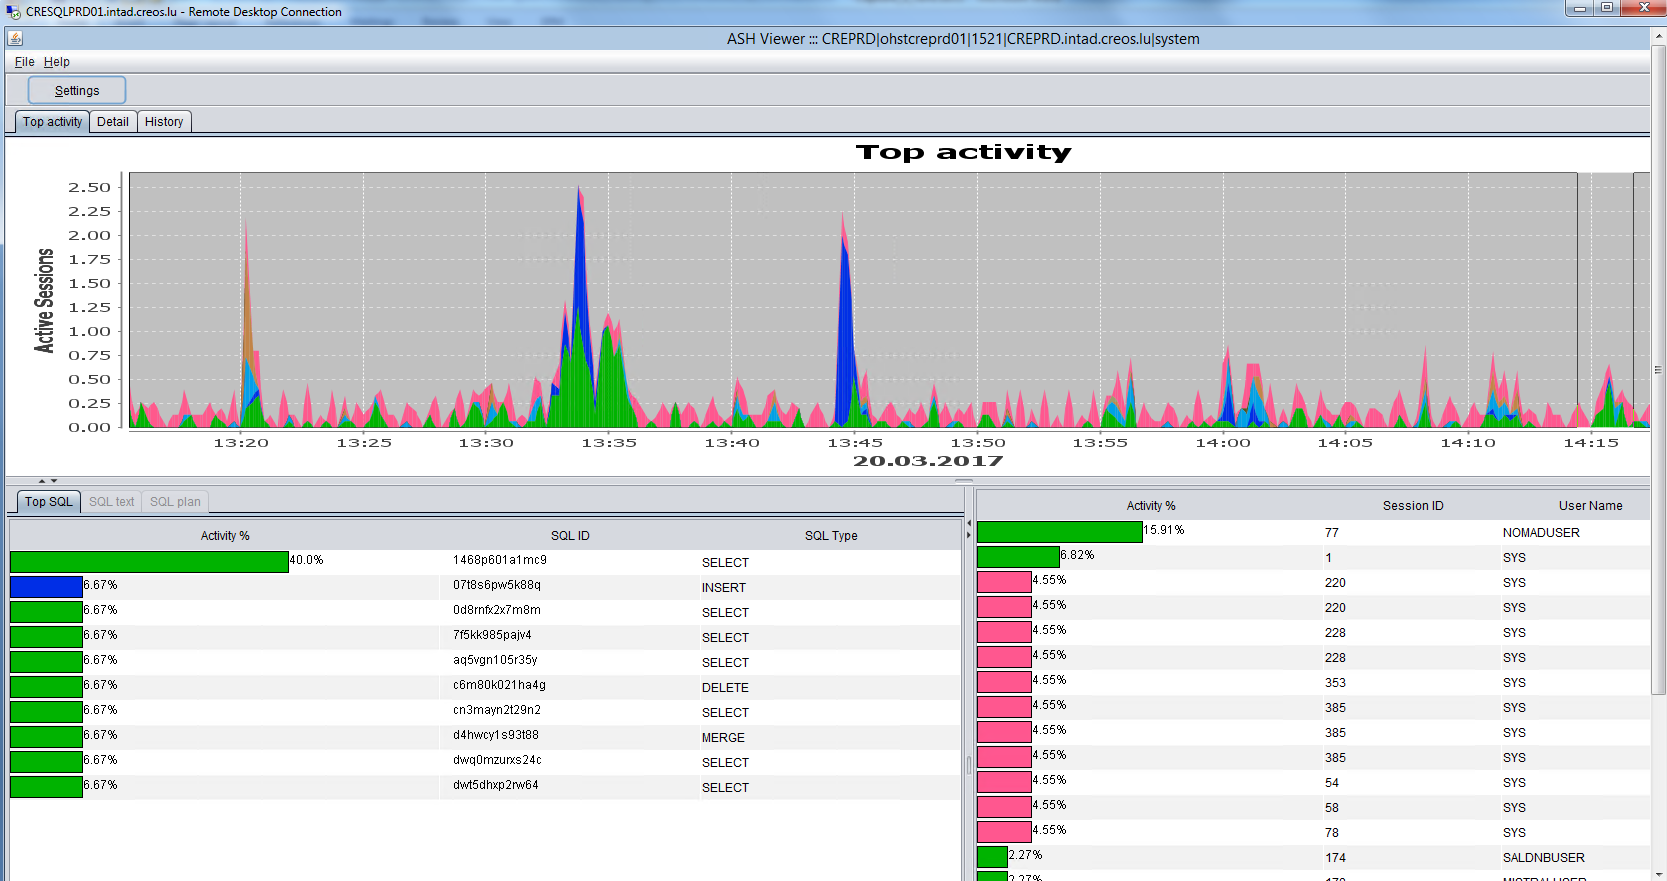

SYS@CREPRD >

SELECT oc.user_name "Username ", oc.sid "Oracle SID ", oc.sql_id "Sql ID", oc.sql_text "Sql Text ", oc.hash_value "Hash value "

FROM v$open_cursor oc, V$SQL sql

WHERE oc.sql_id like '146%'

and oc.sql_id = sql.sql_id

order by 2

/

Press Return to Continue

Username Oracle SID Sql ID Sql Text Hash value

NOMADUSER 77 1468p601a1mc9 SELECT FV.FLOW_VER_ID, FV.FLOW_ID, FV.FLOW_TYPE_CODE, FV.GCV 44092809

NOMADUSER 371 1468p601a1mc9 SELECT FV.FLOW_VER_ID, FV.FLOW_ID, FV.FLOW_TYPE_CODE, FV.GCV 44092809

SYS@CREPRD >

1. Using Putty ‘htop’ Linux process-id and ‘ASH Viewer’ Oracle Session-Id – Sql-Id:

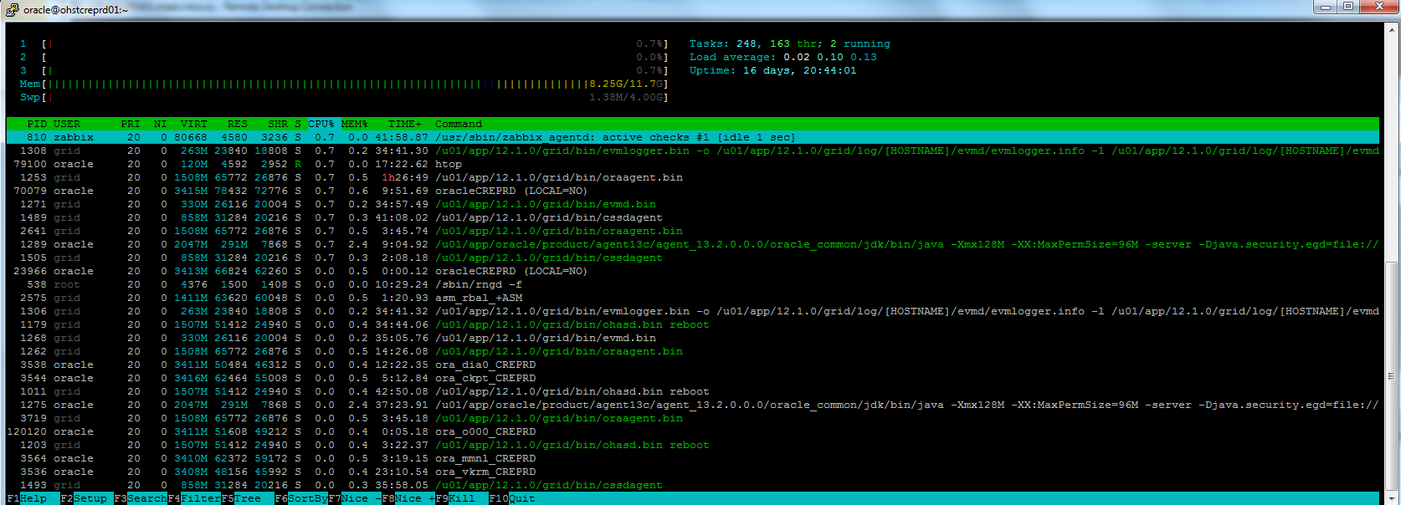

1. Using ‘Ash Viewer’ Sql-id’ – find back the OS Process-Id:

SET PAUSE ON

SET PAUSE 'Press Return to Continue'

SET PAGESIZE 60

SET LINESIZE 300

SET VERIFY OFF

SELECT s.sid "Oracle SID ", p.spid "Requested OS Process Id"

FROM v$session s, v$process p

WHERE p.addr = s.paddr

and s.sid = &Enter_Oracle_SID

/

*SYS@CREPRD >*

*SELECT s.sid "Oracle SID ", p.spid "Requested OS Process Id"*

*FROM v$session s, v$process p*

*WHERE p.addr = s.paddr*

*and s.sid = &Enter_Oracle_SID*

*5 /*

*Enter value for enter_oracle_sid: 77*

*Press Return to Continue*

*Oracle SID Requested OS Process Id*

*------------ ------------------------*

*77 70079*

*SYS@CREPRD >*

1. Using the ‘htop’ OS_Processid - to get back simply the Oracle-SID:

SET PAUSE ON

SET PAUSE 'Press Return to Continue'

SET PAGESIZE 60

SET LINESIZE 300

SET VERIFY OFF

SELECT s.sid "Oracle SID ", p.spid "Requested OS Process Id"

FROM v$session s, v$process p

WHERE p.addr = s.paddr

and p.spid = &Enter_OS_ProcessId

/

*SYS@CREPRD >*

*SELECT s.sid "Oracle SID ", p.spid "Requested OS Process Id"*

*FROM v$session s, v$process p*

*WHERE p.addr = s.paddr*

*and p.spid = &Enter_OS_ProcessId*

*5 /*

*Enter value for enter_os_processid:* ***70079***

*Press Return to Continue*

*Oracle SID Requested OS Process Id*

*------------ ------------------------*

*77 70079*

*SYS@CREPRD >*

1. Using the ‘htop’ OS_Processid – to get back Oracle SID and Sql-id:

*SET PAUSE ON*

*SET PAUSE 'Press Return to Continue'*

*SET PAGESIZE 60*

*SET LINESIZE 300*

*SET VERIFY OFF*

*COLUMN sql_text FORMAT a60*

*SELECT distinct oc.user_name "Username ", oc.sid "Oracle SID", oc.sql_id "Sql Id", oc.sql_text "Sql Text", oc.hash_value "Sql Hash-Value"*

*FROM v$open_cursor oc*

*WHERE oc.sid = (*

*SELECT s.sid*

*FROM v$session s, v$process p*

*WHERE p.addr = s.paddr AND*

*p.spid = &Enter_OS_Process_id*

*)*

*order by 2*

*/*

*SYS@CREPRD >*

*SELECT distinct oc.user_name "Username ", oc.sid "Oracle SID", oc.sql_id "Sql Id", oc.sql_text "Sql Text", oc.hash_value "Sql Hash-Value"*

*FROM v$open_cursor oc*

*WHERE oc.sid = (*

*SELECT s.sid*

*FROM v$session s, v$process p*

*WHERE p.addr = s.paddr AND*

*p.spid = &Enter_OS_Process_id*

*)*

*order by 2*

*/*

*Enter value for enter_os_process_id:* ***70079***

*Press Return to Continue*

Username Oracle SID Sql ID Sql Text Hash value

NOMADUSER 77 1468p601a1mc9 SELECT FV.FLOW_VER_ID, FV.FLOW_ID, FV.FLOW_TYPE_CODE, FV.GCV 44092809

NOMADUSER 371 1468p601a1mc9 SELECT FV.FLOW_VER_ID, FV.FLOW_ID, FV.FLOW_TYPE_CODE, FV.GCV 44092809

*SYS@CREPRD >*