**How to find back in the past the source of error ora1652 on TEMP**

1. You will receive the following Email from HP-OPV :

Node: oraprd01 Major

Msg_Grp=Ora_Conf

ORA-1652: unable to extend temp segment by 128 in tablespace TEM

Appl=Oracle

Message text:

ORA-1652: unable to extend temp segment by 128 in tablespace TEMP

Detected by application: Oracle

Object in question: alert_GFPRD_2.log

Annotations:

Instructions:

1. Investigation path :

Putty

Server : oraprd01 (🡸check with crsstat srv on which server the database is running)

User: oracle

cd /u01/app/oracle/diag/rdbms/dbname/DBNAME_2/trace

vi alert_GFPRD_2.log

search for ORA-1652

Thread 1 advanced to log sequence 4213 (LGWR switch)

Current log# 1 seq# 4213 mem# 0: +DGDATA/gfprd/onlinelog/group_1.273.784195011

Current log# 1 seq# 4213 mem# 1: +DGFRA/gfprd/onlinelog/group_1.272.784195013

Thu Jun 28 16:17:09 2012

ORA-1652: unable to extend temp segment by 128 in tablespace TEMP

Thu Jun 28 16:17:10 2012

ORA-1652: unable to extend temp segment by 128 in tablespace TEMP

Thu Jun 28 16:17:12 2012

ORA-1652: unable to extend temp segment by 128 in tablespace TEMP

Thu Jun 28 16:20:46 2012

Thread 1 advanced to log sequence 4214 (LGWR switch)

Current log# 2 seq# 4214 mem# 0: +DGDATA/gfprd/onlinelog/group_2.274.784195015

Current log# 2 seq# 4214 mem# 1: +DGFRA/gfprd/onlinelog/group_2.273.784195017

Take exact Time reference 🡺 Thu Jun 28 16:17:09 2012

<https://oemqua.process.fluxys.int:7799/em> (🡸 this grid because we are working with the New Linux cluster)

sysman

grid****

Targets <Tab>

<select> databases

<select> GFPRD.FLUXYS.INT

Performance <Tab> <click on > Top Activity

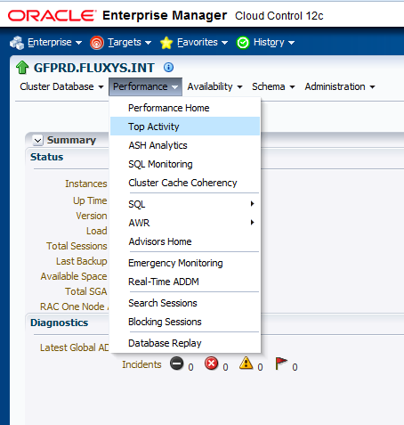

|  |
| --- |
|  |

If the problems has occurred in the past and can’t be found

In the default (1 hour) showed window than <Select> Historical

Put the cursor on the ‘Grey column’ showing the activity on the desired window

and travel in to the past until you reach the desired Time frame (see next Screen

shot)

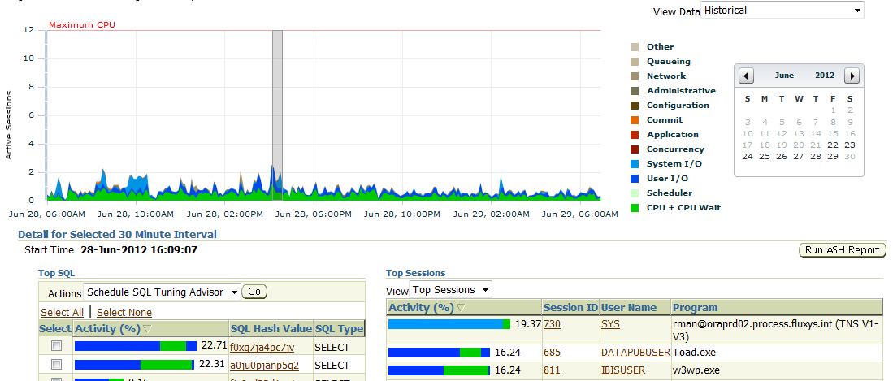

<click on> 685

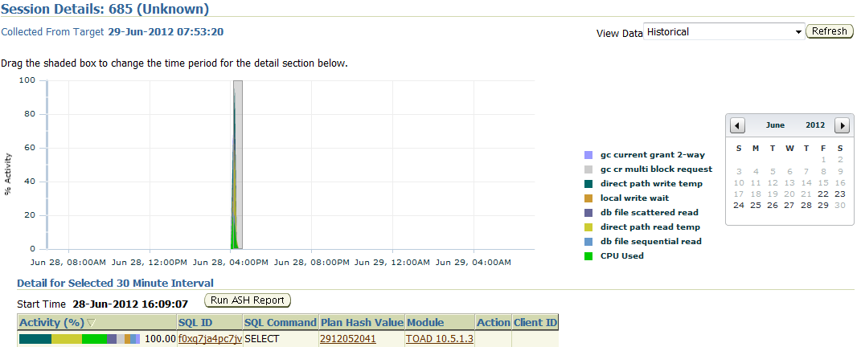

Very short but with a very high Activity (100%) on the temp tablespace

Conclusion :

The guilty is a ‘Toad session’ using the Application Technical user (DATAPUBUSER !!! ) but seen that this session is no more active (status Unknown ), we can’t see who has started it from which Workstation.

But normally if you react in a normal timeframe you will be able to see all this information.

If you click on the SQL ID, you can see the **bad** Query content :

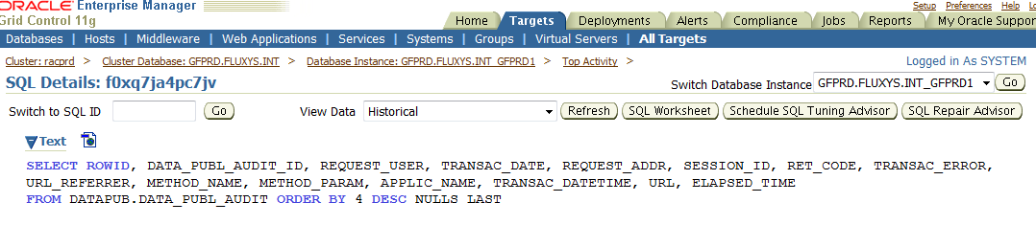

* Query on a huge table without any ‘WHERE’ clause in this case.