SELECT ID,

DOC_ID,

TEMPL_ID,

WORK_ORDER_ID,

NOTIF_ID,

TASK_LIST_ID,

TYPE_ID,

MAJOR_VERSION,

MINOR_VERSION,

trc_num,

chg_set_guid,

client_rec_id,

client_devc,

client_usr_name,

deleted,

dat_mod,

dat_cre

FROM (SELECT vw.*,

ROW_NUMBER ()

OVER (PARTITION BY vw.ID ORDER BY vw.flt_dat_mod DESC)

AS row_num

FROM (SELECT */*+ NO_MERGE(notifjaak) NO_MERGE(wojaak) */* FORM.ID,

FORM.DOC_ID,

FORM.TEMPL_ID,

FORM.WORK_ORDER_ID,

FORM.NOTIF_ID,

FORM.TASK_LIST_ID,

FORM.TYPE_ID,

FORM.MAJOR_VERSION,

FORM.MINOR_VERSION,

FORM.TRC_NUM,

CHL_FORM.chg_set_guid,

CHL_FORM.client_rec_id,

CHL_FORM.client_devc,

CHL_FORM.client_usr_name,

FORM.deleted,

NVL (CHL_FORM.dat_mod, FORM.dat_mod) AS dat_mod,

NVL (CHL_FORM.dat_cre, FORM.dat_cre) AS dat_cre,

FORM.dat_mod AS flt_dat_mod

FROM (

select */*+ ORDERED */* WORK_ORDER.id ident

from (TABLE(CAST (V_ZONEID_LST AS TBL_ZONE))) z, MAMBOOLD.ZONE , MAMBOOLD.WORK_ORDER_ZONE, MAMBOOLD.WORK_ORDER

WHERE WORK_ORDER.ID = WORK_ORDER_ZONE.WORK_ORDER_ID AND WORK_ORDER_ZONE.ZONE_ID = ZONE.ID AND ZONE.ZONE_NUM = z.ID

) wojaak,

(

select */*+ ORDERED */* NOTIF.id ident

from (TABLE(CAST (V_ZONEID_LST AS TBL_ZONE))) z, MAMBOOLD.ZONE , MAMBOOLD.NOTIF

WHERE NOTIF.ZONE_ID = ZONE.ID AND ZONE.ZONE_NUM = z.ID

) notifjaak,

MAMBOOLD.FORM, MAMBOOLD.CHL_FORM

where FORM.dat_mod > P_PREV_SYNC_DATE

AND FORM.ID = CHL_FORM.ID(+)

and ( FORM.WORK_ORDER_ID = wojaak.ident or FORM.NOTIF_ID = notifjaak.ident)

UNION ALL

SELECT CHL_FORM.ID,

CHL_FORM.DOC_ID,

CHL_FORM.TEMPL_ID,

CHL_FORM.WORK_ORDER_ID,

CHL_FORM.NOTIF_ID,

CHL_FORM.TASK_LIST_ID,

CHL_FORM.TYPE_ID,

CHL_FORM.MAJOR_VERSION,

CHL_FORM.MINOR_VERSION,

CHL_FORM.trc_num,

CHL_FORM.chg_set_guid,

CHL_FORM.client_rec_id,

CHL_FORM.client_devc,

CHL_FORM.client_usr_name,

decode(CHL_FORM.CHG_OPER_TYPE_ID, 'D', 1, 0),

CHL_FORM.dat_mod AS dat_mod,

CHL_FORM.dat_cre,

CHL_FORM.dat_mod AS flt_dat_mod

FROM MAMBOOLD.CHL_FORM

WHERE CHL_FORM.dat_mod > P_PREV_SYNC_DATE

AND CHL_FORM.CLIENT_DEVC = P_DEVC) vw

)

WHERE row_num = 1;

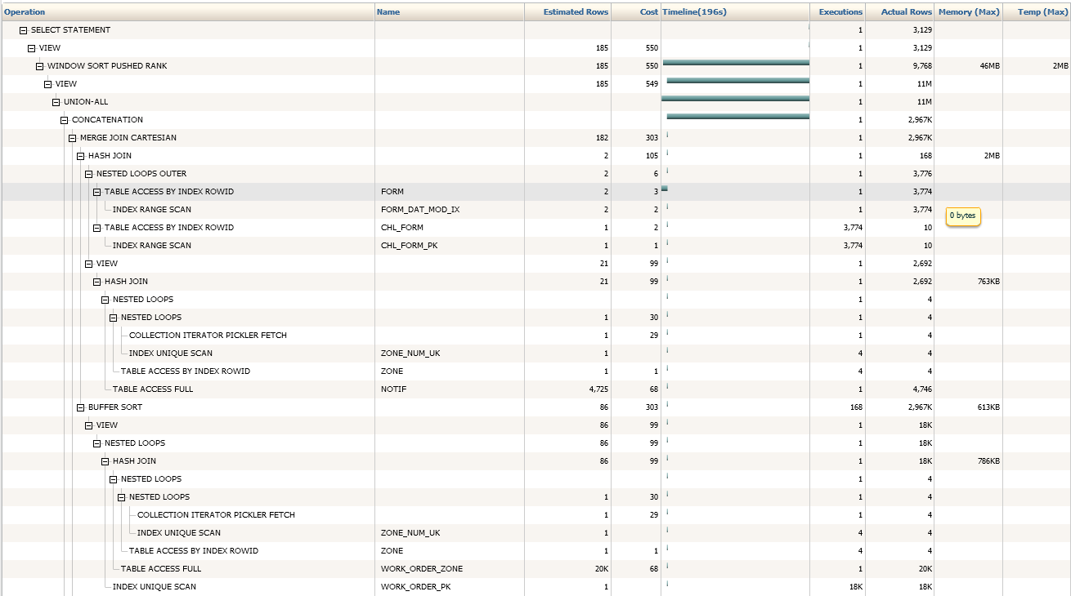

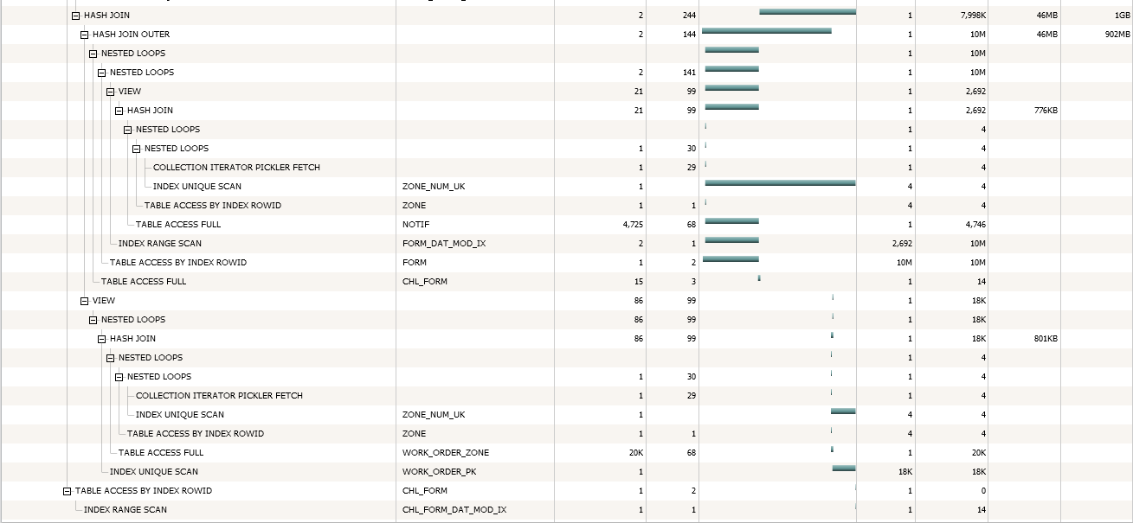

There are 2 things to look at in this execution plan

* We need to try to remove the MERGE JOIN CARTESIAN
* Although the total table size of all tables is only 10 MB, we are using nearly 2 GB of TEMP space. This is probably caused by the MERGE JOIN CARTESIAN.

The total execution time of this query is between 2 and 3 minutes, which is quite high seen the volume of data that has to be processed.

The MERGE JOIN CARTESIAN is caused by the 2 subqueries NOTIFJAAK and WOJAAK which are joined with the FORM table, but there is not actually a join possible between the 2 subqueries.

As the 2 subqueries are joined with the FORM table with an OR condition, the MERGE JOIN CARTESIAN can be avoided by splitting up the query in 2 queries and joining them with a UNION ALL

SELECT ID,

DOC_ID,

TEMPL_ID,

WORK_ORDER_ID,

NOTIF_ID,

TASK_LIST_ID,

TYPE_ID,

MAJOR_VERSION,

MINOR_VERSION,

trc_num,

chg_set_guid,

client_rec_id,

client_devc,

client_usr_name,

deleted,

dat_mod,

dat_cre

FROM (SELECT vw.*,

ROW_NUMBER ()

OVER (PARTITION BY vw.ID ORDER BY vw.flt_dat_mod DESC)

AS row_num

FROM (SELECT */*+ NO_MERGE(wojaak) */* FORM.ID,

FORM.DOC_ID,

FORM.TEMPL_ID,

FORM.WORK_ORDER_ID,

FORM.NOTIF_ID,

FORM.TASK_LIST_ID,

FORM.TYPE_ID,

FORM.MAJOR_VERSION,

FORM.MINOR_VERSION,

FORM.TRC_NUM,

CHL_FORM.chg_set_guid,

CHL_FORM.client_rec_id,

CHL_FORM.client_devc,

CHL_FORM.client_usr_name,

FORM.deleted,

NVL (CHL_FORM.dat_mod, FORM.dat_mod) AS dat_mod,

NVL (CHL_FORM.dat_cre, FORM.dat_cre) AS dat_cre,

FORM.dat_mod AS flt_dat_mod

FROM (

select */*+ ORDERED */* WORK_ORDER.id ident

from (TABLE(CAST (V_ZONEID_LST AS TBL_ZONE))) z, MAMBOOLD.ZONE , MAMBOOLD.WORK_ORDER_ZONE, MAMBOOLD.WORK_ORDER

WHERE WORK_ORDER.ID = WORK_ORDER_ZONE.WORK_ORDER_ID AND WORK_ORDER_ZONE.ZONE_ID = ZONE.ID AND ZONE.ZONE_NUM = z.ID

) wojaak,

MAMBOOLD.FORM, MAMBOOLD.CHL_FORM

where FORM.dat_mod > P_PREV_SYNC_DATE

AND FORM.ID = CHL_FORM.ID(+)

and ( FORM.WORK_ORDER_ID = wojaak.ident)

UNION ALL

SELECT */*+ NO_MERGE(notifjaak) */* FORM.ID,

FORM.DOC_ID,

FORM.TEMPL_ID,

FORM.WORK_ORDER_ID,

FORM.NOTIF_ID,

FORM.TASK_LIST_ID,

FORM.TYPE_ID,

FORM.MAJOR_VERSION,

FORM.MINOR_VERSION,

FORM.TRC_NUM,

CHL_FORM.chg_set_guid,

CHL_FORM.client_rec_id,

CHL_FORM.client_devc,

CHL_FORM.client_usr_name,

FORM.deleted,

NVL (CHL_FORM.dat_mod, FORM.dat_mod) AS dat_mod,

NVL (CHL_FORM.dat_cre, FORM.dat_cre) AS dat_cre,

FORM.dat_mod AS flt_dat_mod

FROM (

select */*+ ORDERED */* NOTIF.id ident

from (TABLE(CAST (V_ZONEID_LST AS TBL_ZONE))) z, MAMBOOLD.ZONE , MAMBOOLD.NOTIF

WHERE NOTIF.ZONE_ID = ZONE.ID AND ZONE.ZONE_NUM = z.ID

) notifjaak,

MAMBOOLD.FORM, MAMBOOLD.CHL_FORM

where FORM.dat_mod > P_PREV_SYNC_DATE

AND FORM.ID = CHL_FORM.ID(+)

and ( FORM.NOTIF_ID = notifjaak.ident)

UNION ALL

SELECT CHL_FORM.ID,

CHL_FORM.DOC_ID,

CHL_FORM.TEMPL_ID,

CHL_FORM.WORK_ORDER_ID,

CHL_FORM.NOTIF_ID,

CHL_FORM.TASK_LIST_ID,

CHL_FORM.TYPE_ID,

CHL_FORM.MAJOR_VERSION,

CHL_FORM.MINOR_VERSION,

CHL_FORM.trc_num,

CHL_FORM.chg_set_guid,

CHL_FORM.client_rec_id,

CHL_FORM.client_devc,

CHL_FORM.client_usr_name,

decode(CHL_FORM.CHG_OPER_TYPE_ID, 'D', 1, 0),

CHL_FORM.dat_mod AS dat_mod,

CHL_FORM.dat_cre,

CHL_FORM.dat_mod AS flt_dat_mod

FROM MAMBOOLD.CHL_FORM

WHERE CHL_FORM.dat_mod > P_PREV_SYNC_DATE

AND CHL_FORM.CLIENT_DEVC = P_DEVC) vw

)

WHERE row_num = 1;

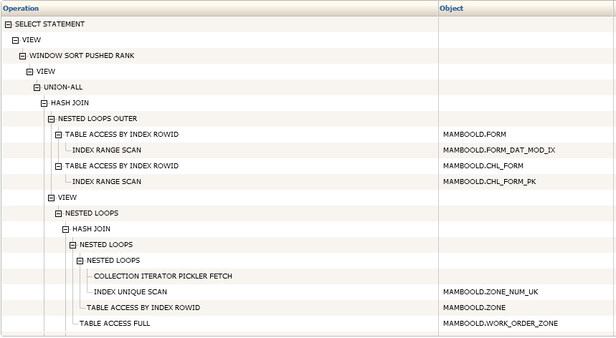

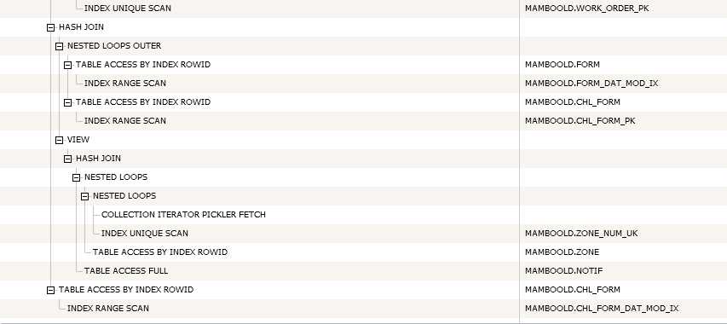

Execution time of the new query is about 1 second.