When will you have to restart OEM Monitoring

I) Context: You <Select> via ‘Targets 🡺 Databases’ 🡺 E.g. BELMETQ.fluxys.int

II) Multiple Symptoms are possible:

a) The **Summary** overview for this Db is empty

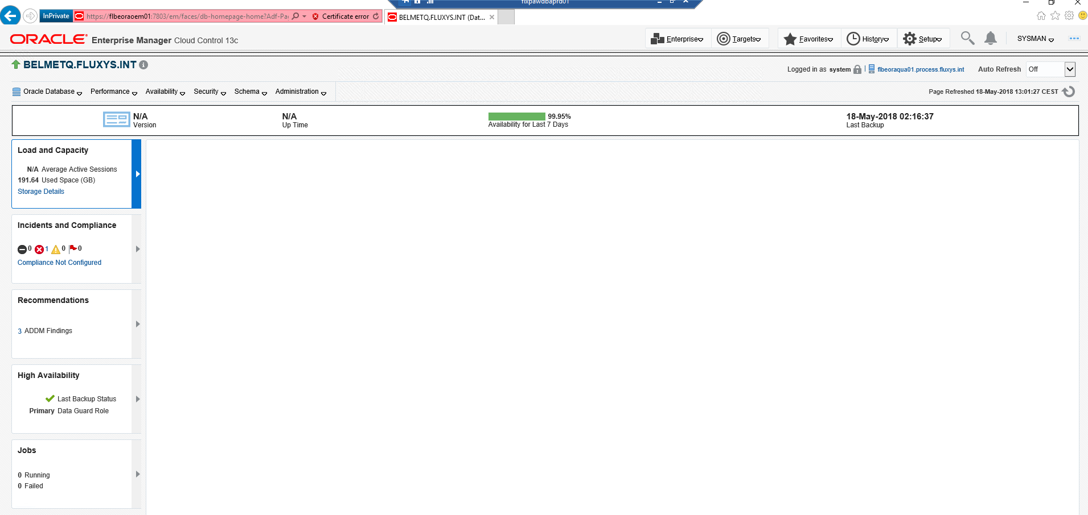

b) Asking for this Db ‘Performance 🡺 Top activity’: you receive the following Java error

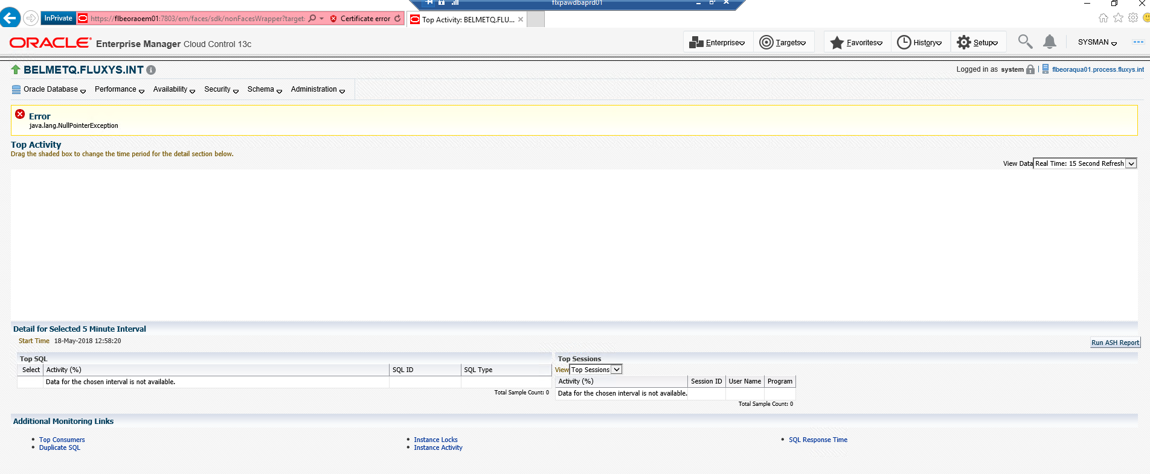

c) Asking for this Db ‘Performance 🡺 Top activity’:

you don’t receive a Java error but nothing is displayed

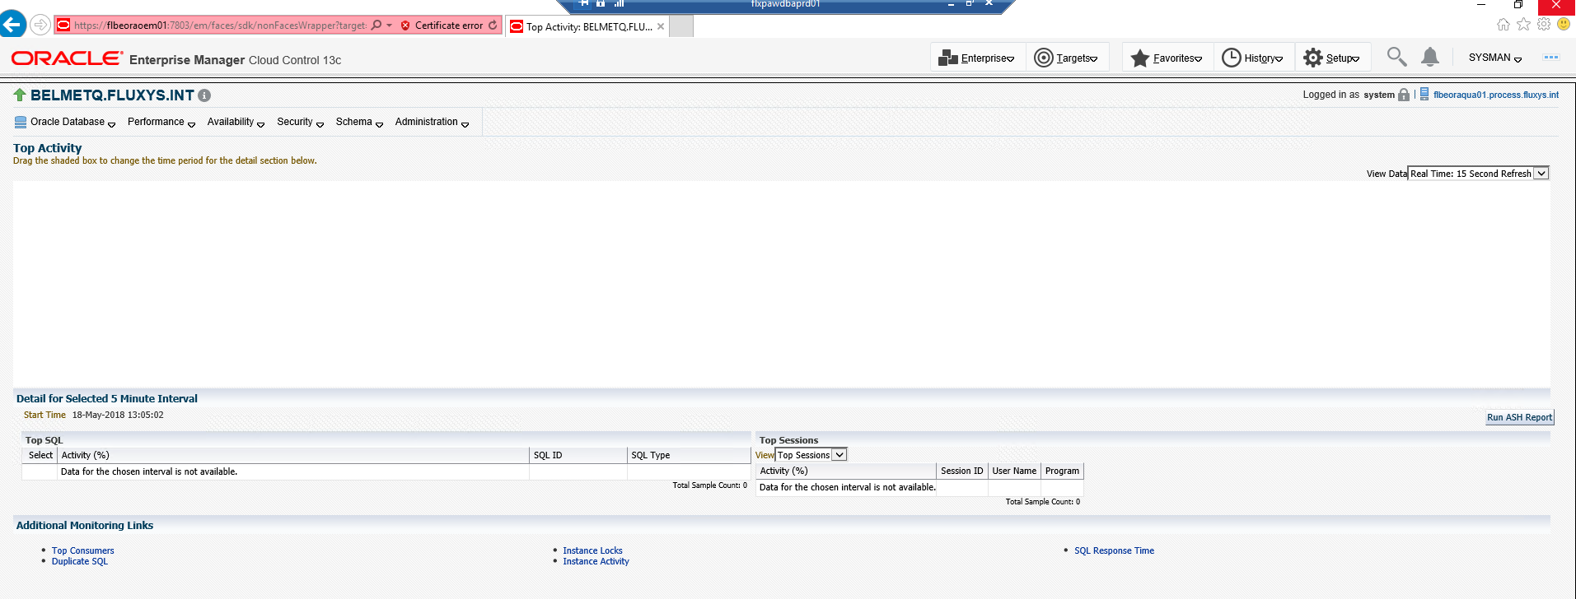

d) Only Historical data is available:

See Data until 12h00 and it’s 13hxx

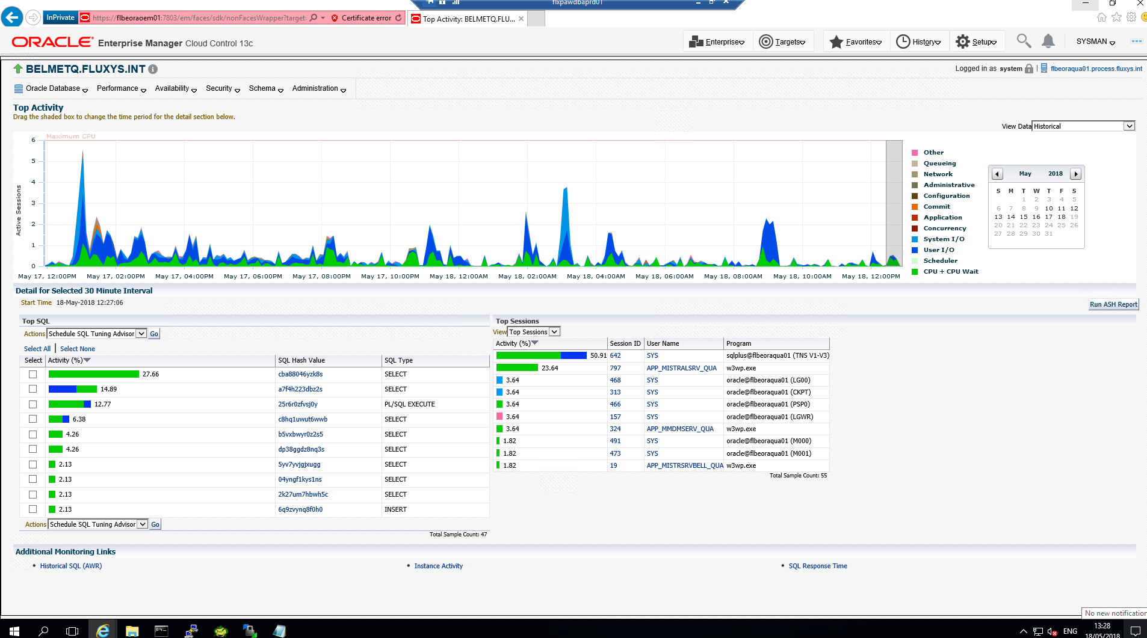

III) Solution:

Restart OEM Repository and OEM local Agent

1) On OEM Central server [ flbeora**oem**01 ] Stop/Restart OEM Central Instance:

Remark: be patient this is Java and could take a while

root

cd /etc/init.d

./gcstartup stop

Your Oracle profile is running...

Oracle Enterprise Manager Cloud Control 13c Release 2

Copyright (c) 1996, 2016 Oracle Corporation. All rights reserved.

Your environment is prepared to work with the CLOUD_CONTROL_PRODUCTION database

The Oracle base has been set to /u01/app/oracle

command cdexp will run 'cd /DD2500/backup/EMPRD/export'

command cdback will run 'cd /DD2500/backup/EMPRD'

command cdimp will run 'cd /u01/app/oracle/admin/EMPRD/import'

command cdscript will run 'cd /u01/app/oracle/admin/EMPRD/script'

command cdhome will run 'cd /u01/app/oracle/product/12.2.0.1'

command cdbin will run 'cd /u01/app/oracle/product/12.2.0.1/bin'

command cdlib will run 'cd /u01/app/oracle/product/12.2.0.1/lib'

command cddbs will run 'cd /u01/app/oracle/product/12.2.0.1/dbs'

command cdnet will run 'cd /u01/app/oracle/product/12.2.0.1/network'

command cdadmin will run 'cd /u01/app/oracle/product/12.2.0.1/rdbms/admin'

command cddiag will run 'cd /u01/app/oracle/diag'

command cdloc will run 'cd /usr/local/bin'

command cdcust will run 'cd /custom/oracle'

sudo exist

Your Oracle profile is running...

Oracle Enterprise Manager Cloud Control 13c Release 2

Copyright (c) 1996, 2016 Oracle Corporation. All rights reserved.

Stopping Oracle Management Server...

Your environment is prepared to work with the CLOUD_CONTROL_PRODUCTION database

The Oracle base has been set to /u01/app/oracle

command cdexp will run 'cd /DD2500/backup/EMPRD/export'

command cdback will run 'cd /DD2500/backup/EMPRD'

command cdimp will run 'cd /u01/app/oracle/admin/EMPRD/import'

command cdscript will run 'cd /u01/app/oracle/admin/EMPRD/script'

command cdhome will run 'cd /u01/app/oracle/product/12.2.0.1'

command cdbin will run 'cd /u01/app/oracle/product/12.2.0.1/bin'

command cdlib will run 'cd /u01/app/oracle/product/12.2.0.1/lib'

command cddbs will run 'cd /u01/app/oracle/product/12.2.0.1/dbs'

command cdnet will run 'cd /u01/app/oracle/product/12.2.0.1/network'

command cdadmin will run 'cd /u01/app/oracle/product/12.2.0.1/rdbms/admin'

command cddiag will run 'cd /u01/app/oracle/diag'

command cdloc will run 'cd /usr/local/bin'

command cdcust will run 'cd /custom/oracle'

[root@flbeoraoem01]

/etc/init.d# Oracle Enterprise Manager Cloud Control 13c Release 2

Copyright (c) 1996, 2016 Oracle Corporation. All rights reserved.

Stopping agent ... stopped.

[root@flbeoraoem01]

/etc/init.d# *WebTier Successfully Stopped*

*Oracle Management Server Successfully Stopped*

*Oracle Management Server is Down*

*JVMD Engine is Down*

*Stopping BI Publisher Server...*

*BI Publisher Server Successfully Stopped*

*AdminServer Successfully Stopped*

*BI Publisher Server is Down*

🡸Press <Enter> because OEM is stopped

*[root@flbeoraoem01]*

/etc/init.d#

./gcstartup start

Your Oracle profile is running...

Oracle Enterprise Manager Cloud Control 13c Release 2

Copyright (c) 1996, 2016 Oracle Corporation. All rights reserved.

Your environment is prepared to work with the CLOUD_CONTROL_PRODUCTION database

The Oracle base has been set to /u01/app/oracle

command cdexp will run 'cd /DD2500/backup/EMPRD/export'

command cdback will run 'cd /DD2500/backup/EMPRD'

command cdimp will run 'cd /u01/app/oracle/admin/EMPRD/import'

command cdscript will run 'cd /u01/app/oracle/admin/EMPRD/script'

command cdhome will run 'cd /u01/app/oracle/product/12.2.0.1'

command cdbin will run 'cd /u01/app/oracle/product/12.2.0.1/bin'

command cdlib will run 'cd /u01/app/oracle/product/12.2.0.1/lib'

command cddbs will run 'cd /u01/app/oracle/product/12.2.0.1/dbs'

command cdnet will run 'cd /u01/app/oracle/product/12.2.0.1/network'

command cdadmin will run 'cd /u01/app/oracle/product/12.2.0.1/rdbms/admin'

command cddiag will run 'cd /u01/app/oracle/diag'

command cdloc will run 'cd /usr/local/bin'

command cdcust will run 'cd /custom/oracle'

sudo exist

Your Oracle profile is running...

Oracle Enterprise Manager Cloud Control 13c Release 2

Copyright (c) 1996, 2016 Oracle Corporation. All rights reserved.

Your environment is prepared to work with the CLOUD_CONTROL_PRODUCTION database

The Oracle base has been set to /u01/app/oracle

command cdexp will run 'cd /DD2500/backup/EMPRD/export'

command cdback will run 'cd /DD2500/backup/EMPRD'

command cdimp will run 'cd /u01/app/oracle/admin/EMPRD/import'

command cdscript will run 'cd /u01/app/oracle/admin/EMPRD/script'

command cdhome will run 'cd /u01/app/oracle/product/12.2.0.1'

command cdbin will run 'cd /u01/app/oracle/product/12.2.0.1/bin'

command cdlib will run 'cd /u01/app/oracle/product/12.2.0.1/lib'

command cddbs will run 'cd /u01/app/oracle/product/12.2.0.1/dbs'

command cdnet will run 'cd /u01/app/oracle/product/12.2.0.1/network'

command cdadmin will run 'cd /u01/app/oracle/product/12.2.0.1/rdbms/admin'

command cddiag will run 'cd /u01/app/oracle/diag'

command cdloc will run 'cd /usr/local/bin'

command cdcust will run 'cd /custom/oracle'

[root@flbeoraoem01]

/etc/init.d# Oracle Enterprise Manager Cloud Control 13c Release 2

Copyright (c) 1996, 2016 Oracle Corporation. All rights reserved.

Starting Oracle Management Server...

Starting agent .............................. started.

WebTier Successfully Started

Oracle Management Server Successfully Started

Oracle Management Server is Up

JVMD Engine is Up

Starting BI Publisher Server ...

BI Publisher Server Successfully Started

BI Publisher Server is Up

WebTier Successfully Started

Oracle Management Server Successfully Started

Oracle Management Server is Up

🡸 Press <Enter> because OEM startup is finished

[root@flbeoraoem01]

/etc/init.d#

2) On the Monitored Db server [e.g. flbeoraqua01 hosting BELMETQ Db] Stop/Restart local Agent:

root

cd /etc/init.d

./gcstartup stop

With which ORACLE database do you want to work ?

BEL_GasFlow_Fluxys_Qua (BELQUA) - 1

BEL_GasFlow_LNG_Qua (BELQUAL) - 2

BEL_GasFlow_Storage_Qua (BELQUAS) - 3

BEL_GasFlow_LNG_Yamal_Qua (BELQUALY) - 4

BEL_Metering_Qua (BELMETQ) - 5

BEL_Weather_Forecast_Qua (BELGOLFQ) - 6

To quit without selection - q

Enter option [1-6] or [q]: 1 🡸 Choose any database that you want it doesn’t matter

Your environment is prepared to work with the BEL_GasFlow_Fluxys_Qua database

The Oracle base has been set to /u01/app/oracle

command cdexp will run 'cd /DD2500/backup/BELQUA/export'

command cdback will run 'cd /DD2500/backup/BELQUA'

command cdimp will run 'cd /u01/app/oracle/admin/BELQUA/import'

command cdscript will run 'cd /u01/app/oracle/admin/BELQUA/script'

command cdhome will run 'cd /u01/app/oracle/product/12.1.0.2'

command cdbin will run 'cd /u01/app/oracle/product/12.1.0.2/bin'

command cdlib will run 'cd /u01/app/oracle/product/12.1.0.2/lib'

command cddbs will run 'cd /u01/app/oracle/product/12.1.0.2/dbs'

command cdnet will run 'cd /u01/app/oracle/product/12.1.0.2/network'

command cdadmin will run 'cd /u01/app/oracle/product/12.1.0.2/rdbms/admin'

command cddiag will run 'cd /u01/app/oracle/diag'

command cdloc will run 'cd /usr/local/bin'

command cdcust will run 'cd /custom/oracle'

[root@flbeoraqua01]

/etc/init.d# *Oracle Enterprise Manager Cloud Control 13c Release 2*

*Copyright (c) 1996, 2016 Oracle Corporation. All rights reserved.*

*Stopping agent ... stopped.*

🡸 Press <Enter> because the Agent is stopped

*You have new mail in /var/spool/mail/root*

[root@flbeoraqua01]

/etc/init.d#

./gcstartup start

With which ORACLE database do you want to work ?

BEL_GasFlow_Fluxys_Qua (BELQUA) - 1

BEL_GasFlow_LNG_Qua (BELQUAL) - 2

BEL_GasFlow_Storage_Qua (BELQUAS) - 3

BEL_GasFlow_LNG_Yamal_Qua (BELQUALY) - 4

BEL_Metering_Qua (BELMETQ) - 5

BEL_Weather_Forecast_Qua (BELGOLFQ) - 6

To quit without selection - q

Enter option [1-6] or [q]: 1 🡸 Choose any database that you want it doesn’t matter

Your environment is prepared to work with the BEL_GasFlow_Fluxys_Qua database

The Oracle base has been set to /u01/app/oracle

command cdexp will run 'cd /DD2500/backup/BELQUA/export'

command cdback will run 'cd /DD2500/backup/BELQUA'

command cdimp will run 'cd /u01/app/oracle/admin/BELQUA/import'

command cdscript will run 'cd /u01/app/oracle/admin/BELQUA/script'

command cdhome will run 'cd /u01/app/oracle/product/12.1.0.2'

command cdbin will run 'cd /u01/app/oracle/product/12.1.0.2/bin'

command cdlib will run 'cd /u01/app/oracle/product/12.1.0.2/lib'

command cddbs will run 'cd /u01/app/oracle/product/12.1.0.2/dbs'

command cdnet will run 'cd /u01/app/oracle/product/12.1.0.2/network'

command cdadmin will run 'cd /u01/app/oracle/product/12.1.0.2/rdbms/admin'

command cddiag will run 'cd /u01/app/oracle/diag'

command cdloc will run 'cd /usr/local/bin'

command cdcust will run 'cd /custom/oracle'

[root@flbeoraqua01]

/etc/init.d#  *Oracle Enterprise Manager Cloud Control 13c Release 2*

*Copyright (c) 1996, 2016 Oracle Corporation. All rights reserved.*

*Starting agent ............................. started.*

🡸 Press <Enter> because startup is finished

*You have new mail in /var/spool/mail/root*

*[root@flbeoraqua01]*

/etc/init.d#