Tablespace Management via TOAD

I) Global Remark

II) How to connect

III) How to extend the size of a Tablespace Datafile

IV) How to Add a Datafile to a Tablespace

V) How to put a Tablespace Datafile back Online

I) **Global remark**

This procedure can be used for all the Oracle databases running at Fluxys:

* Fluxys Belgium
* Hosting
* AMGA

II) **How to connect**

1) Connect with your administrator account to a Dba Jump server:

Mstsc flxpawdbaprd01.central.fluxys.int

Fluxys\admdesmet

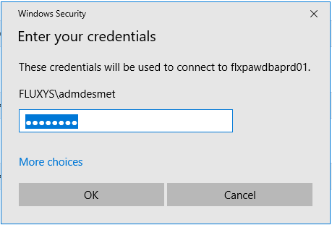

2) Search and Start TOAD:

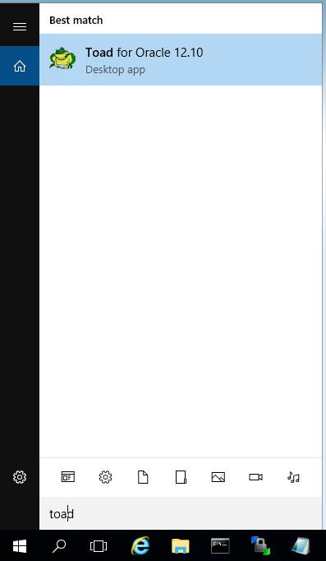

3) Via TOAD Connect to the Target Database: E.g. BELQUA.fluxys.int

a) Directly via the Initial Prompt

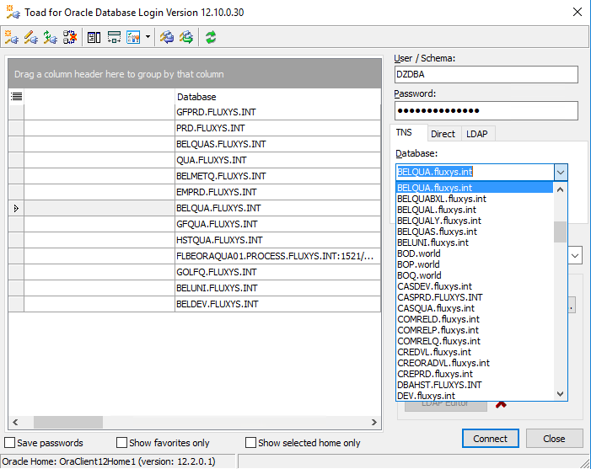

b) Via a New Connection in the Menu:

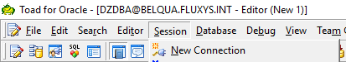

Session 🡺 New Connection

4) Go to TOAD Tablespace Management tool

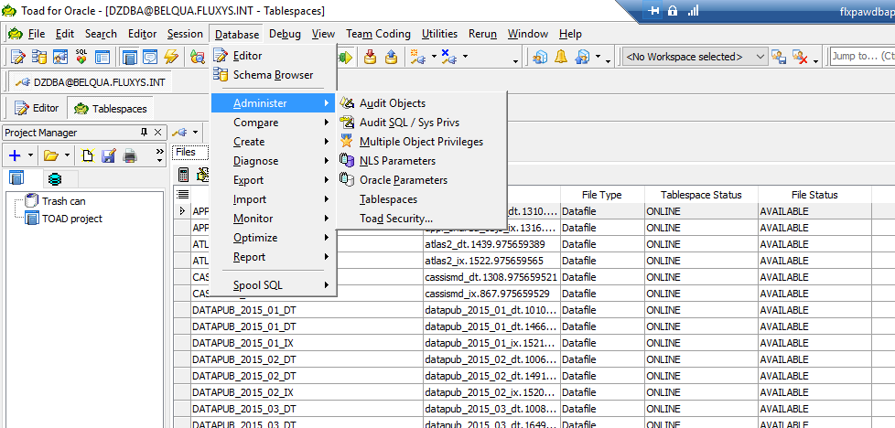

Database 🡺 Administer 🡺 Tablespaces

From here multiple options:

a) increase size of an existing Tablespace database file

b) add a Database file to a Tablespace

NB: only solution for **TEMP** and **UNDOTBS1** tablespaces

c) put a tablespace back online

III) **How to extend the size of a Tablespace Datafile**

1) Check if at ASM level there is enough Disk space free:

Putty

flbeoraqua01.process.fluxys.int

Your Linux account

su - grid

home/grid# asmdisks

=================== OVERVIEW OF ASM DISKGROUPS ==================================

NAME STATE TOTAL_MB Used %Usd NR_ DISKS TYPE

--------------- ----------- ---------- -------- ----- -------- ------

DATA MOUNTED 1605648 1157136 72 4 EXTERN

FRA MOUNTED 516102 96369 18 3 EXTERN

REDO MOUNTED 102398 54 0 2 EXTERN

==================== OVERVIEW OF ASM DISKS ======================================

DISKGROUP PATH Total Used %Usd ST Header FAILGROUP STATE DiskName MOUNT_S

---------- ------------------- ----------- -------- -------- ----- --- --------------- ----------- ---------- --------------- -------

DATA AFD:DATA1 401412 289276 72 ONL MEMBER DATA1 NORMAL DATA1 CACHED

AFD:DATA2 401412 289248 72 ONL MEMBER DATA2 NORMAL DATA2 CACHED

AFD:DATA3 401412 289360 72 ONL MEMBER DATA3 NORMAL DATA3 CACHED

AFD:DATA4 401412 289252 72 ONL MEMBER DATA4 NORMAL DATA4 CACHED

FRA AFD:FRA1 172034 32106 18 ONL MEMBER FRA1 NORMAL FRA1 CACHED

AFD:FRA2 172034 32139 18 ONL MEMBER FRA2 NORMAL FRA2 CACHED

AFD:FRA3 172034 32124 18 ONL MEMBER FRA3 NORMAL FRA3 CACHED

REDO AFD:REDO1 51199 25 0 ONL MEMBER REDO1 NORMAL REDO1 CACHED

AFD:REDO2 51199 29 0 ONL MEMBER REDO2 NORMAL REDO2 CACHED

=================== OVERVIEW OF ASM OPERATIONS ==================================

[grid@flbeoraqua01]

/home/grid#

If there is not enough Disk Space in the target ASM Disk Group, ask Linux team to extend this Disk Group

This is not the case here where only 72% of the DATA Disk Group is in use.

2) **Increase the size of an existing database file** of a Tablespace

Select the target Tablespace and increase the Maximum Size of one the Datafiles:

E.g. MITHRA_DT as tablespace<, we will increase the size of the 4th datafile from 3072Mb

to 4096Mb

<Double-click> on this MITHRA_DT 4th and last database file

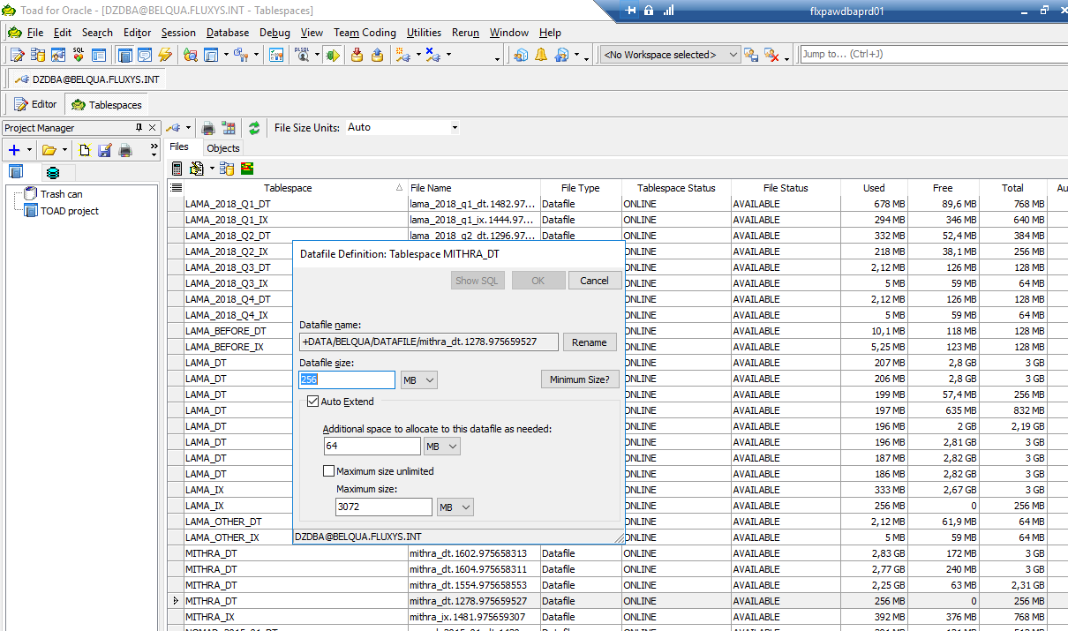

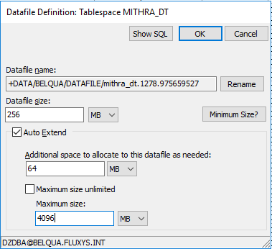

Modify ‘Maximum size’ from 3072 as showed on the previous screen to 4096.

OK

IV) **How to Add a Datafile to a Tablespace**

1) Check if at ASM level there is enough Disk space free:

Putty

flbeoraqua01.process.fluxys.int

Your Linux account

su - grid

home/grid# asmdisks

=================== OVERVIEW OF ASM DISKGROUPS ==================================

NAME STATE TOTAL_MB Used %Usd NR_ DISKS TYPE

--------------- ----------- ---------- -------- ----- -------- ------

DATA MOUNTED 1605648 1157136 72 4 EXTERN

FRA MOUNTED 516102 96369 18 3 EXTERN

REDO MOUNTED 102398 54 0 2 EXTERN

==================== OVERVIEW OF ASM DISKS ======================================

DISKGROUP PATH Total Used %Usd ST Header FAILGROUP STATE DiskName MOUNT_S

---------- ------------------- ----------- -------- -------- ----- --- --------------- ----------- ---------- --------------- -------

DATA AFD:DATA1 401412 289276 72 ONL MEMBER DATA1 NORMAL DATA1 CACHED

AFD:DATA2 401412 289248 72 ONL MEMBER DATA2 NORMAL DATA2 CACHED

AFD:DATA3 401412 289360 72 ONL MEMBER DATA3 NORMAL DATA3 CACHED

AFD:DATA4 401412 289252 72 ONL MEMBER DATA4 NORMAL DATA4 CACHED

FRA AFD:FRA1 172034 32106 18 ONL MEMBER FRA1 NORMAL FRA1 CACHED

AFD:FRA2 172034 32139 18 ONL MEMBER FRA2 NORMAL FRA2 CACHED

AFD:FRA3 172034 32124 18 ONL MEMBER FRA3 NORMAL FRA3 CACHED

REDO AFD:REDO1 51199 25 0 ONL MEMBER REDO1 NORMAL REDO1 CACHED

AFD:REDO2 51199 29 0 ONL MEMBER REDO2 NORMAL REDO2 CACHED

=================== OVERVIEW OF ASM OPERATIONS ==================================

[grid@flbeoraqua01]

/home/grid#

If there is not enough Disk Space in the target ASM Disk Group, ask Linux team to extend this Disk Group

This is not the case here where only 72% of the DATA Disk Group is in use.

3) **Add a Database file** to a Tablespace:

Select the target Tablespace and go to the Menu to select the Addition of new Datafile

E.g. VEGA_DT as tablespace, we will add a 10th datafile of 3072Mb

<**Single**-click> on any datafile you want of VEGA_DT

Menu 🡺 Alter Tablespace

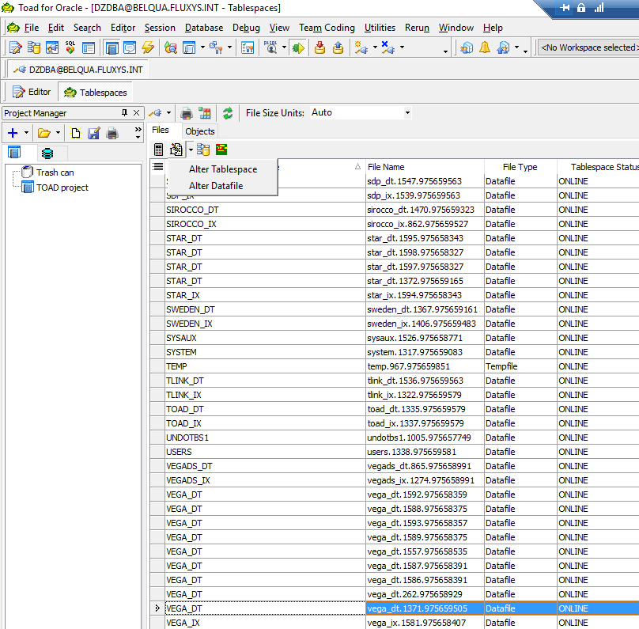

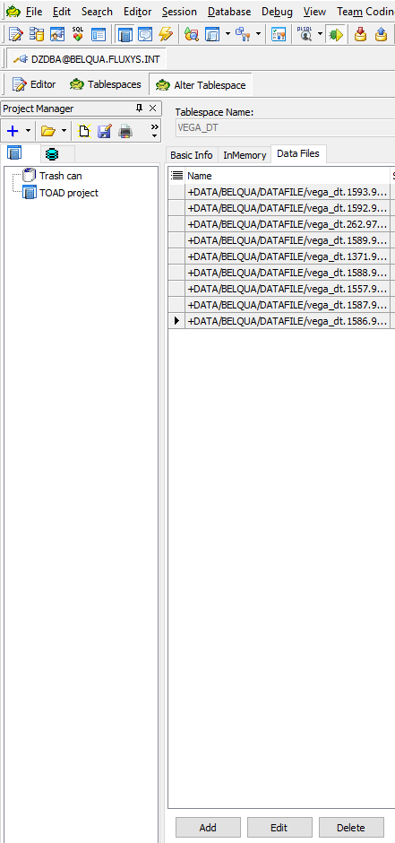

Add

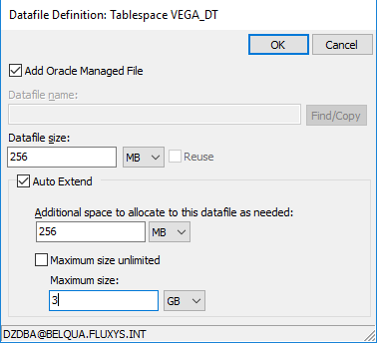

<Select> Add Oracle Managed File

Provide 256 Mb as Database size

<Select> Auto Extend

Provide 256 Mb as Additional space to allocate to this datafile as needed

<**De**select> Maximum size unlimited

Provide 3 Gb as Maximum size

OK

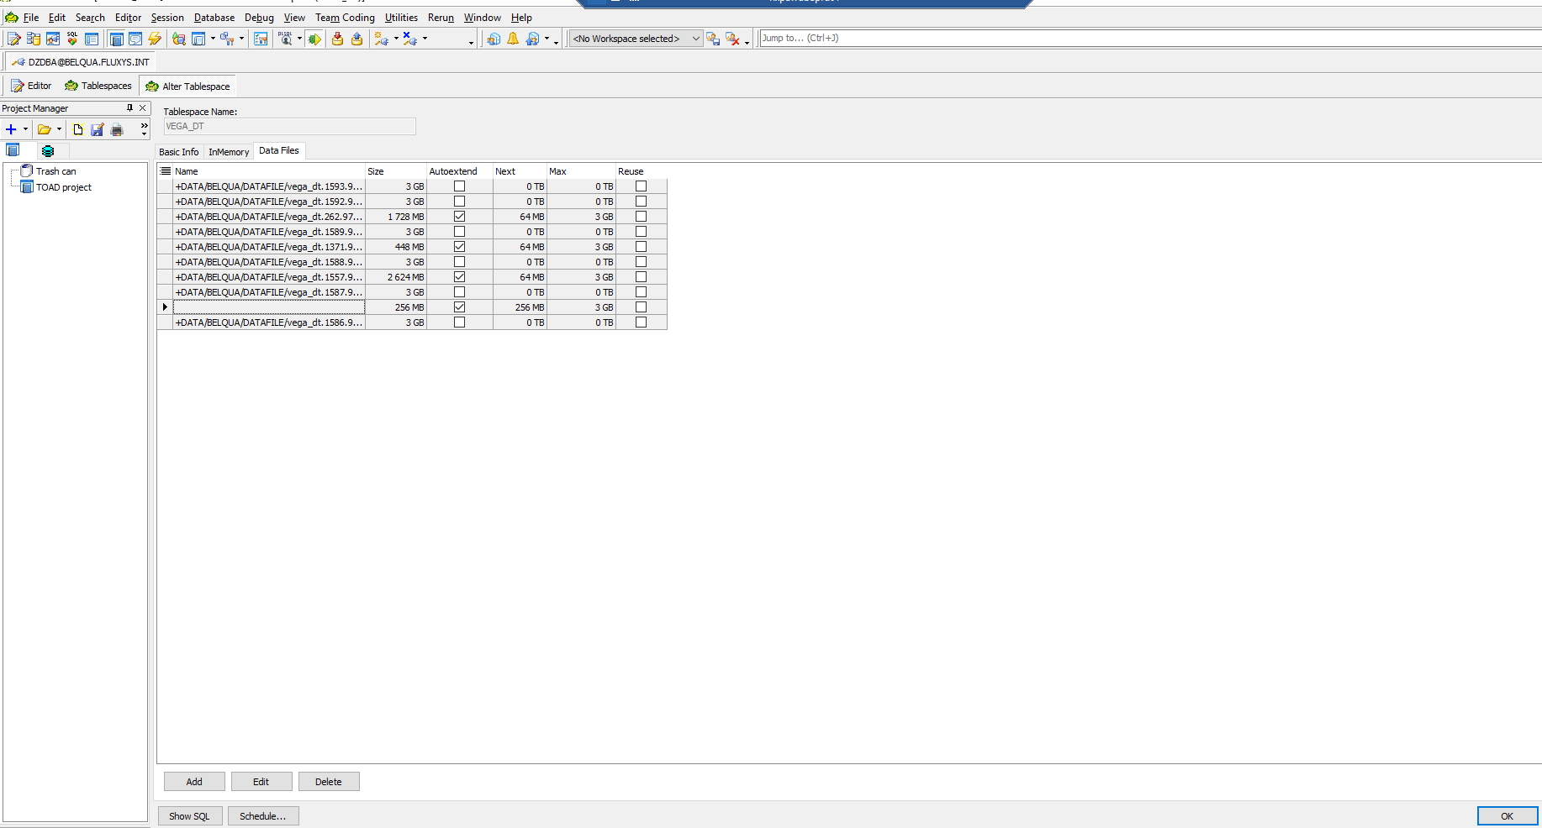

OK

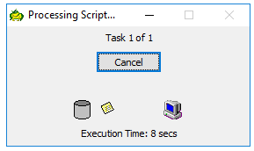

Do a Refresh to vizualise the Add of the Datafile:

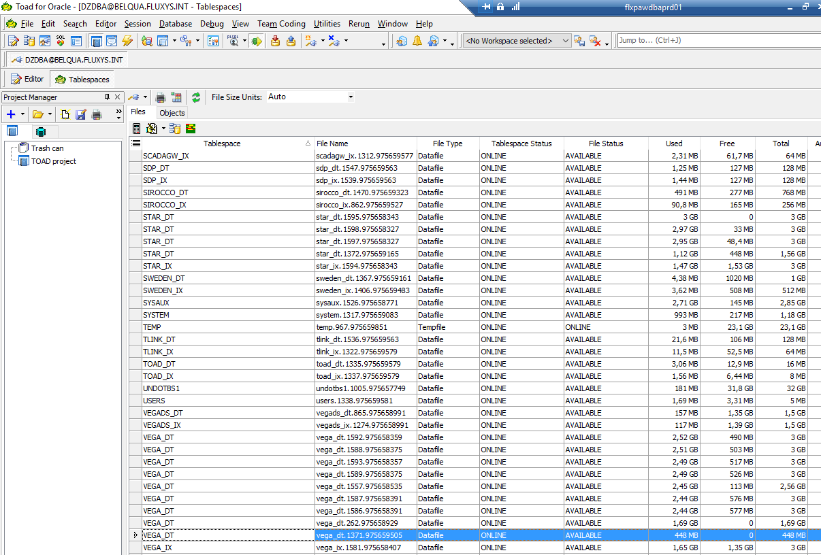

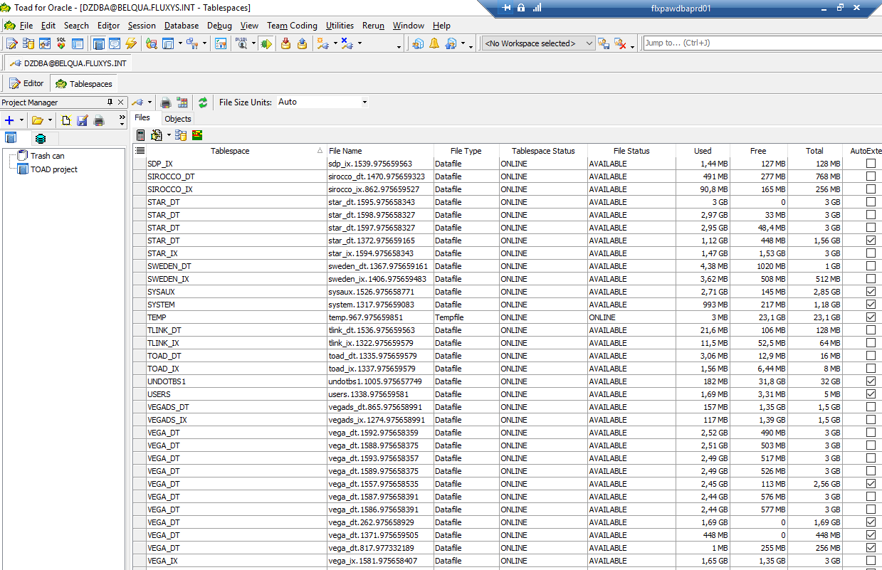

V) **How to put a Tablespace Datafile back Online**

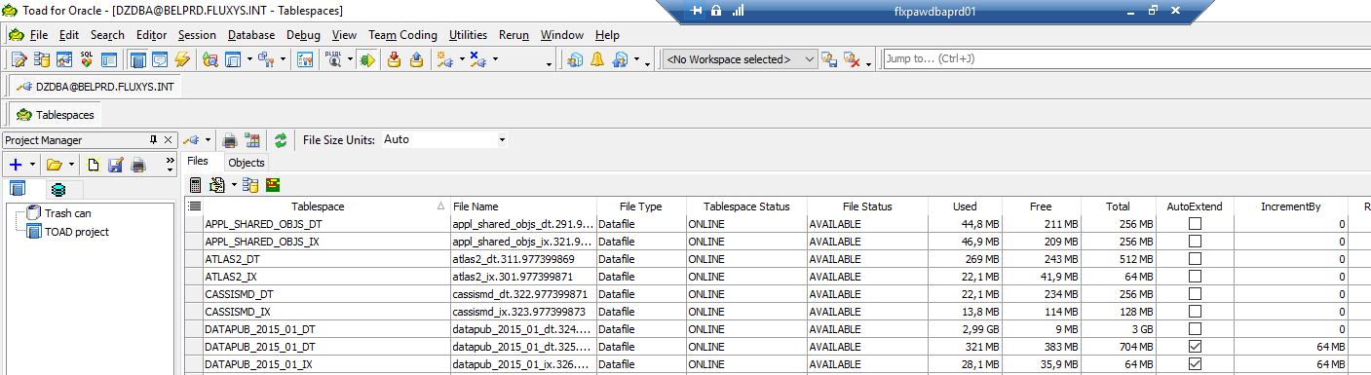

From here you can see the **Tablespace Status** column indicating that a tablespace is online or offline.

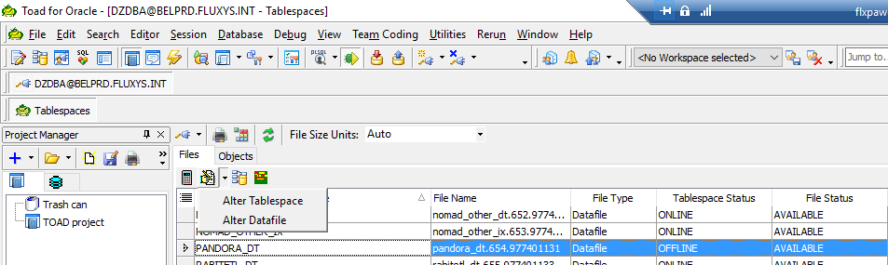

Select tablespace (here PANDORA_DT ) 🡺 Alter Tablespace 🡺 You can see status OFFLINE

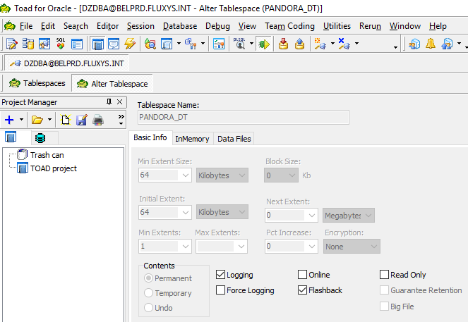

Go to ‘Basic Info’ <Tab> 🡺 You can see that status Online isn’t flagged

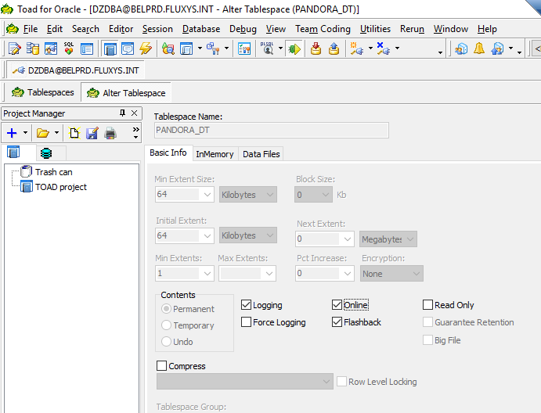

Flag ‘Online’ 🡺 OK

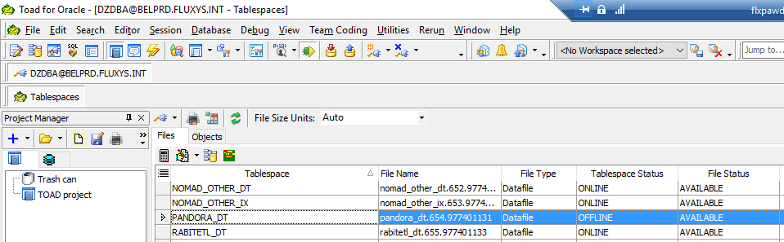

Press ‘Refresh’ button

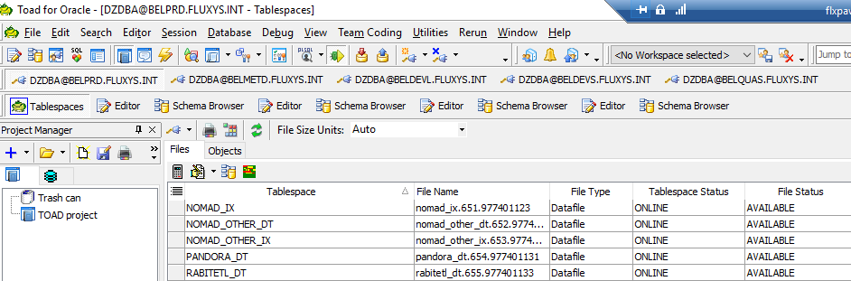

If the tablespace doesn’t change to *Online*, you have to contact the DBA-team (probably OS problem)