Oracle Process Management via TOAD

I) **Global remark**

II) **Connect with your administrator account to a Dba Jump server**

III) **Process Management**

IV) **Detect locking and Kill sessions**

I) **Global remark**

This procedure can be used for all the Oracle databases running at Fluxys:

* Fluxys Belgium
* Hosting
* AMGA

II) **Connect with your administrator account to a Dba Jump server**

Mstsc flxpawdbaprd01.central.fluxys.int

Fluxys\admdesmet

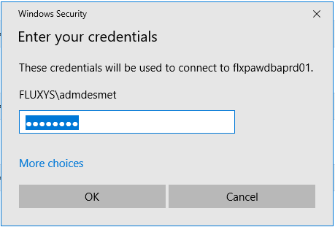

2) Search and Start TOAD:

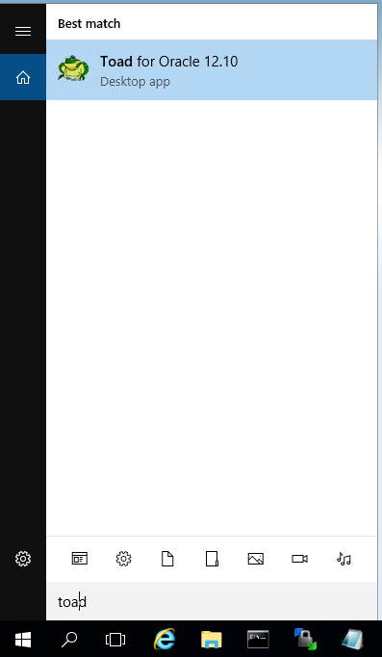

3) Via TOAD Connect to the Target Database: E.g. BELQUA.fluxys.int

a) Directly via the Prompt

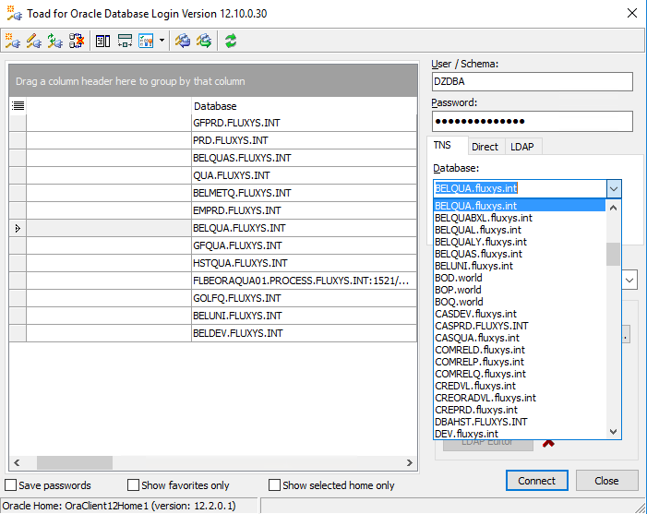

b) Via a New Connection in the Menu:



Session 🡺 New Connection

III) **Process Management**

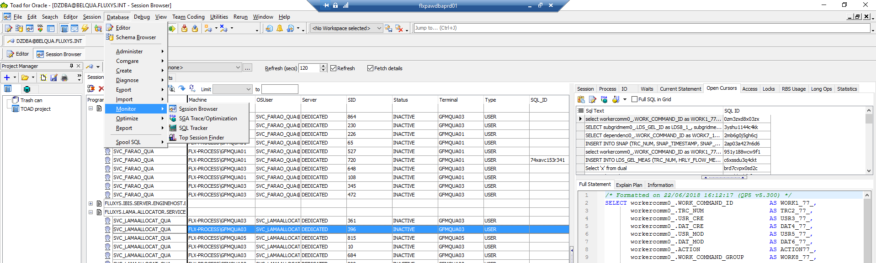

Database 🡺 Monitor 🡺 Session Browser 🡺 **Open Cursors** <tab>

By selecting one sessions ( E.g SVC_IBISHUBENG_QUA - 361 )

you can obtain much more info related to this specific session (Right panel)

IV) **Detect locking and Kill sessions**

1) Detect via: Database 🡺 Monitor 🡺 Session Browser 🡺 **Locks** <tab>

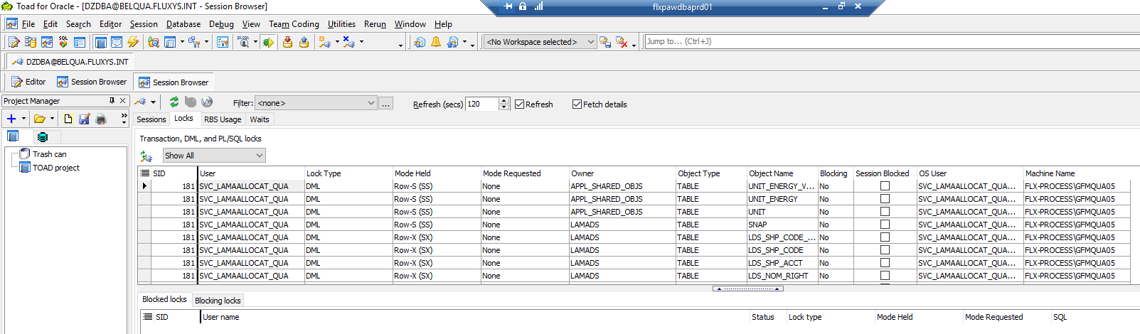

You get the session ID of the locking session ( E.g 181)

2) Kill via: Database 🡺 Monitor 🡺 Session Browser 🡺 **Sessions** <tab>

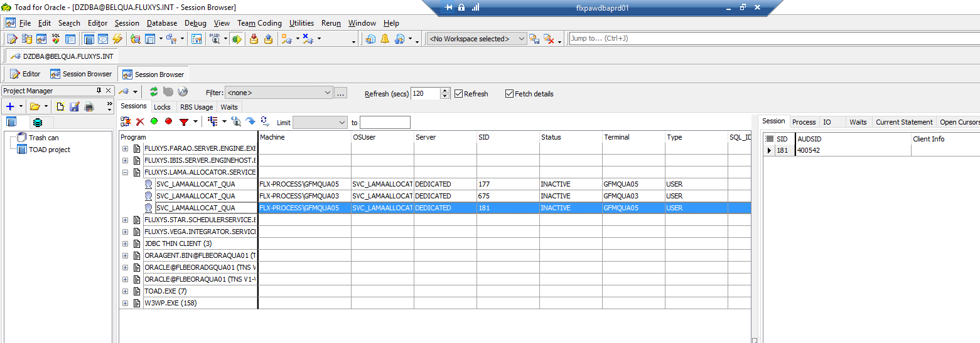

Select the session to Kill (E.g. 181) and press