## Problem 4 – Unresponsive to Responsive Site

You are given an unresponsive Web site (**HTML** + **CSS** + images). Your task is to **make the site responsive**. The site layout should change according to the browser viewport / screen size. You need to implement 4 layouts: **width ≤ 480px**, **481px** **≤ width < 570px**, **571px** **≤ width < 740px** and **width ≥ 740px**:

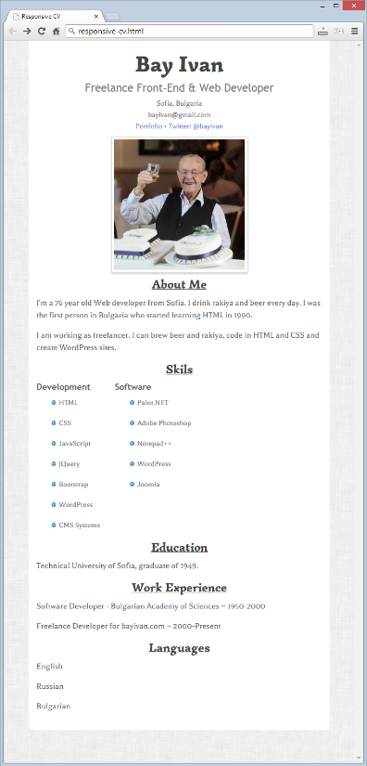

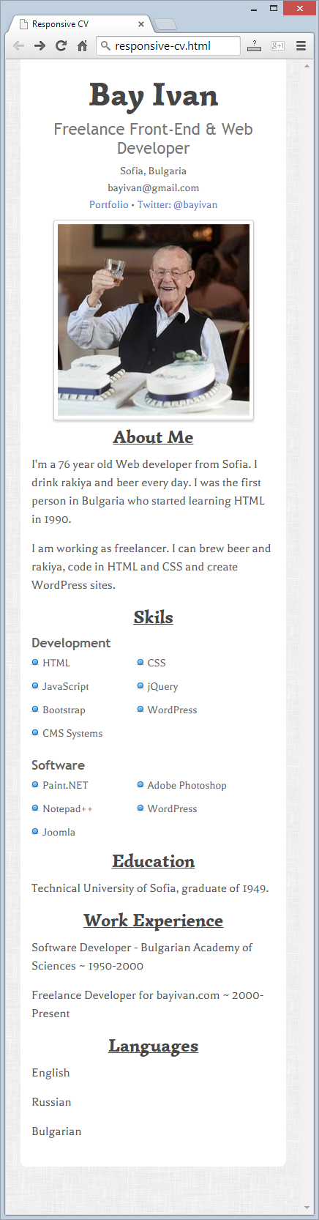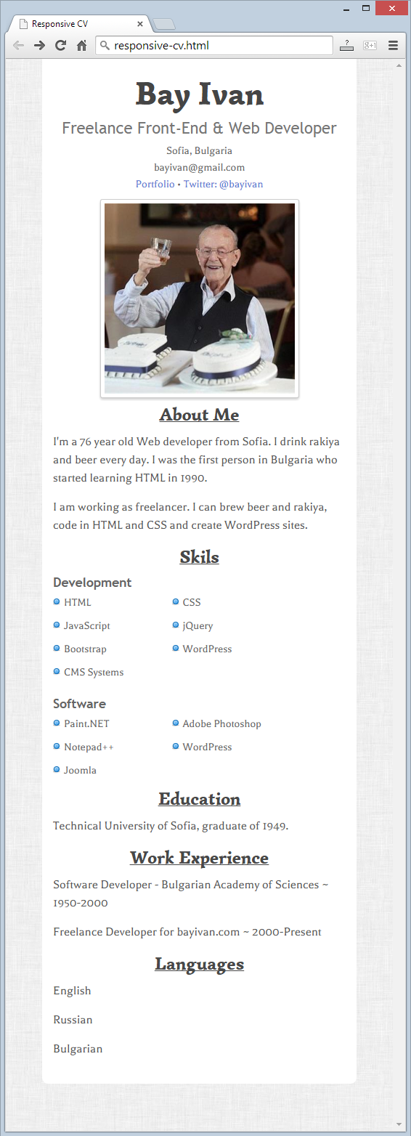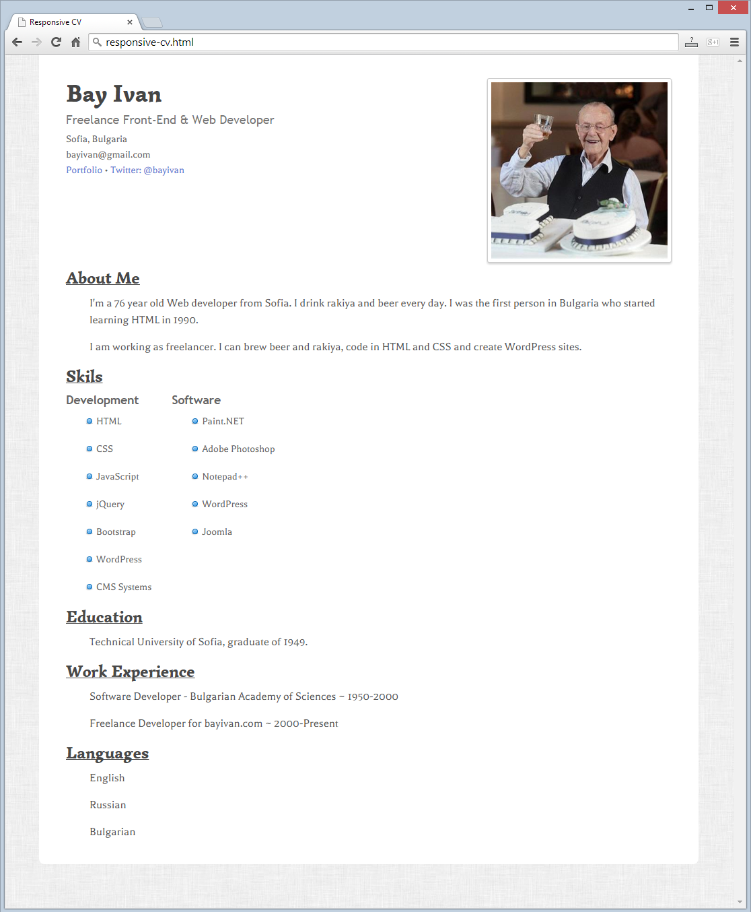

### Input

You are given the unresponsive site as HTML + CSS + images.

### Output

The output should be valid HTML5 + CSS3 + images that implement the above responsive site.

### Constraints

* You are free to change the HTML and CSS, as well as use external frameworks like Bootstrap.
* Pixel-perfect implementation is not required.