Title: Add Employee
Device and Browser: Laptop/Google Chrome
Error/Bug and Scenario: Double scroll bar persists when adding employees.
Date checked: December 16, 2025
Level of Importance: Medium
Done
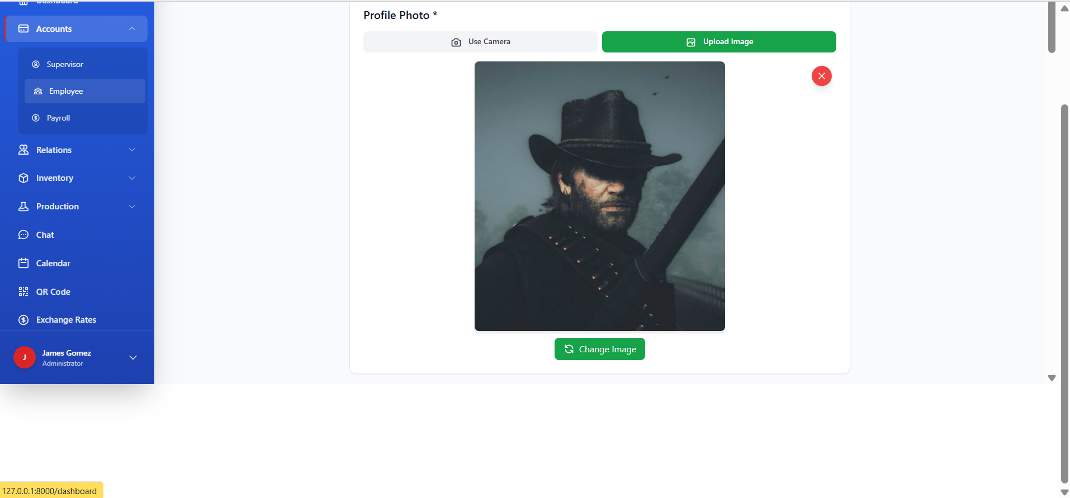
Title: Add Supervisor
Device and Browser: Laptop/Google Chrome
Error/Bug and Scenario: Double scroll bar persists when adding supervisors.
Date checked: December 16, 2025
Level of Importance: Medium
Done
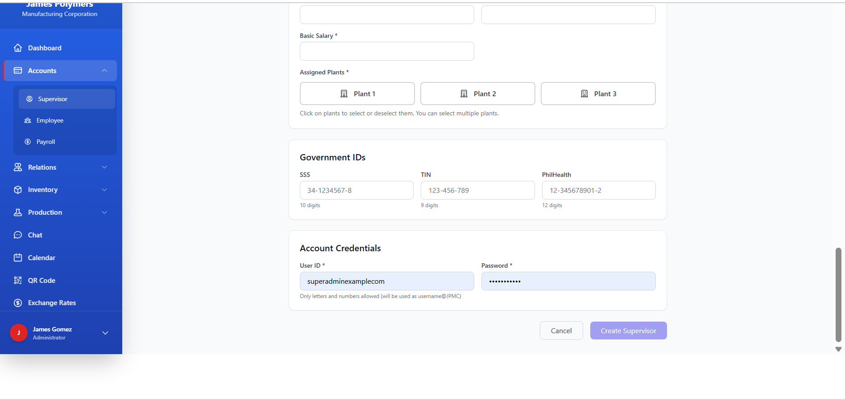

Title: Edit Customer
Device and Browser: Laptop/Google Chrome
Error/Bug and Scenario: The Credit Limit tab in the Edit Customer allows you to input text.
Date checked: December 16, 2025
Level of Importance: Medium
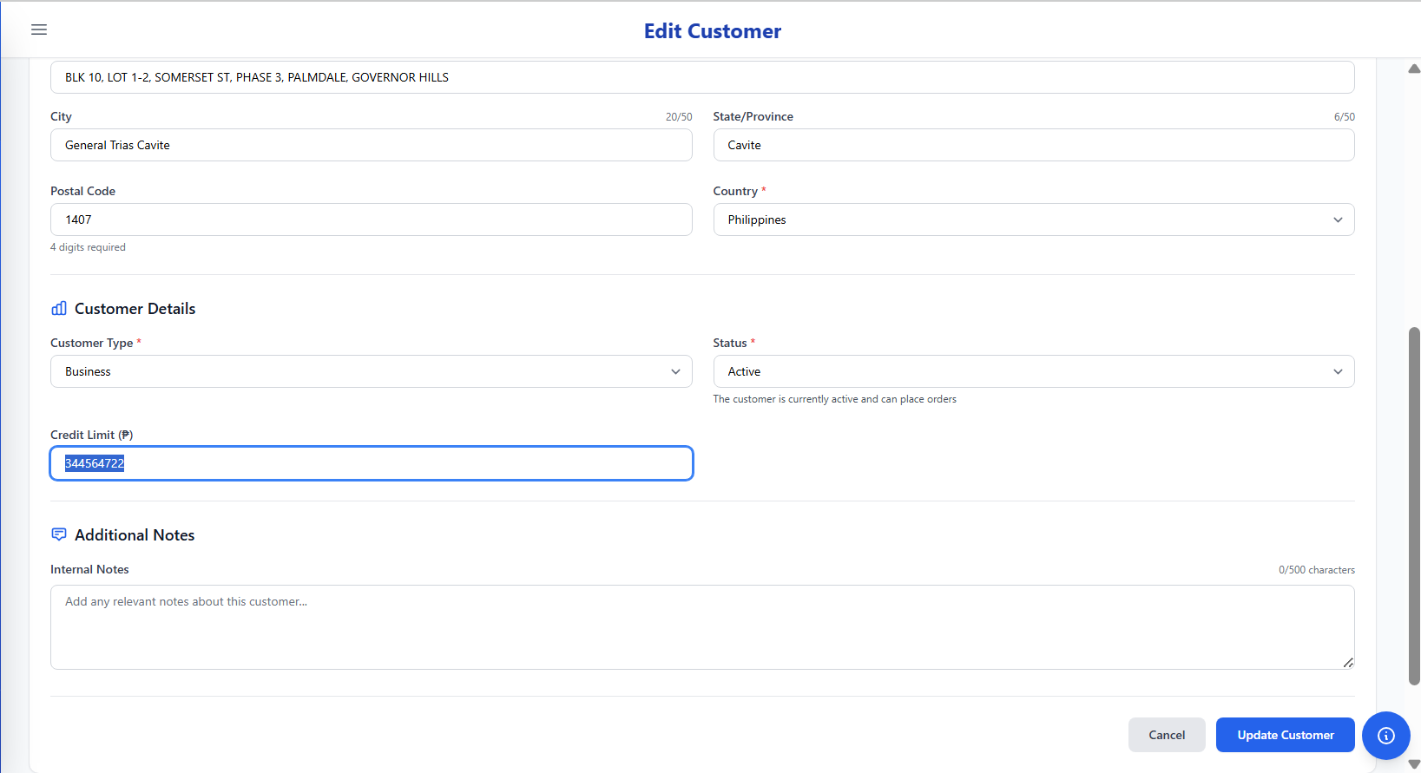

Title: Create Quotation
Device and Browser: Laptop/Google Chrome
Error/Bug and Scenario: Still cannot create Quotation
Date checked: December 16, 2025
Level of Importance: URGENT
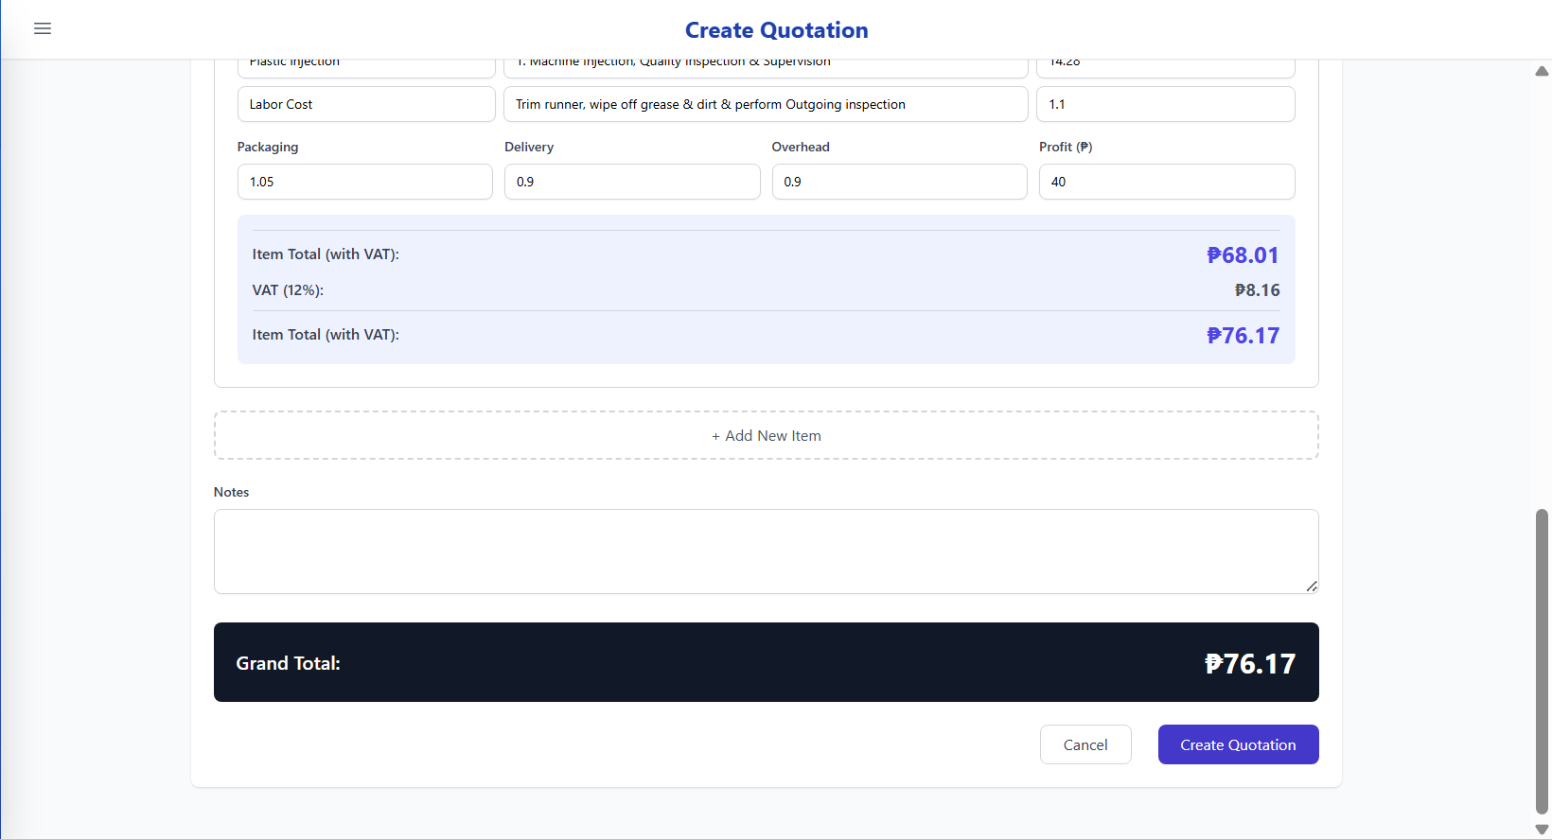

Title: Customer Request Details
Device and Browser: Laptop/Google Chrome
Error/Bug and Scenario: In the Customer Request Details, you can create the following: The Required By date (Dec 17, 2025) is earlier than the Request Date (Dec 31, 2025). This is logically invalid.
Date checked: December 16, 2025
Level of Importance: HIGH
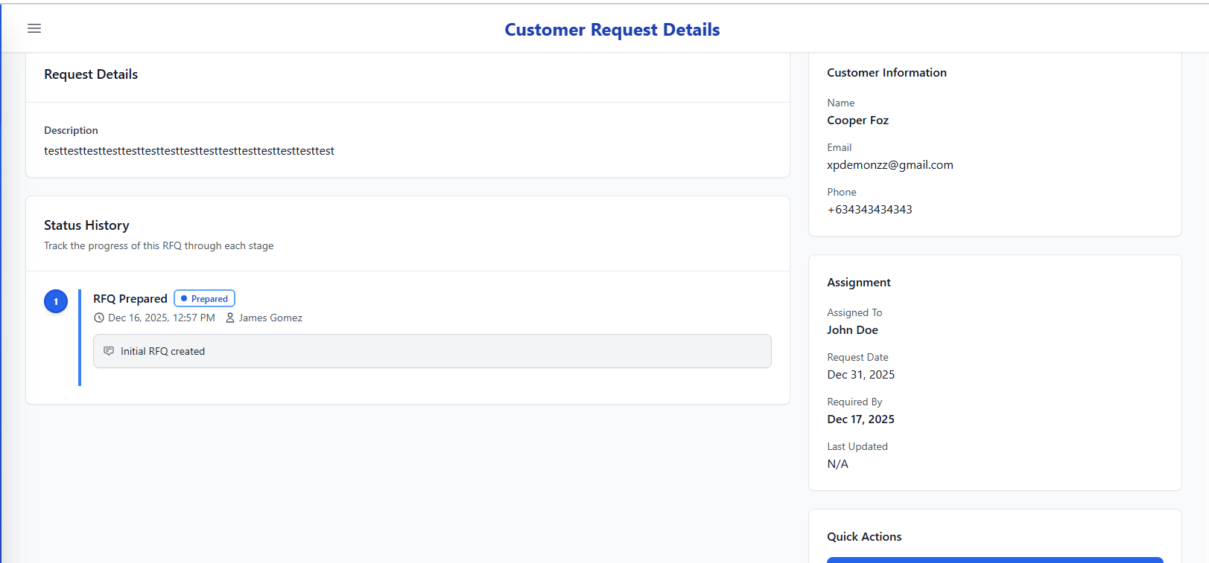

Title: Edit Customer Request
Device and Browser: Laptop/Google Chrome
Error/Bug and Scenario: When editing Customer Request, there is no options to change the date requested date.
Date checked: December 16, 2025
Level of Importance: HIGH
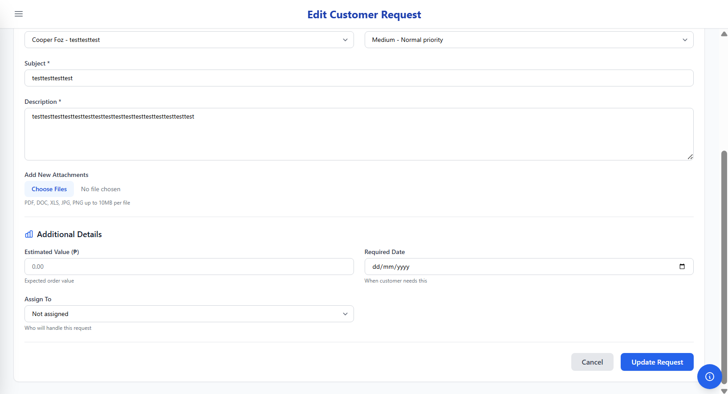

Title: Edit Oder
Device and Browser: Laptop/Google Chrome
Error/Bug and Scenario: When editing order, it request you to input Order Date again.
Date checked: December 16, 2025
Level of Importance: HIGH
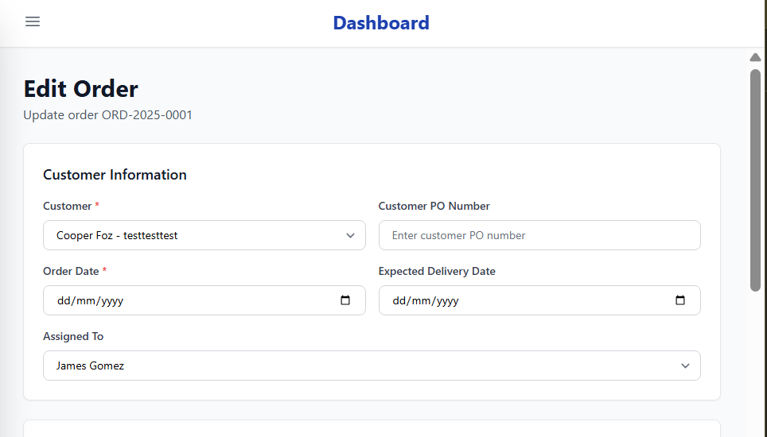

Title: Edit Oder
Device and Browser: Laptop/Google Chrome
Error/Bug and Scenario: When editing order, it request you to input Expected Delivery Date again.
Date checked: December 16, 2025
Level of Importance: HIGH

3

Title: Edit Oder
Device and Browser: Laptop/Google Chrome
Error/Bug and Scenario: When updating edited orders, it shows this.
Date checked: December 16, 2025
Level of Importance: HIGH

When updating edited orders, it shows this.
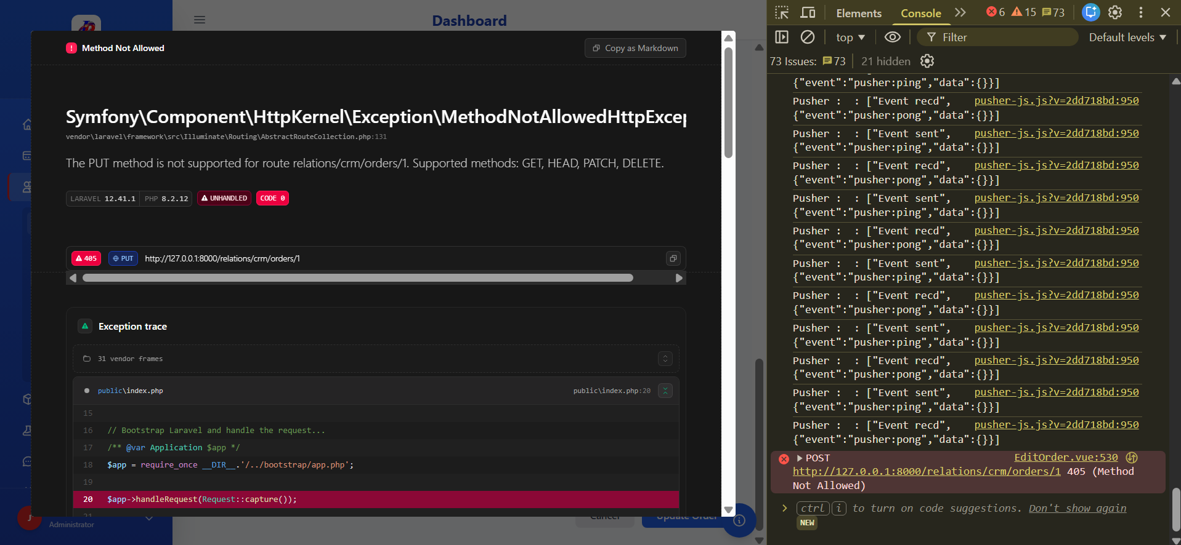

Title: Edit Order
Device and Browser: Laptop/Google Chrome
Error/Bug and Scenario: When updating edited invoice, it shows this.
Date checked: December 16, 2025
Level of Importance: HIGH

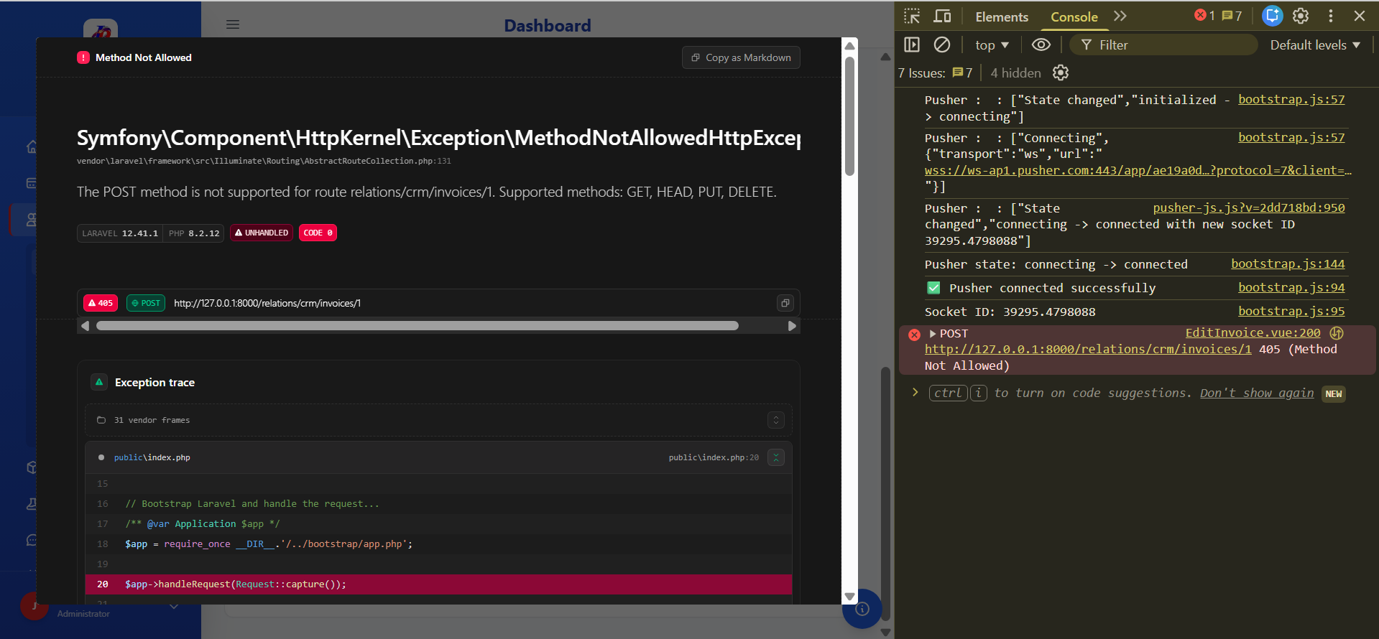

Title: Create New Order
Device and Browser: Laptop/Google Chrome
Error/Bug and Scenario: When in the Create New Order page, The Dashboard only shows the “Dashboard” instead of Create New Order.
Date checked: December 16, 2025
Level of Importance: Low
Done
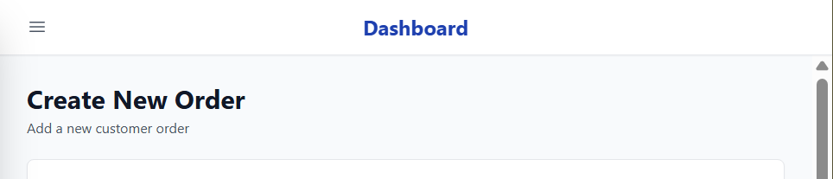
Here is the comparison to other pages. The Dashboard title matches with the page that you’re in.
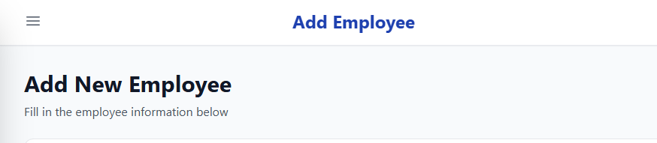

Title: Create New Invoice
Device and Browser: Laptop/Google Chrome
Error/Bug and Scenario: When in the Create New Invoice page, The Dashboard only shows the “Dashboard” instead of Create New Invoice.
Date checked: December 16, 2025
Level of Importance: Low
Done

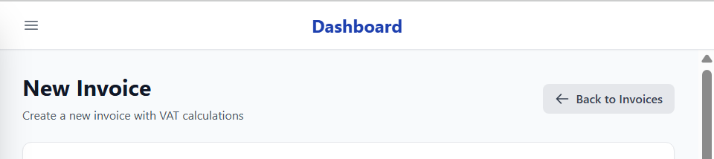

Here is the comparison to other pages. The Dashboard title matches with the page that you’re in.

