Table: users
Field Name | Data Type | Size | Attributes | Description
user_id | Int | 11 | PK | Unique identifier for each user
username | Varchar | 30 |  | User's login username
password | Varchar | 255 |  | Encrypted password hash
email | Varchar | 100 |  | User's email address
first_name | Varchar | 30 |  | User's first name
last_name | Varchar | 30 |  | User's last name
role | Varchar | 20 |  | User role: student, adviser, panel, admin
college | Varchar | 80 |  | User's college affiliation
department | Varchar | 80 |  | User's department
student_id | Varchar | 15 |  | Student identification number
profile_picture | Varchar | 255 |  | Path to profile picture file
is_active | Tinyint | 1 |  | Account active status (1=active, 0=inactive)
registration_status | Varchar | 20 |  | Registration status: pending, approved, rejected
rejection_reason | Text |  |  | Reason for account rejection
account_locked | Tinyint | 1 |  | Account lock status (1=locked, 0=unlocked)
locked_until | Timestamp |  |  | Account unlock timestamp
last_login | Timestamp |  |  | Last successful login timestamp
session_expires_at | Timestamp |  |  | Current session expiration time
created_at | Timestamp |  |  | Account creation timestamp
updated_at | Timestamp |  |  | Last update timestamp

Table: research_groups
Field Name | Data Type | Size | Attributes | Description
group_id | Int | 11 | PK | Unique identifier for research groups
group_name | Varchar | 80 |  | Name of the research group
lead_student_id | Int | 11 | FK | ID of the group leader
adviser_id | Int | 11 | FK | ID of the assigned adviser
college | Varchar | 80 |  | College affiliation
program | Varchar | 50 |  | Academic program
year_level | Varchar | 15 |  | Year level of the group
created_at | Timestamp |  |  | Group creation timestamp

Table: group_memberships
Field Name | Data Type | Size | Attributes | Description
membership_id | Int | 11 | PK | Unique identifier for each membership
group_id | Int | 11 | FK | ID of the research group
user_id | Int | 11 | FK | ID of registered user member
member_name | Varchar | 100 |  | Name of non-registered member
student_number | Varchar | 15 |  | Student number of member
is_registered_user | Tinyint | 1 |  | Whether member is a registered user
join_date | Timestamp |  |  | Date member joined the group

Table: submissions
Field Name | Data Type | Size | Attributes | Description
submission_id | Int | 11 | PK | Unique identifier for each submission
group_id | Int | 11 | FK | ID of the submitting group
submission_type | Varchar | 20 |  | Type: title, chapter
title | Varchar | 200 |  | Title of the submission
description | Text |  |  | Detailed description of submission
chapter_number | Int | 11 |  | Chapter number (for chapter submissions)
document_path | Varchar | 255 |  | Path to uploaded document file
status | Varchar | 20 |  | Status: pending, approved, rejected
submission_date | Timestamp |  |  | Date of submission
approval_date | Datetime |  |  | Date when submission was approved
revision_number | Int | 11 |  | Revision number of the submission
parent_submission_id | Int | 11 | FK | ID of parent submission (for revisions)
required_approvals | Int | 11 |  | Number of required approvals

Table: reviews
Field Name | Data Type | Size | Attributes | Description
review_id | Int | 11 | PK | Unique identifier for each review
submission_id | Int | 11 | FK | ID of reviewed submission
reviewer_id | Int | 11 | FK | ID of the reviewer
comments | Text |  |  | Reviewer's comments
decision | Varchar | 20 |  | Decision: approve, reject, needs_revision
review_date | Timestamp |  |  | Date of review

Table: assignments
Field Name | Data Type | Size | Attributes | Description
assignment_id | Int | 11 | PK | Unique identifier for each assignment
assignment_type | Varchar | 20 |  | Type: reviewer, participant
context_type | Varchar | 20 |  | Context: submission, discussion
context_id | Int | 11 |  | ID of the context (submission or discussion)
user_id | Int | 11 | FK | ID of assigned user
role | Varchar | 20 |  | Role: student, adviser, panel
is_active | Tinyint | 1 |  | Assignment active status
assigned_date | Timestamp |  |  | Date of assignment

Table: thesis_discussions
Field Name | Data Type | Size | Attributes | Description
discussion_id | Int | 11 | PK | Unique identifier for each discussion
group_id | Int | 11 | FK | ID of the research group
title_id | Int | 11 | FK | ID of related title submission
student_id | Int | 11 | FK | ID of student initiating discussion
adviser_id | Int | 11 | FK | ID of assigned adviser
title | Varchar | 200 |  | Discussion title
description | Text |  |  | Discussion description
created_at | Timestamp |  |  | Discussion creation timestamp
updated_at | Timestamp |  |  | Last update timestamp

Table: messages
Field Name | Data Type | Size | Attributes | Description
message_id | Int | 11 | PK | Unique identifier for each message
context_type | Varchar | 20 |  | Context: submission, discussion, general
context_id | Int | 11 |  | ID of the context
user_id | Int | 11 | FK | ID of message sender
message_type | Varchar | 20 |  | Type: text, file, system
message_text | Text |  |  | Message content
file_path | Varchar | 255 |  | Path to attached file
original_filename | Varchar | 100 |  | Original name of attached file
file_size | Int | 11 |  | Size of attached file in bytes
created_at | Timestamp |  |  | Message creation timestamp

Table: notifications
Field Name | Data Type | Size | Attributes | Description
notification_id | Int | 11 | PK | Unique identifier for each notification
user_id | Int | 11 | FK | ID of recipient user
title | Varchar | 80 |  | Notification title
message | Text |  |  | Notification message content
type | Varchar | 30 |  | Type of notification
context_type | Varchar | 20 |  | Context: submission, discussion, group, system
context_id | Int | 11 |  | ID of related context
is_read | Tinyint | 1 |  | Read status (1=read, 0=unread)
created_at | Timestamp |  |  | Notification creation timestamp

Table: user_activity
Field Name | Data Type | Size | Attributes | Description
activity_id | Int | 11 | PK | Unique identifier for each activity
user_id | Int | 11 | FK | ID of user performing activity
activity_type | Varchar | 20 |  | Type: view, submit, review, message
context_type | Varchar | 20 |  | Context: submission, discussion, group
context_id | Int | 11 |  | ID of the context
created_at | Timestamp |  |  | Activity timestamp

Table: login_attempts
Field Name | Data Type | Size | Attributes | Description
id | Int | 11 | PK | Unique identifier for each login attempt
username | Varchar | 30 |  | Username used in login attempt
ip_address | Varchar | 45 |  | IP address of login attempt
attempt_time | Timestamp |  |  | Timestamp of login attempt
successful | Tinyint | 1 |  | Success status (1=successful, 0=failed)
user_id | Int | 11 | FK | ID of user (if successful login)

Table: settings
Field Name | Data Type | Size | Attributes | Description
id | Int | 11 | PK | Unique identifier for each setting
setting_key | Varchar | 100 |  | Setting key/name
setting_value | Text |  |  | Setting value
created_at | Timestamp |  |  | Setting creation timestamp
updated_at | Timestamp |  |  | Last update timestamp
created_by | Int | 11 | FK | ID of user who created setting
updated_by | Int | 11 | FK | ID of user who last updated setting

Default System Settings
Setting Key | Default Value | Description
site_title | Research Approval System | System title displayed in interface
admin_email | admin@essu.edu.ph | Administrator email address
max_file_size | 25 | Maximum file upload size (MB)
allowed_file_types | doc,docx,pdf | Allowed file types for uploads
smtp_host | (empty) | SMTP server hostname
smtp_port | 587 | SMTP server port
smtp_user | (empty) | SMTP username
smtp_pass | (empty) | SMTP password
min_password_length | 6 | Minimum password length
require_special_chars | 1 | Require special characters in passwords
session_timeout | 30 | Session timeout in minutes
max_login_attempts | 3 | Maximum failed login attempts before lockout
lockout_duration | 5 | Account lockout duration in minutes
require_admin_approval | 1 | Require admin approval for new accounts

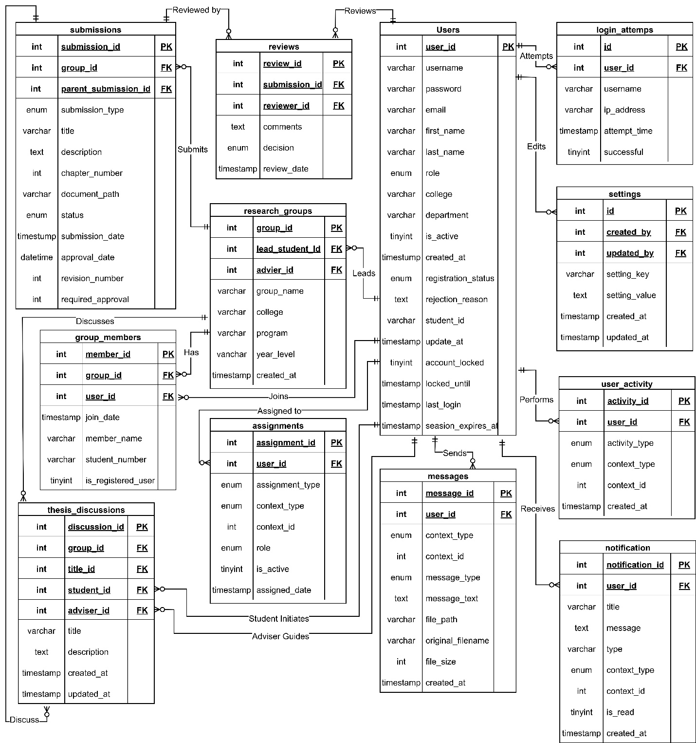
This diagram shows how the system works. At the center of everything are the Users these are the people using the system like students, their advisors, panel members who review work, and system administrators. A student form Research Groups to work on their thesis projects together, and each group has a leader and an assigned advisor to help them. When students are ready, they make Submissions this is where they upload their thesis titles, chapters, or other documents for approval. Once something is submitted, it goes to Reviews where advisors and panel members read the work and decide if it should be approved, rejected, or needs changes. The system also has Thesis Discussions where students and advisors can talk about the research topic, ask questions, and get guidance. To keep everyone informed, there's a Notifications that alert people when something needs their attention it can be new document to review or a message waiting for them. The Assignments table keeps track of who is responsible for reviewing. Finally, the system keeps records of everything people do (User Activity), tracks login attempts for security, and stores system settings that control how everything works.

