Philip John B. Cidro
Email: cidrophilipjohn30@gmail.com
Phone: 09606640744
Address: Brgy. Lunang, San Julian, Eastern Samar

EDUCATION
Bachelor of Science in Information Technology (4th Year)
Eastern Samar State University Main Campus
Expected Graduation: 2026

SKILLS
Programming: XML, Java
Database: MySQL, Firebase
Hardware: Computer assembly, troubleshooting
Networking: Network configuration, router setup, LAN/WAN
Tools: Microsoft Office, Visual Studio Code, Android Studio

PROJECTS
Application Development Project
Created an application using Xml, and Java
Network Setup Project
Configured and implemented a local area network
Hardware Maintenance
Assembled computers and performed hardware troubleshooting

CERTIFICATIONS
Introduction to Cybersecurity
Cisco Networking Academy - March 2025

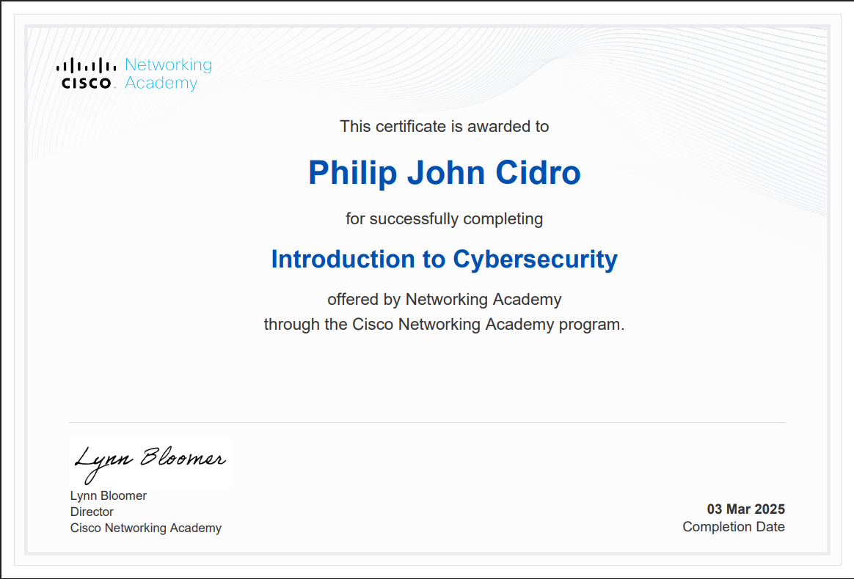

Networking Basics
Cisco Networking Academy - November 2024
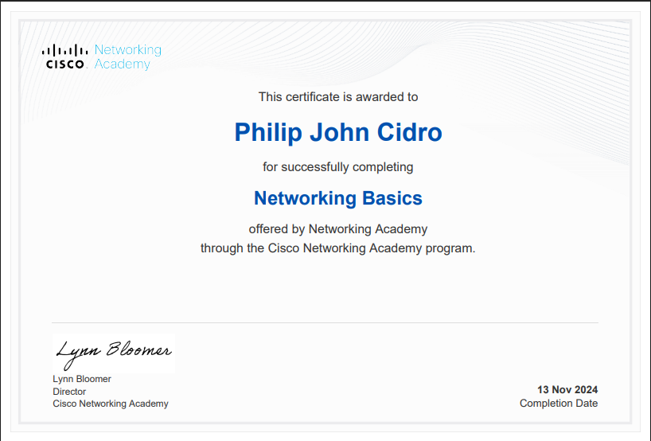

OBJECTIVE
4th-year IT student looking for entry-level positions in software development, network administration, or technical support where I can utilize my programming, hardware, and networking knowledge.

