Web-Based Automated Research Approval and Submission System

An Undergraduate Capstone Project Proposal

Presented to the Faculty of
DEPARTMENT OF INFORMATION TECHNOLOGY
College of Computer Studies
Eastern Samar State University
Borongan City, Eastern Samar

In Partial Fulfillment for the Academic Requirement for the degree

BACHELOR OF SCIENCE IN INFORMATION TECHNOLOGY

Submitted by
Cidro, Philip John B. Catalo, Khent Gabrielle R. Gomez, Emmanuelle A.

Chapter I
INTRODUCTION

Background and Rationale
Research proposal management in higher education institutions has become increasingly complex as academic institutions expand their research activities and face growing demands for transparency and efficiency. Traditional manual processes for research submission, review, and approval create significant challenges for students, faculty, and administrators alike. These challenges include document loss, inconsistent tracking systems, communication gaps between stakeholders, and lengthy approval timeframes that can delay important research activities.
The rapid advancement of digital transformation technologies has fundamentally changed how organizations manage workflows and administrative processes. Benavides et al. (2020) found that digital transformation has touched almost every part of higher education, creating opportunities for schools to improve their operations. This technological evolution has been accelerated by the COVID-19 pandemic, which forced institutions worldwide to quickly adopt digital solutions for maintaining academic operations.
The pandemic's impact on higher education was substantial. By April 2020, UNESCO (2020) reported that lockdowns had affected over 1.37 billion students around the world, representing more than 3 out of every 4 young people globally. This disruption forced many institutions to recognize the limitations of their paper-based systems and the urgent need for digital alternatives.
Research Information Management Systems (RIMS) have emerged as important tools for academic institutions (ACRL, 2021). These systems help universities manage research activities more effectively by providing digital platforms for submission, tracking, and approval processes. However, many institutions, particularly regional universities, continue to rely on manual processes that create inefficiencies and frustrations for all stakeholders involved.
The business sector has demonstrated the clear benefits of process automation. Companies like YouGov have reported saving 10 hours per employee per week after implementing proposal automation systems (Templafy, 2024). These improvements show that automation technology can significantly reduce time spent on repetitive tasks while improving accuracy and consistency.
Current research on system performance supports the effectiveness of digital transformation in academic settings. Huang and Li (2024) conducted a comparative study of student management systems and found that modern automated systems achieved 95% stability compared to 65% for traditional systems, while processing 180 operations per second. These findings demonstrate the technical feasibility and practical benefits of implementing digital systems in educational environments.

At the national level, the Philippines has developed sophisticated research management infrastructure. The DOST Project Management Information System (DPMIS) serves as a comprehensive web-based platform for tracking research programs and projects across the country. Various Philippine research councils have implemented digital systems, including PCHRD's collaborative grant management system and NRCP's Basic Research Information System. These national-level systems demonstrate successful digital transformation in Philippine research management.
However, a significant gap exists between national research infrastructure and institutional-level research management capabilities. While researchers experience efficient digital processes when applying for national funding, they often encounter outdated manual systems at their home institutions. This disconnect creates inefficiencies and inconsistencies in the overall research management ecosystem.
Studies conducted at other Philippine universities highlight common problems with manual research management systems. Malaya et al. (2022) at Don Mariano Marcos Memorial State University identified issues including "scattered, unsecured and prone to risk records; cumbersome record-keeping; and difficulty of generating reports." Similarly, Abrugena and Ramos (2022) at Lyceum of the Philippines University found that "the process of creating a research proposal and submitting it for final approval is a very time-consuming process as any proposal may require multiple parties to review and authorize it at every step."
These documented experiences at comparable institutions suggest that regional state universities in the Philippines face similar challenges in research proposal management. The problems typically include lost documents, unreliable tracking systems, poor communication between students and advisers, extended waiting periods for feedback, and difficulty maintaining consistent evaluation standards across departments.
The development of a Web-Based Automated Research Approval and Submission System addresses several critical needs in higher education research management. First, it responds to the documented inefficiencies in manual research proposal processes that have been identified at similar Philippine institutions. Second, it aligns with global trends toward digital transformation in education, as evidenced by the widespread adoption of digital technologies during the COVID-19 pandemic and the continued investment in digital systems across industries.
The rationale for this system is supported by compelling evidence of digital transformation benefits. More than 95% of organizations are now investing in AI and digital systems, with focus areas including client-facing functions and data management (Broadridge, 2024). Investment in digital transformation nearly doubled between 2020 and 2024, with 68% of executives believing that collaboration between people and technology will be key to future success.
From a technical perspective, the feasibility of developing an effective digital research management system is well-established. Research has shown that modern automated

systems significantly outperform traditional manual systems in terms of reliability, speed, and user satisfaction. The technical infrastructure required for web-based systems is readily available and cost-effective to implement.
The system addresses specific stakeholder needs identified through research and observation. For students, it provides clear submission processes, real-time status tracking, and faster feedback cycles. For faculty advisers, it offers organized document management, standardized review templates, and efficient communication tools. For research administrators, it enables consistent evaluation standards, automated notifications, and comprehensive reporting capabilities.
The timing for this development is particularly appropriate given the current emphasis on digital transformation in Philippine higher education. The Department of Science and Technology has invested heavily in national research infrastructure, including P641 million in funding for 18 Niche Centers in the Regions for R&D (NICER) across 14 regions to capacitate Higher Education Institutions and improve their research capabilities (DOST, 2024). Additionally, DOST has provided almost P125 million in funding to 29 academe-industry collaborations through the CRADLE program, creating an environment where institutional-level improvements can integrate effectively with existing national systems.
Furthermore, the system serves as a model for other regional state universities facing similar challenges. By demonstrating effective digital transformation in research management, Eastern Samar State University can contribute to broader improvements in Philippine higher education research capabilities.
The Web-Based Automated Research Approval and Submission System represents a practical, evidence-based solution to documented problems in academic research management. It leverages proven technologies to address real needs while supporting the academic mission of fostering quality research and innovation.

Objectives of the study
The study generally aims to develop and implement a web-based automated research approval and submission system that facilitates the research proposal workflow from title submission through final panel evaluation, reducing processing time and improving document tracking for students, faculty, and administrators at Eastern Samar State University. Specifically, this study seeks to:
- To create a user registration system where students can input their group members, college affiliation, and academic details with administrative verification.
- To develop a research title submission feature that allows students to upload proposal documents and receive automated notifications for approval or revision requirements.
- To implement a chapter submission workflow that enables sequential submission and review of Chapters 1 through 3, requiring adviser approval before proceeding to the next chapter.
- To establish a panel evaluation system that allows faculty members to review completed research proposals and provide structured feedback.
- To integrate automated notification mechanisms that alert users about submission status changes, pending reviews, and approval decisions.
- To evaluate the system using the ISO 25010 Software Product Quality Model for alpha testing and the IBM Computer Usability Satisfaction Questionnaire for beta testing.

Scope
The Web-Based Automated Research Approval and Submission System is created to make the whole process of submitting, reviewing, and approving research proposals simpler for everyone at the university. Students and faculty can submit proposals online, check how things are progressing, and get feedback from reviewers, all in one place.
The key features of the system include:
- Account creation for students, including input of group members and college information.
- Uploading and reviewing of research titles with panel approval.
- Step-by-step submission of Chapters 1 to 3 with adviser review.
- Notifications for approval or revisions needed.
- Final panel submission for reviewed chapters.
- Document tracking and status monitoring throughout the approval process.
- Role-based access for students, faculty advisers, panel members, and administrators.
Limitations
- Users must have an active internet connection to access this web-based platform.
- While the system manages submission and tracking, the actual review and decision-making still rely on human evaluators.
- File size limits may be implemented to prevent server overload.
- The system includes basic security features but may not be completely immune to cyber threats without further enhancements.
- The system does not provide built-in messaging for direct communication between researchers and reviewers. Feedback is given through status updates and comments, but real-time discussions must occur outside the system.
- The system cannot automatically verify the academic integrity or originality of submitted research proposals.
- System performance may vary across different web browsers and requires modern browser capabilities for optimal functionality.
- The system operates as a standalone platform and does not integrate with existing university management systems or external academic databases.

Significance of the Study
The development of the Web-Based Automated Research Approval and Submission System will benefit:
Students, this system helps at Eastern Samar State University by enabling the digital submission of research proposals, reducing paperwork and confusion. The clear submission process makes it easier for students to understand what's required, so they can put more energy into improving the quality of their research instead of getting bogged down by administrative details. Students receive timely notifications about their submission status and can track their progress throughout the approval process.
Researchers, the system reduces manual work and provides a central place for storing research documents and feedback. Researchers can easily monitor the progress of their proposals, reducing the need for constant status updates. Plus, with all evaluations stored digitally, they have a valuable resource to help them improve future submissions.
Future researchers, the system creates a consistent process and clear evaluation standards, setting expectations for new projects. The stored information gives future researchers the opportunity to learn from past submissions and better understand what makes a proposal successful. This knowledge base helps maintain research quality and reduces learning curves for new researchers.
Faculty, the system organizes research proposals and provides structured review templates, reducing time spent searching for documents or checking submission statuses. This gives faculty the opportunity to offer more detailed feedback and stay more connected with the research activities happening in their department. Faculty members can access submissions from any location, improving flexibility in the review process.
Research administration, digital workflows replace paper-based processes, reducing lost documents and enabling quick information retrieval. With automated notifications, administrators don't have to follow up manually as often, giving them more time to focus on helping and guiding researchers. The system provides comprehensive tracking and reporting capabilities that support institutional decision-making and compliance requirements.
Academic institutions, Eastern Samar State University and similar institutions benefit from standardized procedures that promote fairness and consistency across departments. Improved efficiency can lead to more completed research projects and better institutional standing, while also providing useful data on research activities for planning and resource allocation. The system enhances the university's reputation by demonstrating commitment to modern, efficient research management practices.

DEFINITION OF TERMS
The following terms are defined operationally as used in the study Web-Based Automated Research Approval and Submission System:
Approval - The formal endorsement or acceptance of a research proposal, chapter, or document by authorized reviewers, advisers, or panel members, indicating that the submission meets institutional standards and requirements for proceeding to the next stage of the research process.
Automation - The use of technology, machines, and computer software to perform tasks traditionally executed by humans, resulting in increased efficiency, reduced manual effort, and improved task completion speed in the research proposal management process.
Chapter Submission - The sequential process of uploading and submitting individual chapters (Chapters 1, 2, and 3) of a research proposal for review and approval by designated advisers before proceeding to panel evaluation.
Dashboard - A visual interface that displays key performance indicators, statistics, and status updates related to research proposals, allowing administrators and users to monitor progress and make data-driven decisions.
Digital Platform - An online environment that facilitates the electronic submission, review, and management of research proposals, eliminating the need for paper-based processes and enabling remote access to the system.
Group Members - Students who collaborate as a team on a research project, with one designated as the group leader responsible for system registration and coordination of submissions.
IBM Computer Usability Satisfaction Questionnaire - A validated assessment tool designed to measure user satisfaction and experience with computer systems, focusing on aspects such as ease of use, learnability, and user interface design.
ISO 25010 Software Product Quality Model - A standardized framework used to evaluate software quality characteristics including functionality, reliability, usability, efficiency, maintainability, and portability.
Manual Process - Traditional paper-based methods of handling research proposal submissions, reviews, and approvals that require physical document handling and face-to-face interactions.
Notification System - An automated communication mechanism that alerts stakeholders about important events, status changes, pending tasks, and deadlines through email or in-platform messages.
Panel Members - Faculty members or experts designated to conduct final evaluation and assessment of completed research proposals that have been approved by advisers.

Research Approval - The formal endorsement of a research proposal by authorized reviewers and administrators, indicating that the proposal meets institutional standards and requirements for implementation.
Research Proposal - A formal document submitted by students or faculty that outlines a planned research project, including its objectives, methodology, timeline, and expected outcomes.
Revision - The process of modifying, improving, or correcting a research proposal or chapter based on feedback and recommendations from advisers or panel members before resubmission.
Role-Based Access Control - A security approach that restricts system access based on users' roles within the institution (e.g., student, faculty reviewer, administrator), ensuring appropriate permissions and data protection.
Stakeholders - Individuals or groups with interest in or influence over the research approval process, including students, researchers, faculty reviewers, and administrators.
Status - The current stage or condition of a research proposal within the approval workflow (e.g., pending, under review, approved, requires revision, rejected).
Submission - The act of formally presenting or uploading research documents, proposals, or chapters to the system for review and evaluation by designated authorities.
Submission System - The component of the platform that allows researchers to upload their proposals, supporting documents, and required information through a structured electronic process.
System - Refers specifically to the Web-Based Automated Research Approval and Submission System being developed for Eastern Samar State University.
Tracking System - A mechanism that monitors and displays the current status of research proposals throughout the approval workflow, providing transparency and real-time updates.
User Interface - The visual elements and interactive components through which users interact with the system, including forms, buttons, menus, and display screens.
Web-Based System - A software application accessible through internet browsers, allowing users to interact with the platform from any device with internet connectivity without requiring local installation.
Workflow - The sequence of steps and processes that a research proposal undergoes from initial submission to final approval or rejection, including review stages and feedback incorporation.

Chapter II
REVIEW OF RELATED SYSTEMS
This chapter presents a comprehensive review of current systems, technologies, and research related to research approval and submission processes. The literature examined includes studies on digital research management systems, workflow automation platforms, and technological frameworks from both international and Philippine contexts published from 2020 onwards. This review establishes the foundation for the development of the Web-Based Automated Research Approval and Submission System by identifying contemporary approaches, emerging challenges, and innovation opportunities in academic research management.
The global shift toward digital transformation in higher education has fundamentally reshaped how institutions manage research activities. The COVID-19 pandemic served as a catalyst for this transformation, accelerating digital adoption across universities worldwide. García-Peñalvo et al. (2022) conducted a comprehensive multivocal literature review revealing that higher education institutions have undergone significant evolution toward digital university models requiring not only technology adoption but organizational strategic transformation encompassing information systems, processes, and human factors. Their analysis demonstrated that universities implementing comprehensive digital strategies showed marked improvements in research management efficiency and stakeholder satisfaction.
Building on this foundation, Kerssens and van Dijck (2024) examined the widespread digitalization of academic processes, highlighting how students and staff routinely use digital technologies including learning management systems, e-books, and various applications supporting teaching and research activities. This extensive adoption demonstrates the academic community's readiness for comprehensive digital research management solutions. The study emphasized that digitalization has become essential for institutional competitiveness and sustainability in the modern educational landscape.
Complementing these findings, Li et al. (2023) investigated enterprise digital management and found that digital transformation significantly improves information transmission efficiency while reducing administrative burden. Their research revealed that organizations implementing digital workflows experienced substantial improvements in data accuracy, process transparency, and stakeholder communication—benefits directly applicable to research proposal management systems. These improvements create a strong foundation for the implementation of automated research management systems in academic institutions.
The evolution of digital transformation has led to the emergence of Research Information Management Systems (RIMS) as critical infrastructure for modern universities. OCLC Research (2022) established that research information management systems support the transparent aggregation, curation, and utilization of data about institutional research activities. Their comprehensive report documented the accelerated

adoption of RIMS in US research universities, with institutions implementing systems to manage increasingly complex research workflows and stakeholder interactions.This growing recognition of RIMS importance is reflected in market trends and institutional investments. Digital Science (2024) reported significant growth in the RIMS sector, noting that cutting-edge Research Information Management Systems and Institutional Repository Solutions can empower institutions to effectively manage research endeavours, enhance overall efficiency, and reduce administrative burden. This growth reflects increasing institutional recognition of RIMS value in supporting research excellence and administrative efficiency across diverse academic environments.
The practical implementation of RIMS has been thoroughly examined through case study analysis. Givens (2024) highlighted diverse implementation approaches across institutions, noting that successful RIMS deployment requires careful consideration of institutional context, stakeholder needs, and technical infrastructure. The study emphasized that academic libraries increasingly play leadership roles in RIMS implementation, leveraging their expertise in information management and scholarly communication to drive institutional change.
Further supporting the complexity of RIMS implementation, Bryant et al. (2021) conducted extensive research for OCLC, finding that Research Information Management in the United States represents a complex environment characterized by multiple use cases, stakeholders, and systems. Their analysis of RIM practices at US research universities revealed the critical need for landscape overviews and institutional decision-making frameworks to effectively manage this complexity and ensure successful implementation.
The scholarly recognition of RIMS as an essential academic service has grown substantially. The Association of College and Research Libraries (2023) formally identified RIMS as an emerging service category for libraries, noting that these systems collect and store structured data about faculty research and scholarly activities for institutional repurposing. The report emphasized that RIMS benefit academic institutions through both efficiency and effectiveness, providing centralized repositories of information about faculty scholarship and research activities that support multiple institutional objectives.
Contemporary definitions of research information management continue to evolve with technological advances. Symplectic Research (2025) defined research information management as "the aggregation, curation, and utilization of information and research," emphasizing that RIM Systems play increasingly critical roles in supporting institutional and organizational processes. These processes include centralized collection and curation of research outputs, showcasing public profiles for researchers, and providing comprehensive reporting and insight tracking across research metrics.
The success of RIMS implementation has driven broader interest in automated workflow management within academic institutions. This shift toward automation reflects growing recognition of its potential to transform research process efficiency. Markets and

Markets (2022) documented this trend through their analysis of the global laboratory informatics market, indicating expected growth from $3.4 billion in 2021 to $5.6 billion by 2026, driven by increasing demands for laboratory automation and research data management efficiency.
The integration of emerging technologies into workflow management systems represents a significant advancement in academic research administration. Gartner (2024) forecasted that approximately 60% of data used for artificial intelligence purposes will be artificially generated to replicate reality, envision future scenarios, and reduce risks associated with AI—a dramatic increase from just 1% in 2021. This trend suggests substantial potential for intelligent automation in research approval processes, enabling more sophisticated decision-support systems.
Empirical evidence supports the effectiveness of automated workflow implementation in academic settings. Johnson et al. (2023) conducted a comprehensive study finding that institutions implementing automated workflows reported 40% reduction in processing times and 60% improvement in stakeholder satisfaction compared to manual processes. The integration of automated notification systems and status tracking has become standard practice in modern workflow management, demonstrating measurable benefits for both administrative efficiency and user experience.
The global trends in digital transformation and automated workflow management have found particular relevance in the Philippine higher education context, where institutions face unique challenges and opportunities. Philippine universities have increasingly embraced digital transformation to address research management challenges, with the COVID-19 pandemic serving as a significant accelerator for these initiatives. The University of the Philippines system exemplifies this commitment through comprehensive digital transformation initiatives under its Strategic Plan 2023–2029, where digital transformation serves as a lynchpin for flagship programs ranging from cultivating academic excellence to forging active partnerships and providing online distance e-learning (University of the Philippines, 2024).
The development of specialized systems tailored to Philippine educational contexts has gained significant momentum in recent years. A notable example is the "Development of a Filipinized Learning Management System" (FLMS), funded by the Emerging Interdisciplinary Research Program, which contributed to innovative remote learning practices and was presented at the International Conference on Open and Innovative Education in 2023 (UP Office of the Vice President for Academic Affairs, 2023). This project demonstrated institutional commitment to advancing open and innovative education through localized technological solutions that address specific cultural and educational needs.
Government support for digital transformation in Philippine higher education has been substantial and strategic. The Commission on Higher Education (CHED) granted the University of Rizal System PHP 41,274,000.00 worth of projects in 2022, including a School Management Information System (SMIS) project valued at PHP 16,274,000.00

designed to automate manual transactions across all university operations (University of Rizal System, 2022). This significant investment demonstrates institutional commitment to meaningful, inclusive, and sustainable digital transformation that addresses systemic inefficiencies in academic administration.
Individual institutions have also taken proactive steps toward digital transformation. The University of Science and Technology of Southern Philippines established a Digital Transformation Office to spearhead university-wide business process automation in compliance with RA 11032, the "Ease of Doing Business" Act, focusing on sustainable ICT transformation and modernization programs (USTP, 2021). Similarly, St. Paul University Manila has developed comprehensive research agendas covering 2020-2026 that integrate digital approaches to research management and dissemination (St. Paul University Manila, 2025).
Policy-level support for digital research management has been institutionalized through government agencies. CHED's Research Management Division has actively promoted digital research management through its Research and Innovation Grant-In-Aid (GIA) Program, providing competitive grants up to Ten Million Pesos for collaborative research projects among Philippine Higher Education Institutions (CHED Research Management Division, 2023). The program emphasizes building strategic research portfolios through collaborative and disruptive research projects that leverage digital platforms and technologies.
The broader economic context supports these digital transformation initiatives. According to the Philippine Statistics Authority (2024), the country's digital economy surged to approximately $36.5 billion in 2022, contributing 9.4 percent to the Gross Domestic Product (GDP), with digital-enabling infrastructure accounting for around $28 billion or 77.2 percent of the total. This growth reflects increasing institutional recognition of digital transformation's value in supporting research excellence and administrative efficiency across multiple sectors.
However, significant challenges remain in achieving comprehensive digital transformation. The Department of Trade and Industry reported that only 6% of Micro, Small, and Medium Enterprises (MSMEs) in the Philippines have achieved digital cultural change, with 23% not using any digital tools at all (Digital Cultural Transformation Research, 2024). This digital divide presents challenges for educational institutions in implementing comprehensive digital research management systems, particularly in rural areas where infrastructure and technical expertise may be limited.
Philippine higher education faces unique structural challenges that make digital transformation both essential and complex. Research by TUA Education (2024) found that in the academic year 2020–2021, close to four million students could not enroll, with around 50% of out-of-school youths belonging to families within the bottom 30% of the income distribution. Digital research management systems can help institutions maximize resource utilization and improve access to research opportunities, potentially addressing some of these systemic challenges.

National policy frameworks provide supportive context for university digital transformation initiatives. The Philippine Development Plan (PDP) 2023-2028 specifies digital transformation as one of its underlying themes, with President Marcos directing all government agencies to digitalize essential public services (Philippine ICT Sector Performance, 2023). This national commitment provides a supportive policy environment for university digital transformation initiatives and creates opportunities for institutional alignment with broader national development goals.
Leading research institutions in the Philippines have begun implementing sophisticated digital research management approaches. The University of the Philippines Diliman's Department of Computer Science has been actively involved in developing technological solutions for research management, including partnerships with international organizations and implementation of digital platforms for collaborative research (UP Diliman Computer Science, 2024). These initiatives demonstrate the potential for Philippine institutions to contribute to and benefit from global advances in research management technology.
Despite the promising developments in digital transformation and RIMS implementation, significant challenges persist in research submission systems worldwide, with particular implications for Philippine institutions. Contemporary research management faces increasing complexity due to growing interdisciplinary collaboration and evolving regulatory requirements. A 2023 digital maturity assessment by Omol et al. revealed that official reports from the European Commission and the OECD identify challenges faced by resource-dependent organizations, including poor customization of digital systems, insufficient skill upgrades, and inadequate security measures. These challenges extend to academic institutions, where insufficient digital infrastructure and limited technical expertise impede effective research management implementation.
The complexity of modern research ecosystems has created additional implementation challenges. The 2022 OCLC Research survey found that institutions worldwide struggle with system interoperability, data integration, and standardized reporting requirements. These challenges emphasize the need for flexible, scalable solutions that can adapt to diverse institutional needs while maintaining consistent quality standards across different organizational contexts.
Security and data protection have emerged as critical concerns in digital research management, driven by increasing awareness of cybersecurity risks and regulatory compliance requirements. The regulatory information management system market analysis by Grand View Research (2024) reported that the global regulatory information management system market size was estimated at USD 2.02 billion in 2023 and is projected to grow at a CAGR of 10.4% from 2024 to 2030, driven largely by increasing compliance requirements and data security concerns. These trends highlight the importance of incorporating robust security measures in research management system design.

The challenges in current research submission systems are driving innovation in emerging technologies and implementation approaches. Artificial intelligence and machine learning technologies are increasingly being integrated into research management systems, with institutions exploring AI-powered features for proposal routing, reviewer matching, and quality assessment. However, experts emphasize the importance of maintaining human oversight in evaluation processes to ensure academic integrity and scholarly quality, suggesting a balanced approach to automation implementation.
Cloud-based solutions have become the dominant deployment model for research management systems, reflecting broader trends in enterprise technology adoption. Market analysis by Quixy (2025) showed that organizations increasingly prefer cloud-hosted solutions for their scalability, cost-effectiveness, and accessibility advantages. This trend supports the development of web-based research approval systems that can serve diverse institutional needs while reducing infrastructure requirements and maintenance costs.
The integration of persistent identifiers (PIDs) and interoperability standards has emerged as a critical factor for successful RIMS implementation. The 2023 OCLC Research report emphasized how the use of identifiers, standards, and protocols are perceived as most valuable when they can also facilitate interoperability with external systems and databases. This focus on standardization and interoperability reflects growing recognition of the need for systems that can integrate with broader research ecosystems.
The evolution of research management systems has generated valuable insights into best practices and implementation strategies that can inform future development efforts. Successful research management system implementation requires comprehensive stakeholder engagement and phased deployment approaches. The 2024 analysis by Hanging Together highlighted that most RIMS implementations begin with metadata harvesting from external sources like Scopus, but this represents only the starting point for comprehensive system development. By partnering with other campus units, RIMS can include local data such as patents and academic honors, creating more robust institutional research profiles.
Training and change management have proven critical for successful adoption across diverse institutional contexts. Recent case studies emphasize the importance of user-centered design, comprehensive documentation, and ongoing support to ensure system utilization and stakeholder satisfaction. These findings suggest that technical implementation represents only one component of successful system deployment, with organizational and cultural factors playing equally important roles.

Synthesis
The reviewed literature provides substantial evidence for the critical need and strong foundation for developing web-based research approval systems in higher education institutions. The convergence of global digital transformation trends, technological advancement, and institutional modernization efforts creates an opportune environment for implementing automated research management solutions.
The literature demonstrates that digital transformation in higher education has reached a tipping point, accelerated by the COVID-19 pandemic and sustained by institutional recognition of digital solutions' effectiveness. Universities worldwide have successfully transitioned from traditional paper-based processes to comprehensive digital ecosystems that enhance efficiency, transparency, and stakeholder satisfaction. This transformation extends beyond mere technology adoption to encompass organizational restructuring and cultural change that supports innovation in academic administration.
Research Information Management Systems have emerged as proven solutions for managing complex research workflows in diverse institutional contexts. The substantial growth in RIMS adoption and investment reflects institutional confidence in these systems' ability to address longstanding challenges in research administration. The evidence shows that successful implementations require careful attention to stakeholder needs, institutional context, and phased deployment strategies that allow for organizational adaptation and user acceptance.
The Philippine higher education landscape presents both significant opportunities and unique challenges for digital research management implementation. Government support through substantial funding initiatives, policy frameworks promoting digitalization, and institutional commitment to transformation create favorable conditions for system development. However, digital divides, infrastructure limitations, and varying levels of technical expertise require careful consideration in system design and implementation planning.
Contemporary research management faces evolving challenges that digital solutions are well-positioned to address. Issues of system interoperability, data security, and workflow complexity require sophisticated technological approaches that balance automation with human oversight. The literature emphasizes that successful systems preserve essential academic judgment while leveraging technology for administrative efficiency and process improvement.
The evidence strongly supports the development of web-based research approval systems that incorporate contemporary best practices in user experience design, workflow automation, and institutional integration. Such systems can address documented challenges in research proposal management while positioning institutions for future technological advancement and collaborative opportunities.
For Eastern Samar State University, the literature provides clear guidance for developing a Web-Based Automated Research Approval and Submission System that

addresses identified institutional needs while aligning with broader trends in higher education technology. The system's potential to improve research management efficiency, enhance stakeholder satisfaction, and support institutional research goals is well-supported by documented evidence from similar implementations in comparable institutional contexts.

Chapter III
Methodology
In this chapter, the researchers explain how they will build the Web-Based Automated Research Approval and Submission System for Eastern Samar State University. The researchers are following an Agile development approach to create a website for managing, reviewing, and approving research proposals. This chapter presents the iterative methods the researchers will use to create a system where students can submit research proposals and faculty can review them.
The researchers' method starts by engaging with students, faculty advisers, panel members, and research administrators through continuous collaboration and feedback loops. This helps the researchers determine what the system should do through multiple iterations - like how students should submit their research chapters, how to track proposal status, and how to create appropriate feedback interfaces for reviewers.
For the technology, the researchers will use HTML for page structure, CSS for styling, Bootstrap for responsive design framework, JavaScript for interactive elements, PHP for server processing, and MySQL for the database. The researchers will design the system to function on both desktop computers and mobile devices, allowing users to access it from different locations.
The development process will involve continuous testing and user feedback, with regular demos and iterations. The researchers will teach students, faculty advisers, and panel members how to use the system throughout the development process. The researchers will monitor how the system performs, make necessary updates, and adjust it based on ongoing feedback from administrators and academic users.

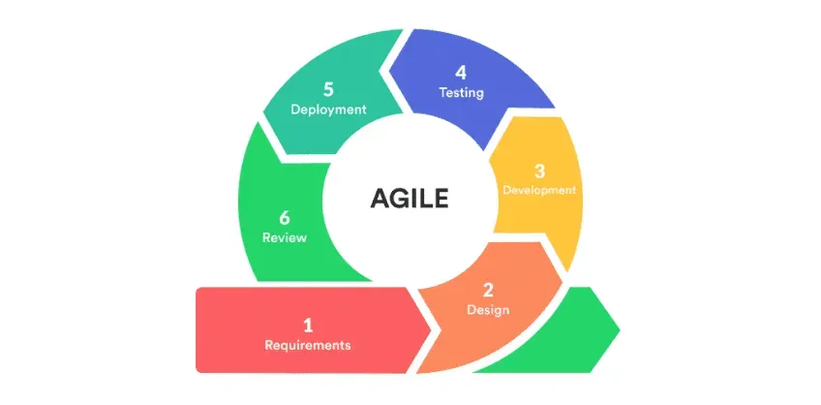

Agile Development Model

Figure 1. Agile Development Life Cycle
The researchers have chosen the Agile methodology to build their Web-Based Automated Research Approval and Submission System because it offers flexibility, continuous user feedback, and iterative improvement suitable for Eastern Samar State University's dynamic academic environment. This approach follows a cyclical process with six interconnected phases: Requirements, Design, Development, Testing, Deployment, and Review, allowing for regular stakeholder input and rapid adaptation to changing requirements throughout the development process.
By following the iterative phases of the Agile model in continuous cycles, the researchers can deliver working features incrementally and incorporate user feedback continuously. This cyclical approach works well in an academic environment where requirements may evolve based on user needs and institutional changes, as each cycle builds upon the insights gained from the previous iteration.

This method helps the researchers build features iteratively through repeated cycles, developing components like user registration, research title submission, chapter-by-chapter submission process, and panel review interfaces. The Agile model's emphasis on collaboration and flexibility through continuous cycles is appropriate for creating a system that maintains academic standards while improving administrative processes.
AGILE DEVELOPMENT PHASES
Requirements
In the requirements phase, the research team collaborates with Eastern Samar State University stakeholders to gather and analyze user needs. The researchers conduct interviews with students, faculty advisers, panel members, and research administrators to understand current challenges with the manual approval process. The research team documents functional and non-functional requirements, creates user stories, and establishes acceptance criteria for each feature. The researchers prioritize requirements based on stakeholder value and system dependencies, ensuring that the most critical features are addressed first in the development cycle.
Design
In the design phase, the research team creates system architecture, user interface mockups, and database schemas based on the gathered requirements. The researchers design responsive layouts using Bootstrap framework to ensure compatibility across desktop and mobile devices. The research team develops wireframes for key interfaces including login screens, submission forms, review dashboards, and administrative panels. The researchers create detailed technical specifications, define data flow diagrams, and establish security protocols for role-based access control.
Development
In the development phase, the research team implements the designed features using HTML for structure, CSS and Bootstrap for styling, JavaScript for interactivity, PHP for server-side processing, and MySQL for data management. The researchers follow coding best practices and maintain version control throughout the development process. The research team builds core functionality including user authentication, file upload systems, notification mechanisms, and workflow management. The researchers ensure that each component integrates properly with existing system elements and follows established security protocols.

Testing
In the testing phase, the research team conducts comprehensive quality assurance to ensure system reliability and functionality. The researchers perform unit testing for individual components, integration testing for connected features, and system testing for overall performance. The research team conducts user acceptance testing with actual stakeholders from Eastern Samar State University, including students testing submission interfaces, faculty testing review processes, and administrators testing management features. The researchers document and address any bugs, performance issues, or usability concerns identified during testing.
Deployment
In the deployment phase, the research team releases working features to a staging environment where stakeholders can interact with real functionality. The researchers configure server environments, establish database connections, and ensure proper security measures are in place. The research team provides training materials and documentation to help users understand new features and capabilities. The researchers monitor system performance during initial deployment and address any technical issues that arise during the transition from development to production environments.
Review
In the review phase, the research team evaluates the completed cycle with stakeholders to gather feedback and identify areas for improvement. The researchers conduct demonstrations of implemented features and collect user feedback on functionality, usability, and effectiveness. The research team analyzes system performance data, user adoption rates, and stakeholder satisfaction metrics. The researchers use insights gained from the review phase to inform requirements for the next development cycle, ensuring continuous improvement and adaptation to evolving user needs.

Fishbone Diagram
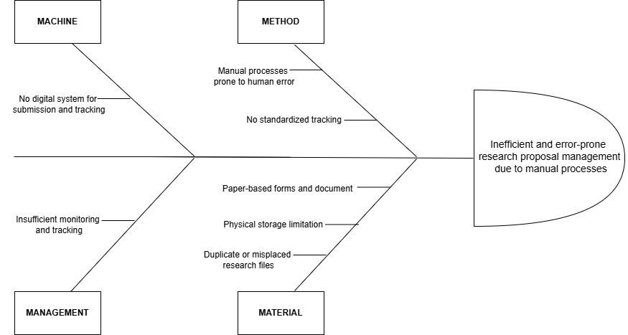

Figure 2. Fishbone Diagram
This fishbone diagram explains why research proposal management has many problems. The main issue is that the process is inefficient and full of errors because everything is still done manually using paper. One of the reasons is under Machine the university doesn’t have a digital system to submit and track proposals, which makes it hard to monitor progress or find files quickly. Under Method, the steps for submitting and reviewing research are done by hand, making them slow and prone to mistakes. There’s also no clear process or tracking system in place, so people can easily get confused about the status of their proposals. In the Material category, the system depends on paper documents, which can be damaged, lost, or duplicated. There’s also limited space to store all the physical files properly. Lastly, under Management, the school lacks strong monitoring tools. All of these issues combine to slow things down and make it difficult for students, faculty, and staff to manage research proposals efficiently.

Gantt Chart
A Gantt Chart organizes tasks over a set timeline, with a time scale at the top and a list of activities on the side. Each task is represented by a bar, where the length and position indicate the start, progress, and completion of the activity. This visual tool simplifies planning and tracking progress.
Figure 3. Gantt Chart Diagram
The Gantt Chart will help the researcher plan out their steps in a span of time. The left side represents the list of activities while the top represents the time scale. Each activity is represented by the bar and the length of it represents the start date, duration and the end of the activity.
Definition

Represented the months and their duration.

Represented the border of the activities.

Represented an activity duration

Symbols

Vertical line

Horizontal line

Shaded Box

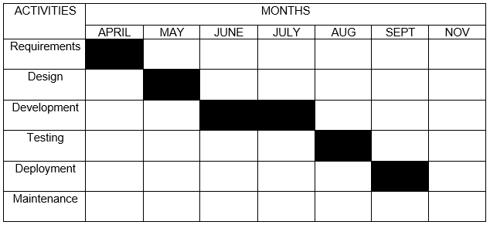

Table 1. Project Timeline
This represent the stages of the task needed to be accomplished within the scheduled period. The researcher needed one month to gather all the necessary requirements needed for the study. For design the researcher also need a month while development will need two months to finish making it the longest activity duration. The researcher will need one month for testing and also a month for deployment.

Table 2. Hardware Specifications (Development)
Shows the hardware requirement needed in implementation of the project.
Hardware | Specifications
Laptop | Device name: Acer Nitro V15  Processor: AMD Ryzen 5 6600H with Radeon Graphics 3.30 GHz  Installed RAM: 8.00 GB (7.74 GB usable)  Storage: 512GB NVMe SSD  System type: 64-bit operating system, x64-based processor  Pen and touch: No pen or touch input is available for this display

Table 3. Software Specifications (Development)
Shows the software requirement needed in implementation of the project.
Software | System Development Requirements
Integrated Development Environment (IDE) | PHP, HTML, JavaScript, Bootstrap, Visual Studio Code, CSS
Web Server | Apache
Operating System | Windows 10, Windows 11
Database | MySQL (XAMPP)

System Flowchart
This flowchart shows physical control or resource level control. This flowchart shows process, system, or algorithm, using standardized symbols to represent the various steps and their sequence.
Process
Indicates any processing function.
Symbols
Terminator
Description.
Indicates the beginning or end of a program flow in the diagram.
On-page Reference
On-page connector is used to replace long line on a flowchart page.
Off-page Connector
An off-page connector is used when the target is on another page.

Data
Flow Line
Can represent any type of data in a flowchart may it be an input or output data.
shows the process description.
Decision
Indicates a decision point between two or more paths in flowchart
Database
Used For representing information kept in a modern storage database.

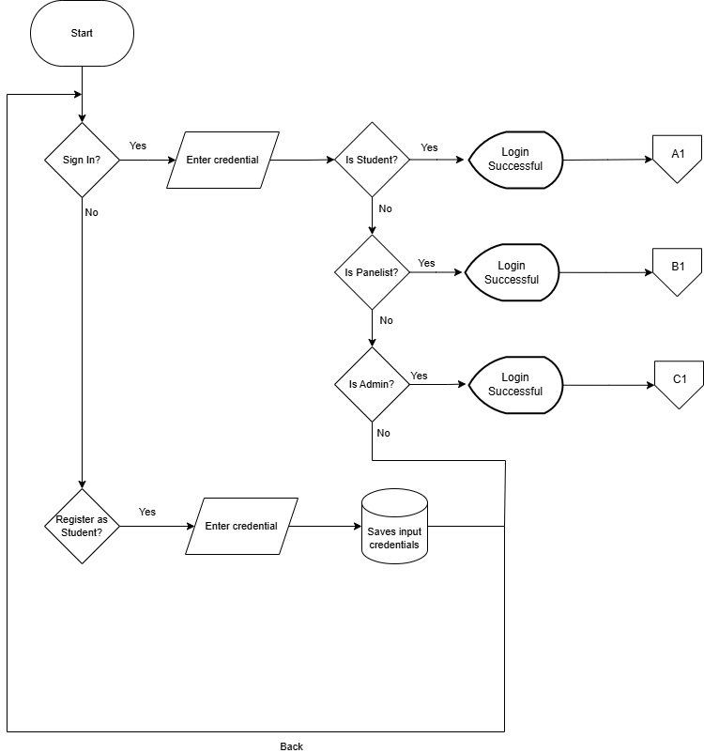
Figure 4. User Authentication Flow
This flowchart shows how users get inside of Wed-based Automated Research Approval and Submission System. To access the page, the user must first enter their account credentials. The system checks if the inputted credential have a match in the system database if it finds a match, the system check what is the user type the account is, whether it is an student (path A1), panelist (path B1), or an admin (path C1). If a user doesn’t have an account, they can sign in to get an account and their information well be saved in the account database.

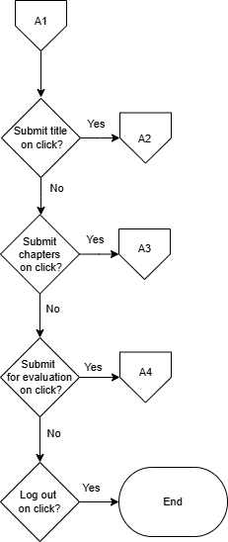

Figure 5: Student Home
The flowchart represents the navigation path for a student on the system. Each decision point offers the student a choice to navigate to a specific feature (Submit title, Submit Chapter, Submit for Evaluation, or Logout). If the student chooses "Yes" at any decision point, they are taken to the corresponding page. If the student chooses "No," they continue to the next decision point until they either log out or exit the system.

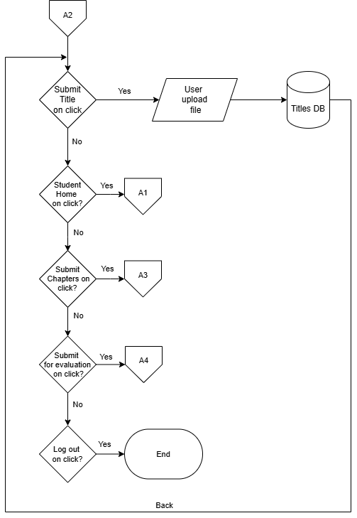

Figure 6. Research Title Proposal Page
The flowchart shows the page for students to submit their research titles. Students can choose to submit a new title, view previously submitted titles, and check the status of their submissions. If a title is approved, they can proceed to chapter submission. If a title is rejected, they must submit a revised title. At each decision point, students have the option to select "No," which will return them to the main Chapter Submission page or keep them within the current flow without exiting or logging out.

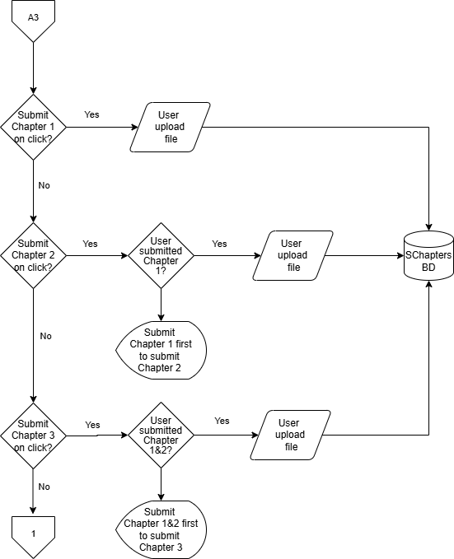

Figure 7. Chapter Submission Page
The flowchart outlines the navigation path for students within this specific section of the system. Students can choose to submit chapters sequentially (Chapter 1, then Chapter 2, then Chapter 3) after each previous chapter is approved. At each submission, the document is stored in the database. At each decision point, students have the option to select "No," which will return them to the main Chapter Submission page or keep them within the current flow without exiting or logging out.

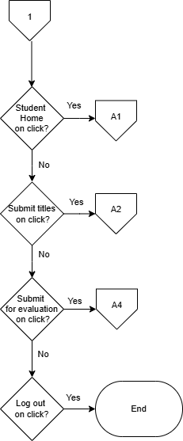

Figure 8. Chapter Submission Page Navigation
This flowchart shows the navigation of Chapter Submission Page the student can access the student home, submit titles, submit for evaluation and log out.

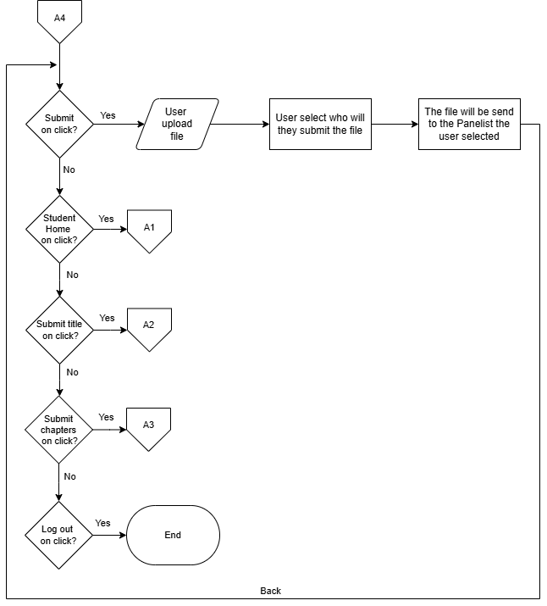

Figure 9. Submit for Evaluation Page
The flowchart shows how students can send their chapters to their selected panelist for checking for revision. The chapter will be send to the selected panelist and well send back the chapter with comments and instructions. Each step, saying "No" keeps them on the same page.

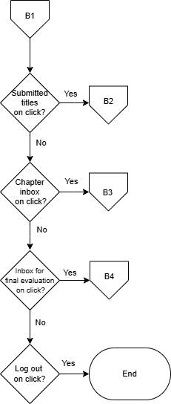

Figure 10. Panel Member Dashboard Page
The flowchart outlines the navigation path for panel members within this specific section of the system. Each decision point offers the panelist a choice to navigate to a specific feature (Submitted title, Chapter inbox, Inbox for final evaluation, or Logout). Throughout the process, panel members have the options to log out or exit the dashboard.

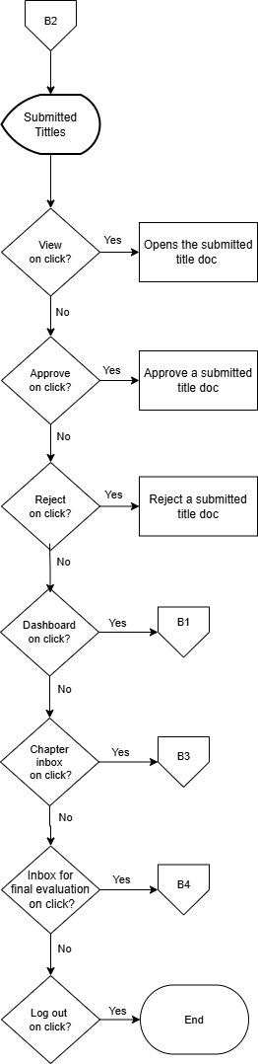
Figure 11. Submitted titles Page
The flowchart shows the submitted titles page. In this page the panelist can view, approve, and reject submitted title proposals. Panelist users have the option to select "No," which keeps them within the current flow without exiting or logging out.

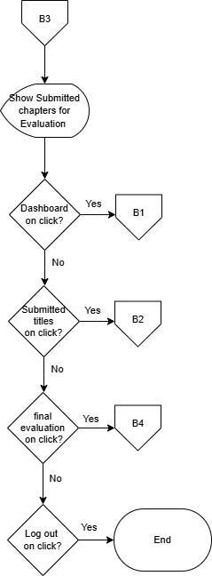
Figure 12. Chapter inbox Page
This flowchart shows the chapter inbox page. The chapter inbox is where the panelist receive chapter documents for revision checking. When the panelist is done putting comments and instructions, the panelist can send the document back to the student. Panelist users have the option to select "No," which keeps them within the current flow without exiting or logging out.

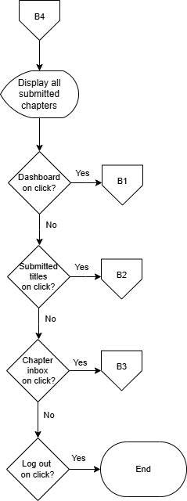
Figure 13. Final Evaluation Page
This flowchart shows the Final Evaluation Page. This page is where the checked chapters are send. In this page the student sends their chapter and it is save to a database. This is where panelist can see all the submitted chapters. Panelist users have the option to select "No," which keeps them within the current flow without exiting or logging out.

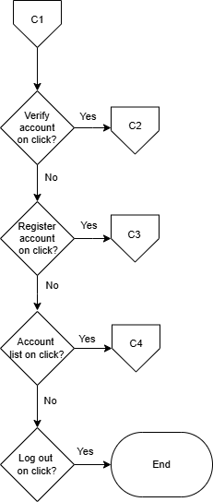

Figure 14. Admin Dashboard Page
The flowchart shows the navigation path for Admin within this specific section of the system. Each decision point offers the Admin a choice to navigate to a specific feature (Verify account, Register account, Account list, or Logout). Throughout the process, panel members have the options to log out or exit the dashboard.

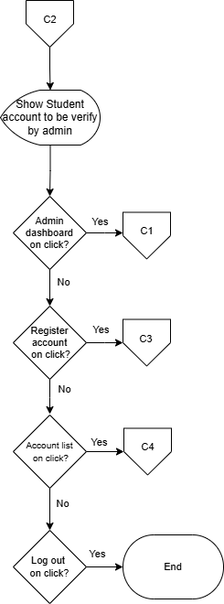

Figure 15. Verify Account Page
The flowchart shows the Verify account page. In this page the Admin can verify or reject student accounts. When a student creates an account in the sign in page. It sends a request to be verify by the admin. If the admin verifies student account this account will be given access to the system. Throughout the process, the admin has the options to log out or exit the page.

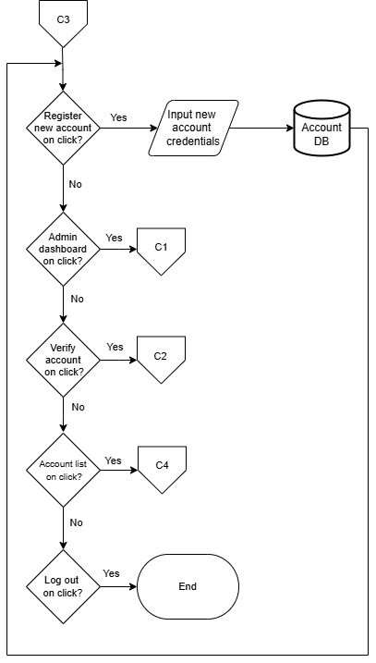
Figure 16. Register Account Page
The flowchart shows the Register account page. In this page the Admin can create an account for the panelist. The created account is then save to the database. Throughout the process, the admin has the options to log out or exit the page.

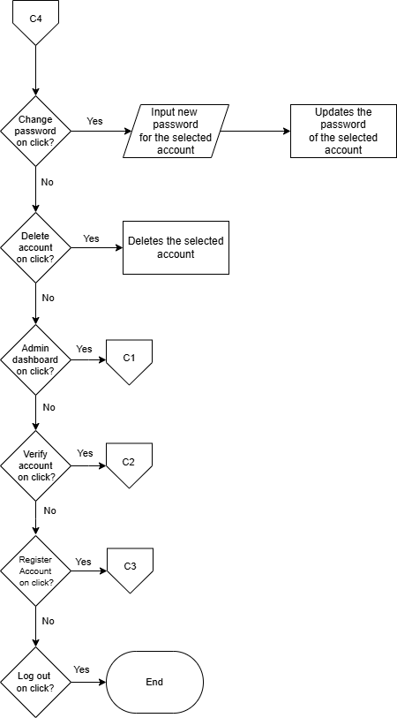

Figure 17. Account List Page
The flowchart shows the Account list page. In this page the admin can see all the accounts that exist in the system wither student or panelist. This page enable admin to change password accounts or delete an account. the admin has the options to log out or exit the page.

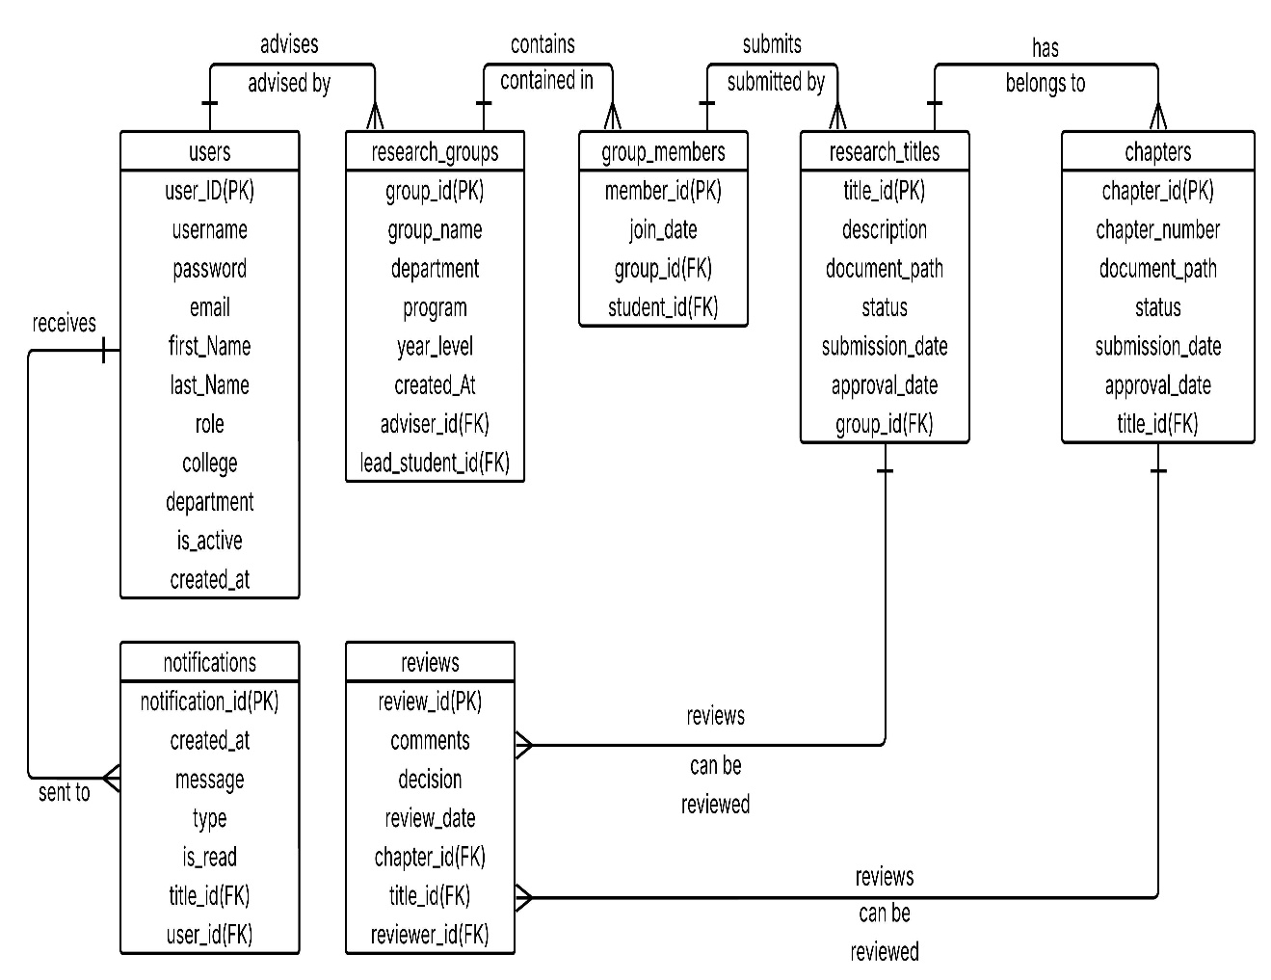
Entity Relationship Diagram
Figure 17. Entity Relationship Diagram
The Entity Relationship Diagram depicts the database structure that supports the Web-Based Automated Research Approval and Submission System. At the center of this system is the Users entity, which connects to all major components. Users can form Research Groups, with each group having designated leaders and panel members. These groups submit Research Titles for approval, which then progress to chapter-by-chapter submissions in the Chapters entity. Faculty members provide feedback through the Reviews entity, which connects to both research titles and individual chapters. Group membership is tracked through the Group Members entity, ensuring proper attribution and collaboration. The system keeps users informed through the Notifications entity, which delivers messages about submission status, review feedback, and approval decisions. This interconnected structure enables seamless tracking of research proposals from initial submission through final approval, while maintaining appropriate relationships between students, faculty, and their respective contributions to the research process.

System Architecture
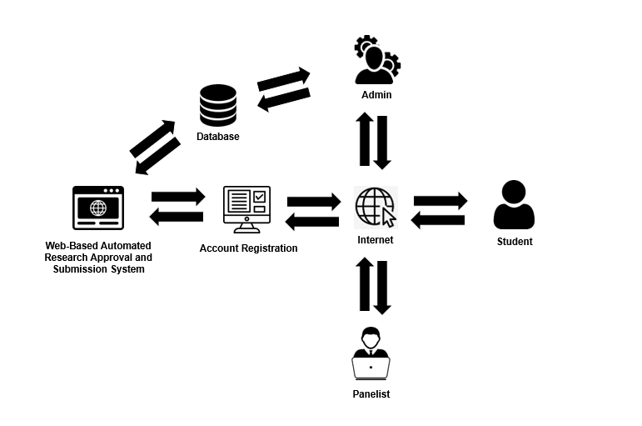
Figure 18. System Architecture
The figure shows the system architecture of the Web-Based Automated Research Approval and Submission System, using a client-server model connected through the internet. On the server side, administrators operate the backend system with dedicated hardware. They manage user accounts, and research submissions. On the client side, users (students, and panelist) access the system through their devices. They submit research proposals, review chapters, and check approval status. The server and clients exchange data over the internet for submissions, reviews, and notifications.

Data Dictionary
Data dictionaries provide a precise vocabulary for specific data elements, helping to standardize a data set and ensure that the relevance and quality of data elements are consistent for all users. They describe the meaning and purpose of data elements within the context of a project and offer guidance on their interpretation.
Table 4. Data Dictionary of Users
Field Name | Field Type | Size | Description
User_ID (PK) | Int | 11 | Unique identifier for users
Username | Varchar | 50 | Login username of user
Password | Varchar | 255 | Encrypted login password
Email | Varchar | 100 | User's email address
First_Name | Varchar | 50 | User's first name
Last_Name | Varchar | 50 | User's last name
Role | Varchar | 20 | User role (student, adviser, panel, admin)
College | Varchar | 100 | User's college affiliation
Department | Varchar | 100 | User's department affiliation
Is_Active | Boolean | 1 | Account Status
Created_At | Timestamp | 4 | User creation timestamp

Table 5. Data Dictionary of Research_Groups
Field Name | Field Type | Size | Description
Group_ID (pk) | Int | 11 | Unique identifier for research groups
Group_Name | Varchar | 100 | Name of the research group
Year_Level | Varchar | 20 | Year level of the students
Created_At | Timestamp | 4 | Group creation timestamp
College | Varchar | 100 | College affiliation of the group
Program | Varchar | 100 | Academic program of the group
Lead_Student_ID(FK) | Int | 11 | ID of the lead student
Adviser_ID (FK) | Int | 11 | ID of the assigned adviser

Table 5. Data Dictionary of Research_Groups
Field Name | Field Type | Size | Description
Group_ID (pk) | Int | 11 | Unique identifier for research groups
Group_Name | Varchar | 100 | Name of the research group
Year_Level | Varchar | 20 | Year level of the students
Created_At | Timestamp | 4 | Group creation timestamp
College | Varchar | 100 | College affiliation of the group
Program | Varchar | 100 | Academic program of the group
Lead_Student_ID(FK) | Int | 11 | ID of the lead student
Adviser_ID (FK) | Int | 11 | ID of the assigned adviser

Table 7. Data Dictionary of Research_Titles
Field Name | Field Type | Size | Description
Title_ID (PK) | Int | 11 | Unique identifier for research titles
Approval_Date | DateTime | 8 | Date of title approval (if approved)
Title | Varchar | 255 | The proposed research title
Description | Text | 65,535 | Brief description of the research
Document_Path | Varchar | 255 | Path to the uploaded title document
Status | Varchar | 20 | Status (pending, approved, rejected)
Submission_Date | Timestamp | 4 | Date of title submission
Group_ID (FK) | Int | 11 | ID of the submitting research group

Table 8. Data Dictionary of Chapters
Field Name | Field Type | Size | Description
Chapter_ID (PK) | Int | 11 | Unique identifier for chapter submissions
Approval_Date | DateTime | 8 | Date of chapter approval (if approved)
Chapter_Number | Int | 11 | Chapter number (1, 2, or 3)
Document_Path | Varchar | 255 | Path to the uploaded chapter document
Status | Varchar | 20 | Status (pending, approved, revision)
Submission_Date | Timestamp | 4 | Date of chapter submission
Title_ID (FK) | Int | 11 | ID of the associated research title

Table 9. Data Dictionary of Reviews
Field Name | Field Type | Size | Description
Review_ID (PK) | Int | 11 | Unique identifier for reviews
Comments | Text | 65,535 | Allow (Adviser) to write comments
Decision | Varchar | 20 | Decision (approve, reject)
Review_Date | Timestamp | 4 | Date of the review submission
Chapter_ID (FK) | Int | 11 | ID of the reviewed chapter
Title_ID (FK) | Int | 11 | ID of the reviewed title
Reviewer_ID (FK) | Int | 11 | ID of the reviewer (adviser)

Table 10. Data Dictionary of Notifications
Field Name | Field Type | Size | Description
Notification_ID(PK) | Int | 11 | Unique identifier for notifications
Created_At | Timestamp | 4 | Notification creation timestamp
Title | Varchar | 100 | Notification title or heading
Message | Text | 65,535 | Notification message content
Type | Varchar | 50 | Type of notification (submission, approval)
Is_Read | Boolean | 1 | Whether notification has been read
User_ID (FK) | Int | 11 | ID of the notification recipient

Output and User Interface
This is the process of designing user interface of the project. It serves as a blueprint on how the project's user interface will look like. Below are the figures showing the key interfaces.
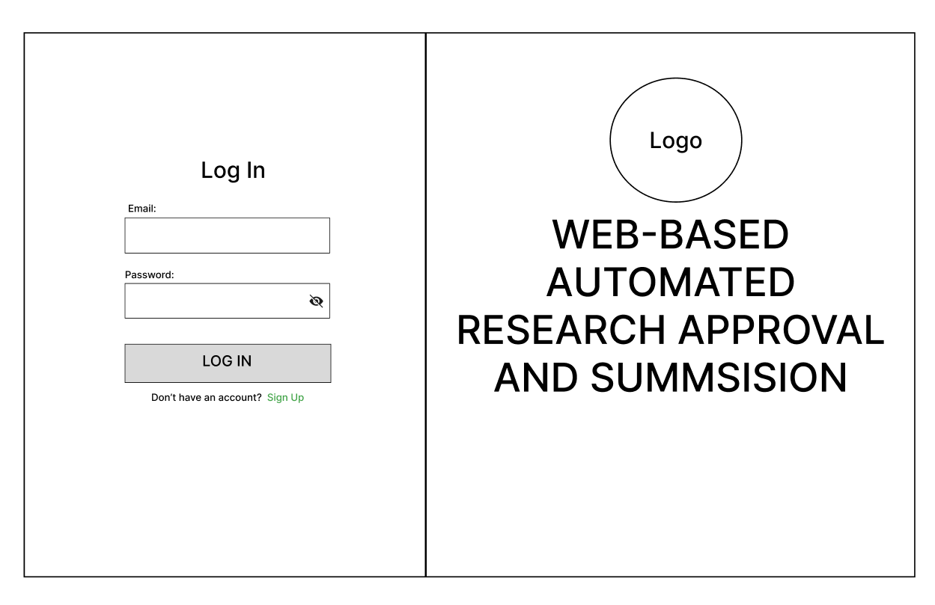

Figure 19. Login Page
Shows the login page for all users. It's a simple screen with just two boxes - one for email and one for password. Users can also select "Sign Up" if they need to create a new account. The page includes the university logo and system name to establish institutional identity.

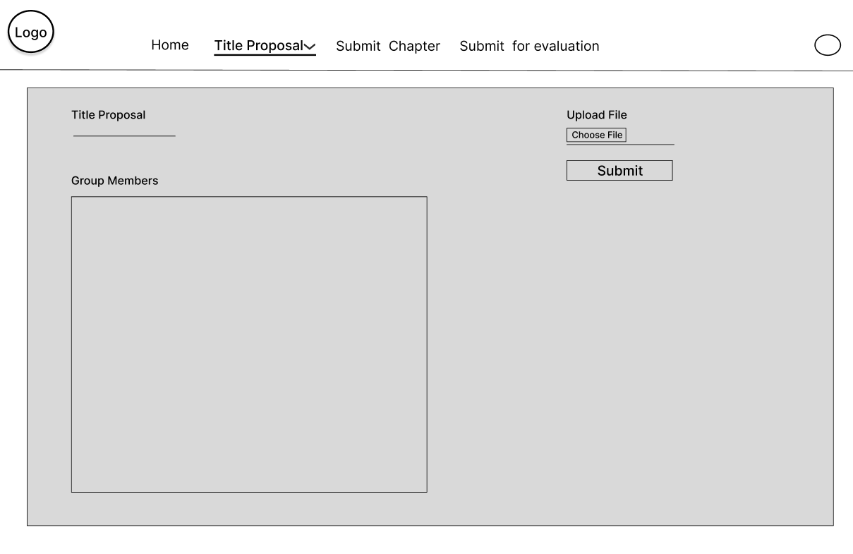

Figure 20. Research Title Submission Page
Shows the page where students submit their research titles for approval. The interface contains a form with four elements: a field to enter the proposed research title, a section for group members, a document attachment button for uploading the title proposal in .docx format, and a submit button.

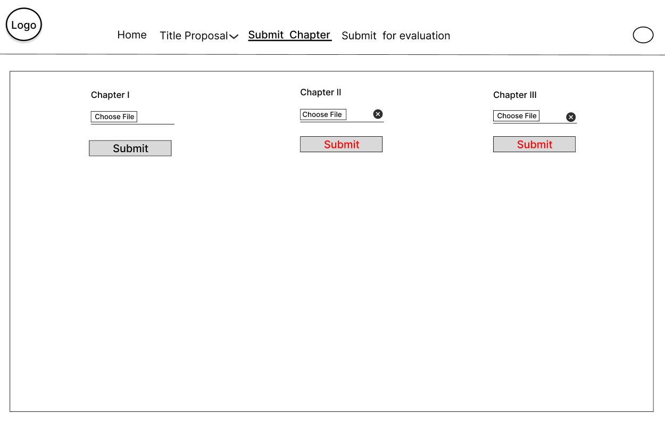

Figure 22. Chapter Submission Page
Shows the page where students upload their research chapters. The interface includes chapter selection options, file upload functionality, and submission controls. Students cannot submit the other steps if the adviser need revision, it will only if its complete or does not require revision.

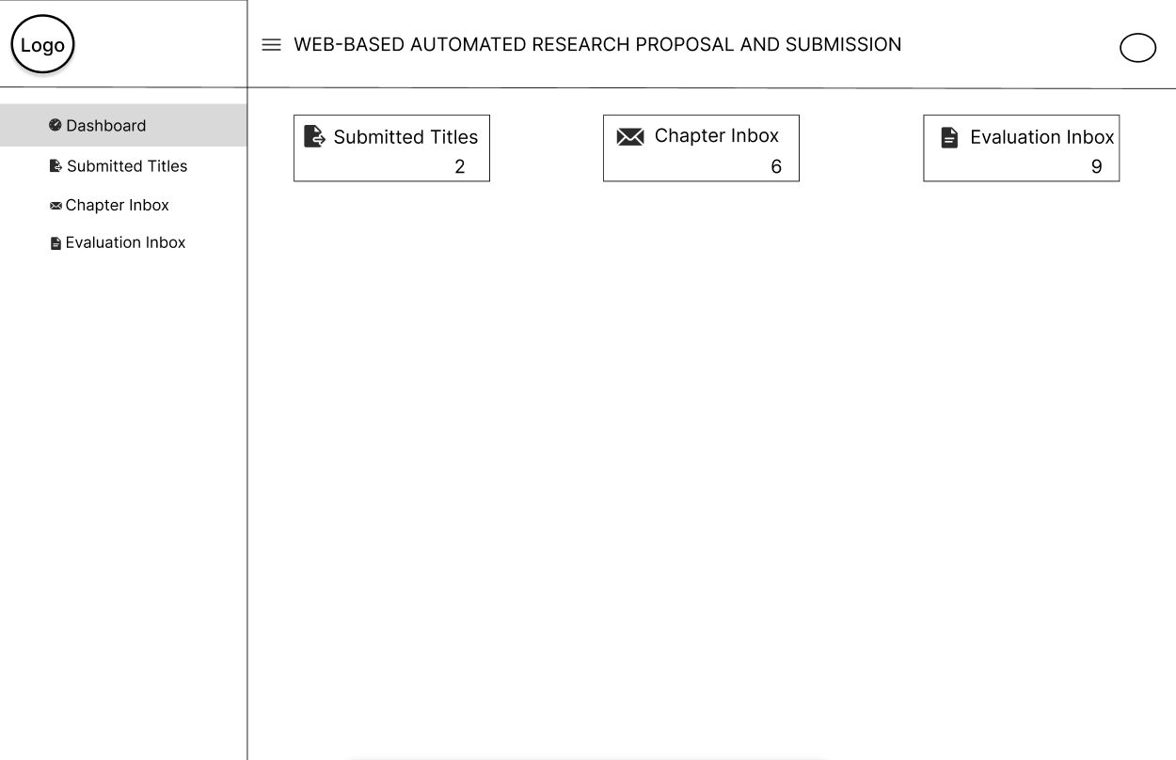

Figure 23. Panel/Adviser Dashboard
Shows the page where advisers can view counts of submitted research titles, chapters, and completed versions in their evaluation inbox. The interface displays numerical indicators showing how many submissions from students are pending review in each category.

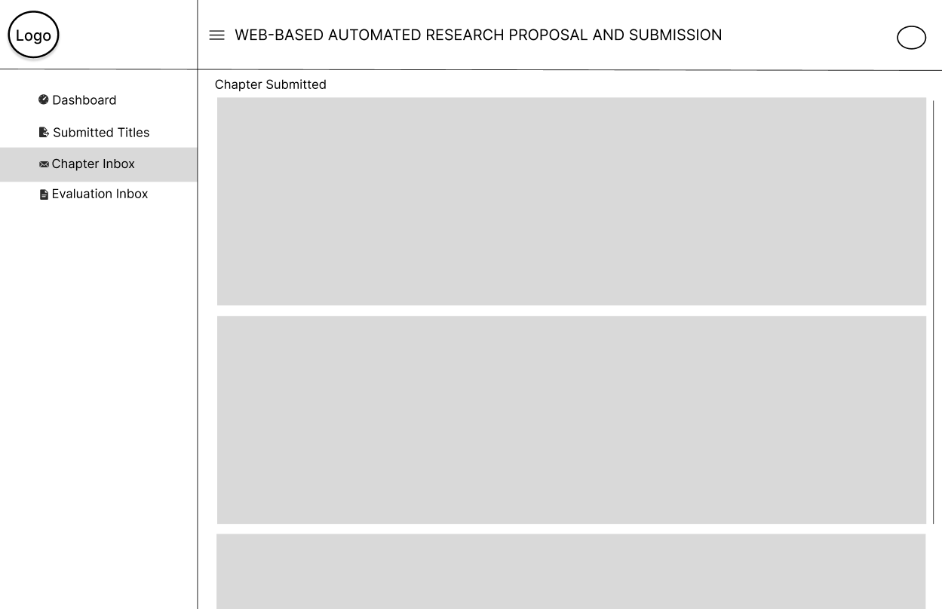

Figure 24. Chapter Review Page
Shows the page where advisers can see the students' submitted chapters in sequential order. The interface displays the chapters sent by students for review. Advisers can return files to students if revisions are needed or approve them to allow students to proceed to the next chapter submission.

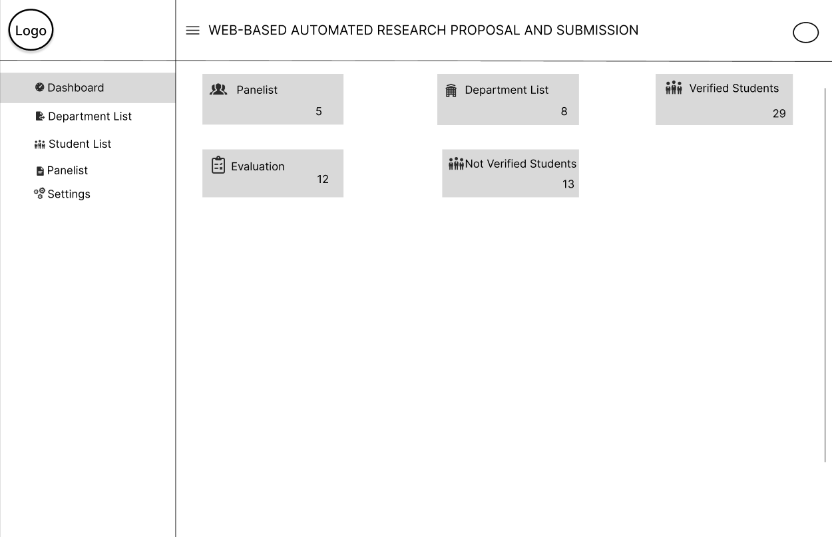

Figure 25. Admin Dashboard
Shows the administrative dashboard for the research approval system. The interface displays statistics about system usage at the top. Below are sections for managing users, monitoring submission activity, and accessing system settings.

Data Flow Diagram
Data flow diagrams show the way information flows through a process or system. They include data inputs and outputs, data stores, and the various sub-processes the data moves through. DFDs are built using standardized symbols and notation to describe various entities and their relationships.

Figure Definition
These are the common symbols that were use to present the specific that the actors had taken in using the entire project. This was presented through a Data Flow Diagram.
Symbols
Description
Source (Sink)
Process
The source of System inputs or sink of system outputs
Step-by-step instructions are followed that transform inputs (a computer or a person or t=both doing the work)

Data Store
An open-ended rectangle represents the location where data is stored
Data Flow Symbol
Represent a pathway for data

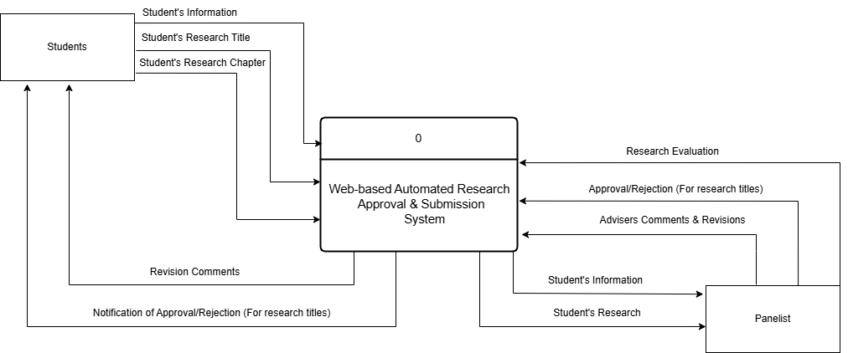

Figure 26. Context Diagram (Level 0)
Shows the entire System and how it interacts Students, and Panelist. Students submit research titles and chapters and receive feedback. Panelist review submissions and provide approval or revision requests. Panel members evaluate final proposals. This diagram illustrates how information flows between the system and its users without showing internal processes.

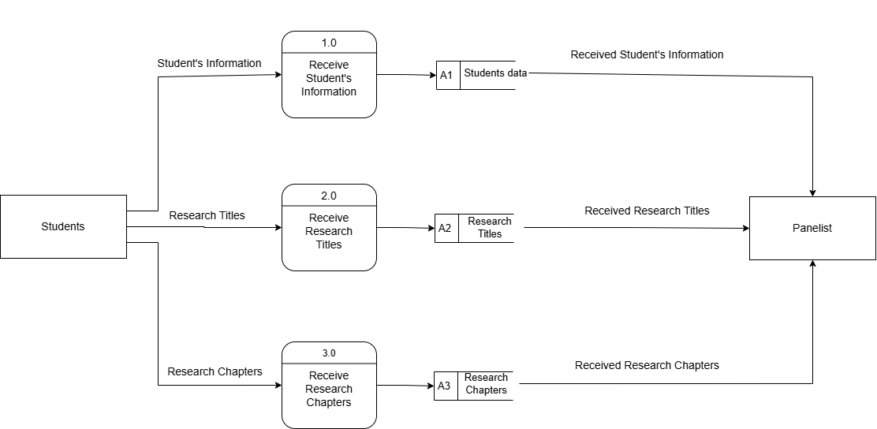

Figure 27. Level 1 Data Flow Diagram part 1
Part 1 shows how the Students sends data to the system. First the student sends data to the system, which received the data and store it to the databases. The stored data is then send to the Panelist to be process and evaluated. This part of the diagram shows how the student provides data such as; student information, Titles, and Chapters to the system which the system stored and sends to the panelist for processing.

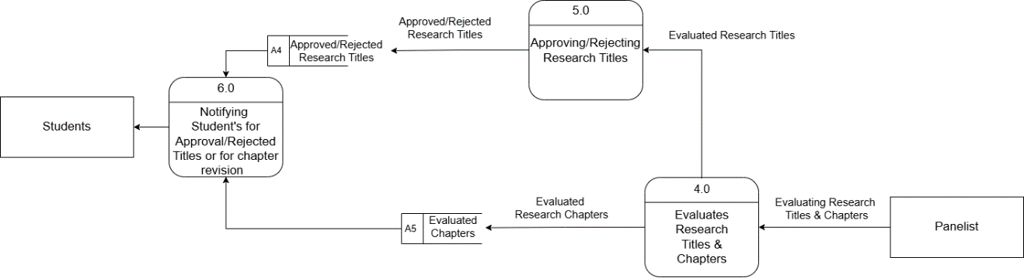

Figure 28. Level 1 Data Flow Diagram
Part 2 shows how panelist process the data that is send by the students. First if the student sent an research title, the panelist evaluate the title. When the panelist is done evaluating the title he can decide if he approve or reject the research title. The approve or reject title is then stored to be used to notify the Students. This part of the diagram shows how the panelist processes the research titles and the chapters that is send by the student.

Programming Environment
HTML (HyperText Markup Language) - HTML creates the basic structure of our Research Approval System. It builds elements like login boxes, submission forms, review interfaces, and dashboards. We use HTML to place components in appropriate locations. It serves as the foundation for other features like styling and interaction.
CSS (Cascading Style Sheets) - CSS adds visual elements to our Research Approval System. It applies the university's colors, formats text, and maintains consistent styling. We use Bootstrap framework to make the system display correctly on both desktop computers and mobile devices. This allows students and faculty to access the system from different devices.
Bootstrap - Bootstrap serves as the foundational CSS framework for our Web-Based Automated Research Approval and Submission System, providing the essential building blocks for creating a professional, responsive user interface. In our system, Bootstrap handles the visual presentation layer by supplying pre-built components such as navigation bars, forms, cards, buttons, and responsive grid layouts that ensure consistent styling across all modules from student dashboards to admin panels. Its mobile first responsive design automatically adapts our interface to work seamlessly on desktop computers, tablets, and smartphones, making the system accessible to users regardless of their device.
JavaScript - JavaScript adds interactivity to our Research Approval System. It checks form inputs before submission, gives immediate responses, and updates content without reloading pages. When advisers review chapters, JavaScript shows the document and feedback form on the same screen. It also runs the notification system that informs users about new submissions or status changes.
PHP (Hypertext Preprocessor) - PHP handles the background processes in our Research Approval System. It processes form submissions, manages user login, and controls database operations. When students upload a chapter or advisers give feedback, PHP processes these actions and updates the database. It also creates pages based on user roles, so each user sees only their relevant information.
MySQL - MySQL stores all Research Approval System information. It contains tables for users, research groups, titles, chapters, reviews, and notifications. The database connects related information through table relationships, like connecting student accounts to research groups and submissions. MySQL handles the different types of data needed in the research approval process.

Evaluation
The respondents evaluated the system using the following scale:
Level of Agreement | Scale Description
5 | Strongly Agree
4 | Agree
3 | Fair
2 | Disagree
1 | Strongly Disagree

System Testing (Alpha Testing)
The obtained mean was interpreted using the following:
Functional Suitability

Numerical Equivalent | Interpretation
4.20 – 5.00 | Highly Functional
3.40 – 4.19 | Functional
2.60 – 3.39 | Moderately Functional
1.80 – 2.59 | Slightly Functional
1.00 – 1.79 | Poorly Functional

Performance Efficiency
<
Numerical Equivalent | Interpretation
4.20 – 5.00 | Highly Efficient
3.40 – 4.19 | Efficient
2.60 – 3.39 | Moderately Efficient
1.80 – 2.59 | Slightly Efficient
1.00 – 1.79 | Inefficient

Compatibility

Numerical Equivalent | Interpretation
4.20 – 5.00 | Highly Compatible
3.40 – 4.19 | Compatible
2.60 – 3.39 | Moderately Compatible
1.80 – 2.59 | Slightly Compatible
1.00 – 1.79 | Incompatible

Reliability
Numerical Equivalent | Interpretation
4.20 – 5.00 | Highly Reliable
3.40 – 4.19 | Reliable
2.60 – 3.39 | Moderately Reliable
1.80 – 2.59 | Slightly Reliable
1.00 – 1.79 | Unreliable
Security
Numerical Equivalent | Interpretation
4.20 – 5.00 | Highly Secured
3.40 – 4.19 | Secured
2.60 – 3.39 | Moderately Secured
1.80 – 2.59 | Slightly Secured
1.00 – 1.79 | Unsecured

Acceptance testing (Beta testing)
The obtained mean was interpreted using the following:
Numerical Equivalent | Interpretation
4.20 – 5.00 | Highly Acceptable
3.40 – 4.19 | Acceptable
2.60 – 3.39 | Moderately Acceptable
1.80 – 2.59 | Slightly Acceptable
1.00 – 1.79 | Unacceptable

Research Design
The study used the developmental-evaluation research design approach as the system was subjected to end user evaluation. This approach combines the development of the Web-Based Automated Research Approval and Submission System with a systematic evaluation of its effectiveness and usability.
Research Locale
The study was conducted at Eastern Samar State University, focusing primarily on the research processes across its various colleges and departments. The university is located in Borongan City, Eastern Samar, Philippines.
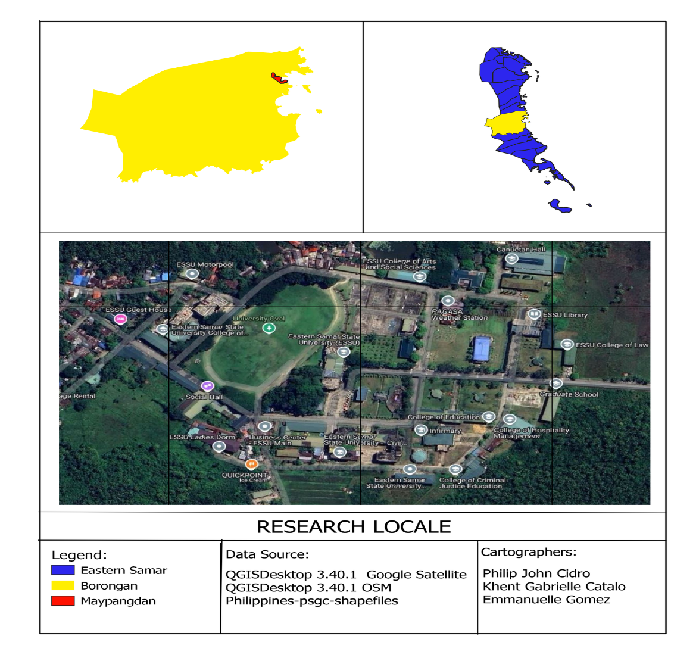

Research Respondents
The evaluation of the Web-Based Automated Research Approval and Submission System will involve 40 carefully selected respondents representing key stakeholder groups at Eastern Samar State University. The first group consists of 5 faculty members who serve as research advisers and have direct experience with the current manual approval process. These faculty members will provide valuable insights on workflow improvements and academic requirements. The second group includes 5 IT professionals from the College of Computer Studies who will evaluate the system's technical aspects, including security, performance, and compatibility with existing university systems. The third group comprises 30 students who are currently working on research proposals and will test the system from an end-user perspective, focusing on ease of use and effectiveness in meeting their submission needs. This balanced selection of respondents ensures comprehensive feedback on both technical functionality and practical application of the system within the university's research ecosystem.

RESPONDENTS | NUMBERS OF RESPONDENTS
Faculty Research Advisers | 5
IT Professionals from College of Computer Studies | 5
Research Students | 30
TOTAL | 40

Table 11. Distribution of Respondents

Instrumentation
In this phase, the system was evaluated using two instruments: the ISO/IEC 25010:2011 Software Evaluation Questionnaire for quality metrics during system testing and the IBM Computer Usability Satisfaction Questionnaire for acceptance testing.
The ISO questionnaire includes a series of questions designed to assess user satisfaction across various dimensions, such as functional suitability, performance efficiency, compatibility, usability, and reliability. This helps evaluate the system's overall quality during the testing phase.
The IBM questionnaire consists of questions that focus on user experience, addressing aspects like system complexity, usage frequency, consistency, and overall satisfaction. By using these standardized evaluation frameworks, the study aims to gather valuable insights into the system's performance, ensuring it meets the desired quality standards and effectively addresses the diverse needs and expectations of its users.
Data Analysis
Statistics using the mean was employed to present the demographic characteristics of the respondents and the level of the system effectiveness. The data from the ISO/IEC 25010:2011 Software Evaluation Questionnaire and IBM Computer Usability Satisfaction Questionnaire will be analyzed to assess the system's quality and usability during the alpha test, and the selected respondents during the beta test.

Mean
This is the average of the score -- the mathematical center of a distribution. It used symmetrical, unimodal distributions of interval or ratio scores.
The ISO's formula mean is:
X = Σ x/n
Where:
- Σx = sum of all scores
- n = number of scores
The IBM formula mean is:
SUS = (Q1 + Q2 + Q3 + ... + Q10) ÷ 10
Where:
- Q1-10: Scores for each question

