Chapter III
Methodology
In this chapter, we explain how we'll build our Web-Based Automated Research Approval and Submission System for Eastern Samar State University. We're following a structured approach to develop a website for managing, reviewing, and approving research proposals. This chapter presents the methods we'll use to create a system where students can submit research proposals and faculty can review them.
Our method starts by asking students, faculty advisers, panel members, and research administrators what they need through surveys and interviews. This helps us determine what the system should do - like how students should submit their research chapters, how to track proposal status, and how to create appropriate feedback interfaces for reviewers.
For our technology, we'll use HTML for page structure, CSS for styling, JavaScript for interactive elements, PHP for server processing, and MySQL for the database. We'll design the system to function on both desktop computers and mobile devices, allowing users to access it from different locations.
After we build the system, we'll teach students, faculty advisers, and panel members how to use it. We'll also inform university stakeholders about the new digital process for research submissions. We'll monitor how the system performs, make necessary updates, and adjust it based on feedback from administrators and academic users.
Waterfall Model Diagram
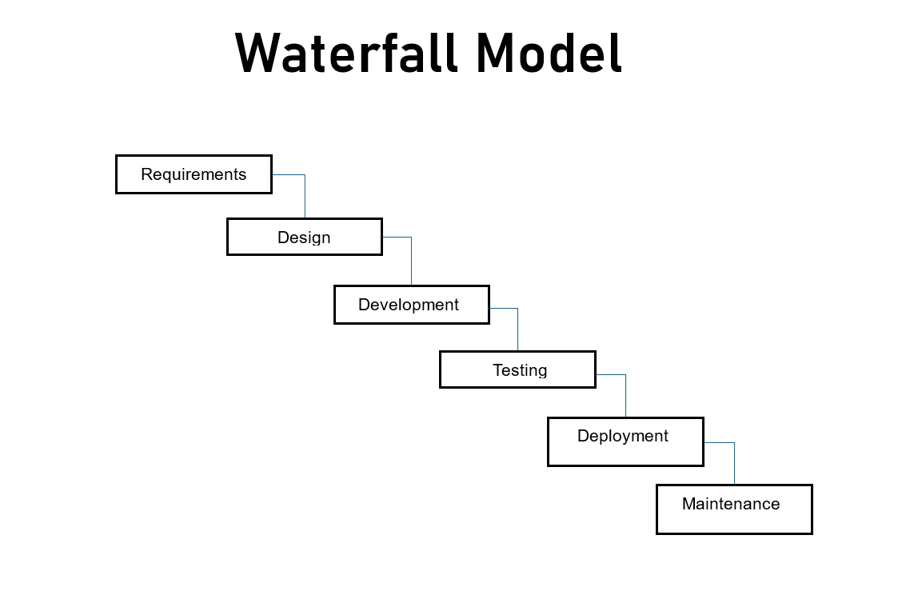

Figure 1. System Development Life Cycle
We have chosen the Waterfall model to build our Web-Based Automated Research Approval and Submission System because it offers documentation and defined milestones suitable for Eastern Samar State University's academic setting. This approach documents all requirements before development begins, reducing misunderstandings in later project stages.
By following the sequential phases of the Waterfall model - requirements analysis, system design, coding, testing, deployment, and maintenance - we complete each stage of development before moving to the next one. This approach works well in our academic environment where requirements are defined and relatively stable.
This method helps us build features in order, like user registration, research title submission, chapter-by-chapter submission process, and panel review interfaces. The Waterfall model's documentation focus is appropriate for creating a system that maintains academic standards while improving administrative processes.
PLANNING
In the planning phase, we work with Eastern Samar State University students, faculty, and research administrators who will use our system. We design our website to help students submit their research proposals and allow faculty to review them. We create a step-by-step process for research approval that includes title submission, chapter-by-chapter review, and final panel evaluation. We develop screens for students to submit their work and for faculty to provide feedback. We organize our work to build both parts: web tools for administrators to track research progress and interfaces for students to submit their proposals and receive feedback.
REQUIREMENTS
In this phase, we determine what our system needs to do for students, faculty advisers, and panel members at Eastern Samar State University. We list key features like user registration where students can input their group members and college details, research title submission with notifications, chapter-by-chapter submission process, and final panel submission functions. We create ways for students to track the status of their proposals and for faculty to review and provide feedback. We gather input from all stakeholders about their needs in the research approval process, addressing the problems identified in the current manual system.

DESIGN
In the design phase, we create a system for both students and faculty. The back-end stores research documents including chapters, feedback, and approval status, while the front-end provides students with interfaces to submit their work and track progress. For faculty, we design screens to review proposals and provide feedback.The system has separate interfaces for different user roles - students, advisers, panel members, and administrators - each with appropriate access levels. We add notification features to alert users about status changes and pending actions, keeping everyone informed during the approval process.
DEVELOPMENT
During development, we build the main components of our system bit by bit, starting with the user registration feature and the research title submission workflow. We implement the chapter-by-chapter submission process where students upload their work and receive feedback at each stage. For faculty, we create review interfaces with standardized criteria. We add notification features to alert users about status changes, new submissions, and required actions. We create a secure data flow that protects research information while allowing access for authorized users. The development follows coding standards that support maintenance and growth as the university's research needs increase.
TESTING
In testing, we check that our system works for both submitting research proposals and reviewing them. We test the registration feature with actual students to confirm they can create accounts and form research groups. We test the submission workflow by having students upload sample chapters and verify that advisers can access and review them. We check that the notification system alerts users about new submissions, feedback, and approval status changes. For faculty, we test how the review interface handles multiple submissions and if the standardized evaluation criteria provide consistent feedback. We also check that all parts of the system work on both computers and mobile devices.
DEPLOYMENT
When we launch the system, we make it available to all Eastern Samar State University students and faculty, focusing on research advisers and panel members learning the digital workflow. We teach administrators, faculty, and student representatives how to use the system and create user guides. We implement the deployment in phases, starting with registration and title submission features, then adding chapter submission, and finally panel review functions. We monitor system performance, collect user feedback, and fix issues that appear during initial use. The deployment phase also moves data from the previous manual system to maintain research tracking.

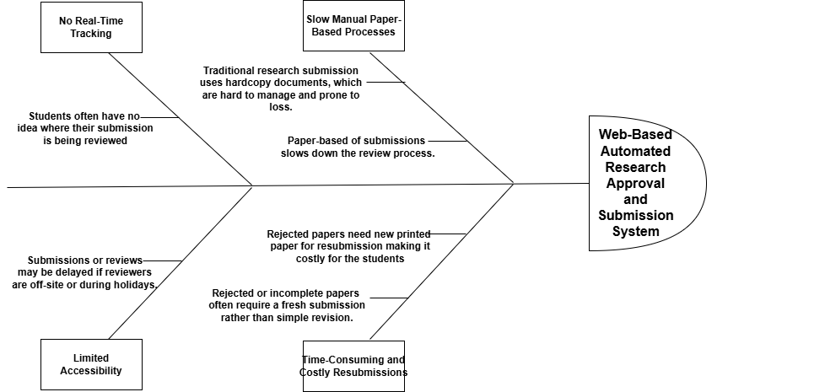
Fishbone Diagram

Figure 2. Fishbone Diagram
This fishbone diagram shows why managing research proposals is difficult. The main cause is inadequate research document handling. Four key problems exist: Slow manual paper-based processes, Time-consuming and costly resubmission, No real-time tracking and limited accessibility. The solution requires a system that guides proper proposal submission, tracks progress, stores documents, and connects stakeholders. This will improve the research process.
Gantt Chart
A Gantt Chart organizes tasks over a set timeline, with a time scale at the top and a list of activities on the side. Each task is represented by a bar, where the length and position indicate the start, progress, and completion of the activity. This visual tool simplifies planning and tracking progress.

Figure 3. Gantt Chart Diagram
The Gantt Chart will help the researcher plan out their steps in a span of time. The left side represents the list of activities while the top represents the time scale. Each activity is represented by the bar and the length of it represents the start date, duration and the end of the activity.

Definition

Represented the months and their duration.

Represented the border of the activities.

Represented an activity that has already been done.

Represents a portion of an activity that has not been yet.
Symbols

Vertical line

Horizontal line

Shaded Box

Unshaded Box

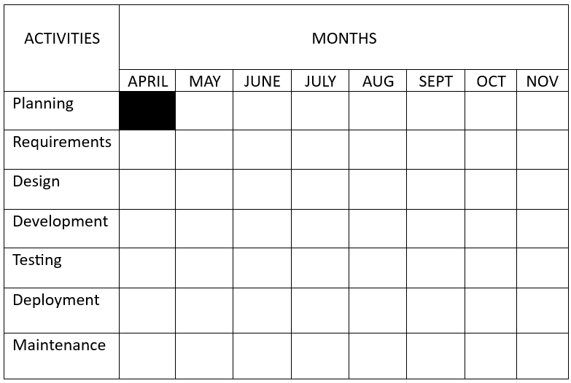

Table 1. Project Timeline
This timeline shows how we will make the Web-Based Automated Research Approval and Submission System. In Month 1, we plan what the system will do and gather requirements. In Month 2, we design how it looks and works. From Month 3 to Month 4, we build the system. Users can register accounts, submit research titles and chapters, and get feedback from advisers and panel members. In Month 5, we test everything to fix any bugs. In Month 6, the system goes live. Students can use it to submit their research proposals, track progress, and receive feedback. We also train users and ask for ideas to make it better.

Table 2. Hardware Specifications (Development)
Shows the hardware requirement needed in implementation of the project.
Hardware | Specifications
Laptop | Device name: Acer Nitro V15  Processor: AMD Ryzen 5 6600H with Radeon Graphics 3.30 GHz  Installed RAM: 8.00 GB (7.74 GB usable)  Storage: 512GB NVMe SSD  System type: 64-bit operating system, x64-based processor  Pen and touch: No pen or touch input is available for this display

Table 3. Software Specifications (Development)
Shows the software requirement needed in implementation of the project.
Software | System Development Requirements
Integrated Development Environment (IDE) | PHP, HTML, JavaScript, Bootstrap v5, Visual Studio Code, CSS
Web Server | Apache
Operating System | Windows 10, Windows 11
Database | MySQL (XAMPP)

System Flowchart
This flowchart shows physical control or resource level control. This flowchart shows process, system, or algorithm, using standardized symbols to represent the various steps and their sequence.
Process
Indicates any processing function.
Symbols
Terminator
Description.
Indicates the beginning or end of a program flow in the diagram.
On-page Reference
On-page connector is used to replace long line on a flowchart page.
Off-page Connector
An off-page connector is used when the target is on another page.

Data
Flow Line
Can represent any type of data in a flowchart may it be an input or output data.
shows the process description.
Decision
Indicates a decision point between two or more paths in flowchart
Database
Used For representing information kept in a modern storage database.

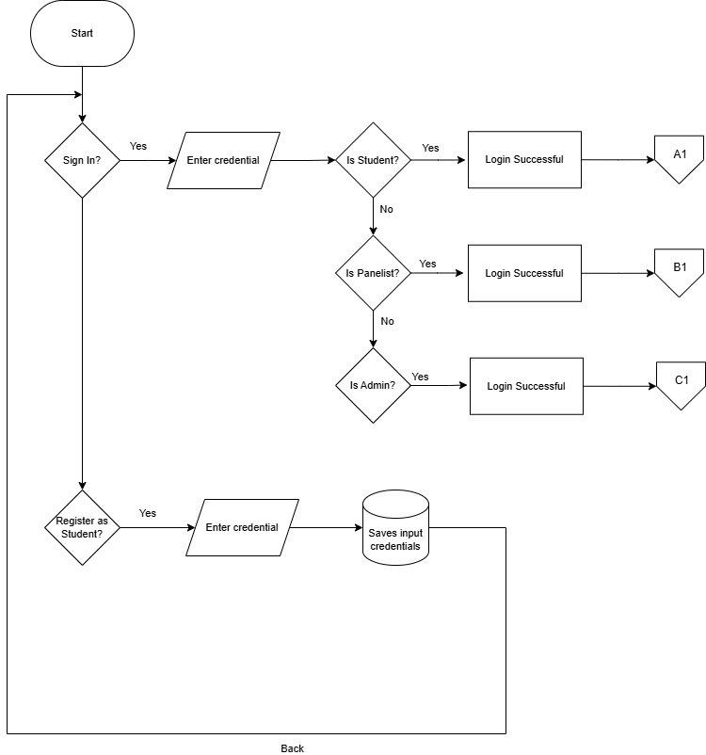

Figure 4. User Authentication Flow
This flowchart shows how users get inside of Wed-based Automated Research Approval and Submission System. To access the page, the user must first enter their account credentials. The system checks if the inputted credential have a match in the system database if it finds a match, the system check what is the user type the account is, whether it is an student (path A1), panelist (path B1), or an admin (path C1). If a user doesn’t have an account, they can sign in to get an account and their information well be saved in the account database.

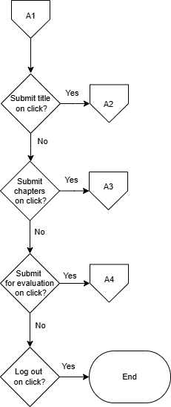

Figure 5: Student Home
The flowchart represents the navigation path for a student on the system. Each decision point offers the student a choice to navigate to a specific feature (Submit title, Submit Chapter, Submit for Evaluation, or Logout). If the student chooses "Yes" at any decision point, they are taken to the corresponding page. If the student chooses "No," they continue to the next decision point until they either log out or exit the system.

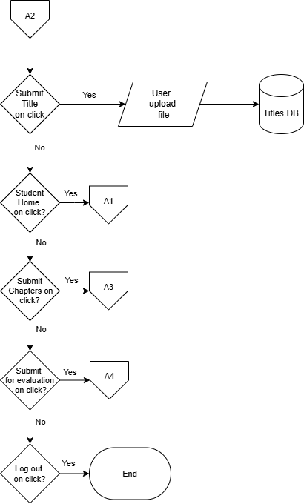

Figure 6. Research Title Proposal Page
The flowchart shows the page for students to submit their research titles. Students can choose to submit a new title, view previously submitted titles, and check the status of their submissions. If a title is approved, they can proceed to chapter submission. If a title is rejected, they must submit a revised title. At each decision point, students have the option to select "No," which will return them to the main Chapter Submission page or keep them within the current flow without exiting or logging out.

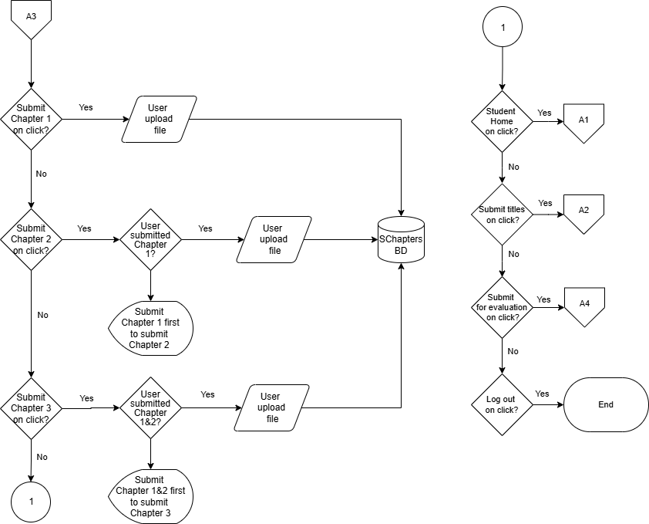

Figure 7. Chapter Submission Page
The flowchart outlines the navigation path for students within this specific section of the system. Students can choose to submit chapters sequentially (Chapter 1, then Chapter 2, then Chapter 3) after each previous chapter is approved. At each submission, the document is stored in the database. At each decision point, students have the option to select "No," which will return them to the main Chapter Submission page or keep them within the current flow without exiting or logging out.

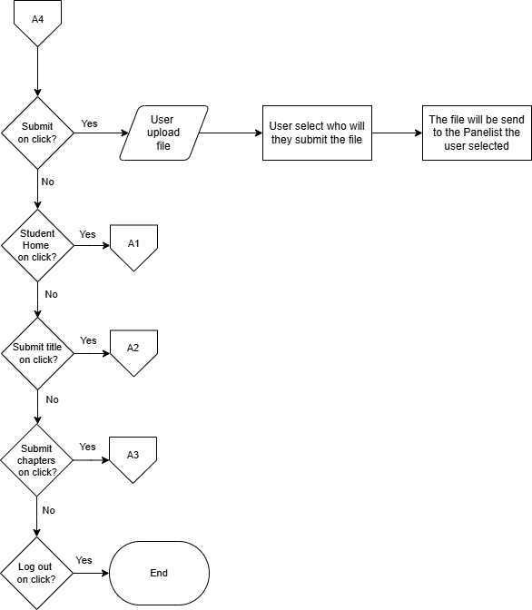
Figure 8. Submit for Evaluation Page
The flowchart shows how students can send their chapters to their selected panelist for checking for revision. The chapter will be send to the selected panelist and well send back the chapter with comments and instructions. Each step, saying "No" keeps them on the same page.

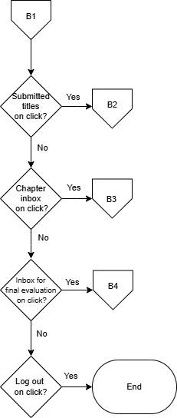

Figure 9. Panel Member Dashboard Page
The flowchart outlines the navigation path for panel members within this specific section of the system. Each decision point offers the panelist a choice to navigate to a specific feature (Submitted title, Chapter inbox, Inbox for final evaluation, or Logout). Throughout the process, panel members have the options to log out or exit the dashboard.

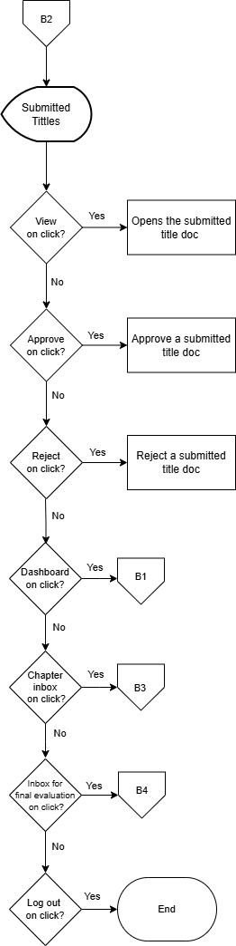

Figure 10. Submitted titles Page
The flowchart shows the submitted titles page. In this page the panelist can view, approve, and reject submitted title proposals. Panelist users have the option to select "No," which keeps them within the current flow without exiting or logging out.

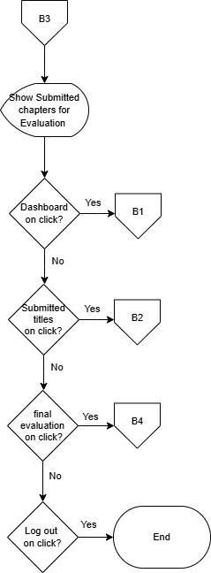

Figure 11. Chapter inbox Page
This flowchart shows the chapter inbox page. The chapter inbox is where the panelist receive chapter documents for revision checking. When the panelist is done putting comments and instructions, the panelist can send the document back to the student. Panelist users have the option to select "No," which keeps them within the current flow without exiting or logging out.

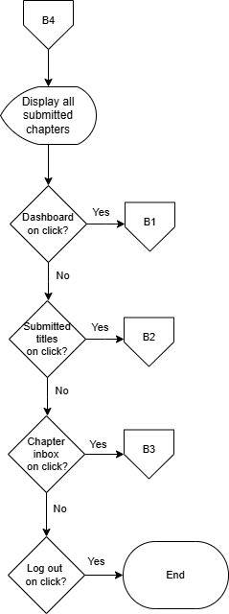

Figure 12. Final Evaluation Page
This flowchart shows the Final Evaluation Page. This page is where the checked chapters are send. In this page the student sends their chapter and it is save to a database. This is where panelist can see all the submitted chapters. Panelist users have the option to select "No," which keeps them within the current flow without exiting or logging out.

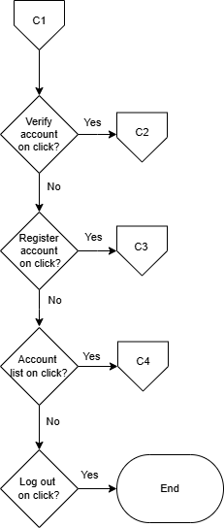

Figure 13. Admin Dashboard Page
The flowchart shows the navigation path for Admin within this specific section of the system. Each decision point offers the Admin a choice to navigate to a specific feature (Verify account, Register account, Account list, or Logout). Throughout the process, panel members have the options to log out or exit the dashboard.

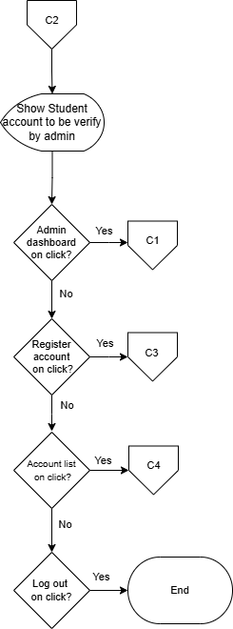

Figure 14. Verify Account Page
The flowchart shows the Verify account page. In this page the Admin can verify or reject student accounts. When a student creates an account in the sign in page. It sends a request to be verify by the admin. If the admin verifies student account this account will be given access to the system. Throughout the process, the admin has the options to log out or exit the page.

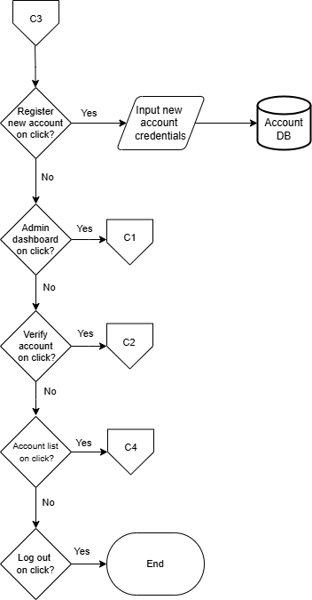

Figure 15. Register Account Page
The flowchart shows the Register account page. In this page the Admin can create an account for the panelist. The created account is then save to the database. Throughout the process, the admin has the options to log out or exit the page.

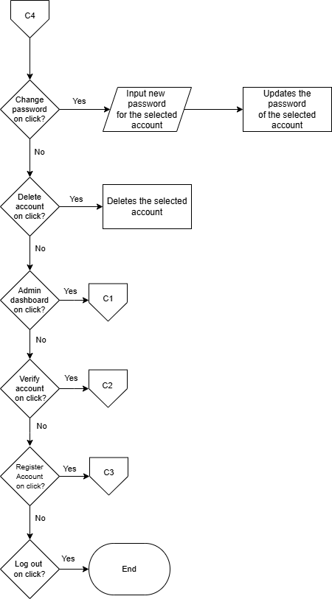

Figure 16. Account List Page
The flowchart shows the Account list page. In this page the admin can see all the accounts that exist in the system wither student or panelist. This page enable admin to change password accounts or delete an account. the admin has the options to log out or exit the page.

Entity Relationship Diagram
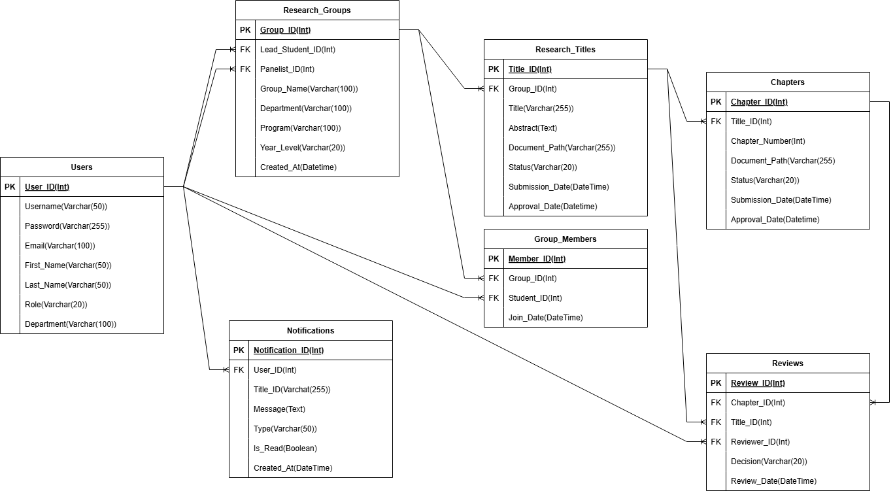
Figure 17. Entity Relationship Diagram
The ERD shows how different parts of the Research Approval System connect. It includes tables for Users (students, panel members, admins), ResearchGroups, Titles, Chapters, Reviews, and Notifications. Users can belong to research groups, which can submit titles and chapters. Panel members provide reviews, and the system sends notifications to users based on actions taken.

System Architecture
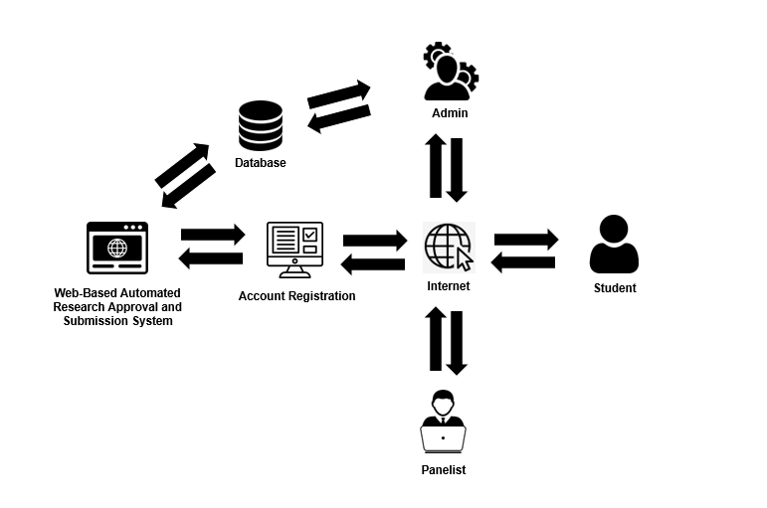
Figure 18. System Architecture
The figure shows the system architecture of the Web-Based Automated Research Approval and Submission System, using a client-server model connected through the internet. On the server side, administrators operate the backend system with dedicated hardware. They manage user accounts, and research submissions. On the client side, users (students, and panelist) access the system through their devices. They submit research proposals, review chapters, and check approval status. The server and clients exchange data over the internet for submissions, reviews, and notifications.

Data Dictionary
Data dictionaries provide a precise vocabulary for specific data elements, helping to standardize a data set and ensure that the relevance and quality of data elements are consistent for all users. They describe the meaning and purpose of data elements within the context of a project and offer guidance on their interpretation.
Table 4. Data Dictionary of Users
Field Name | Field Type | Size | Description
User_ID (pk) | Int | N/A | Unique identifier for users
Username | Varchar | 50 | Login username of user
Password | Varchar | 255 | Encrypted login password
Email | Varchar | 100 | User's email address
First_Name | Varchar | 50 | User's first name
Last_Name | Varchar | 50 | User's last name
Role | Varchar | 20 | User role (student, adviser, panel, admin)
College | Varchar | 100 | User's college affiliation
Department | Varchar | 100 | User's department affiliation
Table 5. Data Dictionary of Research_Groups
Field Name | Field Type | Size | Description
Group_ID (pk) | Int | N/A | Unique identifier for research groups
Group_Name | Varchar | 100 | Name of the research group
Lead_Student_ID (fk) | Int | N/A | ID of the lead student
Adviser_ID (fk) | Int | N/A | ID of the assigned adviser
College | Varchar | 100 | College affiliation of the group
Program | Varchar | 100 | Academic program of the group
Year_Level | Varchar | 20 | Year level of the students
Created_At | DateTime | N/A | Group creation timestamp
Table 6. Data Dictionary of Group_Members
Field Name | Field Type | Size | Description
Member_ID (pk) | Int | N/A | Unique identifier for group membership
Group_ID (fk) | Int | N/A | ID of the research group
Student_ID (fk) | Int | N/A | ID of the student member
Join_Date | DateTime | N/A | Date student joined the group

Table 7. Data Dictionary of Research_Titles
Field Name | Field Type | Size | Description
Title_ID (pk) | Int | N/A | Unique identifier for research titles
Group_ID (fk) | Int | N/A | ID of the submitting research group
Title | Varchar | 255 | The proposed research title
Description | Text | N/A | Brief description of the research
Document_Path | Varchar | 255 | Path to the uploaded title document
Status | Varchar | 20 | Status (pending, approved, rejected)
Submission_Date | DateTime | N/A | Date of title submission
Approval_Date | DateTime | N/A | Date of title approval (if approved)
Table 8. Data Dictionary of Chapters
Field Name | Field Type | Size | Description
Chapter_ID (pk) | Int | N/A | Unique identifier for chapter submissions
Title_ID (fk) | Int | N/A | ID of the associated research title
Chapter_Number | Int | N/A | Chapter number (1, 2, or 3)
Document_Path | Varchar | 255 | Path to the uploaded chapter document
Status | Varchar | 20 | Status (pending, approved, revision)
Submission_Date | DateTime | N/A | Date of chapter submission
Approval_Date | DateTime | N/A | Date of chapter approval (if approved)
Table 9. Data Dictionary of Reviews
Field Name | Field Type | Size | Description
Review_ID (pk) | Int | N/A | Unique identifier for reviews
Chapter_ID (fk) | Int | N/A | ID of the reviewed chapter (null if title review)
Title_ID (fk) | Int | N/A | ID of the reviewed title (null if chapter review)
Reviewer_ID (fk) | Int | N/A | ID of the reviewer (adviser or panel)
Decision | Varchar | 20 | Decision (approve, revise, reject)
Review_Date | DateTime | N/A | Date of the review submission
Table 10. Data Dictionary of Notifications
Field Name | Field Type | Size | Description
Notification_ID (pk) | Int | N/A | Unique identifier for notifications
User_ID (fk) | Int | N/A | ID of the notification recipient
Title | Varchar | 100 | Notification title or heading
Message | Text | N/A | Notification message content
Type | Varchar | 50 | Type of notification (submission, approval, etc.)
Is_Read | Boolean | N/A | Whether notification has been read
Created_At | DateTime | N/A | Notification creation timestamp

Output and User Interface
This is the process of designing user interface of the project. It serves as a blueprint on how the project's user interface will look like. Below are the figures showing the key interfaces.
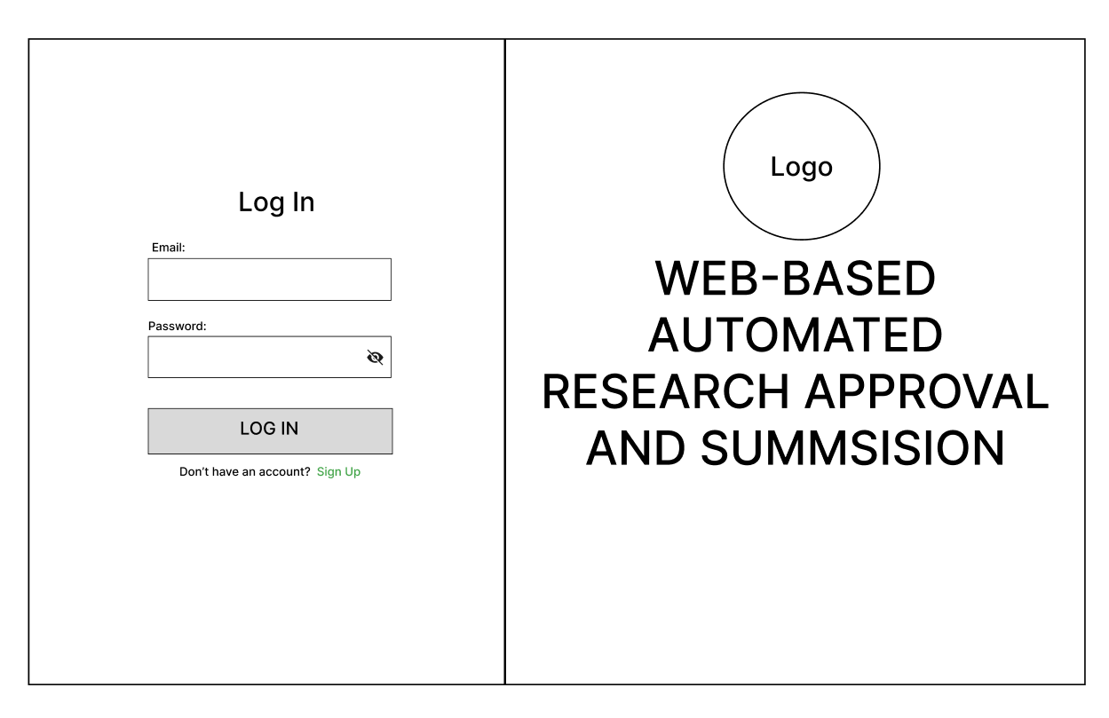
Figure 19. Login Page
Shows the login page for all users. It's a simple screen with just two boxes - one for email and one for password. Users can also select "Sign Up" if they need to create a new account. The page includes the university logo and system name to establish institutional identity.

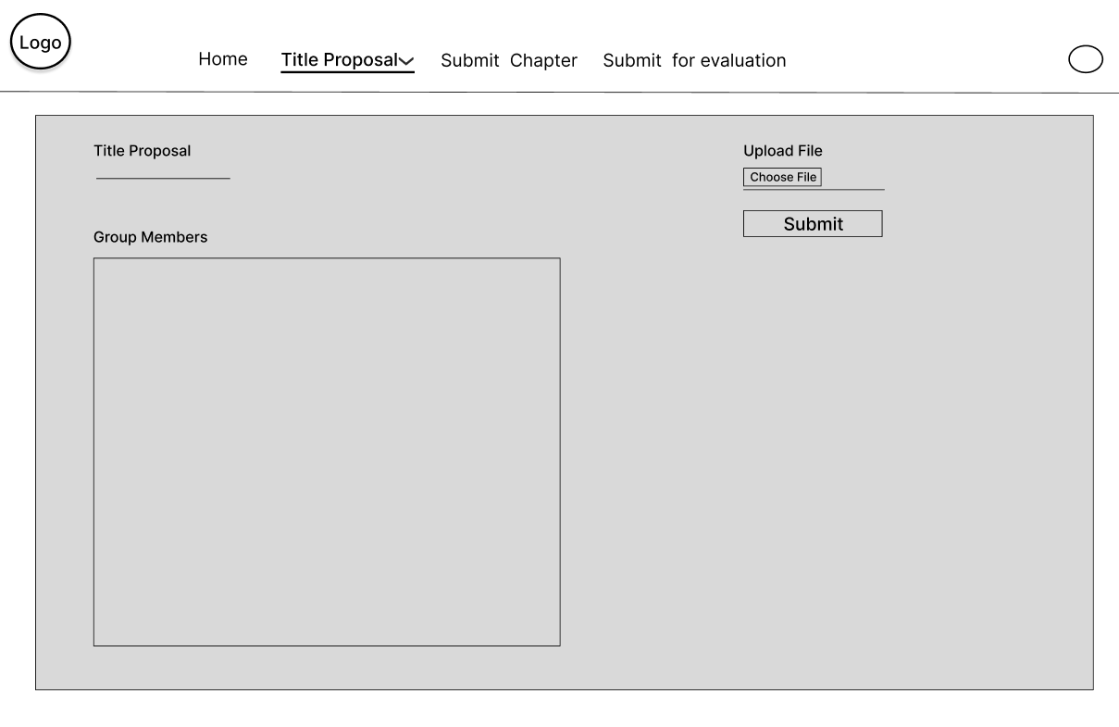
Figure 20. Research Title Submission Page
Shows the page where students submit their research titles for approval. The interface contains a form with four elements: a field to enter the proposed research title, a section for group members, a document attachment button for uploading the title proposal in .docx format, and a submit button.

Figure 22. Chapter Submission Page
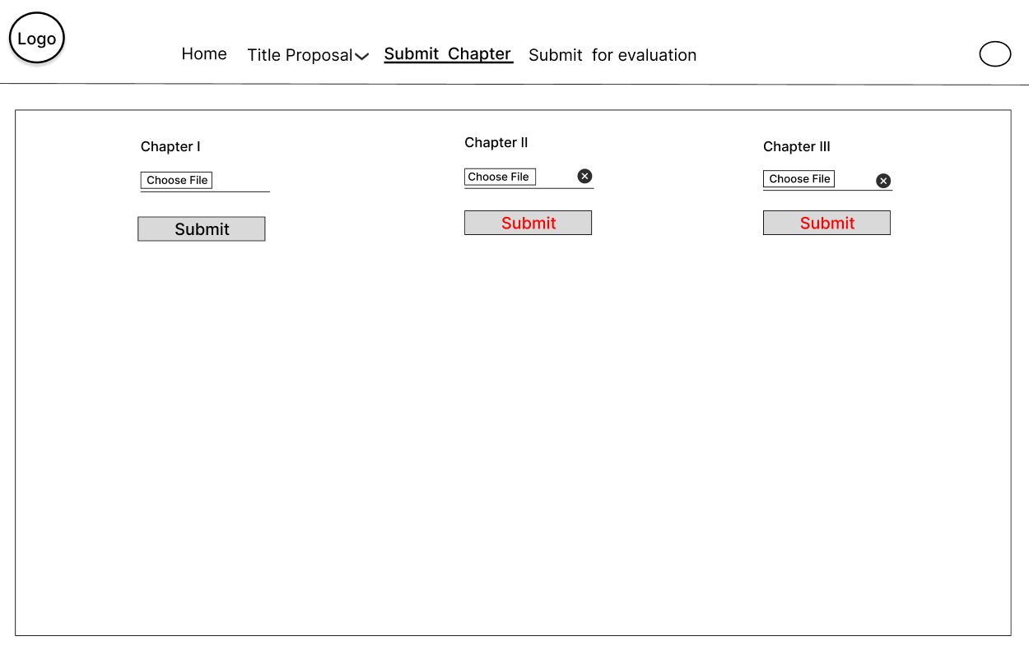
Shows the page where students upload their research chapters. The interface includes chapter selection options, file upload functionality, and submission controls. Students cannot submit the other steps if the adviser need revision, it will only if its complete or does not require revision.

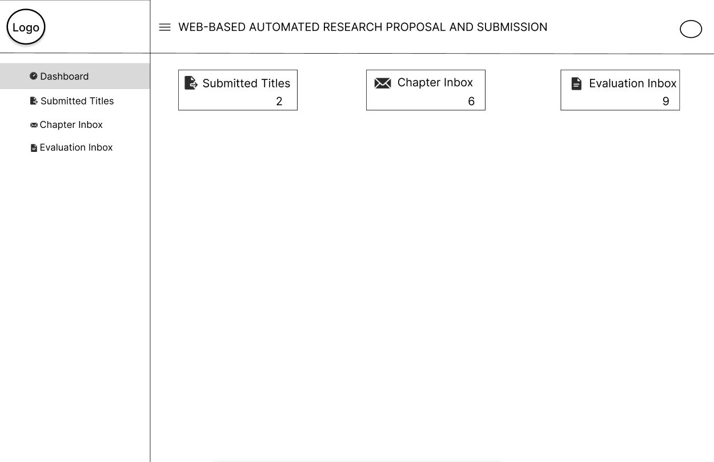

Figure 23. Panel/Adviser Dashboard
Shows the page where advisers can view counts of submitted research titles, chapters, and completed versions in their evaluation inbox. The interface displays numerical indicators showing how many submissions from students are pending review in each category.

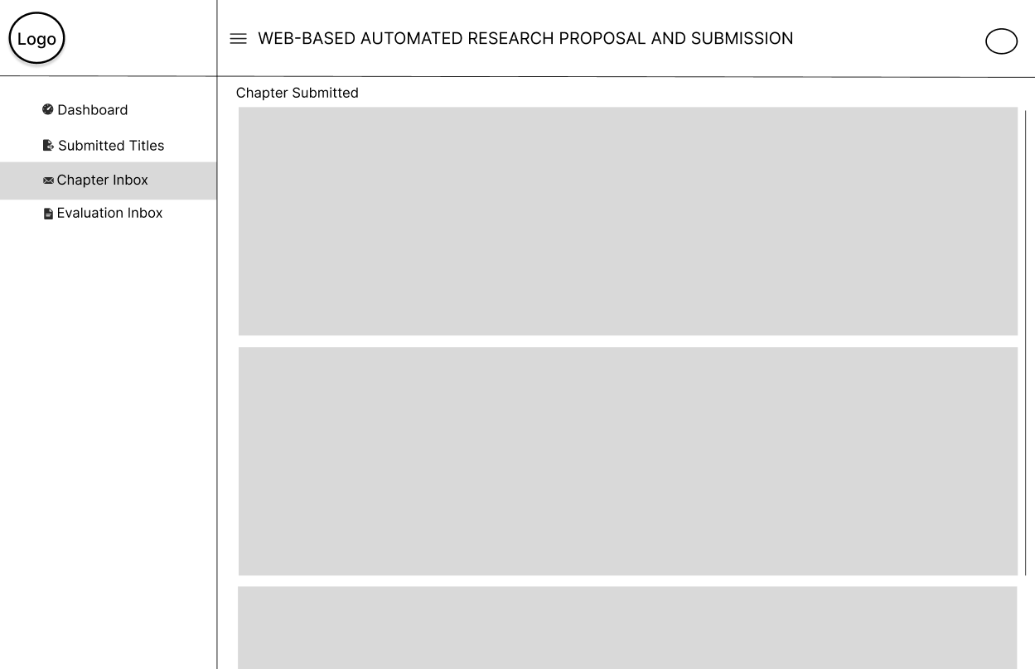
Figure 24. Chapter Review Page
Shows the page where advisers can see the students' submitted chapters in sequential order. The interface displays the chapters sent by students for review. Advisers can return files to students if revisions are needed or approve them to allow students to proceed to the next chapter submission.

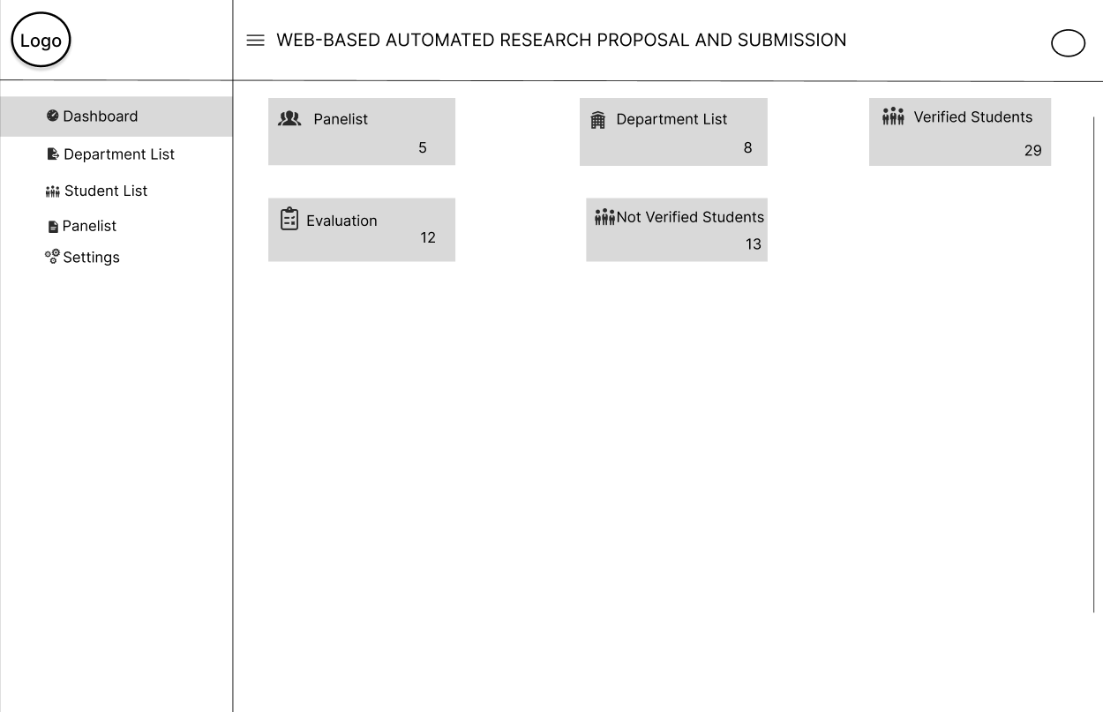

Figure 25. Admin Dashboard
Shows the administrative dashboard for the research approval system. The interface displays statistics about system usage at the top. Below are sections for managing users, monitoring submission activity, and accessing system settings.

Data Flow Diagram
Data flow diagrams show the way information flows through a process or system. They include data inputs and outputs, data stores, and the various sub-processes the data moves through. DFDs are built using standardized symbols and notation to describe various entities and their relationships.

Figure Definition

These are the common symbols that were use to present the specific that the actors had taken in using the entire project. This was presented through a Data Flow Diagram.
Symbols
Description
Source (Sink)
Process
The source of System inputs or sink of system outputs
Step-by-step instructions are followed that transform inputs (a computer or a person or t=both doing the work)

Data Store
An open-ended rectangle represents the location where data is stored
Data Flow Symbol
Represent a pathway for data

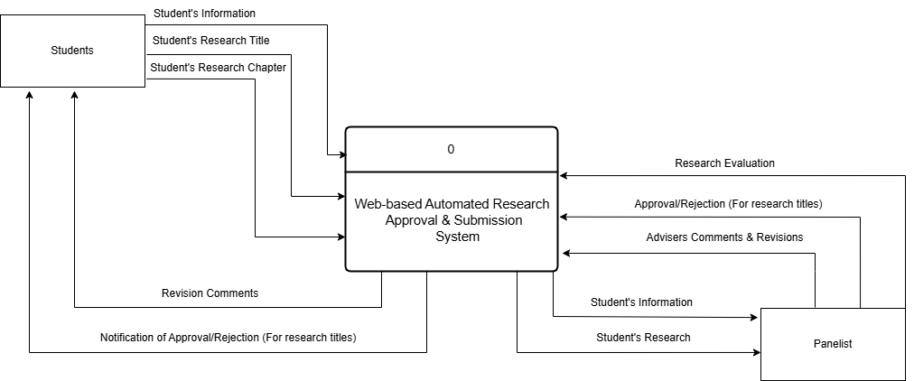

Figure 26. Context Diagram (Level 0)
Shows the entire System and how it interacts Students, and Panelist. Students submit research titles and chapters and receive feedback. Panelist review submissions and provide approval or revision requests. Panel members evaluate final proposals. This diagram illustrates how information flows between the system and its users without showing internal processes.

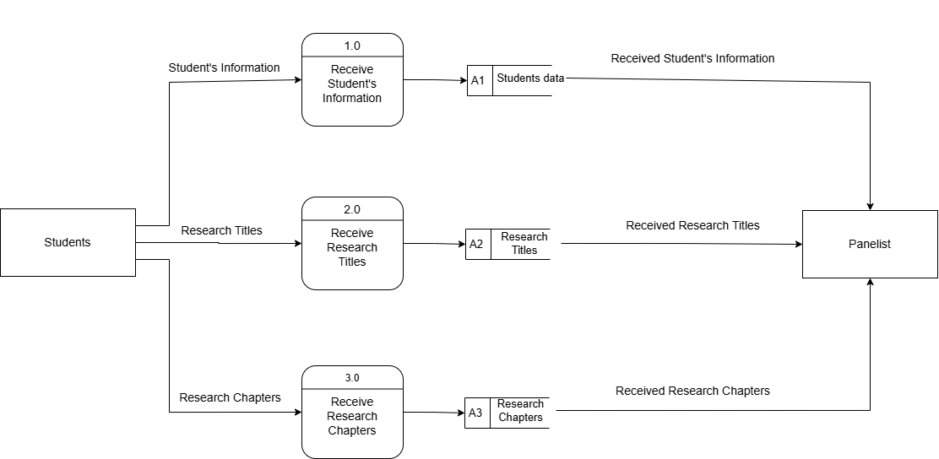

Figure 27. Level 1 Data Flow Diagram part 1
Part 1 shows how the Students sends data to the system. First the student sends data to the system, which received the data and store it to the databases. The stored data is then send to the Panelist to be process and evaluated. This part of the diagram shows how the student provides data such as; student information, Titles, and Chapters to the system which the system stored and sends to the panelist for processing.

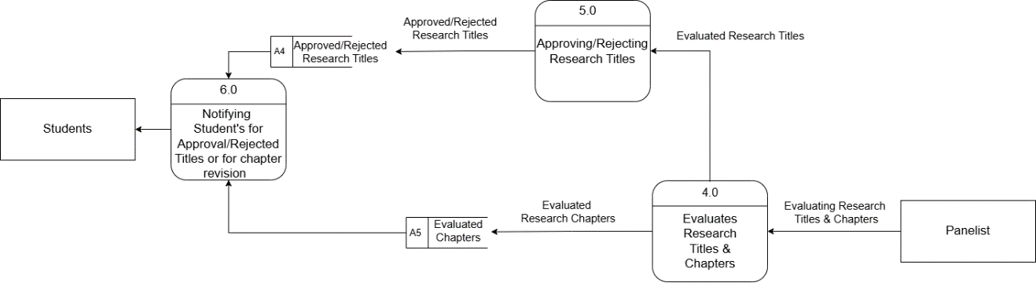

Figure 28. Level 1 Data Flow Diagram
Part 2 shows how panelist process the data that is send by the students. First if the student sent an research title, the panelist evaluate the title. When the panelist is done evaluating the title he can decide if he approve or reject the research title. The approve or reject title is then stored to be used to notify the Students. This part of the diagram shows how the panelist processes the research titles and the chapters that is send by the student.

Programming Environment
HTML (HyperText Markup Language) - HTML creates the basic structure of our Research Approval System. It builds elements like login boxes, submission forms, review interfaces, and dashboards. We use HTML to place components in appropriate locations. It serves as the foundation for other features like styling and interaction.
CSS (Cascading Style Sheets) - CSS adds visual elements to our Research Approval System. It applies the university's colors, formats text, and maintains consistent styling. We use Bootstrap framework to make the system display correctly on both desktop computers and mobile devices. This allows students and faculty to access the system from different devices.
JavaScript - JavaScript adds interactivity to our Research Approval System. It checks form inputs before submission, gives immediate responses, and updates content without reloading pages. When advisers review chapters, JavaScript shows the document and feedback form on the same screen. It also runs the notification system that informs users about new submissions or status changes.
PHP (Hypertext Preprocessor) - PHP handles the background processes in our Research Approval System. It processes form submissions, manages user login, and controls database operations. When students upload a chapter or advisers give feedback, PHP processes these actions and updates the database. It also creates pages based on user roles, so each user sees only their relevant information.
MySQL - MySQL stores all Research Approval System information. It contains tables for users, research groups, titles, chapters, reviews, and notifications. The database connects related information through table relationships, like connecting student accounts to research groups and submissions. MySQL handles the different types of data needed in the research approval process.
Evaluation
The respondents evaluated the system using the following scale:
Level of Agreement | Scale Description
5 | Strongly Agree
4 | Agree
3 | Fair
2 | Disagree
1 | Strongly Disagree

System Testing (Alpha Testing)
The obtained mean was interpreted using the following:
Functional Suitability
Numerical Equivalent | Interpretation
4.20 – 5.00 | Highly Functional
3.40 – 4.19 | Functional
2.60 – 3.39 | Moderately Functional
1.80 – 2.59 | Slightly Functional
1.00 – 1.79 | Poorly Functional
Performance Efficiency
Numerical Equivalent | Interpretation
4.20 – 5.00 | Highly Efficient
3.40 – 4.19 | Efficient
2.60 – 3.39 | Moderately Efficient
1.80 – 2.59 | Slightly Efficient
1.00 – 1.79 | Inefficient
Compatibility
Numerical Equivalent | Interpretation
4.20 – 5.00 | Highly Compatible
3.40 – 4.19 | Compatible
2.60 – 3.39 | Moderately Compatible
1.80 – 2.59 | Slightly Compatible
1.00 – 1.79 | Incompatible
Reliability
Numerical Equivalent | Interpretation
4.20 – 5.00 | Highly Reliable
3.40 – 4.19 | Reliable
2.60 – 3.39 | Moderately Reliable
1.80 – 2.59 | Slightly Reliable
1.00 – 1.79 | Unreliable

Security
Numerical Equivalent | Interpretation
4.20 – 5.00 | Highly Secured
3.40 – 4.19 | Secured
2.60 – 3.39 | Moderately Secured
1.80 – 2.59 | Slightly Secured
1.00 – 1.79 | Unsecured
Acceptance testing (Beta testing)
The obtained mean was interpreted using the following:
Numerical Equivalent | Interpretation
4.20 – 5.00 | Highly Acceptable
3.40 – 4.19 | Acceptable
2.60 – 3.39 | Moderately Acceptable
1.80 – 2.59 | Slightly Acceptable
1.00 – 1.79 | Unacceptable

Research Design
The study used the developmental-evaluation research design approach as the system was subjected to end user evaluation. This approach combines the development of the Web-Based Automated Research Approval and Submission System with a systematic evaluation of its effectiveness and usability.
Research Locale
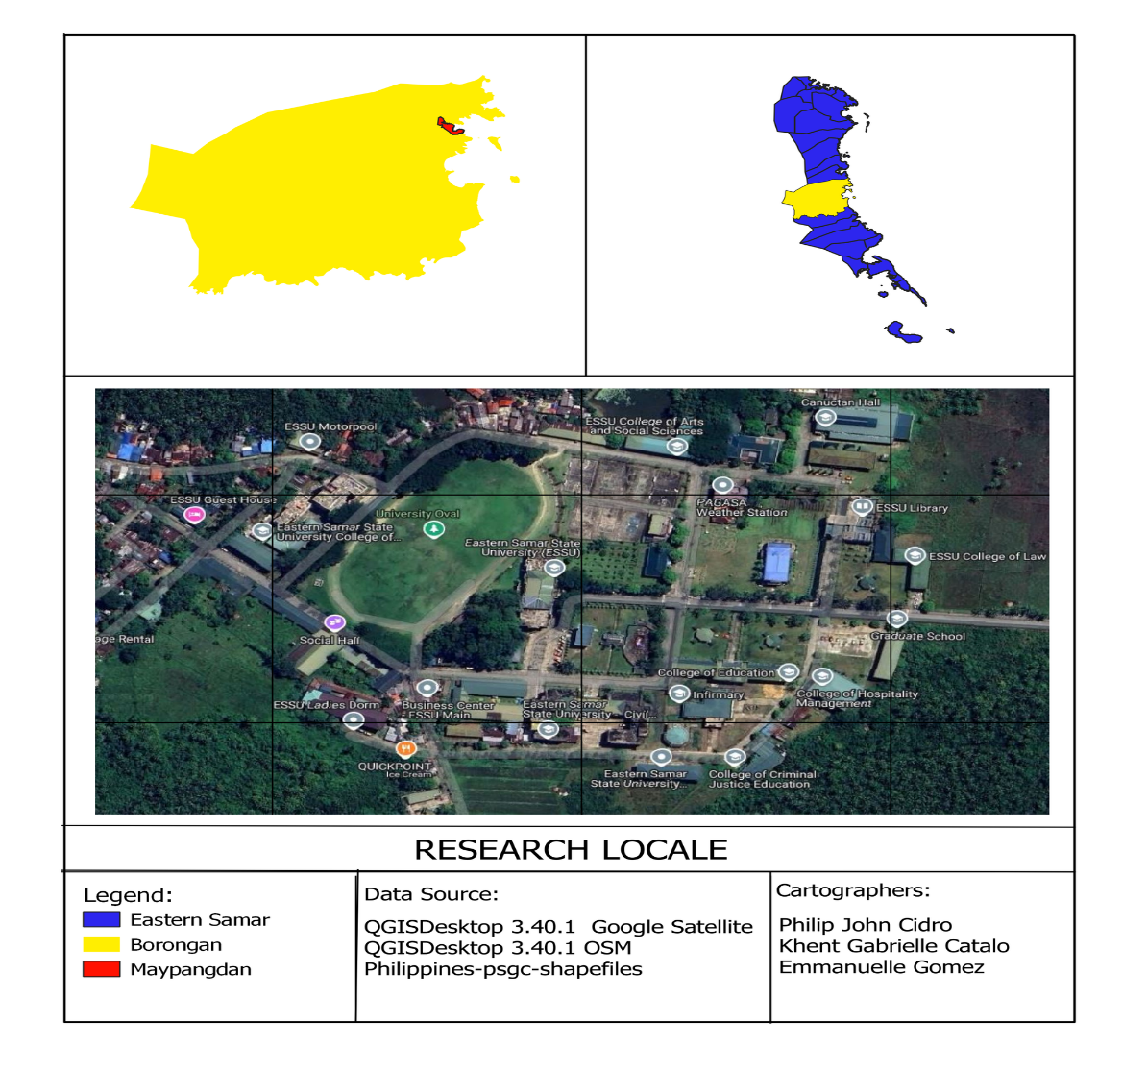
The study was conducted at Eastern Samar State University, focusing primarily on the research processes across its various colleges and departments. The university is located in Borongan City, Eastern Samar, Philippines.

Research Respondents
We will select 15 people to evaluate our Research Approval System. First, we will include 5 faculty members who serve as research advisers and know the current manual process. Second, we will get 5 IT professionals from the university's Computer Center who can evaluate the technical aspects. Third, we will include 5 students who are working on research proposals and can test the system as users. This mix of respondents will give feedback on both technical functions and practical use.
RESPONDENTS | NUMBERS OF RESPONDENTS
Faculty Research Advisers | 5
IT Professionals | 5
Research Students | 5
TOTAL | 15
Table 11. Distribution of Respondents
Instrumentation
In this phase, the system was evaluated using two instruments: the ISO/IEC 25010:2011 Software Evaluation Questionnaire for quality metrics during system testing and the IBM Computer Usability Satisfaction Questionnaire for acceptance testing.
The ISO questionnaire includes a series of questions designed to assess user satisfaction across various dimensions, such as functional suitability, performance efficiency, compatibility, usability, and reliability. This helps evaluate the system's overall quality during the testing phase.
The IBM questionnaire consists of questions that focus on user experience, addressing aspects like system complexity, usage frequency, consistency, and overall satisfaction. By using these standardized evaluation frameworks, the study aims to gather valuable insights into the system's performance, ensuring it meets the desired quality standards and effectively addresses the diverse needs and expectations of its users.
Data Analysis
Statistics using the mean was employed to present the demographic characteristics of the respondents and the level of the system effectiveness. The data from the ISO/IEC 25010:2011 Software Evaluation Questionnaire and IBM Computer Usability Satisfaction Questionnaire will be analyzed to assess the system's quality and usability during the alpha test, and the selected respondents during the beta test.

Mean
This is the average of the score -- the mathematical center of a distribution. It used symmetrical, unimodal distributions of interval or ratio scores.
The ISO's formula mean is:
X = Σ x/n
Where:
- Σx = sum of all scores
- n = number of scores
The IBM formula mean is:
SUS = (Q1 + Q2 + Q3 + ... + Q10) ÷ 10

Where:
- Q1-10: Scores for each question

