LEARNING JOURNAL
Educational Tour to Cebu City

Submitted by: Khent Gabrielle R. Catalo

Submitted to: Dr. Karen W. Cantilang

Course: Bachelor of Science in Information Technology

ACKNOWLEDGEMENT

I want to take a moment to thank everyone who helped make our educational tour to Cebu City such an incredible learning experience.
To Eastern Samar State University - Main Campus and the College of Computer Studies, thank you for giving us this chance to see firsthand how the IT concepts we study in class actually work in the real world. This trip really helped connect the dots for me.
I'm grateful to our faculty members and tour coordinators who looked after us during the entire trip. Your constant support and careful planning made sure we stayed safe while getting the most out of every visit.
A huge thank you to the industry professionals who took time out of their busy schedules to teach us:
Mr. Philmore "Emot" G. Amodia from Emottons Animation Studio – your creativity and storytelling approach to animation really opened my eyes to possibilities I hadn't considered before
Mr. Harold Dasamo Abontin at Cebu City's Geographic Information Division – seeing how GIS actually helps run city operations was fascinating and showed me a whole different side of technology
The Globe Telecom Network Operation Visayas Team – learning about telecommunications infrastructure from the people who manage it daily gave me a much clearer picture of how our connected world actually functions
Mr. Neil Losif Ilagan from ePerformax – your questions about why we're pursuing IT careers really made me reflect on my own goals and motivations
The instructors at Rivan IT Cebu – getting to work with actual networking equipment instead of just reading about it was a game-changer for my understanding
To my classmates who shared this journey with me – the conversations we had and perspectives we exchanged made everything more meaningful.
And to my parents thank you for always supporting my education and believing in what I'm working toward.
This tour genuinely changed how I see my future in IT, and I'm truly thankful I got to be part of it.

TABLE OF CONTENTS
TITLE PAGE i
ACKNOWLEDGEMENT ii
TABLE OF CONTENTS iii
INTRODUCTION 1
NARRATIVE REPORTS
Seminar #01: Emottons Animation Studio 2
Seminar #02: Cebu City Geographic Information (GIS) Division 3
Industry Exposure #01: Globe Telecom -- Site Tour Program 4
Industry Exposure #02: ePerformax - BPO Company 5
Industry Exposure #03: Rivan IT Cebu 6
ADDITIONAL PICTURES FROM SEMINARS & INDUSTRY EXPOSURES 7
REFLECTION 8
STUDENT'S PROFILE 9

INTRODUCTION
An educational tour is basically when schools organize trips that let students learn outside the classroom walls. What makes these different from ordinary field trips is that they're designed with specific learning objectives that tie into our coursework. Instead of just memorizing information from textbooks, we actually get to witness and experience things in real settings like visiting historical landmarks to truly grasp a period in history, exploring science centers to observe concepts in action, or touring companies to see how our academic subjects translate into actual careers.
What I've realized is that educational tours make learning stick. There's something about physically being at a place related to what you're studying that just clicks differently. Seeing things with your own eyes rather than just reading about them creates stronger memories and deeper understanding. For instance, standing at a historical site brings those textbook stories to life, while walking through a real workplace shows you exactly where your degree could take you.
Beyond academics, these experiences push us to grow as individuals. You learn to navigate unfamiliar environments, become more self-reliant, and collaborate with your peers in ways you don't typically do in a regular classroom setting. Encountering new people, different perspectives, and unfamiliar places broadens your worldview and teaches you adaptability qualities that matter long after graduation.
This year, our College of Computer Studies at Eastern Samar State University – Main Campus organized an educational tour to Cebu City. Throughout the trip, we participated in industry seminars and visited various tech companies to witness the IT sector up close. For me, this was eye-opening I finally saw the bridge between our lectures and labs and what actually happens in the technology workplace. Getting to interact with industry professionals and seeing different work environments gave me clearer ideas about where I might fit in the tech world after graduation.

NARRATIVE REPORT
Seminar #01:
Emottoons Animation Studio
Philmore “Emot” G. Amodia – Owner
One of the stops on our educational tour was a seminar at a BIG hotel in Cebu, where we met Sir Emot, the owner of Emottons Animation Studio. He walked us through his journey of starting the studio from scratch and gradually building his team into what it is today. He showed us samples of their projects different animation styles they've created for various clients and honestly, it was pretty impressive seeing the range of work they've done.
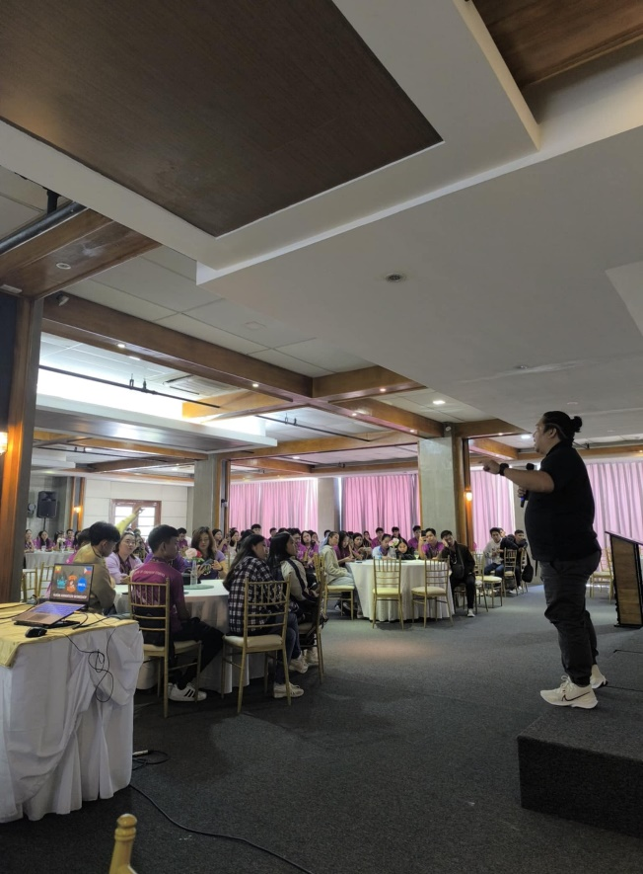
What really caught my attention was when he broke down how much time and effort goes into animating even the smallest movements. I never really thought about it before, but those few seconds of animation we casually watch can take hours or even days to create. He also opened up about the business side of things, particularly the struggle of managing client expectations. Apparently, one of the biggest challenges is getting clients to understand why quality animation can't be rushed it just takes the time it takes.
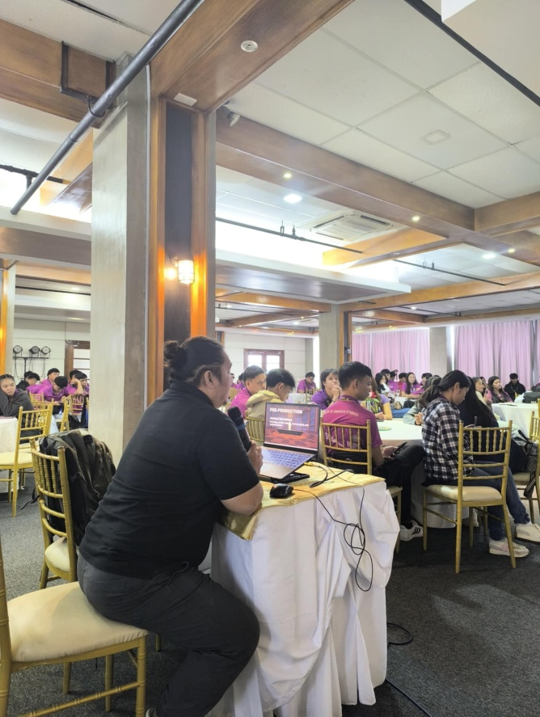
Fig. 2: EMOTTOONS Open Forum
Fig. 1: EMOTTOONS Discussion

NARRATIVE REPORT
Seminar #02:
Cebu City Geographic Information (GIS) Division
Harold Dasamo Abontin – GIS Supervisor
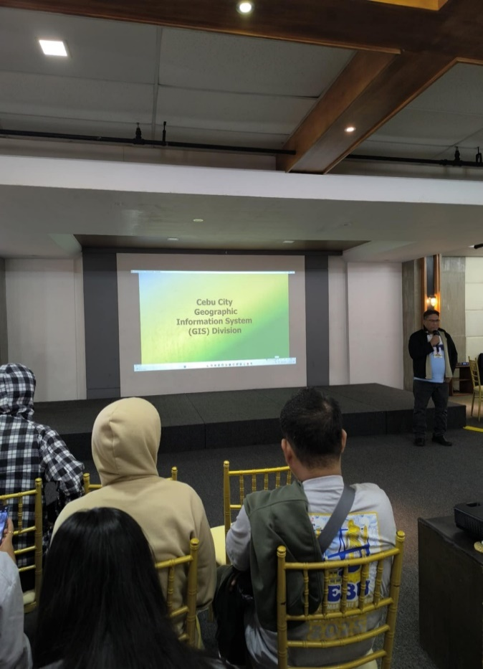
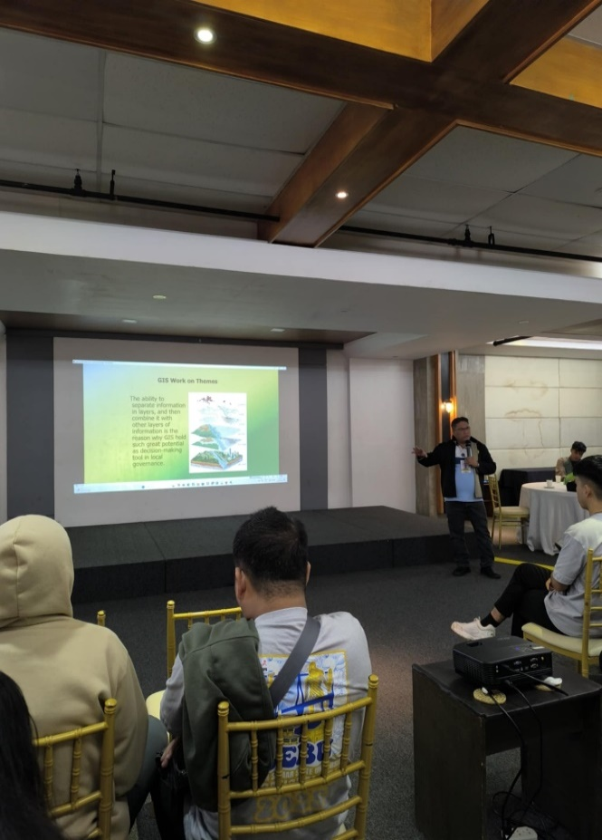
Our seminar with Sir Harold from Cebu City's Geographic Information System Division really opened my eyes to how GIS technology works beyond what we learn in textbooks. He walked us through the practical side of GIS how it's actually being used every day to help run Cebu City more effectively. What stood out to me was the sheer variety of applications he mentioned: they're using it for everything from emergency response and disaster management to business analysis and even mapping out tax collection areas. Sir Harold gave us some historical context too, explaining when and why local governments started adopting GIS technology in the first place. He mentioned that over the last decade, Cebu City has built up an extensive collection of data layers covering different aspects of city operations, and all this information now helps government officials make smarter, more informed decisions about how to allocate resources. The Q&A portion at the end was valuable because we could dig deeper into specific things that caught our interest and hear Sir Harold's insights based on his actual experience working with the system. It definitely made me appreciate how technology like GIS has real, tangible impacts on how cities function and serve their communities.
Fig. 4: Cebu City LGU GIS Division Open Forum
Fig. 3: Cebu City LGU GIS Division Discussion

NARRATIVE REPORT
Industry Exposure #01:
Globe Telecom – Site Tour Program
Network Operation Visayas Team
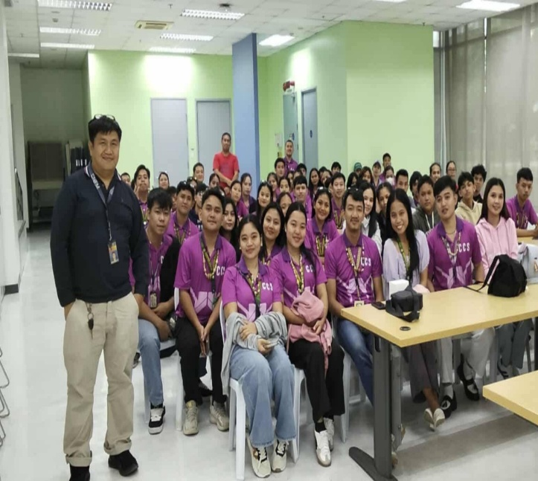
Our first real taste of industry experience came when we visited Globe Telecom's Network Operation Visayas Team. It was fascinating to learn about Globe's background how the company evolved over time, which other companies are part of their network, and the whole process of how they actually get services to millions of customers. The team broke down the fundamentals of telecommunications for us in a way that finally made sense. They explained what happens behind the scenes when we do everyday things like texting, calling, or browsing the internet things we usually just take for granted. What really struck me was understanding that when you send a message or make a call to someone far away, that data is traveling incredible distances and passing through multiple points where things can go wrong. Suddenly, those dropped calls and delayed messages made a lot more sense. The team also emphasized how critical these communication networks are beyond just personal conversations so many essential services, from banking to emergency systems, depend entirely on these networks functioning properly. One of the coolest moments was actually getting to see and handle the physical cables that transmit data between islands and even across countries. It's one thing to know these connections exist, but actually touching the infrastructure that keeps us all connected was pretty amazing. They ended the session with a quiz covering everything we'd discussed, which was a fun and interactive way to test how much we'd absorbed. It definitely helped solidify the information in my mind.
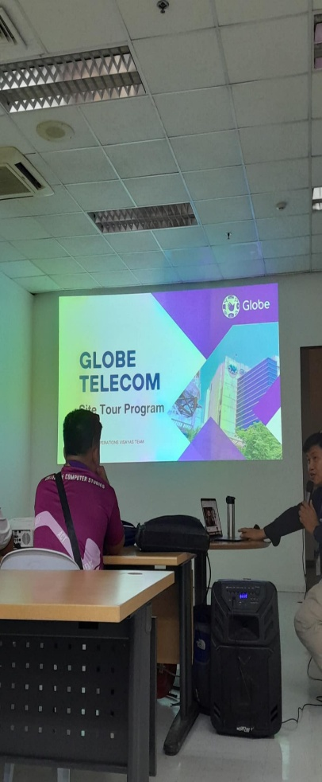
Fig. 6: Globe Telecom After Discussion Pictorial
Fig.5: Globe Telecom Discussion

NARRATIVE REPORT
Industry Exposure #02:
ePerformax - BPO Company
Neil Losif Ilagan – Area Manager
Our visit to ePerformax, a BPO company, started with Sir Neil asking us a deceptively simple question: "Why are you here?" The way he asked made it clear he wasn't just talking about that day he was challenging us to think about our future and what drives us. After that reflective moment, the atmosphere lightened up as he gave us a tour of their facility. He explained what BPO means, shared how the industry developed in Cebu City, and walked us through ePerformax's mission and values. We saw various parts of their office break areas, nap rooms, training classrooms, and even a medical clinic which showed me how much they invest in employee welfare. Sir Neil also clarified their hiring process and corrected common misconceptions about BPO work. What made it personal was when he shared his own journey and the real challenges he faced in the industry. We ended with a discussion about our career plans and potential obstacles ahead. His final message really resonated with me: no matter what career we choose, having a strong sense of purpose is what keeps us going when things get tough.
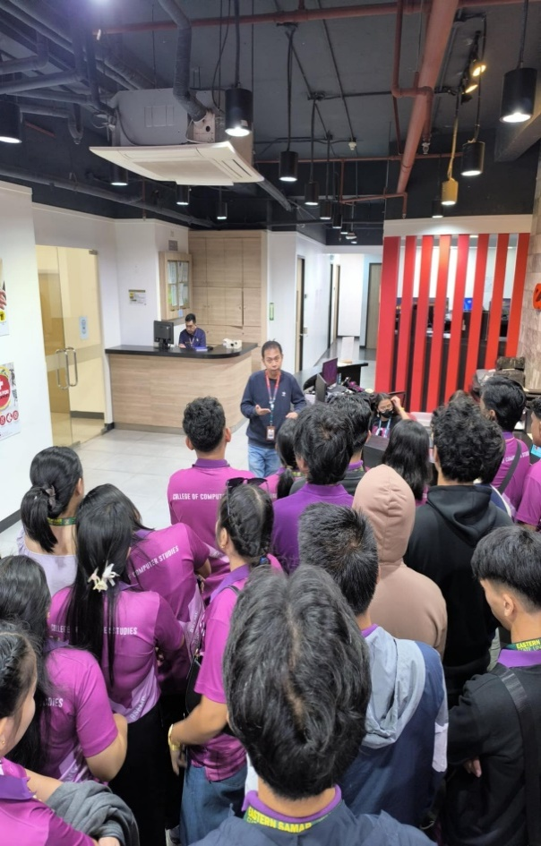
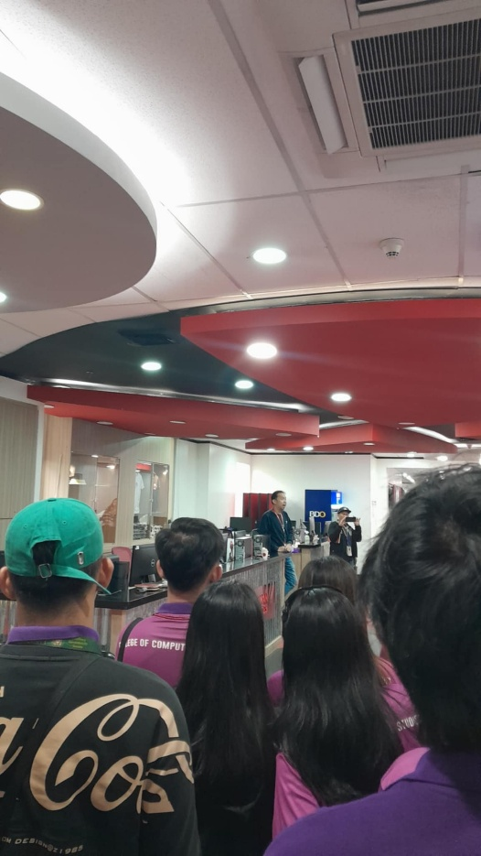

Fig. 8: ePerformax Company Tour
Fig. 7: ePerformax Company Discussion

NARRATIVE REPORT
Industry Exposure #03:
Rivan IT Cebu
Bootcamp Training Center
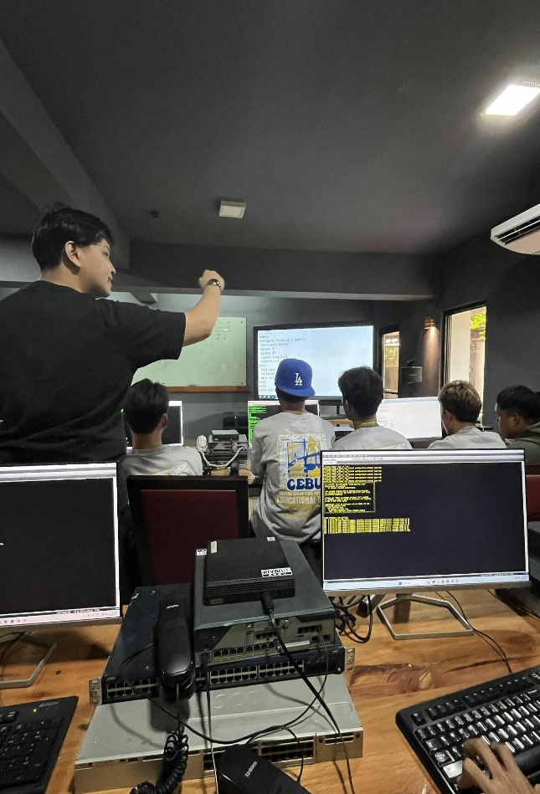
Our final industry visit was at Rivan IT Cebu, a training center for networking certifications like CCNA and CCNP. We started by discussing why we each chose IT, which sparked interesting conversations about our different motivations. The highlight for me was getting hands-on experience with actual networking equipment something we don't get at school where we only use simulation software like Cisco Packet Tracer. I got to physically handle and connect real modems, switches, firewalls, access points, and VoIP phones, which completely changed my understanding of networking concepts. Seeing things like ACL and network configurations work in real life instead of just in theory was exciting, though I was definitely careful since all the equipment was expensive. We completed practical activities like setting up analog telephone systems and building network topologies based on given scenarios, and ended with an open forum for questions. This experience really bridged the gap between what we learn in the classroom and how it actually works in the real world.
Fig. 9: Rivan IT Cebu Analog Telephone Configuration Activity
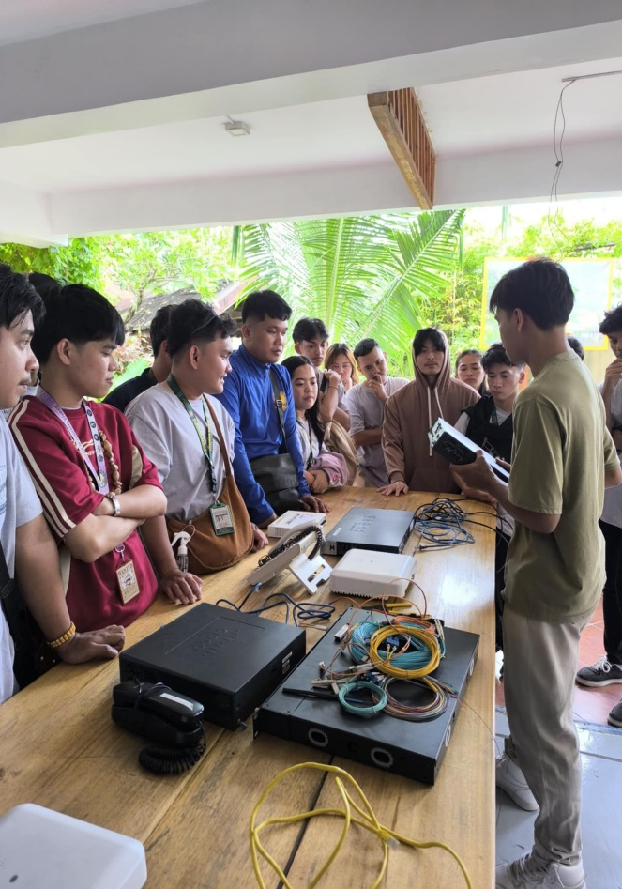
Fig. 10: Rivan IT Cebu Discussion of Different Networking Devices and its Functions

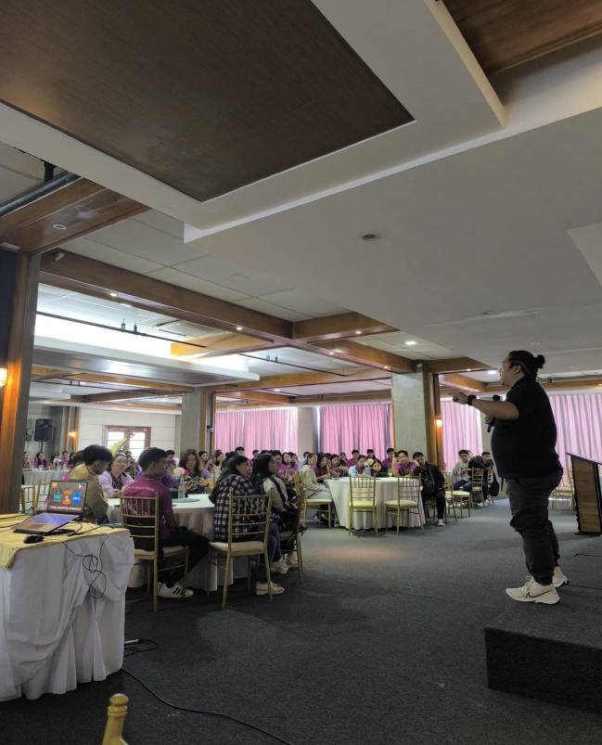
ADDITIONAL PICTURES FROM SEMINARS & INDUSTRY EXPOSURES
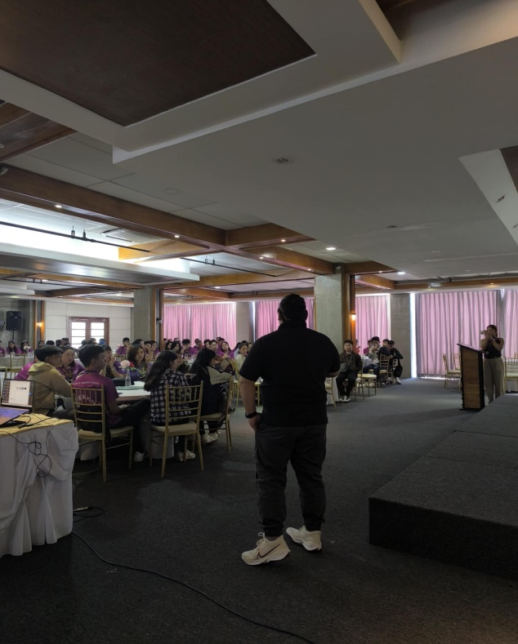
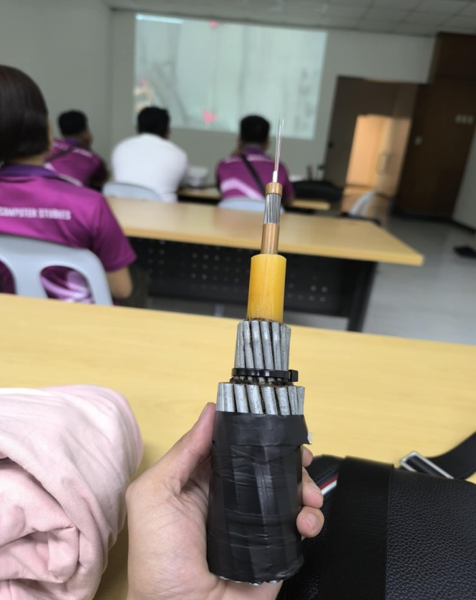
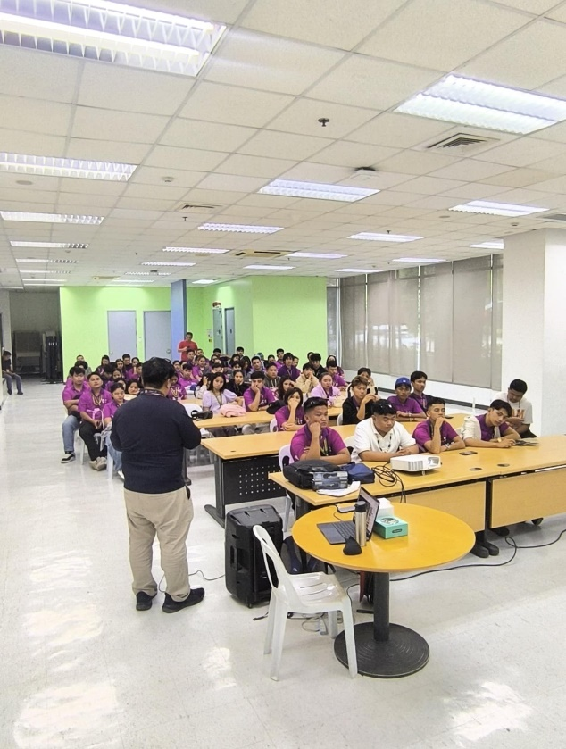

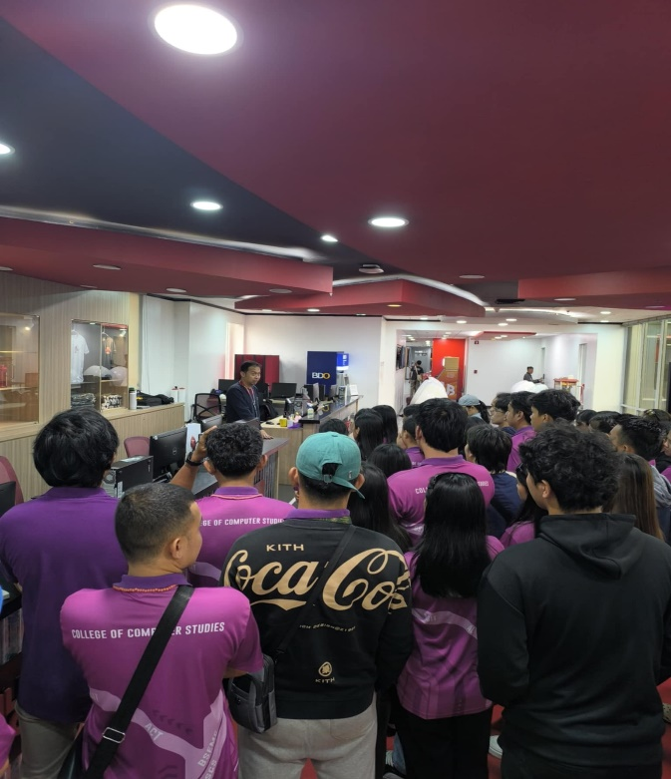
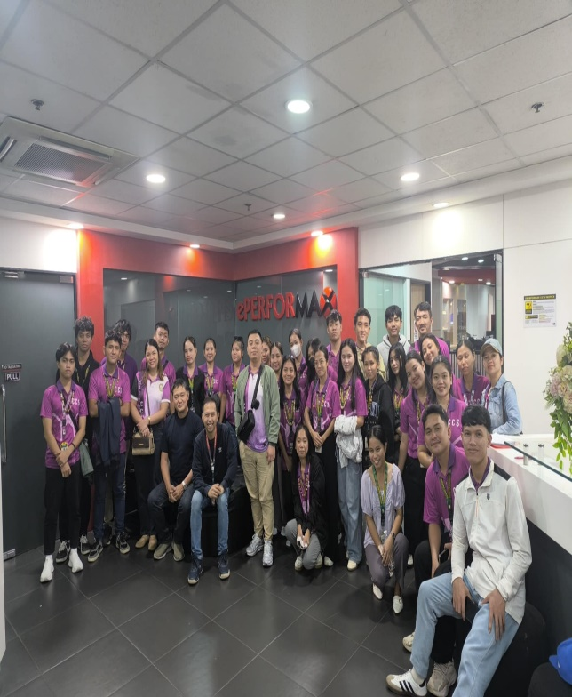
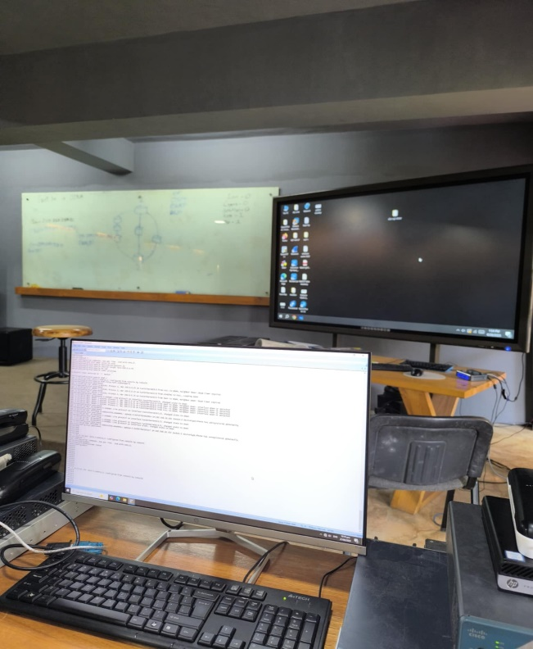
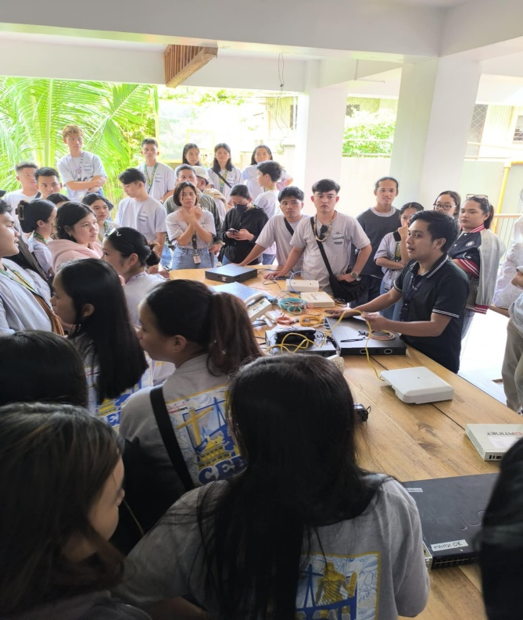

REFLECTION
This educational tour to Cebu City completely changed how I view the IT field. Before the trip, I had a narrow understanding of IT mostly just coding and software. But visiting different companies showed me there are so many career paths I hadn't seriously considered.
Sir Emot at Emottons Animation Studio inspired me with his passion for animation, making me think about finding work I could be that dedicated to. Sir Harold's GIS seminar connected our classroom lessons to real-world applications, showing me how the technology we study actually helps run cities and solve public service problems. The Globe Telecom visit made me appreciate the complexity behind the communication services I use daily, especially when I got to touch the actual cables connecting islands.
ePerformax challenged my assumptions about BPO work it's more than just answering phones. But what really stuck with me was Sir Neil's question: "Why are you here?" It forced me to think seriously about my motivations and goals. Rivan IT was the most exciting because I finally got hands-on experience with real networking equipment instead of just simulations. Working with actual switches and routers made me realize how much I still need to learn, but also sparked my interest in network engineering as a possible career.
The biggest lesson I took away is that finding your "why" your purpose is what keeps you motivated in any career you choose. This tour didn't just show me job opportunities; it proved that what we're learning in school actually matters in the real world. I feel more confident now about my future because I have a clearer picture of what's out there and where I might fit in.

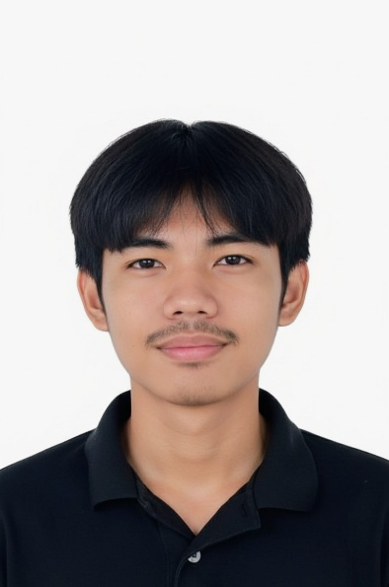
STUDENT’S PROFILE

Name: | Khent Gabrielle R. Catalo
Pseudo Name: | Khent, Gab
E-mail Address: | gabriellecatalok@gmail.com
Contact number: | 09306996867
Civil Status: | Single
Religion: | Roman Catholic
Birthdate: | November 26, 2003
Address: | Brgy. San Saturnino Borongan City, E. Samar
PARENTS
Father Name: | Gil C. Catalo Jr.
Mothers Name: | Jennifer O. Recentes
PRELIMINARY EDUCATION

Elementary: | San Saturnino Elementary School
Year Graduated: | 2016
Secondary: | Sta. Fe National High School
Year Graduated: | 2022
College: | Eastern Samar State University Main Campus
Course: | Bachelor of Science in Information Technology

