Chapter III
Methodology
In this chapter, the researchers explain how they will build the Web-Based Automated Research Approval and Submission System for Eastern Samar State University. The researchers are following an Agile development approach to create a website for managing, reviewing, and approving research proposals. This chapter presents the iterative methods the researchers will use to create a system where students can submit research proposals and faculty can review them.
The researchers' method starts by engaging with students, faculty advisers, panel members, and research administrators through continuous collaboration and feedback loops. This helps the researchers determine what the system should do through multiple iterations - like how students should submit their research chapters, how to track proposal status, and how to create appropriate feedback interfaces for reviewers.
For the technology, the researchers will use HTML for page structure, CSS for styling, Bootstrap for responsive design framework, JavaScript for interactive elements, PHP for server processing, and MySQL for the database. The researchers will design the system to function on both desktop computers and mobile devices, allowing users to access it from different locations.
The development process will involve continuous testing and user feedback, with regular demos and iterations. The researchers will teach students, faculty advisers, and panel members how to use the system throughout the development process. The researchers will monitor how the system performs, make necessary updates, and adjust it based on ongoing feedback from administrators and academic users.

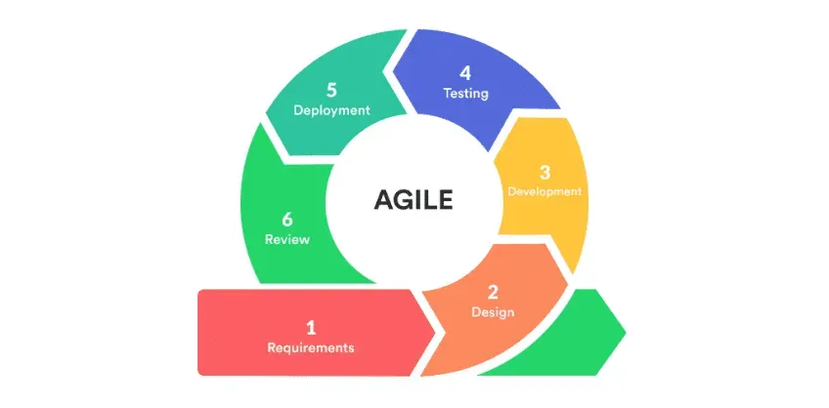
Agile Development Model

Figure 1. Agile Development Life Cycle
The researchers have chosen the Agile methodology to build their Web-Based Automated Research Approval and Submission System because it offers flexibility, continuous user feedback, and iterative improvement suitable for Eastern Samar State University's dynamic academic environment. This approach follows a cyclical process with six interconnected phases: Requirements, Design, Development, Testing, Deployment, and Review, allowing for regular stakeholder input and rapid adaptation to changing requirements throughout the development process.
By following the iterative phases of the Agile model in continuous cycles, the researchers can deliver working features incrementally and incorporate user feedback continuously. This cyclical approach works well in an academic environment where requirements may evolve based on user needs and institutional changes, as each cycle builds upon the insights gained from the previous iteration.

This method helps the researchers build features iteratively through repeated cycles, developing components like user registration, research title submission, chapter-by-chapter submission process, and panel review interfaces. The Agile model's emphasis on collaboration and flexibility through continuous cycles is appropriate for creating a system that maintains academic standards while improving administrative processes.
AGILE DEVELOPMENT PHASES
Requirements
In the requirements phase, the research team collaborates with Eastern Samar State University stakeholders to gather and analyze user needs. The researchers conduct interviews with students, faculty advisers, panel members, and research administrators to understand current challenges with the manual approval process. The research team documents functional and non-functional requirements, creates user stories, and establishes acceptance criteria for each feature. The researchers prioritize requirements based on stakeholder value and system dependencies, ensuring that the most critical features are addressed first in the development cycle.
Design
In the design phase, the research team creates system architecture, user interface mockups, and database schemas based on the gathered requirements. The researchers design responsive layouts using Bootstrap framework to ensure compatibility across desktop and mobile devices. The research team develops wireframes for key interfaces including login screens, submission forms, review dashboards, and administrative panels. The researchers create detailed technical specifications, define data flow diagrams, and establish security protocols for role-based access control.
Development
In the development phase, the research team implements the designed features using HTML for structure, CSS and Bootstrap for styling, JavaScript for interactivity, PHP for server-side processing, and MySQL for data management. The researchers follow coding best practices and maintain version control throughout the development process. The research team builds core functionality including user authentication, file upload systems, notification mechanisms, and workflow management. The researchers ensure that each component integrates properly with existing system elements and follows established security protocols.

Testing
In the testing phase, the research team conducts comprehensive quality assurance to ensure system reliability and functionality. The researchers perform unit testing for individual components, integration testing for connected features, and system testing for overall performance. The research team conducts user acceptance testing with actual stakeholders from Eastern Samar State University, including students testing submission interfaces, faculty testing review processes, and administrators testing management features. The researchers document and address any bugs, performance issues, or usability concerns identified during testing.
Deployment
In the deployment phase, the research team releases working features to a staging environment where stakeholders can interact with real functionality. The researchers configure server environments, establish database connections, and ensure proper security measures are in place. The research team provides training materials and documentation to help users understand new features and capabilities. The researchers monitor system performance during initial deployment and address any technical issues that arise during the transition from development to production environments.
Review
In the review phase, the research team evaluates the completed cycle with stakeholders to gather feedback and identify areas for improvement. The researchers conduct demonstrations of implemented features and collect user feedback on functionality, usability, and effectiveness. The research team analyzes system performance data, user adoption rates, and stakeholder satisfaction metrics. The researchers use insights gained from the review phase to inform requirements for the next development cycle, ensuring continuous improvement and adaptation to evolving user needs.

Fishbone Diagram
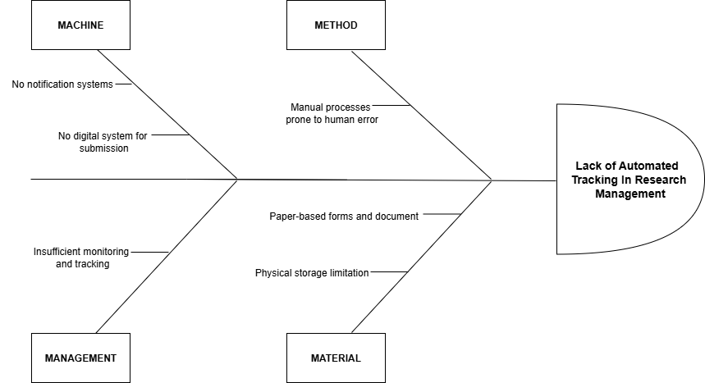
Figure 2. Fishbone Diagram
The fishbone diagram shows the problem of lack of automated tracking in research management. In the Machine, no notification system to notify users. And no digital system for submission. The Method section points out that the current process is mostly manual processes. For Material, the use of paper forms is an issue. Paper-based take more time, are easy to lose, and can lead to duplicate or missing research files and it use physical space to store them. Lastly, under Management, there's poor tracking of how things are going. Without proper monitoring, it’s hard to know where a submission is in the process or who’s responsible for the next step. The propose solution is a web-based automated research proposal and submission system.

Gantt Chart
A Gantt Chart organizes tasks over a set timeline, with a time scale at the top and a list of activities on the side. Each task is represented by a bar, where the length and position indicate the start, progress, and completion of the activity. This visual tool simplifies planning and tracking progress.
Figure 3. Gantt Chart Diagram
The Gantt Chart will help the researcher plan out their steps in a span of time. The left side represents the list of activities while the top represents the time scale. Each activity is represented by the bar and the length of it represents the start date, duration and the end of the activity.
Definition

Represented the months and their duration.

Represented the border of the activities.

Represented an activity that has already been done.

Represents a portion of an activity that has not been yet.
Symbols

Vertical line

Horizontal line

Shaded Box

Unshaded Box

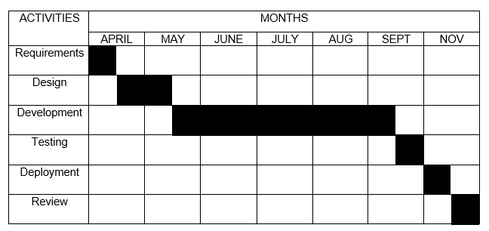

Table 1. Project Timeline
This timeline presents the implementation schedule for the Web-Based Automated Research Approval and Submission System following the Agile Model phases described in the previous section. The project starts in April with the Requirements phase, where the researchers determine exactly what the software needs to do and what features it should have. This phase has been completed.
In April, May the researchers move on to the Design phase, where they plan how the software will look and work, creating blueprints and layouts for the user interface and system architecture. The Development phase begins in June, which is when the actual coding and building of the software happens this is typically the longest phase of any software project.

System Flowchart
This flowchart shows physical control or resource level control. This flowchart shows process, system, or algorithm, using standardized symbols to represent the various steps and their sequence.
Process
Indicates any processing function.
Symbols
Terminator
Description.
Indicates the beginning or end of a program flow in the diagram.
On-page Reference
On-page connector is used to replace long line on a flowchart page.
Off-page Connector
An off-page connector is used when the target is on another page.

Data
Flow Line
Can represent any type of data in a flowchart may it be an input or output data.
shows the process description.
Decision
Indicates a decision point between two or more paths in flowchart
Database
Used For representing information kept in a modern storage database.

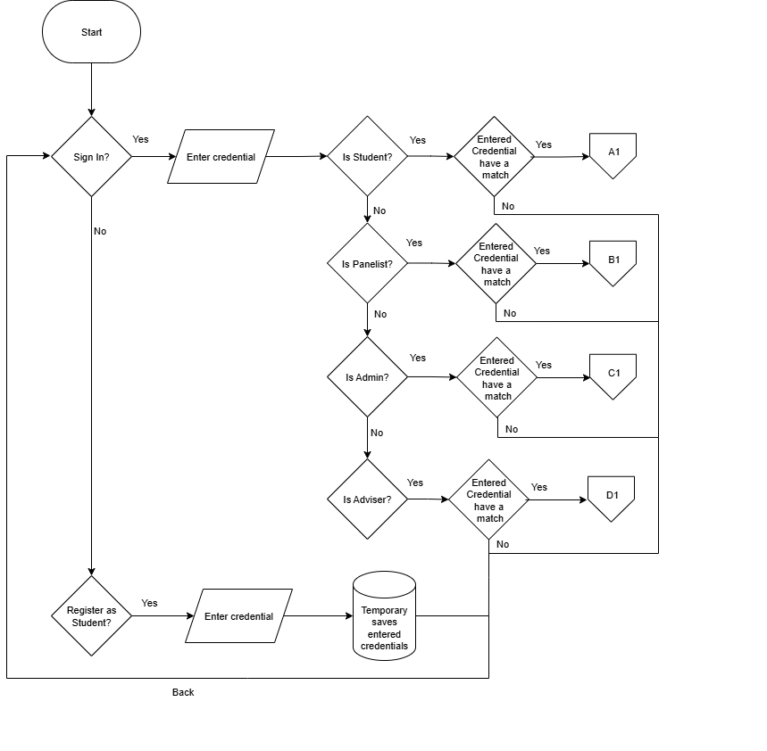

Figure 4. User Authentication Flow
This flowchart shows how users get inside of Wed-based Automated Research Approval and Submission System. To access the page, the user must first enter their account credentials. The system checks if the inputted credential have a match in the system database if it finds a match, the system check what is the user type the account is, whether it is an student (path A1), panelist (path B1), admin (path C1), or an adviser (path D1) If a user doesn’t have an account, they can sign in to get an account and their information well be saved in the account database.

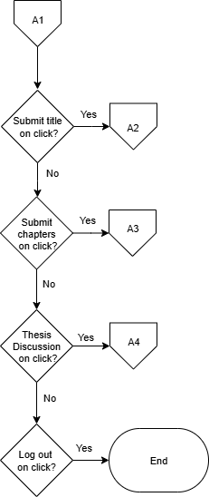

Figure 5: Student Home
The flowchart represents the navigation path for a student on the system. Each decision point offers the student a choice to navigate to a specific feature (Submit title, Submit Chapter, Thesis Discussion, or Logout). If the student chooses "Yes" at any decision point, they are taken to the corresponding page. If the student chooses "No," they continue to the next decision point until they either log out or exit the system.

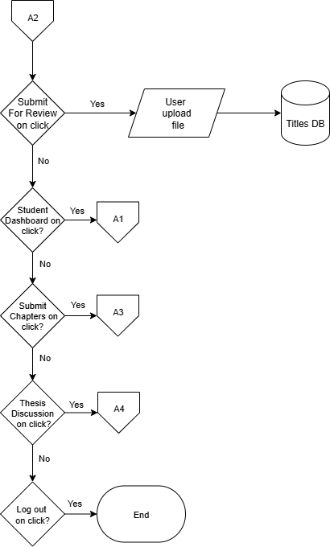

Figure 6. Research Title Proposal Page
The flowchart shows the page for students to submit their research titles. Students can choose to submit a new title, view previously submitted titles, and check the status of their submissions. If a title is approved, they can proceed to chapter submission. If a title is rejected, they must submit a revised title. At each decision point, students have the option to select "No," which will return them to the main Chapter Submission page or keep them within the current flow without exiting or logging out.
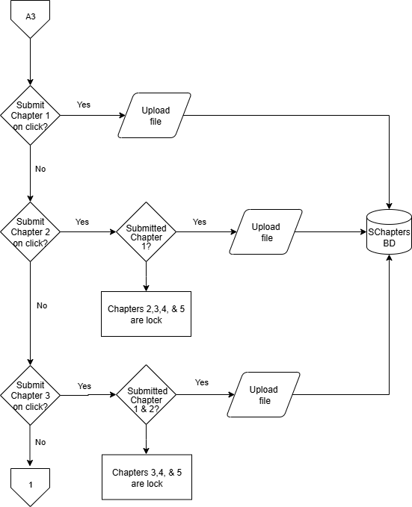

Figure 7. Chapter Submission Page
The flowchart outlines the navigation path for students within this specific section of the system. Students can choose to submit chapters sequentially (Chapter 1, Chapter 2, Chapter 3, Chapter 4, then Chapter 5) after each previous chapter is approved. At each submission, the document is stored in the database. At each decision point, students have the option to select "No," which will return them to the main Chapter Submission page or keep them within the current flow without exiting or logging out.
.

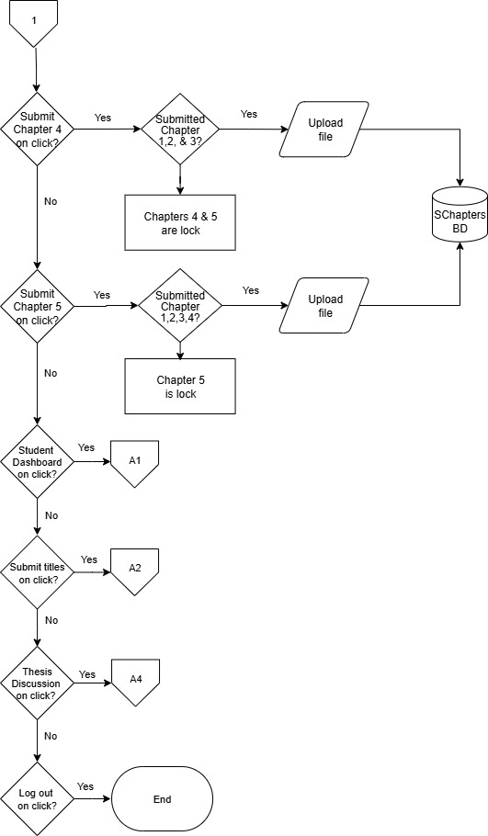

Figure 8. Chapter Submission Page Navigation
This flowchart shows the navigation of Chapter Submission Page the student can access the student home, submit titles, submit for evaluation and log out.

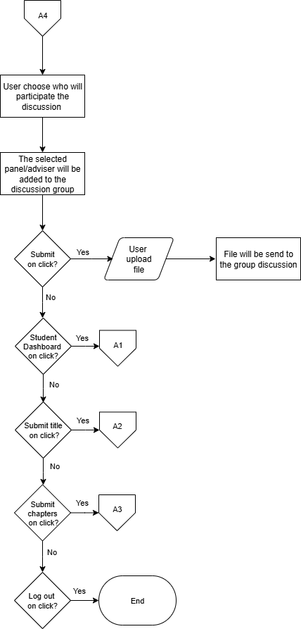
Figure 9. Submit for Evaluation Page
The flowchart shows how students can add their panelist or adviser to their discussion for checking for revision. The chapter will be send to the selected panelist and well send back comments and instructions. Each step, saying "No" keeps them on the same page.

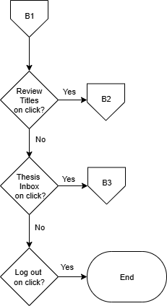

Figure 10. Panel Member Dashboard Page
The flowchart outlines the navigation path for panel members within this specific section of the system. Each decision point offers the panelist a choice to navigate to a specific feature. Throughout the process, panel members have the options to log out or exit the dashboard.

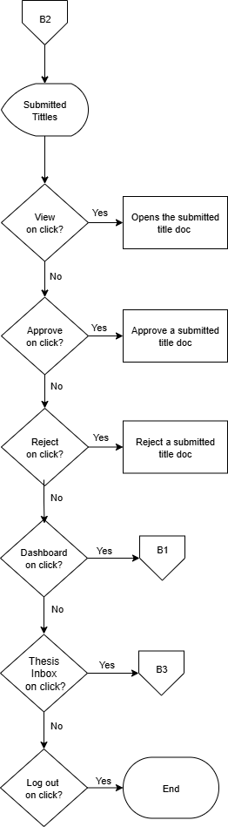

Figure 11. Panel Member Submitted titles Page
The flowchart shows the submitted titles page. In this page the panelist can view, approve, and reject submitted title proposals. Panelist users have the option to select "No," which keeps them within the current flow without exiting or logging out.

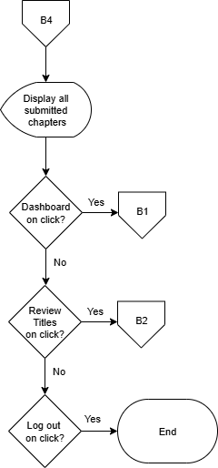

Figure 12. Panel Member Thesis Discussion
This flowchart shows the Thesis Discussion Page. This page is where the panelist and student can send messages. In this page the student sends their chapters and the panelist send comments and revision recommendation. Panelist users have the option to select "No," which keeps them within the current flow without exiting or logging out.

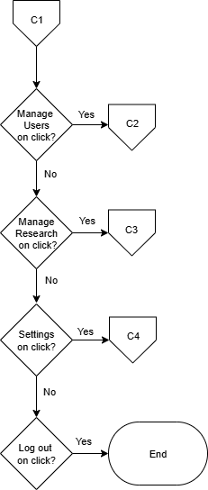

Figure 13. Admin Dashboard Page
The flowchart shows the navigation path for Admin within this specific section of the system. Each decision point offers the Admin a choice to navigate to a specific feature. Throughout the process, panel members have the options to log out or exit the dashboard.

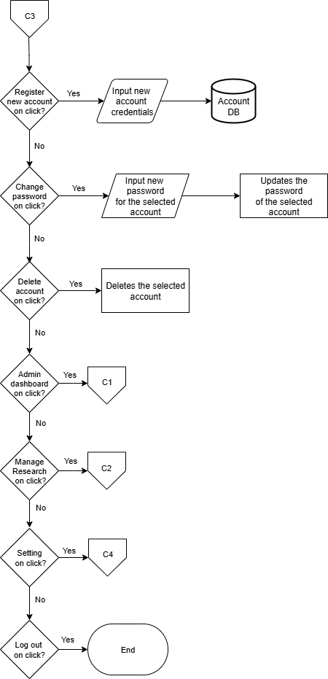

Figure 14. Manage Users Page
The flowchart shows the Manage Users page. In this page the Admin can verify or reject student accounts. When a student creates an account in the sign in page. It sends a request to be verify by the admin. If the admin verifies student account this account will be given access to the system. The admin can also create accounts. Throughout the process, the admin has the options to log out or exit the page.
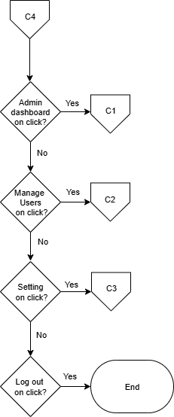

Figure 15. Manage Research Page
The flowchart shows the Manage Research page. In this page the Admin can see and manage submitted research projects. Throughout the process, the admin has the options to log out or exit the page.

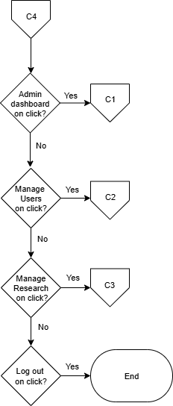

Figure 16. Setting Page
The flowchart shows the Setting page. In this page the admin can adjust the attempt number the user can have before their account is lock and the duration of the time they’re account will be locked. This page enable admin to change password accounts or delete an account. the admin has the options to log out or exit the page.

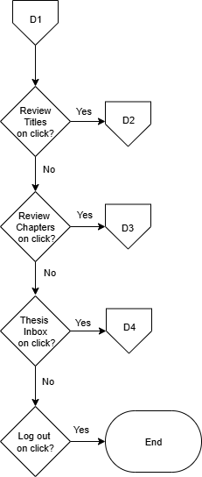

Figure 17. Adviser Member Dashboard Page
The flowchart outlines the navigation path for Adviser members within this specific section of the system. Each decision point offers the adviser a choice to navigate to a specific feature. Throughout the process, advise members have the options to log out or exit the dashboard.

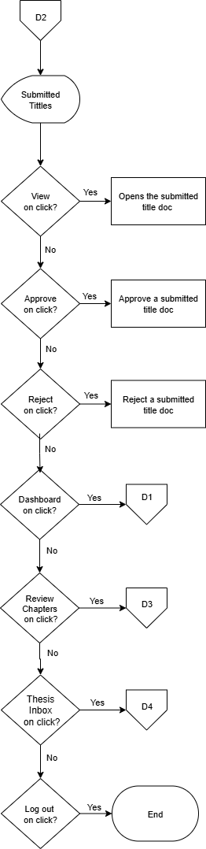

Figure 18. Adviser Member Submitted Titles Page
The flowchart shows the submitted titles page. In this page the adviser can view, approve, and reject submitted title proposals. Adviser users have the option to select "No," which keeps them within the current flow without exiting or logging out.
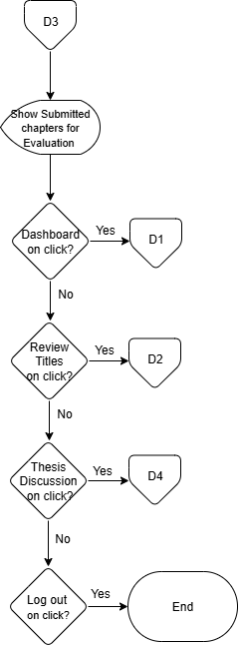

Figure 19. Adviser Member Submitted Chapter Page
This flowchart shows the Adviser Member Submitted Chapter page. This is where the adviser receives chapter documents for revision checking. When the adviser is done putting comments and instructions, the panelist can send the document back to the student. adviser users have the option to select "No," which keeps them within the current flow without exiting or logging out.

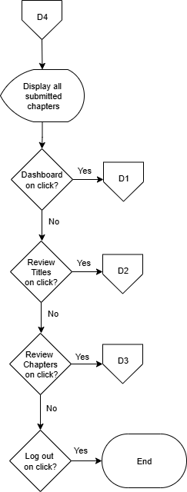

Figure 20. Adviser Member Thesis Discussion
This flowchart shows the Thesis Discussion Page. This page is where the adviser and student can send messages. In this page the student sends their chapters and the adviser send comments and revision recommendation. adviser users have the option to select "No," which keeps them within the current flow without exiting or logging out.

Entity Relationship Diagram
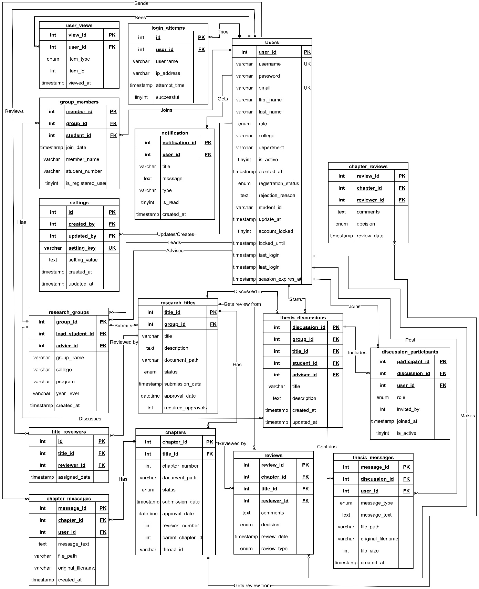

Figure 21. Entity Relationship Diagram
The Entity Relationship Diagram depicts the database structure that supports the Web-Based Automated Research Approval and Submission System. At the center of this system is the Users entity, which connects to all major components. Users can form Research Groups, with each group having designated leaders and panel members. These groups submit Research Titles for approval, which then progress to chapter-by-chapter submissions in the Chapters entity. Faculty members provide feedback through the Reviews entity, which connects to both research titles and individual chapters. Group membership is tracked through the Group Members entity, ensuring proper attribution and collaboration. The system keeps users informed through the Notifications entity, which delivers messages about submission status, review feedback, and approval decisions. This interconnected structure enables seamless tracking of research proposals from initial submission through final approval, while maintaining appropriate relationships between students, faculty, and their respective contributions to the research process.

System Architecture
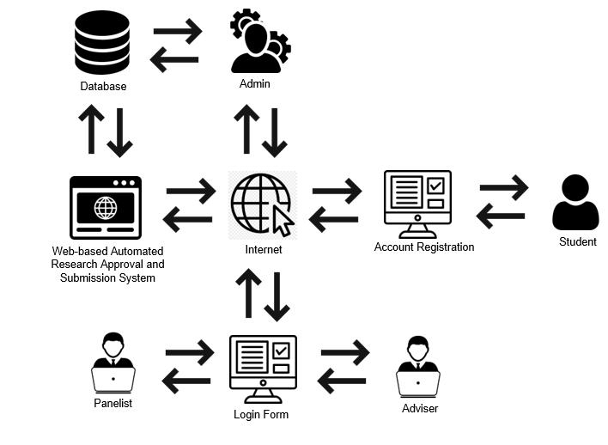
Figure 22. System Architecture
The figure shows the system architecture of the Web-Based Automated Research Approval and Submission System, using a client-server model connected through the internet. On the server side, administrators operate the backend system with dedicated hardware. They manage user accounts, and research submissions. On the client side, users (students, and panelist) access the system through their devices. They submit research proposals, review chapters, and check approval status. The server and clients exchange data over the internet for submissions, reviews, and notifications.

Data Dictionary
Data dictionaries provide a precise vocabulary for specific data elements, helping to standardize a data set and ensure that the relevance and quality of data elements are consistent for all users. They describe the meaning and purpose of data elements within the context of a project and offer guidance on their interpretation
. Table: users
Field Name | Data Type | Size | Attributes | Description
user_id | int | 11 | PK | Unique identifier for users
username | varchar | 30 | UK | Login username of user
password | varchar | 255 |  | Encrypted login password
email | varchar | 100 | UK | User's email address
first_name | varchar | 30 |  | User's first name
last_name | varchar | 30 |  | User's last name
role | enum |  |  | User role (student, adviser, panel, admin)
college | varchar | 80 |  | User's college affiliation
department | varchar | 80 |  | User's department affiliation
is_active | tinyint | 1 |  | Account status (1=active, 0=inactive)
created_at | timestamp |  |  | User creation timestamp
registration_status | enum |  |  | Registration status (pending, approved, rejected)
rejection_reason | text |  |  | Reason for account rejection
student_id | varchar | 15 |  | Student ID number
updated_at | timestamp |  |  | Last update timestamp
account_locked | tinyint | 1 |  | Account lock status (1=locked, 0=unlocked)
locked_until | timestamp |  |  | Account unlock timestamp
last_login | timestamp |  |  | Last successful login timestamp
session_expires_at | timestamp |  |  | Session expiration timestamp

Table: research_groups
Field Name | Data Type | Size | Attributes | Description
group_id | Int | 11 | PK | Unique identifier for research groups
group_name | Varchar | 80 |  | Name of the research group
lead_student_id | Int | 11 | FK | ID of the group leader
adviser_id | Int | 11 | FK | ID of the assigned adviser
college | Varchar | 80 |  | College affiliation
program | Varchar | 50 |  | Academic program
year_level | Varchar | 15 |  | Academic year level
created_at | Timestamp |  |  | Group creation timestamp

Table: group_members
Field Name | Data Type | Size | Attributes | Description
member_id | int | 11 | PK | Unique identifier for group members
group_id | int | 11 | FK | Reference to research group
student_id | int | 11 |  | Reference to registered student user
join_date | timestamp |  |  | Date member joined the group
member_name | varchar | 100 |  | Name of non-registered member
student_number | varchar | 10 |  | Student number of non-registered member
is_registered_user | tinyint | 1 |  | Whether member is a registered user

Table: research_titles
Field Name | Data Type | Size | Attributes | Description
title_id | int | 11 | PK | Unique identifier for research titles
group_id | int | 11 | FK | Reference to research group
title | varchar | 200 |  | Research title text
description | text |  |  | Research description
document_path | varchar | 255 |  | Path to uploaded document
status | enum |  |  | Approval status (pending, approved, rejected)
submission_date | timestamp |  |  | Date of title submission
approval_date | datetime |  |  | Date of title approval
required_approvals | int | 11 |  | Number of approvals required

Table: title_reviewers
Field Name | Data Type | Size | Attributes | Description
id | int | 11 | PK | Unique identifier for reviewer assignments
title_id | int | 11 | FK | Reference to research title
reviewer_id | int | 11 | FK | Reference to reviewer user
assigned_date | timestamp |  |  | Date reviewer was assigned

Table: reviews
Field Name | Data Type | Size | Attributes | Description
review_id | int | 11 | PK | Unique identifier for reviews
chapter_id | int | 11 | FK | Reference to chapter (nullable)
title_id | int | 11 | FK | Reference to title (nullable)
reviewer_id | int | 11 | FK | Reference to reviewer user
comments | text |  |  | Review comments
decision | enum |  |  | Review decision (approve, reject, needs_revision)
review_date | timestamp |  |  | Date of review submission
review_type | enum |  |  | Type of review (title, chapter)

Table: chapters
Field Name | Data Type | Size | Atrributes | Description
chapter_id | int | 11 | PK | Unique identifier for chapters
title_id | int | 11 | FK | Reference to research title
chapter_number | int | 11 |  | Chapter sequence number
document_path | varchar | 255 |  | Path to chapter document
Status | enum |  |  | Chapter status (pending, approved, rejected)
submission_date | timestamp |  |  | Date of chapter submission
approval_date | datetime |  |  | Date of chapter approval
revision_number | int | 11 |  | Chapter revision number
parent_chapter_id | int | 11 | FK | Reference to original chapter (for revisions)
thread_id | varchar | 30 |  | Discussion thread identifier

Table: chapter_messages
Field Name | Data Type | Size | Attributes | Description
message_id | int | 11 | PK | Unique identifier for chapter messages
chapter_id | int | 11 | FK | Reference to chapter
user_id | int | 11 | FK | Reference to message author
message_text | text |  |  | Message content
file_path | varchar | 255 |  | Path to attached file
original_filename | varchar | 100 |  | Original name of attached file
created_at | timestamp |  |  | Message creation timestamp

Table: chapter_reviews
Field Name | Data Type | Size | Attributes | Description
review_id (PK) | int | 11 | PK | Unique identifier for chapter reviews
chapter_id (FK) | int | 11 | FK | Reference to chapter
reviewer_id (FK) | int | 11 | FK | Reference to reviewer user
comments | text |  |  | Review comments
Decision | enum |  |  | Review decision (approve, reject)
review_date | timestamp |  |  | Date of review submission

Table: thesis_discussions
Field Name | Data Type | Size | Attributes | Description
discussion_id | int | 11 | PK | Unique identifier for thesis discussions
group_id | int | 11 | FK | Reference to research group
title_id | int | 11 | FK | Reference to research title
student_id | int | 11 | FK | Reference to student user
adviser_id | int | 11 | FK | Reference to adviser user
Title | varchar | 200 |  | Discussion title
description | text | 100 |  | Discussion description
created_at | timestamp |  |  | Discussion creation timestamp
updated_at | timestamp |  |  | Last update timestamp

Table: discussion_participants
Field Name | Data Type | Size | Attributes | Description
participant_id | int | 11 | PK | Unique identifier for participants
discussion_id | int | 11 | FK | Reference to thesis discussion
user_id | int | 11 | FK | Reference to participant user
Role | enum |  |  | Participant role (student, adviser, panel)
invited_by | int | 11 |  | ID of user who invited participant
joined_at | timestamp |  |  | Date participant joined
is_active | tinyint | 4 |  | Participation status

Table: thesis_messages
Field Name | Data Type | Size | Attributes | Description
message_id | int | 11 | PK | Unique identifier for thesis messages
discussion_id | int | 11 | FK | Reference to thesis discussion
user_id | int | 11 | FK | Reference to message author
message_type | enum |  |  | Message type (text, file, paper)
message_text | text |  |  | Message content
file_path | varchar | 255 |  | Path to attached file
original_filename | varchar | 100 |  | Original name of attached file
file_size | int | 11 |  | Size of attached file in bytes
created_at | timestamp |  |  | Message creation timestamp

Table: notifications
Field Name | Data Type | Size | Attributes | Description
notification_id | int | 11 | PK | Unique identifier for notifications
user_id | int | 11 | FK | Reference to recipient user
Title | varchar | 80 |  | Notification title
message | text |  |  | Notification message content
Type | varchar | 30 |  | Notification type
is_read | tinyint | 1 |  | Read status (1=read, 0=unread)
created_at | timestamp |  |  | Notification creation timestamp

Table: user_views
Field Name | Data Type | Size | Attributes | Description
view_id | int | 11 | PK | Unique identifier for user views
user_id | int | 11 | FK | Reference to user
item_type | enum |  |  | Type of viewed item (title, chapter, discussion)
item_id | int | 11 |  | ID of viewed item
viewed_at | timestamp |  |  | Timestamp of view

Table: login_attempts
Field Name | Data Type | Size | Attributes | Description
id | int | 11 | PK | Unique identifier for login attempts
username | varchar | 30 |  | Username used in attempt
ip_address | varchar | 45 |  | IP address of attempt
attempt_time | timestamp |  |  | Timestamp of login attempt
successful | tinyint | 1 |  | Success status (1=successful, 0=failed)
user_id | int | 11 | FK | Reference to user (if successful)

Table: settings
Field Name | Data Type | Size | Attributes | Description
id | int | 11 | PK | Unique identifier for settings
setting_key | varchar | 100 | UK | Configuration key name
setting_value | text |  |  | Configuration value
created_at | timestamp |  |  | Setting creation timestamp
updated_at | timestamp |  |  | Last update timestamp
created_by | int | 11 | FK | Reference to user who created setting
updated_by | int | 11 | FK | Reference to user who last updated setting

Output and User Interface
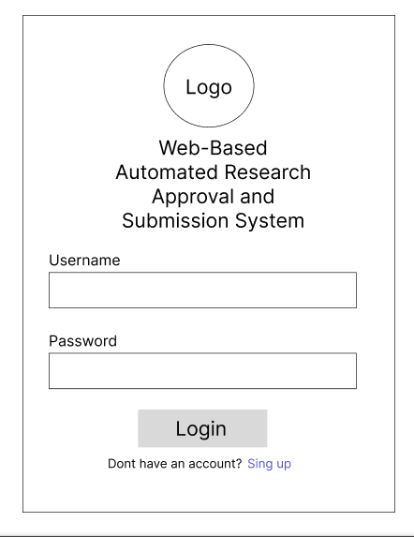
This is the process of designing user interface of the project. It serves as a blueprint on how the project's user interface will look like. Below are the figures showing the key interfaces.

Figure 23. Login Page
Shows the login page for all users. It's a simple screen with just two boxes - one for email and one for password. Users can also select "Sign Up" if they need to create a new account. The page includes the university logo and system name to establish institutional identity.

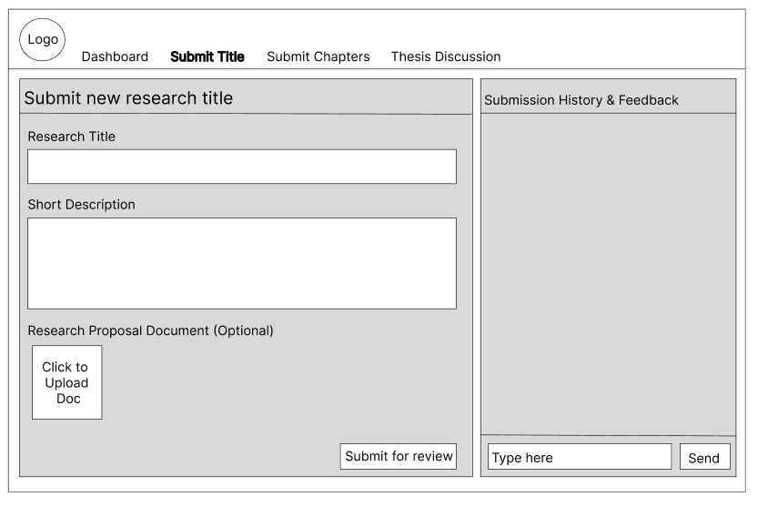

Figure 24. Research Title Submission Page
Shows the page where students submit their research titles for approval. The interface contains a form with four elements: a field to enter the proposed research title, a section for group members, a document attachment button for uploading the title proposal in .docx format, and a submit button.

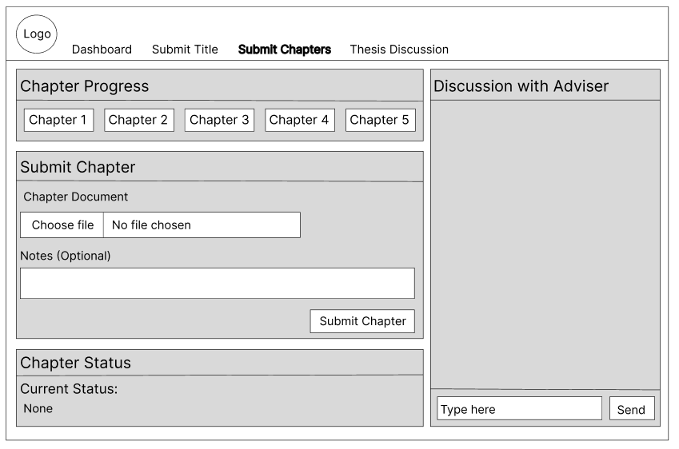

Figure 25. Chapter Submission Page
Shows the page where students upload their research chapters. The interface includes chapter selection options, file upload functionality, and submission controls. Students cannot submit the other steps if the adviser need revision, it will only if its complete or does not require revision.

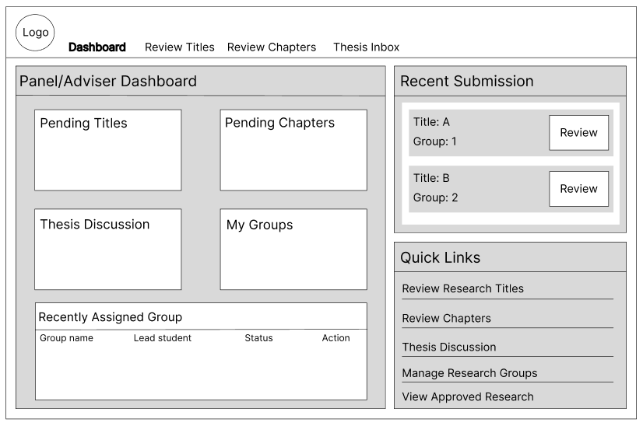

Figure 26. Panel/Adviser Dashboard
Shows the page where advisers can view counts of submitted research titles, chapters, and completed versions in their evaluation inbox. The interface displays numerical indicators showing how many submissions from students are pending review in each category.

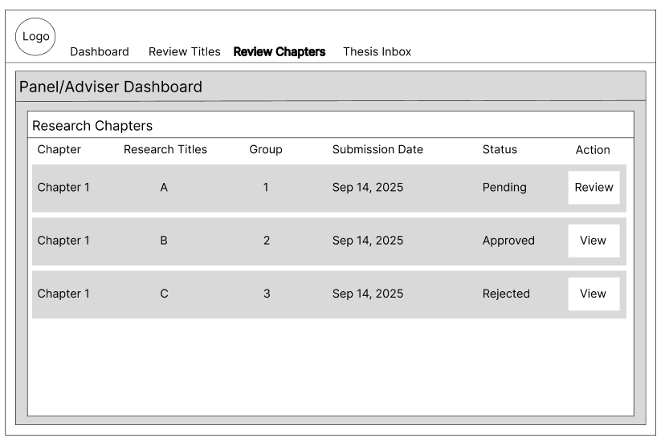
Figure 27. Chapter Review Page
Shows the page where advisers can see the students' submitted chapters in sequential order. The interface displays the chapters sent by students for review. Advisers can return files to students if revisions are needed or approve them to allow students to proceed to the next chapter submission.

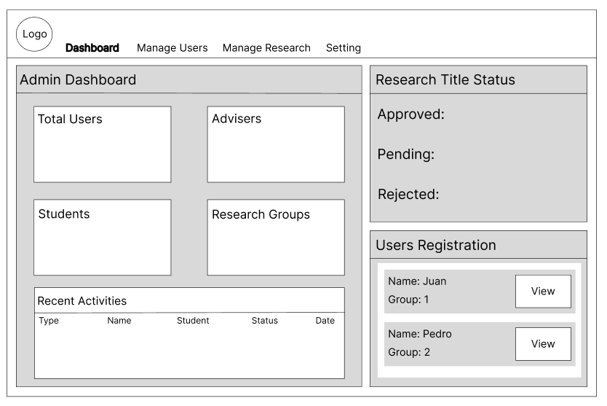

Figure 28. Admin Dashboard
Shows the administrative dashboard for the research approval system. The interface displays statistics about system usage at the top. Below are sections for managing users, monitoring submission activity, and accessing system settings.

Data Flow Diagram
Data flow diagrams show the way information flows through a process or system. They include data inputs and outputs, data stores, and the various sub-processes the data moves through. DFDs are built using standardized symbols and notation to describe various entities and their relationships.

Figure Definition

These are the common symbols that were use to present the specific that the actors had taken in using the entire project. This was presented through a Data Flow Diagram.
Symbols
Description
Source (Sink)
Process
The source of System inputs or sink of system outputs
Step-by-step instructions are followed that transform inputs (a computer or a person or t=both doing the work)

Data Store
An open-ended rectangle represents the location where data is stored
Data Flow Symbol
Represent a pathway for data

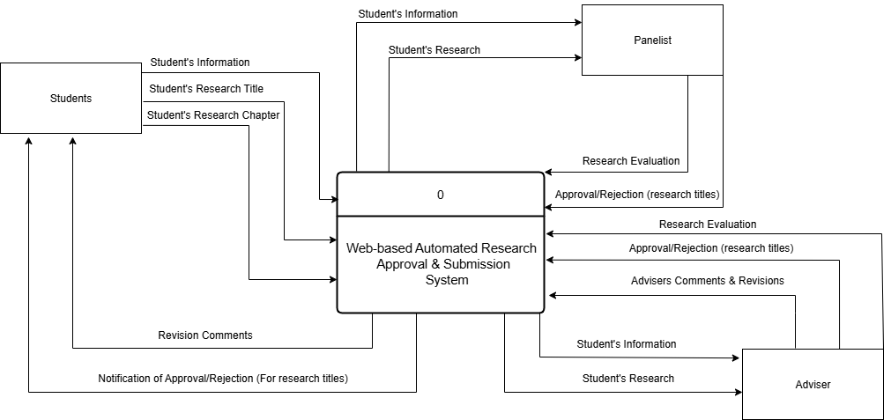

Figure 29. Context Diagram (Level 0)
Shows the entire System and how it interacts Students, and Panelist. Students submit research titles and chapters and receive feedback. Panelist review submissions and provide approval or revision requests. Panel members evaluate final proposals. This diagram illustrates how information flows between the system and its users without showing internal processes.

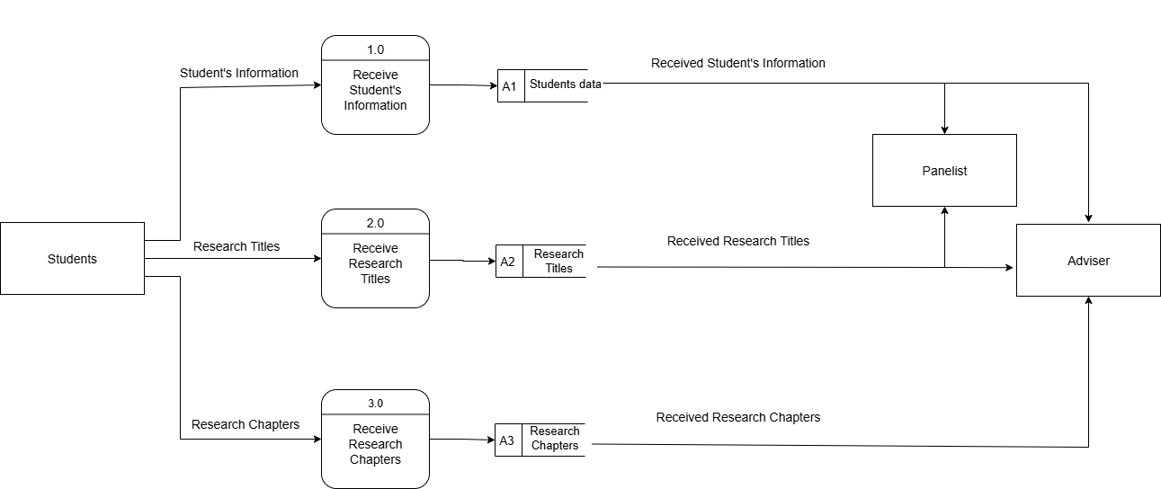

Figure 30. Level 1 Data Flow Diagram
Part 1 shows how the Students sends data to the system. First the student sends data to the system, which received the data and store it to the databases. The stored data is then send to the Panelist to be process and evaluated. This part of the diagram shows how the student provides data such as; student information, Titles, and Chapters to the system which the system stored and sends to the panelist for processing.

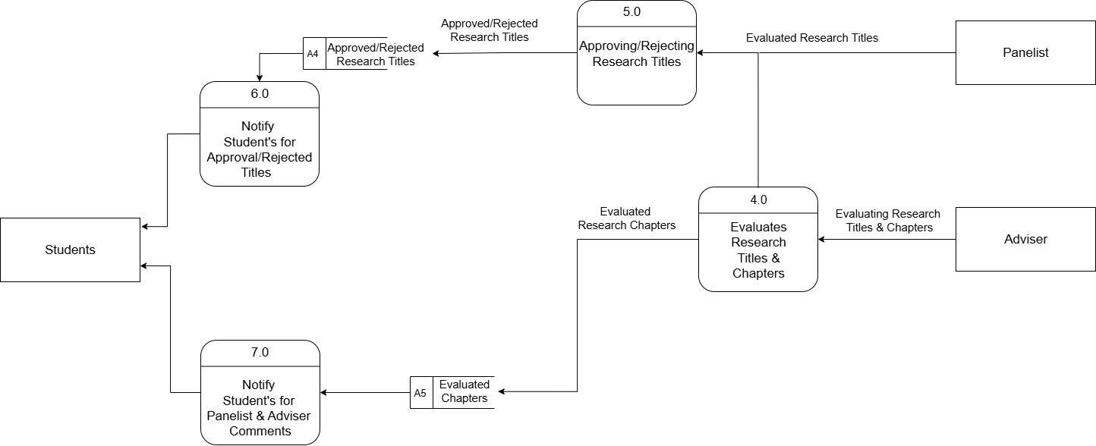

Figure 31. Level 1 Data Flow Diagram
Part 2 shows how panelist process the data that is send by the students. First if the student sent an research title, the panelist evaluate the title. When the panelist is done evaluating the title he can decide if he approve or reject the research title. The approve or reject title is then stored to be used to notify the Students. This part of the diagram shows how the panelist processes the research titles and the chapters that is send by the student.

Programming Environment
HTML (HyperText Markup Language) - HTML creates the basic structure of our Research Approval System. It builds elements like login boxes, submission forms, review interfaces, and dashboards. We use HTML to place components in appropriate locations. It serves as the foundation for other features like styling and interaction.
CSS (Cascading Style Sheets) - CSS adds visual elements to our Research Approval System. It applies the university's colors, formats text, and maintains consistent styling. We use Bootstrap framework to make the system display correctly on both desktop computers and mobile devices. This allows students and faculty to access the system from different devices.
JavaScript - JavaScript adds interactivity to our Research Approval System. It checks form inputs before submission, gives immediate responses, and updates content without reloading pages. When advisers review chapters, JavaScript shows the document and feedback form on the same screen. It also runs the notification system that informs users about new submissions or status changes.
PHP (Hypertext Preprocessor) - PHP handles the background processes in our Research Approval System. It processes form submissions, manages user login, and controls database operations. When students upload a chapter or advisers give feedback, PHP processes these actions and updates the database. It also creates pages based on user roles, so each user sees only their relevant information.
MySQL - MySQL stores all Research Approval System information. It contains tables for users, research groups, titles, chapters, reviews, and notifications. The database connects related information through table relationships, like connecting student accounts to research groups and submissions. MySQL handles the different types of data needed in the research approval process.
Evaluation
The respondents evaluated the system using the following scale:
Level of Agreement | Scale Description
5 | Strongly Agree
4 | Agree
3 | Fair
2 | Disagree
1 | Strongly Disagree

System Testing (Alpha Testing)
The obtained mean was interpreted using the following:
Functional Suitability
Numerical Equivalent | Interpretation
4.20 – 5.00 | Highly Functional
3.40 – 4.19 | Functional
2.60 – 3.39 | Moderately Functional
1.80 – 2.59 | Slightly Functional
1.00 – 1.79 | Poorly Functional
Performance Efficiency
Numerical Equivalent | Interpretation
4.20 – 5.00 | Highly Efficient
3.40 – 4.19 | Efficient
2.60 – 3.39 | Moderately Efficient
1.80 – 2.59 | Slightly Efficient
1.00 – 1.79 | Inefficient
Compatibility
Numerical Equivalent | Interpretation
4.20 – 5.00 | Highly Compatible
3.40 – 4.19 | Compatible
2.60 – 3.39 | Moderately Compatible
1.80 – 2.59 | Slightly Compatible
1.00 – 1.79 | Incompatible
Reliability
Numerical Equivalent | Interpretation
4.20 – 5.00 | Highly Reliable
3.40 – 4.19 | Reliable
2.60 – 3.39 | Moderately Reliable
1.80 – 2.59 | Slightly Reliable
1.00 – 1.79 | Unreliable

Security
Numerical Equivalent | Interpretation
4.20 – 5.00 | Highly Secured
3.40 – 4.19 | Secured
2.60 – 3.39 | Moderately Secured
1.80 – 2.59 | Slightly Secured
1.00 – 1.79 | Unsecured
Acceptance testing (Beta testing)
The obtained mean was interpreted using the following:
Numerical Equivalent | Interpretation
4.20 – 5.00 | Highly Acceptable
3.40 – 4.19 | Acceptable
2.60 – 3.39 | Moderately Acceptable
1.80 – 2.59 | Slightly Acceptable
1.00 – 1.79 | Unacceptable

Research Design
The study used the developmental-evaluation research design approach as the system was subjected to end user evaluation. This approach combines the development of the Web-Based Automated Research Approval and Submission System with a systematic evaluation of its effectiveness and usability.
Research Locale
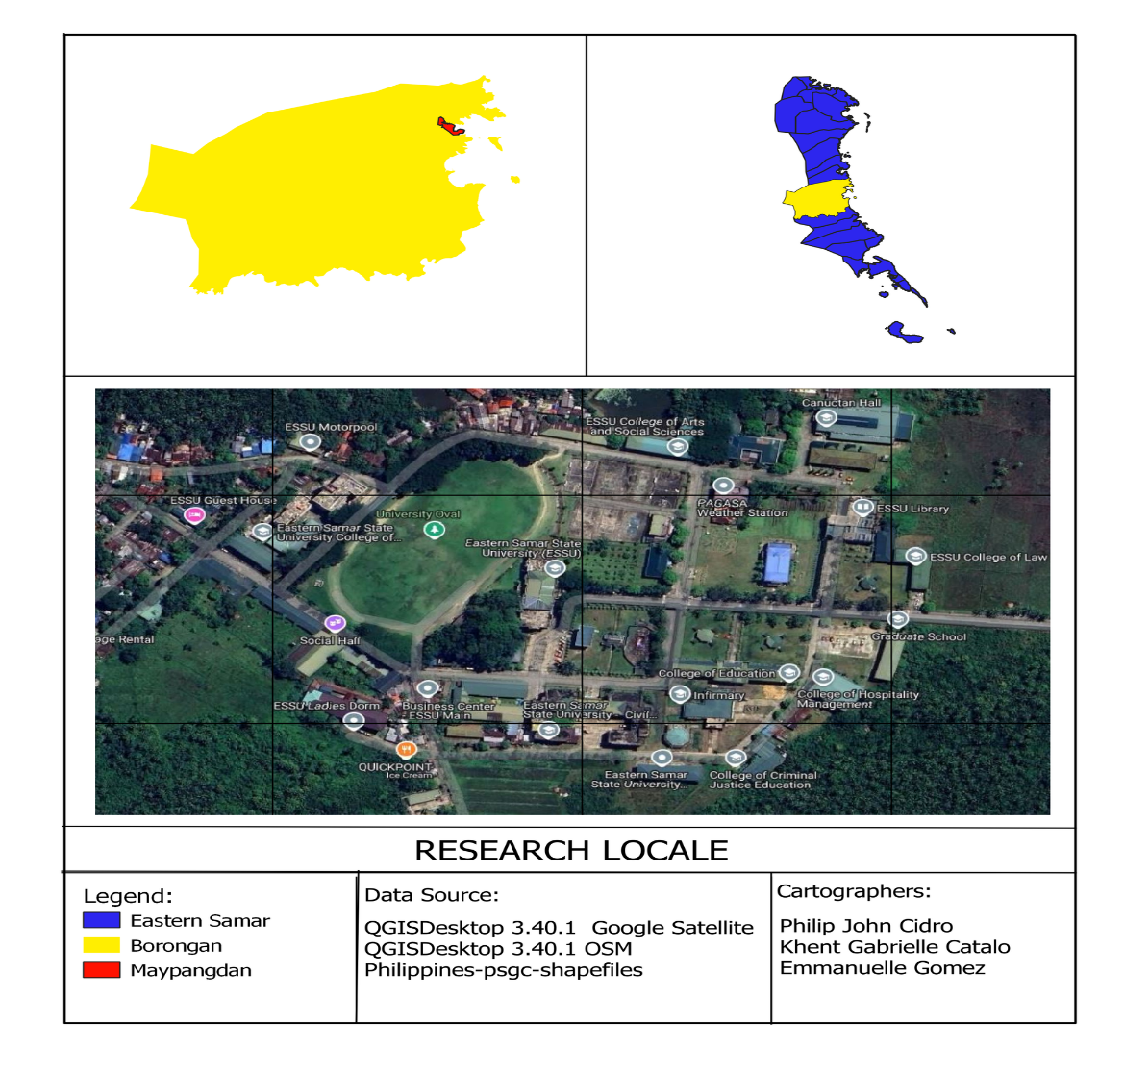
The study was conducted at Eastern Samar State University, focusing primarily on the research processes across its various colleges and departments. The university is located in Borongan City, Eastern Samar, Philippines.

Research Respondents
The evaluation of the Web-Based Automated Research Approval and Submission System will involve 15 carefully selected respondents representing key stakeholder groups at Eastern Samar State University. The first group consists of 5 faculty members who serve as research advisers and have direct experience with the current manual approval process. These faculty members will provide valuable insights on workflow improvements and academic requirements. The second group includes 5 IT professionals from the university's Computer Center who will evaluate the system's technical aspects, including security, performance, and compatibility with existing university systems. The third group comprises 5 students who are currently working on research proposals and will test the system from an end-user perspective, focusing on ease of use and effectiveness in meeting their submission needs. This balanced selection of respondents ensures comprehensive feedback on both technical functionality and practical application of the system within the university's research ecosystem.
.
RESPONDENTS | NUMBERS OF RESPONDENTS
Faculty Research Advisers | 5
IT Professionals | 5
Research Students | 5
TOTAL | 15
Table 11. Distribution of Respondents

Instrumentation
In this phase, the system was evaluated using two instruments: the ISO/IEC 25010:2011 Software Evaluation Questionnaire for quality metrics during system testing and the IBM Computer Usability Satisfaction Questionnaire for acceptance testing.
The ISO questionnaire includes a series of questions designed to assess user satisfaction across various dimensions, such as functional suitability, performance efficiency, compatibility, usability, and reliability. This helps evaluate the system's overall quality during the testing phase.
The IBM questionnaire consists of questions that focus on user experience, addressing aspects like system complexity, usage frequency, consistency, and overall satisfaction. By using these standardized evaluation frameworks, the study aims to gather valuable insights into the system's performance, ensuring it meets the desired quality standards and effectively addresses the diverse needs and expectations of its users.
Data Analysis
Statistics using the mean was employed to present the demographic characteristics of the respondents and the level of the system effectiveness. The data from the ISO/IEC 25010:2011 Software Evaluation Questionnaire and IBM Computer Usability Satisfaction Questionnaire will be analyzed to assess the system's quality and usability during the alpha test, and the selected respondents during the beta test.

Mean
This is the average of the score -- the mathematical center of a distribution. It used symmetrical, unimodal distributions of interval or ratio scores.
The ISO's formula mean is:
X = Σ x/n
Where:
- Σx = sum of all scores
- n = number of scores
The IBM formula mean is:
SUS = (Q1 + Q2 + Q3 + ... + Q10) ÷ 10

Where:
- Q1-10: Scores for each question

