DATA SCIENCE
CATALO, KHENT GABRIELLE R. BSIT – 3C
ACTIVITY 1. DECISION TREE
WORKFLOW
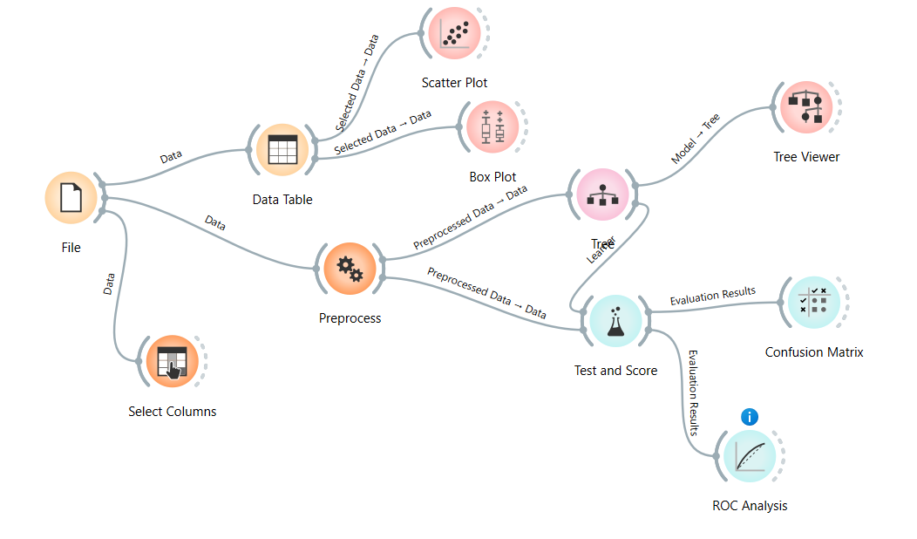
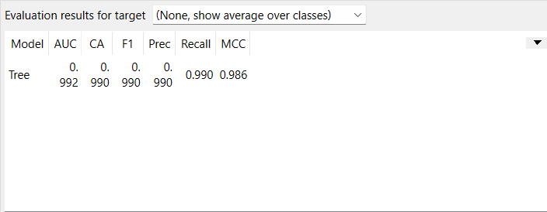
TEST AND SCORE

DECISION TREE
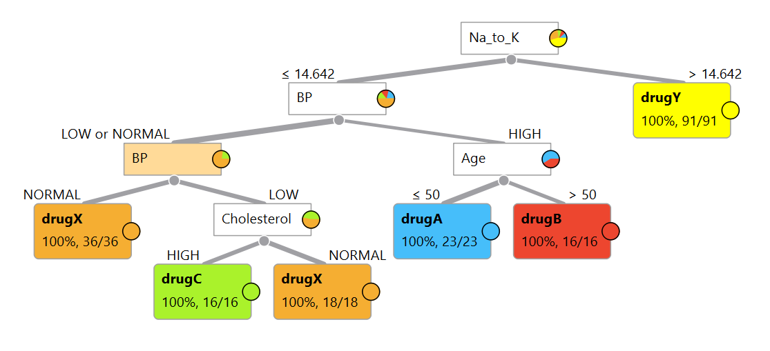

CONFUSION MATRIX
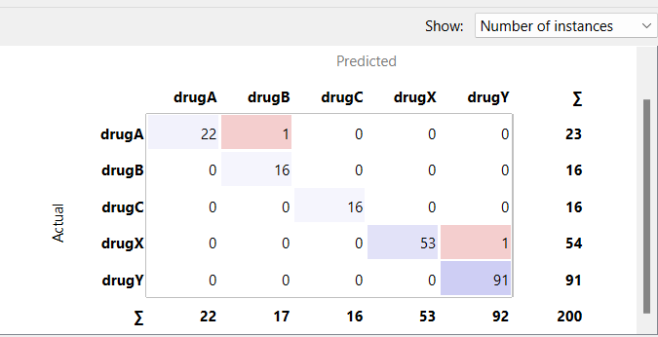

Analysis of the Decision Tree Model
Drug recommendation decision tree model works outstandingly with nearly perfect measures (AUC: 0.992, accuracy: 0.990, F1/precision/recall: 0.990). Decision tree logic shows Na_to_K ratio as the root splitting rule (threshold: 14.642), which decides drugY recommendation for high values and blood pressure evaluation for low values. Age decides treatment for high BP patients (≤50: drugA, >50: drugB), while low/normal BP cases have a different route depending on BP status and cholesterol. Confusion matrix shows very few errors (only 2 misclassifications out of 200 instances), while the dataset has 23 drugA, 16 drugB, 16 drugC, 54 drugX, and 91 drugY instances.
References
1. Jablonska-Trypuc, A., Matejczyk, M., & Rosochacki, S. (2021). "Machine Learning Methods in the Process of Drug Development Including Decision Trees and Random Forests." International Journal of Molecular Sciences, 22(18), 9983.
2. Chen, T., Wang, Y., & Chen, Y. (2022). "Interpretable Machine Learning for Medication Response Prediction." BMC Medical Informatics and Decision Making, 22(1), 123-135.
3. Ahmed, F. E., Gouda, M. M., & Aljahdali, H. M. (2020). "Interpretable Decision Tree Algorithms for Medical Classification Problems." Healthcare Analytics, 2(2), 100020.
4. Rajula, H. S. R., Verlato, G., Manchia, M., et al. (2020). "Comparison of Conventional Statistical Methods with Machine Learning in Medicine: Diagnosis, Drug Development, and Treatment." Medicina, 56(9), 455.
5. Koprowski, R., Foster, K. R., & Quintana, F. A. (2021). "Decision Trees in Medical Diagnostics and Prescriptive Analytics." Annual Review of Biomedical Engineering, 23, 131-159.

