NETWORKING
CATALO, KHENT GABRIELLE R. BSIT – 3C
Module 3: Network Addressing and Basic Troubleshooting
Concept Map
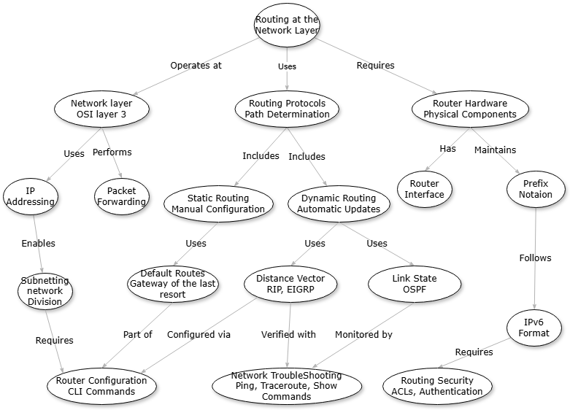

The concept map shows the interwoven connectivity in network layer routing. At its base, the Network Layer exists at OSI Layer 3 and employs IP Addressing to address devices logically, thereby facilitating Subnetting for effective network structuring. The Network Layer does Packet Forwarding, which is the process that enables data to move between networks. Routing Protocols then extend upon this by establishing best paths for these packets, with two primary methods: Static Routing, where configuration is done manually and frequently uses Default Routes as secondary routes, and Dynamic Routing, which dynamically changes based on network updates through either Distance Vector algorithms (such as RIP and EIGRP) or Link State algorithms (such as OSPF). These routing protocols have a direct impact on the contents of Routing Tables, which are hosted by Router Hardware and referenced during packet forwarding. Router Interfaces physically interface to different types of networks and enforce the Network Layer addressing schemes, adhering to certain Router Boot Sequences when booting up. These notions all merge into real applications: Router Configuration using CLI commands carries out the routing protocols and address schemes, Network Troubleshooting utilities (ping, traceroute) test proper functioning of packet forwarding and path calculation, and Routing Security protocols safeguard routing infrastructure integrity. Each idea extends and interrelates with others to form a consistent system that allows for effective and dependable data transmission over networks of any scale.

