Postgres → WAL → Debezium → Kafka Connect → Kafka Topics -> consumer -> S3

Enable logical replication in PostgreSQL
Go into postgresql.conf
Change wal_level = logical
Restart Postgres after making the change

Create Debezium User
In DBeaver
In Postgres sql editor, run
CREATE ROLE debezium WITH REPLICATION LOGIN PASSWORD 'dbz';

Create tables
Connect to local DB - localhost 5432
CREATE DATABASE pocdb;
CREATE TABLE public.person (
person_id BIGINT PRIMARY KEY,
first_name VARCHAR(100),
last_name VARCHAR(100),
dob DATE,
updated_at TIMESTAMP DEFAULT CURRENT_TIMESTAMP
);

CREATE TABLE public.application (
application_id BIGINT PRIMARY KEY,
person_id BIGINT,
application_status VARCHAR(50),
submitted_at TIMESTAMP,
updated_at TIMESTAMP DEFAULT CURRENT_TIMESTAMP
);

CREATE TABLE public.plan_enrollment (
enrollment_id BIGINT PRIMARY KEY,
person_id BIGINT,
plan_id VARCHAR(50),
coverage_start_date DATE,
coverage_end_date DATE,
updated_at TIMESTAMP DEFAULT CURRENT_TIMESTAMP
);

Grant Permissions
GRANT CONNECT ON DATABASE pocdb TO debezium;
GRANT USAGE ON SCHEMA public TO debezium;
GRANT SELECT ON ALL TABLES IN SCHEMA public TO debezium;
ALTER DEFAULT PRIVILEGES IN SCHEMA public GRANT SELECT ON TABLES TO debezium;

Download Kafka - binary download
Get UUID
.\bin\windows\kafka-storage.bat random-uuid
.\bin\windows\kafka-storage.bat format --standalone -t (uuid goes here) -c .\config\server.properties

Download Debezium PostgreSQL Connector
Put in under Kafka folder - kafka\plugins\debezium-postgres
Create two new files under kafka\config :
- Connect-standalone-local.properties
bootstrap.servers=localhost:9092

key.converter=org.apache.kafka.connect.json.JsonConverter
value.converter=org.apache.kafka.connect.json.JsonConverter
key.converter.schemas.enable=false
value.converter.schemas.enable=false

offset.storage.file.filename=C:/kafka_2.13-4.2.0/connect.offsets
offset.flush.interval.ms=10000

plugin.path=C:/kafka_2.13-4.2.0/plugins

internal.key.converter=org.apache.kafka.connect.json.JsonConverter
internal.value.converter=org.apache.kafka.connect.json.JsonConverter

- Debezium-poc-postgres.properties
name=pocdb-postgres-connector
connector.class=io.debezium.connector.postgresql.PostgresConnector
tasks.max=1

database.hostname=localhost
database.port=5432
database.user=debezium
database.password=dbz
database.dbname=pocdb

topic.prefix=pocdb
plugin.name=pgoutput

slot.name=debezium_poc_slot
publication.name=debezium_poc_pub

table.include.list=public.person, public.application, public.plan_enrollment
schema.include.list=public

snapshot.mode=initial

In every terminal before running anything else:
$env:Path = "C:\Windows\System32;C:\Windows;C:\Windows\System32\Wbem;$env:Path"

cd C:\kafka_2.13-4.2.0

Terminal 1 Kafka Broker
.\bin\windows\kafka-server-start.bat .\config\server.properties

Terminal 2 Kafka/Debezium Connector
.\bin\windows\connect-standalone.bat .\config\connect-standalone-local.properties .\config\debezium-poc-postgres.properties

Terminal 3 Status check - should both say "RUNNING"

To check running status:
Invoke-RestMethod -Uri http://localhost:8083/connectors

Invoke-RestMethod -Uri http://localhost:8083/connectors/pocdb-postgres-connector/status | ConvertTo-Json -Depth 10
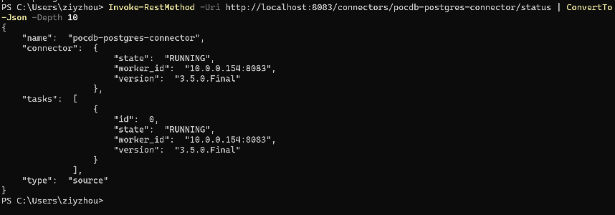

Terminal 4 To validate connection - Kafka Consumer
To see the list of topics:
.\bin\windows\kafka-topics.bat --bootstrap-server localhost:9092 --list

To test snapshot/update/insert/delete (e.g. application table):
.\bin\windows\kafka-console-consumer.bat --bootstrap-server localhost:9092 --topic pocdb.public.application --from-beginning

