Audit, Watermark & Operational Traceability
Scope: Four in-scope Spark jobs and supporting control-plane audit tables

1. Purpose and Scope
This document explains how the Jira story acceptance criteria are addressed for operational audit, incremental watermark handling and run traceability. The document is intended to support story review, validation and operational handover.
The current scope covers the following Spark jobs:
• job0_compact_bronze.py
• job1_bronze_ingest.py
• job2_silver_dq.py
• INT-REC-MST-DATA-MLY-PRC.py

2. Solution Overview
The design uses a common run audit table for job-level execution tracking and a MENR-specific file control table for file-level metadata. The run audit table captures lifecycle status and operational context for all in-scope jobs. The file control table is currently populated only by the MENR Bronze job to track source and target layer processing details.
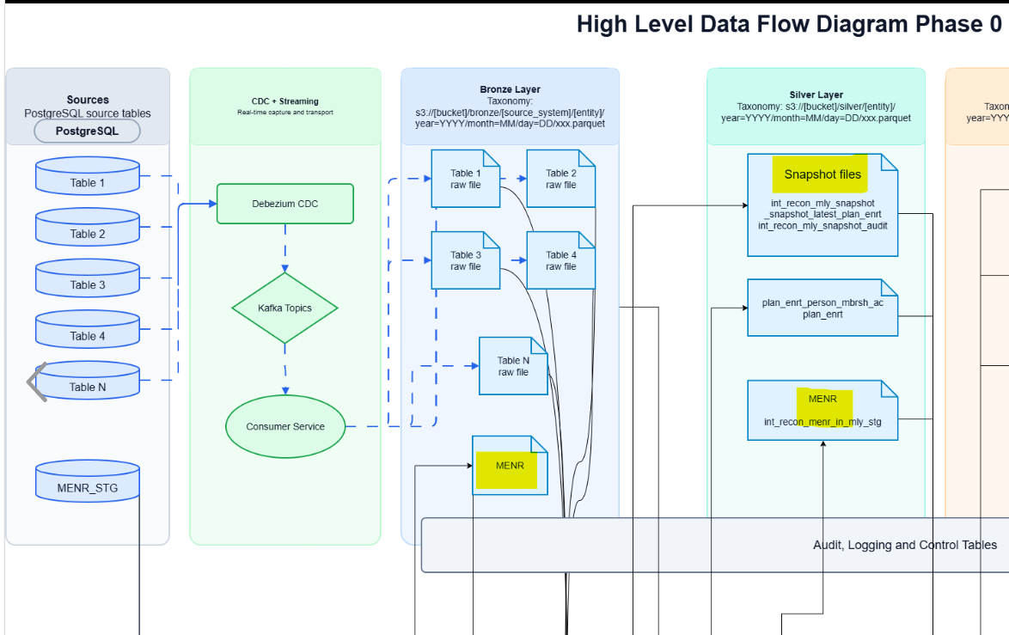

3. Acceptance Criteria Mapping
AC | Requirement | Current implementation / design response | Status
1 | Each in-scope Spark job writes STARTED, SUCCESS and FAILED status with run id, job name, layer/stage, timestamps and error context where applicable. | Implemented through recon.run_audit. The table captures run_id, job_name, job_type, status, start_ts, end_ts, total_records, success_records, reject_records, failed_step and error_message. The failed_step field helps identify exactly where the failure occurred, such as config load, watermark calculation, source read, target write, DQ validation or audit update. | Implemented
2 | job_watermark advances only after the target write succeeds and does not advance for failed or partial runs. | For MENR incremental jobs, no separate watermark table is maintained. The watermark is calculated at runtime from the last successfully loaded target data using MAX(seq_num). Bronze derives the low watermark from Bronze and the high watermark from source. Silver derives the low watermark from Silver and the high watermark from Bronze. If a write fails before target commit, the next run recalculates the watermark from the last successful target state. | Implemented for MENR runtime watermarking
3 | recon_batch_run_ctl captures batch-level source count, target count, reject count, match count, no-match count, multi-match count, error count, run status and recon_month where applicable. | recon_batch_run_ctl is reserved for Recon Matching jobs and is not currently populated by any of the 4 jobs mentioned. | Future scope
4 | recon_summary_daily is used for daily/entity loaded-row summaries where applicable; monthly balancing uses recon_batch_run_ctl and file/count control tables. | This point is not confirmed for the current implementation and is treated as out of scope for this document. It can be revisited once daily summary and monthly balancing requirements are finalized. | Out of scope / TBD
5 | Operational query examples show how support can trace a run across Bronze, Silver, Gold, MENR, snapshot and RCNO stages. | Operational traceability is available for the implemented jobs through run_id, job_name, status, timestamps, failed_step and error_message in recon.run_audit. Gold, Snapshot and RCNO stages are not yet implemented; placeholders are included for future operational query screenshots once available. | Partially implemented

4. Control Tables and Usage

4.1 recon.run_audit
recon.run_audit is the primary job-level audit table. It is used by the in-scope Spark jobs to capture the lifecycle of each execution from start to completion or failure. The unique run_id enables operations and support teams to trace a single execution across logs and downstream control records.
Column | Purpose
run_id | Unique execution identifier for tracing a job run.
job_name | Name of the Spark job being executed.
job_type | Logical category or processing type.
status | Execution status: STARTED, SUCCESS or FAILED.
start_ts / end_ts | Start and end timestamps for duration and SLA checks.
total_records / success_records / reject_records | Record-level processing counts.
failed_step | Identifies the exact job step where failure occurred.
error_message | Captures exception context for troubleshooting.
source_system | Source application or upstream system identifier.
[Diagram 2]
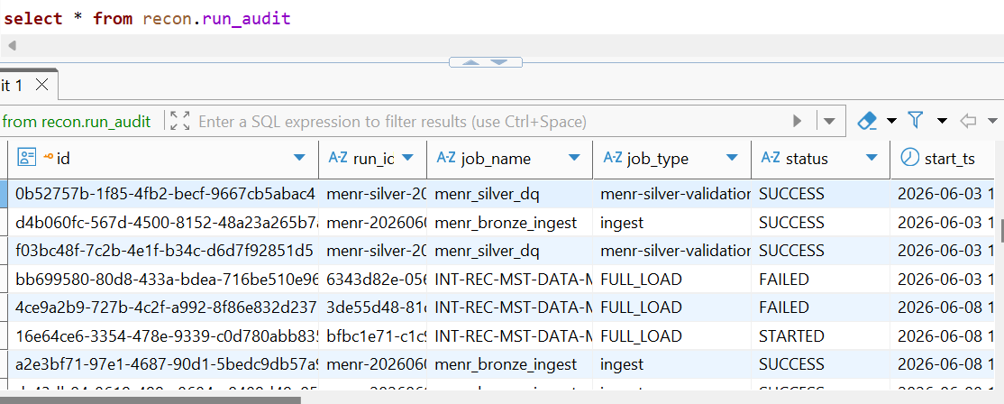
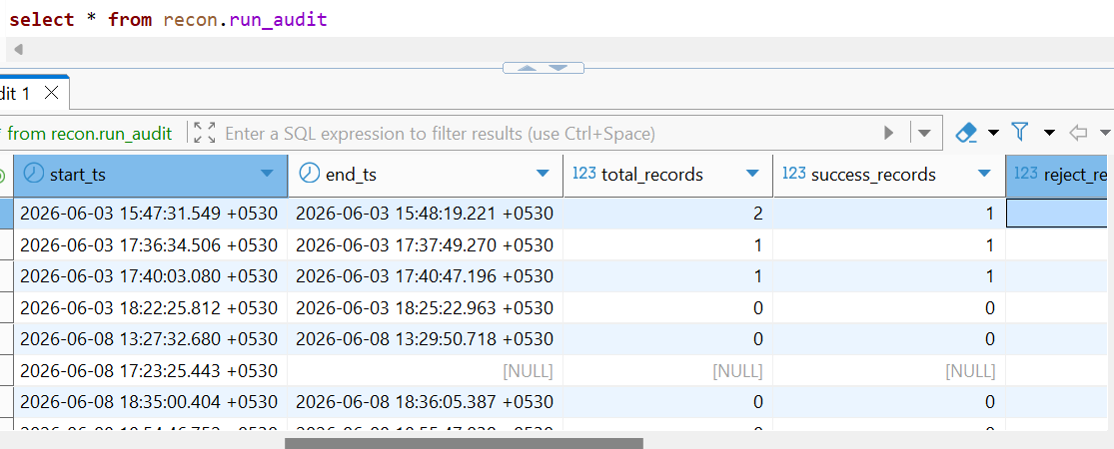
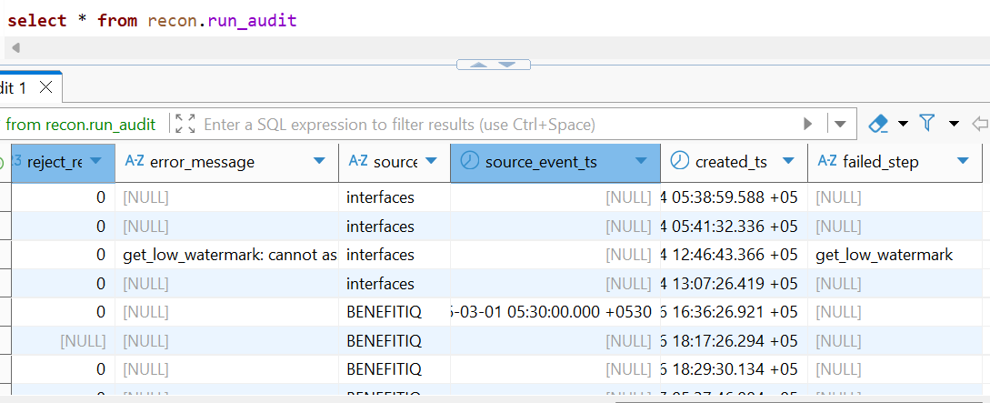

4.2 recon.recon_file_control
recon.recon_file_control is currently used only by the MENR Bronze job. It captures file or batch metadata such as source and target layer, recon month, expected count, actual count, reject count, archive path, processing status and error message. This provides file-level traceability in addition to the job-level run audit.
Column | Purpose
file_name | Input file or source table reference.
recon_month | Recon month where applicable.
source_layer / target_layer | Shows layer movement, such as POSTGRES to BRONZE.
file_arrival_ts / file_process_ts | Arrival and processing timestamps.
expected_record_cnt / actual_record_cnt | Source vs processed record counts.
reject_count | Rejected record count.
file_status | Processing status for the file/control record.
archive_path | Target/archive location used for reference.
error_message | File-level error context where applicable.

5. Runtime Watermark and Failure Handling
The MENR incremental jobs use runtime watermarking based on the auto-increment seq_num column. A separate persisted job_watermark table is not required for the current implementation. This approach ensures that the effective watermark is always derived from the last successfully written target state.
Job / Stage | Low watermark | High watermark
Bronze | MAX(seq_num) from Bronze target | MAX(seq_num) from source PostgreSQL
Silver | MAX(seq_num) from Silver target | MAX(seq_num) from Bronze target
If a job fails before the target write completes, the next execution recalculates the low watermark from the target table and resumes from the last successful load. If the target write succeeds but a later operational step fails, the target table remains the source of truth for the next runtime watermark calculation.
[Diagram 3]
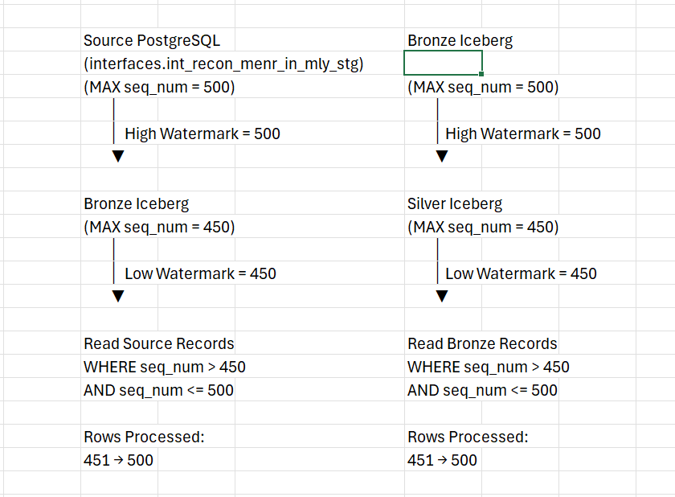

6. Operational Traceability
Support users can trace execution using run_id, job_name, status, start_ts, end_ts, failed_step and error_message. As Gold and RCNO processing are added, the same run audit approach should be extended to maintain consistent operational visibility.
Traceability question | Where to check
Did the job start and finish? | recon.run_audit.status, start_ts, end_ts
Where did the job fail? | recon.run_audit.failed_step and error_message
How many records were processed? | recon.run_audit.total_records, success_records, reject_records
What file/layer information is available for MENR Bronze? | recon.recon_file_control source_layer, target_layer, expected_record_cnt, actual_record_cnt, file_status
How to trace future recon batch jobs? | recon_batch_run_ctl once Recon Matching jobs are implemented
Run Audit by Run ID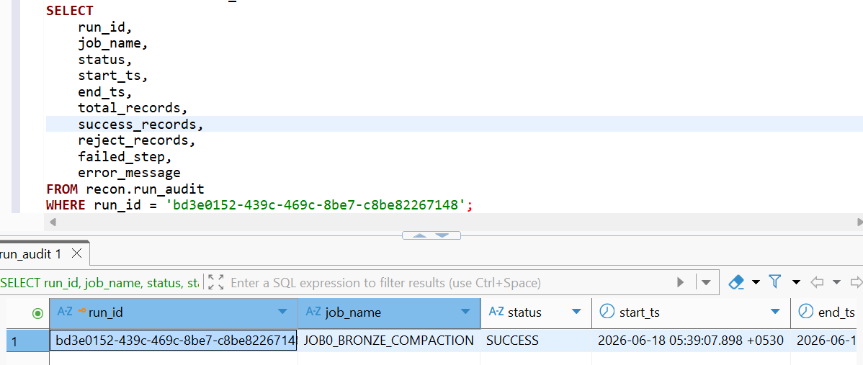.
Run Audit by Job Name
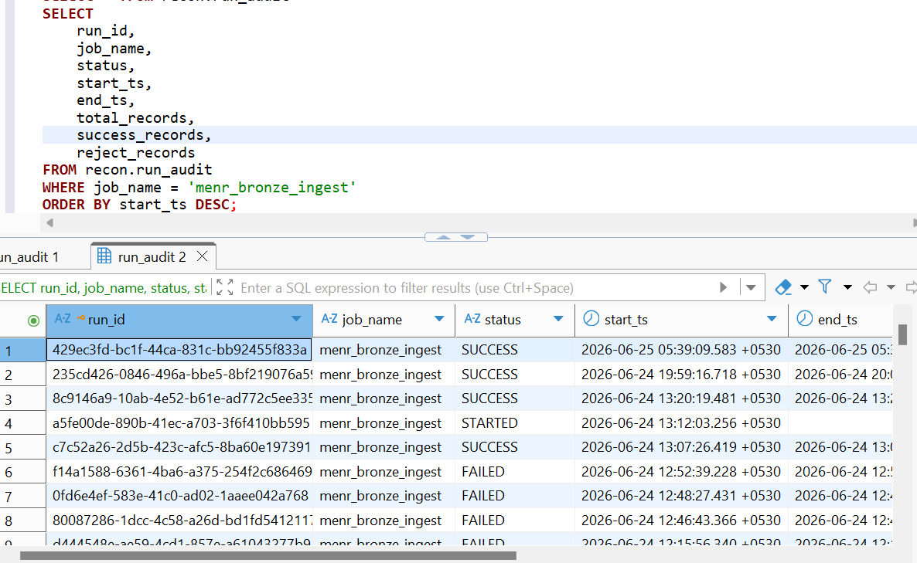
MENR File Control (Recommended)
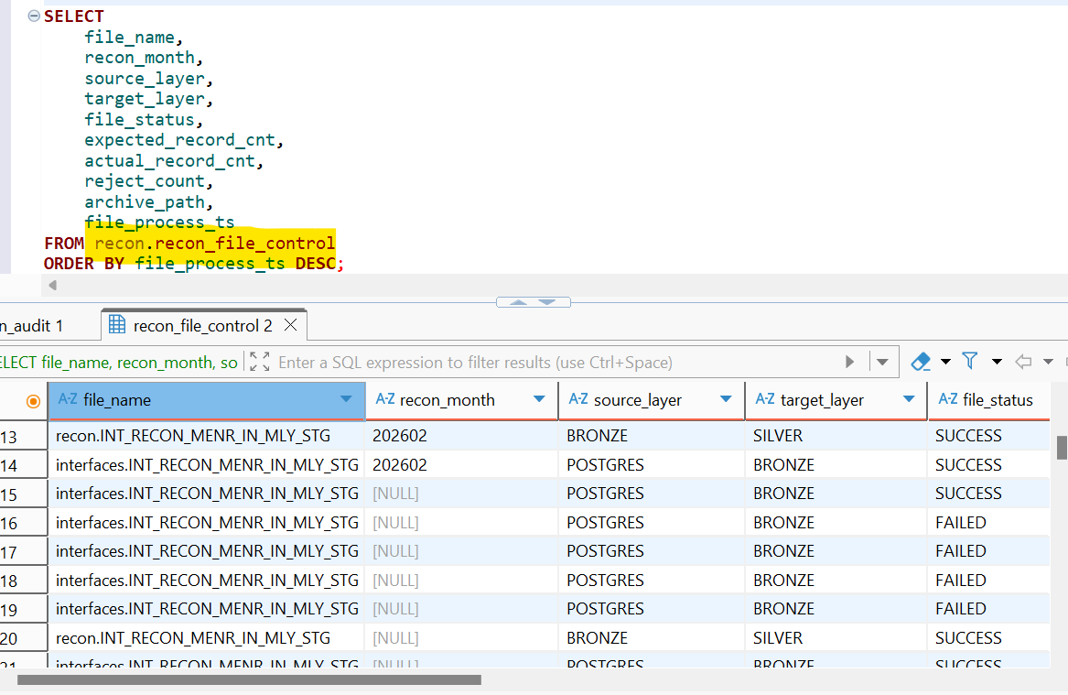

7. Current Scope and Next Steps
Component | Current status | Notes
job0_compact_bronze.py | In scope | Uses common job audit framework.
job1_bronze_ingest.py | In scope | Uses run_audit and recon_file_control.
job2_silver_dq.py | In scope | Uses run_audit; DQ rejects are logged separately where enabled.
INT-REC-MST-DATA-MLY-PRC.py | In scope | Uses common job audit framework.
recon_batch_run_ctl | Future scope | To be used by Recon Matching jobs.
recon_summary_daily | TBD / Out of current scope | To be confirmed with daily summary requirements.
Gold / RCNO | Future scope | Not yet implemented.

Conclusion
The current implementation establishes a common audit framework for the four in-scope Spark jobs. Runtime watermarking supports incremental processing without a separate watermark table for MENR jobs, while failure context is captured through failed_step and error_message. Remaining batch-level reconciliation and summary requirements will be addressed as Recon Matching, Gold and RCNO stages are implemented.

Screenshot Checklist for Final Attachment
Placeholder | Recommended screenshot / evidence to add
Diagram 1 | High-level flow showing four Spark jobs, target tables and audit/control table writes.
Screenshot 2 | Sample recon.run_audit output with run_id, job_name, status, failed_step and error_message.
Diagram 3 | Watermark example showing low watermark, high watermark and processed seq_num range.
Screenshot 4 | Operational query output filtered by run_id or job_name. Add recon_file_control output for MENR Bronze if available.

