### Re-Search: Research Digital Library Web and Mobile Application for ITDS of Bulacan State University – Sarmiento Campus

**A Capstone Project by**

**Bajen, Judy Ann S.**

**Balunan, Ma. Zobell B.**

**Abayan, Steven Arje M.**

**<Last Name, First Name Middle Initial>**

**<Last Name, First Name Middle Initial>**

**Submitted to the Faculty of Information Technology**

**Bulacan State University - Sarmiento Campus**

**In Partial Fulfillment of the Requirements for the Degree**

**Bachelor of Science in Information Technology**

**<Month year>**

# APPROVAL SHEET

This capstone entitled **<TITLE>**, prepared and submitted by **<Names of the Researchers>**, in partial fulfillment of the requirements for the Degree **<Degree>** is hereby accepted.

|  |  |
| --- | --- |
|  | **<Adviser>** |
|  | Technical Adviser |
| **Panel of Examiners**  **<Chairman>** | |
| Chairman | |
| **<Panelist 1>** | **<Panelist 2>** |
| Panel Member | Panel Member |

Accepted and approved for the conferral of the Degree **<Degree>** on __________________.

|  |  |
| --- | --- |
| **Mary Rose C. Columbres, MSIT** | **Eugene S. Perez, MIT** |
| Program Chair, ITDS Department | Instructor, Capstone |

### Prof. Gerald C. Hilario

Dean, BulSU-SC

# DEDICATION

This portion is optional, but perhaps you have someone who has inspired you to push on with your studies? Dedication would be a fitting way to acknowledge their impact on your success.

M.G.H.

E.T.C.

J.A.R.

# sACKNOWLEDGMENTS

The road to this point in your studies couldn't have been traveled alone. Along the way, someone somewhere helped you.

M.G.H.

E.T.C.

J.A.R.

# TABLE OF CONTENTS

APPROVAL SHEET ii

DEDICATION iii

ACKNOWLEDGMENTS iv

TABLE OF CONTENTS v

LIST OF TABLES viii

LIST OF FIGURES ix

ABSTRACT x

CHAPTER I 1

INTRODUCTION 1

Project Context 1

Objectives of the Study 2

Scope and Limitations of the Study 2

CHAPTER II 4

REVIEW OF RELATED LITERATURE/SYSTEMS 4

Technical Background (Related System) 4

Presentation of related literature and studies (Thematic Approach) 4

CHAPTER III 5

DESIGN AND METHODOLOGY 5

CHAPTER IV 6

RESULTS AND DISCUSSION 6

Development of the Proposed System 6

Data Analysis 6

Statistical Tool Used 7

Result of the Evaluation of the System 8

CHAPTER V 12

SUMMARY, CONCLUSIONS AND RECOMMENDATIONS 12

Summary 12

Conclusion 12

Recommendations 12

REFERENCES 13

APPENDICES 14

# LIST OF TABLES

# LIST OF FIGURES

# ABSTRACT

(Note: Use abstract for Capstone Projects with no particular client, and use Executive Summary for Projects with a client.)

Insert your abstract here. It should be clear, concise, and complete. As much as possible, limit the introductory part to a few sentences and make sure that the last sentence reiterates the achievement of the research's general objective. It should be written in the past tense and should not exceed one (1) page in length.

# CHAPTER I

# INTRODUCTION

## Project Context

A Library has a vital role of students learning, According to (Barsaga & Q. Cruz, 2020)the students requirements for a learning space was able to provide by the library, it is mentioned that one of the factor how student maximize the usage of the library is because of the availability of Internet Connection, Uninterrupted space, and comfortable seating. However, during the pandemic the school facilities like library minimize the number of students that can enter and make use of the library, leading to this set-up in Nigeria, researcher develop a system an E-Library that was designed to solve students’ problem with the challenges faced by the students with the use of physical library such as lack of portability and time wastage (Isinkaye & Fred-Yusuff, 2022).

Digital libraries are innovative technology that allows its user to utilized book reading with no physical boundaries. users can access using the available technology such as computers, tablets, and even mobile phones.

As stated in the Bulacan State University’s vision, the university is a progressive knowledge generating institution globally recognized for excellent instruction, pioneering research, and responsive community engagement, faculty and students are encouraged to produce research.

While faculty are doing research aside from their teaching duties, students are also mandated to conduct research as part of their curriculum. Action Research for Education students, Thesis for Hotel Management and Business Management students and Capstone Project for Information Technology students.

Approved research papers and capstone projects will be placed in the research office and in the physical library of the university to allow other researchers to make use of those as reference. As years passes by the shelves are becoming more and more crowded which limits the space for other essential papers a student may need, the paper itself becomes brittle, aside for space consumption, the manual monitoring of books placement to avoid common situations like, misplacing and lost seems a little harder to perform in the physical storage system.

There are situations where in one or more students has to browse certain research at the same time, the library displays only one copy of a research project which makes it impossible to browse one certain book at the same period of time.

The researchers would like to propose a web-based and mobile application to promote mobility and easy access.

An integration of mobile application and a web-based system for the browsing of research papers conducted in Bulacan State University-Sarmiento Campus’s ITDS Department will allow the students to conveniently access the system using their android smartphones, the system will also add comment box or form section wherein it can provides valuable insights into user preference regarding on a specific capstone paper.

For the system development, the researchers will use Android Studio as an Integrated Development Environment. Its functionality will make the system be more engaging, more user friendly and more functional as a mobile application.

To measure the quality of the system the researcher will evaluate the proposing system in terms of the ISO/25010, in order for the researcher to identify what seems to be lacking in the system and can be further improve for future studies.

**OBJECTIVES OF THE STUDY**

The general objective of the study is to develop Re-Search: Research Digital Library Web and Mobile Application for ITDS of Bulacan State University – Sarmiento Campus.

The study specifically aims to:

1. Design a system that protects and maintains library collections from any physical damage.
2. Develop a mobile application specifically for the ITDS Research office that will allow browsing of student completed research.
3. Design a system that will have comment boxes serves enabling users to provide feedback and suggestions,
4. Evaluate the system in terms of (ISO/ IEC 25010) standard.

**SCOPE AND LIMITATIONS**

This study focuses on developing the Bulacan State University Sarmiento Campus Web and Mobile Application for storing research papers conducted by the students during the ITDS course.

For the Research Coordinator, the system should be able to allow the admin to validate the student from the master list, provide statistical reports on the number of research papers, students, and favorites, and create, read, update, and delete information from the research papers.

The system will only provide the IMRAD format of research. Only students enrolled in the current semester will be allowed to access the system, and shall be given username and password.

The application is intended for Android users only. Only research papers from 2019 up to the present are included. The system will not be able to store full copies of research.

# CHAPTER II

# REVIEW OF RELATED LITERATURE/SYSTEMS

## Technical Background (Related System)

In this chapter, the researcher will provide related system and related literature that serves as a references or additional information that will able to help the researcher enhance the research.

The following are some of the online research databases that are available online.

**Research Gate**

ResearchGate is an online database that was launched in 2008 and contains more than a thousand journals, essays, and other scholarly publications. The academic article may be viewed in preview by the user or visitor, who can then request to sign up or log in to view the entire document. The majority of the academic articles that are kept are produced in more than 190 countries and deal with science and technology. This website has purposes beyond merely storing academic articles digitally. Additionally, this website provides a forum for showcasing the creative and intelligent ideas and work of researchers from around the globe.

However, ResearchGate functions as a social networking platform that links researchers with other researchers to facilitate the sharing of research-related data.

**KOHA**

Exclusive to University of the Philippines Los Baños (UPLB) students, it is an integrated library system. Among the many features available on this website is the Online Public Address Catalogue (OPAC). Users of this tool can add items to be reserved, search objects, and even see recommended books or assignments.

Through this website, users can reserve the books of their choice at a time that works for them. They can also find the closest or open physical library locations so they know which one is closest to them. In addition to location, users can check the library's hours of operation and contact information.

Only UPLB students are permitted to view this website because it requests personal information from them.

**PHILIPPINE E-JOURNALS**

Hosted by one of the most reputable publishers and developers in the Philippines, C&E Publishing. A website called Philippine e-Journals keeps archives of scholarly journals and papers from all throughout the Philippines. Numerous research areas, including social science, science, technology, and the humanities, are available in this online library.

**Google Scholar**

Created by Google, Google Scholar is one stop website where user can search for scholarly literature from different categories and many disciplines such as articles, theses, books and even court opinions.

In this website it offers a unique feature such as locating the complete document through web, keep up with recent developments, or if the user publish, the website can notify who’s citing their publications.

**Academia**

One of the well-known academic research sharing platform, Academia store for over a 47-million papers, and for over a hundred million of academic, professionals and students use Academia every month. Academia is free to use providing access to research papers for free, by subscribing on their premium it enables user to access more advanced research discovery tools.

Regardless if the user is a premium subscribers or not, Academia was able to provide research paper to it user that is helpful and well-informative and can be used as a reference for more innovative research that can be a huge help in revolutionizing different fields.

**Foreign Literature**

**Browser app approach: Can it be an answer to the challenges in cross-platform app development? (Huynh, M., & Ghimire, P. 2017.)**

In the present day, as technology arises, almost all organizations and institutions are urged to go along with the rising technological status. The researchers from Southeastern Louisiana University in Hammond, LA, USA, aimed to develop an application that will help both IS educators and students create a more feasible way to learn to develop a fully functional application without having technical problems. “As smartphones proliferate, many different platforms begin to emerge. The challenge to developers as well as IS educators and students is how to learn the skills to design and develop apps to run on cross-platforms." (Huynh & Ghimire, 2017).

The proposed approach is based on three key premises: (1) viewing the web browser as a platform; (2) relying on open-source technology standards; and (3) applying the “write once and run anywhere” concept to minimize the learning curve. Throughout the paper, the attempt is to demonstrate that app development does not have to be time-consuming, highly sophisticated, and platform-specific. Rather, we show how we went through the development of a series of mobile browser-based apps in a timely and efficient manner without a steep learning curve. Therefore, the organization of the paper is as follows:. In the first section, the previous development of the prototype called the Student Services Web App and the on-going progress have been highlighted. Next, the researchers describe the major enhancements that are added to the web app. These experiences led to the proposed approach for the design and development of mobile browser-based apps, or browser apps in short. In the following section, the proposed approach is put into action. This section illustrates the process of creating a new browser app based on the proposed approach. The subsequent section then provides technical details on how to practically set up an environment to run browser apps and to adopt the code to create more apps. This is then followed by a discussion section where the users make the case for the browser app approach. Finally, the paper concludes with the highlights of the work, the potential contributions, limitations, and future development work.

**Digital Library Applications In Department Libraries Lampung University Computer Science Based On Android**

According to the Department of Computer Science at Lampung University, a library information system has been implemented. Based on this system, they still use manual methods for borrowing and returning books, so in terms of service time efficiency, of course the effect is still somewhat worse. In order to provide more effective services to library users, a digital library system that can meet the needs of users to access book collections online is needed. The development of the digital library was developed on a small scale in advance, specifically for the Department of Computer Science at Lampung University.

This digital library is built using Android and Web-based programming with Java programming language, Php and MySQL databases. The data collection methods used are observation method and literature research method. The results of the literature study are taking references based on books, journals, and the internet which provide information about previous research regarding digital library applications as well as related information about Android, Android Studio, and language. Java programming. The results of this study indicate that the application has been successfully built using an online database, based on Android and can be run on a mobile device so that the application supports it to be used anytime and anywhere and also this library system makes it easy for admins to manage book data and make it easier to create library reports. “Along with current technological advances, the existence of mobile communication devices or smartphones which can be easily carried anywhere so that they can be used as a medium for accessing libraries that are not limited by space and time. Therefore, it is necessary to create an Android-based digital library application as an alternative access option to pre-existing library services.”(Yuda & Muludi, 2021).

**The Smart Library Project (Baryshev, R. A., Verkhovets, S. V., & Babina, O. I. , 2018)**

An analysis mainly written by foreign scientists was conducted, given the dearth of Russian literature on the smart library and its services. The analysis revealed that in Western countries, the term smart library represents a wide range of meanings – from the understanding that it is a typical type of networking to assumptions about the total services provided by libraries in an urban environment. In this study the researcher aims to analyse the phenomenon of smart libraries, which began in the 2000s, alongside the development of computer technology, digital storage, the internet and human–computer interactions. The smart library is a system of library and information services developed to support research and training activity. The paper describes the need to introduce innovative library and information services at universities through users’ personal accounts. The paper presents a review of both classical library services and those that are focused on the needs of modern education and science, as a result the research results have practical use in the Library and Publishing Complex of the Siberian Federal University. Consequently, a new library information environment has been developed and integrated into the university’s information space, and social use in Siberian Federal University. The personal account can be regarded as a functioning system of interaction and information exchange among the automated systems of the Library and Publishing Complex, automated learning management system and integrated educational environment.(Baryshev et al., 2018)

**Bibliometrics Analysis on “Role of Libraries in Supporting Knowledge Management” (Tupan, T., & Setiorini, R. A. , 2020)**

“Research topics that were mostly carried out were knowledge management systems, knowledge management, libraries and information science, academic libraries, knowledge sharing, knowledge management models, librarians, research development management, information science, innovation, library services, and university libraries.” (Tupan & Setiorini, 2020).

Libraries must play a role in knowledge management created by all academicians so that it can be used by anyone. The retrieval technique is by entering the keywords "Knowledge Management" and "Library" with a publication year limitation between 1992-2020. The data obtained were then grouped based on the year of publication, publication source and type of literature. For keyword mapping, this study used VosViewer. The results of the analysis showed that research publications on the role of libraries in supporting knowledge management were mostly carried out in 2013 and 2016. Library Management is the journal that publishes the most literature related to this research object, there were 11 documents with a total of 185 citations, in the form of articles. From the VosViewer mapping, it showed that there were four clusters.

**Review of Multi-platform Mobile Application Development Using WebView: Learning Management System on Mobile Platform Adinugroho (T. Y., Reina, & Gautama, J. B. ,2015)**

In the year 2015, researchers from the International Conference on Computer Science and Computational conducted a study on how to determine the strengths and weaknesses of an integrated mobile application under android platforms. “The advancement of mobile technology and the internet network and their rapid adoption has enabled instant information access without relying on desktop or notebook computers. By using this technology, Learning Management System (LMS) can provide an unimpeded interaction for their users and promote awareness for any information updates. It is crucial to develop mobile applications for each major mobile platform to reach most of the LMS users. In this paper, the mobile application development was done by combining native mobile technology and web technology using WebView API. This approach was taken to anticipate the need for creating and maintaining the application on multiple mobile platforms and was expected to cut development time frame while retaining consistent interface and still enable platform specific's feature usage. The purpose of this study is to review the strengths and weaknesses of such combination in mobile application development specifically under android platform.”(Adinugroho et al., 2015)

**Assessment of Library Users’ Problems on Transactional Procedures: Basis for Library Management System Development**

Finding books in the library is still a problem for some researchers, despite the fact that the catalogue is probably the most important tool and a vital tool for finding resources in the library and that reference materials are arranged and classed differently. It can be difficult for an analyst to locate a book physically since not everyone is familiar with or understands the Dewey decimal classification, and libraries may have a large collection of reference materials.

Organizing and maintaining a collection manually would be very labor-intensive for a librarian in charge of the library. One risk associated with manual operating systems is human error. As an illustration, a librarian who incorrectly files a borrower's data or incorrectly indexes a book slows down the process and wastes the time of staff. Manual processes are also ineffective. Finding and making changes to a card index is laborious and slow to issue and return books without using a computer. By hand methods are unable to store massive volumes of data in an efficient manner. With manual methods, staff must instead of engaging with library user, devote more time to mechanical and administrative tasks. Conversely, Automated IT solutions enable libraries to publish up-to-date material on a website and allow readers to look through it. (Daphine, 2013)

**Local Literature**

**Assessment of Library Users’ Problems on Transactional Procedures: Basis for Library Management System Development (Padilla, R. C. , 2022)**

Finding books in the library is still a problem for some researchers, despite the fact that the catalogue is probably the most important tool and a vital tool for finding resources in the library and that reference materials are arranged and classed differently. It can be difficult for an analyst to locate a book physically since not everyone is familiar with or understands the Dewey decimal classification, and libraries may have a large collection of reference materials.

Organizing and maintaining a collection manually would be very labor-intensive for a librarian in charge of the library. One risk associated with manual operating systems is human error. As an illustration, a librarian who incorrectly files a borrower's data or incorrectly indexes a book slows down the process and wastes the time of staff. Manual processes are also ineffective. Finding and making changes to a card index is laborious and slow to issue and return books without using a computer. By hand methods are unable to store massive volumes of data in an efficient manner. With manual methods, staff must instead of engaging with library user, devote more time to mechanical and administrative tasks. Conversely, Automated IT solutions enable libraries to publish up-to-date material on a website and allow readers to look through it. (Daphine, 2013)

**Design And Implementation Of Emrc Web-Based Portal (Dahuya Et Al., 2023)**

Prajapati (2015) stated the role of libraries is to collect, arrange, make available for use, and maintain material that is available to the public, regardless of how it is packaged, so that it can be located and used when needed. ICT is now widely available, and libraries and information centers are utilizing its advantages. The majority of libraries have developed their own websites that feature important information and statistics as well as library services. According to ( Stair and Reynolds, 2016), a web portal is a website with links, quick access to information, and other features. Typical features include a search engine, daily news, a subject directory, and other interesting content. These web portals are accessible to stakeholders, who can obtain information from a distance. It is possible to modify Web 2.0's new service models, techniques, and technologies to enhance library services (Ankuya, 2015). According to (Mratinkovic, Piestun, Fouda, Killings, and El Hajj 2017), libraries around the world now have access to "intelligent systems" that provide transparent, one-step searching and a variety of internal and external databases. The web portal is now undoubtedly one of the ICT innovations that libraries and information centers use the most. The web portal for libraries has become important for providing users with services and information. Although libraries are the best place to find reliable material, the World Wide Web has emerged as the most popular resource for information search.

**Client's Assessment on the Accessibility, User-friendliness, and Relevance of E-Resources of a Public Library in the Philippines** **(Mallo-Eustaquio, G. G. (2019).**

The advent of digital information and the advantages that come with it present a significant threat to traditional libraries. A smart way to get around the aforementioned problem and help keep traditional libraries up to date is to routinely assess user expectations and needs and concentrate on fulfilling those information demands. One method that can be modified to determine user expectations and gauge their level of satisfaction with the materials and services provided by the library is the use of user surveys (Amarasekara & Marasinghe, 2020).

Okon (2013) defined an e-library is a system that can be accessed online from any location and provides users with direct access to knowledge without restricting them to the materials in a physical library or trapping them in a maze of disorganized, poorly managed data. In a similar vein, Anyim (2018) clarified that, as opposed to merely generating electronic repositories from digitized physical materials, a digital library offers library and information resources in an electronic format other than print format and improves the searching of electronic collections distributed across networks. A digital library allows computer access to collections kept in digital format. Both local and distant access are possible to the content. A public library provides an electronic library with numerous materials from several portals in accordance with these definitions.

**E-Libraries In The Government Sector ( Marciano, L V. 2019)**

While some agencies have an e-library component integrated into their website, others have an e-library on a different website or domain. In order to guarantee consistency and openness in official papers and transactions, the Department of Science and Technology (DOST) gave all government agencies access to a template website in 2014. The template enables agencies to link to e-libraries and reroute people to alternative information portals or webpages using multi-platform embedding and linking. However, it is unknown if this method of disseminating information to the public has fulfilled its intended role as an e-library or, at the very least, has been adopted by several Philippine government agencies. As Kozlovo (2016), Zare-Farashbandi et al. (2014), or Joint and Law (2000) contended, e-libraries, as information systems, must be able to provide services comparable to those offered by physical libraries as well as other services made possible by the internet or virtual technology. Additionally, the majority of literature libraries currently in existence focus on assessing e-libraries in academic settings, educational institutions, and special libraries with an emphasis on their impact, usability, and accessibility. On the other hand, very few had assessed the format, organization, content, and services offered by government agency e-libraries.

**Silliman University Virtual Library During the Pandemic (Marcial & Villanueva, 2023)**

This study examines the library management practices at Silliman University during the worldwide pandemic, when the campus was closed. They made a virtual library that users could access from home in order to keep things going. How this online library was created and developed is explained in the research paper. Two methods were used in the research: first, interviews with librarians and IT specialists who were involved in the creation of the online library, and second, gathering feedback from library users regarding the online resources and databases.

According to (Villanueva, M. & Marcial, D. , 2023), the effort to improve the library was completed before the pandemic and proved to be very helpful during the lockdown. They discovered that, given how prepared the library is, introducing online services should take place eventually.

Table . Synthesis

|  |  |  |  |  |  |  |
| --- | --- | --- | --- | --- | --- | --- |
|  | **Research Gate** | **KOHA** | **PHILIPPINE**  **E-JOURNALS** | **Academia** | **Google Scholar** | **Re-Search!** |
| 1. User Profile | ✔️ |  | ✔️ | ✔️ | ✔️ | ✔️ |
| 1. User Management |  | ✔️ |  |  |  | ✔️ |
| 1. Public Sharing | ✔️ |  | ✔️ | ✔️ | ✔️ |  |
| 1. Search Functionality | ✔️ | ✔️ | ✔️ | ✔️ | ✔️ | ✔️ |
| 1. Collaboration | ✔️ | ✔️ | ✔️ | ✔️ | ✔️ | ✔️ |
| 1. Metrics and Analytics | ✔️ | ✔️ |  |  |  | ✔️ |
| 1. Acquisitions |  | ✔️ |  |  |  |  |
| 1. Author Profile | ✔️ |  | ✔️ | ✔️ | ✔️ | ✔️ |
| 1. Registration | ✔️ |  | ✔️ | ✔️ | ✔️ |  |
| 1. File Uploading | ✔️ | ✔️ |  | ✔️ | ✔️ | ✔️ |
| 1. Free to Use (freemium) |  | ✔️ |  |  |  | ✔️ |
| 1. Allows downloading of files |  | ✔️ |  | ✔️ | ✔️ | ✔️ |
| 1. Accessible in both smartphone and computer devices |  | ✔️ | ✔️ | ✔️ | ✔️ | ✔️ |
| 1. Admin validation before uploading |  |  |  | ✔️ | ✔️ | ✔️ |
| 1. Citation | ✔️ | ✔️ | ✔️ | ✔️ | ✔️ | ✔️ |
| 1. Built-In Dictionary |  |  |  |  |  | ✔️ |
| 1. Filtered comments |  |  |  |  |  | ✔️ |

In the above table, it shows that all of the features are present in Re-Search! Application except for registration, and public sharing. It is due to the fact that the Re-Search! application is intended for Bulacan State University—Sarmiento Campus ITDS. On the other hand, a built-in dictionary and filtering of comments were added as unique features of the system for better utilization.

# CHAPTER III

# DESIGN AND METHODOLOGY

# In this chapter, the researcher discusses various approaches to data gathering such as Interview, Questionnaire, Observation, and Online Research as well as the development process of the proposed system using the Agile Method that is thoroughly discussed in this chapter.

# RESEARCH METHODOLOGY

This study will use various methods to gather necessary data, such as the problems encountered by the students and the focal person in the research office. The researcher will also gather data from the existing digital libraries available online to contribute to the development of the system.

**RESEARCH INSTRUMENTS**

In this research, the researcher will create a mobile-based digital research library system at Bulacan State University—Sarmiento Campus for the ITDS Department. The following are the research gathering instruments to obtain the necessary data that will help the system's development.

**Interview.** The researcher will prepare a list of questions to be asked to the Research Focal Person, and to selected ITDS students.

**Questionnaire.** In this data gathering procedure, researcher will compose an open-ended questionnaire that will be answered by the participant in order for the researcher to get their insights regarding the utilization of the Research Office as well as their suggested additional user experience.

**Online Research.** The information that will be gathered online will be used in this research for the development of the system making it more usable and enhance the level of user experience.

**Observation.** in this research, the researcher will observe the physical Research office and Library to see how many students dropping by and browsing capstone project.

**SOFTWARE DEVELOPMENT METHODOLOGY**

For the development of the software application, the researcher will be using the Agile Method wherein in this method the researcher will be ensured that the user input and insights regarding the initial usage of the system will take account upon the development of the system.

According to Kausar Parveen (2021), agile method is advisable to be used by system developers to have a continuous coordination with its client.

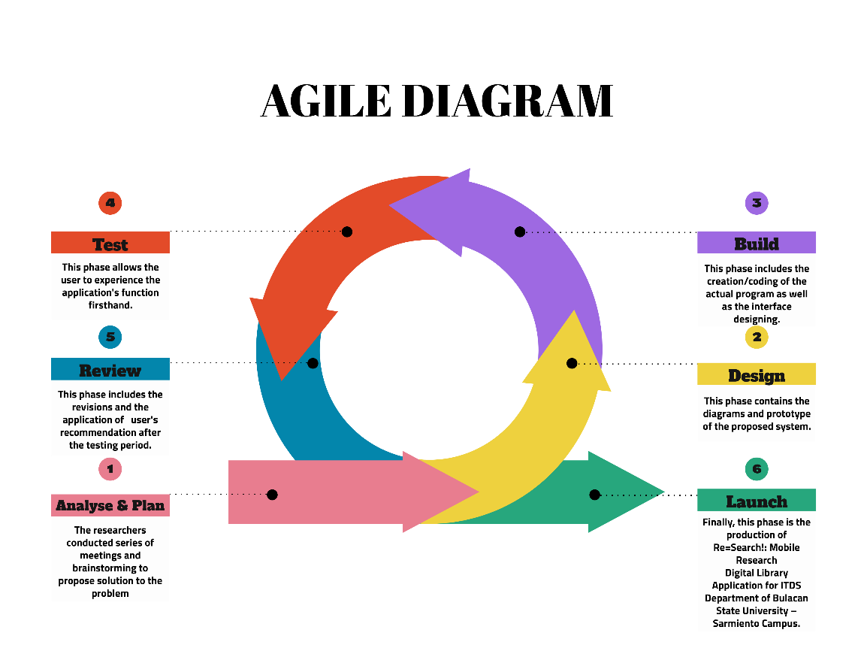

**Figure 1.0** AGILE METHOD

**Phase 1: Analyze and Plan**

In this phase, the researchers will conduct an interview with the focal person of the Bulacan State University-Sarmiento Campus and will ask open-ended questions regarding the methods of storing capstone papers in ITDS department, during this interview researcher will as well observe the research office environment and conduct a short survey questionnaire as well to the respondents, after having all the data needed the researchers will start to have brainstorming and stand-up meetings and afterwards goes to a more critical sortation of ideas. In determining the problem of the research office, the researchers will jump into reading related studies, articles and programs regarding research paper management system and digital library system. The plan for the system's construction is to enable its users to access the capstone papers in any time necessary, allowing the students to highlight, bookmark, add to favorite folder and download the papers in IMRAD format, add comments for their insights regarding on the choose capstone paper aside from the given features researchers who have successfully defended their capstone project can then upload their documentation but after the administration have finished its verification.

**Phase 2: Design**

In this phase the researchers will begin to design a layout of the system’s interface and establishes the ideas that have been sorted out during the planning period. The colors and sizes of each widget have been analyzed by the members that are assigned to the design area to match the overall theme and not overdo the aesthetics of the user’s interface, this involves the creation of the prototype application using the Context flow Diagram (Figure 2.0) and Data flow Diagram (Figure 3.0). The designing of the program flow regarding its interaction with the user will be done using the Use Case Diagram shown in (Figure 4.0) to have an overview of the basic operation of the system. In addition to the above diagrams the researchers will also use the Visual Site Map and Entity Relationship Diagram shown in figure 5.0 & 6.0. This tools will enable the researchers to ensure the appropriateness and accuracy between each features and it design layout.

**Context Flow Diagram**

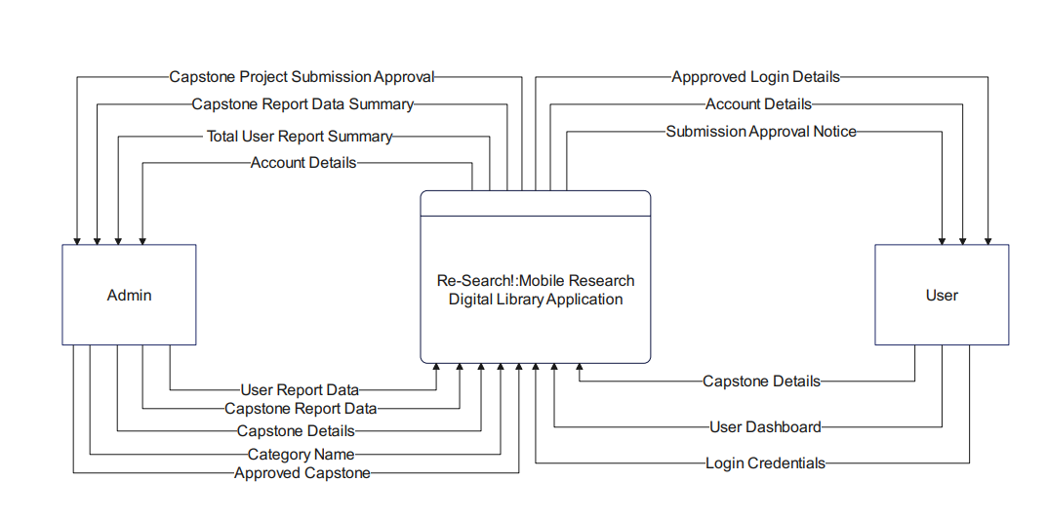

**Figure 2.0. Context Flow Diagram**

**Data Flow Diagram Level 1**

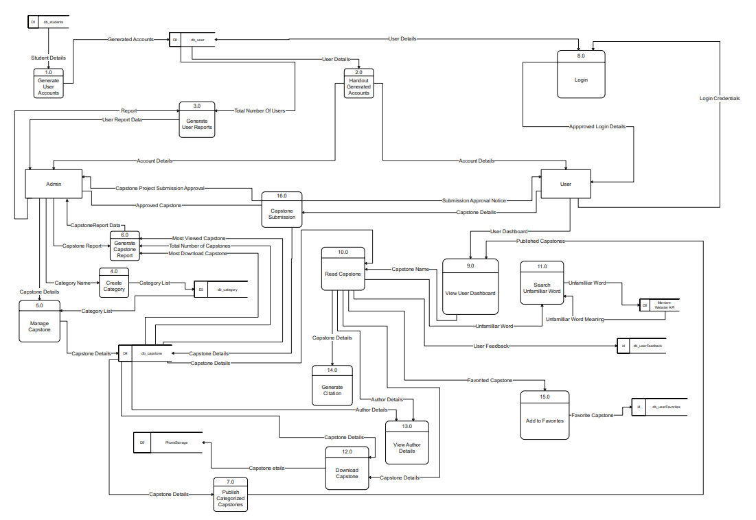

**Figure 3.0 Data Flow Diagram Level 1**

**Use Case**

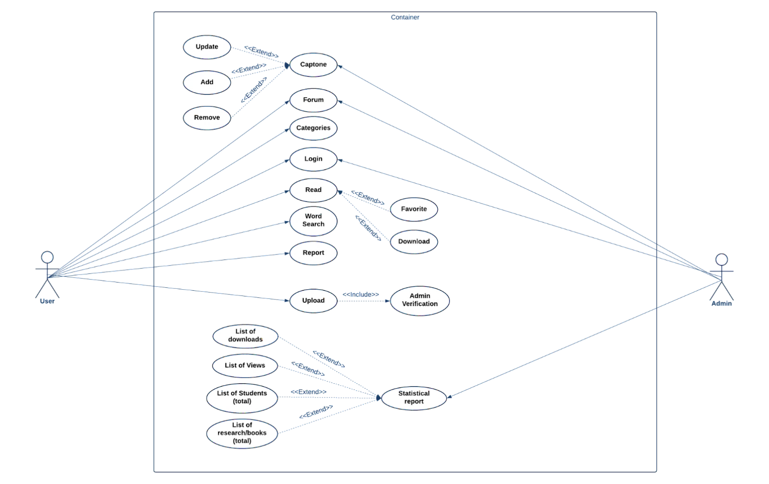

**Figure 4.0. Use Case Diagram**

# 

# Visual Site Map

# 

**Figure 5.0. Visual Site Map**

**Entity Relationship Diagram**

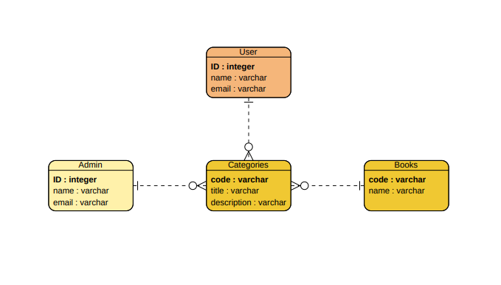

**Figure 6.0. Entity Relationship Diagram**

**System Features**

The system has a variety of features that enable users to explore and store capstone projects effectively. Furthermore, the administrator may manage the system and keep track of users, settings, and resources.

**USER MANAGEMENT**

In order to protect user security, only students enrolled in the ITDS program at Bulacan State University's Sarmiento Campus will be granted user log-ins, which will be sent via BulSu email. For the current academic year, the system's automatic administrator will be the research focal person, In this feature the administrator can add, modify or delete user if necessarily.

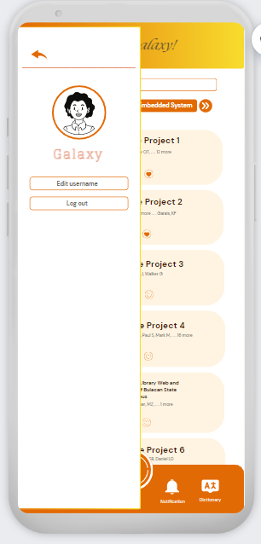

**COMMENT SECTION**

This feature will allow users to drop their comments or suggestions that act as a forum in a specific capstone paper. comments containing restricting words or negative words will be filtered to maintain a positive environment of the system.

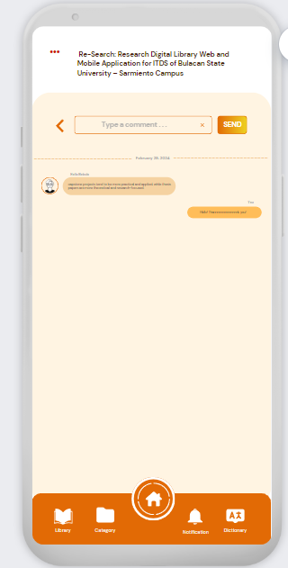

**CAPSTONE REQUEST MANAGEMENT**

User’s will be allowed to ask for request upload of their own capstone paper, as long as it is already done and defended, while waiting for validation the paper will temporarily tagged as pending. As administrator the admin can add capstone paper as well.

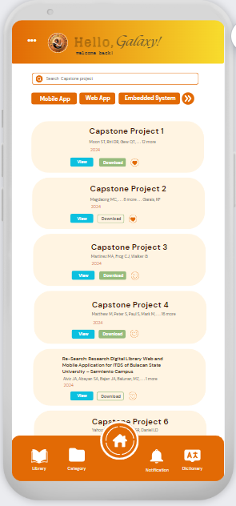

**CAPSTONE MANAGEMENT**

Aside for managing the upload request, papers that will be uploaded should be categorized depending on what discipline it falls under the ITDS category, paper must be constructed in IMRAD Format.

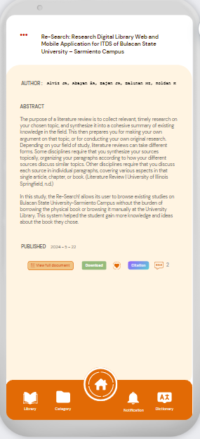

**BUILT-IN DICITIONARY**

User who finds unfamiliar words hard to understand can access the built in dictionary, allowing them to effectively perceive the paper they reading they can as well save words.

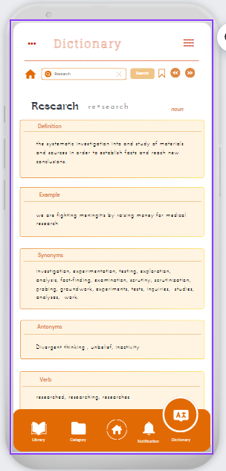 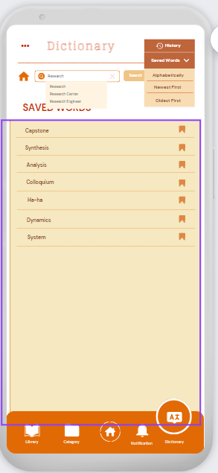

**DOWNLOADABLE CAPSTONE PROJECTS**

Uploaded capstone paper is available to download, downloaded books will be stored on user phone and can be found on downloaded book tab. This feature will allow the user to read the book round-the-clock whenever the user has to.

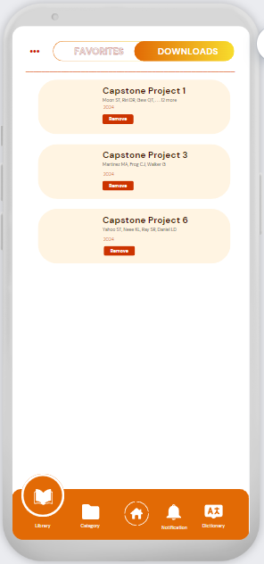

**ADD TO FAVORITES**

This will also act as bookmark, papers that is tagged as favorites can be found in favorites tab allowing user to navigate the paper easily incase, they need to read it again.

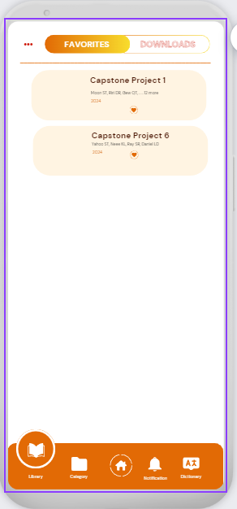

**REPORT GENERATION**

In administrator, the system can provide statistical report of total number of books, books view, users and downloaded books to keep on track.

**CITATION GENERATOR**

For faster referencing the system will add a citation generator wherein It has two format the APA (American Psychological Association) and MLA (Modern Language Association).

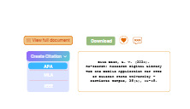

**Phase 3: Build**

The system will be build using different mobile application programming tools, that includes Android Studio, Firebase, Java, // and more.

**Phase 4: Test**

To gather the user insights and input of the proposing system, the researcher will test the system by randomly selecting ITDS students to get their initial experience of the system and gathered data will be used in Phase 5 for the development of the System.

**Phase 5: Review**

After the collected user feedback, the researcher will implement the suggestive comments, for further enhancement of the system. Next, the system will undergo thorough evaluation. Researchers will be providing evaluation form to measure the quality that the system has, this will serve as a preparation for the implementation of the system at Bulacan State University – Sarmiento Campus ITDS department.

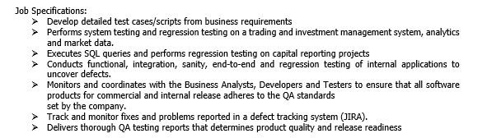**EVALUATION** 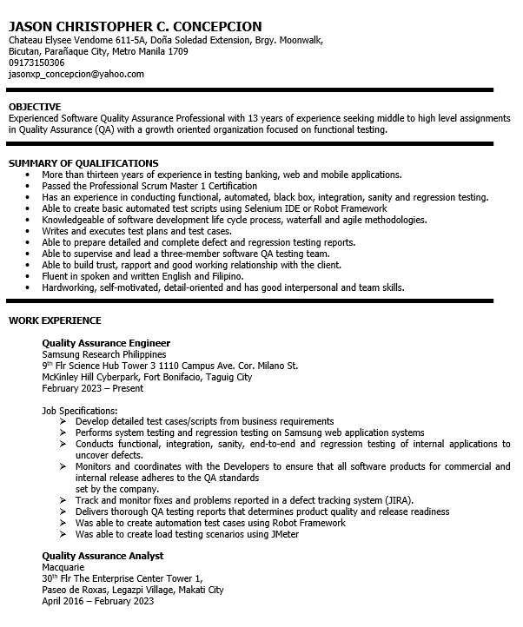

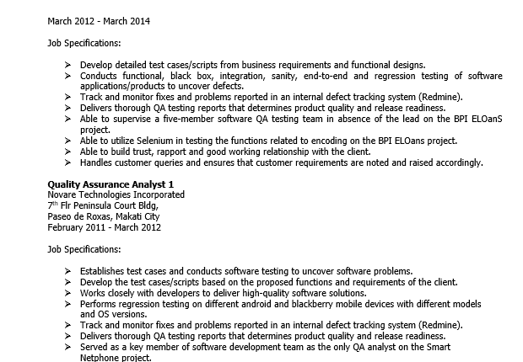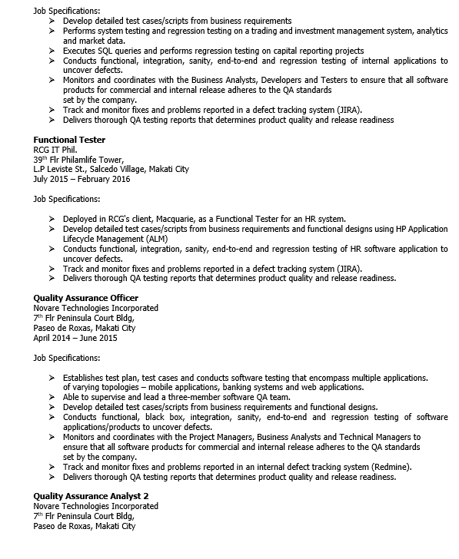

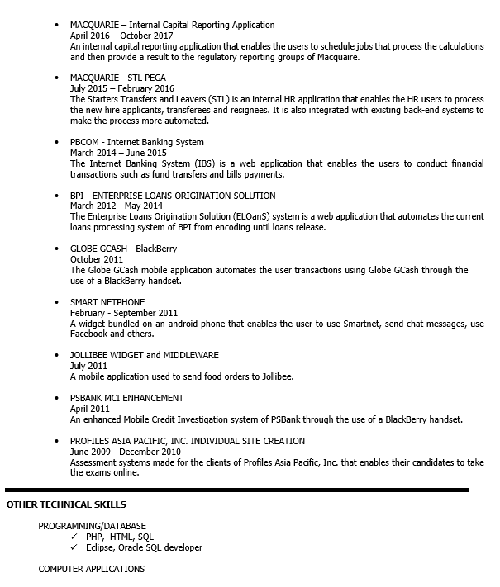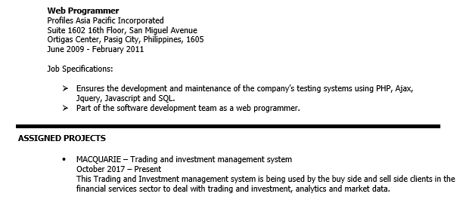

# 

# 

# 

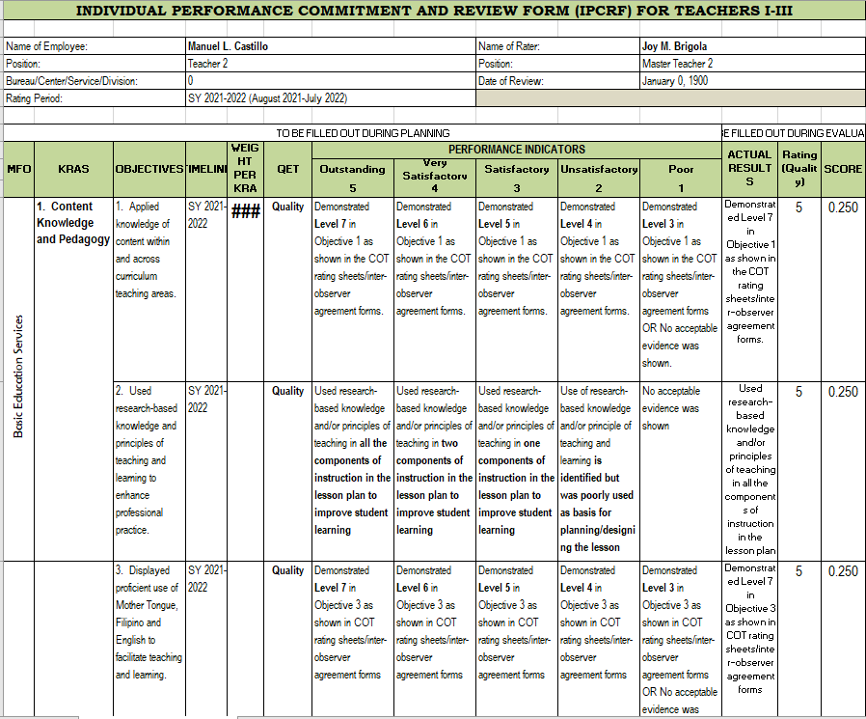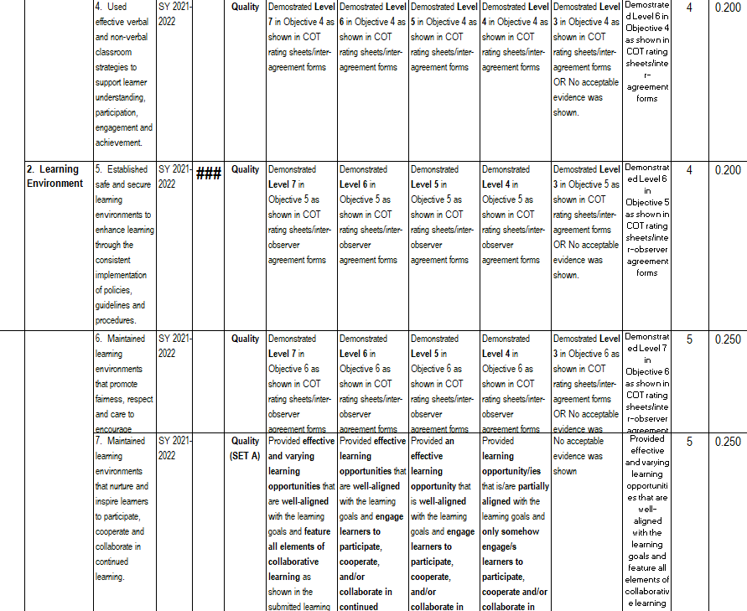

# 

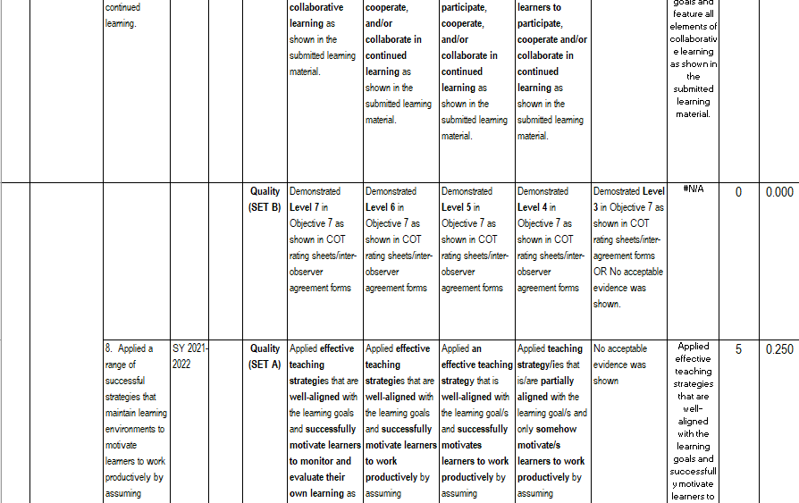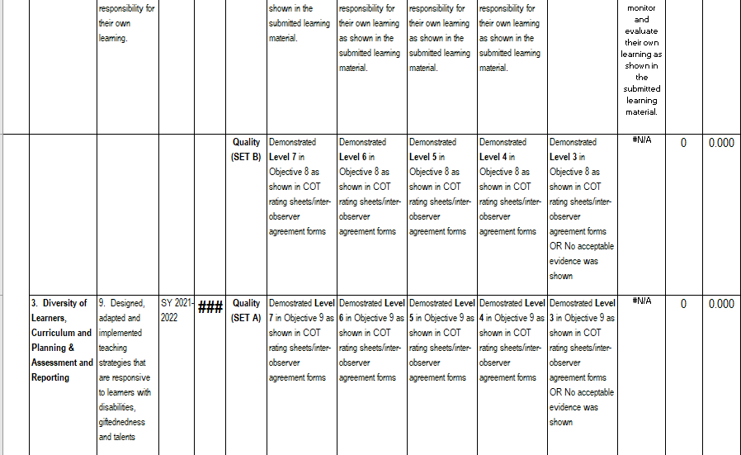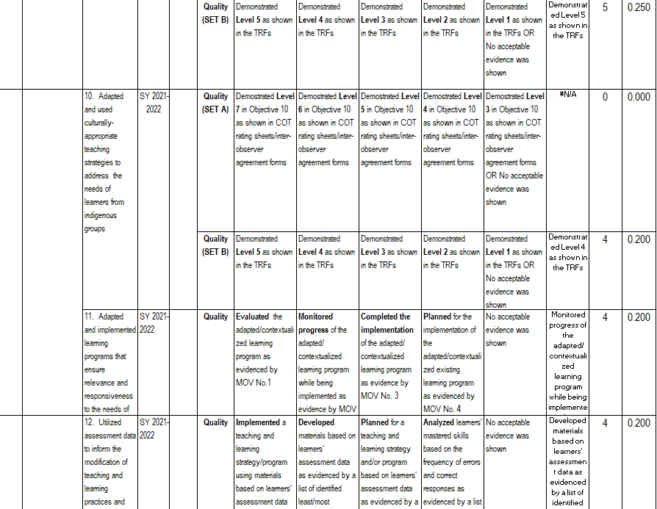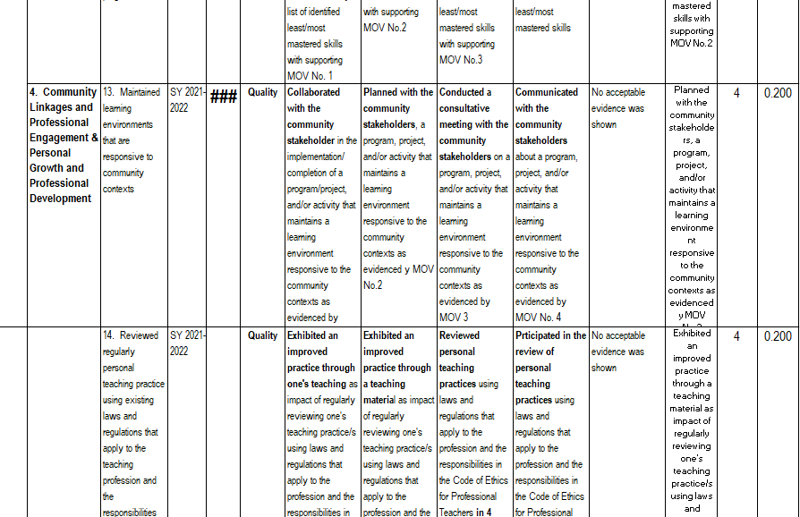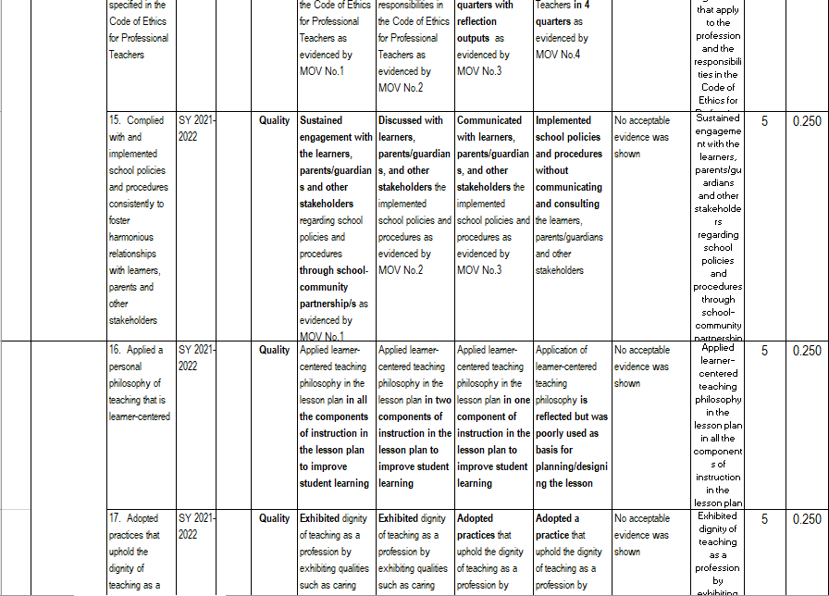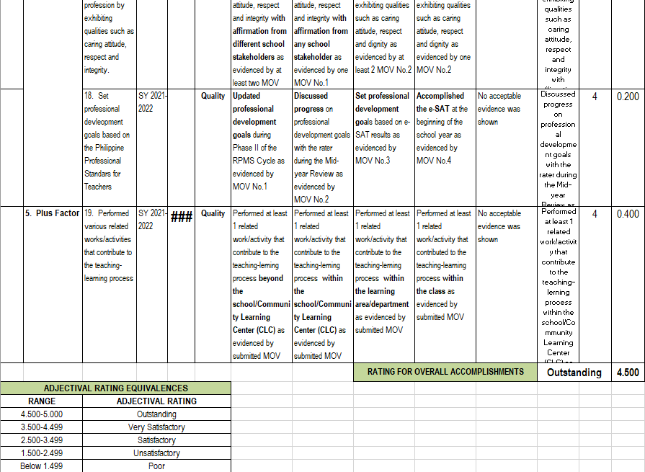

|  |  |  |
| --- | --- | --- |
| **Quality Goal** | **Sub-characteristics** | **Recommendation** |
| **Table 2.** ISO/IEC 25010 Quality Model Mapping | | |
| Functional Suitability | Functional Completeness |  |
| Functional Correctness |  |
| Functional Appropriateness |  |
| Performance Efficiency | Time Behaviour |  |
| Capacity |  |
| Compatibility | Co-existence |  |
| Interoperability |  |
| Usability | Appropriateness recognizability |  |
| User-interface aesthetics |  |
| Learnability |  |
| Operability |  |
| User error protection |  |
| Accessibility |  |
| Reliability | Maturity |  |
| Availability |  |
| Fault Tolerance |  |
| Recoverability |  |
| Security | Confidentiality |  |
| Integrity |  |
| Non-repudiation |  |
| Accountability |  |
| Authenticity |  |
| Maintainability | Modularity |  |
| Reusability |  |
| Analyzability |  |
| Modifiability |  |
| Testability |  |

**//RESPONDENTS OF THE STUDY**

**//DATA GATHERING PROCEDURE**

## Data Analysis

This study used the purposive sampling technique in determining the respondents of the study. In this sampling technique, all the respondents' responses were considered, and no responses were discarded to get a better representation of the data.

To interpret the results of the survey questionnaire, the researcher employed the Likert Scale with the following formula:

Where:

**Table 3.** Likert Scale Conversion Table

|  |  |  |
| --- | --- | --- |
| **DESCRIPTION** | **VALUE** | **CONVERSION** |
| E | 5 | 4.51-5.00 |
| VG | 4 | 3.51-4.50 |
| G | 3 | 2.51-3.50 |
| F | 2 | 1.51-2.50 |
| P | 1 | 0.51-1.50 |

## Statistical Tool Used

This research utilized the following statistical methods in quantifying the results of the study.

**Frequency.** This was used to quantify the number of respondents falling into a statistical survey for the variation of specified characteristics.

**Percentage.** This was used to determine the number of respondents. The formula is:

P = F * 100

N

Where:

**P** = Percentage

**F** = Frequency

**N**= Total number of population

# REFERENCES

Use A.P.A. formatting for all references (in the body and the listing here). Use Mendeley for referencing.

# APPENDICES

1. Project Gantt Chart
2. Relevant Source Code
3. User's Guide
4. Evaluation Tool
5. Endorsement
6. I.T. Expert's Resume
7. Curriculum Vitae