Travaux dirigés

Les réseaux sans fil - LRWPAN - 802.15.4 - ZigBee

Table des matières
1 -Caractéristiques d'un module ZigBee 2
2 -Exemple de kit de développement 4
3 -Exemple d'application : Lowpower 5
3.1 -Description de l'application 5
3.2 -Etude des Makefiles 5
3.3 -Etude des codes sources 8
4 -Décodage de trames ZigBee 15

- Caractéristiques d'un module ZigBee
On donne les caractéristiques d'un module ZigBee du marché.
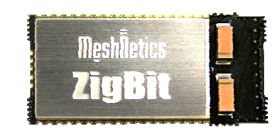
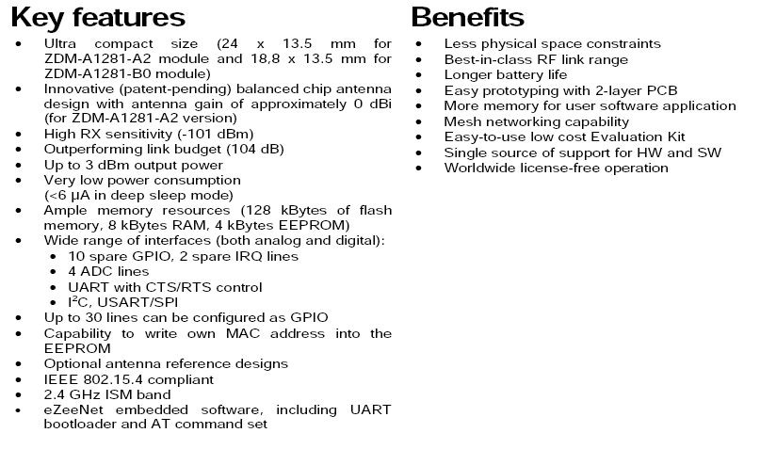
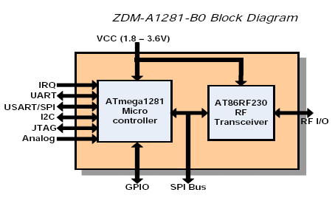
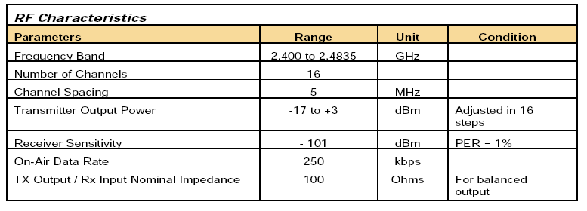

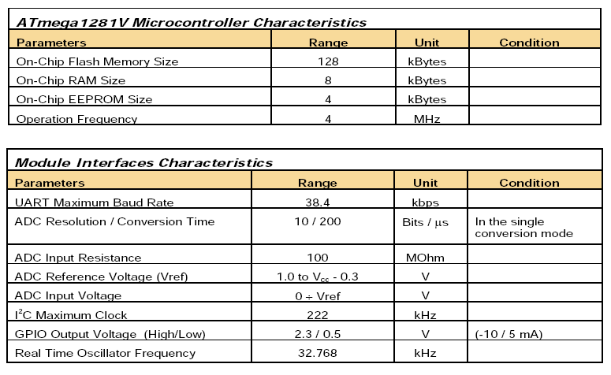

Question 1 : Complétez le tableau suivant :

Question | Réponse
Bande de fréquence utilisée | 2.4 GHz à 2.4835 GHz
Nombre de canaux RF | 16
Puissance d'émission maxi (en dBm et en mW) | 3dB 1.99mW (Watts = 10exp(dB/10))
Vitesse de transmission entre module en RF | 250 kbits/s
Vitesse de transmission filaire maximum via RS232 | 38kbits/s
Topologies possibles | Mesh, star, tree
Entrées/Sorties disponibles | 10 GPIO, 4 ADC, i2c, SPI,
Sensibilité de la réception (dBm et mW) | -101dBm (0.000000000079 mW)

- Exemple de kit de développement
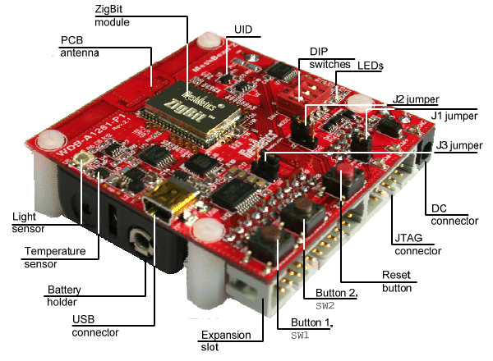
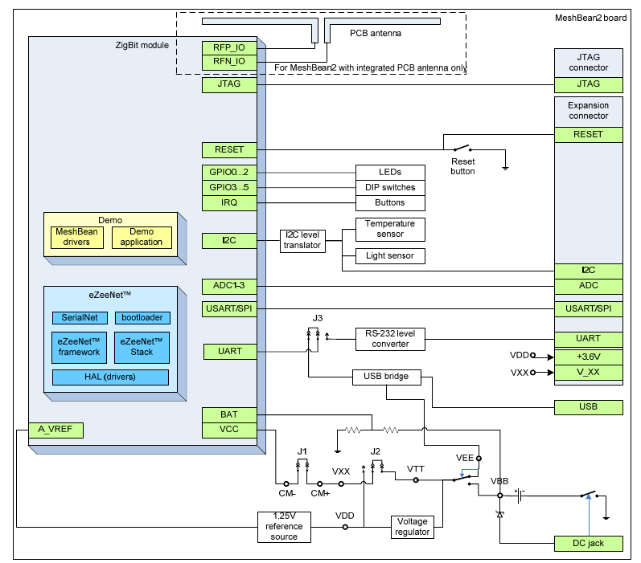
Question 2 : Repérez sur les figures précédentes les principales caractéristiques du kit de développement ZigBee (E/S, Liaisons, etc.).
- Exemple d'application : Lowpower
  - Description de l'application
This sample shows how to collect data transmitted from low-power devices, employing the simplest power management strategy. At least 2 nodes are participating, but up to 7 end devices can be engaged. There must be one and only coordinator, and the rest of nodes must be configured as end devices.
For simple node identification, define unique logical addresses by DIP switches. When setting 8 possible DIP combinations, keep in mind that:
- ON position corresponds to logical 1;
- Third DIP switch defines the most significant bit for logical address;
- Zero logical address corresponds to the coordinator, which must be unique.
To start the application and to initiate the network push SW1 button on each node, starting with coordinator. Green LED is switched ON if the network is started successfully.
Coordinator organizes the network with its own 'unique' PAN ID which is determined by its MAC address (considering the 16 least significant bits). Besides, user can set PAN ID in flash memory or EEPROM. In order to join, end devices are scanning the network.
End device measures temperature each 10 seconds and sends data to coordinator if the absolute increment of the measured value exceeds 0.5°C. Flashing yellow LED is indicating that data are transmitting. After the transmission is completed, the end device falls asleep. Unconditionally, the current temperature value is also sent if SW2 button is pressed on an end device, regardless the current node mode (sleeping or active). Do not abuse the device with quick series of multiple clicks, since this may cause unstable work.
Coordinator never sleeps; it keeps sending the received temperature data to UART via US

Question 3 : Que fait cette application ?
Mesure de température

Question 4 : Quelle topologie réseau est mise en place dans cet exemple ?
Topologie étoile

  - Etude des Makefiles
Extrait du Makefile de l'enddevice :

PROJNAME = enddevice

## path to BitCloud stack
STACK_PATH = ../../BitCloud/Components

include $(STACK_PATH)/../lib/MakerulesBcAll
include ./Makerules

CFLAGS += -DCHANGES_THRESHOLD=0
CFLAGS += -DAPP_USE_APS_ACK=1

#-------------------------------------
# Stack parameters being set to Config Server
#-------------------------------------
CFLAGS += -DCS_NWK_UNIQUE_ADDR=true
CFLAGS += -DCS_DEVICE_TYPE=DEVICE_TYPE_END_DEVICE
CFLAGS += -DCS_EXT_PANID=0xAAAAAAAAAAAAAAAALL
CFLAGS += -DCS_RX_ON_WHEN_IDLE=false

CFLAGS += -DCS_NEIB_TABLE_SIZE=7
CFLAGS += -DCS_MAX_CHILDREN_AMOUNT=6
CFLAGS += -DCS_MAX_CHILDREN_ROUTER_AMOUNT=2
CFLAGS += -DCS_ROUTE_TABLE_SIZE=30
CFLAGS += -DCS_END_DEVICE_SLEEP_PERIOD=10000

ifneq (, $(findstring -DAT86RF230B, $(CFLAGS)))
CFLAGS += -DCS_CHANNEL_MASK=(1L << 0x18)
else
ifneq (, $(findstring -DAT86RF230, $(CFLAGS)))
CFLAGS += -DCS_CHANNEL_MASK=(1L << 0x18)
endif
endif

CFLAGS += -g

## app include dirs
INCLUDES += -I.

## app objects to build
OBJ =
## path to app objects
VPATH += .:

## objects to build with -O0
DBG_OBJ = enddevice.o

#-------------------------------------
# Build
#-------------------------------------
all: $(PROJNAME).elf $(PROJNAME).srec $(PROJNAME).hex size

$(OBJ) $(STACK_OBJ): %.o: %.c
$(CC) -c $(CFLAGS) $(INCLUDES) $^ -o $@

$(DBG_OBJ): %.o: %.c
$(CC) -c $(CFLAGS) -O0 $(INCLUDES) $^ -o $@

#-------------------------------------
# Link
#-------------------------------------
$(PROJNAME).elf: $(OBJ) $(DBG_OBJ) $(STACK_OBJ) Makefile
$(CC) $(CFLAGS) $(OBJ) $(DBG_OBJ) $(STACK_OBJ) $(LIB_PATH)/WdtInitatmega1281.o -o $(PROJNAME).elf -L$(LIB_PATH) -L$(BSP_PATH)/lib -lBSPMeshBean -l$(STACK_LIB)
rm -f *.o

%.srec: %.elf
avr-objcopy -O srec --srec-len 128 $< $@

%.hex: %.elf
avr-objcopy -O ihex $(HEX_FLASH_FLAGS) $< $@

size:
avr-size -td $(PROJNAME).elf

clean:
rm -rf $(PROJNAME).elf $(PROJNAME).hex $(PROJNAME).srec $(PROJNAME).o

flash:
jtagiceii -d ATmega1281 -f 0x9F62 -e -pf -if $(PROJNAME).hex

# eof Makefile
Question 5 : Complétez le tableau suivant :

Question | Réponse
Type d'adressage dans le réseau ? | Adressage unique : chaque enddevice a une  adresse
Donnez l'identifiant PAN. | 0xAAAAAAAAAAAAAAAALL  (LL pour LONGLONG)
Numéro de canal ? Calculez la fréquence utilisée pour ce canal. | 1 << 0x18 (24) : canal 24  fréquence = 2405 + 5(24 - 11) = 2470 MHz
Temps endormissement de l'enddevice ? | -DCS_END_DEVICE_SLEEP_PERIOD=10000ms  = 10s
Que représente enddevice.o ? | Fichier objet issu de l'assembleur.
Repérez la commande de compilation. | $(CC) $(CFLAGS) $(OBJ) $(DBG_OBJ) $(STACK_OBJ) $(LIB_PATH)/WdtInitatmega1281.o -o $(PROJNAME).elf -L$(LIB_PATH) -L$(BSP_PATH)/lib -lBSPMeshBean -l$(STACK_LIB)
Repérez la commande de génération du fichier hexa à flasher. | %.hex: %.elf  avr-objcopy -O ihex $(HEX_FLASH_FLAGS) $< $@
Quel sera le nom du fichier à flasher dans l'avr ? | enddevice.hex
On donne un extrait du Makefile du coordinateur :

PROJNAME = coordinator

## path to BitCloud stack
STACK_PATH = ../../BitCloud/Components

include $(STACK_PATH)/../lib/MakerulesBcAll
include ./Makerules

# UART channel number
CFLAGS += -DAPP_UART_CHANNEL=UART_CHANNEL_1

CFLAGS += -DCHANGES_THRESHOLD=0
CFLAGS += -DAPP_USE_APS_ACK=1

#-------------------------------------
# Stack parameters being set to Config Server
#-------------------------------------
CFLAGS += -DCS_NWK_UNIQUE_ADDR=true
CFLAGS += -DCS_NWK_ADDR=0x0000
CFLAGS += -DCS_DEVICE_TYPE=DEVICE_TYPE_COORDINATOR
CFLAGS += -DCS_EXT_PANID=0xAAAAAAAAAAAAAAAALL
CFLAGS += -DCS_RX_ON_WHEN_IDLE=true

CFLAGS += -DCS_NEIB_TABLE_SIZE=8
CFLAGS += -DCS_MAX_CHILDREN_AMOUNT=7
CFLAGS += -DCS_MAX_CHILDREN_ROUTER_AMOUNT=0
CFLAGS += -DCS_ROUTE_TABLE_SIZE=8
CFLAGS += -DCS_END_DEVICE_SLEEP_PERIOD=10000

ifneq (, $(findstring -DAT86RF230B, $(CFLAGS)))
CFLAGS += -DCS_CHANNEL_MASK=(1L << 0x18)
else
ifneq (, $(findstring -DAT86RF230, $(CFLAGS)))
CFLAGS += -DCS_CHANNEL_MASK=(1L << 0x18)
endif
endif

Question 6 : Complétez le tableau suivant :

Question | Réponse
Type d'adressage dans le réseau ? | Adressage unique : chaque enddevice a une  adresse  L'adresse du coordinateur est NWK_ADDR=0x0000
Donnez l'identifiant PAN. | PANID=0xAAAAAAAAAAAAAAAALL
Numéro de canal ? | 24 (2470 MHz)  -DCS_CHANNEL_MASK=(1L << 0x18)
Combien de enddevices peuvent se connecter au coordinateur ? | -DCS_MAX_CHILDREN_AMOUNT=7  7 enfants (enddevice)

Capture d'écran de la sortie du Coordinateur :

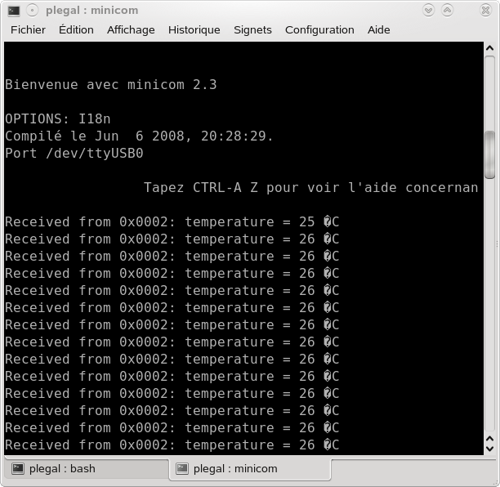
  - Etude des codes sources
On donne le fichier source de l'enddevice:
/************************************************************************
enddevice.C

ZigBeeNet Low-Power: Enddevice part of application implementation.

Written by V.Marchenko
**************************************************************************/

//#include <lowpower.h>
#include <configServer.h> // Config Server header
#include <appFramework.h> // Main stack types
#include <zdo.h> // Main ZDO header
#include <aps.h> // Main APS header
#include <appTimer.h> // Application timer header
#include <sliders.h> // BSP sliders (DIP-switches) header
#include <buttons.h> // BSP buttons header
#include <sensors.h> // BSP sensors header
#include <leds.h> // BSL LEDs header

#ifndef COORDINATOR_NETWORK_ADDRESS
#define COORDINATOR_NETWORK_ADDRESS 0x0000 // Default coordinator short (NWK) address
#endif

#ifndef APP_JOINING_INDICATION_PERIOD
#define APP_JOINING_INDICATION_PERIOD 500L // Period of blinking during starting network
#endif

#define APP_ENDPOINT 2 // Endpoint will be used
#define APP_PROFILE_ID 1 // Profile Id will be used
#define APP_CLUSTER_ID 1 // Cluster Id will be used

// Leds aliases definition hardware platfor supported if
#define APP_NETWORK_STATUS_LED LED_GREEN // Network status LED
#define APP_RECEIVING_STATUS_LED LED_YELLOW // Data receiving status LED
#define APP_SENDING_STATUS_LED LED_RED // Data transmission status LED

typedef enum
{
APP_BUTTON_RELEASED_STATE,
APP_BUTTON_PRESSED_STATE
} AppButtonState_t;

typedef enum
{
APP_INITIAL_STATE, // Application initial state (after Power On or Reset)
APP_START_WAIT_STATE, // Waiting while the Button0 was not pressed
APP_NETWORK_JOINING_STATE, // Joining network state
APP_NETWORK_JOINED_STATE, // Network available
APP_ERROR_STATE // Error state
} AppState_t;

// Enddevice state
typedef enum
{
DEVICE_ACTIVE_IDLE_STATE, // Device is not in sleep state and the temperature must be measured
DEVICE_MEASURING_STATE, // Temperature measuring
DEVICE_MESSAGE_SENDING_STATE, // Current temperature sending to the coordinator
DEVICE_SLEEP_PREPARE_STATE, // Message was sent successfully. Node ready to sleep.
DEVICE_SLEEP_STATE, // Actually sleep state
DEVICE_AWAKENING_STATE // Node was interrupted. Awakening.
} AppDeviceState_t;

typedef enum // Data transmission feature state
{
APP_DATA_TRANSMISSION_IDLE_STATE, // Data transmission was finished or(and) not started yet
APP_DATA_TRANSMISSION_BUSY_STATE // Data transmission in progress
} AppDataTransmissionState_t;

typedef struct // Application message
{
uint16_t temperature; // Current temperature
} PACK AppMessage_t;

typedef struct // Application message buffer
{
uint8_t header[APS_ASDU_OFFSET]; // Auxilliary header (stack required)
AppMessage_t message; // Actually application message
uint8_t footer[APS_AFFIX_LENGTH - APS_ASDU_OFFSET]; // Auxilliary footer (stack required)
} PACK AppMessageBuffer_t;

/***********************************************************************************
Global variables
***********************************************************************************/
/***********************************************************************************
Local variables
***********************************************************************************/
static AppState_t appState = APP_INITIAL_STATE; // Current application state
static AppDeviceState_t appDeviceState = DEVICE_ACTIVE_IDLE_STATE; // Current device state

// Application data transmission entity state
static AppDataTransmissionState_t appDataTtransmissionState = APP_DATA_TRANSMISSION_IDLE_STATE;
static ShortAddr_t nwkAddr; // Node NWK address

static HAL_AppTimer_t networkTimer; // Timer indicating network start

// Endpoint simple descriptor (ZDO endpoint descriptor)
static SimpleDescriptor_t simpleDescriptor = {APP_ENDPOINT, APP_PROFILE_ID, 1, 1, 0, 0 , NULL, 0, NULL};
static APS_RegisterEndpointReq_t apsRegisterEndpointReq; // APS Register Endpoint Request primitive (APS endpoint descriptor)
static APS_DataReq_t apsDataReq; // APS Data Request primitive (for application message sending)

// ZDO primitives
static ZDO_StartNetworkReq_t zdoStartNetworkReq; // Request parameters for network start
static ZDO_SleepReq_t zdoSleepReq; // Request parameters for stack sleep
static ZDO_WakeUpReq_t zdoWakeUpReq; // Request parameters for stack awakening
static AppMessageBuffer_t appMessageBuffer; // Application message buffer

static AppButtonState_t key1State = APP_BUTTON_RELEASED_STATE; // KEY1 (SW2) current state

/***********************************************************************************
Static functions
***********************************************************************************/
static void buttonReleased(uint8_t button); // Button released handler
static void buttonPressed(uint8_t button); // Button pressed handler
// Network start/join confirmation handler
static void ZDO_StartNetworkConf(ZDO_StartNetworkConf_t *conf);
static void APS_DataConf(APS_DataConf_t *conf); // Data transmission confirmation handler
// Temperature measured handler
static void temperaturesSensorHandler(bool result, int16_t temperature);
static void ZDO_SleepConf(ZDO_SleepConf_t *conf); // Sleep confirmation handler
static void ZDO_WakeUpConf(ZDO_WakeUpConf_t *conf); // Wake up confirmation handler
static void initApp(void); // Common application initial function
static void deviceTaskHandler(void); // Common device task handler in network state
static void openPeriphery(void); // Open LEDs and Temperature Sensor
static void closePeriphery(void); // Close LEDs and Temperature Sensor
static void sendMessage(void); // Send the application message
static void startNetwork(void); // Start Network

/********************************************************************
Description: Starting network timer has fired. Toggle LED for blink
Parameters: none.
Returns: none
********************************************************************/
void startingNetworkTimerFired()
{
BSP_ToggleLed(APP_NETWORK_STATUS_LED); // Network Status LED toggling
}

/********************************************************************
Description: Application task handler
Parameters: none.
Returns: none
********************************************************************/
void APL_TaskHandler()
{
switch (appState)
{
// node is in initial state
case APP_INITIAL_STATE: // Initial (after RESET) state
initApp(); // Init application as a whole
SYS_PostTask(APL_TASK_ID); // Application task posting
break;

case APP_NETWORK_JOINING_STATE: // Network is in the joining stage
startNetwork(); // Start/joing network
break;

case APP_NETWORK_JOINED_STATE: // Network was successfully started
deviceTaskHandler(); // Normal device operation when one joined network
break;

default:
break;
}
}

/********************************************************************
Description: Open LEDs and Sensor
Parameters: none
Returns: none
********************************************************************/
static void openPeriphery(void)
{
BSP_OpenLeds(); // LEDs opening
BSP_OpenTemperatureSensor(); // Temperature Sensor opening
}

/********************************************************************
Description: Close LEDs and Sensor
Parameters: none
Returns: none
*******************************************************************/
static void closePeriphery(void)
{
BSP_OffLed(APP_NETWORK_STATUS_LED);
BSP_OffLed(APP_SENDING_STATUS_LED);
BSP_OffLed(APP_RECEIVING_STATUS_LED);
BSP_CloseLeds(); // LEDs closing
BSP_CloseTemperatureSensor(); // Temperature Sensor closing
}

/********************************************************************
Description: application and stack parameters init
Parameters: none
Returns: none
********************************************************************/
static void initApp(void)
{
// Read NWK address as dipswitch's state.
nwkAddr = BSP_ReadSliders();
// In this application end device cannot have network address the COORDINATOR_NETWORK_ADDRESS
if (COORDINATOR_NETWORK_ADDRESS != nwkAddr)
{
// Set valid network address to Config Server
CS_WriteParameter(CS_NWK_ADDR_ID, &nwkAddr);
openPeriphery(); // Periphery opening
// Buttons opening with button released handler defining
BSP_OpenButtons(buttonPressed, buttonReleased);
appState = APP_START_WAIT_STATE; // Wait for Button0 was released (pressed one time) state switching
}
else
{
appState = APP_ERROR_STATE; // Network address isn't valid. Error state switching to.
}
}

/********************************************************************
Description: Data sent handler
Parameters: conf - APS Data Confirm primitive
Returns: none
********************************************************************/
static void APS_DataConf(APS_DataConf_t *conf)
{
appDataTtransmissionState = APP_DATA_TRANSMISSION_IDLE_STATE; // Data transmission entity is idle
BSP_OffLed(APP_SENDING_STATUS_LED);
if (APS_SUCCESS_STATUS == conf->status) // Data transmission was successfully performed
{
appDeviceState = DEVICE_SLEEP_PREPARE_STATE; // Switch device state to prepare for asleep
}
else
{
appDeviceState = DEVICE_ACTIVE_IDLE_STATE; // Data transmission wasn't successfully finished. Retry.
}
SYS_PostTask(APL_TASK_ID); // Application task posting
}

/********************************************************************
Description: Temperature measured handler
Parameters: result - measurement status (true - success, 0 - fail)
temperature - value measured
Returns: none
********************************************************************/
static void temperaturesSensorHandler(bool result, int16_t temperature)
{
if (true == result)
{
appDeviceState = DEVICE_MESSAGE_SENDING_STATE; //Switch device state to application message sending
appMessageBuffer.message.temperature = temperature; // Temperature measured will be sent as an application message
}
//else
// still in measuring
SYS_PostTask(APL_TASK_ID); // Application task posting
}

/********************************************************************
Description: Send the application message
Parameters: none
Returns: none
********************************************************************/
static void sendMessage(void)
{
if (APP_DATA_TRANSMISSION_IDLE_STATE == appDataTtransmissionState) // If previous data transmission was finished
{
appDataTtransmissionState = APP_DATA_TRANSMISSION_BUSY_STATE; // Data transmission entity is busy while sending not finished
// prepare and send APS Data Request
apsDataReq.dstAddrMode = APS_SHORT_ADDRESS; // Short addressing mode
apsDataReq.dstAddress.shortAddress = COORDINATOR_NETWORK_ADDRESS; // Destination node short address
apsDataReq.dstEndpoint = APP_ENDPOINT; // Destination endpoint
apsDataReq.profileId = simpleDescriptor.AppProfileId; // Profile ID
apsDataReq.clusterId = APP_CLUSTER_ID; // Destination cluster ID
apsDataReq.srcEndpoint = APP_ENDPOINT; // Source endpoint
apsDataReq.asduLength = sizeof (AppMessage_t); // ASDU size
apsDataReq.asdu = (uint8_t *) &appMessageBuffer.message;; // ASDU pointer as an application message
apsDataReq.txOptions.acknowledgedTransmission = 1; // Acknowledged transmission enabled
apsDataReq.radius = 0; // Default radius
apsDataReq.APS_DataConf = APS_DataConf; // Confirm handler
APS_DataReq(&apsDataReq); // Data Request sending
BSP_OnLed(APP_SENDING_STATUS_LED);
}
}

/********************************************************************
Description: ZDO Sleep Confirm handler
Parameters: conf - ZDO Sleep Confirm primitive
Returns: none
********************************************************************/
static void ZDO_SleepConf(ZDO_SleepConf_t *conf)
{
if (ZDO_SUCCESS_STATUS == conf->status) // Stack was slept successfully
{
closePeriphery(); // LEDs and Temperature Sensor closing
appDeviceState = DEVICE_SLEEP_STATE; // Device actually slept
}
else
SYS_PostTask(APL_TASK_ID); // Still in current state.
// Application task posting for attempt repeat.
}

/********************************************************************
Description: Prepare to sleep
Parameters: none
Returns: none
********************************************************************/
static void prepareToSleep(void)
{
zdoSleepReq.ZDO_SleepConf = ZDO_SleepConf; // Sleep Confirm handler defining
ZDO_SleepReq(&zdoSleepReq); // Sleep Request sending
}

/********************************************************************
Description: Device common task handler
Parameters: none
Returns: none
********************************************************************/
static void deviceTaskHandler(void)
{
switch (appDeviceState) // Actual device state when one joined network
{
case DEVICE_ACTIVE_IDLE_STATE: // Device ready to temperature measuring
BSP_ReadTemperatureData(temperaturesSensorHandler); // Temperature measuring
break;

case DEVICE_MESSAGE_SENDING_STATE: // Message sending state
sendMessage(); // Application message sending
break;

case DEVICE_SLEEP_PREPARE_STATE: // Prepare to sleep state
if (APP_BUTTON_RELEASED_STATE == key1State)
prepareToSleep(); // Prepare to sleep
else
SYS_PostTask(APL_TASK_ID); // Still in current state.
break;

case DEVICE_AWAKENING_STATE: // Awakening state
zdoWakeUpReq.ZDO_WakeUpConf = ZDO_WakeUpConf; // ZDO WakeUp confirm handler defining
ZDO_WakeUpReq(&zdoWakeUpReq); // ZDO WakeUp Request sending
break;

default:
break;
}
}

/********************************************************************
Description: Application endpoint indication handler
Parameters: ind - APS Data Indication primitive
Returns: none
********************************************************************/
static void APS_DataInd(APS_DataInd_t *ind)
{
ind = ind; //unused parameter warning prevention
BSP_ToggleLed(APP_RECEIVING_STATUS_LED);
}

/********************************************************************
Description: ZDO_StartNetwork primitive confirmation was received.
Parameters: confirmInfo - confirmation information
Returns: none
********************************************************************/
void ZDO_StartNetworkConf(ZDO_StartNetworkConf_t *confInfo)
{
// Joined network successfully
if ((ZDO_SUCCESS_STATUS == confInfo->status)) // NEtwork was started successfully
{
appState = APP_NETWORK_JOINED_STATE; // Application state switching
appDeviceState = DEVICE_ACTIVE_IDLE_STATE; // Device state setting
HAL_StopAppTimer(&networkTimer); // Network join state indication timer stopping

// Turn network indication on
BSP_OnLed(APP_NETWORK_STATUS_LED);
// Set application endpoint properties
apsRegisterEndpointReq.simpleDescriptor = &simpleDescriptor;
apsRegisterEndpointReq.APS_DataInd = APS_DataInd;
// Register endpoint
APS_RegisterEndpointReq(&apsRegisterEndpointReq);
}
SYS_PostTask(APL_TASK_ID); // Application task posting
}

/********************************************************************
Description: start network
Parameters: none.
Returns: none
********************************************************************/
static void startNetwork(void)
{
// Configure timer for LED blinking during network start
networkTimer.interval = APP_JOINING_INDICATION_PERIOD;
networkTimer.mode = TIMER_REPEAT_MODE;
networkTimer.callback = startingNetworkTimerFired;
HAL_StartAppTimer(&networkTimer);
// Network started confirm handler
zdoStartNetworkReq.ZDO_StartNetworkConf = ZDO_StartNetworkConf;
// start network
ZDO_StartNetworkReq(&zdoStartNetworkReq);
}

/********************************************************************
Description: Button pressed handler
Parameters: button - number of button was released
(KEY1 as BSP_KEY0 - Join network,
KEY2 as BSK_KEY1 - Wake up and send temperature value)
Returns: none
********************************************************************/
static void buttonPressed(uint8_t button)
{
switch (button)
{
case BSP_KEY1: // Device wake up button
key1State = APP_BUTTON_PRESSED_STATE; // Button1 state changing
break;

default:
break;
}
}

/********************************************************************
Description: Button released handler
Parameters: button - number of button was released
(KEY1 as BSP_KEY0 - Join network,
KEY2 as BSK_KEY1 - Wake up and send temperature value)
Returns: none
********************************************************************/
static void buttonReleased(uint8_t button)
{
switch (button)
{
case BSP_KEY0: // Network start button
if (APP_START_WAIT_STATE == appState) // If application wait this event
{
appState = APP_NETWORK_JOINING_STATE; // Application state to join network switching
SYS_PostTask(APL_TASK_ID); // Application task posting
}
break;

case BSP_KEY1: // Device wake up button
key1State = APP_BUTTON_RELEASED_STATE; // Button1 state changing
if (DEVICE_SLEEP_STATE == appDeviceState) // If device has slept
{
appDeviceState = DEVICE_AWAKENING_STATE; // Device state switching
SYS_PostTask(APL_TASK_ID); // Application task posting
}
break;

default:
break;
}
}

/********************************************************************
Description: Device wakeup handler. Initialize
Parameters: button - number of button was released
(KEY1 as BSP_KEY0 - Join network,
KEY2 as BSK_KEY1 - Wake up and send temperature value)
Returns: none
********************************************************************/
static void wakeUpHandler(void)
{
appState = APP_NETWORK_JOINED_STATE;
appDeviceState = DEVICE_ACTIVE_IDLE_STATE;

openPeriphery();

// Turn network indication on
BSP_OnLed(APP_NETWORK_STATUS_LED);

SYS_PostTask(APL_TASK_ID);
}

/********************************************************************
Description: End device wake up indication

Parameters: none.

Returns: nothing.
********************************************************************/
void ZDO_WakeUpInd(void)
{
if (DEVICE_SLEEP_STATE == appDeviceState)
wakeUpHandler();
}

/********************************************************************
Description: Network update notification

Parameters: ZDO_MgmtNwkUpdateNotf_t *nwkParams - update notification

Returns: nothing.
********************************************************************/
void ZDO_MgmtNwkUpdateNotf(ZDO_MgmtNwkUpdateNotf_t *nwkParams)
{
ZDO_StartNetworkConf_t conf;
if (ZDO_NETWORK_STARTED_STATUS == nwkParams->status)
{
conf.status = ZDO_SUCCESS_STATUS;
ZDO_StartNetworkConf(&conf);
}
else if (ZDO_NETWORK_LEFT_STATUS == nwkParams->status)
{
appState = APP_NETWORK_JOINING_STATE;
SYS_PostTask(APL_TASK_ID);
}
}

/********************************************************************
Description: Wake up confirmation handler

Parameters: conf - confirmation parameters

Returns: nothing.
********************************************************************/
void ZDO_WakeUpConf(ZDO_WakeUpConf_t *conf)
{
if (ZDO_SUCCESS_STATUS == conf->status)
wakeUpHandler();
else
SYS_PostTask(APL_TASK_ID);
}

//eof enddevice.c

Question 7 : Complétez le tableau suivant :

Question | Réponse
Quel est le langage utilisé ? | langage C
Quelle est la différence entre  APP_NETWORK_JOINING_STATE, et APP_NETWORK_JOINED_STATE  ? | APP_NETWORK_JOINING_STATE : le enddevice est en cours de jonction au réseau  APP_NETWORK_JOINED_STATE : le enddevice fait partie du réseau
Repérer la structure d'émission. Combien d'octets sont envoyés ? | AppMessageBuffer_t;  4 octets (127 max)
Quelle fonction est appelée au Reset ? | initApp
Quelle fonction est appelée lorsque la jonction au réseau est effective ? | ZDO_StartNetworkConf
Quelle fonction est appelée systématiquement lorsque l'enddevice est connecté au réseau ? | deviceTaskHandler();
Quelles sont les principales activités de l'enddevice lorsque qu'il est connecté au réseau ? | dort et au réveil il envoie la température
Dans quelle fonction se passe l'émission sur le réseau ? | sendMessage()
Quelle est l'adresse du destinataire du message ? | 0x0000 - > coordinateur
Quelle fonction sera automatiquement appelée par la stack ZigBee après l'émission ? | static void APS_DataConf(APS_DataConf_t *conf)  {  appDataTtransmissionState = APP_DATA_TRANSMISSION_IDLE_STATE; // Data transmission entity is idle  BSP_OffLed(APP_SENDING_STATUS_LED);  if (APS_SUCCESS_STATUS == conf->status) // Data transmission was successfully performed  {  appDeviceState = DEVICE_SLEEP_PREPARE_STATE; // Switch device state to prepare for asleep  }  else  {  appDeviceState = DEVICE_ACTIVE_IDLE_STATE; // Data transmission wasn't successfully finished. Retry.  }  SYS_PostTask(APL_TASK_ID); // Application task posting  }
Que se passe-t'il si l'émission à échouée ? | else  {  appDeviceState = DEVICE_ACTIVE_IDLE_STATE; // Data transmission wasn't successfully finished. Retry.
Que se passe-t'il si l'émission est réussie ? | if (APS_SUCCESS_STATUS == conf->status) // Data transmission was successfully performed  {  appDeviceState = DEVICE_SLEEP_PREPARE_STATE; // Switch device state to prepare for asleep
A quoi sert la fonction SYS_PostTask(APL_TASK_ID); ? | A annoncer la tache d'application  After initialization application state is changed to APP_AWAITING_NETWORK_START_STATE and hence  APL_TaskHandler needs to be executed again. To achieve this, we use  SYS_PostTask(APL_TASK_ID) in the end of the code block, thus putting a request to call the APL_TaskHandler in the scheduler queue.

- Décodage de trames ZigBee
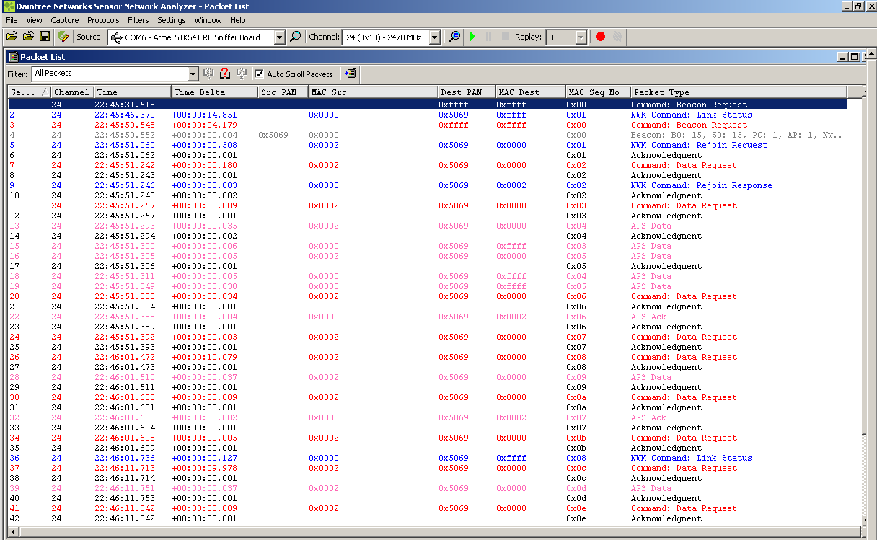
Question 8 : Complétez le tableau suivant :
Question | Réponse
Nombre de modules ZigBee en communication. | 2
Adresses logiques des modules ZigBee en communication. | 0  2
A quoi reconnait-on le coordinateur ? | @0
Donnez l'identifiant PAN. | 0x5069
Quels sont les types de trames en jeux dans l'échange ? | ACK, Commande, beacon
A quoi sert la trame 5 ?  Justifier. | demande de jonction au réseau
A quoi sert la trame 9 ?  Justifier. | demande de jonction acceptée
Se trouve-t'on en présence du communication en mode beacon ou non-beacon ?  Justifier. | Mode beacon
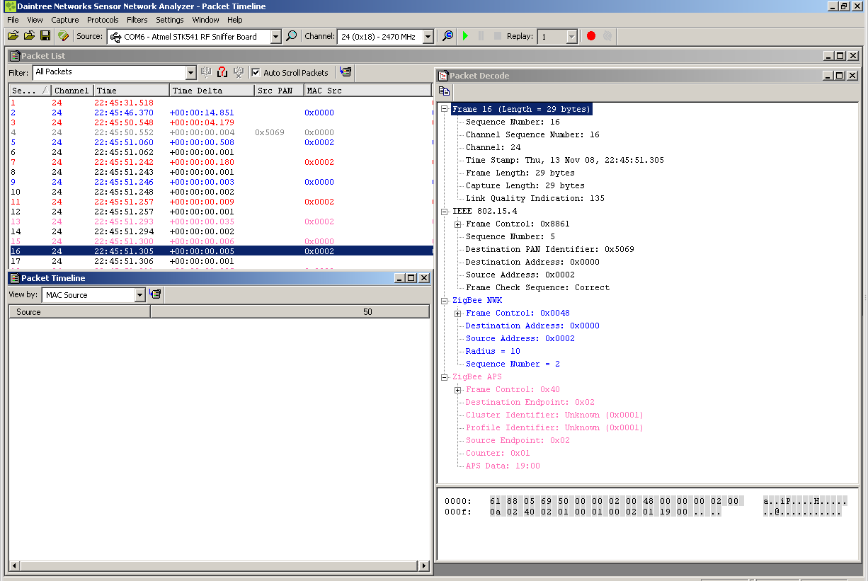
Question 9 : Complétez le tableau suivant :

Question | Réponse
A qui s'adresse la trame 16 ? | Au coordinateur
Quel sont les valeurs des endpoints source et destination ? | 0x02
Quel est l'utilité de la notion de endpoint ? | Défini quelle application est concernée : Endpoints, identified by a number between 1 and 240, define each application running in a ZigBee node (yes, a single ZigBee node can run multiple applications).
Quel est la données transportée ? | 19 00
Quelle est la taille de la trame ? | 29 octets
Calculez la durée de transmission de la trame. | 29/250k = 116us

