**Monthly Tournament Rules and Prizes**

**VAGA Competition Rules**

* Tournament entry fee includes green fee + $20 for prizes
* Stroke play, USGA and local rules unless otherwise instructed prior to tee off for abnormal conditions
* Players are flighted into 2 brackets (A Flight and B Flight) to compete for low NET based latest GHIN handicap index
  + A Flight – Handicap Index 0 – 12.0
  + B Flight – Handicap Index 12.1 – Above
* Players without official GHIN or WHS handicap will be assigned a HC Index by the VAGA Tournament Director

**VAGA Tournament Scoring System**

All members must have an established handicap prior to the tournament to compete for prizes, VAGA cup points and Ace of the month.

Tournament Director will assign handicap index to individual who doesn’t have an established handicap.

Tournament handicap = 80% * the course handicap which derived from the established hdcp and Course Rating & Slope.

Net score = Gross score – Tournament Handicap.

Tie breaker will be determined using back 9 score and then we will go into score card playoff starting with the #1 hdcp hole if necessary

**Monthly Tournament Rules**

1. At a standard course with blue, white and red tees, A Flight (0-11.9) will tee off at blue/championship and B Flight (12+) will tee off at blue/white with ladies at Red. Courses with more tees than that will be adjusted accordingly. You may request to tee off at a longer tee

2.. Putts that are fully within the “leather”, are given.

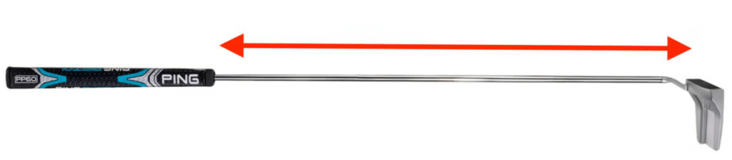

3. All PGA and local rules including drop zones apply. Hit a provisional if you think you went OB, otherwise if you can’t find your ball you will incur a 2 stroke penalty or you will have to re-tee

4. You can move your ball out of a plugged lie anywhere except for bunkers. You can lift and clean on your fairway only if spring rules apply due to wetness. Nearest point of relief applies for man made structures, cart paths, flooded bunkers and standing water

5. Lost ball due to rough, plugged or falling leaves will need a witness then drop from knee high in the search area with 1 stroke penalty

6. Lost ball in hazard (not white stakes or residential backyards) can either re-tee or lateral drop, 2 club length, from point of entry with 1 strokes penalty

7. When there is no drop zone for water or ravines and you fail to make it across the second time, you can drop on the other side and hitting 4 or re-tee.

8. Every year, there are 9 monthly tournaments that can earn you VAGA points and Ace of the Month. The 9 Ace of the Month winners and the top 3 in VAGA season standings—excluding any Ace of the Month winners already in the top 3—will compete in a one-round playoff for the VAGA Championship, based on net score

9. For VAGA members, there are prizes for closest to the pin, overall net score and flight A & B champs (based on net scores). Guest can compete for par 3 closest to the pin prizes only.

10. For team events (eg Ryder Cup), 3/4 of the team will be earned through the VAGA points with 1/4 through Captain’s pick

11. Friendly reminder to enter your scores during the official season from February 15th – December 31st to maintain an accurate handicap index. Your most current HDCP on the Friday/Saturday prior will be used for Tournament net score calculation

12. Non-VAGA guests are always welcome to play as long as they pre-register prior to the event

**Monthly Tournament Prizes (based on minimum of 16 players)**

1. Overall Champion – $100
2. A Flight Winner – $50
3. B Flight Winner – $50
4. Closet to the pin on two Par 3 – Dozen golf balls

Note: remainder of entry fee will be used for Year-End Award Banquet to crown the VAGA Cup Champion (see below)

**The VAGA Cup Champion**

CVGA Cup Champion

* First Place – $1000
* Second Place – $600
* Third Place – $400