Phuc Nguyen

August 10th, 2022

Foundation of Programming: Python

Assignment05

**To Do List**

# Introduction:

The purpose of this document is to create a new program that will load a pre-made to do list; add/remove task in that list. Finally, the modify list will be saved in a text file called ToDoToDoList.txt.

# Procedure:

1. Load the list of tasks from ToDoList.txt (Figure 3) into the list object in the program with open(“.txt”, “r”). For the list of dictionaries, it will contain “Task” as keys and “Priority” as values (Figure 1).
2. Display a menu of choices to the user using while loop and if-else functions with 5 choices total: 1) Show current data, 2) Add a new items, 3) Remove an existing item, 4) Save Data to File, 5) Exit Program.
3. For 5 total actions (Figure 2):
   1. Action 1: Show current data: use two for loops to print items of dictionaries of the list.
   2. Action 2: Add a new item: use input() to add Priority and Task into dictionaries, and use append() to add new dictionaries into the list.
   3. Action 3: Remove an existing item: use del to delete the last task and priority
   4. Action 4: Save Data to File: use json.dump() function to load the list object into the ToDoToDoList.txt text file.
   5. Action 5: Exit Program: use exit() function to exterminate the program.
4. Run the program on python, with add new “Task” drive and “Priority” 10 (Figure 4)
5. Run the program on command prompt (Figure 6), with add new “Task” drive and “Priority” 10 (Figure 4)
6. New list will be saved to ToDoToDoList.txt text file (Figure 5).

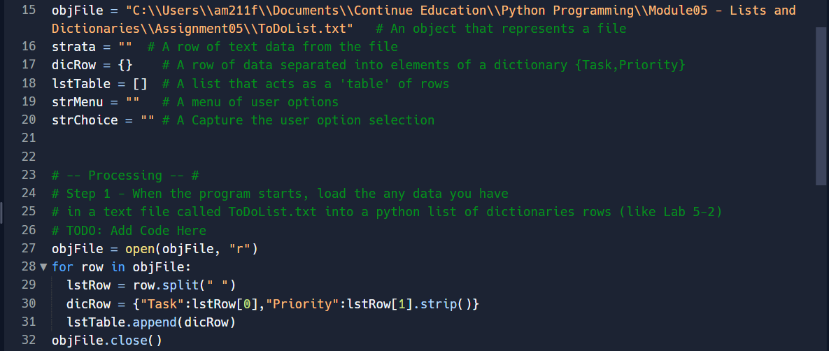

Figure 1 – Code for loading data from ToDoList.txt to list object.

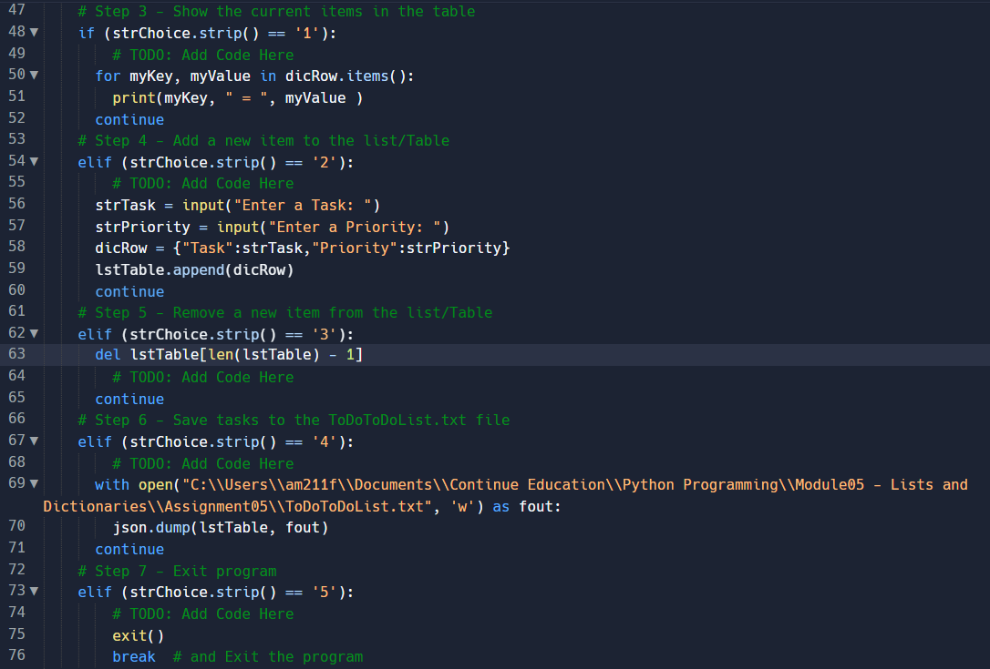

Figure 2 – Code for 5 total actions based on user’s choice.

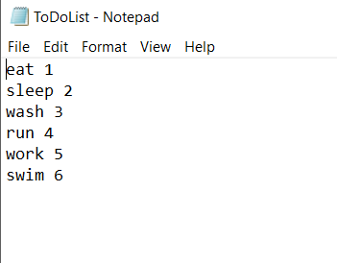

Figure 3 – Data in ToDoList.txt text file .

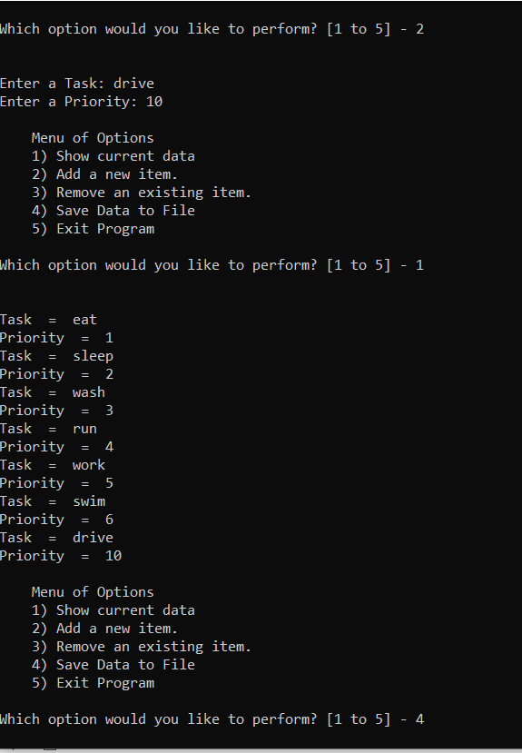

Figure 4 – Add new task and priority into the list and save the new list to ToDoToDoList.txt text file.

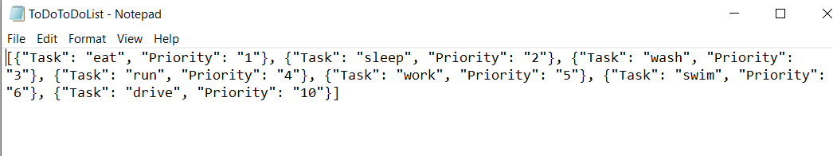

Figure 5 – Output got saved to ToDoToDoList.txt text file.

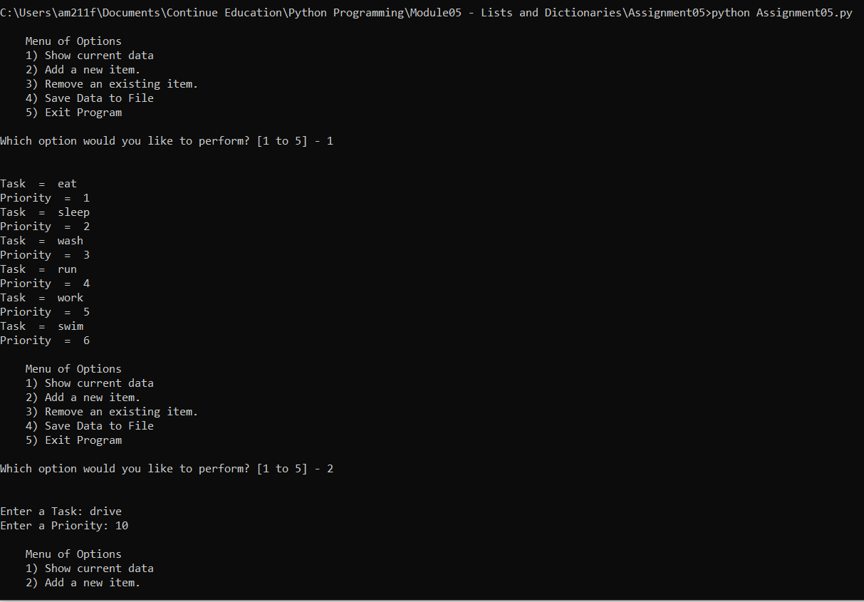

Figure 6 – Running the To Do List program on command prompt.

# Summary:

In order to add user’s input into a list of dictionaries, the input() is important to get user input, and append() function to add the new dictionaries into the list. To write user’s input into a text file, one way would be assign user input value into variables, then use .write() function to insert that value into the text file. When we want to write into the text file, we need to use .open(“.txt”, “w”) because “w” is a writable version of the text file, allowing us to write into the text file. When we want to read the text file, we need to use .open(“.txt”, “r”) because “r” is a readable version of the text file, so the content in the text won’t be modified.