RESULTS AND DISCUSSION

Testing
In this section, the proponents tested the Web-Based Sales and Inventory Management System with Integrated Real-Time Expiry Monitoring for Amson Pharmaceuticals against the functional and non-functional requirements of the study and the ISO/IEC 25010 Software Product Quality Model. The testing ensured that all components of the customer platform and the administrative portal operate correctly under the branch’s actual operating conditions.
- Functional and System Testing: A full system test plan was prepared with test cases covering every module of the customer platform and the administrative portal, each linked to its functional requirement (REQ001 to REQ124). Test scenarios verified account registration and login, product browsing, cart and checkout, QR Ph payment upload, prescription pre-orders, order tracking, walk-in POS sales, voids, inventory receiving, FEFO deduction, near-expiry and bad-order flagging, purchase orders and discrepancy reports, stock counts, wholesale orders, payment verification, reports, and the audit log. A shorter go-live test was then run on the live website before deployment, and the issues found were fixed and confirmed in a re-test.
- Integration Testing: The external services used by the system were tested to verify smooth end-to-end communication:
  - Google Firebase (Authentication, Cloud Firestore, and Hosting): Verified account creation, email verification, login lockout, and real-time updates of stock and order status across devices without a page refresh.
  - Cloudinary: Verified the upload and display of product photos, payment screenshots, prescription photos, and wholesale documents.
  - EmailJS: Verified the sending of verification codes, order notifications, and delivery notices.
  - Gemini (Firebase AI Logic): Verified that the AI chat assistant answers common inquiries on products, orders, payment, delivery, store hours, and location, and passes concerns to staff when needed.
  - jsPDF, SheetJS, and Chart.js: Verified the generation of printable receipts, invoices, and PDF and Excel reports, and the sales charts on the dashboard.
- Performance and Compatibility Testing: The system was tested on desktop computers, laptops, tablets, and mobile phones using current web browsers, checking page loading, saving speed, and layout on different screen sizes. Testing on mobile phones found that some pages stayed on the loading screen; this was fixed before deployment.
- Security and Role-Based Access Control (RBAC) Testing: Each page of the system was tested against each user role (Guest, Customer, Sales Staff, Technical Staff, and Branch Manager) to confirm that users can only open the pages and perform the actions assigned to their role. The database security rules were tested to confirm that customer records, costing and wholesale prices, and staff functions cannot be accessed by unauthorized users, together with the login lockout after five failed attempts, reCAPTCHA, and Branch Manager approval for voids made by Technical Staff.

Description of Prototype
The developed prototype replaces the manual and disconnected processes of the Las Piñas branch of Amson Pharmaceuticals, such as handwritten invoices, Excel re-encoding, and ordering through personal messaging applications, with an integrated web-based system that consists of a customer e-commerce platform and an administrative portal.
- System Requirements Realization: The prototype implements the functional requirements (REQ001 to REQ124) and non-functional requirements (REQNF001 to REQNF029) established during the client interviews:
  - Customer E-Commerce Platform: Allows guests to browse products and registered customers to order online, pay through QR Ph with screenshot verification, pre-order prescription medicines for in-store pick-up, track their orders, download receipts, and ask questions through the AI chat assistant.
  - Sales and Point-of-Sale: Allows Sales Staff and Technical Staff to record walk-in sales with the payment method and reference number, print a receipt for every sale, and process voids and walk-in returns or exchanges.
  - Inventory with Expiry Monitoring: Records stock by batch and expiry date, applies First Expired, First Out (FEFO) deduction, removes near-expiry batches from retail sale six months before expiry, flags bad orders two months before expiry, and supports purchase orders, discrepancy reports, write-offs, and month-end stock counts.
  - Wholesale, Reports, and Administration: Manages wholesale accounts, orders, free items, and exchanges; generates exportable sales and inventory reports in PDF and Excel; and enforces role-based access and an audit log of sensitive actions.
- Preliminary and Architectural Design: The system architecture reflects the models designed in the planning phase:
  - Frontend Layer: Responsive web pages built with HTML5, CSS, JavaScript, and Bootstrap, usable on desktops, laptops, tablets, and smartphones.
  - Backend and Database Layer: Google Firebase provides user authentication (Firebase Authentication), the real-time database (Cloud Firestore) protected by role-based security rules, and hosting (Firebase Hosting). Cloudinary stores uploaded images and documents.
  - Third-Party Services: Gemini through Firebase AI Logic for the AI chat assistant, EmailJS for email notifications, and jsPDF, SheetJS, and Chart.js for receipts, reports, and charts.
  - Workflow Modeling: Aligned with the workflows in the Use Case Diagrams (Figures 2.2 to 2.7) and Activity Diagrams (Figures 2.8 to 2.15).
- System Evaluation and Testing Methodology: The prototype was evaluated in its operational environment by fifty-three (53) respondents across all user roles:
  - Branch Manager (1 respondent): Evaluated reports, product and price management, and staff account management.
  - Technical Staff (1 respondent): Evaluated payment verification, prescription checking, and stock receiving.
  - Sales Staff (1 respondent): Evaluated the point-of-sale, receipt printing, and stock visibility.
  - Customers (50 respondents): Evaluated account registration, product browsing, ordering, order tracking, prescription pre-ordering, and the AI chat assistant.
Feedback was collected using Likert-scale survey questionnaires rated from 1 to 5 (5 – Excellent, 4 – Good, 3 – Fair, 2 – Poor, 1 – Unacceptable), with the questions grouped under the ISO/IEC 25010 quality characteristics of Functional Suitability, Performance Efficiency, Usability, Reliability, and Security, together with overall satisfaction based on the Technology Acceptance Model.

Implementation Plan
The Implementation Plan outlines how the system was deployed, installed, and transitioned into an operational system for the Las Piñas branch. It includes the following major implementation tasks:
- Deployment of the system: Publishing the web-based system on Firebase Hosting at amsonpharma.web.app, together with the Cloud Firestore database, its security rules, and the connected services. The system was deployed to the branch on October 22, 2026.
- Configuration of the system modules: Creating the Branch Manager, Technical Staff, and Sales Staff accounts with their assigned roles, entering the store details, and loading the branch’s actual products and stock records into the system.
- Installation on client devices: Setting up and bookmarking the system on the branch’s laptop and desktop computer. Since the system is web-based, no additional software installation is required.
- Orientation of users and staff: Demonstrating the system to the branch, walking through the customer ordering process, payment verification, delivery booking, the point-of-sale, inventory, and reports, and providing guides for each staff role.
- Testing in actual operation: Monitoring the system during actual use at the branch and applying fixes and requested changes as they were reported.
The plan also covers the resources needed to support the implementation, including hardware (the branch’s laptop and desktop computer, and a receipt printer to be purchased by the branch), software (a current web browser such as Google Chrome or Microsoft Edge, Firebase, Cloudinary, EmailJS, and Gemini), a stable internet connection, and the personnel involved in the installation and testing (the proponents, the Branch Manager, and the branch staff).

Implementation Results
This section presents the data gathered from the evaluation survey and the outcomes of the implementation. The survey was conducted from October 27 to 28, 2026, among the branch staff who use the administrative portal and among customers who used the online store.
During the implementation, the branch also requested changes based on its actual use of the system, which were completed and deployed: printing a receipt for every sale (walk-in, online, and wholesale), walk-in returns and exchanges referenced by the receipt (SI) number, marking pick-up orders as Picked Up, displaying the store’s address, hours, and FDA License to Operate, hiding costing and wholesale prices from the public, and a data backup function for the Branch Manager.
What is your role in the system?
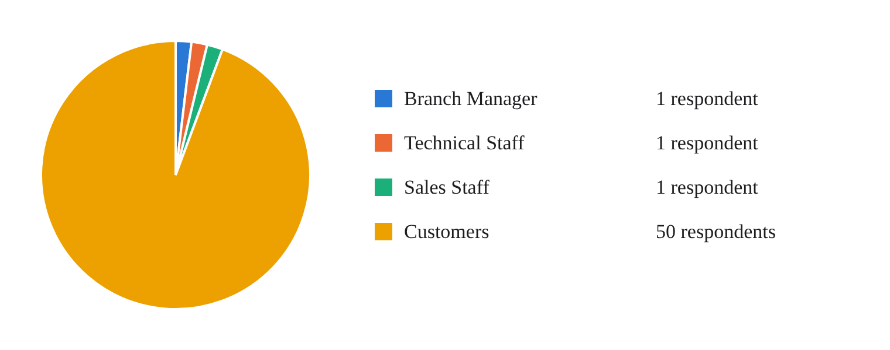
Chart 2.1. Respondents’ Role

Branch Manager Evaluation (1 respondent)
Functional Suitability
- How useful are the daily and monthly sales and inventory reports (with batch numbers and expiry dates) for the main office?
- How well can you manage product details and prices, and control which staff can change them?
- How easy is it to add staff accounts and choose what each staff can do?
- How correct is the stock count shown in the system?
- How helpful are the expiry and low-stock alerts, and how well does the system keep near-expiry items from being sold?
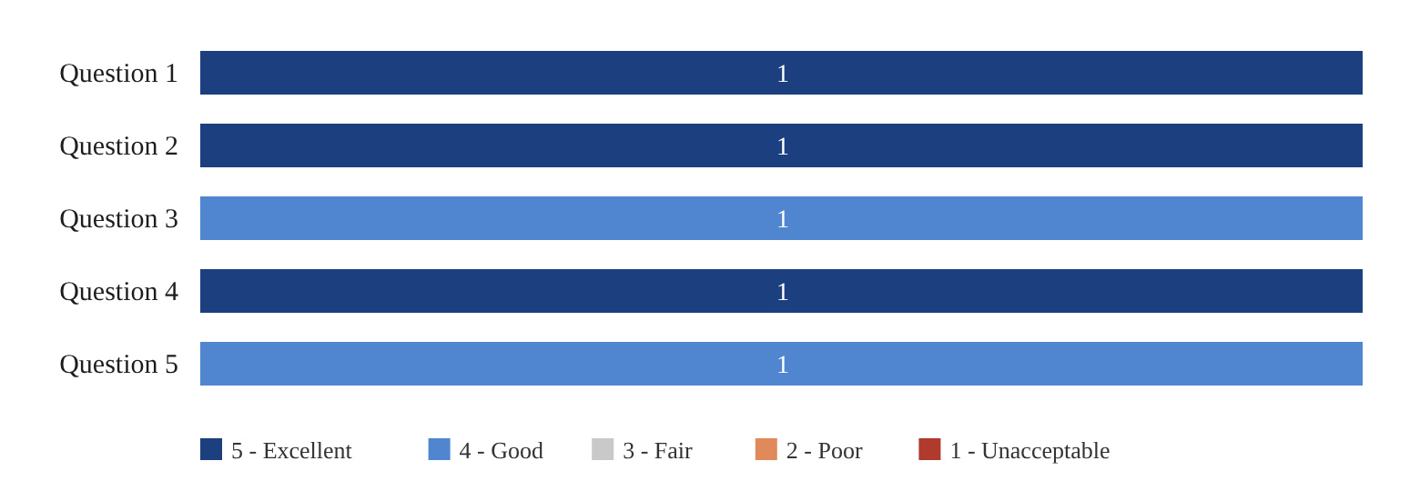
Chart 2.2. Functional Suitability of Branch Manager
This section shows that the Branch Manager believes the system meets their expectations for the features needed to manage the branch. The Branch Manager rated the sales and inventory reports, the management of product details and prices, and the accuracy of the stock count as 5 (Excellent), while adding staff accounts and the expiry and low-stock alerts were rated 4 (Good). The survey result indicates that the Branch Manager is satisfied with the functional suitability of the system.
Performance Efficiency
- How fast does the system load and save your work?
- How well does the system work on busy days with many sales and orders?
- How well does the system keep up with changes, like new products or new prices?
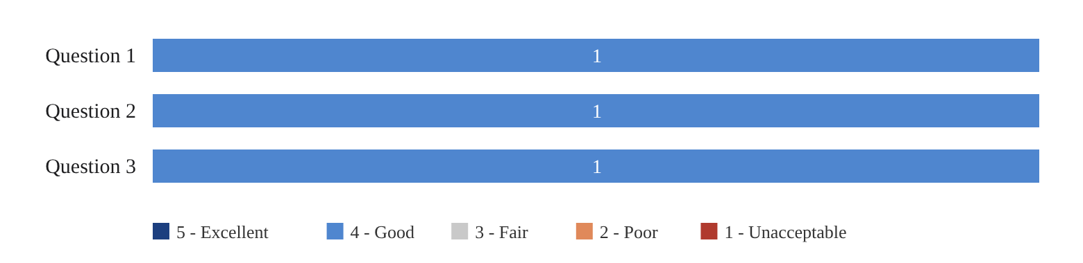
Chart 2.3. Performance Efficiency of Branch Manager
This section shows that the Branch Manager believes the system meets their expectations for loading and saving speed, performance on busy days, and keeping up with new products and prices, rating all three questions 4 (Good). The survey result indicates that the Branch Manager is satisfied with the performance efficiency of the system.
Usability
- How easy is the system to use?
- How easy are the words and steps in the system to understand?
- How well does the system work on a phone, tablet, or computer?
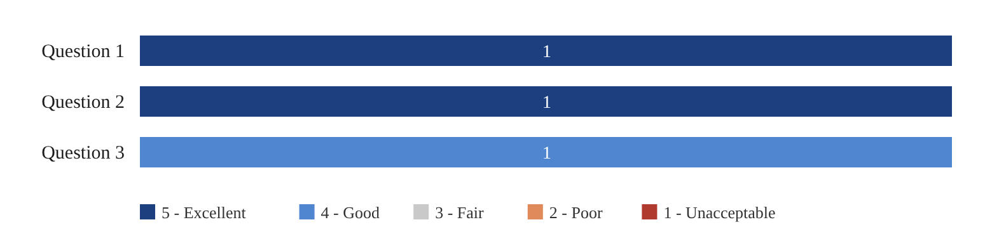
Chart 2.4. Usability of Branch Manager
This section shows that the Branch Manager finds the system easy to use and its words and steps easy to understand, rating both 5 (Excellent), while how well the system works on different devices was rated 4 (Good). The survey result indicates that the Branch Manager is satisfied with the usability of the system.
Reliability
- How well does the system save your work without errors or lost data?

Chart 2.5. Reliability of Branch Manager
This section shows that the Branch Manager believes the system saves work without errors or lost data, rating it 4 (Good). The survey result indicates that the Branch Manager is satisfied with the reliability of the system.
Security
- How safe is your account (login code on a new device, lock after wrong passwords)?
- How well does the system help the branch follow the rules (expiry dates, prescriptions, customer privacy)?
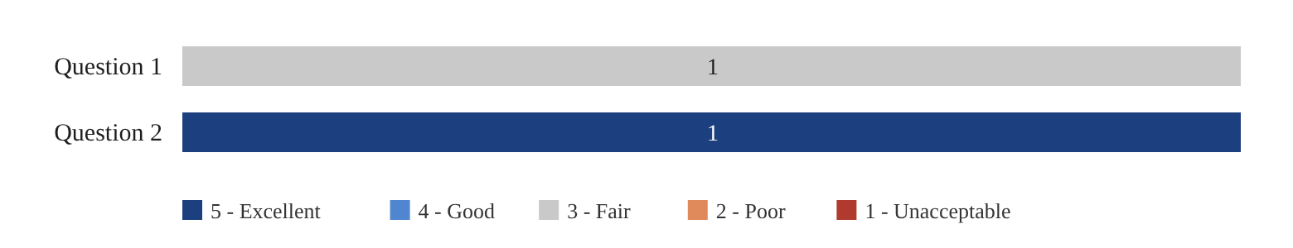
Chart 2.6. Security of Branch Manager
This section shows that the Branch Manager rated how well the system helps the branch follow the rules on expiry dates, prescriptions, and customer privacy as 5 (Excellent). Account safety received a rating of 3 (Fair), the lowest rating given by the Branch Manager, indicating that the account security features can be further strengthened.
Overall Satisfaction
- How satisfied are you with the system overall?
Chart 2.7. Overall Satisfaction of Branch Manager
This section shows that the Branch Manager rated their overall satisfaction with the system as 4 (Good), indicating that the system meets the Branch Manager’s expectations.

Technical Staff Evaluation (1 respondent)
Functional Suitability
- How easy is it to check online payments and approve or hold orders?
- How easy is it to check prescriptions for prescription orders?
- How easy is it to add new stock with the batch number and expiry date?
- How correct is the stock count shown in the system?
- How helpful are the expiry and low-stock alerts, and how well does the system keep near-expiry items from being sold?
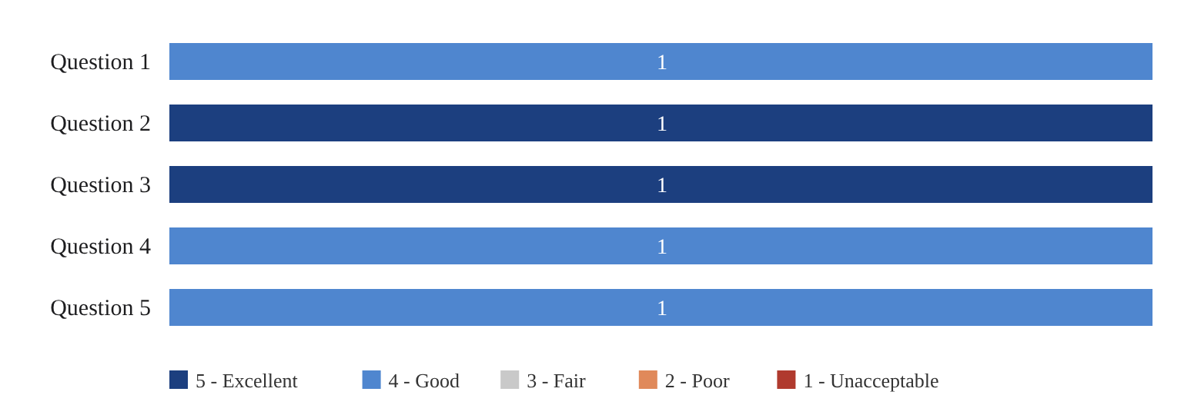
Chart 2.8. Functional Suitability of Technical Staff
This section shows that the Technical Staff believes the system meets their expectations for handling orders and inventory. Checking prescriptions for prescription orders and adding new stock with the batch number and expiry date were rated 5 (Excellent), while checking online payments, the accuracy of the stock count, and the expiry and low-stock alerts were rated 4 (Good). The survey result indicates that the Technical Staff is satisfied with the functional suitability of the system.
Performance Efficiency
- How fast does the system load and save your work?
- How well does the system work on busy days with many sales and orders?
- How well does the system keep up with changes, like new products or new prices?
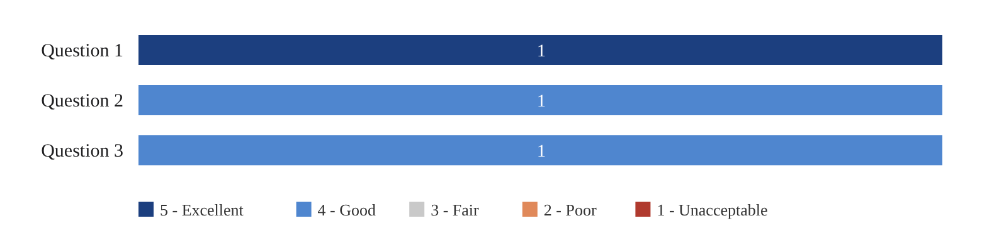
Chart 2.9. Performance Efficiency of Technical Staff
This section shows that the Technical Staff rated the system’s loading and saving speed as 5 (Excellent), and its performance on busy days and in keeping up with changes as 4 (Good). The survey result indicates that the Technical Staff is satisfied with the performance efficiency of the system.
Usability
- How easy is the system to use?
- How easy are the words and steps in the system to understand?
- How well does the system work on a phone, tablet, or computer?
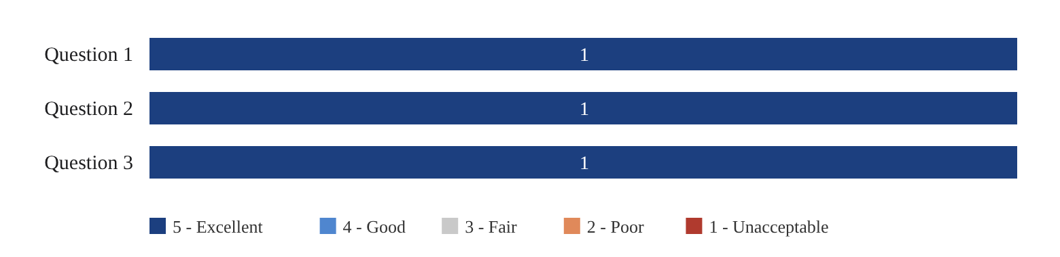
Chart 2.10. Usability of Technical Staff
This section shows that the Technical Staff rated all usability questions 5 (Excellent): ease of use, clarity of the words and steps, and how well the system works on a phone, tablet, or computer. The survey result indicates that the Technical Staff is highly satisfied with the usability of the system.
Reliability
- How well does the system save your work without errors or lost data?

Chart 2.11. Reliability of Technical Staff
This section shows that the Technical Staff rated the system 5 (Excellent) for saving work without errors or lost data. The survey result indicates that the Technical Staff is highly satisfied with the reliability of the system.
Security
- How safe is your account (login code on a new device, lock after wrong passwords)?
- How well does the system help the branch follow the rules (expiry dates, prescriptions, customer privacy)?
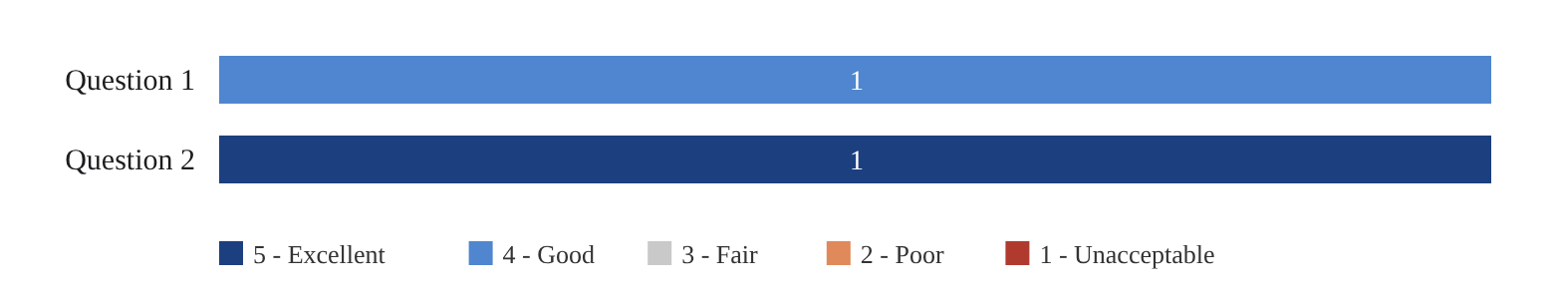
Chart 2.12. Security of Technical Staff
This section shows that the Technical Staff rated how well the system helps the branch follow the rules as 5 (Excellent) and account safety as 4 (Good). The survey result indicates that the Technical Staff is satisfied with the security of the system.
Overall Satisfaction
- How satisfied are you with the system overall?
Chart 2.13. Overall Satisfaction of Technical Staff
This section shows that the Technical Staff rated their overall satisfaction with the system as 5 (Excellent), indicating that the system fully meets their expectations.

Sales Staff Evaluation (1 respondent)
Functional Suitability
- How easy is it to find a product and make a sale in the POS?
- How easy is it to print the receipt?
- How helpful is seeing the stock left before you sell an item?
- How correct is the stock count shown in the system?
- How helpful are the expiry and low-stock alerts, and how well does the system keep near-expiry items from being sold?
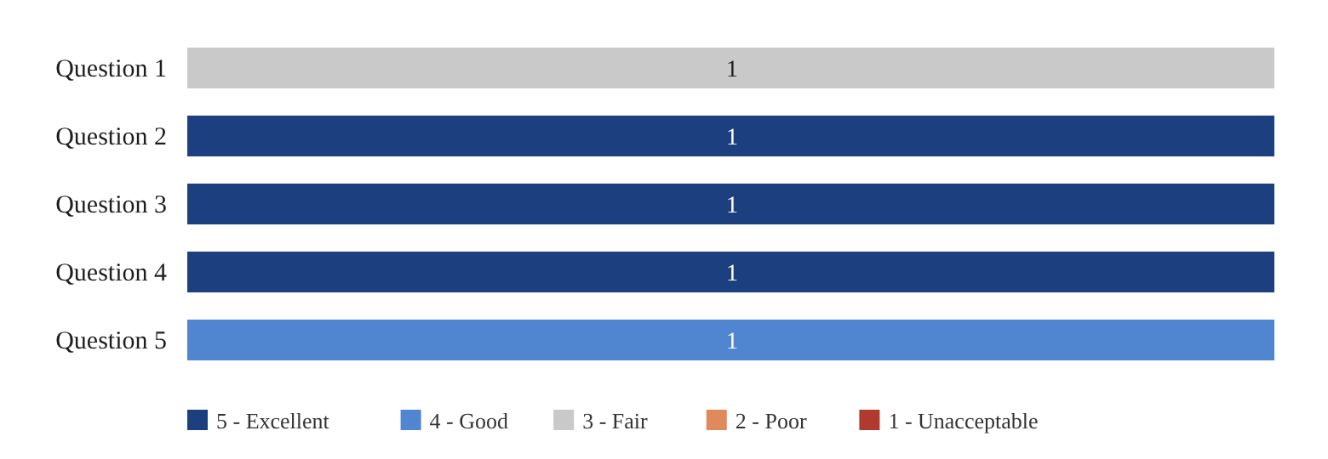
Chart 2.14. Functional Suitability of Sales Staff
This section shows that the Sales Staff rated printing the receipt, seeing the remaining stock before selling an item, and the accuracy of the stock count as 5 (Excellent), and the expiry and low-stock alerts as 4 (Good). Finding a product and making a sale in the POS was rated 3 (Fair), indicating that the product search in the POS can be improved. Overall, the survey result indicates that the Sales Staff is satisfied with the functional suitability of the system.
Performance Efficiency
- How fast does the system load and save your work?
- How well does the system work on busy days with many sales and orders?
- How well does the system keep up with changes, like new products or new prices?
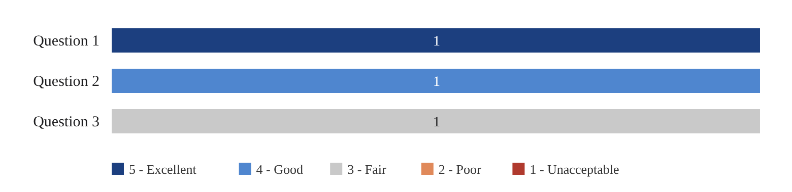
Chart 2.15. Performance Efficiency of Sales Staff
This section shows that the Sales Staff rated the system’s loading and saving speed as 5 (Excellent) and its performance on busy days as 4 (Good), while how well the system keeps up with new products and prices was rated 3 (Fair). The survey result indicates that the Sales Staff is generally satisfied with the performance efficiency of the system, with room for improvement in reflecting catalog changes.
Usability
- How easy is the system to use?
- How easy are the words and steps in the system to understand?
- How well does the system work on a phone, tablet, or computer?
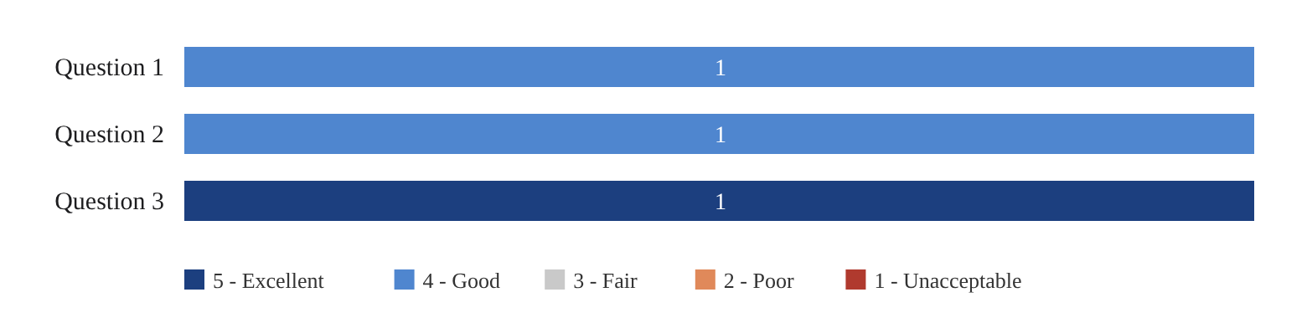
Chart 2.16. Usability of Sales Staff
This section shows that the Sales Staff rated how well the system works on different devices as 5 (Excellent), and its ease of use and clarity of the words and steps as 4 (Good). The survey result indicates that the Sales Staff is satisfied with the usability of the system.
Reliability
- How well does the system save your work without errors or lost data?
Chart 2.17. Reliability of Sales Staff
This section shows that the Sales Staff rated the system 4 (Good) for saving work without errors or lost data. The survey result indicates that the Sales Staff is satisfied with the reliability of the system.
Security
- How safe is your account (login code on a new device, lock after wrong passwords)?
- How well does the system help the branch follow the rules (expiry dates, prescriptions, customer privacy)?
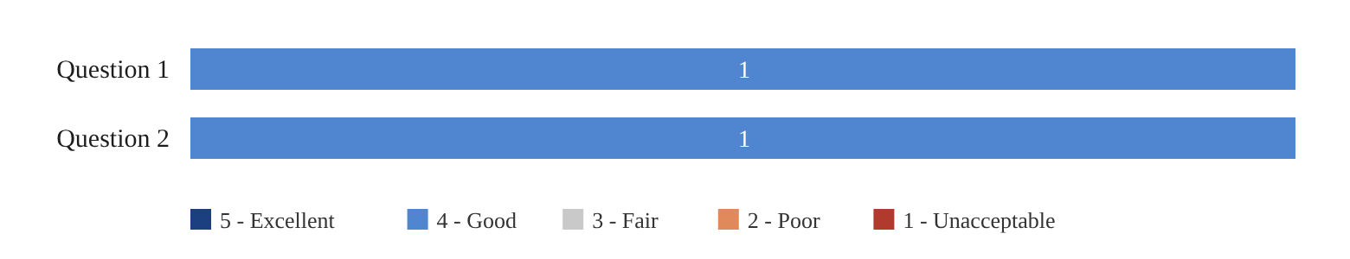
Chart 2.18. Security of Sales Staff
This section shows that the Sales Staff rated both account safety and how well the system helps the branch follow the rules as 4 (Good). The survey result indicates that the Sales Staff is satisfied with the security of the system.
Overall Satisfaction
- How satisfied are you with the system overall?
Chart 2.19. Overall Satisfaction of Sales Staff
This section shows that the Sales Staff rated their overall satisfaction with the system as 5 (Excellent), indicating that the system meets their expectations for daily point-of-sale work.

Customer Evaluation (50 respondents)
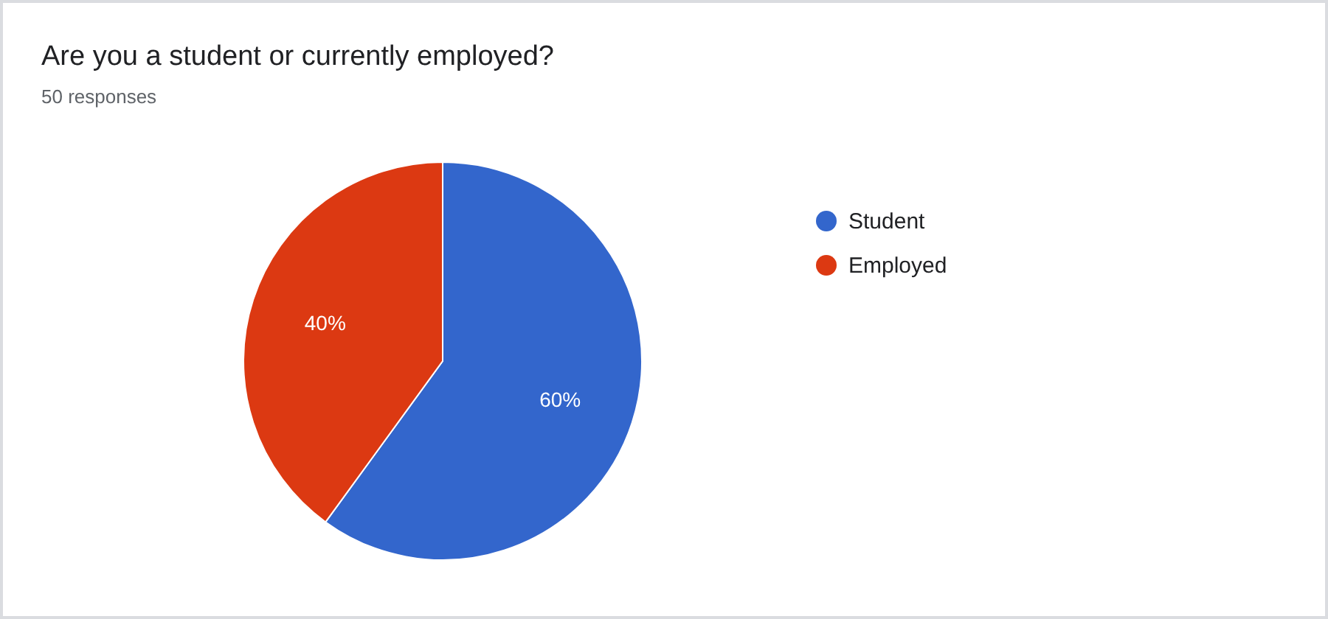
Chart 3.1. Respondents’ Occupation
The majority of the respondents (60%) are students, while 40% are employed. The respondents come from both the student and working demographic.
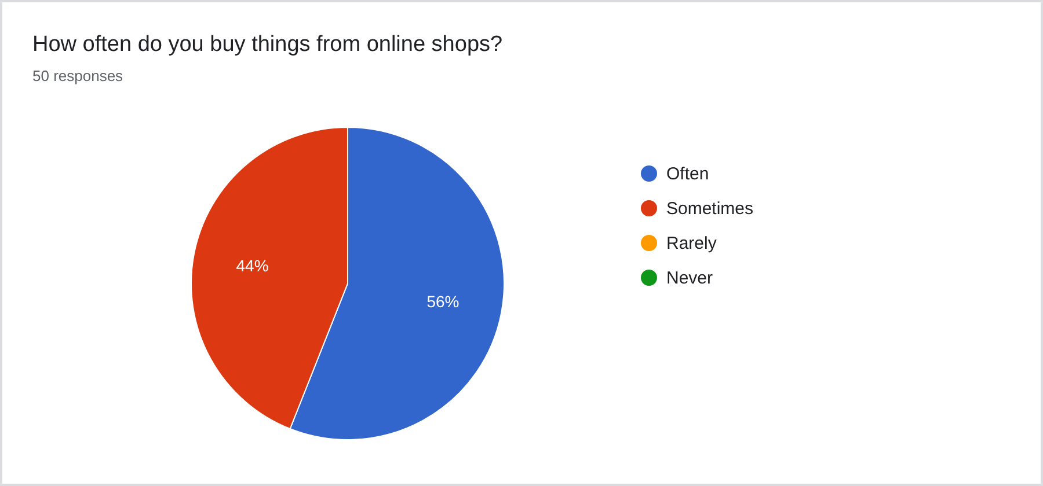
Chart 3.2. Frequency of Buying from Online Shops
More than half of the respondents (56%) often buy things from online shops, while 44% do so sometimes. No respondents selected “rarely” or “never,” so all respondents have experience with online shopping.
Functional Suitability
- How easy was it to add products to your cart and place an order online?
- How helpful is seeing the products, prices, and stock online before you buy?
- How helpful is following your order in My Orders (status and tracking link)?
- How helpful is being able to pre-order prescription medicine online and pick it up at the store?
- How helpful is the AI chat assistant in answering your questions?
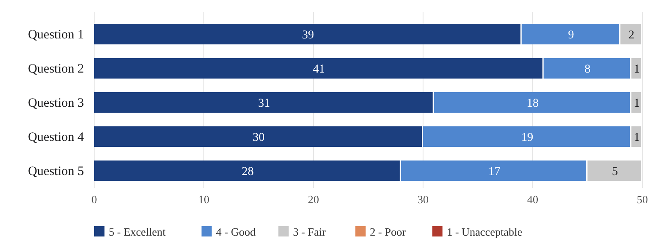
Chart 3.3. Functional Suitability of Customers
This section shows that customers believe the system meets their expectations for the features of the online store. Most customers rated seeing the products, prices, and stock online (41 of 50) and adding products to the cart and placing an order (39 of 50) as 5 (Excellent). The AI chat assistant received the most 3 (Fair) ratings in this category (5 of 50), indicating that it can be further improved. The survey result indicates that customers are satisfied with the functional suitability of the system.
Performance Efficiency
- How fast is the website when you browse and order?
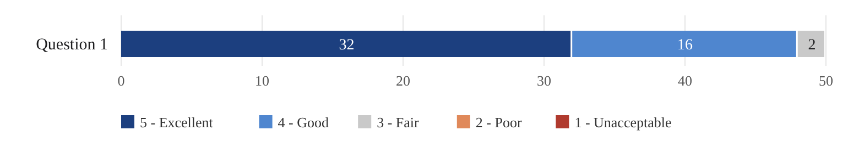
Chart 3.4. Performance Efficiency of Customers
This section shows that customers believe the system meets their expectations for speed when browsing and ordering, with 32 of 50 respondents rating it 5 (Excellent) and 16 rating it 4 (Good). The survey result indicates that customers are satisfied with the performance efficiency of the system.
Usability
- How easy was it to make an account and enter the code sent to your email?
- How easy was it to find the medicine or product you needed?
- How easy are the words and instructions on the website to understand?
- How well does the website work on your phone, tablet, or computer?
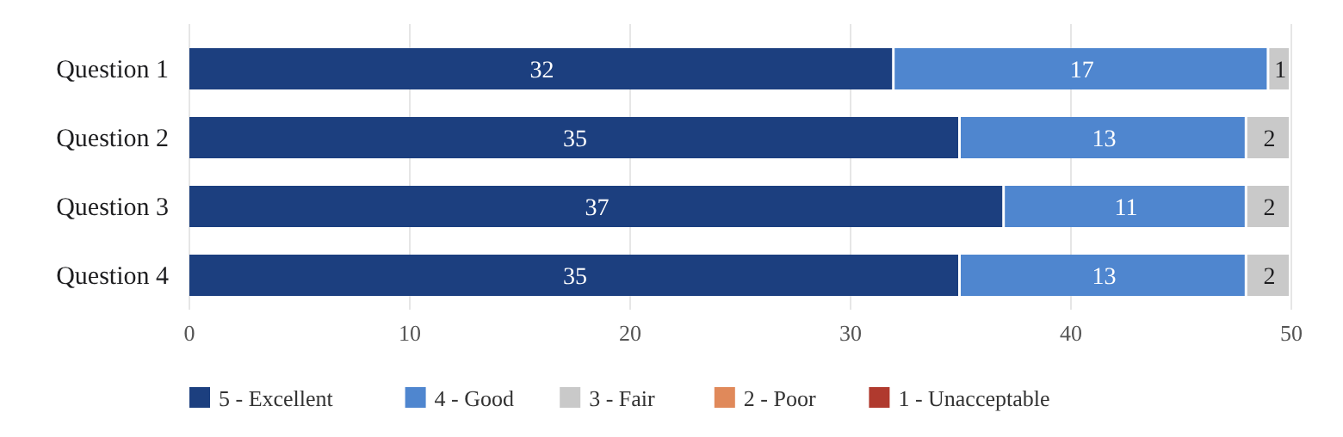
Chart 3.5. Usability of Customers
This section shows that customers find the system easy to use. Most respondents rated creating an account, finding products, understanding the words and instructions, and using the website on different devices as 5 (Excellent), with only one or two respondents rating each question 3 (Fair). The survey result indicates that customers are satisfied with the usability of the system.
Reliability
- How correct was your order (right items, right price, right status)?
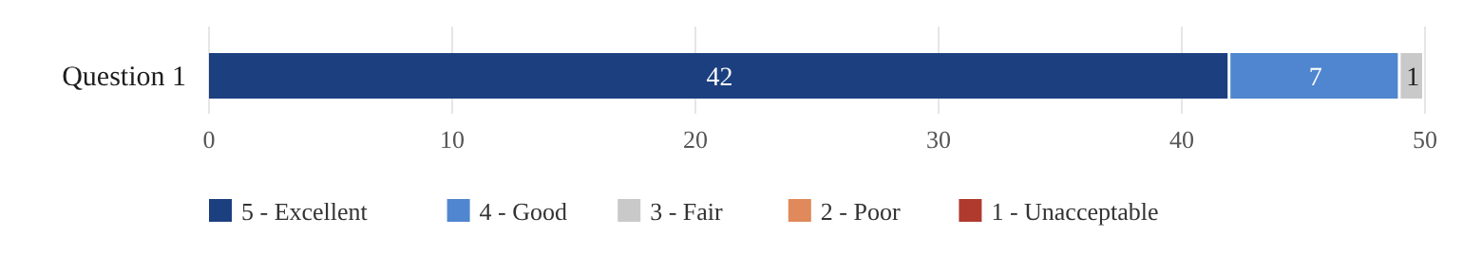
Chart 3.6. Reliability of Customers
This section shows that customers believe their orders were correct in items, prices, and status, with 42 of 50 respondents rating it 5 (Excellent), the highest-rated question in the user survey. The survey result indicates that customers are highly satisfied with the reliability of the system.
Security
- How safe do you feel your account and personal information are on the website?
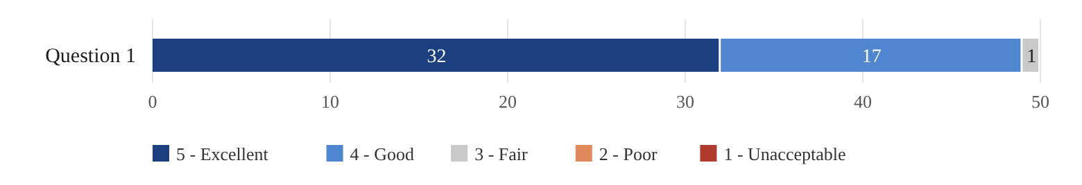
Chart 3.7. Security of Customers
This section shows that customers feel their account and personal information are safe on the website, with 32 of 50 respondents rating it 5 (Excellent) and 17 rating it 4 (Good). The survey result indicates that customers are satisfied with the security of the system.
Overall Satisfaction
- Overall, how happy are you with the website?
- How likely are you to use the website again when you need to buy medicine from Amson Pharmaceuticals?
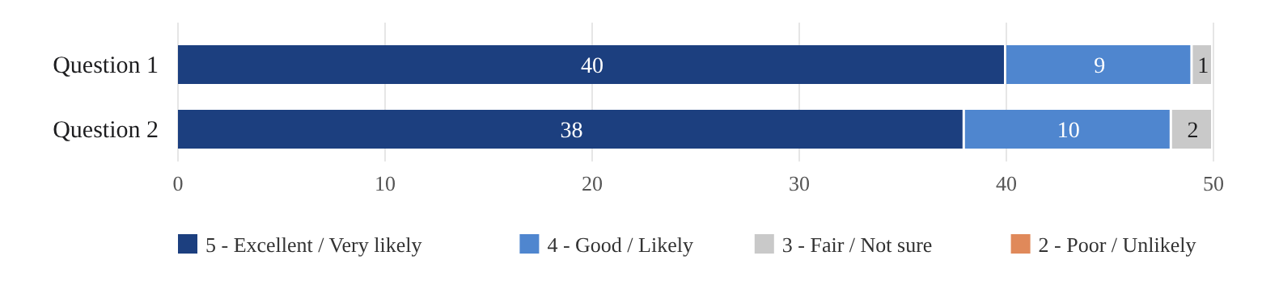
Chart 3.8. Overall Satisfaction of Customers
This section shows that 40 of 50 customers rated their overall satisfaction as 5 (Excellent), and 48 of 50 are likely or very likely to use the website again when buying medicine from Amson Pharmaceuticals. The survey result indicates that customers are satisfied with the system overall.

Summary of Survey Results
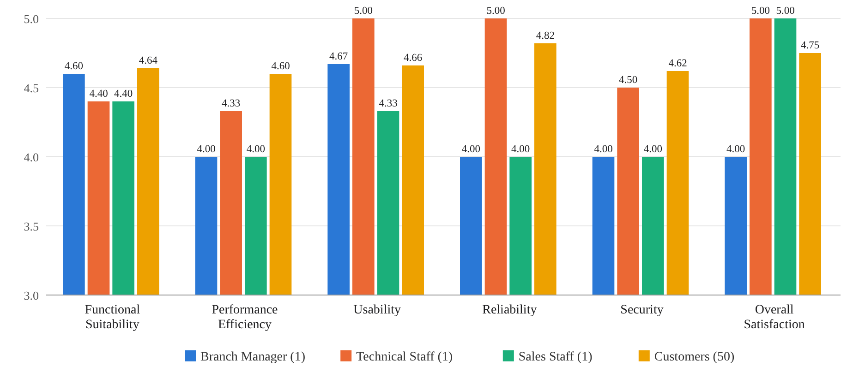
Chart 4.1. Summary of Survey Results
The evaluation results presented in the chart show that the developed system satisfies the software quality requirements set under ISO/IEC 25010. All respondent groups rated every quality characteristic at an average of 4.00 or higher. Customers (50 respondents) gave average ratings of 4.60 to 4.82 across all characteristics, with Reliability rated highest at 4.82, confirming that orders placed through the website were accurate. The Technical Staff gave perfect averages of 5.00 for Usability, Reliability, and Overall Satisfaction, while the Sales Staff also rated their overall satisfaction 5.00.
The relatively lower averages from the Branch Manager and the Sales Staff in Performance Efficiency, Reliability, and Security (4.00) reflect the individual Fair ratings on account safety, POS product search, and keeping up with catalog changes. These indicate that while the system is effective and ready for daily use, future improvements should focus on faster product search at the point-of-sale, quicker reflection of catalog changes, and stronger account security.

CONCLUSION
The development and deployment of the Web-Based Sales and Inventory Management System with Integrated Real-Time Expiry Monitoring for Amson Pharmaceuticals effectively resolved the operational problems of the Las Piñas branch caused by handwritten invoices, Excel re-encoding, ordering through personal messaging applications, and manual expiry monitoring. The system was developed using the Agile methodology, tested against its functional and non-functional requirements, and deployed to the branch on October 22, 2026. It was evaluated by 53 respondents, consisting of the Branch Manager, the Technical Staff, the Sales Staff, and 50 customers, using the ISO/IEC 25010 quality characteristics and the Technology Acceptance Model. All respondent groups gave average ratings of 4.00 to 5.00 across functional suitability, performance efficiency, usability, reliability, and security. Customers rated the system highest in reliability at 4.82, and 40 of 50 rated their overall satisfaction as Excellent.
From these findings, the researchers conclude that all four objectives of the study were achieved. First, the customer e-commerce platform enables retail customers to browse products, place orders online, access AI-powered chat support, and pre-order prescription medicines for in-store pick-up, reducing the branch’s reliance on personal messaging applications. Second, the sales and inventory module generates a transaction record and printed receipt for every sale, applies FEFO stock prioritization, monitors inventory in real time with expiry and low-stock alerts, and removes near-expiry products from sellable inventory, so the prevention of expired products no longer depends only on the staff’s physical vigilance. Third, the administrative portal allows authorized users to manage products and prices through role-based access, handle both online and walk-in transactions, and generate exportable daily and monthly sales and inventory reports with batch numbers and expiration details for main office submission, while recording sensitive actions in the audit log. Fourth, the evaluation shows that the end-users accept the system as useful and easy to use, and that it meets the ISO/IEC 25010 quality characteristics.
Based on the survey results, the researchers recommend improving the product search in the point-of-sale through barcode scanning or search by generic name, since the Sales Staff rated finding a product and making a sale as Fair. New products and price changes should also appear more quickly on all screens, and account security should be strengthened through additional login verification for staff, since account safety received the lowest rating from the Branch Manager. The AI chat assistant’s answers should also be improved, as it received the most Fair ratings in the user survey.
Beyond the scope of this study, future researchers and developers are encouraged to register the system with the Bureau of Internal Revenue so that its receipts and invoices can serve as official receipts with VAT computation, and to add multi-branch support for the planned Sta. Cruz branch and the main office. Integration with the branch’s existing point-of-sale system would remove the need to record sales and stock in two systems, while connecting a payment gateway and a courier API would replace manual screenshot verification and manual Lalamove booking. Offline support for when the internet connection is down, and an upgrade to a paid cloud plan as transactions grow, would further improve the system’s usage limits and data backup.

