2017

Cloud Computing web app v1.0
Author – Mark Schafers
21/03/17

Requirements Specifications

Table of Contents
1. Executive Summary 2
1.1 Project Overview 2
1.2 Purpose and Scope of this Specification 2
2. Requirements 3
3. Use Case Diagrams 4
4. User Interface/Design 5

Executive Summary

Project Overview

This project involves building an educational platform for the client, Louise Lenny who is an educator. Louise is looking for a quick prototype in order to push forward with the management personal at the school she works at and get funds for development of this new system.

Purpose and Scope of this Specification

This specification is to provide a detailed description of the purpose and environment of the intended program and describes all functionality it includes and how it is expected to run.
The purpose of this project is to build an application using the ruby on rails web application framework. This application will allow a student to log in and view their currently enrolled courses and the content contained within. A Lecturer will also be able to log in and view course content but they will also have administrator privileges that will allow them to create, read, update and delete any student or course details. This application must be able to be run on any browser and device.

In scope
The following addresses the main scope related to the development phase of this project:
- Development of a web application using the ruby on rails framework.
- Creation of a web site with a chosen style and colour scheme
- Creation and integration of a database with user, course and content tables, using rails framework
- Populating the database with relevant data
- Creating a log in system. An optional authentication system may be implemented
- Creating individual pages including a landing, login, user homepages and course content pages
- Add admin privileges for lectures with CRUD functionality for student, course and content modifications
- Display relevant course information on a student homepage
- Display course content on a new page when the student has clicked a button to do so

Requirements

Functional Requirements

The following requirements are essential to the functionality of the program.
- Log in system. optional - authentication system
- A database will be needed to store user, course and content data
- CSS styled HTML pages including a homepage, login page and user homepage
- Lecturer admin privileges on their homepage which includes CRUD options for course content
- Course information must be displayed on the screen
- If a specific course has been clicked on a user will be redirected to a new page and the course content will be displayed there
- All content is unique to one course. optional – make available to multiple courses

Non-Functional Requirements

- Performance
- Reliability
- Maintainability
- Security
- Data Integrity

Use Case Diagrams

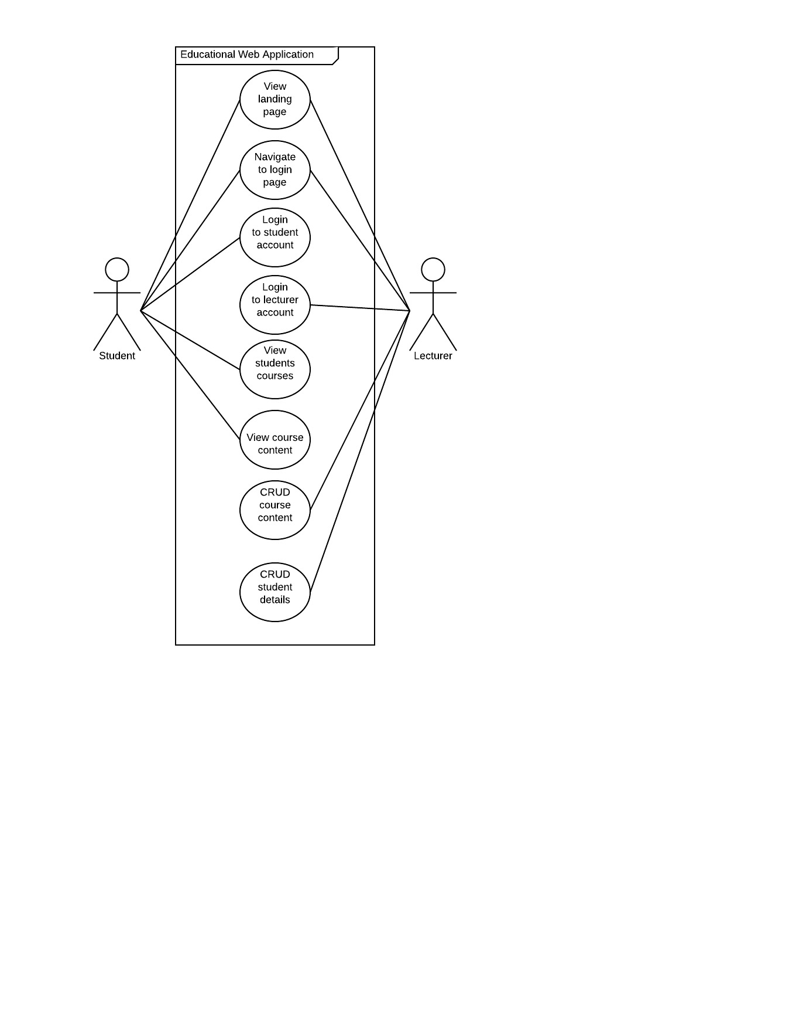

User Interface/Design

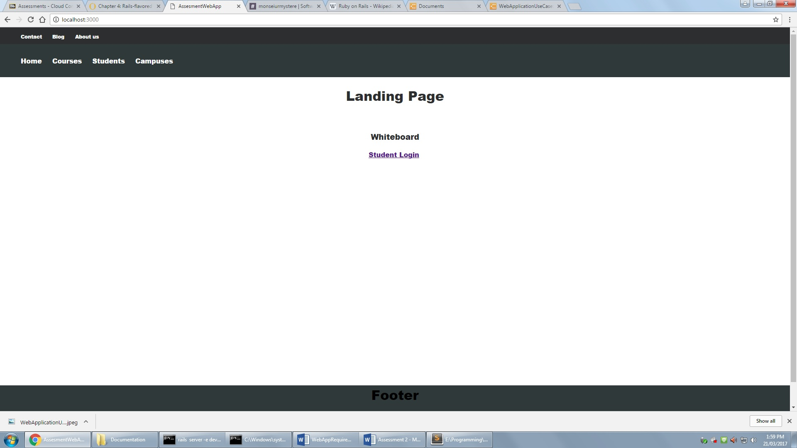

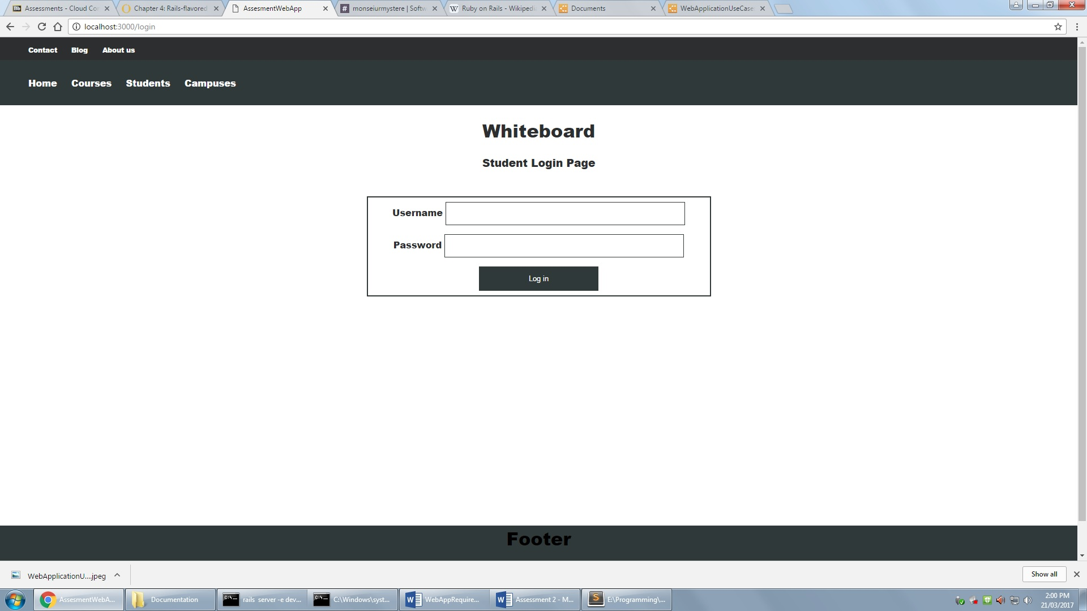

Entity Relationship Diagram

