Effects of progressive resistance training on the expression of long non-coding RNAs in skeletal muscle of young adults

## Abstract

The benefits of progressive resistance exercise training (RT) are largely known and relatively well-researched. RT is a potent way of stimulating an increase in muscle strength and mass which contribute to an individual’s quality of life. Loss of muscle strength and mass tend to occur as a result of aging and certain disease conditions. The challenge often lies in personalizing an individual’s regimen as different individuals respond differently to the same RT program. As per today, a one-size-fits-all approach is in use. This means it is necessary to not only understand the responses to RT, but also understand what regulates those responses. Lon non-coding RNAs (lncRNAs) are said to play regulatory roles in different aspects of cellular physiology. Most studies today are focused on their roles in diseases, especially cancers. This study is focused on understanding the effects of RT on the expression of long non-coding RNAs in skeletal muscle of young adults; as a step towards understanding how responses to RT are regulated. lncRNAs expressed in the *vastus lateralis* muscle of young adults were modeled using glmmTMB to analyse the effects of RT in trained versus untrained legs, and the effects of volume of RT on trained legs. lmer was used to build a model that predicted protein-coding genes that are coexpressed with the differentially expressed lncRNAs based on the correlation of their expression patterns.

## Introduction

The skeletal muscle is important for physical health and vitality. It responds to both use and disuse by hypertrophying, and loss of muscle strength and mass respectively (*1*, *2* ). Aging in humans correlate to loss of muscle mass and strength (*3*, *4* ) which in turn correlate to the risks of falls, injuries and impaired mobility (*5*) . Certain disease conditions like chronic obstructive pulmonary disease (COPD) could also accelerate loss in muscle mass and strength (*6*) . Thus, muscle strength and mass are important for improved quality of life.

Progressive resistance exercise training (RT); a type of exercise where the skeletal muscle is exercised against progressively increased types of resistance (*7*) such as free weights , is the most potent non-pharmacological method of stimulating muscle hypertrophy and countering the loss in muscle strength and mass (*1*, *8*) . RT has been shown to reduce blood glucose levels (*9*, *10*) improve strength and performance in older adults (*7*) and in children with cerebral palsy (*11*) , improve health status and pain intensity in women with fibromyalgia (*12*, *13*) , counteract the adverse effects of androgen deprivation therapy in prostate cancer patients (*14*) , as well as decrease menopause-related symptoms (*15*). The benefits of RT are dependent on its volume (*16*) and extend beyond physical health to include the mental health of participants (*17*) . Besides volume, factors such as ribosome biogenesis, transcriptome profile and responses, metabolites profile *etc* determine an individual’s response to RT (*1*, *18*).

Numerous studies have reported the gene expression patterns following RT, but how these patterns are regulated is poorly understood. Understanding these could also help understand the factors regulating response to RT. Long non-coding RNAs (lncRNAs) are said to regulate the expression of protein-coding genes (*19*, *20*) as well as different aspects of cellular physiology and function (*21*, *22*) . lncRNAs are non-protein-coding RNAs of more than 200 nucleotides in length. Most lncRNAs have low levels of expression and sequence conservation (*23*) , their expressions however are highly tissue and condition-specific (*19*, *24*, *25*) . Over 240,000 lncRNAs in humans have been curated (*26*) even though not much is known about the functional roles of a majority of them (*25*) . Some have been reported to play roles in cell cycle regulation (*27*, *28*) , differentiation (*29*) , metabolism (*30*) , and muscle regeneration (*31*) . There is currently significant uncertainty about the mechanisms of actions of most lncRNAs. Figuring out lncRNAs that are differentially expressed in a given condition could thus be the first in a series of steps aimed towards elucidating their functions and mechanisms of action.

Most publicly available research on this group of RNAs are focused on their roles in diseases, especially cancers, . Relatively fewer studies like (*24*) are available on their roles in health promotion. It is perhaps pertinent to investigate the possible functional roles of lncRNAs in health promoting activities like RT. This knowledge could not only contribute towards a deeper understanding of the mechanisms of response to RT, but perhaps optimizing the benefits as well as personalizing an individual’s RT regimen. This knowledge could also be extended to other areas of health where specific RNAs have been confirmed to play roles in diseases. lncRNAs have a strong potential of usage as biomarkers of diseases, or as therapeutic agents (*32*) , as such they could be great tools for personalised medicine.

This study aims to identify lncRNAs that are differentially expressed following RT based on exercise conditions, that is, between the trained and untrained legs of participants, and between RT volumes among the trained. The study hopes to enhance the current knowledge about the responses to RT and how these can be optimized and personalized for individual participants.

## Methods

### Study design, RNA extraction and sequencing

Study design , sample preparation and RNA sequencing were done as described by Hamarsland et al (in_view).

### Data Analyses

The quality of the RNA sequences was checked using FastQc (v0.11.5) (*33*) while RSEM (v.1.3.3-foss-2019b) (*34*) was used to align and count the reads mapping to human genome(GRCh 38) with gencode v40 primary assembly annotation . The expected count and FPKM values of the gene level counts were used during the data analyses . Further data extraction and statistical analyses were done on RStudio (2023.06.2 Build 561). An overview of data analyses steps is shown in Figure 1

#### Models and visualization

Using BiomaRt (*35*) , all genes annotated as lncRNA by the Ensembl database were filtered for downstream analyses. A total of 1024 lncRNAs were included in the analyses. These lncRNA counts were modeled using negative binomial GLMM (Generalized Linear Mixed Model) with the effective library size and time as fixed effects. Each participant was used as random effect having an individual intercept. To analyse the effect of RT over time, differential expression of lncRNAs between trained and the untrained contralateral legs was evaluated with the interaction between training status and time added to the fixed effects. To analyse the volume-dependent effects of RT on lncRNA expression, the interaction between the different training conditions and time were added to the fixed effects. Both model types were iteratively fitted using glmmTMB in Seqwrap , an R package built by Hammastrom et al (in view). All models were evaluated for uniformity and dispersion using DHARma (0.4.6). lncRNAs were identified as differentially expressed when their absolute log2 fold change was greater than 1 or less than -1, their adjusted p-values equal to or less than 0.05, and the p values of their model’s uniformity and dispersion test above 0.05. All the DE lncRNAs based on interaction effects of training status, and RT conditions were individually researched in publicly available literature to ascertain current knowledge about them

#### Coexpression analyses

To predict the potential functions of the differentially expressed lncRNAs, coexpressed protein-coding genes were modeled and iteratively fitted using lmer (*36*) in Seqwrap . Each lncRNA count, time, condition, and sex of participants were used as fixed effects, while each participant was used as random effect with a fixed intercept. Coexpressed proteins were identified as those with adjusted p values above or at 0.05 and p values of their DHaRma uniformity test above 0.05. Gene ontology and KEGG gene sets of the coexpressed protein-coding genes were retrieved from org.Hs.eg.db.

## Results and Discussion

This work was aimed at investigating which lncRNAs were differentially expressed in young individuals following about 12 weeks of RT.

#### Trained versus untrained

15 lncRNAs were differentially expressed (DE) between the trained and untrained legs at midexercise , while only eight were differentially expressed by the end of the training regimen see Tables 1 and 2.

Differentially expressed lncRNAs halfway through the training program

| target | adj.p | log2fc | pval.unif | pval.disp |
| --- | --- | --- | --- | --- |
| ALDH1A3-AS1 | 0.0004806 | 1.152359 | 0.3524781 | 0.712 |
| APCDD1L-DT | 0.0001946 | 1.224609 | 0.6862977 | 0.452 |
| CEROX1 | 0.0152184 | 1.147871 | 0.8367375 | 0.276 |
| DUXAP10 | 0.0001488 | 1.279252 | 0.3831917 | 0.902 |
| DUXAP8 | 0.0033227 | 1.064152 | 0.9148090 | 0.798 |
| DUXAP9 | 0.0013596 | 1.204039 | 0.3634461 | 0.640 |
| FAM225B | 0.0110342 | 1.465142 | 0.8444963 | 0.184 |
| HOTAIR | 0.0007144 | 1.035910 | 0.8144807 | 0.672 |
| LINC01558 | 0.0116309 | 1.017939 | 0.7772307 | 0.636 |
| LINC02893 | 0.0221652 | -1.261748 | 0.2858413 | 0.442 |
| MEG8 | 0.0001818 | 1.050177 | 0.6147018 | 0.948 |
| MIR503HG | 0.0166287 | 1.491199 | 0.9560182 | 0.772 |
| PPP1R14B-AS1 | 0.0070762 | 1.124654 | 0.9891466 | 0.582 |
| SMIM2-IT1 | 0.0019184 | -1.165741 | 0.5681950 | 0.500 |
| THY1-AS1 | 0.0000018 | 2.655731 | 0.6664769 | 0.604 |

Differentially expressed lncRNAs halfway through the training program among trained legs

| target | adj.p | log2fc | pval.unif | pval.disp |
| --- | --- | --- | --- | --- |
| ADAMTS9-AS1 | 0.0324783 | -1.121054 | 0.6353546 | 0.566 |
| ARRDC3-AS1 | 0.0041232 | 1.648962 | 0.9232524 | 0.776 |
| DUXAP10 | 0.0376164 | -1.013399 | 0.3831917 | 0.902 |
| FAM151B-DT | 0.0209471 | -1.120704 | 0.2964269 | 0.094 |
| FAM86JP | 0.0163077 | 1.260720 | 0.8372905 | 0.482 |
| GJD2-DT | 0.1031041 | 1.695448 | 0.9975262 | 0.614 |
| LANCL1-AS1 | 0.0006304 | -1.095400 | 0.7733522 | 0.338 |
| LINC00310 | 0.0038325 | -1.048791 | 0.2932104 | 0.862 |
| LINC00390 | 0.0000007 | -2.384346 | 0.7135282 | 0.976 |
| LINC00702 | 0.0355446 | 1.015226 | 0.9370691 | 0.888 |
| LINC02119 | 0.0431824 | -1.643777 | 0.9675003 | 0.544 |
| MEF2C-AS1 | 0.0000226 | 1.023059 | 0.9035214 | 0.878 |
| NPSR1-AS1 | 0.0278066 | -1.674890 | 0.4538572 | 0.442 |
| PKN2-AS1 | 0.0000071 | -1.690447 | 0.6122706 | 0.334 |
| SMIM2-IT1 | 0.0142646 | -1.330589 | 0.5681950 | 0.500 |

The interaction effect between the training status of the participant’s leg and time showed 15 DE lncRNAs at midexercise and 1 at postexercise as shown in the Tables 3 and 4.

DE lncRNAs between the trained and untrained legs postexercise

| target | adj.p | log2fc | pval.unif | pval.disp |
| --- | --- | --- | --- | --- |
| ADAMTS9-AS1 | 0.0000345 | 1.203590 | 0.6353546 | 0.566 |
| APCDD1L-DT | 0.0000111 | 1.182892 | 0.6862977 | 0.452 |
| CEROX1 | 0.0000108 | 1.540443 | 0.8367375 | 0.276 |
| DLEU2L | 0.0002079 | 1.594925 | 0.5274705 | 0.190 |
| DUXAP10 | 0.0000066 | 1.202267 | 0.3831917 | 0.902 |
| DUXAP9 | 0.0000002 | 1.541281 | 0.3634461 | 0.640 |
| MIR503HG | 0.0000025 | 2.125202 | 0.9560182 | 0.772 |
| THY1-AS1 | 0.0000701 | 1.896072 | 0.6664769 | 0.604 |

DE lncRNAs between the trained and untrained legs postexercise among trained legs

| target | adj.p | log2fc | pval.unif | pval.disp |
| --- | --- | --- | --- | --- |
| DUXAP9 | 0.0560568 | -1.025863 | 0.3634461 | 0.64 |

While the role of many lncRNAs are yet to be understood, some of the DE lncRNAs had been reported to play roles in certain disease conditions, especially cancers.

##### Differentially expressed lncRNAs in trained legs at midexercise

The DEs of interest are those who expression patterns are results of the interaction between training status and time. That is, they show the DE lncRNAs among trained legs. see Figure 1.

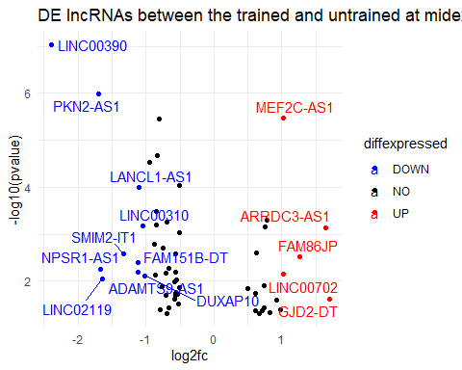

Volcano plot of DE lncRNAs at midexercise

The MEF2C-AS1 was up-regulated at midexercise in trained legs . It is reportedly down-regulated significantly in gastric cancer (*37*) and cervical cancer [ (*38*); (*39*) ]. It plays tumour suppressor roles during tumorigenesis (*40*). Its over-expression suppressed cervical cancer (*39*) which suggests that its up-regulation following a few weeks of RT could potentially be beneficial to health. MEF2C-AS1 alongside five other lncRNAs could predict prognosis in breast cancer patients. (*41*). ARRDC3-AS1 was upregulated among trained legs but was downregulated in lung cancer (*42*) (*43*). LINC00702 was quite lowly expressed in colorectal cancer tissues (*43*) and in lung cancer (*44*) but is upregulated in trained legs at midexercise. PKN2-AS1 is over-expressed in sepsis (*45*) but down-regulated by RT. Overexpression of NPSR1-AS1 is a marker of shorter disease-specific survival or overall survival in lung adenocarcinoma (*46*) and promotes the proliferation and glycolysis of hepatocellular carcinoma cells (*47*); it was down-regulated by RT The current knowledge about the lncRNAs and their expression patern following RT tends to suggest that RT might have some disease-suppression or preventing effects.

719 protein-coding genes were correlated to their expression. The gene ontology results of the coexpressed proteins are as shown in (fig:Correlation_plot_bp), (fig:Correlation_plot_mf) and (fig:Correlation_plot_cc)

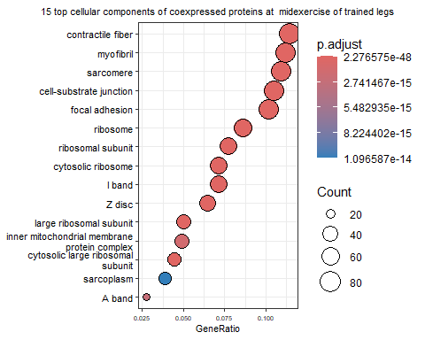

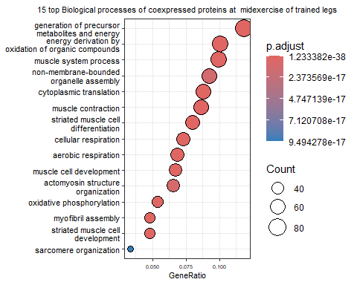

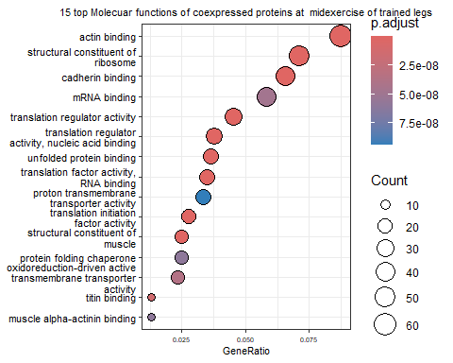

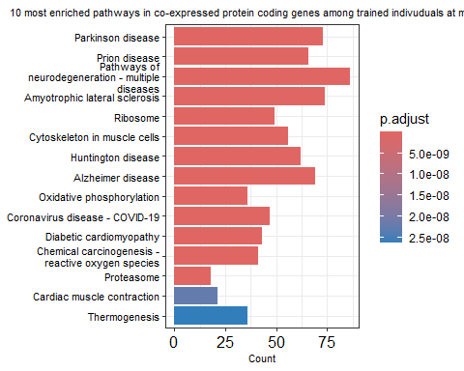

##### Differentially expressed lncRNAs in trained legs post exercise

DUXAP9 was down-regulated in the trained leg postexercise. Its over-expression has been linked to different cancers (*48*–*50*) . DUXAP9’s expression according to the model, correlated with the expression of 184 protein-coding genes. see Figures below.

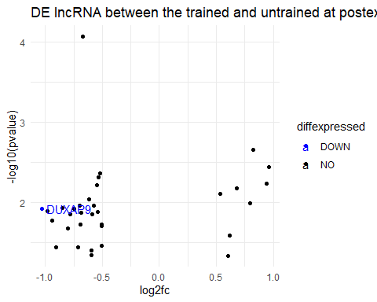

Volcano plot of DE lncRNAs postexercise

The gene ontology and Kegg enrichment plots are as shown in

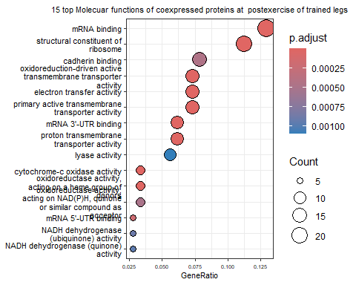

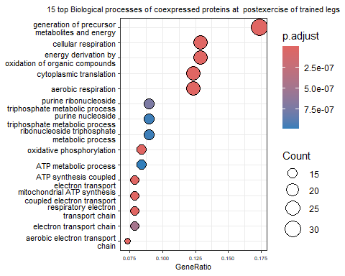

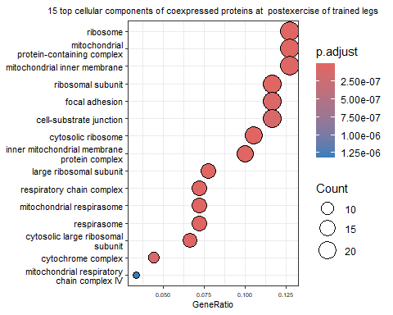

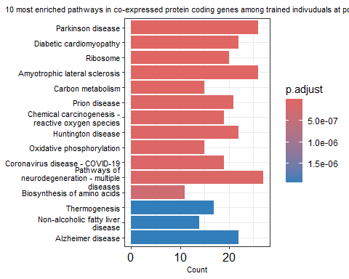

#### Volume-specific benefits

The modality and/or intensity of exercise training affects the responses . That is, there is a dose-dependent response to RT (*16*). This suggests there should be a difference between the individual legs that performed relatively more intense exercise than those that performed less.

##### Non-trained leg as a reference level

Using the control group as reference level, 16 and 18 lncRNAs were differentially expressed at post and mid exercise respectively. The interaction between set 6 and time gave 23 DE lncRNAs at mid exercise and 11 at postexercise. 13 lncRNAs were differentially expressed in set3 at mid exercise while 10 were differentially expressed at post exercise. A volcano plot showing the DE lncs are shown in the figure below.

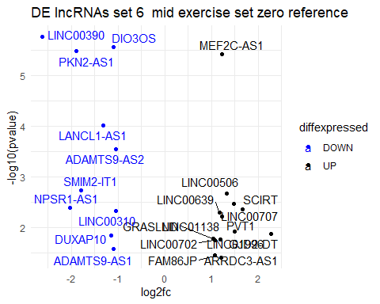

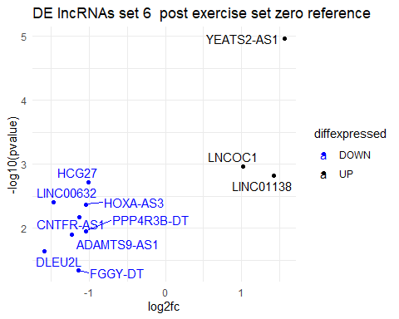

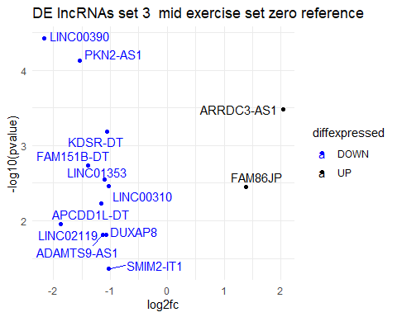

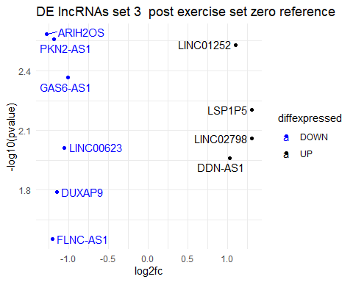

These DE lncRNAs are somewhat similar to those in the trained versus untrained analyses. Except that the trained were seperated into the two different RT groups and compared to the untrained.

The 13 DE lncRNAs of set3 at midexercise coexpressed with 749 protein-coding genes and 745 at midexercise.

The 11 DE lncRNA of set6 at postexercise had 1077 coexpressed protein coding genes and 1114 at midexercise

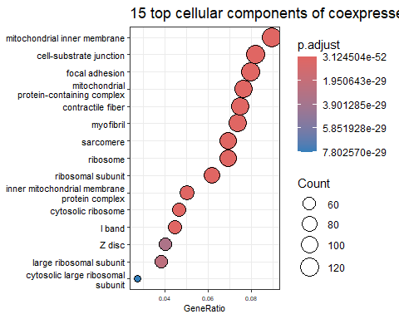

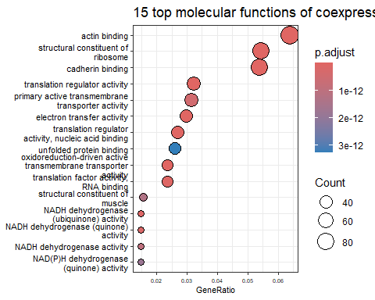

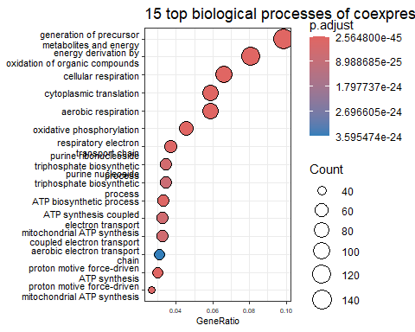

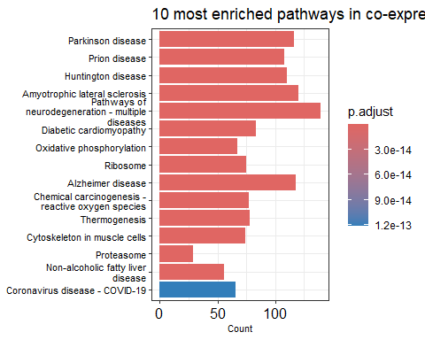

##### The difference between 3 sets and 6 sets of RT

To ascertain the difference in both RT intensities, the 3 set samples were used as reference level in a model. This gave the DE lncRNAs in the 6 sets samples in comparison to the 3 sets, in addition to other coefficients. There were 15 and 14 DE lncRNAs at post and mid exercise respectively. See table below.

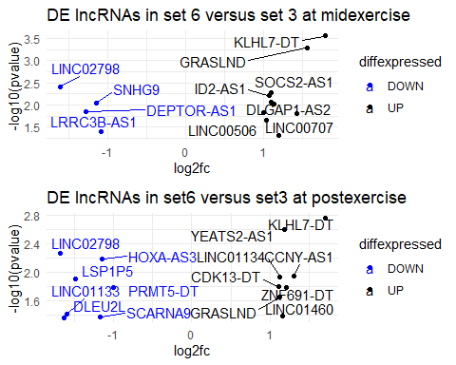

#### Potential functional characterization of the differentially expressed lncRNAs

There is a poor understanding of the lncRNA functions owing to their relative low expressions , weak conservation and relatively less research into them (*51*). The most common method used in functional characterization of lncRNAs is the “guilty by association” method of inferring the functions of lncRNAs by the function of protein-coding genes with correlating expression patterns (*54*). This method assumes that expression patterns encode functionality (*51*).

The large number of correlating expressions in protein-coding genes needs experimental validation, though this tends to agree with (*32*) that a particular lncRNA could be regulating different cellular processes and thus might be co-expressing with different protein-coding genes. Worthy of mention is the fact that correlation does not necessarily mean causation ; or regulation in this case. Though the functions of lncRNAs should be studied using wet-lab based methods, the increasing knowledge and access to computational methods for gene expression studies makes it easier to begin somewhere, by filtering a few lncRNAs from the thousands from where to begin the studies.

While this study does not enforce predictions of the functional roles of lncRNAs, it provides pointers towards lncRNAs of interest and perhaps points to areas where we could further enhance the understanding of the regulatory landscape of PRET and its benefits.

## Conclusion

The roles of lncRNAs should be explored beyond diseases, this could not only be useful towards personalisation of RT , but may also shed light on how RT can be used for health promotion and/or disease prevention . Understanding how RT impacts lncRNAs that are biomarkers of diseases could further the possibility of using RT for therapeutic interventions. While lncRNAs are believed to be regulators of different aspects of cellular physiology, it might also be helpful to investigate the regulation of these “regulators”. lncRNA expression is said to be tissue specific, which suggests that the results obtained in this study might be specific to the skeletal muscle, but the benefits of RT are not limited to the muscles alone, it might thus be important for further studies to investigate if the benefits of RT as regards lncRNAs extend beyond skeletal muscles.

RT leads to the change in expression of certain lncRNAs overtime, with the specific RT condition mediating specific expression patterns. These computationally derived results will need to be validated using wet-lab methods. To validate the functional roles of these DE lncRNAs, *in vitro* studies involving their manipulation is recommended. Also, it might be pertinent to study them as they relate to muscle strength and/of muscle gain, both of which are measurable impacts of RT

# References

1. C. Lim, E. A. Nunes, B. S. Currier, J. C. McLeod, A. C. Q. Thomas, S. M. Phillips, [An Evidence-Based Narrative Review of Mechanisms of Resistance Exercise-Induced Human Skeletal Muscle Hypertrophy.](https://doi.org/10.1249/MSS.0000000000002929) *Medicine and science in sports and exercise* **54**, 1546–1559 (2022).

2. Y. Khan, D. Hammarström, B. R. Rønnestad, S. Ellefsen, R. Ahmad, [Increased biological relevance of transcriptome analyses in human skeletal muscle using a model-specific pipeline](https://doi.org/10.1186/s12859-020-03866-y). *BMC Bioinformatics* **21**, 548 (2020).

3. G. A. Power, B. H. Dalton, C. L. Rice, [Human neuromuscular structure and function in old age: A brief review.](https://doi.org/10.1016/j.jshs.2013.07.001) *Journal of sport and health science* **2**, 215–226 (2013).

4. E. Volpi, R. Nazemi, S. Fujita, [Muscle tissue changes with aging.](https://doi.org/10.1097/01.mco.0000134362.76653.b2) *Current opinion in clinical nutrition and metabolic care* **7**, 405–410 (2004).

5. L. Wolfson, J. Judge, R. Whipple, M. King, [Strength is a major factor in balance, gait, and the occurrence of falls.](https://doi.org/10.1093/gerona/50a.special_issue.64) *The journals of gerontology. Series A, Biological sciences and medical sciences* **50 Spec No**, 64–67 (1995).

6. K. S. Mølmen, D. Hammarström, G. S. Falch, M. Grundtvig, L. Koll, M. Hanestadhaugen, Y. Khan, R. Ahmad, B. Malerbakken, T. J. Rødølen, R. Lien, B. R. Rønnestad, T. Raastad, S. Ellefsen, [Chronic obstructive pulmonary disease does not impair responses to resistance training.](https://doi.org/10.1186/s12967-021-02969-1) *Journal of translational medicine* **19**, 292 (2021).

7. C.-J. Liu, N. K. Latham, [Progressive resistance strength training for improving physical function in older adults.](https://doi.org/10.1002/14651858.CD002759.pub2) *The Cochrane database of systematic reviews* **2009**, CD002759 (2009).

8. C. Hurst, S. M. Robinson, M. D. Witham, R. M. Dodds, A. Granic, C. Buckland, S. De Biase, S. Finnegan, L. Rochester, D. A. Skelton, A. A. Sayer, [Resistance exercise as a treatment for sarcopenia: Prescription and delivery.](https://doi.org/10.1093/ageing/afac003) *Age and ageing* **51** (2022).

9. Y. Xie, H. Zhao, M. Zhao, H. Huang, C. Liu, F. Huang, J. Wu, [Effects of resistance exercise on blood glucose level and pregnancy outcome in patients with gestational diabetes mellitus: A randomized controlled trial.](https://doi.org/10.1136/bmjdrc-2021-002622) *BMJ open diabetes research & care* **10** (2022).

10. W. L. Westcott, [Resistance training is medicine: Effects of strength training on health.](https://doi.org/10.1249/JSR.0b013e31825dabb8) *Current sports medicine reports* **11**, 209–216 (2012).

11. B. Hanssen, N. Peeters, N. De Beukelaer, A. Vannerom, L. Peeters, G. Molenaers, A. Van Campenhout, E. Deschepper, C. Van den Broeck, K. Desloovere, [Progressive resistance training for children with cerebral palsy: A randomized controlled trial evaluating the effects on muscle strength and morphology.](https://doi.org/10.3389/fphys.2022.911162) *Frontiers in physiology* **13**, 911162 (2022).

12. A. Larsson, A. Palstam, M. Löfgren, M. Ernberg, J. Bjersing, I. Bileviciute-Ljungar, B. Gerdle, E. Kosek, K. Mannerkorpi, [Resistance exercise improves muscle strength, health status and pain intensity in fibromyalgia–a randomized controlled trial.](https://doi.org/10.1186/s13075-015-0679-1) *Arthritis research & therapy* **17**, 161 (2015).

13. A. J. Busch, S. C. Webber, R. S. Richards, J. Bidonde, C. L. Schachter, L. A. Schafer, A. Danyliw, A. Sawant, V. Dal Bello-Haas, T. Rader, T. J. Overend, [Resistance exercise training for fibromyalgia.](https://doi.org/10.1002/14651858.CD010884) *The Cochrane database of systematic reviews* **2013**, CD010884 (2013).

14. L. H. P. HOUBEN, M. OVERKAMP, P. VAN KRAAIJ, J. TROMMELEN, J. G. H. VAN ROERMUND, P. DE VRIES, K. DE LAET, S. VAN DER MEER, U. R. MIKKELSEN, L. B. VERDIJK, L. J. C. VAN LOON, S. BEIJER, M. BEELEN, [Resistance Exercise Training Increases Muscle Mass and Strength in Prostate Cancer Patients on Androgen Deprivation Therapy](https://journals.lww.com/acsm-msse/Fulltext/2023/04000/Resistance_Exercise_Training_Increases_Muscle_Mass.2.aspx). *Medicine & Science in Sports & Exercise* **55** (2023).

15. E. Berin, M. Hammar, H. Lindblom, L. Lindh-Åstrand, M. Rubér, A.-C. Spetz Holm, [Resistance training for hot flushes in postmenopausal women: A randomised controlled trial.](https://doi.org/10.1016/j.maturitas.2019.05.005) *Maturitas* **126**, 55–60 (2019).

16. D. Hammarström, S. Øfsteng, L. Koll, M. Hanestadhaugen, I. Hollan, W. Apró, J. E. Whist, E. Blomstrand, B. R. Rønnestad, S. Ellefsen, [Benefits of higher resistance-training volume are related to ribosome biogenesis.](https://doi.org/10.1113/JP278455) *The Journal of physiology* **598**, 543–565 (2020).

17. T. Kekäläinen, K. Kokko, S. Sipilä, S. Walker, [Effects of a 9-month resistance training intervention on quality of life, sense of coherence, and depressive symptoms in older adults: Randomized controlled trial.](https://doi.org/10.1007/s11136-017-1733-z) *Quality of life research : an international journal of quality of life aspects of treatment, care and rehabilitation* **27**, 455–465 (2018).

18. D. Hammarström, S. J. Øfsteng, N. B. Jacobsen, K. B. Flobergseter, B. R. Rønnestad, S. Ellefsen, [Ribosome accumulation during early phase resistance training in humans.](https://doi.org/10.1111/apha.13806) *Acta physiologica (Oxford, England)* **235**, e13806 (2022).

19. L. Statello, C.-J. Guo, L.-L. Chen, M. Huarte, [Gene regulation by long non-coding RNAs and its biological functions](https://doi.org/10.1038/s41580-020-00315-9). *Nature Reviews Molecular Cell Biology* **22**, 96–118 (2021).

20. J. L. C. Richard, P. J. A. Eichhorn, [Platforms for investigating LncRNA functions](https://doi.org/10.1177/2472630318780639). *SLAS TECHNOLOGY: Translating Life Sciences Innovation* **23**, 493–506 (2018).

21. J. A. Oo, R. P. Brandes, M. S. Leisegang, [Long non-coding RNAs: Novel regulators of cellular physiology and function](https://doi.org/10.1007/s00424-021-02641-z). *Pflügers Archiv - European Journal of Physiology* **474**, 191–204 (2022).

22. M. C. Bridges, A. C. Daulagala, A. Kourtidis, [LNCcation: lncRNA localization and function.](https://doi.org/10.1083/jcb.202009045) *The Journal of cell biology* **220** (2021).

23. J. S. Mattick, P. P. Amaral, P. Carninci, S. Carpenter, H. Y. Chang, L.-L. Chen, R. Chen, C. Dean, M. E. Dinger, K. A. Fitzgerald, T. R. Gingeras, M. Guttman, T. Hirose, M. Huarte, R. Johnson, C. Kanduri, P. Kapranov, J. B. Lawrence, J. T. Lee, J. T. Mendell, T. R. Mercer, K. J. Moore, S. Nakagawa, J. L. Rinn, D. L. Spector, I. Ulitsky, Y. Wan, J. E. Wilusz, M. Wu, [Long non-coding RNAs: Definitions, functions, challenges and recommendations](https://doi.org/10.1038/s41580-022-00566-8). *Nature Reviews Molecular Cell Biology* **24**, 430–447 (2023).

24. B. Bonilauri, B. Dallagiovanna, [Long Non-coding RNAs Are Differentially Expressed After Different Exercise Training Programs.](https://doi.org/10.3389/fphys.2020.567614) *Frontiers in physiology* **11**, 567614 (2020).

25. T. Ali, P. Grote, [Beyond the RNA-dependent function of LncRNA genes](https://doi.org/10.7554/eLife.60583). *eLife* **9**, e60583 (2020).

26. L. Ma, J. Cao, L. Liu, Q. Du, Z. Li, D. Zou, V. B. Bajic, Z. Zhang, [LncBook: A curated knowledgebase of human long non-coding RNAs](https://doi.org/10.1093/nar/gky960). *Nucleic Acids Research* **47**, D128–D134 (2018).

27. M. Kitagawa, K. Kitagawa, Y. Kotake, H. Niida, T. Ohhata, [Cell cycle regulation by long non-coding RNAs.](https://doi.org/10.1007/s00018-013-1423-0) *Cellular and molecular life sciences : CMLS* **70**, 4785–4794 (2013).

28. M. R. Khan, M. Avino, R. J. Wellinger, B. Laurent, [Distinct regulatory functions and biological roles of lncRNA splice variants.](https://doi.org/10.1016/j.omtn.2023.03.004) *Molecular therapy. Nucleic acids* **32**, 127–143 (2023).

29. M. J. Delás, L. R. Sabin, E. Dolzhenko, S. R. Knott, E. Munera Maravilla, B. T. Jackson, S. A. Wild, T. Kovacevic, E. M. Stork, M. Zhou, N. Erard, E. Lee, D. R. Kelley, M. Roth, I. A. Barbosa, J. Zuber, J. L. Rinn, A. D. Smith, G. J. Hannon, [lncRNA requirements for mouse acute myeloid leukemia and normal differentiation.](https://doi.org/10.7554/eLife.25607) *eLife* **6** (2017).

30. T. M. Sirey, K. Roberts, W. Haerty, O. Bedoya-Reina, S. Rogatti-Granados, J. Y. Tan, N. Li, L. C. Heather, R. N. Carter, S. Cooper, A. J. Finch, J. Wills, N. M. Morton, A. C. Marques, C. P. Ponting, [The long non-coding RNA Cerox1 is a post transcriptional regulator of mitochondrial complex I catalytic activity.](https://doi.org/10.7554/eLife.45051) *eLife* **8** (2019).

31. S. Sweta, T. Dudnakova, S. Sudheer, A. H. Baker, R. Bhushan, [Importance of Long Non-coding RNAs in the Development and Disease of Skeletal Muscle and Cardiovascular Lineages.](https://doi.org/10.3389/fcell.2019.00228) *Frontiers in cell and developmental biology* **7**, 228 (2019).

32. C. C. M. Correia, L. F. Rodrigues, B. R. de Avila Pelozin, E. M. Oliveira, T. Fernandes, [Long non-coding RNAs in cardiovascular diseases: Potential function as biomarkers and therapeutic targets of exercise training](https://doi.org/10.3390/ncrna7040065). *Non-Coding RNA* **7** (2021).

33. S. Andrews, F. Krueger, A. Segonds-Pichon, L. Biggins, C. Krueger, S. Wingett, FastQC (2012).

34. B. Li, C. N. Dewey, [RSEM: Accurate transcript quantification from RNA-seq data with or without a reference genome](https://doi.org/10.1186/1471-2105-12-323). *BMC Bioinformatics* **12**, 323 (2011).

35. S. Durinck, P. T. Spellman, E. Birney, W. Huber, [Mapping identifiers for the integration of genomic datasets with the R/Bioconductor package biomaRt](https://doi.org/10.1038/nprot.2009.97). *Nature Protocols* **4**, 1184–1191 (2009).

36. D. Bates, M. Mächler, B. Bolker, S. Walker, [Fitting Linear Mixed-Effects Models Using lme4](https://doi.org/10.18637/jss.v067.i01). *Journal of Statistical Software* **67**, 1–48 (2015).

37. T. Luo, J. Zhao, Z. Lu, J. Bi, T. Pang, H. Cui, B. Yang, W. Li, Y. Wang, S. Wu, X. Xue, [Characterization of long non-coding RNAs and MEF2C-AS1 identified as a novel biomarker in diffuse gastric cancer](https://doi.org/10.1016/j.tranon.2018.06.007). *Translational Oncology* **11**, 1080–1089 (2018).

38. Q. Guo, L. Zhang, L. Zhao, X. Pang, P. Wang, H. Sun, S. Liu, [MEF2C-AS1 regulates its nearby gene MEF2C to mediate cervical cancer cell malignant phenotypes in vitro](https://doi.org/10.1016/j.bbrc.2022.09.091). *Biochemical and Biophysical Research Communications* **632**, 48–54 (2022).

39. X. Wang, C. Zhang, M. Gong, C. Jiang, A novel identified long non-coding RNA, lncRNA MEF2C-AS1, inhibits cervical cancer via regulation of miR-592/RSPO1. *Frontiers in molecular biosciences* **8**, 687113 (2021).

40. S. Qian, S. Lin, X. Xu, H. Bai, A. Yeerken, X. Ying, Z. Li, X. Fei, J. Yang, M. Tang, Hypermethylation of tumor suppressor lncRNA MEF2C-AS1 frequently happened in patients at all stages of colorectal carcinogenesis. *Clinical Epigenetics* **14**, 111 (2022).

41. Y. Luo, Y. Zhang, Y.-X. Wu, H.-B. Li, D. Shen, Y.-Q. Che, Development of a novel five-lncRNA prognostic signature for predicting overall survival in elderly patients with breast cancer. *Journal of Clinical Laboratory Analysis* **36**, e24172 (2022).

42. S. N. A. Shah, R. Parveen, Lung cancer biomarker identification from differential expression analysis using RNA-seq data for multitargeted drug designing. (2024).

43. D. Yu, X.-Y. Wang, Z.-L. Jin, Linc00702 inhibits cell growth and metastasis through regulating PTEN in colorectal cancer. *European Review for Medical & Pharmacological Sciences* **24** (2020).

44. W. Yu, D. Li, X. Ding, Y. Sun, Y. Liu, J. Cong, J. Yang, J. Sun, X. Ning, H. Wang, LINC00702 suppresses proliferation and invasion in non-small cell lung cancer through regulating miR-510/PTEN axis. *Aging (Albany NY)* **11**, 1471 (2019).

45. J. Yuan, L. Cao, J. Bao, Y. Zha, S. Chen, W. Fan, M. Fang, Y. Gui, N. Liu, M. Shao, Circulating long noncoding RNAs positively correlate with the increased risk, elevated severity and unfavorable prognosis in the sepsis patients. (2022).

46. H. Zhang, J. Yuan, Y. Xiang, Y. Liu, Comprehensive analysis of NPSR1-AS1 as a novel diagnostic and prognostic biomarker involved in immune infiltrates in lung adenocarcinoma. *Journal of Oncology* **2022**, 2099327 (2022).

47. H. He, T. Chen, H. Mo, S. Chen, Q. Liu, C. Guo, Hypoxia-inducible long noncoding RNA NPSR1-AS1 promotes the proliferation and glycolysis of hepatocellular carcinoma cells by regulating the MAPK/ERK pathway. *Biochemical and Biophysical Research Communications* **533**, 886–892 (2020).

48. Q. Zhu, J. Liu, J. Tang, D.-L. Guo, Y. Li, R. Duan, Overexpression of long non-coding RNAs DUXAP9 and DUXAP10 is associated with prognosis in patients with hepatocellular carcinoma after hepatectomy. *International journal of clinical and experimental pathology* **11**, 1407–1414 (2018).

49. J. Chen, W. Lou, B. Ding, X. Wang, [Overexpressed pseudogenes, DUXAP8 and DUXAP9, promote growth of renal cell carcinoma and serve as unfavorable prognostic biomarkers.](https://doi.org/10.18632/aging.102152) *Aging* **11**, 5666–5688 (2019).

50. T. Zhu, S. An, M.-T. Choy, J. Zhou, S. Wu, S. Liu, B. Liu, Z. Yao, X. Zhu, J. Wu, Lnc RNA DUXAP 9-206 directly binds with cbl-b to augment EGFR signaling and promotes non-small cell lung cancer progression. *Journal of cellular and molecular medicine* **23**, 1852–1864 (2019).

51. B. Uszczynska-Ratajczak, J. Lagarde, A. Frankish, R. Guigó, R. Johnson, [Towards a complete map of the human long non-coding RNA transcriptome](https://doi.org/10.1038/s41576-018-0017-y). *Nature Reviews Genetics* **19**, 535–548 (2018).

52. B. Bonilauri, B. Dallagiovanna, [Long Non-coding RNAs Are Differentially Expressed After Different Exercise Training Programs.](https://doi.org/10.3389/fphys.2020.567614) *Frontiers in physiology* **11**, 567614 (2020).

53. A. R. Chapman, D. F. Lee, W. Cai, W. Ma, X. Li, W. Sun, X. S. Xie, [Correlated gene modules uncovered by high-precision single-cell transcriptomics.](https://doi.org/10.1073/pnas.2206938119) *Proceedings of the National Academy of Sciences of the United States of America* **119**, e2206938119 (2022).

54. F. Seifuddin, K. Singh, A. Suresh, J. T. Judy, Y.-C. Chen, V. Chaitankar, I. Tunc, X. Ruan, P. Li, Y. Chen, H. Cao, R. S. Lee, F. S. Goes, P. P. Zandi, M. S. Jafri, M. Pirooznia, [lncRNAKB, a knowledgebase of tissue-specific functional annotation and trait association of long noncoding RNA](https://doi.org/10.1038/s41597-020-00659-z). *Scientific Data* **7**, 326 (2020).

:::

# Appendix