**1: Create Trello & Scrum**

1. What did you do since the last meeting? Team members comment on whether or not their commitments from the previous day were met.

2. What will you do today? Team members explain what they’re working on today and will have done by the daily stand-up tomorrow.

3. What issues do you have? Team members explain where they are running into trouble with certain aspects of the project.

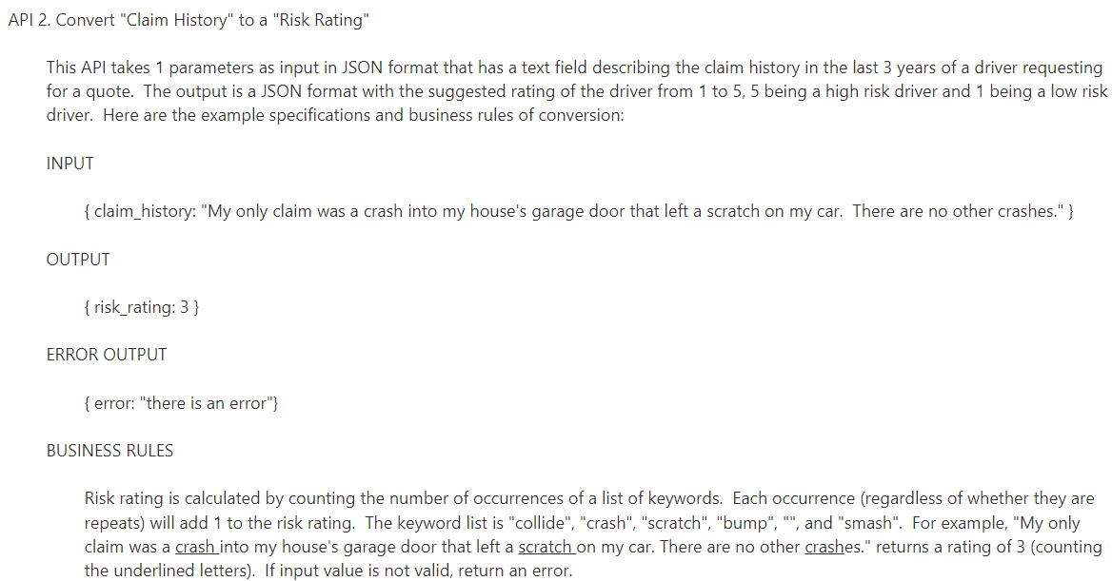**2:** API 2

https://www.freecodecamp.org/news/javascript-split-how-to-split-a-string-into-an-**array**-in-js/

https://stackoverflow.com/questions/12433604/how-can-i-find-matching-values-in-two-arrays

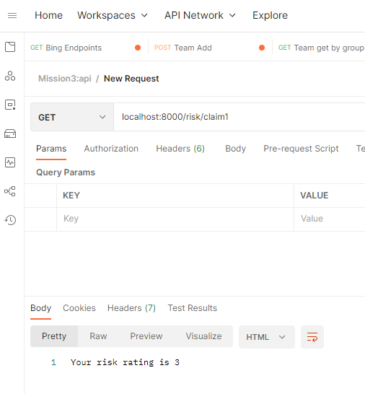

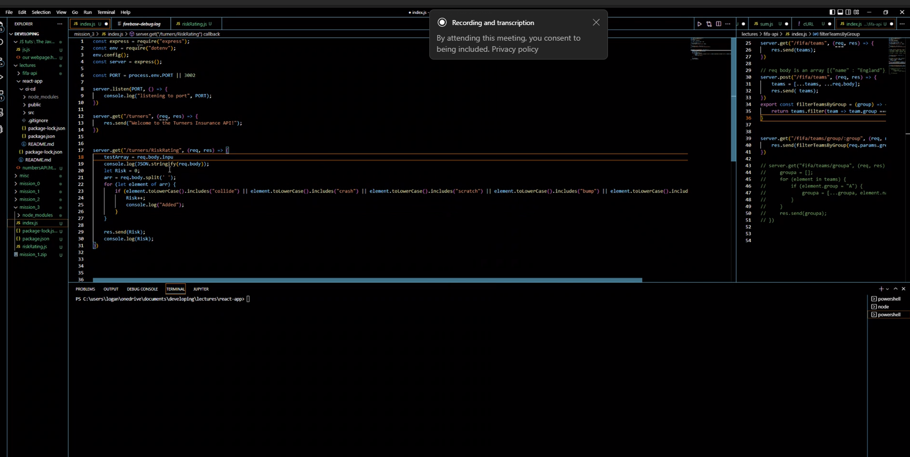

Req.body

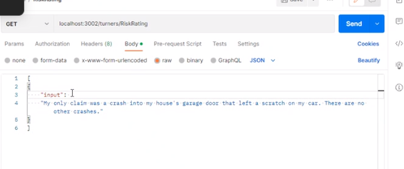

{

|  |  |  |  |
| --- | --- | --- | --- |
| Test Case Number | Input (“Claim”) | Expect Output(rating) | Test Description |
| 1 | [“I have nothing to claim”] | Rating:0 |  |
| 2 | ["My only claim was a crash into my house's garage door that left a scratch on my car.  There are no other crashes.] | Rating:2 |  |
| 3 | ["bad accident, bump, and a lot of scratch."] | Rating:3 |  |

https://medium.com/@oyetoketoby80/how-to-write-unit-test-for-your-rest-api-f8f71376273f

