**Proposal**

**2x2x2 Rubik’s cube solver**

**- Chandan Ahire**

I learned solving Rubik’s cube and got interested in speed cubing as well since class 8. Also I was into Arduino since last year so eventually I ended up with an idea of making own Rubik’s cube solver. Like many people searching for "Rubik's Cube Solver" on Google, one of the first robots I found was the Tilted Twister design by Hans Andersson made with lego which has a simple design which can be implemented easily using basic knowledge of auduino.

**Aim:-**

As a beginner, I started with a simple algorithm of 2x2 Rubik cube. My aim is to successfully solve a 2x2x2 Rubik cube using a robotic arm.

**Materials Used:-**

2x2 Rubik Cube

Electronics:

- Arduino UNO R3

- 2 servos (I used MG995s)

- Wires

- USB cable

Hardware:

- Popsicle sticks

- Screws

- Thin plywood

- Cardboard wheel

- Hot glue

**Software:-**

- Arduino IDE - (Algorithm in C++)

**Concept:-**

After researching, and discussing with seniors I found out the simplest approach to solve a Rubik cube is using mathematical path. God's Number shows the smallest number of moves needed to solve the Rubik's Cube from any random starting position and it is 14 quarter turns or 11 half turns for 2x2x2 Rubik's Cube.

Reduction to the graph problem:

We treat every possible combination of our Rubik cube as a node in the graph and an undirected edge exist between 2 nodes if we can reach one node from another node by applying only single operation from the set of 6 operations(quarter turns)(F,Fi,L,Li,U,Ui).

So, now our problem is reduced to find the shortest path from the start position (or node) to the final position. Since there are no weights on an edge we can find the shortest path using Breadth First Search (BFS).

Using Serial communication to send moves to Arduino and arduino code performing respective moves physically.

**Electronics:-**

Two servos are used

Push Servo (PIN 6) - This servo is responsible for two mechanical moves, one to push Rubik cube and one to hold Rubik cube when rotate servo rotates it.

Rotate Servo (PIN 9) - This is responsible for rotating cube.

**Mechanical Design:-**

The mechanism (Idea of Hans Anderson) has basically two parts:-

i) A platform holds and rotates the cube - This platform is connected with rotate servo.

ii) The arm pushes and holds the cube - This arm is made using Push servo.

This push and rotation will eventually solve the cube.

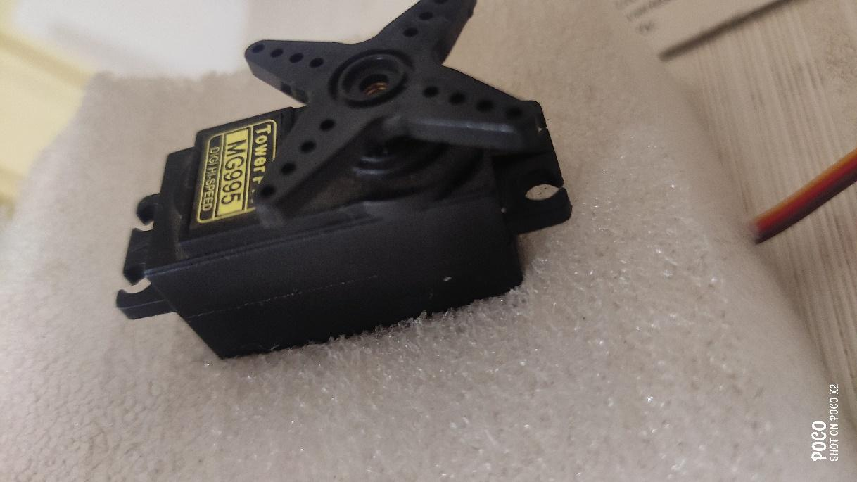

**Budget:-**

Arduino UNO R3 and USB cable- 600 rupees

Servos (mg995s) - 400*2=800 rupees

Wooden Sticks, Cardboard and Glue- 200 rupees

2x2 Rubik cube- 350 rupees

Total- 1950 rupees.

**Problems Faced:-** While coding faced a major problem of making serial connection with arduino but with the help of google and alumni of another college I fixed this problem with the following cpp code



Finally small problem occurred during making of mechanical arm. Also, many small problems were faced while coding of main code but solved it eventually.



**Possible Changes:-**

- Reading the initial stage using sensors.

- Coding in more efficient language.

**Future Plans:-**

- To work on complex algorithms of 3x3x3 Rubik’s cube,

- To make solving faster,

- Using modern techniques of machine learning and artificial intelligence,

- Using modern coding language,

- Making it more efficient in every possible way.

**Project Status:-**

Final Testing stage will be done soon in less time.